**AI- powered solutions for load and route optimization in supply chain management incorporating the travelling salesman problem (TSP)\***

Mrs.Harsha Patil Assistant Professor Department of Computer Application MIT Arts

Commerce and Science College Alandi Pune India

Dr.Vikas Mahandule HOD, Assistant Professor, Department of Computer Application MIT

Arts Commerce and Science College Alandi Pune India

Ms. Sneha Parab, Student, Department of computer application MIT Arts commerce and science college Alandi, Pune India

Ms. Sharayu Patil, Student, Department of computer application MIT Arts commerce and science college Alandi, Pune India

**Abstract:**

The rising advancements of supply chain complexities and the demand for cost-effective, time-saving, and environmentally friendly logistics has driven innovative solutions. As logistics systems become more and more complex in their operations, and the utilization of traditional means is challenged to provide solutions for efficient routing. The study aims to examine the use of artificial intelligence methods in supply chain incorporating with TSP problem. A comparative worldview will be briefly addressed in-order to display the strength of applicability. There is a comparative analysis of the methods, explicating the differences among them, and discussing the circumstances where one method may be more appropriate than another in a certain logistics case. The required data for conducting each AI method is laid out, along with what the possible impact of the data quality could be on the selected performance measure. Future work directed at hybrid methods, utilizing real-time data systems, and introductions of scalability of the methods across the supply chain will be articulated. The takeaway findings are that AI can fundamentally alter complex routing issues and can move the performance and more importantly the agility and responsiveness of the supply chain into a new distributive sonic layer. We hope this work illuminates future investigations into the body of work that exists on AI in logistics, and serves as a meaningful review of practical implications for the practitioner audience. The focus of this research shows the capability of AI to enhance operational efficiency, travel cost, and aid in intelligent decision-making for uncertain conditions inherent and dynamic in supply chain.

**Keywords**: Artificial intelligence, TSP, Supply chain, Route and Load optimization, load optimization, ACO, Reinforcement learning, Swarm Intelligence

**Introduction:**

As the world grows more fast-paced and interconnected, the efficiency of supply chains is an increasingly important component of business success. Companies face pressure to deliver their goods faster, cheaper, and more reliably than ever before; therefore, maximizing efficiency in logistics has never been more important. One of the inherent challenges of logistics is essentially the Traveling Salesman Problem (TSP), a complex routing problem that is an important transportation and delivery issue. This paper explores the use of Artificial Intelligence (AI) as potentially innovative and scalable solutions to this classic and practical problem, TSP, in the logistics field. Growing complexity in logistics networks, changing customer demands, and rising operational costs have created the necessity for innovative solutions to ease load and route optimization. Conventional methods of route planning and load distribution often use static algorithms and manual processes and delay in meeting the dynamic nature of real-world supply chains. This research seeks to illustrate the use of AI-based strategies to illuminate the TSP in a supply chain management. AI arrangements take a different approach by learning designs, adjusting to a changing setting, and making choices under uncertainty all of which are fundamental characteristics within the genuine world of co-ordinations .This examine explorers diverse strategies of AI as Each of these advanced AI driven courses of action copies common, animal, or human behaviours to academic individuals examine and optimize complex arrangement spaces. By comparing these methods, this research paper aims to explore how AI can effectively solve the Traveling Salesman Problem (TSP) within the environment of supply chain management. The purpose of this is not just to improve the situation of route planning, but to provide an avenue for further research into intelligent logistics. A study of AI-enabled routing systems is part of a transition into creating smarter and more resilient supply chains, which is able to address the challenges of modern commerce. By evaluating cutting-edge AI methods, this ponder points to contribute significant experiences into building smarter, more versatile, and productive supply chain frameworks for long run.

**Overview of the traveling salesman problem (TSP):**

The Traveling Salesman Problem (TSP) is a fundamental optimization problem related to supply chain management, mostly in load and route optimization. It helps to find the shortest possible route for a "salesman" to visit a various locations throughout the delivery (e.g., delivery points or warehouses) and return to the starting point. It make sure that each location is visited only once. This problem is needed in supply chain as it directly effects cost minimization, delivery efficiency, and customer satisfaction. Until now TSP is classified as an NP-hard problem, solving it exactly for large datasets (e.g., hundreds of delivery points) is computationally expensive. This challenge made businesses adopt AI-powered solutions to depict approximate but near-optimal solutions for realistic time duration. In supply chains, it is rather an integration of TSP with real-world constraints like capacity of vehicles-Vehicle Routing Problem with TSP as its subset-time windows, fuel consumption, and traffic conditions. AI techniques, for example machine learning and metaheuristic algorithms, are commonly used to solve TSP efficiently. Genetic algorithms, ant colony algorithms, and neural networks are other notions that enhance routing efficiency. They enable dynamic decisions, real-time changes, and scalability for large networks.

**AI strategies for route and load optimization challenges:**

**Ant Colony Optimization:**

Ant Colony Optimization (ACO) is algorithm that is inspired by the forging behaviour of ants, especially his ability to find the smallest path for food sources. In terms of traveling salesmen problem (TSP), the ACO can effectively determine the most efficient passage to visit a set of locations. This process begins with a fake colony of artificial ants that cross a graph representing the paths between cities and them. Each ant begins in a specified destination and selects the next destination to travel based on two major factors: pheromone levels and heuristic information (e.g. distance of the next city). Since ants go from one city to another, they accumulate pheromones on the path they take. The amount of pheromone accumulated is usually proportional to the quality of the solution – shorter tracts receive more pheromones. Over time, the paths with high pheromone concentrations become more attractive to latter ants, leading to a positive response loop where successful passages are reinforced. This collective behaviour allows the algorithm to detect various routes by gradually converting to the optimal solution. For example, consider a delivery service that needs to adapt your routes for multiple delivery in a city. Using ACO, the service can simulate several virtual ants that represent delivery vehicles. Each ant currently examines various routes depending on the distance for pheromone levels and distribution points. As ants complete their routes, they accumulate pheromones on the paths taken by them. Following several recurrences, the algorithm identifies the most efficient passage based on accumulated pheromone data, allowing delivery service to reduce the cost of travel and fuel. In real –life applications, ACOs have been successfully implemented in various industries, including logistics, telecommunications, and even robotics. Its adaptability and efficiency make it a valuable tool to solve complex routing problems, especially when conditions can change rapidly to deal with the dynamic environment. By mimicking the natural behaviour of ants, the ACO provides a strong structure to deal with the challenges generated by the TSP in practical scenarios.

**Reinforcement Learning:**

Reinforcement Learning (RL) is a robust machine learning method that allows agents to learn to make optimal decisions through trial and error in order to maximize the cumulative reward by interacting with their environment. For the TSP, RL can be applied to solve efficiently to optimize the route of a salesman traveling between various cities. The agent, on behalf of the decision-maker, searches for different paths by choosing actions that consist of going from one city to another. The agent initially does not know the distances between cities and starts by randomly searching for different paths. When it makes deliveries, it gets feedback in rewards in the terms of the distances covered; shorter paths earn higher rewards, and longer paths incur penalties. This feedback process enables the agent to figure out the most efficient routes in the long run.

As an example, when the agent goes from one city A to another city B, and then from B to C and back to A, it adds up the distance travelled and is rewarded accordingly. Employing methods such as Q-learning or Deep Q-Networks (DQN), the agent modifies its knowledge base, adapting its approach to use the shorter, more efficient route. The agent also needs to balance exploration—experimenting with new paths—and exploitation—selecting known good paths—frequently employing techniques such as ε-greedy to make sure it keeps finding potentially better solutions. In a real-world example, imagine a logistics firm that has to deliver packages to different destinations in a city. Using RL, the firm can train an agent to learn best delivery paths from past data and current traffic conditions. As the agent navigates through the environment, it keeps refining its route choice, eventually resulting in shorter travel times and lower operating expenses. This flexibility and ongoing learning make RL an important tool for solving the TSP in dynamic and complicated logistics environments, improving efficiency in supply chain management.

**Swarm intelligence:**

Swarm Intelligence, when used in the Traveling Salesman Problem (TSP), utilizes a highly advanced blend of computational algorithms, heuristic approaches, and artificial intelligence to effectively solve intricate routing problems. The process starts with a precise definition of the problem, determining all the places that must be visited and collecting pertinent data like distances and travel times between these places. A starting path is then defined, usually via a heuristic process such as the nearest neighbour, where the following closest unvisited point is picked in sequence. To optimize this starting path, Swan Intelligence uses several heuristic optimization methods, namely Greedy Algorithms, Simulated Annealing, and Genetic Algorithms. The Greedy Algorithm constructs the route in an incremental fashion by always taking the most direct beneficial choice, whereas Simulated Annealing replicates the process of heating and cooling materials to avoid local optima by the acceptance of inferior routes according to a probability parameter. Genetic Algorithms use concepts from natural selection by means of mutation, crossover, and selection to improve the route for travel step by step. Furthermore, machine learning and artificial intelligence methods are combined to learn from past routing solutions to continuously optimize the process. Local search methods like 2-opt or 3-opt exchanges are used to make minor changes to the routes found, further optimizing them for efficiency. The solution is improved iteratively until a stopping condition is reached, either a set number of iterations or negligible improvements. Lastly, the efficient path is determined to confirm if it satisfies all initial constraints for Swan Intelligence to give a robust platform for effective solving of TSP, and in turn help firms optimize activity and resource allocations.

**Comparative analysis of AI-driven TSP solutions: ACO, SI and RL:**

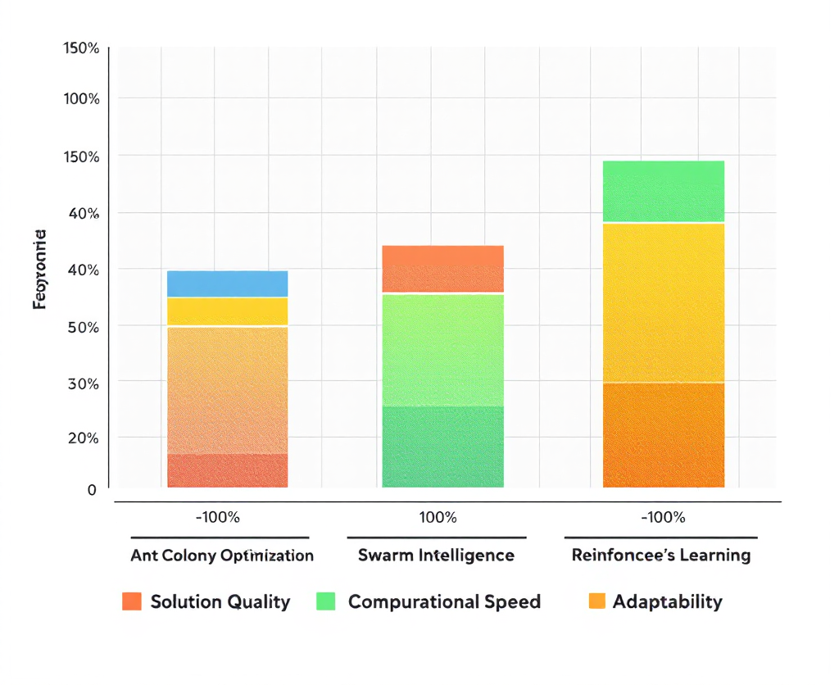

Fig.1. Comparative analysis of AI algorithms for TSP

In the field of artificial intelligence, there are many algorithms to deal with problems of route optimization and, in particular, the Traveling Salesman Problem (TSP). This comparison will show some characteristics, advantages, disadvantages and applications of Ant Colony Optimization, Swarm Intelligence and Reinforcement Learning, as well as provide recommendations for their appropriate use in practice. Each of these artificial intelligence approaches has its own pros and cons. ACO performs well for searching large solution spaces and dynamic environments, and is particularly suited to complex routing problems; however, it can be very sensitive to pheromone parameter settings. It also can converge toward a local optimum and consume many iterations to find an optimum. Swarm Intelligence converges quickly, and is easy to implement and is capable of quickly returning good solutions; however, it may be less capable of solving issues set in high dimensionality, and sensitive parameter tuning can significantly degrade its performance. Lastly, reinforcement learning has very high capability in environments, where data is real time and dynamic, because the agent can learn and adjust to receive the best strategy, when it is present; however, it typically requires significant computational power and input data to outrun poor convergence settings, particularly when making training more difficult or complicated.

When considering the implementation of these methodologies, ACO has greater application in logistics route planning and delivery, especially when the setting is dynamic and needs to be adaptable; for instance, it has been applied to vehicle routing problems with frequently changing constraints. Swarm Intelligence – for example, PSO – is also sometimes used for scheduling and optimization, in many of the same contexts as ACO, especially where near-instantaneous convergence to reasonable solutions within short time limits is paramount (e.g., in telecommunications and robotics). RL is especially relevant to dynamic routing and scheduling applications, such as traffic management systems and autonomous vehicle routing, as agents have to be continuously able to respond to change and learn from experiences. If practitioners understand the unique characteristics, strengths, weaknesses, and contexts in which ACO, SI, and RL can be applied, they should be able to choose the most suitable AI-based approach to the route planning and delivery tasks they are faced with in supply chain management.

**Data collection:**

Supply chain management requires accurate and dynamic data collection to optimize both route planning and load distribution. AI-driven models influence real-time and historical data to enhance decision-making, reduce transportation costs, and improve delivery efficiency. These are the major data categories that are crucial in data collection.

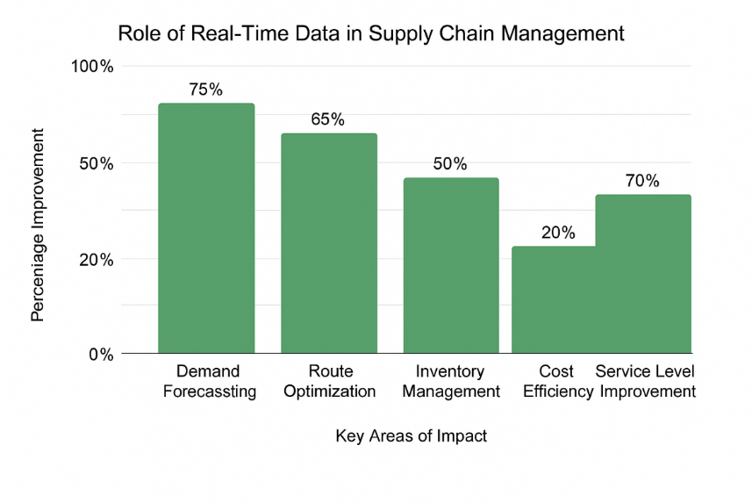

Fig. 2. How real time data helps in supply chain

**Traffic and Road Condition Information:** Real-time traffic data is a requirement if AI routing technology is to work properly in order to reroute automatically delivery routes. Blockages or accidents on the road will directly affect delivery timings. Information collected through various sources like GPS tracking, government traffic APIs, and IoT sensors installed on fleet vehicles. This helps AI to find routes that are faster and offer more economical solutions, which minimizes fuel consumption and delays in deliveries.

**Delivery and Order Data:** When data is structured accurately, it helps AI models to determine high demand and optimize route planning and vehicle load capacity. AI can analyzed consumer demand patterns by using information from e-commerce, WMS, and inventory management software. By optimizing delivery routing and balancing the load between vehicles, companies can greatly reduce empty miles and improve their use of resources.

**Vehicle and Fleet Data:** The tracking of vehicle performance, fuel efficiency, and maintenance schedules is necessary for load optimization. Various data is collected through GPS trackers, telematics systems, and IoT-based fleet management software. This enables carrying out predictive maintenance planning, which ensures an even load distribution, thus preventing unnecessary strain on the vehicles, and optimizing fuel consumption. Importantly, AI enables identifying vehicles which are suited for particular delivery routes based on their respective load, mileage, and performance history.

**Customer Preferences and Environmental Factors:** Last-mile logistics are highly influenced by customer preferences when it comes to selecting timeframes for delivery or drop-off locations. Data that are collected through mobile applications, customer interactions, and feedback surveys provide insight to AI in modifying routes and schedules based on parameters of customer availability in real time. Apart from this, environmental parameters such as bad weather, perishables, and local regulations have been analyzed through weather APIs and IoT-based environmental tracking systems. This ensures that plans are modified in case of extreme weather situations.

**Challenges:**

Ant Colony Optimization (ACO), Reinforcement Learning (RL) and Swarm Intelligence (SI) are robust computational paradigms that draw inspiration from natural systems, but each has different challenges when used to solve real-world problems.

Ant Colony Optimization (ACO), drawing inspiration from the foraging behaviour of ants, is particularly good at solving combinatorial optimization problems. If the size of the problem increases; the computational complexity grows exponentially, and it becomes inefficient for large-scale applications. Moreover, ACO performs less efficiently in dynamic environments where the problem constraints or variables change with time since it does not possess built-in adaptability. Simulating multiple agents and tracking pheromone trails also require substantial computational power, which is a challenge when used in real-time applications.

Reinforcement Learning (RL) works well for sequential decision-making problems but has its own set of challenges. RL algorithms are sample-inefficient, needing large amounts of data and computational efforts when trained, especially in high-dimensional tasks. Another problem is scalability because big state and action spaces may lead to a "state-space explosion" such that the problem becomes computationally intractable and bad design of rewards may cause undesired behaviour.

Swarm Intelligence (SI), which emulates nature's collective behaviour, is challenged in achieving scalability and robustness. Controlling large numbers of distributed agents is computationally intensive and even causes communication bottlenecks. SI systems can be plagued by stagnation and premature convergence, particularly when diversity among agents is low, diminishing their efficiency. Adjusting to real-time changes in dynamic environments also makes their application more difficult.

**Conclusion:**

To summarize, the applications of AI-driven methods in load management and routing in the supply chain discussed in this paper are significant developments in response to the challenges presented by the Traveling Salesman Problem (TSP) complex. Specifically, we have reviewed techniques based on AI, such as Ant Colony Optimization (ACO), Swarm Intelligence (SI), and Reinforcement Learning (RL), which are innovative methods for improving routing efficiency and lowering operational costs. Each has its strengths and weaknesses, which are best suited to different contexts in the supply chain system. For instance, ACO works better in dynamic environments and RL has a distinct advantage of adaptability from its continual learning algorithms. Conversely, the comparison also shared valuable information on operational demands and constraints, acknowledging that in each instance, one of the techniques could also yield an algorithm that should be selected prior to proceeding it.it is evident that decision making and processes are increasingly important with reliance on technology. Overall, our research shows how a systems, method, etc. based on artificial intelligence will affect supply chain logistics and supply chain coordination, and it opens doors for future research and development.

**References:**

A. N​. Aliyu, K. I. Musa, and A.Y.Dutse,"QoS-Based Resource Allocation Using Ant Colony Optimization in Cloud Computing," International Journal of Science Research and Technology, vol. 4, no.9,2024 https://taapublications.com/tijsrat/article/view/214.

​ J. Wang, C. Xiao, S. Wang, and Y. Ruan, "Reinforcement Learning for the Traveling Salesman Problem: Performance Comparison of Three Algorithms," The Journal of Engineering, vol. 2023, no. 9, Sep. 2023. [Online]. Available: https://doi.org/10.1049/tje2.12303.

F. K. H. Quek, R. S. S. Singh, and P. K. Sinha, "Solving the Traveling Salesman Problem for Efficient Route Planning Through Swarm Intelligence Based Optimization," in Proceedings of the 2023 International Conference on Intelligent Computing and Control Systems (ICICCS), May 2023. Available: https://dl.acm.org/doi/10.1007/978-981-97-7184-4_1.

**R. E. R. Shawon, M. R. Hasan, M. A. Rahman, M. Ghandri, I. A. Lamari, M. Kawsar, and R. Akter**, "Designing and Deploying AI Models for Sustainable Logistics Optimization: A Case Study on Eco-Efficient Supply Chains in the USA," arXiv preprint arXiv:2503.14556, 2025. [Online]. Available: https://arxiv.org/abs/2503.14556.​

**A. M. Abdelmoaty and I. I. Ibrahim**, "Comparative Analysis of Four Prominent Ant Colony Optimization Variants: Ant System, Rank-Based Ant System, Max-Min Ant System, and Ant Colony System," arXiv preprint arXiv:2405.15397, May 2024. [Online]. Available: https://arxiv.org/abs/2405.15397.​

**A. Kumar and N. Singh**, "Route Optimization in Supply Chain Management," International Journal of Engineering Research & Technology, vol. 10, no. 5, pp. 1203–1210, 2021. [Online].Available:https://www.researchgate.net/publication/381686437_Route_Optimization_in_Supply_Chain_Management.​

**P. K. Gupta and R. K. Sharma**, "Solving a Multi-Conveyance Travelling Salesman Problem using an Ant Colony Optimization Method," Indian Journal of Science and Technology, vol. 14, no. 23, pp. 1831–1840, 2021. [Online]. Available: https://doi.org/10.17485/IJST/v14i23.2021.​