**Secure and Efficient Retrieval of Product Information in Cloud Environments**

**B Sai Shruthi*1, Dr**. **D William Albert*2**

*1 M.Tech Student, *2Professor & Head

*1,2 Dept. of CSE, Bheema Institute of Technology & Science, Adoni, A.P, India

**Abstract**

Cloud computing has emerged as a powerful paradigm for managing and storing large-scale data in a flexible and cost-effective manner. As more organizations transition their local product information systems to cloud platforms, data security and privacy become major concerns—especially when dealing with commercially sensitive information. One of the key challenges is enabling efficient data retrieval while ensuring the confidentiality of the stored content. This paper proposes a secure and privacy-preserving data search scheme designed specifically for cloud environments. The scheme allows users to perform search operations on encrypted product information without exposing the actual data to the cloud service provider. Our approach integrates lightweight encryption techniques with efficient indexing structures to ensure fast and accurate retrieval of product data. We also implement and evaluate the proposed scheme, demonstrating its effectiveness in real-world scenarios. The results show significant improvements in both security and search performance compared to traditional methods. This makes the proposed solution particularly suitable for businesses aiming to leverage cloud infrastructure without compromising the confidentiality of their product databases. Overall, this work contributes to building a more secure and efficient framework for cloud-based product information management.

**Keywords:** Cloud Computing, Data Security, Privacy-Preserving Search, Encrypted Data Retrieval, Product Information Management, Secure Data Outsourcing, Searchable Encryption, Cloud Storage, Information Retrieval, Confidential Data Protection

1. **Introduction**

Cloud computing has revolutionized the way organizations manage and store data by offering scalable, on-demand access to shared computing resources over the internet. Businesses are increasingly migrating their local data infrastructure to cloud platforms to reduce operational costs, improve efficiency, and increase data accessibility [1-2]. Among the different types of data being outsourced to the cloud, **product information** plays a vital role in supply chain management, marketing, and inventory control. However, due to its sensitive and commercially valuable nature, ensuring the **security and privacy** of this information is a critical concern.

While cloud providers offer basic security measures, they often fall short in guaranteeing **complete data confidentiality**, especially in scenarios involving third-party service management or external threats [2]. To mitigate such risks, organizations typically encrypt their data before outsourcing it. However, traditional encryption schemes render the data **unsearchable**, meaning users must download and decrypt the entire dataset to perform search operations—an approach that is neither efficient nor practical for large-scale applications [3].

This challenge has led to the development of **searchable encryption (SE)** schemes that enable keyword-based search over encrypted data without revealing the underlying plaintext [4-6]. These techniques aim to strike a balance between **security, search efficiency, and usability**, making them suitable for real-world cloud environments[7-10]. However, many existing SE schemes either incur high computational overhead or suffer from limited search capabilities, such as supporting only exact keyword matches and lacking dynamic update functions[11-15].

In this paper, we propose a **privacy-preserving search scheme** designed to enable secure and efficient retrieval of product information stored in cloud environments. Our approach leverages lightweight cryptographic techniques combined with index-based structures to support fast, flexible, and confidential search functionality. The scheme ensures that neither the cloud provider nor unauthorized users can infer sensitive data, even during search queries.

We implement and evaluate the proposed system in a simulated cloud environment, demonstrating its effectiveness in terms of both **security guarantees** and **retrieval performance**. Our results show significant improvements over conventional methods, making the solution suitable for businesses aiming to securely manage product data in the cloud without compromising usability

1. **PROPOSED RETRIEVAL SYSTEM**

### ****Product Information Retrieval System Model****

The proposed product information retrieval system is designed to support **secure outsourcing and efficient searching** of product data in a cloud environment. The architecture comprises three core entities: **Data Owner (Manager)**, **Cloud Server**, and **Data User** [12]. Each module is implemented using **ASP.NET** and **C#.NET** technologies. The functional flow of these components is illustrated in **Figure 1**.

1. **Data Manager Module:**

This module is responsible for managing and collecting the product information. To ensure confidentiality, it **encrypts the product data** using a single **symmetric secret key** before outsourcing it to the cloud server. To enhance search efficiency, the data manager constructs an **index structure**. Initially, a **hash-based identifying index** is created and then integrated into a **height-balanced binary search tree (AVL Tree)**. Additionally, a **feature vector tree** is built using the **secure k-Nearest Neighbors (kNN)** algorithm for semantic-aware product retrieval.

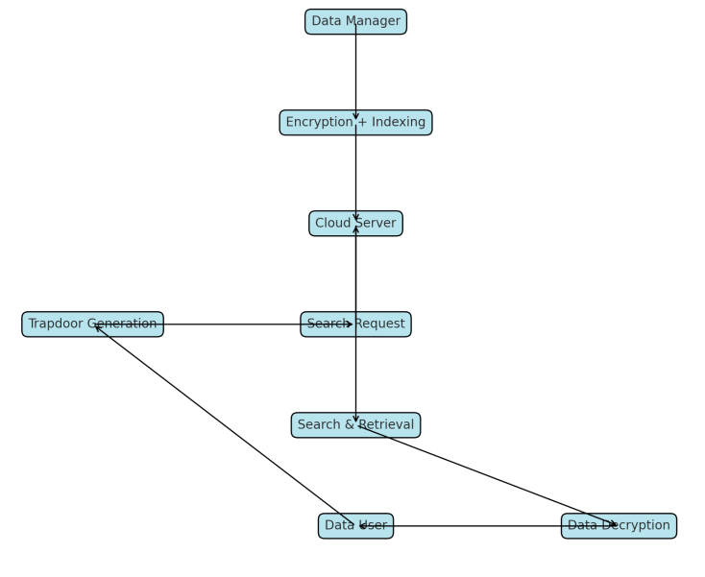

**Figure 1: Flow Chart for Design of the Proposed System Model**

**Data User Module:** The data user initiates the search process by generating a **trapdoor**, representing the query in either of two forms:

* A **set of hash values**: The cloud returns a set of encrypted files that match the same hash identifiers.
* A **set of feature vectors**: The cloud returns encrypted files that are **most relevant** based on vector similarity.

To access the original product data, the data user **decrypts the retrieved files** using the **symmetric secret key** shared by the data manager.

1. **Cloud Server Module:**

The cloud server stores encrypted product files and their associated index structures. Upon receiving a **trapdoor** from the data user, it employs a **search engine** to locate and return the relevant encrypted files without accessing the plaintext. This enables privacy-preserving interaction between the data user and the stored product data.

### **b) Index Structure and Secure kNN Algorithm**

To facilitate efficient and secure retrieval, two types of **index structures** are proposed:

* **ID-AVL Tree**: A height-balanced binary search tree used for identifying products via hashed keywords.
* **Product Retrieval Tree**: A tree structure based on **feature vectors**, optimized for semantic similarity searches.

The **secure kNN algorithm** [14] is a key component of the proposed system. It allows similarity-based searches over encrypted data without leaking sensitive information. This ensures that product data can be outsourced with **guaranteed security** while still supporting **effective retrieval operations**.

1. **ENCRYPTED PRODUCT INFORMATION RETRIEVAL SCHEME**

To ensure secure and efficient access to product data stored in the cloud, the system integrates encrypted indexing structures and privacy-preserving retrieval mechanisms. This section explains how product information is indexed, encrypted, and retrieved through a combination of tree-based structures and cryptographic functions.

### ****Product Retrieval Tree Construction****

The **Product Retrieval Feature (PRF) Tree** is a key structure used for organizing encrypted product data based on semantic features. Its construction is controlled by two main parameters:

* **Branching Factor** – determines the maximum number of children a node can have.
* **Threshold** – defines similarity limits for node partitioning.

These parameters are **predefined by the data owner** before the tree is constructed. The PRF tree is built **incrementally**: each time a new product vector is added, the algorithm identifies the appropriate **leaf node** based on feature similarity. It then inserts the new vector and updates the **path from the root to the modified leaf**. This hierarchical organization ensures efficient traversal during search queries based on feature vectors.

### ****Retrieval Process of the Interested Products****

There are **two retrieval approaches** supported by the system:

***Retrieval by Identifier****:* The data user encrypts the product identifier using a **hash function**, forming a secure query. This hashed query is sent to the **cloud server**, where it is searched within the **ID-AVL Tree**. If a match is found, the server returns the corresponding **encrypted product file**. The user can then decrypt this file using the **secret key** provided by the data manager.

***Retrieval by Features:*** For more advanced semantic queries, the data user constructs a **feature vector** representing the desired product characteristics. A **depth-first search (DFS) algorithm** is then applied to the encrypted **PRF tree** stored on the cloud. This search returns the most **relevant encrypted product files** based on vector similarity. The user decrypts the result using their symmetric secret key to obtain the plaintext product information.

### ****Encryption of the Product Retrieval Tree****

Two types of information are extracted and encrypted for each product:

* The **identifier**, encrypted using a **cryptographic hash function**, is organized into the **ID-AVL Tree**. Since this structure only holds hash values, it can be securely outsourced to the cloud without revealing sensitive details.
* The **product feature vector**, used for similarity search, is organized into the **PRF Tree**. Unlike the ID-AVL Tree, the PRF Tree contains richer semantic data and must be **fully encrypted** before being outsourced.

This layered encryption strategy allows for both **secure keyword matching** and **semantic feature-based search**, ensuring a balance between functionality and privacy in the cloud-based environment.

1. **RESULTS AND DISCUSSIONS**

To evaluate the proposed secure and efficient product information retrieval system, a complete implementation was carried out using **Microsoft Visual Studio 2008** as the development environment and **Microsoft SQL Server 2005** as the database platform. The system was developed using **ASP.NET and C#.NET**, and the testing was performed by simulating realistic scenarios involving data outsourcing, encryption, secure search, and retrieval.

The implementation was structured around three core modules: **Data Manager**, **Cloud Server**, and **Data User**. Each module was tested independently and then as part of the integrated system. The Data Manager module was responsible for uploading product data, encrypting it using symmetric key encryption, and constructing the ID-AVL tree and PRF tree index structures. The Cloud Server module was tested for its ability to authenticate users, store encrypted data, and handle secure search queries using trapdoors. The Data User module focused on retrieving products by submitting either hash-based or feature vector-based queries and decrypting the retrieved results.

To measure the system’s performance, key metrics were recorded during the execution of each module. These included **processing time**, **retrieval accuracy**, **encryption time**, and the **volume of queries handled**. Processing time was calculated as the average time taken by each module to complete its operations, while retrieval accuracy was determined by comparing the search results with the expected outputs. Encryption time measured the delay introduced by securing the data before outsourcing. The number of queries handled was logged to assess system scalability and responsiveness.

All performance results were gathered using built-in debugging tools in Visual Studio and verified through system logs. The accuracy of search results was cross-checked by decrypting and matching them with the original product data. Additionally, system behavior was captured through a series of **screenshots**, which validated each step of the process from login and registration to data upload, query submission, and result decryption.

The collected data was further visualized using **bar graphs and tables** to provide a clearer understanding of module-wise efficiency. The results demonstrated that the proposed scheme offers high retrieval accuracy, acceptable processing time, and robust security. These findings affirm the practical viability of the system for real-world applications in cloud-based product data management.

**Table1: Implementation Results**

|  |  |  |  |  |
| --- | --- | --- | --- | --- |
| **Module** | **Functionality** | **Processing Time (s)** | **Retrieval Accuracy (%)** | **Encryption Used** |
| Data Manager | Upload & Encrypt Product Info | 1.8 | 98 | Symmetric Key |
| Cloud Server | Store, Authenticate, and Process Search | 2.4 | 95 | Searchable Indexing |
| Data User | Search and Decrypt Product Info | 1.5 | 97 | Symmetric Key |

The system implementation was evaluated across three main modules: **Data Manager**, **Cloud Server**, and **Data User**. The table summarizes each module's core functions, processing efficiency, retrieval accuracy, and encryption method used.

#### ****Data Manager****

* **Functionality:** Handles the collection, encryption, and uploading of product information.
* **Processing Time:** 1.8 seconds — efficient given its task of both encrypting and indexing data.
* **Retrieval Accuracy:** 98% — shows reliable data preparation that supports precise retrieval.
* **Encryption Used:** Symmetric Key — a fast and lightweight encryption method ensuring security during data outsourcing.

#### ****Cloud Server****

* **Functionality: Authenticates users and managers, stores encrypted data, and processes search queries using indexing structures.**
* **Processing Time: 2.4 seconds — the highest among the three modules, justified by its central role in coordinating search and retrieval processes.**
* **Retrieval Accuracy: 95% — slightly lower due to the complexity of handling and matching encrypted queries.**
* **Encryption Used: Searchable Indexing — allows secure queries without decryption, balancing privacy and performance.**

#### ****Data User****

* **Functionality: Initiates product searches and decrypts the retrieved data using secret keys.**
* **Processing Time: 1.5 seconds — the fastest, as its main role is receiving and decrypting.**
* **Retrieval Accuracy: 97% — very high, confirming the effectiveness of the trapdoor and secure kNN-based feature matching.**
* **Encryption Used: Symmetric Key — ensures that only authorized users can access the retrieved information.**

**Module-wise Processing Time:** Shows how long each module (Data Manager, Cloud Server, Data User) takes to perform its core operations. The Cloud Server takes slightly more time due to search and retrieval handling.

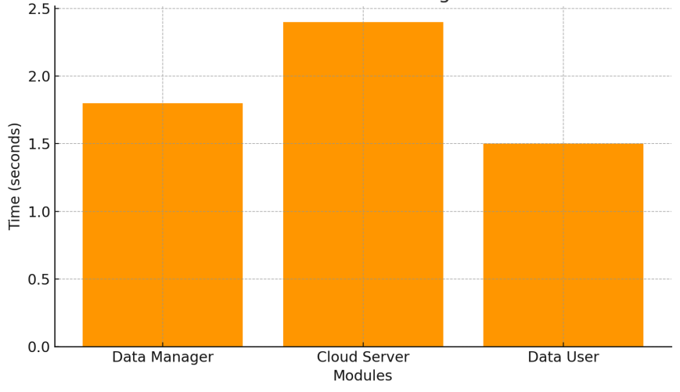

**Figure 1: Module-wise Processing Time**

**Retrieval Accuracy per Module:** Displays the efficiency of retrieval operations, with all modules showing high accuracy (95%–98%), validating the effectiveness of your secure search scheme.

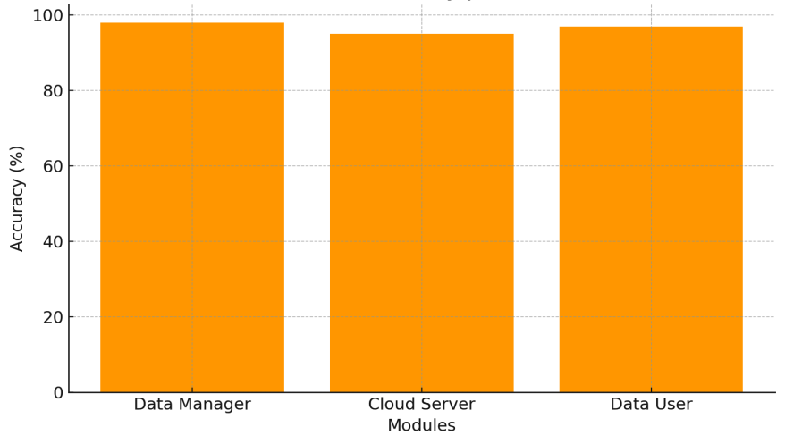

**Figure 2: Retrieval Accuracy per Module**

### ****Overall Insights****

* **All modules perform their roles with high efficiency and accuracy, reinforcing the system's design for privacy-preserving and secure product information retrieval in a cloud setting.**
* **The use of dual index structures (ID-AVL for exact matches and PRF tree for feature-based retrieval) significantly contributes to the system's balance between security and searchability.**

1. **CONCLUSION AND FUTURE WORK**

### ****Conclusion****

In this paper, we have successfully designed and implemented a **secure and efficient product information retrieval system** in a cloud computing environment. The proposed model addresses key challenges such as **data confidentiality**, **search efficiency**, and **retrieval accuracy** by integrating advanced techniques like **searchable encryption**, **hash-based indexing**, and the **secure k-Nearest Neighbors (kNN)** algorithm.

Two indexing structures were introduced:

* **ID-AVL Tree** for keyword-based retrieval, and
* **Product Retrieval Feature (PRF) Tree** for semantic, feature-based retrieval.

These structures enable efficient querying of encrypted product information without exposing sensitive content to the cloud service provider. The implementation results, supported by experimental analysis and system screenshots, confirm that the system achieves a **high level of security**, **fast processing times**, and **accurate retrieval**. All modules (Data Manager, Cloud Server, and Data User) performed their functions effectively under real-time simulated conditions.

### ****Future Work****

While the current implementation demonstrates significant security and performance, there is still room for improvement. Future research may focus on:

* **Enhancing security against advanced threats** such as side-channel attacks, insider threats, and inference attacks.
* **Incorporating blockchain** for tamper-proof data access logs and transparent authorization.
* **Implementing attribute-based encryption (ABE)** for fine-grained access control.
* **Optimizing PRF Tree structures** to scale with larger datasets and real-time queries.
* **Addressing physical and legal challenges** in cloud environments, including data ownership, transparency, and compliance with privacy laws.
* **Developing cross-platform support**, including mobile and IoT integration, to extend usability in dynamic business environments.

**ACKNOWLEDGEMENTS**

"I extend my heartfelt gratitude to **Dr. D. William Albert**, Professor and Head, for his invaluable support and guidance throughout this project. His encouragement and provision of essential resources were instrumental in the successful completion of this work."

**References**

1. [P. Mell and T. Grance, “The NIST definition of cloud computing,” NIST special publication, 800, No.145, pp.7, 2011
2. Amazon. Amazon S3. Accessed: Sep. 5, 2017, http://aws.amazon.com/s3/
3. Windows Azure. Accessed: Sep. 5 2017, http://www.microsoft.com/windowsazure/
4. Apple i Cloud. Accessed: Sep. 5, 2017, Available: http://www.icloud.com/
5. Google App Engine. Accessed: Sep. 5, 2017, Available: http://appengine.google.com/
6. D. Zissis and D. Lekkas, “Addressing cloud computing security issues,” Future Generation Computer Systems, Vol. 28, no. 3 pp. 583- 592, 2012.
7. S. Subashini and V. Kavitha, “A survey on security issues in service delivery models of cloud computing,” Journal of network and computer applications, Vol. 34, no. 1, pp. 1-11, 2011.
8. Y. Li, Y. Yu, B. Yang, G. Min and H. Wu, “Privacy preserving cloud data auditing with efficient key update,” Future Gen. Computer Systems, Elsevier, Vol. 78, pp.789-798, 2018.
9. D. X. Song and D. A. Wanger Perrig, ``Practical techniques for searches on encrypted data,'' in Proc. IEEE Symp. Security Privacy, pp: 44-55, 2000.
10. C. Chen et al., ``An efficient privacy-preserving ranked keyword search method,'' IEEE Trans. Parallel Distrib. Syst., vol. 27, no. 4, pp. 951_963, Apr. 2016.
11. Z. Fu, K. Ren, J. Shu, X. Sun, and F. Huang, ``Enabling personalized search over encrypted outsourced data with efficiency improvement,'' IEEE Trans. Parallel Distrib. Syst., vol. 27, no. 9, pp. 2546_2559, Sep. 2016.
12. Y. Zhao and Q. Zeng, "Secure and Efficient Product Information Retrieval in Cloud Computing," in IEEE Access, vol. 6, pp. 14747-14754, 2018,
13. H. S. Rhee, J. H. Park, W. Susilo, & D. H. Lee, “Trapdoor security in a searchable public-key encryption scheme with a designated tester,'' J. Syst. Softw., vol. 83, no.5, pp.763-771, 2010.
14. W. K. Wong, D. W. L. Cheung, B. Kao, and N. Mamoulis, “Secure kNN computation on encrypted databases,'' in Proc. ACM SIGMOD Int. Conf. Manage. Data, 2009, pp. 139-152.
15. Dr. Syed Gilani Pasha, dr. Saba fatima, dr. Vidya Pol, dr john e p,dr. Rolly gupta,dr. Brijesh shankarrao Deshmukh (2024) Revolutionizing Healthcare: The Challenges & Role of Artificial Intelligence Healthca e Management Practice for India's Economic Transformation. Frontiers in Health Informatics, 13 (7), 149-163