**STUDY THE EFFECT OG GRADING ON HYDRAULIC CHARACTERISTICS OF GSB MIX**

***Prashant Kumar1*, Shivani2***

*1Student, 2Assistant Professor*

*Sat Priya Group of Institutions, Rohtak*

***\*Corresponding Author***

***E-mail Id:-prashantkumar160293@gmail.com***

***ABSTRACT***

Good drainage is essential for the operation of the road. Excessive moisture in the substrate, sub-base and sub-base can cause premature problems and premature failure of the coating. Therefore, the cost of road maintenance and the cost of improving water quality should be compared when choosing an appropriate repair strategy. Therefore, it is necessary to analyze the effects of different types of waterproofing on road properties. A granular base (GSB) is placed near the surface of the foundation and below the bearing layer in the structure for drainage and load transfer into the layer.

In India, pavement design guidelines recommend GSB thickness based on subgrade performance and design traffic conditions. By examining the permeability of the GSB mixture, it is necessary to understand the importance of the fluidity of the GSB mixture in road construction. Current guidelines in India recommend the use of natural sand, calcareous soil, gravel, crushed stone or a combination of these in GSB layers. In special cases, the use of crushed slag, crushed stone, bricks and kankar will be allowed. While the above connections may meet design standards, it is unclear whether they will meet the minimum AASTO code requirement of 300 m/day.

*Keywords:- waterproofing, subgrade, granular base, compacted subgrade, crushed concrete*

**INTRODUCTION**

A granular base (GSB) is placed just above the subgrade and below the base layer in the pavement structure as shown in Fig. The main purpose of providing granular subgrades (GSB) in road pavements is to serve stability and drainage function. In India, current guidelines recommend the use of natural sand, moorum, gravel, crushed stone or a combination of these in the GSB layer. Crushed slag, crushed concrete, brick and kankar may be allowed in special cases.

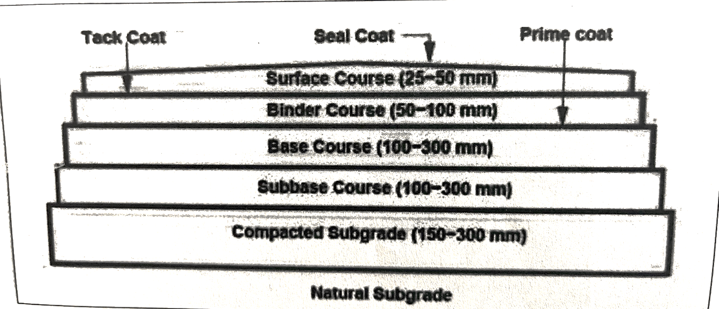

Fig. Cross-section of a pavement structure

In recent years, numerous studies have shown that a large percentage of road pavements in India are threatened by excessive moisture in the pavement structure and increasing traffic loads and volumes. Excessive moisture occurs in the construction of the roadway due to insufficient drainage of the subgrade and subgrade. According to the AASHTO Guide (1993), most pavement design methods are used to design the pavement to resist the combined effects of loading and moisture. However, they do not take into account the potential destructive effects of water in the roadway structure. As a result, these pavements have a shorter lifespan than intended, moisture enters the pavement structure either through cracks, joints, pavement surfaces and shoulders, or by ground water from a broken aquifer or high water table When water becomes trapped in the pavement structure, it causes it has many negative effects, as described below.

(1) Reduced strength of unbound granular materials,

(2) Reduced strength of roadbed soils,

(3) Pumping of concrete pavements with subsequent faulting. cracking, and general shoulder deterioration, and

(4) Pumping of fines in the aggregate base under flexible pavements with resulting loss of support.

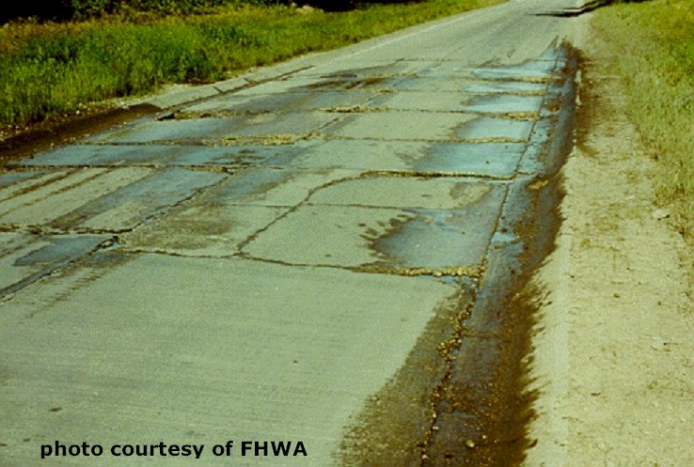

Fig. Mud pumping through joints/cracks in rigid pavements

The effects of subsurface moisture can be minimized if an adequate subsurface drainage system is properly installed. It should be included as part of the pavement design in both new and rehabilitated pavements. A subsurface drainage system usually drains water by gravity. In other words, only free water from saturated soils present in the pavement structure can be removed by the energy gradient supplied by elevation (gravity). For the conditions that exist within the pavement structure, the laminar flow assumption of Darcy's law is satisfactory. The application of Darcy's law requires the determination of the coefficient of permeability k, a measurement that represents the drainage property of materials. Laboratory determination of the coefficient of permeability of materials used as subgrade and subgrade is essential for the design of highway pavements, especially for subsurface drainage systems.

In general, the permeability coefficient of soils can be determined in the laboratory by two different methods: the constant gradient method and the decreasing gradient method. The constant head method is suitable for granular materials, while the decreasing head method is suitable for fine-grained soils.

The base and subgrade layers usually consist of graded granular materials or materials

stabilized with suitable additives. Sorted granular materials include crushed stone, crushed slag, crushed gravel and sand or a combination of these materials. Many additives are used for modified aggregates such as Portland cement, asphalt, lime, fly ash and lime fly ash.

Determination of the coefficient of permeability of pavement subgrade materials performed in laboratories usually uses water as the permeable fluid. However, the permeability coefficient of pavement materials can change over time with the infiltration of different fluids, e.g. streams containing different types of fluids with different viscosity values. In this study, a laboratory test is set up to determine the liquid (water) permeability coefficient of GSB materials using a constant head permeability test for a granular mixture.

Water (as runoff) has a number of adverse effects on roadways if not properly controlled. Water entering the pavement structure migrates as structural moisture. The amount of water penetrating the roadway is dependent on rainfall, drainage, design of the roadway structure, type and condition of the surface layer (cracks, joints, etc.) and shoulders and materials of the roadway, subgrade and subgrade. Excess water can cause a lower bearing capacity of the pavement structure and reduces the life of the pavement. It has many adverse effects such as reduction of shear strength, pumping of fine particles. removal of asphalt in flexible roads, etc.

**OBJECTIVES**  
In order to have the knowledge of the drainage properties of pavement base materials, an experimental study was conducted to determine the coefficient of permeability of different types of grading of pavement base materials. The following objectives were established for this research:

1. To find the physical properties of aggregates to be used in various gradings of GSB mixes.  
  
2. To measure the permeability characteristics of different gradings of GSB mixes as per Talbot method and MORTH (2013) gradings of GSB mixes in laboratory and compare them.

**LITERATURE REVIEW**

Excessive moisture in the pavement structure (surfacing, subgrade and subgrade) and subgrade can cause a variety of problems that lead to overall damage to the pavement and ultimately total destruction of the pavement if remedial measures are not taken.

Unsatisfactory pavement performance from excessive subsurface water can be found in both asphalt concrete (AC) and portland cement (PCC) pavements. If the pavement structure and subgrade become saturated with groundwater and/or infiltration, its ability to carry dynamic loads caused by traffic can be significantly impaired. For asphaltic concrete (AC) pavements, this deterioration is primarily the result of the temporary development of very high pore water pressure and subsequent loss of strength in the unbonded subgrade, subgrade, and subgrade under dynamic loading. In a Portland cement (PCC) pavement, water and fines are sprayed, called pumping, at the joints between slabs and/or edges between slabs and shoulders. Concrete slabs may crack due to lack of adequate support (Cedergren et al. 1973).

Veeraragavan and shailendra (2010) find that “subsurface drainage is a key element in pavement system design. Optimum pavement system performance can be achieved by preventing water ingress with a well-designed subsurface drainage system. drainage continues to be identified as a major cause of pavement problems. Water trapping in the pavement leads to a "bathtub" condition, resulting in premature pavement failure and distress. This leads to a large number of costly repairs or replacements of pavements long before they reach their design life. Therefore, research is needed in India to demonstrate and quantify the impact of drainage on road performance to reduce future maintenance costs and preserve road assets.”

The subsequent drama and integration of roads also facilitated the flooding of urban areas. Belete (2011) reported that due to the lack of integration between water drainage and stormwater infrastructure in cities, many areas are subject to flooding problems. In other words, urbanization and modernization in Ethiopia results in higher rainfall intensity and consequently accelerated and concentrated runoff in urban areas:

Rokade et al. (2012) Drainage design criteria used in the past were based on the assumption that both water flow through pavements and drainage of pavement layers can be represented by saturated flow assumptions. The harmful effects of water can be reduced by preventing water from entering the pavement, by providing adequate drainage to remove infiltration, or by building the pavement strong enough to withstand the combined effect of loads and water. The life of the pavement can be increased by 50% if the soaked water can be drained without delay. Similarly, well-drained pavement systems can be expected to last two to three times as long as undrained sections of pavement.

Due to insufficient drainage, poor maintenance and inadequate road profile, a considerable amount of water has accumulated on the road and causes roadway problems (Besha and Alemayehu, 2016). They said that the surface water from the road and shoulder should not be drained off and the runoff water from the adjoining properties easily enters the road due to poor drainage provision.

Most studies conclude that if water is removed quickly from pavements, it can extend the life of the pavement. In addition, subsurface drainage systems should be installed as part of the roadway structure for drainage purposes.

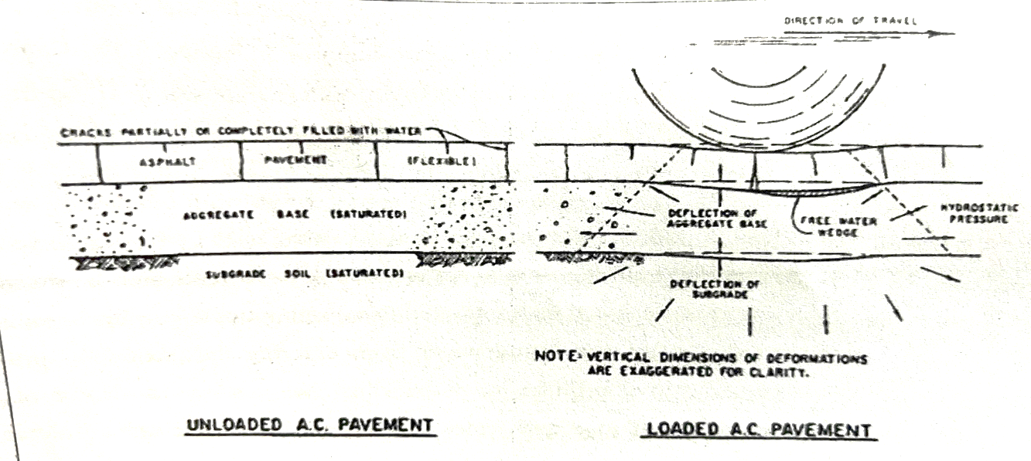

Fig. Action of free water in AC pavement structural sections under dynamic loading

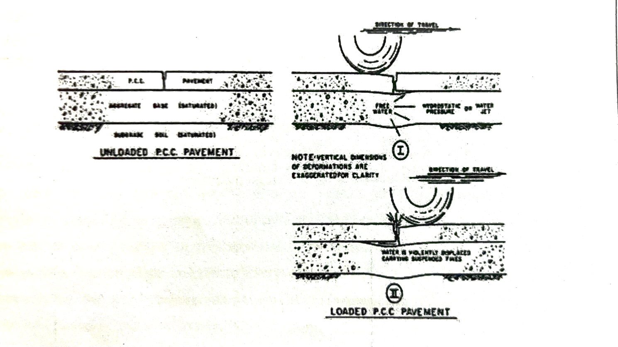

Fig. Pumping phenomena under PCC pavement (Cedergren et al. 1973).

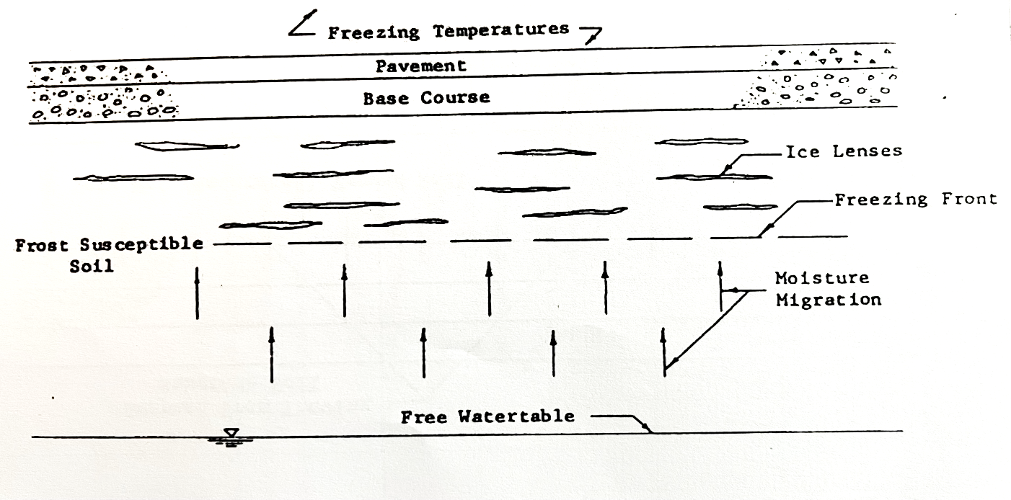

Fig. Capillary moisture migrating towards freezing front to feed the growth of ice lenses

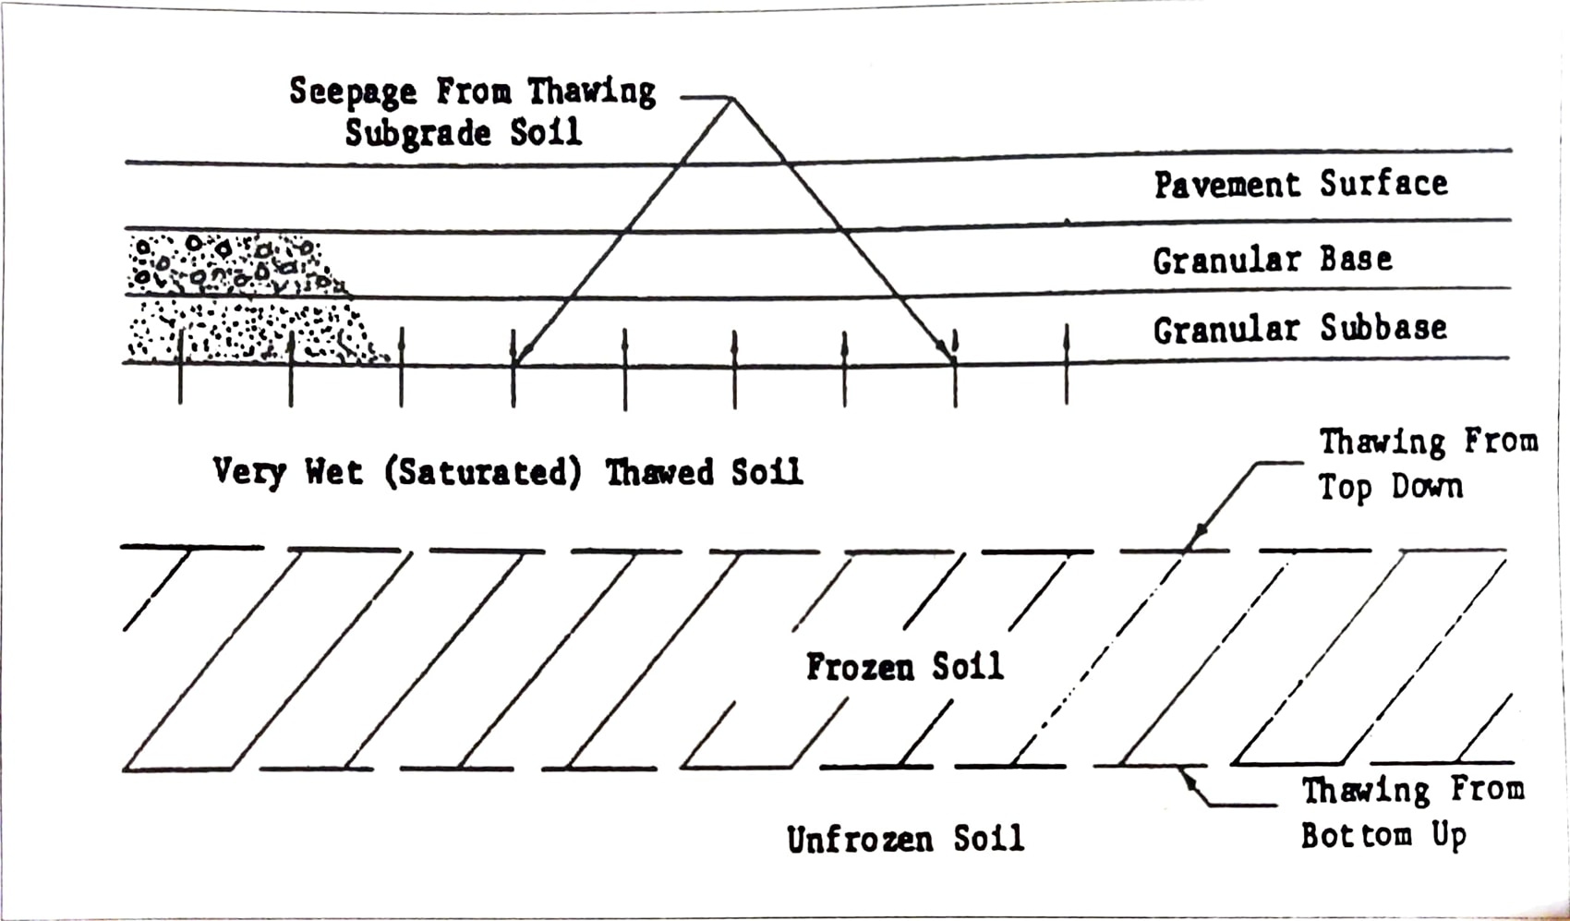

Fig. Seepage of melt water from ice lenses into pavement structure (Moulton, 1980)

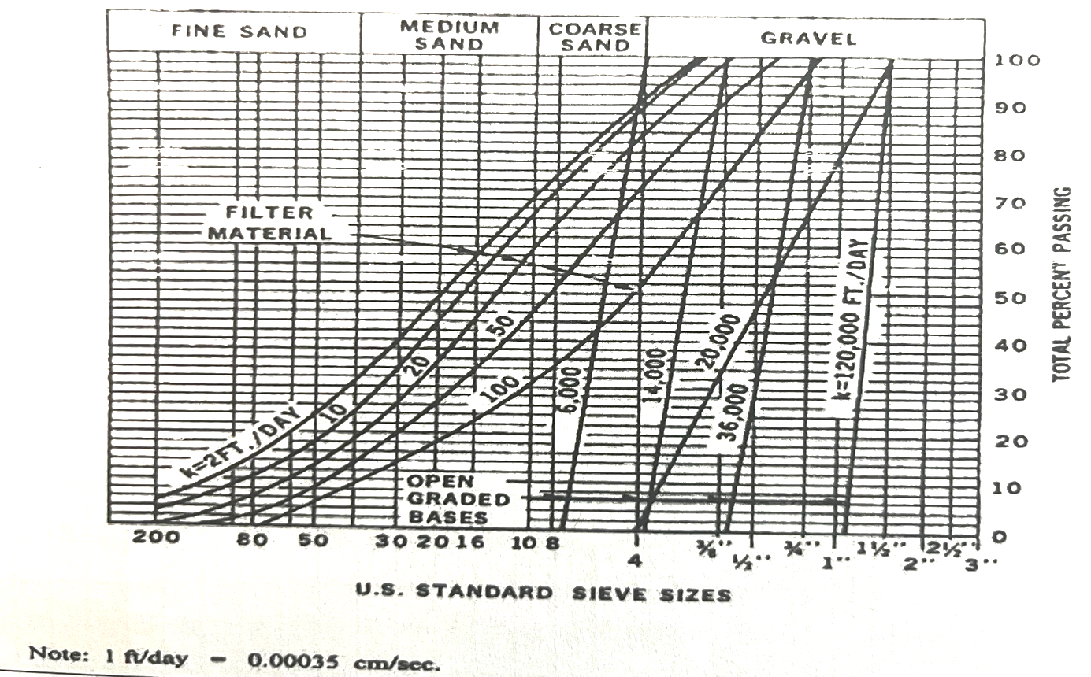

Fig. Typical gradations and permeabilities of open-graded bases and filter materials.

Talbot and Richard (1923), developed an ideal shape of gradation and concluded that aggregates should be graded in sizes to give the greatest density. So later on, In 1923 Talbot and Richard created the formula for gradationTalbot method is adopted to prepare the proportion of different size of aggregates as shown in table 2.1 and 2.2 for making the sample.  
 P = \{d / D\} n eq(1)  
Where  
P = Percentage of aggregate passing through the sieve

d = Sieve size of aggregate

D = Max. size of aggregate

n = Talbot coefficient

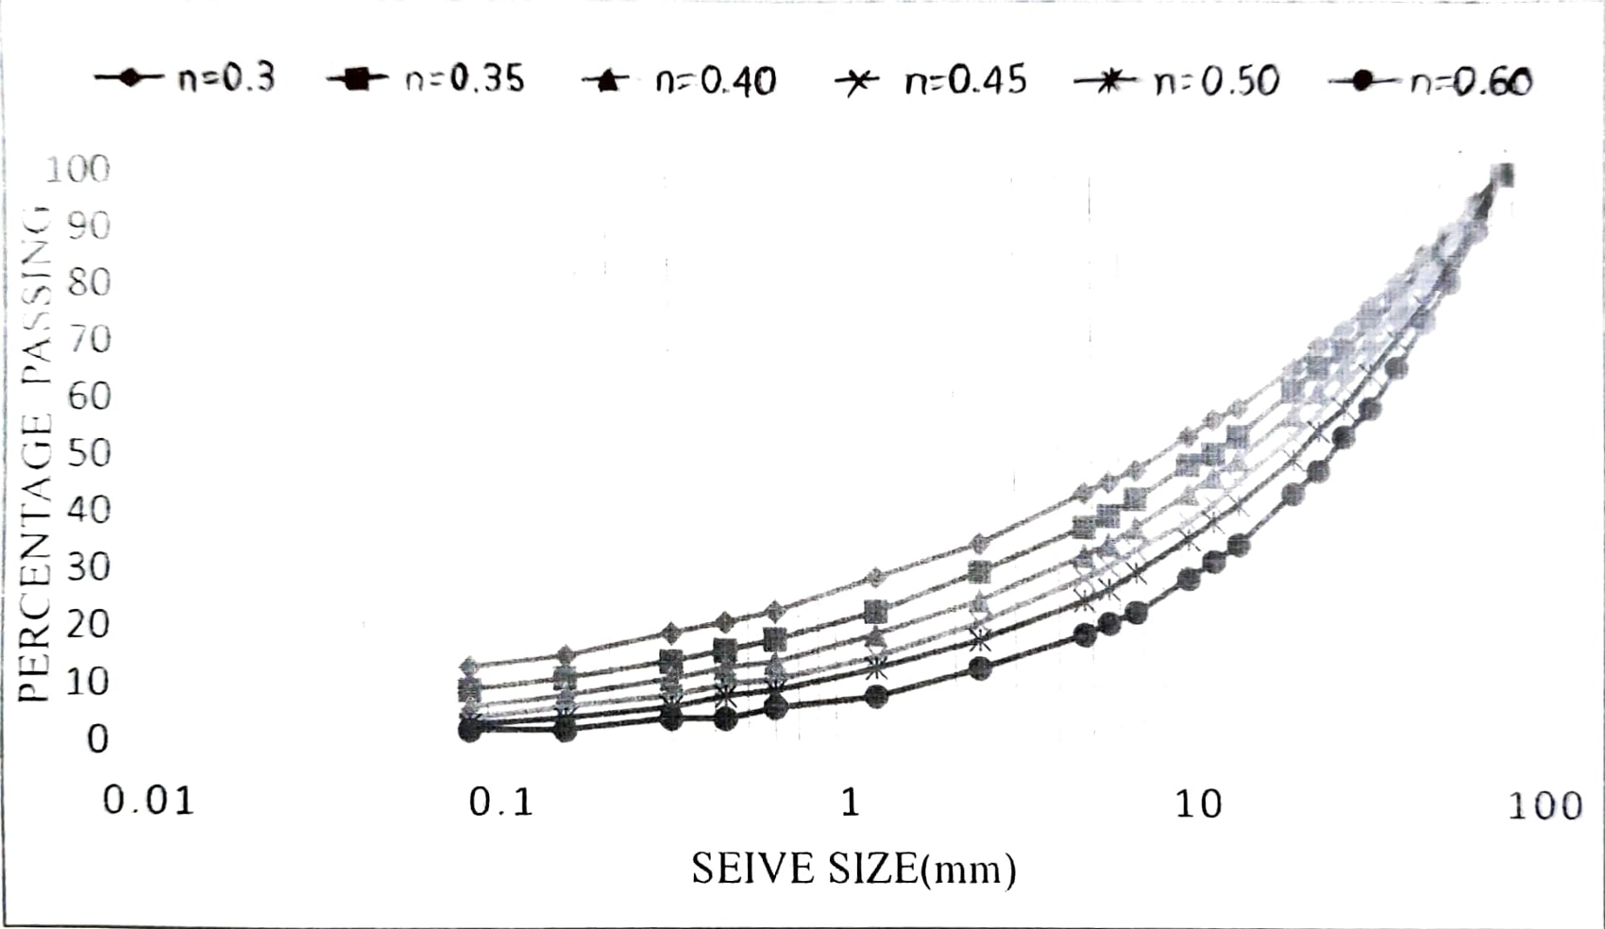

Fig. Relation between sieve size and percentage passing for different value of Talbot coefficient

Most of the studies conclude that if water is removed rapidly from pavement structures, it can extend the life of pavement. Moreover, subsurface drainage systems should be installed as part of pavement structure for drainage purposes.

**SOURCES OF SUBSURFACE WATER**

Water in a pavement structure can exist in many forms such as free water, capillary water, bound water, and water vapor. However, only free water can be considered in subsurface drainage design because of two reasons: (1) it can decrease the strength of granular materials and (2) it is the only form of moisture that can be removed by a subsurface drainage system (Ridgeway, 1982).

Sources of free water that enter pavement structure are considered as groundwater and infiltration (Moulton, 1980). The melting of ice water from a frost area during a thawing cycle is considered as groundwater, as shown in Figure 2.4. Infiltration water reaches the pavement structure in several ways, which is illustrated in Figure 2.5. For PCC pavement, water enters the structural section through longitudinal and transverse joints, the joints between concrete slabs and shoulders, and cracks in concrete slabs and shoulders as shown  
fig-2.7. For AC pavement, water enters structural pavement through joints between shoulders and the surface course, longitudinal and transverse cracking joints, and  
voids in the surface course.

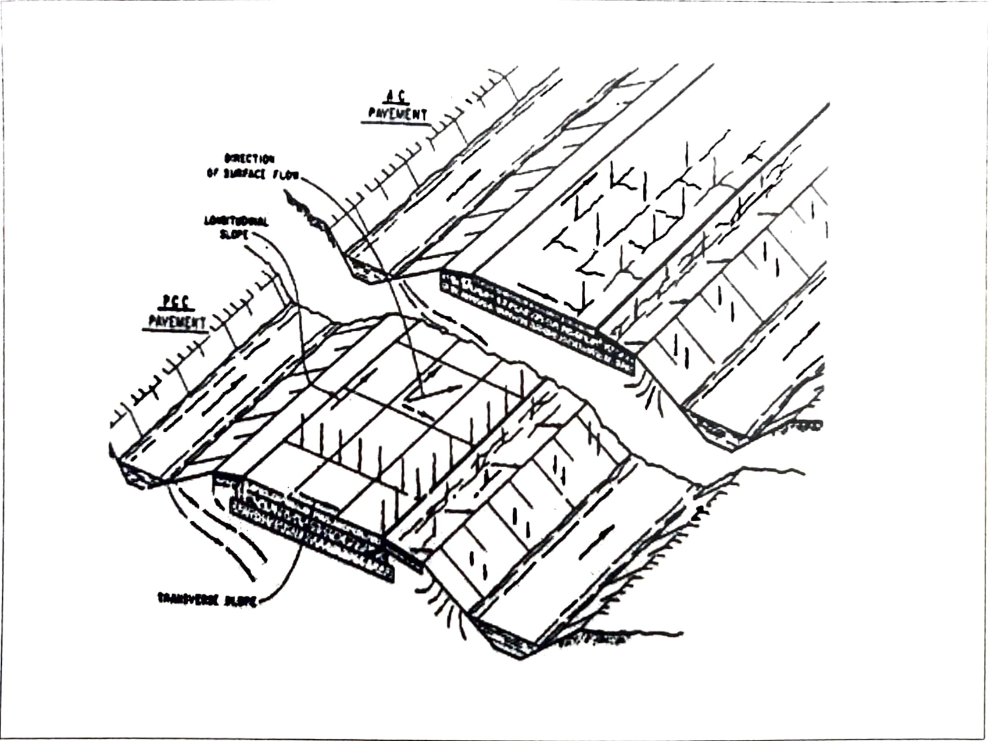

Fig. Points of entrance of water into highway pavement structural section.

**CONCLUSIONS**

The objectives were fulfilled through experimentation and analysis of test data. A constant head permeability setup was designed to study the permeability of different types of grading of GSB mix. Tap water collected in a water tank was passed through the specimens in order to determine the permeability, of different gradations of GSB mixes

Several tests were conducted in the laboratory for this study. Material are prepared and compacted into a horizontal permeameter made of metallic plate. All specimen dimensions were 30cm x 30cm x 30cm. For tests only tap water was used, to pass through the specimens. The flow of water was continued until it reached to a steady state of flow.

The following conclusions can be drawn from the data results:

1. The physical requirements of the aggregates such as Aggregate Impact Value (AIV), Water Absorption Value are within the permissible limits as specified by MORTH (2013).  
  
2. Maximum dry density as per GSB gradings of MORTH (2013), varies from 2.12 g/ce to 2.19 g/cc and it is maximum for Grading-II having highest proportion of finer particles in the mix. On the other hand, as per G.S.B. gradings of Talbot method, Maximum dry density varies from 2.09 g/cc to 2.26 g/cc.

3. In both the G.S.B. gradings of MORTH (2013) and Talbot method, it is found that with increase in proportion of fines, M.D.D. tends to increase and the permeability tends to decrease. This is due to the fact that with the increase in percentage of fines, a denser mass is formed with less voids.

**REFERENCES**

1. IS 2386 part III (1963), Method of test for aggregate. Specific Gravity. Density Impact value, and Water absorption Bureau of Indian Standards (BIS) .

2. IS 383 (1970) Indian standard specifications for Course and fine aggregates from natural source of concrete" (second revision).  
3. Cedergren, H.R. KH. O'Brien, and J.A. Arman, (1973) "Guidelines for the Design of Subsurface Drainage Systems for Highway Structural Sections Report No. FHWA-RD-30-72, Washington, DC.  
4. Moulton L.K. (1980). "Highway Sub drainage Design", Federal Highway Administration, Report No. FHWA-TS-80-224.

5. Ridgeway H.H. (1982). "Infiltration of water through the pavement surface" Transportation research record no. 616, pp. 98-100. Washington D.C.