Soil Moisture Retrieval with Vertical and Horizontal polarization Satellite Data Using Deep Learning Models

Logeswaran.J | Ancin Dino.M | Arthi.K
Department of ECE | Department of ECE | Department of ECE
SRM Valliammai Engineering College | SRM Valliammai Engineering College | SRM Valliammai Engineering College
TamilNadu,India | TamilNadu,India | TamilNadu,India
logeswaranj.ece@srmvalliammai.ac.in | ancindino05@gmail.com | arthikuppusamy27@gmail.com
Balajee.V.S | Devaprasath.AT
Department of ECE | Department of ECE
SRM Valliammai Engineering College | SRM Valliammai Engineering College
TamilNadu,India | TamilNadu,India
bala07msd@gmail.com | tdevaprasath@gmail.com

Abstract: Soil moisture (SM) is a critical factor for comprehending the interactions and feedback mechanisms between the atmosphere and the Earth's surface, particularly in relation to energy and water cycles. The challenge of accurately determining the spatiotemporal distribution of land surface SM has persisted within the remote sensing field. The model proposed here incorporates various algorithms, including artificial neural networks (ANN), deep neural networks, and three support vector regression (SVR) models—namely, radial basis function (SVR_rbf), linear (SVR_linear), and polynomial (SVR_quad) kernels—as well as two tree-based techniques: random forest and eXtreme Gradient Boosting (XGBoost). A comparison of predicted and observed soil moisture values indicated that the most accurate retrievals were achieved using Sentinel-1 data at VV polarization, yielding correlation coefficients (R) between 0.68 and 0.76, along with root-mean-square errors (RMSE) of 0.05 m³/m³ and 0.06 m³/m³. Ultimately, SVR_rbf was selected for generating high-resolution soil moisture maps from Sentinel-1 data over irrigated wheat fields, owing to its favorable balance of retrieval accuracy, processing efficiency, and ease of use.

Keywords: Machine learning (ML), Deep Learning (DL), Vertical and Horizontal polarization.

soil moisture sensors, hydrogeo physical techniques, and both active and passive microwave remote sensing. However, there remains a gap between local and regional measurements that can accurately reflect the true values of areal soil moisture, which is vital for validating remote sensing data and calibrating hydrological models.

This review article presents several innovative concepts and algorithms, including Surface Soil Moisture (SSM) retrieval utilizing geostationary satellite-derived temporal data of land surface parameters, all-weather SSM retrieval, and an asynchronous-assumed feature space that has not been extensively covered in previous SSM reviews. Importantly, these new approaches enable SSM retrieval to be largely independent of soil texture and applicable under all-weather conditions, paving the way for advancements in SSM retrieval techniques that aim to achieve high spatiotemporal resolution in the near future. In this era of rapid data growth, there is a strong push to uncover additional information to enhance SSM estimates [2]. The application of artificial intelligence and deep learning offers a promising avenue to investigate the intricate relationships between SSM and other remotely sensed parameters, as well as to generate more precise auxiliary data, which can help address the current challenges faced in satellite SSM retrieval.

1. INTRODUCTION

Soil moisture plays a crucial role in terrestrial ecosystems and exhibits significant variability both spatially and temporally, with typical scales ranging from a few centimeters to several kilometers. Understanding the variability of soil moisture at the field scale is essential for effective management of irrigated agriculture[1]. Common methods for measuring soil moisture at this scale include point measurements using electromagnetic

Surface Soil Moisture (SSM) retrieval utilizes various techniques, primarily through remote sensing, to estimate the water content in the uppermost layer of soil. These techniques can be classified into three main categories: optical, thermal, and microwave, each presenting its own set of benefits and drawbacks. Recently, deep learning (DL) methods have gained traction in SSM retrieval, providing high-resolution and efficient estimates that surpass traditional approaches. These methods utilize extensive datasets and sophisticated algorithms to understand the correlation between remote sensing

data and soil moisture levels. The current study focuses on employing Deep Learning Methods for SSM retrieval[3]. The objective is to evaluate the performance of machine learning (ML) algorithms and semi-empirical models in retrieving surface soil moisture by analyzing Sentinel-1 backscatter and interferometric coherence data. Initially, three widely used categories of ML algorithms are assessed using data collected from various rainfed and irrigated wheat fields in Morocco and Tunisia. The algorithms under consideration include artificial neural networks (ANN), deep neural networks, three support vector regression (SVR) models (radial basis function, linear, and polynomial kernels), and two tree-based methods (random forest and eXtreme Gradient Boosting, XGBoost). The comparison of predicted versus measured SSM indicated that the most accurate retrieval results were achieved using Sentinel-1 data at

- polarization, with correlation coefficients (R) ranging from 0.68 to 0.76 and root-mean-square errors (RMSE) of 0.05 m³/m³ and 0.06 m³/m³. Furthermore, to evaluate their transferability, the ANN, SVR_rbf, and XGBoost—identified as the top performers from each category—were compared against the coupled Water Cloud and Oh models (WCM) using a second dataset obtained from a drip-irrigated wheat field in Morocco[4].

This research will examine the effectiveness of several widely-used machine learning regression algorithms, including artificial neural networks (ANN), deep neural networks (DNN), and support vector regression (SVR) methods—specifically radial basis function (SVR_rbf), polynomial (SVR_quad), and linear (SVR_linear) variants—as well as tree-based approaches like random forest (RF) and eXtreme Gradient Boosting (XGBoost). Additionally, the study will evaluate the transferability of these algorithms and their performance in relation to the coupled Water Cloud and Oh models (WCM). Data for this analysis were gathered from irrigated and rainfed winter wheat fields in Morocco and Tunisia, as part of the Tensift and Kairouan network observatories [5]. The subsequent sections will include a literature review in Section 2, a discussion of the proposed methodology in Section 3, an analysis of the results in Section 4, and a conclusion in Section 5.

II. LITEATURE SURVEY

The challenges linked to physical and semi-empirical methods have prompted researchers to seek purely data-driven predictive tools by investigating the recent advancements in machine learning (ML) algorithms[6] and [7]. These algorithms, grounded in statistical learning theory, can autonomously learn the complex nonlinear relationships between soil moisture content (SSM) [8] and land surface characteristics (predictors) on a global scale. Recently, the application of ML algorithms has garnered significant interest in SSM retrieval due to their capacity to

overcome many of the limitations associated with semi-empirical and physically based models. Previous research has primarily concentrated on the combined use of radar and optical data, which serves as a vegetation descriptor, to train ML algorithms for SSM retrieval. However, a significant challenge arises from the scarcity of optical data during extended periods of cloud cover, a common occurrence during the wet season when crops, especially cereals, are grown in the South-Mediterranean regions.

To address this problem [9], [10] and [11], Efremova et al.[12] proposed a framework for unsupervised deep domain adaptation utilizing radar and optical satellite imagery through cycle-consistent adversarial networks (cycleGANs). Similarly, leveraging a comprehensive in situ database gathered from irrigated and rainfed wheat in Morocco and Tunisia, Ouaadi et al. developed a novel approach for predicting SSM based solely on two complementary and relatively independent pieces of information derived from Sentinel-1 radar: the backscattering coefficient and interferometric coherence (ρ). Their research indicated that ρ, which represents the variance of the interferometric phase, can effectively serve as a vegetation descriptor due to its strong correlation with vegetation attributes such as dry above-ground biomass and vegetation water content. Furthermore, they demonstrated that employing ρ as a descriptor enhances the predictive capability.

III.PROPOSED METHODOLOGY

The analysis of the predicted versus measured Soil Moisture Content (SSM) indicated that the optimal retrieval outcomes were achieved using Sentinel-1 data in VV polarization, with correlation coefficients (R) ranging from 0.68 to 0.76 and root-mean-square errors (RMSE) of 0.05m³/m³ and 0.06m³/m³. To evaluate their transferability further, the Artificial Neural Network (ANN), Support Vector Regression with radial basis function (SVR_rbf), and XGBoost—each showing the best performance in their respective categories—were assessed against the combined Water Cloud and Oh models (WCM). This assessment utilized a second dataset gathered from a drip-irrigated wheat field in Morocco.

The ANN and SVR_rbf models produced the highest retrieval results, achieving R and RMSE values of 0.81 and 0.034m³/m³, respectively. Notably, their performance was comparable to that of the WCM, which recorded R and RMSE values of 0.81 and 0.04m³/m³, respectively. Ultimately, SVR_rbf was selected for generating high-resolution SSM maps from Sentinel-1 data over irrigated wheat fields due to its effective balance of retrieval accuracy, processing efficiency, and simplicity.

DATASET: Satellite Data

This research utilized Sentinel-1 radar data to extract Soil Surface Moisture (SSM), focusing on the backscattering coefficient and coherence at both VV and VH polarizations. The Sentinel-1 mission comprises two identical satellites: Sentinel-1A, which was launched on April 3, 2014, and Sentinel-1B, launched on April 25, 2016. Both satellites are equipped with a C-band Synthetic Aperture Radar (SAR) system that operates in three distinct imaging modes, enabling all-weather and continuous day-and-night imaging with a six-day revisit interval.

Preprocessing Stage

Data from the Sentinel-1 mission is typically available through its official data hub in two formats: single look complex (SLC) and ground range detected (GRD).

Phase I Processing

In the initial phase, the study aimed to evaluate the effectiveness of three widely used categories of machine learning algorithms to identify the optimal model within each category specifically for the retrieval of SSM using only Sentinel-1 data.
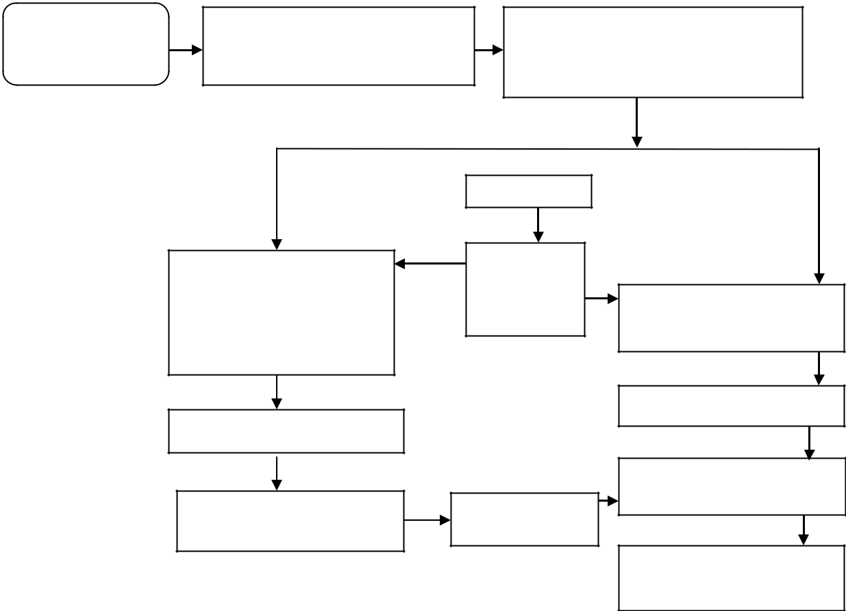

It showcases various algorithms, including neural networks (ANN and DNN), support vector machines with radial basis function (SVR_rbf), linear (SVR_linear), and polynomial (SVR_quad) kernels, as well as tree-based algorithms like Random Forest (RF) and XGBoost. These algorithms were trained and validated using data sourced from multiple rainfed and irrigated wheat fields located in the Sidi Rahal and Kairouan regions. After comparing the predicted soil moisture values with the actual measurements, a model was chosen from each category based on its statistical performance indicators, including root-mean-square error (RMSE), R², and BIAS.

In the second phase, the chosen models were evaluated for their transferability to enhance their applicability under varying conditions, utilizing different datasets obtained from drip irrigation wheat fields in the Chichaoua area. Concurrently, these models were compared to the Water Cloud Model (WCM), which uses similar inputs such as backscatter coefficient and coherence, along with additional factors like fractional cover and surface roughness.

SAR data

Sentine-1

Preprocessing the ground stage and complex environment

Feature Detection of VV and VH polarization for Black scattering Coefficients

Phase I

Training Dataset using

ML algorithm Kairouan

site, Chichaoua site and

Sidi Rahal site

Evaluating the models

Best model selection for

individual category

Figure1 illustrates the proposed methodology employed in this study.

Field Data

SSM Target

for ML

Retrieved SSM

Phase II

Evaluating the selected model Chichaoua site

Inverted SSM

Evaluation over measured SSM

Accuracy Calculation for the best model

The results produced by the selected machine learning models and the WCM were analyzed against the observed data to identify the most effective model.

ANNs and DNNs

Artificial Neural Networks (ANNs) establish a connection between input features and the anticipated output. This connection is formed by summing the weighted inputs and fine-tuning the weights until the desired output is achieved. Numerous ANN architectures are documented in the literature, each comprising multiple neural layers interconnected by their respective weights. These neurons typically include activation functions, often nonlinear, which play a crucial role in defining the input-output relationship of the ANN by enhancing its learning capabilities.

averaging the outputs of all decision trees, thereby enhancing the model's performance.

XGBoost is another tree-based ensemble technique that employs the gradient boosting method. The key distinction between RFR and XGBoost lies in their construction approach: RFR builds multiple decision trees independently and in parallel during training, while XGBoost develops decision trees sequentially, starting with an initial decision tree as the base learner.

It then adds new base learners trained on the residuals of the previous tree, effectively reducing the error between predicted values and the target.

Support Vector Regression

Support Vector Regression (SVR) utilizes nonparametric kernel functions (Φ) that enable effective modeling of various relationships. These kernel functions are combined with an epsilon-insensitive loss function to facilitate regression tasks, utilizing a dataset of n input-output training pairs.

Tree-Based Algorithms: Random Forest Regression and XGBoost Regression

The Random Forest Regression (RFR) algorithm generates each tree from a distinct sample of the training dataset. At each node of the tree, RFR selects a different subset of features for splitting, allowing the decision trees to operate in parallel without interaction. The final predictions are obtained by

IV. RESULT ANALYSIS

The proposed work is implemented using the MATLABR2021aa Figures 2 and 3 illustrate that this finding aligns closely with the results derived from the ANN algorithm and previous research, which indicated that the backscatter coefficient and interferometric coherence at VV polarization can effectively estimate soil moisture using a backscattering modeling inversion approach. Furthermore, all machine learning algorithms exhibited diminished performance for both polarizations when soil moisture values surpassed 0.3 m³/m³.

Table 1 presents the characteristics of Sentinel-1 processed products utilized throughout this study.

Site | Season |  | Relative orbit | Incident | Relative orbit with | Product | Number
 |  |  | number | Angle | Overpass time |  | Of Images
Chichaoua (F1) | October | 2016-July | 52 | 35.2ᶱ | Descending-06:30 | GRD | 110
 | 2018 |  |  |  |  | SLC | 106
Sidi Rahal | November2016-June |  | 154 | 40ᶱ | Descending-06:28 | GRD | 61
 | 2018 |  |  |  |  | SLC | 60
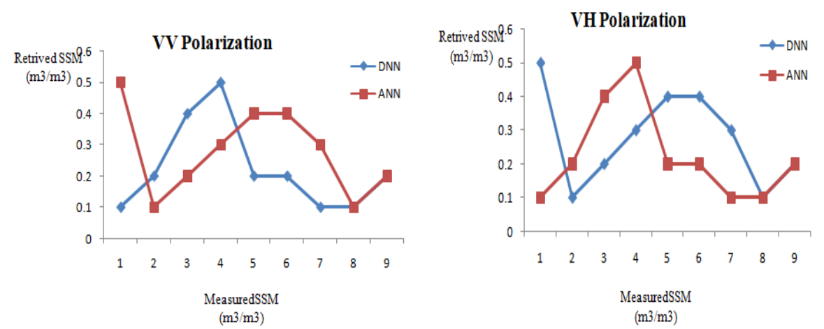

Figure 2 : VV polarization Figure 3:VH polarization.

This occurrence is attributed to the saturation of the radar signal in areas with elevated soil moisture, resulting in decreased accuracy of the inversion outcomes. To assess the transferability of the selected machine learning algorithms, which demonstrated the highest prediction accuracy for soil moisture estimation (ANN, SVR_rbf, and XGBoost), datasets from a drip-irrigated winter wheat field were utilized. In this region, Sentinel-1 data, including the backscatter coefficient and interferometric coherence, were collected at an incidence angle of 35.2°. This setup will also allow us to examine the impact of incidence angle on soil moisture retrieval. Additionally, the performance of the machine learning algorithms was compared to that of the coupled Water Content Model (WCM). The effectiveness of various machine learning algorithms, along with the WCM model, in retrieving soil moisture at both VV and VH polarizations was analyzed.

V. CONCLUSION

In the initial phase, all machine learning algorithms were trained and validated using data gathered from various irrigated and rainfed wheat fields in Morocco and Tunisia. A comparison of estimated and measured soil moisture content (SSM) indicated that the Artificial Neural Network (ANN), Deep Neural Network (DNN), Radial Basis Function Support Vector Regression (SVR_rbf), and XGBoost emerged as the top performers in their respective categories for retrieving SSM, particularly for VV polarization, achieving correlation coefficients between 0.75 and 0.76 and a root mean square error (RMSE) of 0.05 cm³/cm³. In the subsequent phase, the transferability of these algorithms was assessed using a second in situ dataset obtained from a drip-irrigated wheat field in Morocco. The focus was narrowed to ANN, SVR_rbf, and XGBoost, as the complex DNN produced similar results. Overall, both the ANN and SVR_rbf algorithms demonstrated a strong ability to estimate SSM at VV polarization, with correlation coefficients and RMSE values of 0.81 and 0.034 m²/m², respectively, slightly outperforming XGBoost, which had values of 0.76 and 0.038 m²/m². Furthermore, their performance was found to be comparable to that of the WCM model, highlighting their effectiveness in retrieving SSM using solely radar data. Notably, due to its favorable balance of retrieval accuracy, processing time, and simplicity, SVR_rbf is recommended for use in the SSM inversion process over backscattering modeling, including semi-empirical methods, especially for SSM mapping applications. Our analysis also indicated that generating an SSM map for a 4 × 4 km² area using the WCM model required significantly more time— approximately 20 times longer—than using SVR_rbf.
Reference

- Zhongli Zhu, Lei Tan, Shengguo Gao, and Qishun Jiao. Observation on Soil Moisture of Irrigation Cropland by Cosmic-Ray Probe. IEEE GEOSCIENCE AND REMOTE SENSING LETTERS, VOL. 12, NO. 3, MARCH 2015. Digital Object Identifier 10.1109/LGRS.2014.2346784.

- Zhao-Liang Li a,b, Pei Leng a,*, Chenghu Zhou b, Kun-Shan Chen c, Fang-Cheng Zhou d, Guo-Fei Shang e. Soil moisture retrieval from remote sensing measurements: Current knowledge and directions for the future. Earth-Science Reviews 218 (2021) 103673 Available,

- Jamal Ezzahar , Abdelghani Chehbouni , Nadia Ouaadi , Mohammed Madiafi , Khabba Said , Salah Er-Raki , Member, IEEE, Ahmed Laamrani , Adnane Chakir , Zohra Lili Chabaane , and Mehrez Zribi , Senior Member, IEEE. Sentinel-1 Backscatter and Interferometric Coherence for Soil Moisture Retrieval in Winter Wheat Fields Within a Semiarid South-

Mediterranean Climate: Machine Learning Versus Semiempirical Models. IEEE JOURNAL OF SELECTED TOPICS IN APPLIED EARTH OBSERVATIONS AND REMOTE SENSING, VOL. 17, 2024, Digital Object Identifier 10.1109/JSTARS.2023.3339616.

- Z. L. Li, P. Leng, C. Zhou, K. S. Chen, F. C. Zhou, and G.

F. Shang, “Soil moisture retrieval from remote sensing measurements: Current knowledge and directions for the future,” Earth-Sci. Rev., vol. 218, 2021, Art. no. 103673.

- P. R. Houser, W. J. Shuttleworth, J. S. Famiglietti, H. V.

Gupta, K. H. Syed, and D. C. Goodrich, “Integration of soil moisture remote sensing and hydrologic modeling using data assimilation,” Water Resour. Res., vol. 34, pp. 3405–3420, 1998.

- I. Goodfellow, Y. Bengio, and A. Courville, Deep Learning. Cambridge, MA, USA: MIT Press, 2016.

- I. Ali, F. Greifeneder, J. Stamenkovic, M. Neumann, and

C. Notarnicola, “Review ofmachine learning approaches for biomass and soilmoisture retrievals from remote sensing data,” Remote Sens., vol. 7, pp. 16398–16421, 2015.

- Q. Yuan, H. Xu, T. Li, H. Shen, and L. Zhang,

“Estimating surface soil moisture from satellite observations using a generalized regression neural network trained on sparse ground-based measurements in the continental US,” J. Hydrol., vol. 580, 2020, Art. no. 124351.

- M. El Hajj, N. Baghdadi, M. Zribi, and H. Bazzi, “Synergic use of Sentinel-1 and Sentinel-2 images for operational soil moisture mapping at high spatial resolution over agricultural areas,” Remote Sens., vol. 9, 2017, Art. no.

1292.

  - A. K. Holtgrave,M. Förster, F. Greifeneder, C.

Notarnicola, and B. Kleinschmit, “Estimation of soil moisture in vegetation-covered floodplains with Sentinel-1 SAR data using support vector regression,” PFG—J. Photogrammetry, Remote Sens., Geoinformation Sci., vol. 86, pp. 85–101, 2018.

- R. Inoubli, L. Bennaceur, N. Jarray, A. Ben Abbes, and I. Farah, “A comparison between the use of machine learning techniques and the water cloud model for the retrieval of soil moisture from Sentinel-1A and Sentinel-2A products,” Remote Sens. Lett., vol. 13, pp. 980–990, 2022.

[12]. N. Efremova, M. E. A. Seddik, and E. Erten, “Soil

moisture estimation using Sentinel-1/-2 imagery coupled

with cycleGAN for time-series gap filing,” IEEE Trans.

Geosci. Remote Sens., vol. 60, pp. 1–11, Dec. 2021, doi:

10.1109/TGRS.2021.3134127.

[13]. N. Ouaadi et al., “Monitoring of wheat crops using the

backscattering coefficient and the interferometric coherence

derived from Sentinel-1 in semi-arid areas,” Remote Sens.

Environ., vol. 251, 2020, Art. no. 112050.

  - E. Njoku, AMSR-E/Aqua Daily L3 Surface Soil Moisture, Interpretive Parameters, QC EASE-Grids, Version 2. Boulder, CO, USA: NASA Nat. Snow Ice Data Center Distributed Active Arch. Center, 2004, doi: 10.5067/AMSR-E/AE_LAND3.002.

- Y. H. Kerr, P. Waldteufel, J. P. Wigneron, J.

Martinuzzi, J. Font, and M. Berger, “Soil moisture retrieval from space: The soil moisture and ocean salinity (SMOS) mission,” IEEE Trans. Geosci. Remote Sens., vol. 39, no. 8, pp. 1729–1735, Aug. 2001.

