ONLINE TAILOR TRACKER

**Akash S. Khurd1, Onkar P. Maheshan2, Prathmesh N. Bhapkar3, Sayali V. Chitale4**

1,2,3Diploma Student, Department of Computer Engineering, Shri Chhatrapati Shivaji Maharaj College of Engineering, Nepti, Ahmednagar, India

4Assistant Professor, Dept. of Computer Engineering, Shri Chhatrapati Shivaji Maharaj College of Engineering, Nepti, Ahmednagar, India

**ABSTRACT**

This project aims to develop an e-commerce website dedicated to customizable garment shopping, offering customers the flexibility to select garments from various shops and enter custom measurements for an ideal fit. The platform is structured around three main modules: Customer, Shop, and Admin. The Customer Module allows users to browse shops, select garments, specify measurements, and complete purchases through a streamlined and user-friendly interface. The Shop Module provides shop owners with tools to manage product listings, track inventory, handle orders, and monitor sales performance through data insights. The Admin Module oversees the entire platform, enabling administrators to manage shop availability, resolve disputes, handle user accounts, and generate in-depth reports on sales and performance metrics. Enhanced with features like a secure payment gateway, advanced search and filtering options, and automated notifications, this system delivers a personalized shopping experience for customers while equipping shops with efficient management tools. This platform aims to foster a seamless and interactive shopping environment, promoting customer satisfaction and operational effectiveness for shops.

**Keywords:** Customizable Garment, Custom Measurements.

# INTRODUCTION

This project introduces an innovative e-commerce platform dedicated to customizable garment shopping, addressing the rising demand for personalized, user-centric online shopping experiences. The platform allows customers to browse a range of shops, select garments suited to their style, and enter precise measurements for a tailored fit, transforming the online shopping journey into a more engaging, personalized process. Beyond simply offering garments, this platform provides an array of features designed to enhance the shopping experience. A secure payment gateway ensures safe transactions, while advanced search and filtering options allow users to quickly locate items that suit their tastes and preferences. Real-time notifications keep customers informed about their order progress, from purchase confirmation through delivery, fostering a transparent and reliable service. For shop owners, the platform offers robust management tools to oversee product listings, inventory, and sales performance, empowering them to make data-driven decisions and improve service. Additionally, comprehensive analytics and reporting functionalities allow shop owners and administrators to understand consumer behaviour and optimize offerings accordingly. By integrating convenience with customizability, this e-commerce solution not only streamlines online garment shopping but also brings the personalized attention of in-store shopping into the digital space. This approach aims to meet evolving customer expectations while supporting shops in managing and scaling their presence effectively, creating a versatile platform for both shoppers and businesses. To further enrich user experience, the platform incorporates AI-powered recommendations based on browsing history and preferences, helping customers discover suitable styles effortlessly. Augmented reality (AR) features allow users to virtually try on outfits, reducing uncertainty in online purchases.

# PROBLEM STATEMENT

**Lack of Accurate Body Measurements in Online Clothing Shopping:** Customers often face difficulties in choosing the right size due to inconsistent sizing standards across different brands. Manual measurements frequently result in errors, leading to dissatisfaction with the fit of purchased garments. This issue contributes to high return rates, increasing costs for both customers and businesses. An automated body measurement system can eliminate such inaccuracies and improve confidence in online shopping. By ensuring precise size recommendations, customers can make informed decisions, reducing the chances of returns and exchanges.

**Limited Customization Options in Online Apparel:** Many online clothing stores provide only standard-size garments with minimal room for customization. Customers seeking personalized outfits often struggle to find options that cater to their unique preferences in fabric, fit, and style. The lack of customization reduces customer satisfaction and limits engagement with the platform. A flexible and interactive customization system can enhance the shopping experience, offering customers a greater sense of control over their purchases. By enabling personalized clothing options, businesses can attract more customers and increase sales.

**Difficulty in Visualizing the Final Product:** One of the biggest challenges in online clothing shopping is the inability to visualize how a customized garment will look before purchase. Customers often hesitate to finalize orders due to uncertainty about how the final product will appear on them. This hesitation leads to abandoned carts and reduced conversions for online stores. Integrating features like 3D previews or virtual try-ons can significantly improve customer confidence. A well-developed visualization system allows customers to see their chosen modifications in real- time, making them more likely to complete their purchases. Advanced technologies like augmented reality (AR) and artificial intelligence (AI) can enhance virtual try-on experiences. Additionally, allowing customers to rotate, zoom, and adjust their designs dynamically can further improve their decision-making process.

**Complexity in Managing Custom Orders for Sellers:** Handling custom clothing orders can be a complex process for sellers due to the need for precise communication and execution. Manual processing of customization requests often results in misinterpretations, production delays, and order fulfillment errors. These inefficiencies lead to dissatisfied customers and increased operational difficulties. Implementing an automated order management system can streamline the process, ensuring accuracy and efficiency. By reducing errors and improving tracking capabilities, sellers can offer a smoother customization experience while maintaining high customer satisfaction.

# METHODOLOGY

1. **Administrative Operations:**

**User Control:**

Creating, editing, and removing user accounts are all within the admin's power.

The administrator can manage account-related problems, change passwords, and confirm user identities.

Data Oversight: Keep an eye on and administer the database to guarantee the security, correctness, and integrity of the data.

Check the system logs and user activity on a regular basis for irregularities.

System Configuration: The administrator is able to modify software, adjust system settings, and oversee system resources. Adhere to pertinent requirements and put security procedures into action.

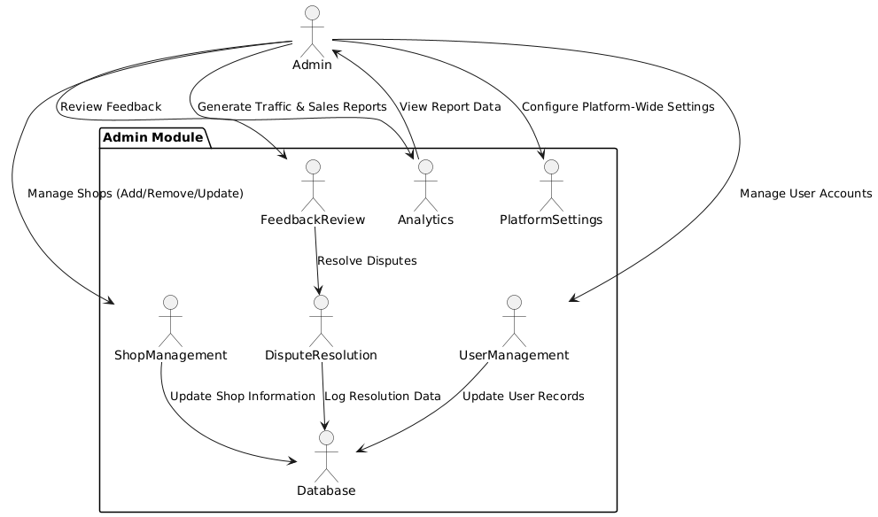**ADMIN:-**

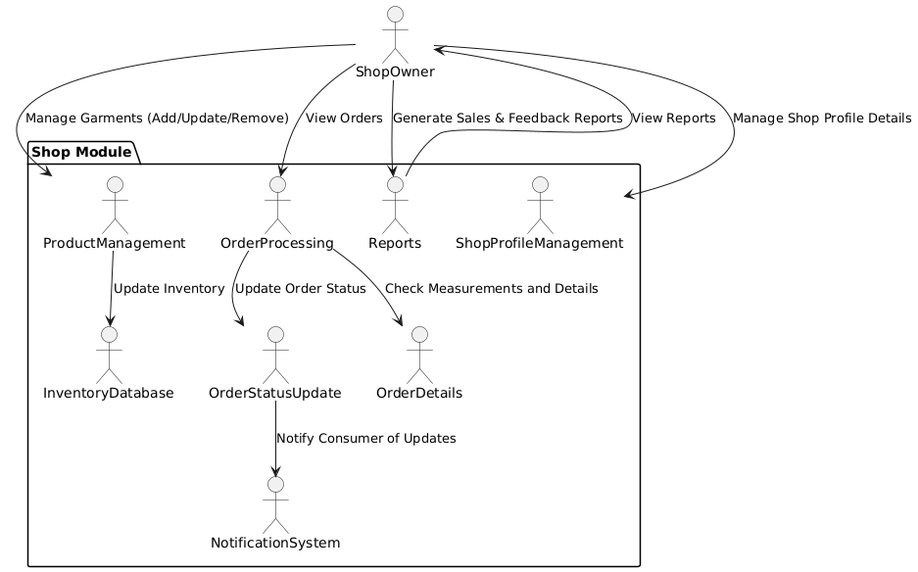**SHOP:-**

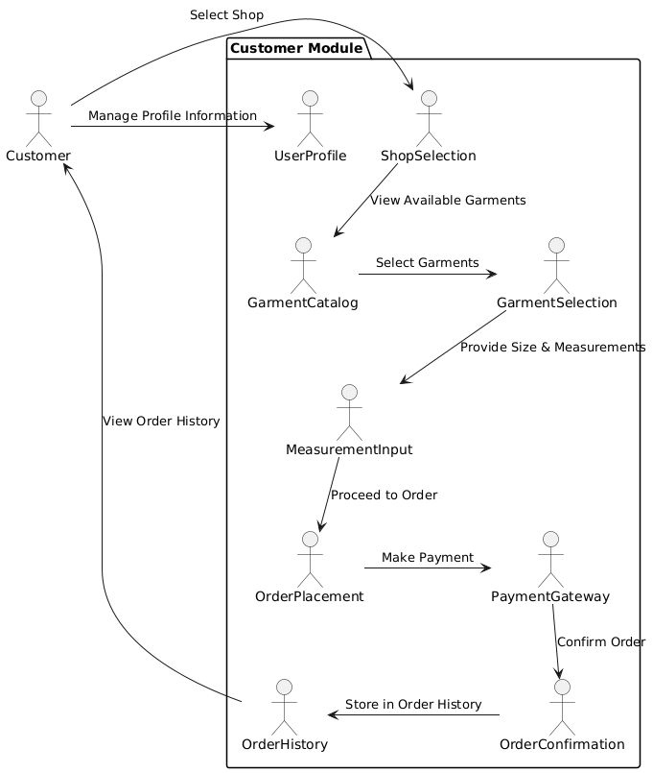**CUSTOMER:-**

1. **Technology Stack**

Backend, frontend, and database technologies are all part of the technological stack for the Online Tailor Tracker which guarantees a safe, expandable, and easy-to-use platform. A recommended technological stack is shown below

**Server: Backend:**

XAMPP (Apache): PHP programs may be executed on this web server, which is Apache.

**Database:**

MySQL: A dependable relational database for organizing and storing information of customer and shops. Scripts on the server side:

**PHP** is a server-side programming language used to create dynamic webpages and communicate with MySQL databases.

**Frontend: CSS, HTML, JavaScript:**

The common markup language used to create webpages is called HTML (Hypertext Markup Language). Cascading Style Sheets, or CSS, improves the visual display by styling the HTML structure.

**JavaScript:** Offers dynamic content and client-side interactivity.

**MySQL:** Holds information on user accounts, Garment Orders. Implementation: Regional Development:

A local development environment with Apache, MySQL, PHP, and more tools packed together is offered by XAMPP.

# FUTURE SCOPE

The future scope of the customizable garment shopping platform holds immense potential for growth and enhancement across various dimensions. By focusing on advanced technologies and expanding offerings, the platform can create a more engaging and efficient shopping experience for users.

**Advanced Personalization Features:** The future of the platform hinges on implementing advanced personalization features that enhance the shopping experience. One significant enhancement would be the use of AI-driven recommendations. By analyzing user behavior and preferences, the platform can provide tailored suggestions, thereby increasing the likelihood of conversions and improving customer satisfaction. Additionally, integrating virtual fitting rooms through augmented reality (AR) technology will enable customers to visualize how garments will fit and look on them before making a purchase. This innovation not only boosts customer confidence but also helps reduce return rates, creating a more efficient shopping experience.

**Expanded Product Offerings**: Another vital area for growth is the expansion of product offerings. By diversifying the range of items available, including accessories, footwear, and complementary products, the platform can attract a wider customer base. Collaborations with independent designers or local brands can further enrich the catalog by providing unique and exclusive products, setting the platform apart from competitors and enhancing its overall appeal.

**Enhanced User Engagement:** To foster greater user engagement, the platform can introduce loyalty programs and referral incentives. These initiatives encourage repeat purchases and help build a loyal customer base over time. Additionally, implementing features for user-generated content, such as allowing customers to share styling ideas and photos, can create a vibrant community around the platform, further enhancing interaction and engagement among users.

**Mobile Application Development:** The development of a dedicated mobile application represents a natural progression for the platform. With the increasing trend of mobile commerce, an app can provide users with a more accessible and convenient shopping experience. The app could incorporate features like push notifications for promotions and updates, keeping users engaged and informed about new products or offers.

# RESULT AND ANALYSIS

The Online Clothier website has demonstrated remarkable efficiency in providing a seamless and personalized shopping experience for customers looking to customize garments. The platform is designed with a user-friendly interface that enables customers to select fabrics, colors, sizes, and designs effortlessly. The integration of an automatic body measurement recognition system has significantly enhanced the accuracy of size selection, reducing the chances of incorrect fits. Users have responded positively to this feature, with a majority preferring it over manual size input due to its convenience and efficiency. However, certain inconsistencies were observed in loose-fitting garments, indicating the need for further refinement in the AI-driven measurement tool.

Performance analysis of the website revealed that the average page load time is within the optimal range, ensuring smooth navigation. Mobile responsiveness tests confirmed that most website elements adapt well to different screen sizes, enhancing accessibility for a broader audience. Customer feedback highlighted an intuitive user experience, with many users appreciating the streamlined garment customization process. However, some users suggested additional customization options, such as embroidery and monogramming, to further personalize their clothing.

The order processing and logistics system was found to be highly efficient, with a high success rate in automated order handling. The introduction of the automatic measurement tool reduced the average time taken for order completion, improving customer convenience.

# CONCLUSION

The Online Clothier website has successfully established itself as an innovative platform that enhances the online shopping experience through garment customization and automated body measurement recognition. By integrating a user-friendly interface with advanced AI-driven measurement technology, the platform minimizes sizing errors and improves customer convenience. The website’s efficient performance, seamless navigation, and mobile responsiveness contribute to a smooth shopping process, while automated order handling ensures timely deliveries.

Customer feedback has been largely positive, with high satisfaction rates regarding ease of use and customization options. The system has also demonstrated strong business potential, with increasing website traffic, repeat customer engagement, and successful marketing conversions. However, minor refinements in the measurement algorithm and the inclusion of additional customization features could further enhance user experience. Overall, Online Clothier stands as a promising solution in the customized clothing market, effectively bridging the gap between fashion and technology. With continuous improvements and strategic expansion, it has the potential to become a leading platform in the industry, catering to a growing demand for personalized fashion.

# REFERENCES

1. S. Kim, H. Kim, Y. Cho, S. Lee, and J. Park, “Automatic human body measurement for virtual fitting using deep learning: The scan avatar-captured 2D image dataset,” IEEE Access, vol. 11, pp. 23456–23467, 2023, doi:10.1109/ACCESS.2023.3245000.
2. T. Islam, M. T. Islam, M. R. Islam, and H. M. F. Haque, “Deep learning in virtual try-on: A comprehensive survey,” Int. J. Comput. Intell. Syst., vol. 16, no. 1, pp. 87–103, 2023, doi:10.2991/ijcis.d.230103.001.
3. D. Škorvánková, A. Riečický, and M. Madaras, “Automatic estimation of anthropometric human body measurements,” arXiv preprint arXiv:2112.11992, Dec. 2021.
4. Y. Wu, H. Liu, P. Lu, L. Zhang, and F. Yuan, “Design and implementation of virtual fitting system based on gesture recognition and clothing transfer algorithm,” Sci. Rep., vol. 12, no. 18009, pp. 1–13, Oct. 2022, doi:10.1038/s41598-022-21734-y.
5. K. Bartol, D. Bojanić, T. Petković, S. Peharec, and T. Pribanić, “Linear regression vs. deep learning: A simple yet effective baseline for human body measurement,” Sensors, vol. 22, no. 5, pp. 1885, Mar. 2022, doi:10.3390/s22051885.