**A Study on Green Startup Prospects in India: Fostering a Greener Future in Entrepreneurship**

**¹Ms. Taranpreet Kaur, ²Mr. Gourav Kamboj, ³Ms. Preet, ⁴Ms. Khushi Nathani, ⁵Ms. Shital Kumari**

**¹Assistant Professor, Department of Management, SD Institute of Management and Technology, Yamuna Nagar**

**² Postgraduate Researcher at Guru Nanak Khalsa College, Yamuna Nagar**

**³Postgraduate Researcher at Mukand Lal National College, Yamuna Nagar**

**⁴ Postgraduate Researcher at Guru Nanak Khalsa College, Yamuna Nagar**

**⁵Postgraduate Researcher at Tilak Raj Chadha Institute of Management and Technology, Yamuna Nagar**

**Abstract:** *India’s start-up ecosystem has seen incredible growth in recent years, positioning the country as one of the world’s most promising destinations for entrepreneurial endeavours. This study explores emerging start-up opportunities in India with a focus on fostering a sustainable and environmentally conscious future. The Indian government’s emphasis on sustainable development, coupled with increasing awareness of environmental issues, has created a conducive environment for innovative entrepreneurs seeking to make a positive impact while achieving business success. This research investigates various sectors within the Indian start-up landscape that hold immense potential for green entrepreneurship. The study highlights key areas, such as Sustainable agriculture, renewable energy, waste management, clean transportation, and ecofriendly technology, where Start-ups can play a key role in contributing to India’s sustainability goals and addressing global environmental challenges. Furthermore, this study delves into the challenges and opportunities of green Start-ups, also emphasizes the significance of social and environmental impact alongside financial success, as an Increasing number of entrepreneurs are aligning their businesses with the United Nations Sustainable Development Goals (SDGs). These goals are becoming a framework for measuring the contribution of Start-ups to creating a greener and more sustainable future. The findings of this study provide valuable insights for aspiring entrepreneurs, investors, policymakers, and ecosystem builders looking to engage with the burgeoning green Start-up landscape in India. It under-scores the need for innovative solutions that not only drive economic growth but also contribute to India’s journey towards a greener, more sustainable future.*

**Keywords:** Green, Startup, Future, Entrepreneurship, Innovation, Development, Sustainable

**Introduction:** The world is facing unprecedented environmental challenges, from climate change and pollution to deforestation and biodiversity loss. The consequences of these challenges are far-reaching, affecting not only the health of our planet but also the well-being of its inhabitants. As governments, corporations, and individuals struggle to address these issues, a new generation of entrepreneurs is emerging with innovative solutions to drive sustainable development. Green entrepreneurship and eco-friendly startups are revolutionizing the way we live, work, and interact with the environment.

By leveraging cutting-edge technologies, business models, and sustainable practices, these entrepreneurs are creating new markets, jobs, and opportunities for growth while reducing environmental degradation. From renewable energy and sustainable agriculture to eco-friendly products and waste management, innovative green entrepreneurship is transforming industries and communities around the world. According to a report by the International Renewable Energy Agency (IRENA), the renewable energy sector alone has created over 11 million jobs globally, with solar and wind energy accounting for the largest share of employment opportunities.

The growth of green entrepreneurship and eco-friendly startups is driven by a combination of factors, including increasing consumer demand for sustainable products and services, advances in technology, and government policies and regulations that support sustainable development. For instance, the European Union’s Green Deal aims to make Europe the first climate-neutral continent by 2050, with a focus on investing in clean technologies, reducing greenhouse gas emissions, and promoting sustainable land use. Similarly, the United States’ Green New Deal proposes a comprehensive plan to transition the country to renewable energy, reduce carbon emissions, and promote sustainable infrastructure.

Despite these efforts, significant challenges remain for green entrepreneurs and eco-friendly startups. Securing funding, navigating complex regulatory environments, and competing with established industries are just a few of the hurdles that these entrepreneurs face. Moreover, the transition to a sustainable economy will require fundamental changes in the way we produce, consume, and waste resources. This will necessitate a shift in cultural values, business practices, and individual behaviors, which can be difficult to achieve.

However, the potential rewards of green entrepreneurship and eco-friendly startups far outweigh the challenges. By creating sustainable products, services, and business models, these entrepreneurs can drive economic growth, reduce environmental degradation, and improve the well-being of communities around the world. Moreover, the growth of green entrepreneurship and eco-friendly startups can help to address some of the world's most pressing challenges, including climate change, poverty, and inequality.

**Review of Literature:**

**(Ryan & Wayuparb, 2004)** in their study in the article titled “Green space Sustainability in Thailand” Enlighten that there is a changing scenario in the opportunities for Green entrepreneurs. It is a conceptual based on the green product and green marketing focus on the consumer health and environment conscious. This focus on the companies focusing on The new innovation and redesigning their product and services in ecological manner.

**(Schaper, 2010)** concludes in his article “Understanding the green entrepreneur” that green entrepreneurs recognise and use their innovative ideas for the benefit of society and the Environment. The snowball sampling technique is utilised to collect research questionnaires from engineering and MBA graduates. ANOVA was utilised, and its results indicate that Parents have no influence on their children’s business decisions; hence, more enticing policies for green business investment can be proposed.

**(Seuring, and Müller, 2008)** discuss in their article “Green entrepreneurship: Road to green economy-environment-sustainable social system” the effect of an economy’s GDP on India, the barriers and issues by using case studies and quantitative statistics from 2009 to 2013 to understand the country’s policies for the impact of green entrepreneur in order to develop Green entrepreneurship. It is the responsibility of policymakers and educators to encourage the development of green entrepreneurship. The construction of a holistic and sustainable economic-environmental-social system is green entrepreneurship.

**(Shabbir, Shariff, and Shahzad, 2016)** in their study “Catalyzing the transition to Mediterranean Green Economies” discuss the demands of green entrepreneurship in the Mediterranean countries. Under the three phases of making he development, the art of green Entrepreneurship, awareness on government, business, and financial inclusion, and action on providing technical assistance and support to green entrepreneurs were implemented. The mediterranean area provides the ideal environment for social innovators and grassroots Organisations to provide the innovative solutions necessary to catalyse and sustain multinational Corporations’ transformation to “Green Economy.”

**(Shah, Arjoon, & Rambocas, 2016)** in its paper “Green entrepreneurship: Creating Green jobs through sustainable” proves that thinking beyond the technology-based aspects of doing business. Mainly focus on the green innovation at societal level. The result shows that Green entrepreneur play a vital role in the GDP growth of Namibia employment since the entry are ow willingness for innovation is high.

**Lokesh K (2022),** A study on green entrepreneurship in India explores the concept of green entrepreneurship, which involves environmental social and problems through entrepreneurial activities that are both environmentally beneficial and financially sustainable. It highlights the increasing significance of green entrepreneurship in India and the necessity for individual to take responsibility for environmental stewardship. The findings of the paper suggest that the incorporating of sustainable practices in business operations is essentials for achieving sustainable growth.

**Parminder Kaur et.al (2023),** the research paper titled Green entrepreneurship in India: A study of select green business, explores the green entrepreneurship concept by considering sustainable development and Environmental awareness in India. It highlights the change in preference of consumers towards ecofriendly Products, leading to the emergence of green entrepreneurs who aim to create awareness and promote sustainable practices. The study emphasizes the importance of integrating environmental education in early learning stages to cultivate a sustainable mindset in future generations.

**Objectives of the Study:**

* To investigate the impact of green entrepreneurship on sustainable development.
* To explore the initiatives taken by Government of India to promote green entrepreneurship.
* To study the prospects of Green Start-ups in India
* To understand the Operational framework and Revenue Model of Green Start-up through Case Study
* To analyse the factors leading to the growth of green Start-ups through Case Study.
* To suggest measures to adapt a sustainable model for upcoming and existing start-ups

**Research Methodology:**

As it is an exploratory study, the research paper is primarily dependent on secondary data that was gathered from many Journals, periodicals, and publications. The needs of the study’s objectives are taken into consideration when using a descriptive study. The study made considerable use of secondary data.

**Green Entrepreneurship:** Green entrepreneurship refers to the process of creating and managing a business that focuses on environmental sustainability and social responsibility. Green entrepreneurs are individuals who identify opportunities to develop innovative products, services, or processes that reduce environmental degradation, promote sustainable development, and improve the quality of life for communities. They combine their passion for environmental protection with business acumen to create enterprises that are not only profitable but also contribute to a more sustainable future. Green entrepreneurship encompasses a wide range of industries and sectors, including renewable energy, sustainable agriculture, eco-friendly products, green building, and waste management. Green entrepreneurs often face unique challenges, such as higher upfront costs, regulatory hurdles, and market education, but they also reap significant benefits, including access to growing markets, improved brand reputation, and contribution to a sustainable future. By embracing green entrepreneurship, individuals can turn their passion for environmental sustainability into a successful business venture, creating a positive impact on the environment, society, and the economy. Furthermore, green entrepreneurship has the potential to drive innovation, create new job opportunities, and stimulate local economic growth, making it an essential component of a sustainable and equitable future.

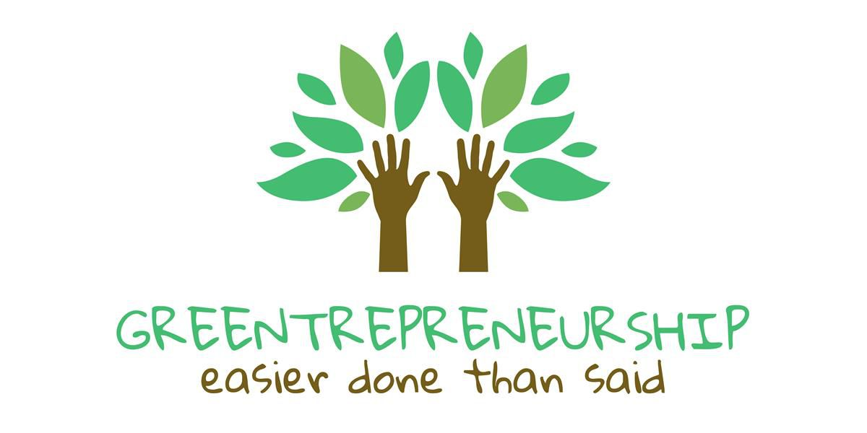

**Green Innovation:** Green innovation refers to the development and implementation of new or improved products, services, or processes that reduce environmental degradation, promote sustainable development, and improve the quality of life for communities. It involves the application of cutting-edge technologies, such as biotechnology, nanotechnology, and information and communication technology (ICT), to create environmentally friendly solutions that address pressing global challenges, including climate change, resource depletion, and pollution. Green innovation encompasses a wide range of fields, including renewable energy, sustainable agriculture, eco-friendly materials, green building, and waste management. It requires a multidisciplinary approach, involving collaboration between governments, businesses, academia, and civil society to develop and deploy innovative solutions that balance economic, social, and environmental objectives. By driving green innovation, individuals and organizations can create new business opportunities, improve competitiveness, and contribute to a sustainable future, while also enhancing their brand reputation, reducing environmental risks, and improving the well-being of communities. Furthermore, green innovation has the potential to create new industries, jobs, and economic growth, making it an essential component of a sustainable and equitable future.

**Overview of Green Entrepreneurial activity in India:**

**“The next industrial revolution will be green, and entrepreneurs will be at the forefront of this revolution, driving innovation, creating jobs, and building a sustainable future.” – Richard Branson, Founder of Virgin Group**

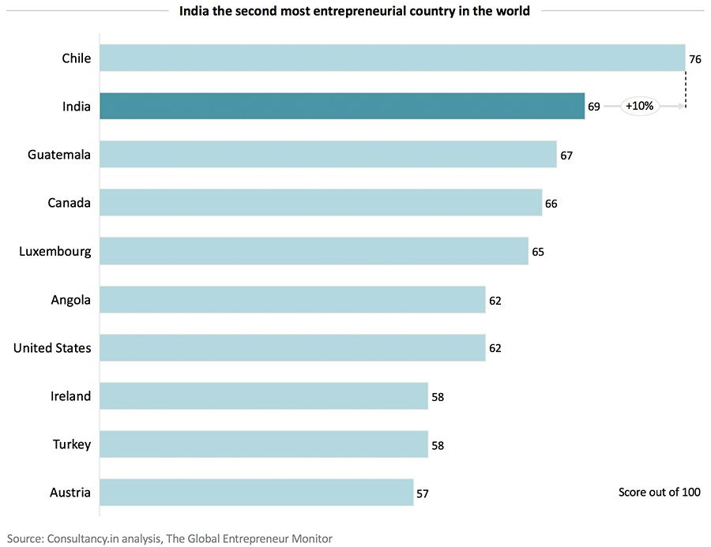

Green entrepreneurship is thriving in India, with the country emerging as a hub for innovative and sustainable businesses. India is home to over 50,000 registered start-ups, with many focusing on environmental sustainability and social responsibility .

**Key Sectors:**

- Renewable Energy: India has set ambitious renewable energy targets, driving innovation and entrepreneurship in the sector.

- Sustainable Agriculture: Green entrepreneurs are developing sustainable agricultural practices, reducing waste, and promoting eco-friendly products.

- Eco-friendly Products: Start-ups are creating innovative, eco-friendly products, such as biodegradable plastics, sustainable textiles, and natural personal care products.

- Waste Management: Entrepreneurs are developing sustainable waste management solutions, including recycling, composting, and waste-to-energy technologies.

**Government Initiatives:**

- Start-up India:A flagship initiative launched by the Government of India to promote entrepreneurship and innovation.

- The Biotechnology Industry Research Assistance Council (BIRAC): Provides funding and support to biotechnology start-ups, including those focused on environmental sustainability.

**Challenges and Opportunities:**

- Access to Funding: Green entrepreneurs often face challenges in securing funding, highlighting the need for more investors and funding mechanisms.

- Regulatory Framework: A supportive regulatory framework is essential for promoting green entrepreneurship in India.

- Growing Demand:Increasing consumer awareness and demand for sustainable products and services present significant opportunities for green entrepreneurs.

Overall, India’s green entrepreneurial ecosystem is vibrant and growing, with many opportunities for innovation, investment, and sustainable growth.

**Government Initiatives for fostering a greener future in Entrepreneurship:**

The Indian government has launched a plethora of initiatives to foster a greener future in entrepreneurship, aiming to promote sustainable development and environmental stewardship. One of the flagship programs is the **Startup India** initiative, which provides a comprehensive framework for nurturing innovation and entrepreneurship in the country. Under this program, startups can avail benefits such as tax exemptions, legal support in patent filing, and easy compliance, enabling them to focus on developing innovative solutions for a greener future. Additionally, the government has established the **Atal Incubation Centre (AIC)**, which provides funding of up to Rs. 10 crore to support entrepreneurs in developing sustainable technologies and business models. Furthermore, the **National Small Industries Corporation Subsidy** offers financial benefits for raw material assistance and marketing assistance, while the **MSME Business Loans in 59 Minutes** scheme provides quick access to loans of up to Rs. 1 crore. The **MUDRA Loans** program also offers financial assistance to micro-business units, enabling them to adopt sustainable practices and reduce their environmental footprint. The **Ministry of Skill Development and Entrepreneurship** has also launched various initiatives to promote entrepreneurship development amongst women, marginalized communities, and individuals from lower socio-economic backgrounds, including programs like **Pradhan Mantri Janjati Adivasi Nyaya Maha Abhiyan (PM-JANMAN)** **and Rashtriya Udyamita Vikas Pariyojana.** These initiatives demonstrate the government’s commitment to fostering a greener future in entrepreneurship and promoting sustainable development in the country.

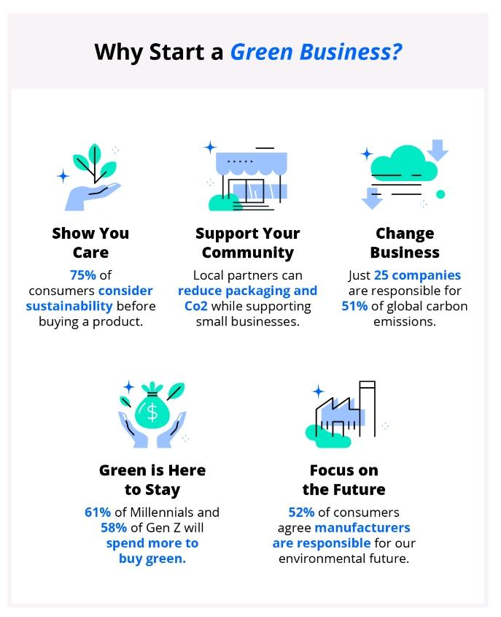

**Green Entrepreneurship model for Sustainable Development:**

A Green Entrepreneurship model for Sustainable Development is a holistic approach that integrates environmental, social, and economic considerations to create a sustainable and regenerative business ecosystem. This model encompasses a range of key components, including environmental sustainability, social responsibility, economic viability, innovation and technology, and collaboration and partnerships. By adopting eco-friendly practices, reducing carbon footprint, and promoting renewable energy sources, businesses can minimize their environmental impact while promoting sustainable development. Additionally, by ensuring fair labor practices, promoting diversity and inclusion, and supporting local communities, businesses can contribute to social justice and human well-being. Economic viability is also a critical component, as businesses must generate revenue while minimizing waste and environmental degradation. The integration of innovation and technology is also essential, as it enables businesses to develop sustainable products, services, and processes that drive growth and competitiveness. Finally, collaboration and partnerships with stakeholders, including governments, NGOs, and local communities, are vital for scaling impact and promoting systemic change. By embracing this Green Entrepreneurship model, businesses can contribute to a more equitable, resilient, and environmentally conscious future, while ensuring their own long-term viability and success. This approach not only helps businesses to reduce their environmental footprint but also provides opportunities for innovation, job creation, and economic growth, ultimately contributing to the achievement of the United Nations’ Sustainable Development Goals (SDGs).

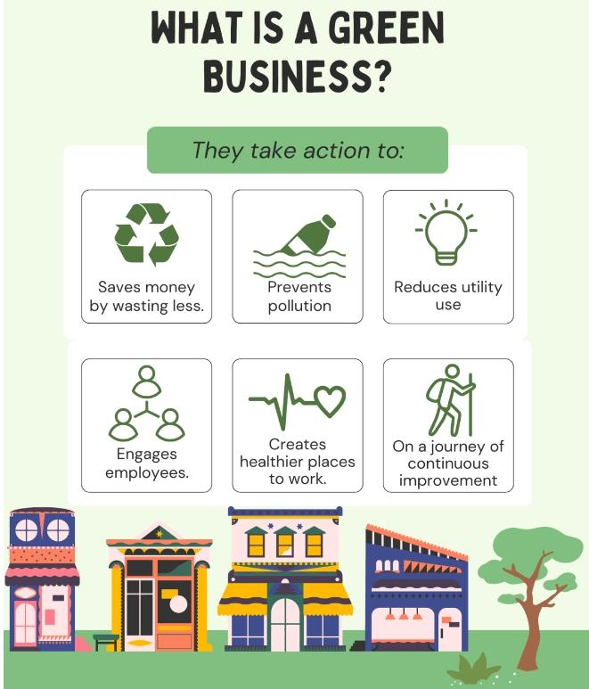

**Green Entrepreneurs- Some Case Studies:**

**ReNew Power** is a leading renewable energy company in India, founded by Sumant Sinha in 2011. The company has successfully transitioned from traditional fossil fuels to renewable energy sources, reducing carbon emissions and promoting sustainable development. ReNew Power’s innovative approach to renewable energy has made it a leader in the Indian market, with a portfolio of over 5 GW of renewable energy assets.

**Tara Earth** is a social enterprise founded by Anusha Naik that focuses on sustainable waste management and recycling. The organization works with local communities to promote eco-friendly practices and reduce waste. Tara Earth’s innovative approach to waste management has made it a model for sustainable waste management in India.

**Eco Femme** is a social enterprise founded by Kathy Walkling and Jessica Smith that promotes sustainable menstrual health and hygiene. The organization provides eco-friendly menstrual products and educates women about sustainable menstrual practices. Eco Femme’s innovative approach to menstrual health has made it a leader in the Indian market, with a presence in over 10 states.

**Greenway Grameen** is a social enterprise founded by Neha Juneja that develops innovative, eco-friendly products for rural communities. The organization focuses on sustainable energy, water, and sanitation solutions. Greenway Grameen’s innovative approach to product development has made it a model for sustainable product design in India.

**Sampurn€arth** is a social enterprise founded by Debartha Banerjee that focuses on sustainable waste management and recycling. The organization works with local communities to promote eco-friendly practices and reduce waste. Sampurn€arth’s innovative approach to waste management has made it a model for sustainable waste management in India.

**Arogya Finance** is a social enterprise founded by Kartikeya Bhandari that provides financial services for healthcare and sustainable development. The organization focuses on promoting sustainable healthcare practices and reducing healthcare costs. Arogya Finance’s innovative approach to financial services has made it a leader in the Indian market, with a presence in over 5 states.

**Svadha** is a social enterprise founded by Sachin Chandra that focuses on sustainable waste management and recycling. The organization works with local communities to promote eco-friendly practices and reduce waste. Svadha’s innovative approach to waste management has made it a model for sustainable waste management in India.

**Daily Dump** is a social enterprise founded by Poonam Bir Kasturi that focuses on sustainable waste management and recycling. The organization works with local communities to promote eco-friendly practices and reduce waste. Daily Dump’s innovative approach to waste management has made it a model for sustainable waste management in India.

These case studies demonstrate the innovative approaches and commitment to sustainability that Indian green entrepreneurs are bringing to the table. Through their innovative products, services, and business models, these entrepreneurs are reducing environmental degradation, promoting social justice, and driving economic development.

**Conclusion:** In conclusion, innovative green entrepreneurship and eco-friendly startups are crucial for creating a sustainable future. These entrepreneurs and startups are developing innovative solutions to environmental challenges, promoting sustainable development, and driving economic growth. Through their commitment to sustainability, they are reducing environmental degradation, promoting social justice, and improving human well-being.

The case studies of Indian green entrepreneurs and eco-friendly startups demonstrate the potential for innovation and sustainability in various sectors, including renewable energy, sustainable waste management, eco-friendly products, and sustainable agriculture. These entrepreneurs and startups are not only contributing to environmental sustainability but also creating jobs, stimulating local economies, and improving the quality of life for communities.

To further promote innovative green entrepreneurship and eco-friendly startups, it is essential to provide supportive policies, funding mechanisms, and mentorship programs. Governments, corporations, and civil society organizations must work together to create an enabling environment for green entrepreneurship to thrive.

Ultimately, innovative green entrepreneurship and eco-friendly startups have the potential to transform the way we live, work, and interact with the environment. By supporting and promoting these entrepreneurs and startups, we can create a more sustainable, equitable, and prosperous future for all.

**References:**

1. India’s growing startup ecosystem and its potential for green entrepreneurship (NASSCOM, 2020)

2. Government initiatives and policies supporting green startups in India (MNRE, 2020)

3. The role of green entrepreneurship in promoting sustainable development in India (UNDP, 2019)

4. Opportunities and challenges faced by green startups in India (YourStory, 2020)

5. The growth of renewable energy sector in India and its prospects for green startups (IRENA, 2020)

6. Green financing options available for startups in India (SIDBI, 2020)

7. The impact of green startups on employment generation and economic growth in India (ILO, 2019)

8. Case studies of successful green startups in India, such as ReNew Power and Greenway Grameen (Forbes, 2020)

9. The role of incubators and accelerators in supporting green startups in India (NASSCOM, 2020)

10. Green technology innovations and their applications in various sectors in India (DST, 2020)

11. The potential of green startups in addressing environmental challenges in India, such as air and water pollution (MoEFCC, 2020)

12. The growth of sustainable agriculture sector in India and its prospects for green startups (FAO, 2020)

13. Green entrepreneurship education and training programs in India (AICTE, 2020)

14. The role of green startups in promoting sustainable consumption patterns in India (UNEP, 2020)

15. The impact of green startups on rural development and poverty alleviation in India (IFAD, 2019)

16. Green infrastructure development and its prospects for green startups in India (MoUD, 2020)

17. The growth of eco-tourism sector in India and its prospects for green startups (MoT, 2020)

18. Green supply chain management practices and their adoption by startups in India (CII, 2020)

19. The role of green startups in promoting sustainable urban development in India (MoHUA, 2020)

20. Green innovation and intellectual property rights in India (IPR, 2020)

21. The impact of green startups on public health and well-being in India (WHO, 2019)

22. Green entrepreneurship and its relationship with sustainable development goals (SDGs) in India (UNDP, 2019)

23. The growth of green startup ecosystem in India and its comparison with other countries (Startup Genome, 2020)

24. The role of green startups in addressing climate change and its impacts in India (MoEFCC, 2020)

25. Green startup funding and investment trends in India (IVCA, 2020)