**A STUDY ON THE DEVELOPMENT OF HUMAN RESOURCE MANAGEMENT AND ITS STRATEGIC FUNCTION IN MODERN COMPANIES**

Arun Sreevatsan M1,Mrs Naveena M2,

1MBA Student, School of Arts, Humanities and Management, Jeppiaar University, Chennai, India.

2Associate Professor, School of Arts, Humanities and Management, Jeppiaar University, Chennai, India.

1***sreevatsan1411@gmail.com***,

2***naveenasweth15@gmail.com***,

**ABSTRACT**

The field of human resource management, or HRM, has evolved from an authoritative role to a crucial partner in business success. This study examines the historical development of HRM, its crucial role today, and its potential future. In today's competitive and dynamic trade economy, the study emphasizes the fundamental importance of HRM by examining its impact on organizational performance, worker engagement, and development. The difficulties faced by HR professionals are also discussed, including globalization, technological advancements, and shifting worker socioeconomics. In its conclusion, the report offers suggestions for HRM practices that support long-term growth while adapting to current corporate goals.

Keywords: globalization, employee engagement, and HRM.

**INTRODUCTION**

Over the past few years, there has been a significant shift in human asset management, or HRM. HRM is now seen as a crucial task that propels organizational success, having previously been limited to arranging authoritative tasks like financial preparation and employee record-keeping. The shift from traditional staff management to a more thorough and important HRM approach is a reflection of the sophisticated trade environment's growing complexity. The development of HRM, its role in organizations today, and the opportunities and difficulties it faces going forward are all examined in this study.  
  
The ability to manage a company's most valuable asset—its people—makes human asset management (HRM) a potentially vital function within businesses. HRM has evolved over the last century from a basic regulatory component to a dynamic and critical skill that primarily influences organizational success. This shift reflects the growing recognition that human resources are a source of competitive advantage rather than merely a resource to be managed.  
  
Organizations need to quickly adapt to shifts in innovation, globalization, and labor socioeconomics in the fiercely competitive and fast-paced trade world of today. This calls for a more strategic approach to managing human resources, where HRM contributes to the overall important goals of the company rather than being merely operationally and compliance-effective.Today, the ability to attract, retain, and develop talent is regarded as a fundamental aspect of business strategy, and human resources professionals have been crucial in developing and advancing this approach.

**HISTORICAL EVOLUTION OF HRM**

Although Human Asset Management (HRM) has a history dating back to the early 1900s, its origins are considerably deeper and reflect the need for organized labor management that existed even in pre-industrial societies.  
  
In any event, the formalization of workforce administration techniques was sparked by the Mechanical Transformation, which prepared the company for what would unavoidably become advanced HRM.

1. **Initial Steps:**

Time Before Industry and the Mechanical Revolution  
Labor was primarily arranged around tiny, family-run enterprises and societies in pre-industrial social regimes, with an emphasis on manual labor and handicraft. The need for formal HR practices as we know them today was minimal. In any event, this began to change significantly with the rise of the Mechanical Insurgency in the late 18th and early 19th centuries. The transition from rural to urban areas led to the development of large manufacturing facilities, where managing employees became a fundamental difficulty.  
  
During this time, labor administration was primarily focused on cost containment and efficiency maximization. Regularly, the working conditions were harsh, with excessive hours, inadequate pay, and little regard for the welfare of the employees. In response to these circumstances, labor unions began to grow, advancing security standards and demanding far higher wages and reasonable working hours. Instead of actively monitoring employee relations, the early forms of HRM were largely responsive, suggesting that labor disputes should be addressed and strikes should be anticipated.

1. **The Evolution of Faculty Management:**

A more structured method of managing employees began in the early 20th century. Frederick Winslow Taylor championed the development of logical administration, which offered guidelines for improving proficiency through time-and-motion calculations and standardized techniques. Taylorism placed a strong emphasis on the need for effective planning and rational worker selection, two of the most essential HR practices.  
  
Around this period, larger companies began to establish faculty divisions that were primarily focused on hiring, firing, and maintaining employee records. With a focus on ensuring adherence to labor regulations and managing employee benefits, the faculty administration portion was remained mostly regulatory.However, the growing influence of labor unions and the growing recognition of the importance of worker efficiency and resolve began to shift the center toward more employee-centric practices.

1. **The Development of Critical HRM**

The late 20th century  
A significant turning point in the development of HRM occurred in the late 20th century. The role of HRM evolved from operational to crucial as companies grew more intricate and competitive. The idea of Key Human Resource Management (SHRM) was created, emphasizing the need to align HR practices with the organization's overarching goals.

The integration of HRM into the larger commerce process is motivated by the recognition that human resources can provide a competitive advantage. During this time, innovations like essential workforce planning, ability management, and authority advancement were introduced with the goal of making sure the company had the right people in the right places at the right times.  
  
Additionally, the globalization of trade during this period presented HRM with both contemporary opportunities and challenges. Businesses expanded globally, necessitating HRM to manage diverse and geographically dispersed workforce. The need for universal labor law compliance, global ability securing, and cross-cultural administration skills became increasingly important.

1. **HRM in the Age of Data:**

The twenty-first century  
As we go into the twenty-first century, HRM has continued to develop in response to rapid advancements in technology, shifting workforce socioeconomic, and growing globalization. The selection of HR data frameworks (HRIS), information analytics, and counterfeit insights (AI) gadgets are examples of how the rise of computerized innovation has altered HR forms. These developments have enabled better decision-making, more effective HR operations, and a more notable focus on important tasks.  
The idea of representative involvement has also gained prominence, with HRM increasingly focusing on creating a productive workplace that attracts and retains talent. Work-life balance initiatives, flexible work schedules, and a more grounded emphasis on diversity, equality, and inclusion (DEI) are all included in this.

**THE STRATEGIC IMPACT OF HRM IN CONTEMPORARY COMPANIES**  
Human resource management, or HRM, is acknowledged as a vital partner in contemporary business settings, essential to achieving organizational goals. HRM has evolved beyond its traditional regulatory responsibilities to demand a more proactive and crucial role as companies investigate increasingly complicated and competitive marketplaces. The growing recognition that human capital may be a fundamental resource that might generate a workable competitive advantage is reflected in this action. The following are the main areas where HRM is crucial to innovative organizations:

1. **Capacity for Administration and Procurement**

A crucial component of HRM is ability administration. Organizations understand that achieving long-term success requires the capacity to draw in, create, and maintain beat ability. Planning thorough ability administration frameworks that adapt to the goals and culture of the company is a crucial component of HRM. This includes:

1. Crucial Choice and Enrollment:

HRM develops hiring strategies that focus on the right applicants who not only possess the necessary skills but also mesh well with the company's culture. This could entail using data-driven recruitment tools, harnessing social media, and developing a strong manager brand.

1. Setting Up Progress:

For an organization to be sound and grow, authority coherence must be guaranteed. A key component of HRM is identifying high-potential employees and preparing them for future leadership roles through targeted advancement initiatives.

1. Representative Enhancement:

Continuous learning and development are essential to maintaining a workforce that is competitive. Human resource management (HRM) ensures that employees' career growth opportunities align with their goals and the organization's primary objectives.

1. **Enhancing Employee Maintenance and Engagement**

Representatives who are locked in to their companies are more useful, creative, and dedicated. HRM is crucial to fostering employee engagement since it:

1. Workplace Culture and Employee Involvement:

HRM is concerned with creating and fostering an environment that fosters cooperation, diversity, and well-being. This includes initiatives that improve the overall employee experience, like wellness initiatives, recognition programs, and flexible work schedules.

1. Techniques for Maintenance:  
   High turnover rates can be problematic and costly. By addressing the fundamental factors that contribute to employee satisfaction, such as opportunities for professional growth, competitive pay, and a stable work environment, essential HRM focuses on maintenance.
2. Employee Feedback and Interaction:   
   Strong communication and feedback elements, including employee summaries and performance reviews, enable HRM to assess representative estimation and proactively address issues, hence increasing engagement and reducing turnover.
3. **Advancement of Organizations and Alter Administration**

HRM may play a significant role in promoting organizational development and managing change. HRM ensures that the personnel is adapted to the modern heading as organizations progress, whether through development, reconstruction, or adjusting to marketing shifts.

1. Organizing the Key Workforce:

HRM identifies gaps and develops processes to fill them by analyzing the demands of the workforce both now and in the future. This ensures that the company has the right mix of skills and knowledge to achieve its main objectives.

1. Promoting Organizational Change:

Managing the human aspect of organizational change is a major responsibility of HRM. This entails effectively explaining changes, attending to employee concerns, and providing preparation and return to ensure a seamless transition.

1. Encouraging a Learning Institution:

The ability to memorize and adapt could be a crucial competitive edge in the rapidly evolving world of today. HRM fosters a culture of continuous learning, enabling representatives to acquire cutting-edge skills and knowledge that support progress and adaptability.

1. **Administration of Execution and Essential Planning**

The foundation for achieving important goals is effective execution administration. HRM ensures that frameworks for execution administration are modified in accordance with the organization's goals, which in turn promotes high performance at all levels. The following are important factors.

1. Establishing Specific Goals:   
   HRM works with authority to establish measurable, well-defined goals that align with the organization's key objectives. This ensures that employees understand how their job fits into the bigger vision.
2. Advancing Input and Development:

Continuous input components are gradually replacing traditional annual execution audits. HRM makes it easier for reps and supervisors to check in on a frequent basis, providing opportunities for growth and real-time input.

1. Acknowledging and completing execution:

HRM develops pay and compensation structures that encourage high performance. This could include promotions, performance-based incentives, and non-cash benefits like recognition and opportunities for professional progression.

1. **Promoting Value, Consideration, and Differences (DEI)**

A diverse and inclusive workforce is not only a significant advantage, but also a moral requirement. Research suggests that different groups are more creative and adept at solving problems. HRM contributes significantly to the advancement of DEI by:

1. Various Hones for Enrollment:

HRM ensures that enrollment practices are thorough, reaching a large number of applicants from various backgrounds. This could entail creating thorough task descriptions, implementing equitable recruitment procedures, and forming partnerships with other competent groups.

1. Whole-person workplace culture:

Regardless of their background, HRM aims to create an atmosphere where all representatives feel valued and involved. This includes promoting arrangements that address segregation and inclination, supporting representational asset bunches, and advertising distinctions preparation.

1. Importance for Enhancing Careers:

HRM ensures that all representatives have access to possibilities for career growth and break even. This entails identifying and removing barriers that prevent minority groups from advancing inside the company.

1. **Making Use of Information Analytics and Innovation**

HRM is undergoing a change thanks to the application of innovation and information analytics, which enables better informed decision-making and effective forms. Essential HRM consists of:

1. HRIS (HR Data Frameworks):

HRM uses HRIS to expedite processes including representative records administration, benefits administration, and finance.   
Additionally, these frameworks provide useful data that may be applied to ability management and essential workforce planning.

1. Data-Informed Decision Making:

HRM increasingly relies on information analytics to make informed decisions regarding employee engagement, maintenance, execution, administration, and enrollment. For example, predictive analytics can help identify which employees are most likely to leave and what barriers may prevent them from doing so.

1. Automation and AI Appropriation:

AI and automation tools are being used to enhance several HR functions, like as employee engagement and ability security. AI-powered enrollment tools, for example, can perform initial interviews and resume screening, freeing up HR professionals to focus on more important tasks.

**CHALLENGES FACING HRM IN THE 21ST CENTURY**

HRM has certain difficulties in the modern commerce economy, despite its critical importance. These difficulties include:

1. Globalization:

Managing a diverse and geographically dispersed workforce has become increasingly challenging due to the global nature of trade. While maintaining consistency in HR practices, HRM must investigate a variety of social, legal, and administrative contexts.

1. Progressions in mechanics:

The working environment has altered due to the rapid pace of innovation. HRM must innovate to improve HR processes including hiring, administration, and employee engagement while also addressing the difficulties of advanced cooperation and additional work.

1. Changing Socioeconomic of the Workforce:

The workforce is becoming more and more diverse, with Millennial and Generation Z becoming closer. HRM needs to change to meet the evolving needs of these younger generations, who value flexibility, work with a purpose, and opportunities for personal growth.

1. Deficiencies in Ability:

There is a shortage of gifted talent in many industries. To ensure that businesses remain competitive, HRM must develop innovative processes for acquiring, enhancing, and maintaining talent.

1. Compliance with Administration:

The evolving legal landscape poses ongoing difficulties for HRM, particularly in areas like worker rights, labor regulations, and information protection. HRM needs to ensure that organizations remain compliant and stay up to date on administrative changes.

1. HRM Driven by Data:

Making informed decisions will become increasingly dependent on HRM's use of information analytics. HR professionals can use predictive analytics to identify trends, assess risks, and take preventative action.

**DATA ANALYSIS**

Sampling Size: - the sampling size is 70

1. **Had the company implemented AI-powered HR tools?**

|  |  |  |
| --- | --- | --- |
| **Options** | **Percentage** | **Total** |
| yes | 98 | 65 |
| No | 2 | 5 |

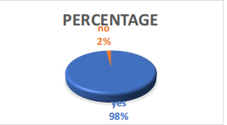

**INTERPRETATION**

Based on this, it appears that 98% of businesses have used AI-powered HR department technologies, compared to just 2% that have not.

1. **To what extent do you know about AI technologies?**

|  |  |  |
| --- | --- | --- |
| **Familiar** | **Percentage** | **Total** |
| Very familiar | 15 | 10 |
| Somewhat familiar | 67 | 48 |
| Not familiar | 15 | 10 |
| Expert | 3 | 2 |

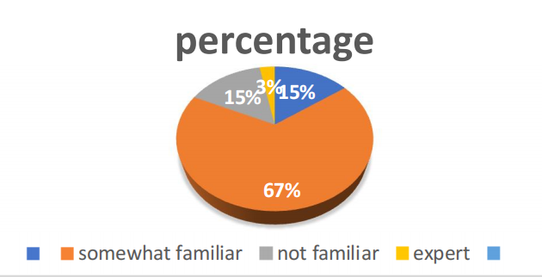

**INTERPRETATION**

The answers about people's acquaintance with AI technologies show that different people have different perspectives. Only 15% of respondents are highly familiar with AI, although 67% are at least somewhat knowledgeable, indicating a general awareness and interest in the technology. A knowledge gap that could be filled by education is indicated by the 15% who are completely unfamiliar. The fact that only 3% of people think of themselves as experts emphasizes how uncommon actual AI expertise is still.

1. **What area do you think the AI can impact the most?**

|  |  |  |
| --- | --- | --- |
| **Areas** | **Percentage** | **Total** |
| Recruitment | 30 | 20 |
| Training | 40 | 30 |
| Performance evaluation | 18 | 13 |
| Payroll | 12 | 7 |

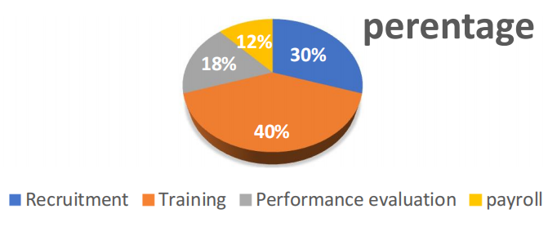

**INTERPRETATION**

According to the replies, training is anticipated to be the area where AI will have the biggest impact on HR, followed by recruitment (30%), performance evaluation (18%), and payroll (12%). There is no denying AI's influence on HR.

1. How has AI impacted HR process in your organization

|  |  |  |
| --- | --- | --- |
| **Impact** | **Percentage** | **Total** |
| Improved efficiency | 50 | 34 |
| Enhanced employee experience | 30 | 20 |
| Increased accuracy | 20 | 16 |

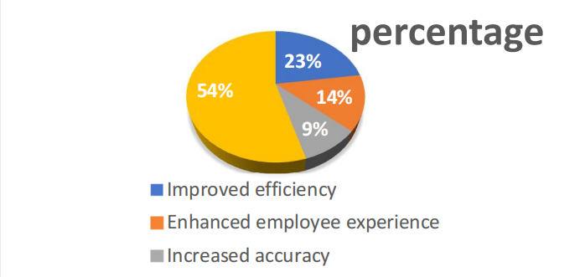

**INTERPRETATION**

When asked how AI affected HR, 50% of respondents said it improved efficiency, 30% said it improved employee experience, and 20% said it boosted accuracy. This poll indicates that increased efficiency has had a greater influence on the HR procedure.

1. **What changes do you think AI posses the HR?**

|  |  |  |
| --- | --- | --- |
| **Changes** | **Percentage** | **Total** |
| Job displacement | 33 | 28 |
| Bias discrimination | 27 | 22 |
| Data security concerns | 30 | 12 |
| Lack of transparency | 10 | 8 |

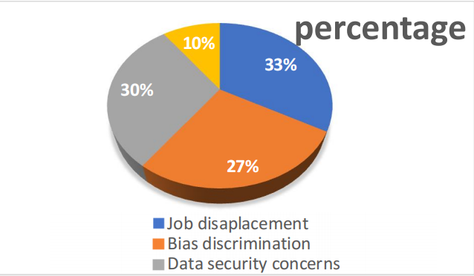

**INTERPRETATION**

Data from respondents indicates that 33% of HR changes are due to AI, followed by job displacement (27%), and bias and discrimination (27%). 10% goes toward openness, and 30% goes toward data security. As a result, AI has the ability to alter job displacement.

1. **Do you think AI can take the role of human resources positions?**

|  |  |  |
| --- | --- | --- |
| **Option** | **Percentage** | **Total** |
| Yes | 59 | 38 |
| No | 25 | 20 |
| Maybe | 16 | 12 |

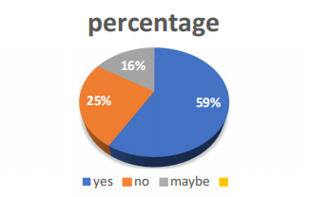

**INTERPRETATION**

Maybe (16%), no (25%), and yes (59%). According to respondents, since the "yes" option received the majority of votes, AI can take the role of HR positions.

**CONCLUSION**

The dynamic character of modern business conditions is reflected in the evolution of human asset management (HRM) from a primarily regulatory function to an essential partner.  
  
HRM has emerged as a key factor in organizational success as businesses face ever-more complex problems, from globalization and technological advancements to shifting labor market conditions and heightened rivalry.These days, HRM is essential for aligning human resources with business objectives, fostering an engaged and progressive culture, and ensuring that companies can attract, develop, and retain the talent needed to achieve long-term goals.HRM not only enhances operational productivity but also plays a significant role in the overall vital course of the organization by focusing on areas like ability administration, representative engagement, organizational improvement, different qualities and consideration, and execution administration.  
  
Furthermore, the way HRM functions has evolved as a result of the incorporation of innovation and information analytics, enabling more notable effectiveness and informed decision-making. Together with the growing importance of data-driven experiences, the introduction of AI and automation has made it possible for HR professionals to anticipate problems, respond swiftly to changes, and more effectively contribute to crucial planning.

**REFERENCES**

1. Budhwar, P. S., and Sparrow, P. R. (1997). "Competition and Change in India’s Emerging Market Economy: Strategic HRM Implications." World Business Journal, 32(3), 261-278.
2. D. Ulrich. 1997. The Future Agenda for Adding Value and Achieving Outcomes: Human Resource Champions. Harvard Business Review Press.
3. Jackson, S. E., and R. S. Schuler (2007). A Reader on Strategic Human Resource Management. Blackwell Wiley.
4. Budhwar, P., and D. S. Saini (2008). "Managing the Human Resource in Indian SMEs: The Role of Indigenous Realities." 43(4), 417-434, Journal of World Business.
5. Bhatnagar, J., and Budhwar, P. S. (2009). India's Changing People Management Landscape. Routledge.
6. Varma, A., Budhwar, P. S., and Katou, A. A. (2009). "The Role of HR in the Success of the Indian Software Industry." 157–169 in Journal of World Business, 44(2).
7. Varma, A., and Budhwar, P. S. (Eds.). (2010). Establishing Research-Based Practice in Indian Business. Routledge.
8. D. S. Saini (2012). Concepts and Practices of Human Resource Management in India. India's SAGE Publications.
9. T. V. Rao (2014). SAGE Publications India, "Performance Management Toward Organizational Excellence."
10. Purcell, J., and Boxall, P. (2016). Palgrave Macmillan, Strategy and Human Resource Management.
11. R. J. Stone (2020). Management of Human Resources. John Wiley & Sons.
12. Bhattacharyya, S., and Kumar, N. (2017). "Strategic Human Resource Management in India: A Review and Directions for Future Research." Journal of Human Resources Management in South Asia, 4(2), 223-243.
13. In 2017, Das, D. K., and Ghosh, D. "Strategic HRM and Firm Performance: Evidence from Indian Manufacturing Firms." 1154–1172, Global Business Review, 18(5).
14. According to Mishra and Dhar (2019), "HRM Practices in India: Challenges in the Post-Liberalization Era." Human Resource Management International, 30(2), 196-218.
15. M. Armstrong and S. Taylor (2020). Human Resource Management Practice: Armstrong's Handbook. Page Publishers, Kogan.