**Why Oncologists Are Turning to Webinars for the Latest Cancer Insights?**

Varun Gadia1

1 Infedis Infotech Private Limited

varun@hidoc.co

### Abstract

Oncologists are obliged to learn as precision medicine, immunotherapy, and targeted therapy grow at such a rapid pace. Webinars are progressively replacing traditional distribution strategies such as conferences and publications due to their flexibility, live expert engagement, and cost-effective education. This paper discusses the revolutionary impact of webinars on oncology education, their advantages convenience, peer-to-peer networking, instant access to the latest research, and high rates of engagement (75–80% attendance, 75% post-event engagement). Hidoc, with 13,000 active users, is a prime example of how customized webinars on subjects such as PD-1 inhibitors and bispecific antibodies improve clinical decision-making. Data indicate robust preferences for applied, case-based content and integrated treatment strategies. Webinars fill the knowledge gap between research and practice and are invaluable for oncologists confronting rapid innovations. With the development of digital education, webinars are likely to continue being the foundation of continuous learning and better patient outcomes in oncology.

### Keywords

Oncology education, medical webinars. Continuing Medical Education (CME) Digital learning in healthcare, updates on cancer treatments Hidoc Platform, Physician Engagement, Immunotherapy Advancements, Personalized medication.

### Introduction

Oncology is progressing faster than ever before, primarily due to advances in immunotherapy, targeted therapy, and precision medicine. (1) New medicines, such as CAR-T cell therapy, bispecific antibodies, and liquid biopsy technologies, are transforming cancer treatment, and doctors must stay up to date on the most recent evidence-based approaches.

Oncologists have typically kept up with continuing medical education through medical journals, conferences, and in-person workshops. However, the rapid rise of digital platforms has altered the nature of medical knowledge distribution completely. Webinars, for example, have shown to be an efficient way for oncologists to stay up to date on the newest discoveries despite their busy schedules.(2)

**This article focuses at how webinars have altered oncology education through creating it more accessible and interactive for medical professionals.**

**Webinars' Growing Significance in Medical Education**

A vital component of medical education, webinars bridge the gap between theory and practice.(3) Unlike passive learning methods like reading journal articles or watching lectures on tape, webinars allow for real-time communication with subject matter experts, which results in prompt discussion and a direct influence on patient treatment.

**Advantages of Webinars for Oncologists**

**1) Convenience and Flexibility:**

• Oncologists can view live or marked sessions to accommodate their hectic schedules.

• Reduces travel time and delays to patient treatment.

**2) Real-Time Interaction & Peer Networking:**

• Live Q&A sessions allow oncologists to seek professional advice on complex cases.   
• Enables networking with global oncology professionals and peers.

**3) A Cost-Effective Alternative to Traditional CME:**

• Webinars provide free or low-cost access, enabling ongoing learning without financial constraints.   
• Hospitals and institutions save expense while ensuring their oncologists remain current.

**4) Immediate access to the most recent research and guidelines:**

Live case discussions, clinical trial updates, and new guideline recommendations are frequently included in webinars. For example, current research on immunotherapy and targeted therapy from ASCO's annual meeting has been a major topic of discussion in webinars. Provides practical advice on how to apply novel treatments in clinical settings.

**For oncologists, the ability to learn from world-class specialists without ever leaving the clinic or hospital is revolutionary.**

### Webinar Impact: Key Metrics and Engagement Insights

**a)    Webinar Participation & Engagement Overview**

Webinar participation percentages indicate a high degree of engagement among oncologists, with strong retention and involvement after the session.

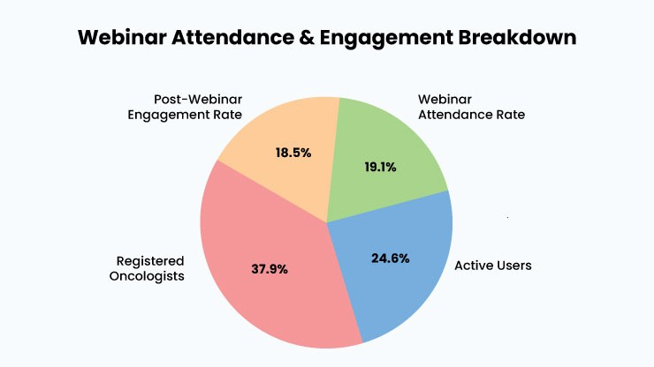

Fig 1 – Webinar attendance and engagement breakdown

High engagement, with 75-80% attendance and 75% post-webinar interaction, shows that the topic is very relevant. The presence of 13,000 active users indicates long-term interest and retention.

**b) Monthly Webinar Trends and Consistency**

Tracking the number of webinars conducted monthly and their average duration provides information about consistency and frequency.

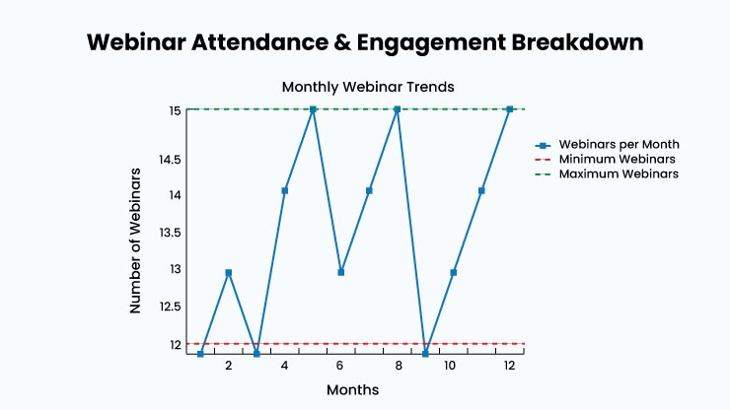

Fig 2 – Webinar attendance and engagement breakdown

Hosting 12-15 webinars per month provides ongoing learning possibilities. The 45-minute session format increases engagement, and trend data can help enhance future webinar scheduling.

**c) Webinar Topics and Registration Trends**

Oncologists are particularly interested in cutting-edge research and practical therapeutic applications.

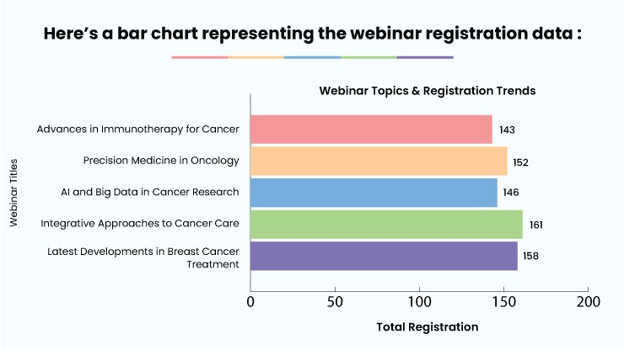

Fig. 3- Bar chart representing the webinar registration

Increasing registration numbers demonstrate oncologists' keen interest in both holistic treatment techniques and the most recent advances in breast cancer therapy.

### Key Takeaways

**High Engagement**: The majority of oncologists actively participate in webinars.   
**Enhanced information Retention**: Interactive learning promotes greater information retention than passive methods.   
**Direct Clinical Impact**: Expert-led conversations equip oncologists with practical insights for making evidence-based treatment decisions.

### ****Why Oncologists Prefer Hidoc?****

Hidoc has 13,000 active members and 20,000 registered oncologists, making it one of the most popular online forums for cancer professionals.

**Here's why it stands out:**1. Tailored webinars: on new cancer therapies, including PD-1 inhibitors, PARP inhibitors, and bispecific antibodies.  
2. High Engagement: With a 75% engagement rate post-webinars and an 80% attendance rate.  
3. Intuitive Platform: Hidoc's simplicity allows oncologists to view and engage with content even during chaotic clinical hours.   
Hidoc's oncology-specific webinars have a 75% engagement rate, indicating that they can give professionals with high-quality, well-structured training.

**Conclusion**

Oncologists have discovered webinars to be excellent ways to learn about new cancer treatments, providing a practical, amusing, and cost-effective approach to stay current on developments. Hidoc and other online tools lead the way in offering content targeted to oncologists' needs.Even though oncology is a rapidly evolving field, evidence-based webinars can help bridge the gap between research findings and clinical application, facilitating oncologists' adoption of novel medications. Webinars can remain an important component of ongoing education and improved patient care as long as the oncology profession embraces new technologies and overcomes current challenges.(5)

**References :**

1. Krzyszczyk P, Acevedo A, Davidoff EJ, Timmins LM, Marrero-Berrios I, Patel M, White C, Lowe C, Sherba JJ, Hartmanshenn C, O'Neill KM, Balter ML, Fritz ZR, Androulakis IP, Schloss RS, Yarmush ML. The growing role of precision and personalized medicine for cancer treatment. Technology (Singap World Sci). 2018 Sep-Dec;6(3-4):79-100. doi: 10.1142/S2339547818300020. Epub 2019 Jan 11. PMID: 30713991; PMCID: PMC6352312.
2. Zekri, J., Alshehri, A. S., Alomary, I. S., Bahadur, Y., & [Author 5's Last Name, First Initial]. (2021). The perspective of the oncology health care professionals on educational conferences. Global Journal of Health Science, 14(2), 1. <https://doi.org/10.5539/gjhs.v14n2p1>
3. Sivaramalingam, J., Rajendiran, K. S., Mohan, M., Cassinadane, A. V., & et al. (2022). Effect of webinars in teaching–learning process in medical and allied health science students during COVID-19 pandemic: A cross-sectional study. Journal of Education and Health Promotion, 11(1), 274. <https://doi.org/10.4103/jehp.jehp_1450_21>
4. Haritha, C. K., Shaikh, A., Gadia, V., & Mulllick, A. (2024). Empowering healthcare professionals: A closer look at Hidoc Dr user experience. International Journal of All Research Education and Scientific Methods (IJARESM), 12(1), 267. [https://www.ijaresm.com](https://www.ijaresm.com/)
5. Borkar S, Chakole S, Prasad R, Bansod S. Revolutionizing Oncology: A Comprehensive Review of Digital Health Applications. Cureus. 2024 Apr 28;16(4):e59203. doi: 10.7759/cureus.59203. PMID: 38807819; PMCID: PMC11131437.