**Trendy fashion recommender system by machine learning**

Danish Khan1* , Kunal Khandelwal2 ,Shaunak Shandilya3  ,Rishabh Jain 4

1,2,3Research Scholar, Dr.Akhilesh Das Gupta Institute of Professional Studies

4Assistant Professor ,Dr.Akhilesh Das Gupta Institute of Professional Studies

*[dk831675@gmail.com](mailto:dk831675@gmail.com)

**ABSTRACT**

Fashion recommendation systems, powered by ML (machine learning) algorithms, offer customized clothing, with accessory suggestions based on user choices, past actions, furthermore current fashion. This research paper focuses centrally on collaborative filtering and content-based filtering techniques as it extensively investigates the development of these systems. Hybrid models are additionally explored; these models thoroughly combine the described approaches to produce elevated accuracy and increased user satisfaction. The results from all of these implementations show that the recommendations experienced large improvement, greatly increasing both user engagement and purchasing rates.

A recommendation program or algorithm extensively examines many datasets to identify and present applicable information, thereby giving all customers customized suggestions. These systems look at patterns and trends related to users and what they choose, so businesses can better understand what customers do and like.

Fashion recommender systems are very important in online retail because they show stores, using detailed analysis, which products to offer based on what customers like, view, and buy. They can predict the demand for all specific clothing items, guaranteeing that stores have enough popular products and avoid too many unwanted items. Sales improve when customers are shown products they may enjoy, and the chances of selling more increase. With technical improvements, these systems will continue to improve at providing recommendations that are more personalized and accurate. A few companies, such as Amazon, Flipkart, Myntra, Ajio, as well as TATA Cliq, use recommender systems in order to both simplify product offerings along with improving customer experience.

**Keywords :** Fashion, Machine Learning, Deep Learning , Recommender systems, Neural Networks, Feature Extraction

**1 Introduction**

With the explosion of E-Commerce platforms, fashion recommender systems have become essential for improving user experience and driving sales. These systems offer personalized product suggestions by analyzing user behavior, preference and patterns. The application of Machine learning (ML) as well as Deep Learning (DL) which is itself a subset of machine learning, in these systems has revolutionized fashion retail, making the shopping process smoother and more relevant for customers.

The goal of this project is to create or use a machine learning model for a fashion recommendation system that works by analyzing images. The model takes an image as input and then finds the most similar fashion items. The main objectives of this project are:• Develop a fashion recommendation system that answers queries related to fashion services.

• Build a fashion recommendation system that can answer queries related to fashion.

• Identify the features in the input images.

• If the input image is correct, display similar product recommendations on the interface.

• Implement the project across different software platforms.

**2 Research Overview**

Fashion recommender systems have been a subject of research for several years. Early approaches involved basic recommendation methods like demographic filtering, but with advancements in machine learning, more sophisticated algorithms have been developed. Image classification using CNN algorithm, in which we classify the input image by providing certain labels using supervised learning Algorithms.

There are various projects and work related to the recommender system and metrics related to Image Classification using CNN algorithm, in which we classify the input image by providing certain labels using supervised learning algorithms.

Another example of a recommender system is style feature detection, where deep learning algorithms are used to classify the category and style of clothing. This method makes it easier to extract features and embed them, resulting in more accurate recommendations and categorization.

**3 Methodology**

The project is based on a system architecture with a few key steps, including:

• Image preprocessing and selection of model

• Building the recommendation engine

• A dynamic User Interface (UI)

**3.1 Model Selection (selecting right model)**

Here, we utilize the pre-trained model ResNet50, which was developed by expert engineers and developers for computer vision tasks. This model employs deep learning techniques to extract and process features from input images, making it suitable for both computer vision applications and recommendersystems.  
In extract a range of features from low-level (edge, textures) to high-level (shapes, patterns). Additionally, ResNet50 leverages transfer learning, allowing the knowledge from this model to be applied across various projects and systems.

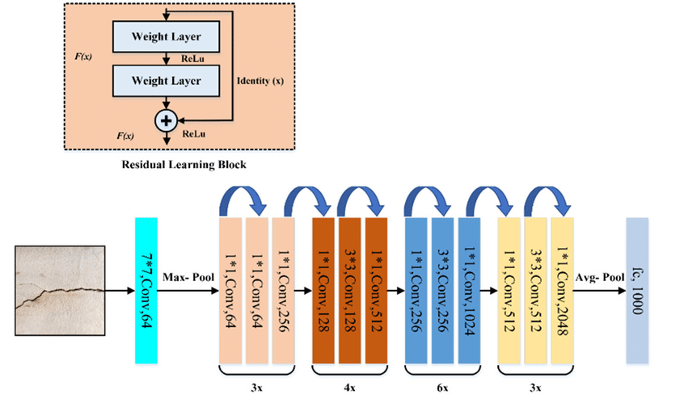

**Figure 1:** RestNet50 model architecture

**3.2 Image preprocessing**

The input image is processed using Deep Learning techniques in the ResNet50 model, which prepares it for the next steps. We use Convolutional Neural Networks (CNNs) in this process. CNNs are deep learning algorithms designed for image classification and feature extraction from multi-dimensional data, achieved through specialized layers called Convolutional layers. These layers are responsible for detecting and extracting important features from the input data.

A filter moves across the layers to create “feature maps,” which highlight the key details. Pooling is then used to reduce noise and retain only the most relevant data, by shrinking the size of the final layer. These pooling layers are flattened into 1D vectors, which are then 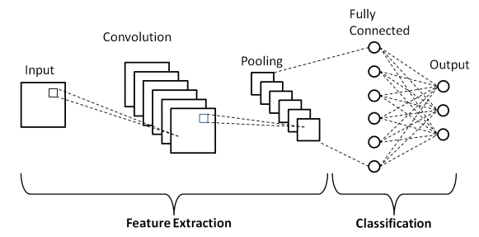connected to neurons for output classification.

**Figure 2:** Process flow of working of CNN

**3.3 Building Up Recommendation engine**

Now we are going to build our recommendation engine for this project which acts as the main backbone for recommendation system. Top 5 similar images to the input image will be suggest by our recommendation engine. We do classification using KNN algorithm. We calculate the euclidean distance between the features of the image and the features in the dataset which as the building block for our classification process. Therefore our recommendation engine can recommend the similar images to the input image by identifying the most close matches. Hence, this ensures both accuracy and efficiency in the recommendation process.

• Initially the data is collected and cleaned with all noises and errors removed to prepare it for the process of filtering.

• Then, the data is analyzed to make predictions and filter relevant features, while also evaluating the dataset’s implicit structure.

• Finally the data features are filtered for classification and embedded in a pickle file. The Euclidean distance is then calculated to find the closest matches for recommendation.

• The data features are filtered again for classification and stored in a pickle file, where the Euclidean distance is measured and compared to find the closest recommendations.

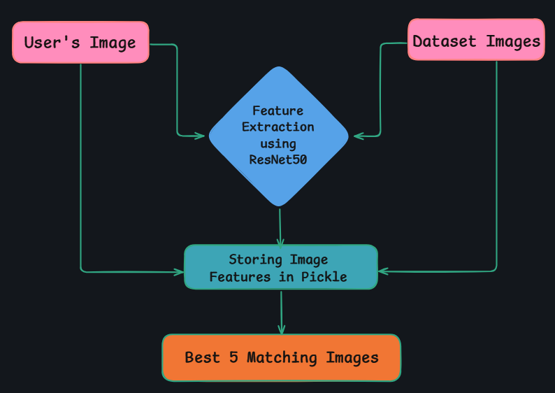

**Figure 3:** Model Deployment flowchart of ResNet50

**3.4 Dynamic User Interface**

With the help of the Python package Streamlit, we will develop an interactive web application that functions in the standard browser. Users will be able to upload an image from a sample folder using the application's user-friendly interface. The top five suggested images that most closely resemble the input image will be shown after upload.

**4 Implementation**

After the completion of transfer learning, we will use Python libraries "Keras" and "Tensorflow" to deploy our ResNet50 model. An image of flowchart is also provided below to understand the architecture of ResNet50 model which we are using here in our project.

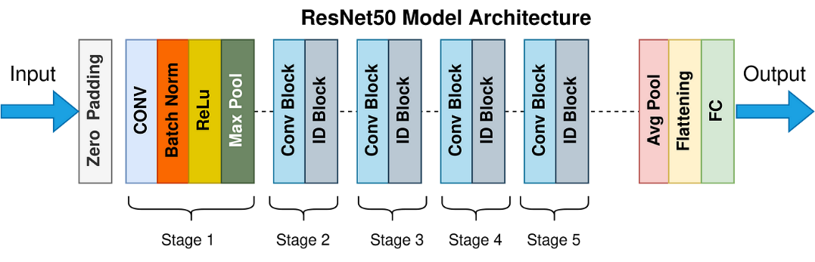

**Figure 4:** Architecture of ResNet50 Model

**4.1 Image Optimization**

• ***Pandas****:* Python library used for data manipulation and data analysis.

• *Numpy:* Stands for Numerical Python, is a library that allows performing mathematical operations on arrays and creating dynamic arrays.

•*Tensorflow:* An open-source library used for deep neural network algorithms, enabling fast prototyping of neural networks.

• *Scikit:* A Python library for implementing various machine learning algorithms such as classification and regression.

• *Open CV*: A popular library for computer vision tasks, including image and text recognition, as well as preprocessing. It’s often used for converting text to images and vice versa.

• *Pickle*: A tool for serializing and deserializing data, helping save and load image features.

• *Streamlit*: A Python library for building dynamic, interactive web applications that link the backend to the user interface.

• *Pillow*: A Python library that aids in processing images and supports multiple image file formats, such as .jpg, .png, .jpeg, etc.

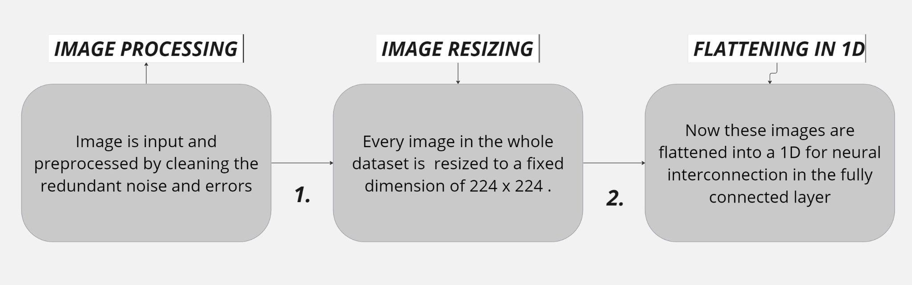

**Figure 5:** Image/Data Preprocessing Flowchart

**4.1.1 Recommendation Engine**

When click on the browse button, this application allows the user to upload an image. The uploaded image is then saved in a folder known as "upload folder". Next step is the process of classification of image which has to be done by our recommendation engine. We will perform the classification process here and then calculate the metrics such as accuracy score. After this our recommendation system starts determining the similarity between the input image and all the other images available in the dataset. When all this process gets completed, then finally our recommendation system will display the image recommendations on user interface. Now let’s see they key algorithm we are going to use in this project.

**4.1.2 KNN ( K-Nearest Neighbors)**

K-Nearest Neighbors (KNN) is a popular machine learning algorithm mainly used for classification and regression problems. Hence, we can say it is both a classification as well as a regression algorithm. If we talk about it as classification algorithm, KNN assigns a new data point to the majority set within in neighbors. On the other hand, if we talk about it as regression algorithm, KNN makes a prediction based on the average of the values closest to the query point.

Here in our case, we will use K-Nearest Neighbors (KNN) algorithm to implement our project. It is a supervised learning type of algorithm. It will select the 5 images with the smallest distance (Euclidean distance as a distance metrics) and then will recommend that to user.



K=total number of neighbors which is 5 in our case

**Figure 6:** KNN Algorithm visualization

**4.3 Dynamic User Interface**

Streamlit is an excellent tool used to create the user interface for this application, providing a simple yet effective way to allow users to interact with the system. It helps build a dynamic web application that connects the Python backend code to the frontend display in the web browser. The user interface features an easy-to-use ‘Browse’ button, which allows users to upload an image from their local system. Once the image is selected, the system automatically saves the image file and sends it to the recommendation engine for further processing.

The recommender engine, which is powered by various machine learning algorithms like KNN, uses the uploaded image to compare it against a large dataset consisting of 44k images. This process involves analyzing the features of the input image and calculating similarity scores using the distance metric. Based on these calculations, the engine then selects and returns the top 5 most similar images from the dataset, providing personalized recommendations for the user. The integration of Streamlit with Python makes this process seamless and efficient, offering an intuitive experience for users to interact with the system.

**5 Result**

When user uploads an image the working of recommendation system starts. After the uploading of image by user, web application or user interface shows the user top 5 similar fashion images of products after fining patterns among the data in dataset. This enhances many E-commerce platforms and businesses. These recommendations help user to select from the various options available which are similar to first fashion image uploaded by user.

Recommendation systems use concepts like Euclidean distance to identify the nearest or similar matches. Model retrieves relevant features from the image uploaded by user and uses concepts like distance metrics. Euclidean distance is an example of distance metrics which we discussed above.

**6 User Interface**

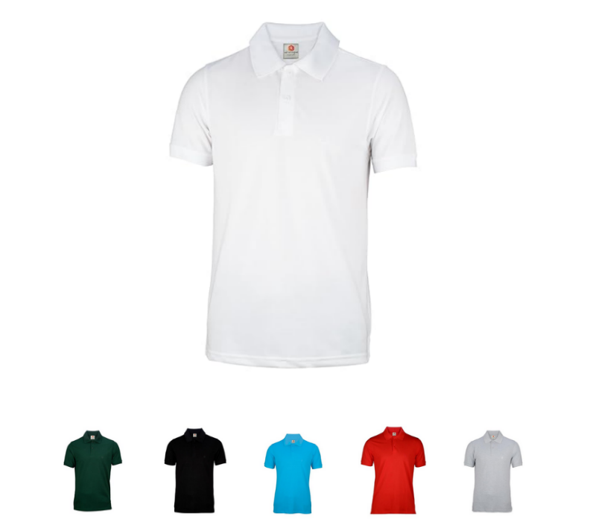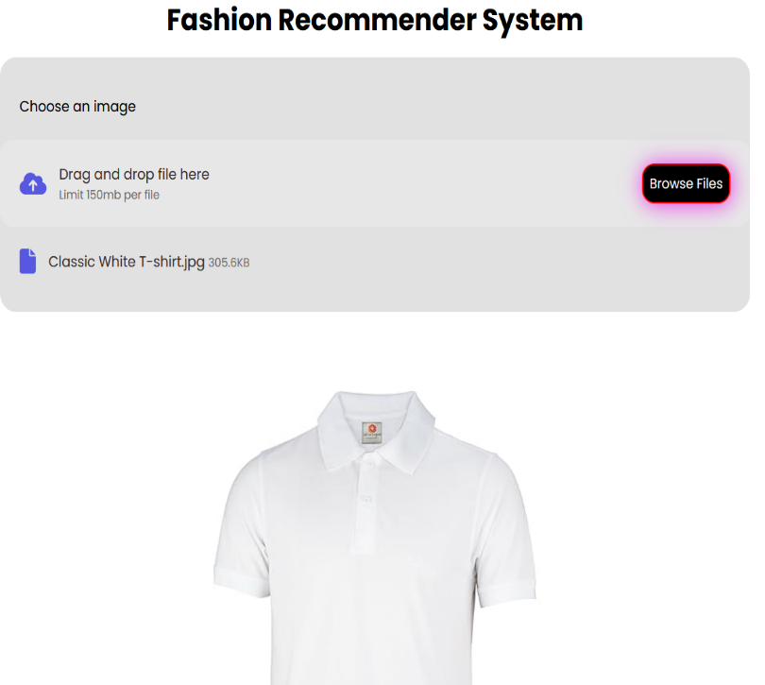

**Figure 7:** User Interface

**7 Discussion**

Factors like accuracy and diversity in the field of recommendations have been improved by using and combining preferences of user and item attributes through recommender systems.

Techniques such as Neural Networks and Matrix Factorization helped to adapt user changes. Convolutional Neural Networks (CNN) and other machine learning algorithms can be used to improve user engagement by providing better recommendations.

**8 Conclusion**

Recommendation systems are playing very major role nowadays in almost every sector. Fashion sector is one of the best examples to understand the need and importance of recommendation systems. As in terms of fashion, everyone wants to style according to their personality and sense of fashion, hence to make the user experience better from the past user data these recommendation systems come in forefront to enhance user experience. These recommendation systems use some great Machine Learning algorithms and better and advanced techniques to predict the matching or we can say most relevant product based on the customer preference on the product.

Recommendation systems hence also play a very major role in customer satisfaction which can increase the brand's sale and obviously then the brand will gain profit.

The use of recommendation systems helps business to grow by enhancing shopping experience for their customers. Large datasets with tons of images can easily create a better a ML model for recommendation system to achieve a precise accuracy from the first or parent image to classify and get such more relevant images which matches it.

This makes the customer experience smoother and more enjoyable as user can interact with their interest now.

Examples of big E-commerce businesses like Myntra, Souled Store, Amazon, Flipkart, Alibaba and Ajio have adopted recommendation systems in their platforms. This benefits them as it improves better user interface, provides better interaction with platform and also makes customer engagement better.

These systems help in creating better dynamic and responsive online shopping experience. This increases both the customer satisfaction and the purchase of products from brand's online platform.

**9 References**

[1] Maphosa, V., & Maphosa, M,” Fifteen Years of Recommender Systems Research in Higher Education: Current Trends and Future Direction”, Applied Artificial Intelligence,vol 37,Jan2023,DOI:https://doi.org/10.1080/08839514.2023.2175106

[2] Sarker I.H,” Deep Learning: A Comprehensive Overview on Techniques, Taxonomy, Applications and Research Directions”, *SN COMPUT. SCI,* vol 2, art. 420 ,August 2021, DOI:10.1007/s42979-021-00815-1

[3] Małgorzata Bach,New Undersampling Method Based on the kNN Approach,Procedia Computer Science,Vol 207 pp 3403-3412,2022,DOI:https://doi.org/10.1016/j.procs.2022.09.399.

[4] Kreutz, C.K., Schenkel, R,” Scientific paper recommendation systems: a literature review of recent publications:, *Int J Digit Libr* vol **23**, pp 335–369 ,Oct.2022, DOI:https://doi.org/10.1007/s00799-022-00339-w

[5] Shirkhani, S., Mokayed, H., Saini, R. *et al.* “Study of AI-Driven Fashion Recommender Systems”. *SN COMPUT. SCI.* vol 4, pp 514 July 2023,DOI: <https://doi.org/10.1007/s42979-023-01932-9>

[6] Hatem, M.Q,” Skin lesion classification system using a K-nearest neighbor algorithm”.,*Vis.Comput.Ind.Biomed*.Art5,7,March2022,DOI:https://doi.org/10.1186/s42492-022-00103-6

[7] Chakraborty, Samit & Hoque, Md. Saiful & Rahman, Naimur & Biswas, Manik Chandra & Bardhan, Deepayan & Lobaton, Edgar.” Fashion Recommendation Systems, Models and Methods: A Review”. *Informatics*.vol 8. pp49. July 2021. 10.3390/informatics8030049.

[8] Aketi Thanuja,Sri Dantuluri Aashika,Kalidindi Manaswi,Balagam Avinash,Vijaya Bharathi Manjeti,"Fashion Recommendation System using Deep Learning", International Journal of Emerging Technologies and Innovative Research (www.jetir.org), ISSN:2349-5162, Vol.9, Issue 4, pp g583-g587, April-2022 . DOI:<http://www.jetir.org/papers/JETIR2204684.pd>

[9] Zhang, Luying, Yuchen Bian, Peng Jiang, and Fengyun Zhang. 2023. "A Transfer Residual Neural Network Based on ResNet-50 for Detection of Steel Surface Defects" *Applied Sciences.*vol 13, pp 9: 5260,April 2023. DOI:https://doi.org/10.3390/app13095260

[10] M. Kuzlu, F. O. Catak, S. Sarp, U. Cali and O. Gueler, "A Streamlit-based Artificial Intelligence Trust Platform for Next-Generation Wireless Networks," *IEEE Future Networks World Forum (FNWF), Montreal, QC, Canada*, pp. 94-97,October 2022, doi: 10.1109/FNWF55208.2022.00025.

[11]Sajitha, I., Sambandam, R.K., John, S.P. ,” Review on Image Processing-Based Building Damage Assessment Techniques”, In: Swaroop, A., Kansal, V., Fortino, G., Hassanien, A.E. (eds) Proceedings of Fourth Doctoral Symposium on Computational Intelligence . DoSCI 2023. Lecture Notes in Networks and Systems, vol 726, pp 863-882,Sept 2023, DOI:https://doi.org/10.1007/978-981-99-3716-5_69

|  |
| --- |
|  |