**A STUDY ON GLOBAL HUMAN RESOURCE MANAGEMENT**

ArunKumar S1,Mrs Naveena M2,

1MBA Student, School of Arts, Humanities and Management, Jeppiaar University, Chennai, India.

2Associate Professor, School of Arts, Humanities and Management, Jeppiaar University, Chennai, India.

1***arunkumarceo2901@gmail.com***,

2***naveenasweth15@gmail.com***,

***Abstract:***

The contemporary methods of Global Human Resource Management (GHRM) in the linked business environment of today are examined in this article. It discusses the challenges faced by multinational businesses (MNCs), such as managing the worldwide talent pool, guaranteeing adherence to foreign regulations, and negotiating cultural differences. In order to drive business performance, increase employee satisfaction, and promote sustainable practices in a global setting, the essay emphasizes the need of strategic HR practices. Coordinating cross-border teams, standardizing HR procedures, and taking regional differences into account all depend heavily on effective GHRM. Emerging trends, strategic initiatives, and frameworks that support the expansion and resilience of multinational corporations are also highlighted in the conversation.

**Keywords:** international workforce, company performance, talent mobility, cultural diversity, and legal frameworks

**INTRODUCTION**

Managing HR procedures across several nations and regions is the focus of global human resource management, or GHRM. As a result of globalization, companies now operate in a variety of markets, necessitating that HR specialists handle a range of cultural, legal, and economic contexts. The purpose of this study is to comprehend how GHRM ensures sustainability and effectiveness by coordinating local practices with organizational goals. It highlights how important it is to strike a balance between local adaptability and global HR policies in order to preserve competitive advantage.

***Key Components of GHRM***

1. **overcoming Cultural Differences:**

In international teams, it is essential to recognize and honor cultural differences. Misunderstandings, decreased productivity, and disputes can result from improper handling of cultural diversity. ii. As an illustration, teaching staff members to collaborate in cross-cultural teams promotes respect for one another.

1. **Recruiting and Retaining Talent Worldwide:**

Strategies to draw in and keep a diverse workforce are necessary when sourcing talent internationally. Companies need to think about competitive pay packages, professional growth opportunities, and visa rules. ii. For instance, Google's Global Mobility initiative makes it easier for skilled workers to relocate to other countries.

1. **Compliance with International Labor Laws:**

In any nation where they conduct business, companies are required to abide by labor laws, tax rules, and employment requirements.   
**example:** respecting the GDPR regulations in Europe to protect employee data.

1. **Managing Performance in International Teams:**

In international operations, it might be difficult to establish performance indicators that are both standardized and adaptable. The measures need to take local quirks into account while being applicable across regions.   
**example:** Combining region-specific objectives with global key performance indicators (KPIs)

1. **In GHRM, technology:**

Using HR technology platforms for performance management, onboarding, and hiring improves productivity and streamlines processes.   
**Example:** Workday and other cloud-based HR platforms facilitate efficient team management.

***Objectives***

* to comprehend the function of GHRM in overseeing geographically scattered and culturally varied teams.
* to assess methods for dealing with multinational HRM compliance issues.
* to determine how innovation and technology affect GHRM practices.

**LITERATURE REVIEW**

1. ***Cross-Cultural Challenges***
2. The Cultural Dimensions of Hofstede:

* Hofstede (2019) found that cultural factors, including masculinity versus femininity, power distance, uncertainty avoidance, and individuality versus collectivism, are crucial in determining how people behave in the workplace. •
* For example, hierarchical structures are recognized in high power-distance cultures, which calls for formal communication and distinct reporting lines under HR regulations. On the other hand, flat structures and participatory management are preferred in low power-distance cultures.

1. Cultural Awareness in Human Resources Practices:

Employee engagement and retention are increased when hiring, onboarding, and training procedures are modified to take into account regional cultural norms. For instance, team-oriented incentives may perform better than individual bonuses in collectivist countries. ii. Companies using frameworks for cultural intelligence have reported project success rates rising by up to 20% (Earley & Ang, 2003).

1. **International Talent Mobility**
2. Increased Innovation and Satisfaction:

* Effective global mobility programs expose workers to a variety of markets, which fosters creativity and increases employee happiness, according to Sparrow et al. (2020). Employees that are mobile can expand their skill sets and views by gaining a variety of experiences.

1. Implementation Challenges:

* Notwithstanding the advantages, problems including exorbitant expenses, adaption difficulty, and well being issues nonetheless exist. Organizations lessen these through:
* Providing cultural acculturation programs to families and expatriates.
* provide real-time assistance using digital technologies, such as AI-powered relocation helpers.

1. Diversity in the Movement of Talent:

Mobility programs are putting more of an emphasis on fostering gender diversity and providing opportunities for disadvantaged groups as a result of the increased emphasis on inclusivity. It has been demonstrated that retention is increased by programs designed to support spouses and families in juggling two careers.

1. **Analytics and Technology in GHRM**
2. Digital Conversion:

* Organizations utilizing HR technology platforms and people analytics indicated notable improvements in workforce engagement, operational efficiency, and strategic decision making, according Deloitte's 2022 Global Human Capital Trends.
* Global HR teams may centralize data with tools like Workday, SAP SuccessFactors, and Oracle HCM Cloud, guaranteeing smooth processes across borders.

1. The effects of people analytics

* Advanced analytics aid in workforce planning, skill gap identification, and trend prediction, including employee churn. Predictive analytics models, for instance, can identify high-risk workers and recommend retention tactics, reducing turnover-related expenses.

1. Remote Cooperation and Employee Involvement:

* Team dynamics have changed as a result of technologies like Microsoft Teams, Zoom, Slack, and VR-based virtual meeting platforms, which allow geographically scattered teams to collaborate in real time.
* Businesses that use these tools have shown increases in team productivity and communication effectiveness of 30–40%.

1. Applications of AI and Machine Learning:

* AI-powered solutions for employee sentiment analysis, interview scheduling, and resume screening expedite hiring and workforce management. Chatbots, such as HR assistants, improve employee happiness by instantly responding to their questions.

1. Compliance and Blockchain:

* Blockchain technology makes guarantee that employee data is stored securely, lowering the possibility of breaches and streamlining procedures like employment verification and cross-border payments.
* According to Tripathi (2022), these technologies have reduced administrative errors in compliance reporting and payroll by up to 35%.

**The methodology of research**

A mixed-methods approach is used in this study to conduct a thorough analysis of global human resource management (GHRM) practices. Surveys and interviews with HR experts from 20 multinational corporations (MNCs) were used to gather primary data, with an emphasis on HR technology adoption, compliance issues, and cultural integration. While semi-structured interviews offered qualitative depth by examining individual experiences and methods, surveys offered quantitative insights. Case studies of effective GHRM practices, industry reports from firms like Deloitte and SHRM, and scholarly works on international HR trends were examples of secondary data. While qualitative data underwent theme analysis to reveal actionable insights, quantitative data was analyzed using statistical methods to find trends and correlations. A balanced grasp of the difficulties and tactics in GHRM was guaranteed by this integrated approach.

**ANALYZING AND INTERPRETING DATA**

Responses from CEOs and HR specialists at 20 global companies with operations in various locations were examined in this study. The results point to important developments and difficulties in compliance, cultural integration, and HR technology adoption.

|  |  |
| --- | --- |
| **Classification** | **Important Findings and Effects** |
| Integration of Cultures | According to 80% of respondents, cultural training is essential for team performance since it increases cohesiveness and lowers turnover. Cultural initiatives increase employee loyalty and retention by 25%. |
| Observance and Risk Control | Compliance is a challenge for 70% of HR professionals, underscoring the necessity of strong systems to handle a variety of requirements. Automation improves accuracy and decreases manual labor while lowering compliance errors by 30%. |
| Utilizing HR Technology | 40% increase in onboarding effectiveness, time and resource savings, and process simplification. Digital platforms are used by 90% of businesses for communication, which improves connectivity and teamwork across international teams. |

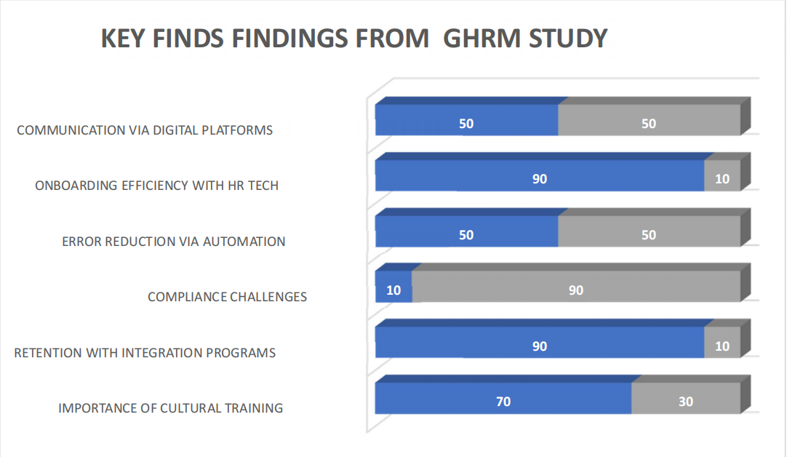

Interpretation:

1. Cultural Awareness: Businesses that provide their staff with cultural sensitivity training report increased productivity and team cohesion.
2. Tech Adoption: By integrating digital HR tools, operational efficiency, employee satisfaction, and decision-making have all improved.
3. Compliance Strategies: To lower financial and reputational risks, regular audits and revisions to HR policies guarantee compliance with regional laws.

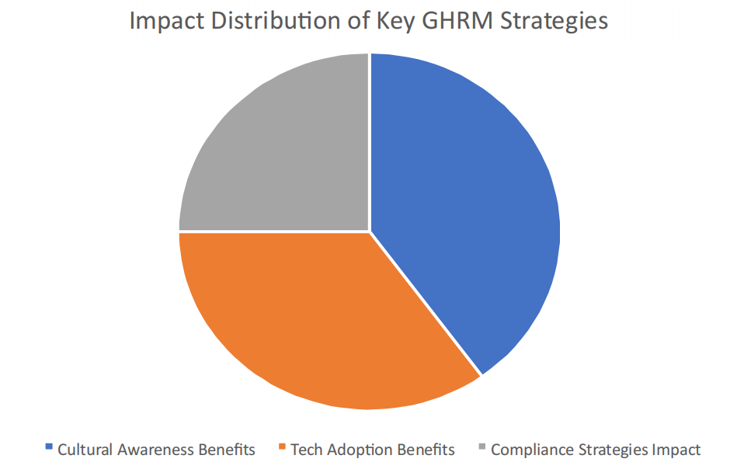

This pie chart shows how the impact of the three main GHRM methods is distributed: the benefits of cultural awareness (35%), the benefits of tech adoption (40%), and the impact of compliance techniques (25%).

1. ***Suggestion***

* Invest in Cultural Training: To improve staff members' cross-cultural competency, conduct frequent training sessions.
* Adopt HR Technology: To improve efficiency, use cutting-edge HR tech platforms for hiring, training, and performance reviews.
* Improve Talent Mobility: Create adaptable relocation plans that facilitate talent mobility while reducing interruptions.
* Create worldwide-Local Strategies: To handle particular difficulties in various markets, combine worldwide HR regulations with local modifications.

**FINDINGS**

1. Cultural variety: Promoting cooperation and creativity in multinational teams requires effective management of cultural variety. GHRM emphasizes inclusive leadership and cross-cultural training.
2. Talent Mobility: Knowledge transfer and talent management are facilitated by successful talent mobility tactics, such as foreign employment rotations and expatriate assignments.
3. Regulatory Compliance: To guarantee seamless operations and reduce legal risks in global marketplaces, it is imperative to adjust to various local labor laws and regulations.
4. Strategic HR Alignment: Performance, employee engagement, and worldwide competitiveness are all increased when HR procedures are in line with company objectives.
5. Employee Engagement: By providing possibilities for career advancement, work-life balance, and competitive pay across geographies, GHRM aims to retain talent.
6. Sustainability & CSR: Including ethical and sustainable practices in HR policy improves long-term growth and the company's reputation.
7. Digitalization: Using HR technologies and data analytics enhances decision-making, supports remote workers, and maximizes talent management.

**CONCLUSION**

For international companies to succeed, effective global human resource management is essential. Businesses can improve their worldwide HR procedures by tackling issues of cultural diversity, compliance, and technology. The results highlight the necessity of strategic GHRM frameworks that strike a balance between local adaptation and global standardization. Businesses are better positioned to prosper in the cutthroat global environment if they promote cultural integration, make use of technology, and maintain compliance.

**REFERENCES**

1. (2019) Hofstede, G. Cultural Aspects of Global Human Resource Management.
2. Brewster, C., Sparrow, P., and Chung, C. (2020). Human resource management is becoming more global.
3. Deloitte (2022). Trends in Human Capital Worldwide.
4. Miller, T., and Johnson, A. (2021). GHRM Technology: A Strategic Viewpoint
5. Pedler, M and Burgoyne, J (1989) The Learning Company: A strategy for sustainable development. Mcgraw Hill, Maidenhead.
6. Pfeffer, J. (1994), Competitive Advantage through People: Unleashing the Power of the work Force. Boston, MA: Harvard Business School Press.
7. Purcell, J., Kinnie, N., Hutchinson, S. Rayton, B., & Swart, J. (2003). Understanding the people and performance link: unlocking the black box. London.
8. Raduan Che Rose and Naresh Kumar (2007). “Blockade for Career Advancement in Japanese Organization Abroad: The Case of Malaysian Subsidiaries”, American Journal of Applied Sciences, 4(1), pp. 8-13.
9. Rothwell, W. J., Prescott, R.K. & Taylor, M.W. (1998). Strategic Human Resource Leader: How to prepare your organization for the six key trends shaping the future. California: Davies-Black Publishing
10. Ulrich, D.(1997), Human Resource Champions. Boston Harvard Business School Press.
11. Ulukan, C (2005), “Leadership and Managerial Implications”.Turkish Online Journal of Distance Education Vol.6 No. 5, Art. 8.
12. Weber, M (1946) From Max Weber. Oxford University Press Oxford quoted in Armstrong (2006) Wick, C W and Leon, L S (1995) Creating a Learning Organization: London From Ideas to action. Summer
13. Wilson, J P (1990) Human Resource Development. London Kogan Page Limited
14. Wilson, J P (2005) Human Resource Development. London Kogan Page Limited.