Analysis of Behavior of Investors Towards Investing in Indian Stock Market in Amravati Region

Submitted By

**Mr. Aditya Manoj Pande**

Student of Shri Sant Gajanan Maharaj College of Engineering, Shegaon- 444 203 (M.S.), Sant Gadge Baba Amravati University, Amravati

Under the Guidance of Prof. Vishal Patil, Department of Business Administration and Research, Shri Sant Gajanan Maharaj College of Engineering, Shegaon, Maharashtra, India )

# ABSTRACT

The Indian stock market has seen remarkable growth over the past few years, with investors from diverse backgrounds, including retail and institutional investors. Knowledge of investor behavior is important to evaluate market trends, risk appetite, and investment attitudes. This research examines the behavior of investors in the Amravati area towards investing in the Indian stock market. It investigates major determinants of investment choice, such as risk perception, financial literacy, knowledge of markets, and economic situation. The study also investigates the influence of demographic factors like age, income level, and education level on investment behavior. Through primary data gathered through questionnaires and interviews, the study reveals typical investment approaches, favored classes of assets, and determinants of investor confidence. The results are rich in insights on regional investment behavior and can assist policymakers, financial institutions, and advisors in customizing investment products and strategies to increase market participation. Knowledge of these behavioral patterns is critical in promoting a more informed and active investment culture in the Amravati region and other regions

**Keywords:** Investor behavior, Indian stock market, investment decisions, Amravati region, financial literacy, risk perception, market awareness, investment strategies, stock market participation, economic conditions.

# INTRODUCTION

The studies on the current trader behavior towards share market investments can be deemed as a topic of rising interest especially in the developing marketplace like India. Primary market in India is represented by two exchanges, the BSE and NSE, which has emerged as one of the most volatile hubs around the globe. In the past few decades, institutional investors and individual investors increased their participation to invest owing to economic liberalization, growing segments of the middle class and, advanced innovation in electronic trading systems. But this participation stays constrained to the urban population though semi urban and rural like Amravati of Maharashtra has limited involvement with stock market. Explicating the factors that dictate investor behavior in Amravati is essential for improving the money access and designing the distinct area financial policies. The BSE is one of the most happening stock exchanges in Asia and has garnered fame as one of the world’s fastest-growing markets. The Indian share exchanges include the Bombay Stock Exchange (BSE) and the National Stock Exchange (NSE), where investors and speculators across the country are engaged in trading shares of public limited companies. This market facilitates the collective savings of individuals, various institutions in the form of financial instruments that would support the business units

in question hence accelerate the growth of the economy, wealth creation opportunities. India’s stock market, linked to the economy liberalized in the early 1990s, has changed greatly through its early part as a newly growing market after liberalization programs opened the country’s markets to foreign investors and business deregulation, and encouraged private enterprises. There is nothing like something new in the market, over the decade, SEBI and other regulatory authorities have worked rigorously on reinforcing the market rules and regulations as well as to increase investor awareness and providing them safety in the stock market. New technologies such as the development of internet-based trading systems has only deepened their participation and made it easier for the retail trader to participate in the stock market.

# LITERATURE REVIEW

* **Research in Management (Vol.3, Issue-03), ISSN :2348-4764** - In India, overall opportunity to invest in capital market is considered in the reciprocal risky by the investors. However, the newer investors are always willing to invest in capital market instruments and that too to a very large extent in Derivatives segment. Although the knowledge to the investors in the Derivative segment is not adequate, they tend to take decisions with the help of the brokers or through their friends and were trying to invest in this market.
* **Krunal K Bhuva and Vijay H Vyas (2015),** A review of Article on “Dividend Policy and Stock Price Behavior in Indian Corporate Sector: In this article of PARIPEX – Indian Journal of Research, successfully published Volume-4 issue -2, ISSN- 2250- 1991, the Policies of Dividend and Behavior of Stock Price is discussed in details in the part heading “A panel data approach”.
* **Snehal Bandi Vadekar and Saurabh Gosh in 2003**: Assessed the incremental effects that arise out of introduction of derivative products esp.; index futures on spot. Fluctuations in the effect of market risks in stock exchanges in India. BSE Sensex and S&P CNX Nifty are down in the after the introduction of index future, the lip service period of political parties was on rise.
* **Raja Mannar Badur**: International Journal of Recent Advances in Multidisciplinary Research, 2018. Indian financial market has seen an extraordinary volatility in the last few years. Since the year 2002, Indian market has grown from a much volatile condition to growth phenomena, from a SENSEX point of 5500 in December 2003 to 13,787 in December 2006 and crossed the mark of 20,000 in the year 2007 and again in 2013.

# RESEARCH METHODOLOGY

**Objective of the Study:**

* + The main aim of the study is to understand the demographic and socio– economic status of the investors in Amravati region.
  + To determine the demographic variables, including risk taking propensity, level of knowledge on stock market investment, and the cultural endowment of the investors towards stock market investment.
  + In order to examine the regional investors preference for the types of instruments as follows.
  + To investigate the factors that relate to and influence investment decisions through financial literacy, awareness and access.

# Scope of Study:

* Aims at the analysis of investment behavior among retail and institutional investors in the Amravati area.
* Considers the determinants of investment choice, including perception of risk, financial knowledge, and level of market awareness.
* Investigates the effects of demographic characteristics such as age, income, educational level, and occupation on stock market involvement.
* Analyzes investor attitudes towards alternative asset classes, including equities, mutual funds, and other financial securities.
* Considers the influence of financial education, advisory services, and technology on the investment decision-making process.

# Research Design:

Correspondingly, this research employs descriptive and exploratory research methods to understand the behavior of investors in Amravati. Categorized as exploratory research, the aim is to systematically establish the profiles and frequency and preferences of investment amongst the investors. The exploratory feature aims to identify the psychological, social and financial motivators and barriers to the stock market investment participation in the defined semi-urban region. This quadruple emphasize makes the study design suitable for understanding both the behavior of investors, as well as their phenomenology, including what matters to them and what may hinder them in achieving their goals.

# Sample Design

* **Population**: A population is a whole group that you want to conclude about, known as a population. The population of this study are random age group between 18 to 60 and above based on their demographic factor, level of confidence, preferences, psychological factors
* **Sample Size**: The sample size chosen for this study is between 100 to125 Investors

# Data Interpretation

**Fig 1**

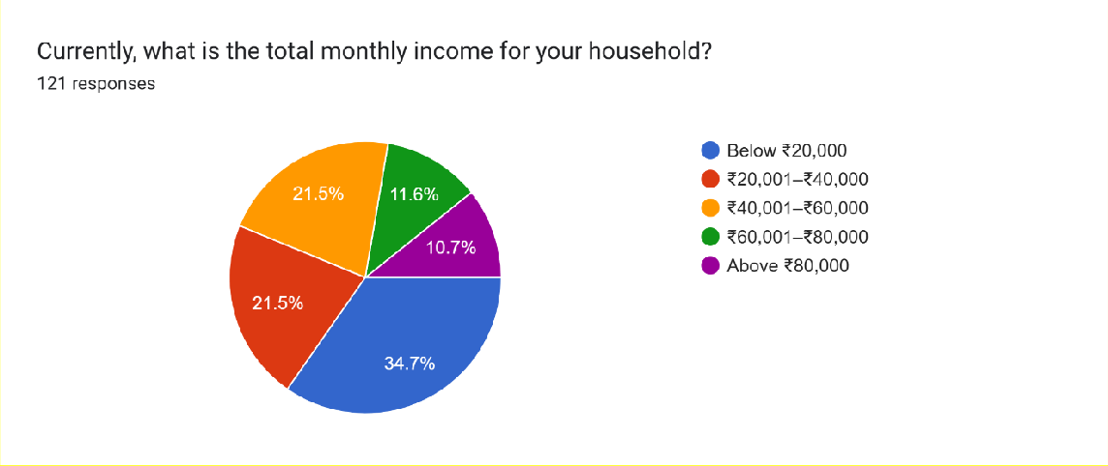

This distribution implies that a substantial proportion of respondents belong to lower and middle-income groups, which could affect their investment decisions, risk tolerance, and investment planning strategies in the stock market.

# Fig 2

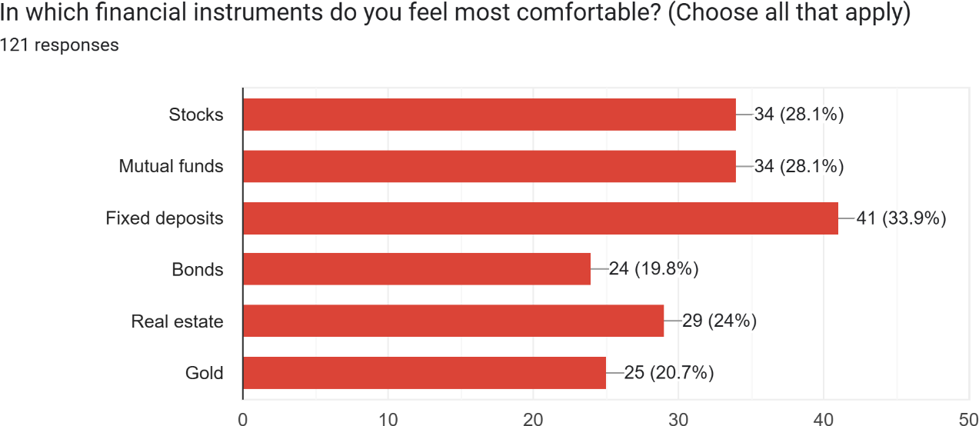

Lower preference is noted for Gold (20.7%) and Bonds (19.8%), which can be interpreted as investors perceiving these as less desirable in relation to other alternatives. The data indicates that although most investors are ready to risk market-based investments, a high percentage still prefers safe, fixed-return instruments.

# Fig 3

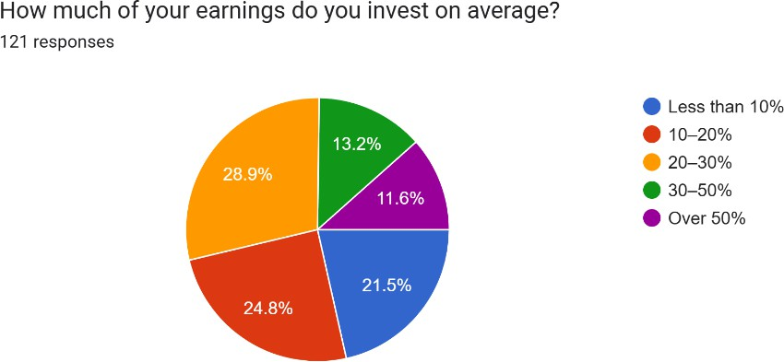

A less but considerable proportion (21.5%) invests below 10%, which indicates a preference for liquidity or lower investment capacity. 13.2% of the sample invests between 30-50%, showing high dedication towards wealth accumulation. A mere 11.6% of the investors invest more than 50% of their income, showing an aggressive investment approach.

# Fig 4

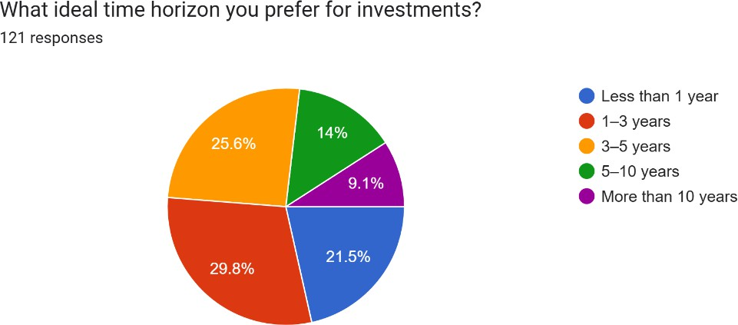

A smaller but significant percentage (21.5%) choose 1-3 years, indicating short-to-medium term orientation. As few as 14% are interested in more than 10 years, perhaps for retirement fund planning or long-term asset development. The smallest segment (9.1%) chooses less than 1 year, indicating urgent liquidity requirements or short-term market speculation.

# Fig 5

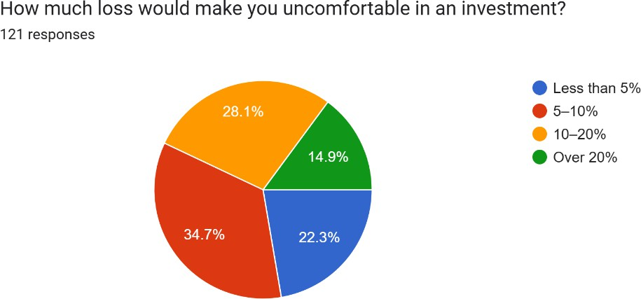

A lesser percentage (22.3%) is uneasy about less than a 5% loss, indicating an extremely conservative strategy, with emphasis on preservation of capital. 14.9% are only uneasy about losses above 20%, indicating greater risk tolerance and appetite for market uncertainty.

# Fig 6

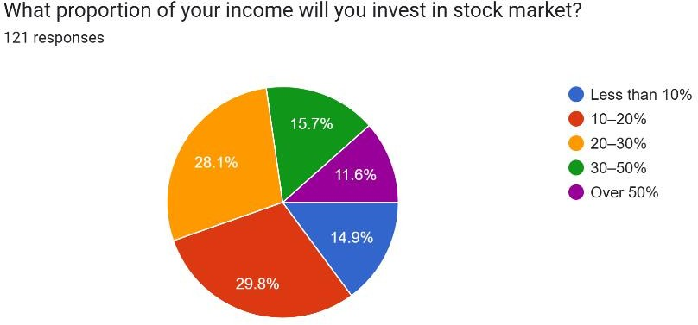

A lower group (15.7%) intend to invest 30-50%, which points to high faith in the stock market. 14.9% will invest below 10%, which reflects a conservative investment approach. Only 11.6% would invest more than 50%, which points towards high-risk appetite and aggressive investing.

# Findings and Results

1. **Investor Participation Trends**
   * **Low Awareness & Financial Literacy**: Investors in Amravati are not well-informed about stock markets, and hence they stick to conventional investments such as gold, FDs, and real estate.
   * **Increased Interest Among Youth**: Young investors (25-40 years) exhibit rising participation because of online platforms (Zerodha, Groww) and social media influence.
   * **Domination of Local Brokers**: Investors rely more on local brokers than direct online trading because of trust and confidence deficiencies in self-trading.

# Market Volatility & Risk Perception

* + **High Risk Aversion**: Risk aversion investment attitude because of fear of market volatility.
  + **Influence of National & Global Events**: Investment decisions are affected by events such as elections, RBI policy decisions, and global recessions.
  + **Preference for Blue-Chip Stocks**: Investors prefer safe large-cap stocks (e.g., Reliance, TATA) rather than mid-cap or small-cap due to perceived safety.

# Local Economic Factors' Influence

* + **Agricultural Dependency**: As Amravati is an agrarian economy, stock market participation declines during peak agricultural seasons.
  + **Limited Local Listed Companies**: There are not many companies from the region listed, which decreases direct local investment interest.
  + **Urban vs. Rural Divide**: Urban investors (Amravati city) are more active compared to rural investors.

# Trends in Digital Adoption & Brokerage

* + **Increase in Demat Accounts**: Higher penetration of smartphones has resulted in greater demat account opening.
  + **Choice of Discount Brokers**: Products such as Groww and Upstox are becoming more popular than conventional brokers.
  + **Absence of Sophisticated Trading**: Low participation in derivatives, futures, and options due to lack of sophistication.

# Investment Decision Behavioral Biases

* + **Herding**: Investors mimic trends (e.g., IPO mania) without analysis.
  + **Short-Term Trading Emphasis**: Intraday or swing trading is preferred over long-term investment by many.
  + **Excessive Dependence on Tips**: Relying on WhatsApp groups, YouTube personalities, and broker tips instead of fundamental analysis.

# Government & Regulatory Influence

* + **Taxation Impact**: Capital gains tax and STT (Securities Transaction Tax) changes influence trading volumes.
  + **SEBI Awareness Programs**: Limited accessibility of investor education programs in small cities such as Amravati.

# Conclusion

The study of Indian stock market movement in the Amravati area shows a blend of cautious optimism and changing involvement. Although there is increasing participation in stock market investment, specifically among young people with technical aptitude, knowledge and awareness on financial matters still pose a serious hindrance. Most investors prefer conventional assets in the form of gold and fixed deposits because they are risk averse and lacking in confidence when it comes to market fluctuations.

The role of online trading platforms has instigated a step-by-step drift toward equity investment, but over-reliance on local brokers and herd behavior continue to characterize much of this activity, as a result often contributing to speculative trading over strategic. Local economic realities, such as the agrarian economy of the area, also influence patterns of investment, with urban-based investors more proactive than rural ones.

In spite of these problems, growing use of discount brokerage applications and demat account openings suggest a positive direction toward market inclusion. But for long-term growth, improved financial literacy, campaigns by watchdog agencies such as SEBI, and easier access to sound investment advice are necessary. Overall, Amravati's stock market activity depicts a transitional phase in which old-style investment attitudes exist side by side with new-age trends, offering scope for greater market penetration with appropriate interventions.

# Limitations

* + **Limited Sample Size**: The research might not capture the whole investor group because of a limited number of participants.
  + **Geographical Constraint**: Results are for Amravati and might not be generalizable to other areas with varying economic conditions.
  + **Self-Reported Data**: Responses from the investors might be based on personal beliefs or memory lapses regarding financial choices.
  + **Market Volatility Impact**: Diverging stock market patterns could influence investor actions, rendering previous information increasingly less pertinent in the future.
  + **Lack of Long-Term Orientation**: The research may fail to reflect the long-term investment pattern because of short-term analysis.
  + **Influence of External Factors**: Economic policies, inflation, and international market trends may influence investment decisions outside the purview of the study.

# References

1. Abdalla, I.S.A. and V. Murinde (1997), "Exchange Rate and Stock Price Interactions: Evidence on India, Korea, Pakistan and Philippines", Applied Financial Economics, vol. 7, pp 25-35.
2. Aggarwal, R. (1981), "Exchange rates and stock prices: a study of the United States capital markets under floating exchange rates", Akron Business and Economic Review, vol. 21, pp. 7-12.
3. Agmon, T (1972), "The relationship among equity markets: a study of share price comovement in the United States, United Kingdom, Germany and Japan", Journal of Finance, Vol 27, pp 839-55.
4. Ahmed, Shahid (2008), "Aggregate Economic Variables and Stock Markets in India" International Research Journal of Finance and Economics, Issue 14.
5. Ajayi, R.A., and M. Mougoue, M. (1996), "On the Dynamic Relation Between Stock Prices and Exchange Rates", Journal of Financial Research, vol. 19, pp. 193-207.
6. Akdogan, H. (1995), "The Integration of International Capital Markets: Theory and Empirical Evidence", Edward Elgar, Aldershot.