**Investigating Drivers of Measles Prevalence in Rural Northern Nigerian Communities; a Case Study of Arewa Local Government, Northwestern Nigeria**

Ahmad Abdullahi1, Abdullahi Alhassan2, Aliyu Umar1, Abakar Abakar1

1.Department of Geography, Adamu Augie College of Education Argungu

2. Department of History, Adamu Augie College of Education Argungu

Corresponding Email: ahmadasauwa@gmail.com

**Abstract**

*Nigeria still experiences recurrent outbreaks of measles especially in the north despite the efforts at strengthening routine immunization activities. It has one of the highest measles burdens in the world and remained a public health challenge, and important caused of childhood morbidity and mortality in Nigeria particularly in the north. This paper assessed factors contributing to Measles outbreaks in Arewa local government northwestern Nigeria. Key informants interviews was conducted in five wards selected out of eleven political wards in Arewa local government using simple random sampling techniques, Descriptive statistics were used to analyze data collected. The result indicated low vaccination coverage, Low accessibility and utilization of healthcare facilities, Poor healthcare infrastructures and geographical inaccessibility, social and economic constraints as the main drivers of Measles prevalence in the area. Government at all levels and NGOs should assist in strengthening healthcare system by investing in healthcare infrastructure, training and deployment of more healthcare workers and ensuring adequate vaccine distribution and storage. Launching public awareness campaigns and partnerships with local traditional leaders on the importance of immunization were recommended.*

**Keywords**: Measles, Childhood Morbidity, Childhood Mortality, Immunization &Public Health

**INTRODUCTION**

Nigeria still experiences recurrent outbreaks of measles especially in the north despite the efforts at strengthening routine immunization activities. It has one of the highest measles burdens in the world (Saleh, 2016, Ibrahim, 2016, Folajini, 2019 and Muhammad, 2019). In 2023, Nigeria had the world’s highest largest number of measles cases than any other country. Despite the enormous efforts by the World Health Organization (WHO) and United Nations Children’s Fund (UNICEF) at reducing the global burden of measles, it has remained a public health challenge. Worldwide, measles is fifth leading cause of death (Onoja, 2012, Mathics, 2018 and Rabi, 2019). Measles infection is still prevalent in many developing countries especially in parts of Africa and Asia where more than 20million measles cases are reported annually (World Health Organization, 2021). In Nigeria, measles is an important cause of childhood morbidity and mortality, and Failure to deliver at least one dose of measles vaccine to all infants remains the main reason for high measles morbidity and mortality, as 95% coverage is required to interrupt measles (WHO, 2006, Adeoye, 2010). However, routine immunization coverage remains low in the country especially in the northern parts. The situation is worse in the rural areas which may likely due to their geographical inaccessibility, climatic variability and socio-economic characteristics of the people among others. This paper provides investigation results on factors contributing to measles prevalence in Arewa local Government areas, and provided evidence based information that will guide appropriate policies and programs for prevention of measles outbreaks in Arewa Local Government in particular and Nigeria in general.

**Literature Review**

Measles is a highly contagious viral disease that affects people of ages. Measles or Rubella infection starts in the respiratory system and eventually spreads to other parts of the body through the bloodstream. It is one of the world’s most contagious diseases, spread by contact with infected nasal or throat secretions (coughing or sneezing) or breathing the air that was breathed by someone with measles (Melinda, 1977, Tylor, 2013). It still remains a significant cause of death worldwide, despite the availability of a safe and effective vaccine (Adeoye, 2010). The main risk factors for catching measles are being unvaccinated. Some groups are at a higher risk of developing complications from measles infection including young children, people with a weakened immune system and pregnant women (Saudat, 2017, Rabiu, 2019). In Nigeria, measles is an important cause of childhood morbidity and mortality. However, routine immunization coverage remains low in the country especially in the northern parts (Saudat, 2017). The situation is worse in the rural areas which may likely due to their geographical inaccessibility, climatic variability and socio-economic characteristics of the people among others. Measles outbreaks in Northern Nigeria can be attributed to several factors. Poor Healthcare infrastructures, Low Vaccination coverage is a significant contributors, as many children in the region lack access to vaccine programs (Olusesan et al, 2022). This is often attributed to conflicts and displacement, which has affected many areas like northeast Boko Haram insurgency, Lakurawa in the northwest and armed bandits that frustrated most of parts of the region has disrupted healthcare services and led to a high burden of measles (Saudat, 2017). Furthermore, food insecurity and malnutrition can weaken the immune system, making individuals more susceptible to measles infections. Cultural and social factors can also contribute to measles outbreaks, for example some communities may be hesitant to accept vaccination programs due to cultural or religious beliefs.. Addressing these factors is crucial to preventing and controlling measles outbreaks in Northern Nigeria.

**The Study Area**

Arewa local Government is situated in the North-western part of Kebbi State. It is located between latitude 12012'N and 13012'N and longitude 3012'E and 4028'E. It has total land area of 3901km². The climate of Arewa Local Government is the tropical continental type (Sahallian type). It is essentially semi-arid in nature, with high temperature throughout the year and a marked seasonal rainfall ranging from 500-1500mm of rainfall per annum, with the heaviest amount of rainfall in the month of August.

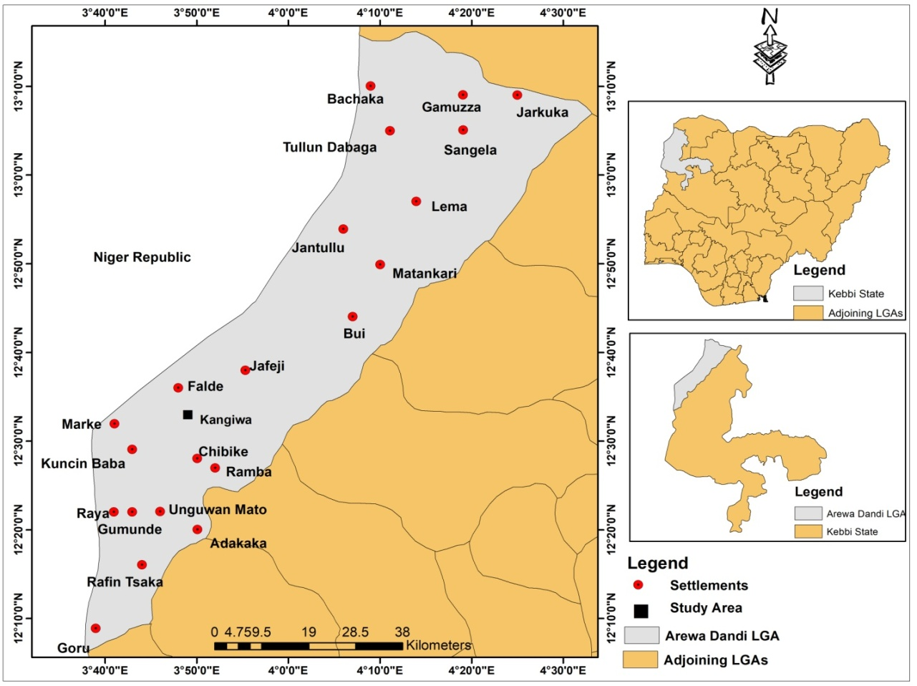

Figure 1: Map of the Study Area

Arewa Local Government is one of the most populated Local Governments areas in Kebbi State. In 2006 census, the population of Arewa Local Government was recorded to be 189,728 people, while based on 2016 projection; its population reached 258,700 people and 2022 projection found to be 324200 inhabitants. The gender distribution of population according to 2006 census reveals that, Arewa local government has about 94,825 males and 94,903 females. The age distribution shows 0-14 years of age have population of 91,819, 15-64years were 92, 619, while 65years and above were 5,290 people (NPC, 2006). Arewa Local Government has the population density of 66.32/km². The predominant ethnic group in the area is the Hausa (Arawa), Fulani and Zabarmawa. The homogeneity of the culture of people of people living in Arewa Local Government is not in doubt, they are predominantly Muslims. Agriculture is the predominant economic activity of the people, which involves crop farming and animal husbandry.

**METHODS**

To find out information on the factors contributing to measles outbreaks in Arewa Local Government area, Key informants interviews was conducted in five wards selected out of eleven political wards in Arewa local government using simple random sampling techniques. In each ward, a total of thirteen (13) people were purposively selected**,** comprised of Village head and two (2) representatives each from the association of; farmers, Herdsmen, Youths, women, Ward focal person, and three (3) elderly people above 60years with good knowledge of the locality. This is based on a belief that, these people have better knowledge of the health matters in their local communities. The participants were contacted through District Head Offices, and Arewa local government Health Department. The discussions focused on factors responsible for Measles outbreaks in their area.

**Data Analysis and Presentation**

Descriptive statistics were used to analyze data collected. Table with frequencies, percentages and simple ranking techniques were used to summarized, organized and present data, followed by discussion of the findings.

**RESULTS**

Table 1 below indicated main drivers of Measles prevalence in Arewa local Government areas. Low vaccination coverage(100%), Low accessibility and utilization of healthcare facilities(100%), Poor healthcare infrastructures(100%) and geographical inaccessibility(100%) ranked as most contributing factors in the measles outbreaks in the area. all the informants experiencing these factors in their respective communities.

**Table 1: Factors Contributing to Measles outbreaks in Arewa local Government Area**

|  |  |  |  |  |
| --- | --- | --- | --- | --- |
| **S/N** | **Driver** | **Frequency** | **Percentage** | **Ranking** |
| 1 | Low vaccination coverage | 13 | 100 | 1st |
| 2 | Low accessibility and utilization of healthcare facilities | 13 | 100 | 1s**t** |
| 3 | Poor healthcare infrastructures | 13 | 100 | 1st |
| 4 | Geographical inaccessibility | 13 | 100 | 1st |
| 5 | Low level of Education and Health Extension Services | 12 | 92 | 5th |
| 6 | Social and Economic Constraints | 11 | 85 | 6th |
| 7 | Migration and Mobility | 10 | 77 | 7th |
| 8 | Misconception and Myths | 8 | 62 | 8th |
| 9 | Political Factors | 7 | 54 | 9th |
| 10 | Food insecurity and Malnutrition | 4 | 31 | 10th |
| 11 | No idea | 1 | 7 | 11th |

Source: Fieldwork, 2025

Some of the excerpts from Key informants Interviews are extracted and stated below:

Extract 1: “we only received measles vaccine immunization when the outbreaks occurred and worsen”.

Extract 2: “you see, there are no healthcare facilities in our area, you’re to trek long distance to access health services, which we cannot afford, and as such therefore we are patronizing traditional healthcare providers for our various health needs”.

Extract 3: “The fathers sometimes disapprove of taking their children for immunization because they do not believe in it”.

Extract 4: “Why should our children receive immunization? We do not know what it contains; it could be beneficial or harmful”.

Extract 5: “We are hungry and i wonder why government cannot provide us with food and emphasized on immunization? There must to be something”.

Extract 6: “……even if you rushed to nearby health facilities, Health workers are not available and even if you met them they just write drugs prescription for you. Hospitals don’t have drugs”.

**DICUSSION**

From data presented above, the main drivers of Measles prevalence in Arewa local Government are; low vaccination coverage, Low accessibility and utilization of healthcare facilities, Poor healthcare infrastructures and geographical inaccessibility. Low vaccination coverage plays a significant role in Measles outbreaks in many areas of Arewa local Government. When vaccination coverage is low, a larger proportion of the population remains susceptible to measles, creating an environment conducive to outbreaks. Measles vaccination not only protects the individual but also help prevent the spread of the disease in the community. It reduced herd immunity making it easier for the disease to spread. Low vaccination coverage increased risk of measles transmission, prolonged outbreaks, increased severity of the outbreaks and resulted in economic burden and mortality. Further investigation reveals that, factors contributing to low vaccination coverage in the area include; limited access to vaccination services particularly in rural and underserved areas, misinformation and misconception about vaccine leading to vaccine hesitancy, lack of trust in healthcare providers as well as insecurity. Low level of education and health extension services also contributed to the measles prevalence in Arewa local government areas. Most of the parents and caregivers lack education and they’re less likely to understand the importance of vaccination than educated individuals that are more likely to seek medical care and adhere to vaccination schedules. Uneducated individuals may harbor misconception about vaccination, leading to vaccine hesitancy and low utilization of healthcare services. Low accessibility and utilization of healthcare facilities among rural dwellers in Arewa local government can lead to delayed detection of measles cases and response, inadequate vaccination coverage and increased and prolonged severity of the outbreaks. Furthermore rugged terrain, limited road networks, and dispersed rural communities hinder access to healthcare services, and making it difficult to transport vaccine, medical supplies and personnel. Leading to delayed detection and response to measles outbreaks, allowing the disease to spread further. Poor healthcare infrastructures play a significant role in measles outbreaks in Arewa local government. Few health facilities are available in rural areas, making it difficult for people to access medical care. The available health facilities are in disrepair, lacking basic amenities such as electricity, water, sanitation and equipments such as refrigerators for vaccine storage. There is severe shortage of health workers, including doctors, nurses and community health workers and available ones lack training on measles case management, vaccination and surveillance. Further investigation reveals that, inadequate measles vaccine supply was experiencing in most health facilities across the local government. Measles vaccine is often in short supply, leading to stock out and disrupting vaccination programs. These increased risk of outbreaks, delayed response and increased severity of the outbreaks. Cultural or social barrier and financial constraints also contributed to a great extent indirectly to the prevalence of measles in Arewa local government. The social stigma prevents many infected measles individuals from accessing healthcare services. Also, high cost of healthcare services, transportation, medication and poverty can deter many rural dwellers from seeking medical attention. Migration also has significant impacts on measles outbreaks in the area. When people move from one area to another, they carry infectious diseases like measles with them, potentially spreading it to new areas. Food insecurity and malnutrition among many rural dwellers contributed to measles persistent in the area. Food insecurity limits access to nutritious food, leading to malnutrition and weakened immune systems making individuals more susceptible to measles infections. Malnutrition delays recovery from measles, leading to prolonged illness and increased risk of complication and mortality, especially among children.

CONCLUSION

The prevalence of Measles outbreaks in Arewa local government areas were due to low vaccination coverage, Low accessibility and utilization of healthcare facilities, Poor healthcare infrastructures and geographical inaccessibility, social and economic constraints. These resulted in an accumulation of susceptible individuals in many communities. Any effort at minimizing and controlling Measles outbreaks may be ineffective if these socio-cultural factors and weak health infrastructure responsible for low immunization uptake are not addressed. Therefore, we recommended Government at all levels, Nongovernmental organizations and Well-to-do individuals to assist in strengthening healthcare system in Arewa local government by investing in healthcare infrastructure, training and deployment of more healthcare workers and ensuring adequate vaccine distribution and storage. Promoting vaccine awareness by launching public awareness campaigns and enhancing community engagement to educate rural dwellers about importance of vaccination and address misconception about vaccine through outreach programs and partnerships with local traditional leaders. Improving vaccination coverage by enhancing routine immunization services particularly in hard- to-reach areas and improving food security.

**ACKNOWLEDGEMENTS**

We highly acknowledged Tertiary Education Trust Fund (TETFUND) for sponsoring the research.

**REFERENCES**

Adeoye I A et al (2010) investigation of a Measles outbreaks in Rural Nigerian Community- The Aladura experience. *African journal of Microbiology Research* Vol.4(5) pp360-366.

Folajimi O Shorunke et al (2019) Descriptive epidemiology of Measles surveillance data, Osun State, Nigeria 2016-2018 *BMC Public Health* 19; 1636

Graves SH (1995) Assessment and Possible control of endemic measles in urban Nigeria*. Journal of Public Health Med*. 17: 140–145.

Ibrahim Bs and Godwin GJ(2016) Outbreak of measles in Sokoto state N.W,Nig. *Medical journal* 9(8): 324-335

Melinda S Meade (1977) *Medical Geography and Human Ecology*. CSISS Classic

Muhammad Alhaji et al (2019) Impact of Climate Variables on the Prevalence of Measles in Wudil local government, Kano State.

Mathias RG, Meekson WG, Arcand TA, Schechter MT (2018).The role of secondary vaccine failures in measles outbreaks. *AM. Journai for Public Health* 79(4):475-478

National Population Commission, Birnin Kebbi (*Population Census report 2006)* Kebbi State, Nigeria

Nigeria Center for Diseases Control, 2021 report.

Onoja A, (2012). Evaluation of measles vaccination program conducted in two separate centres. Vaccine 10(1): 49-52

Otten M, Kezaala R,(2015) Public-health impact of accelerated measles control in the WHO African Region 2000-2003. Lancet 366: 832-839.

Olusesan F et al (2022) Geographical and time trends of measles vaccination and coverage and their correlation in Nigeria, *Human Vaccine and Immunotherapeutic*, volume18, 6

Rabi U, and Zainab D (2019)Burden of measles in nigeria after five year review of case base surveillance Data 2012-2016*. pan African medical journal*. 32 (supp12):5

Saleh AJ (2016) Trends of Measles in Nigeria: A Systematic review. *Sahel Medical Journal* 2016; 19 (1) 5

Saudat A B et al (2017) Factors influencing immunization coverage among Children less than 2 years of age in rural local government areas in Kebbi State, Nigeria, *Pakistan Journal of public Health*.

Tylor and francis (2013) Measles elimination: progress, challenges and implications for rubella control, Expert Review of Vaccines, 12:8, 917-932, DOI: 10.1586/14760584.2013.814847

World Health Organization (2006) Guidelines for Measles Surveillance and Outbreak Investigation in Nigeria pp 5-40.