

**TRANSDISCIPLINARY PROJECT CENTRIC LEARNING**

**TITLE: Neuro-Adapt Learning**- “**Personalized AI-Driven Neuroadaptive Learning Platform”**

TD-PCL Report submitted in partial fulfilment for degree of

**Master in business administration**

Submitted By

|  |  |
| --- | --- |
| Anoushka Singh Chauhan | 24MBAR1056 |
| Ashwin Vasudevan Midde | 24MBAR0773 |
| Aravind Nair | 24MBAR0098 |
| Ardhara S | 24MBAR0021 |
| Ayaan Ali Rahman | 24MBAR1067 |
| R Komala | 24MBAR0486 |

**Under the guidance of**

**Dr. Uma C Swadimath**

**Faculty of Management Studies**

**CMS Business School** **JAIN (DEEMED-TO-BE UNIVERSITY)**

**CERTIFICATE**

This is to certify that this PCL 1 report submitted to Faculty of Management Studies, CMS Business School, JAIN (Deemed-to-be University), Bangalore, by the following Students is a record of project work done on the topic**“Neuro-Adapt Learning” Personalized AI-Driven Neuroadaptive Learning Platform** This work was done during the academic year 2024-25, under my guidance and supervision.

|  |  |
| --- | --- |
| Anoushka Singh Chauhan | 24MBAR1056 |
| Ashwin Vasudevan Midde | 24MBAR0773 |
| Aravind Nair | 24MBAR0098 |
| Ardhara S | 24MBAR0021 |
| Ayaan Ali Rahman | 24MBAR1067 |
| R Komala | 24MBAR0486 |

This PCL report has not been submitted for the award of any Degree, Diploma, Associateship or Fellowship or any other title in this University or any other University.

Place: Bangalore Dr. Uma C Swadimath

Date: 04-04-2025

**DECLARATION**

We, hereby declare that this PCL - 1 Project Report on “Neuro-Adapt Learning” Personalized AI-Driven Neuroadaptive Learning Platform is prepared by us during the academic year 2024-25 under the guidance of Dr. Uma C Swadimath

This report is not based on any previously submitted project for the award of Degree or Diploma offered by any University. It is the result of our own effort.

1. 24MBAR0021 - Ardhara. S
2. 24MBAR0098 - Aravind Nair
3. 24MBAR0773 - Ashwin Vasudevan Midde
4. 24MBAR1056 - Anoushka Singh Chauhan
5. 24MBAR1067 - Ayaan Ali Rahman
6. 24MBAR0486 - R Komala

Date: 04-04-2025

**ACKNOWLEDGEMENT**

We express our gratitude to Dr. Uma C Swadimath, our distinguished faculty mentor, whose advice, encouragement, and support were crucial throughout the entire process. His perceptive criticism, subject-matter knowledge, and readiness to spend time answering our inquiries were crucial in determining the course and calibre of our project.

We also want to express our gratitude to our coworkers and fellow students. Our project experiences were greatly enhanced by the collaborative learning environment, which promoted candid communication, knowledge exchange, and teamwork.

We express our gratitude to the faculty for their unwavering collaboration and to the entire library staff for their punctual service. Finally, but certainly not least, we would like to express our sincere gratitude to everyone who, at some point.

**NO OBJECTION FOR PUBLICATION / IPR PROCESSING**

This is to certify that the Project Centric Learning Report on“Neuro-Adapt Learning” Personalized AI-Driven Neuroadaptive Learning Platform was completed at CMS Business School/The D School, JAIN (Deemed-to-be University) under the supervision of

Dr. Uma C Swadimath

We have no objection if the University uses the contents for any kind of publication – print/online, including but not limited to IPR-related processing in the future. We hereby, authorize the University authorities to take all decisions pertaining to the same and will abide by their decisions.

1. 24MBAR0021 - Ardhara. S
2. 24MBAR0098 - Aravind Nair
3. 24MBAR0773 - Ashwin Vasudevan Midde
4. 24MBAR1056 - Anoushka Singh Chauhan
5. 24MBAR1067 - Ayaan Ali Rahman
6. 24MBAR0486 - R Komala

Date:04-04-2025

**PART A**

**RESEARCH REPORT**

INDEX

|  |  |  |
| --- | --- | --- |
| SNO | TITLE | PAGENO |
| 1 | EXECUTIVE SUMMARY | 8-11 |
| 2 | INTRODUCTION | 12-15 |
| 3 | REVIEW OF LITERATURE | 16-21 |
| 4 | RESEARCH METHODOLOGY | 22-28 |
| 5 | DATA ANALYSIS AND INTERPRETATION | 29-36 |
| 6 | FINDINGS AND RECOMMENTATIONS | 37-42 |
| 7 | CONCLUSION | 43-47 |
| 8 | BIBLIOGRAPHY | 48 |
| 9 | RESEARCH OUTCOMES | 49 |

# **EXECUTIVE SUMMARY**

## Overview:

NeuroAdapt Learning is an ed-tech firm that makes learning more intelligent with AI-based neuroadaptive learning platforms. It brings together brain-computer interface (BCI) technology, biometric sensors, and machine learning algorithms to personalize the learning experience in real-time for a learner's cognitive and emotional state. Its aim is to optimize engagement, retention, and comprehension by making continuous adjustments in content, speed, and instruction to address individual-specific needs of each learner.

## Key Innovations:

1. **​Real-Time Cognitive Monitoring**

* Utilizes non-invasive BCI hardware like EEG headbands and biometric sensors to track brain activity, attention levels, and emotional feedback.
* Analyzes data to detect when a student is struggling, distracted, or fatigued and adjusts content accordingly.

1. **​Dynamic Content Adaptation**

* Adjusts the difficulty level, presentation mode, and method of content delivery based on real- time mental feedback.
* If the student is struggling with a mathematical operation, the platform can switch to illustrative explanations, interactive models, or gamification content.

1. **​Personalized Learning Paths**

* Creates customized learning pathways based on the unique pupil's strengths and weaknesses, and learning preference.
* Incorporates gamification elements to maintain interest and motivation.

**4.Insights for Teachers and Parents:**

* Provides in-depth analytics to parents and teachers regarding a student's area of concentration, improvement areas, and improvement.
* Assists teachers in implementing data-based interventions to improve learning outcomes.

**5.Applications Beyond K-12 Education**

Although NeuroAdapt Learning is specifically designed for schooling, its use can also be applied to:

* Corporate upskilling and training– Personalized learning pathways for employees
* Lifelong learning schemes – Adaptive and flexible learning tools for ongoing education
* Special needs education – Tailored learning accommodations for special-needs students.

## Focus of the Research Paper:

* This project addresses the field of intersection of neuroscience, artificial intelligence, and education, emphasizing:
* The advancements and accuracy of neuroadaptive algorithms in optimizing real-time learning.
* The efficacy of adaptive learning on student performance compared to traditional methods.
* Ethics in data confidentiality, especially while collecting brainwave and biometric data. Scalability and accessibility of BCI technology across diverse educational settings.

## Market Potential:

* The global edtech market is anticipated to reach $404 billion by 2025, driven by the demand for personalized and adaptive learning solutions.
* Post-pandemic digital education growth has fueled investment in AI-driven learning platforms by schools, colleges, and companies.
* Companies are looking for efficient training materials, making adaptive learning its own weight in the business community.

## Influence and Future Directions:

* NeuroAdapt Learning aims to transform education into an inclusive, efficient, and engaging experience. This method can potentially:
* Shrink achievement gaps by addressing varied learning requirements. Decrease dropout rates by preventing disengagement.
* Make learners ready for an increasingly dynamic world through providing them with tailor-made learning experiences.

Using the intersection of neuroscience, artificial intelligence, and pedagogy, NeuroAdapt Learning is an on-the-cutting-edge research and business opportunity with severe economic and societal implications

# **INTRODUCTION**

Technology breakthroughs and an increasing focus on individualized learning are driving a rapid evolution in the educational landscape. This study examines how neuroadaptive learning, a rapidly developing field, might transform teaching methods. The study specifically looks at the creation and use of AI-powered platforms that combine eye tracking, biometric sensors, and brain-computer interface (BCI) technology to dynamically adapt learning experiences to each learner's unique cognitive and emotional states. Using platforms such as NeuroAdapt Learning as examples, this cutting-edge method seeks to maximize learner engagement, retention, and comprehension by developing personalized learning paths that instantly adjust to the individual requirements and reactions of every student.

Education is changing fast, thanks to breakthroughs in technology and a growing focus on personalized learning. The traditional “one-size-fits-all” approach is giving way to methods that adapt to each student's unique needs. One of the most exciting developments in this area is neuroadaptive learning—a cutting-edge approach that uses artificial intelligence (AI) and biometric technology to create dynamic, personalized learning experiences.

This method takes things to the next level by analyzing real-time data from students, including eye movements, heart rate, and even brain activity. AI-powered platforms like **NeuroAdapt Learning** use this data to adjust content, pacing, and difficulty based on a student’s cognitive and emotional state. This means students can learn in a way that keeps them engaged, reduces frustration, and helps them retain information better. Let’s take a closer look at how this works and why it has the potential to transform education.

## What is Neuroadaptive Learning?

Neuroadaptive learning is an advanced approach that combines neuroscience and AI to personalize education in ways we’ve never seen before. Unlike traditional adaptive learning, which adjusts based on past performance, neuroadaptive systems respond to real-time physiological signals. These systems monitor factors like attention, stress, and fatigue to determine what kind of learning experience is best for each student at any given moment. For example, if a student starts losing focus while studying, the system might introduce a short interactive break or change the way information is presented. If it detects stress, it may simplify the content or provide calming prompts. By constantly adapting, neuroadaptive learning ensures that students remain in their optimal learning zone.

## Key Technologies Behind Neuroadaptive Learning

Three main technologies power neuroadaptive learning:

1. **Eye Tracking**: Ever wondered what your eyes say about how you’re learning? Eye- tracking technology monitors where and how long a student looks at certain parts of a screen. If a student is struggling to focus or showing signs of cognitive overload, the system can tweak the lesson to make it more engaging or provide helpful hints.
2. **Biometric Sensors**: These sensors track things like heart rate, skin conductance, and facial expressions to gauge emotions. If a student appears anxious or bored, the system can adjust the difficulty level, introduce gamification, or suggest a short break.
3. **Brain-Computer Interfaces (BCI)**: This is where things get really futuristic. BCIs measure brain activity through EEG sensors, giving direct insight into a student’s cognitive load. If the system detects mental fatigue, it might slow down the lesson, add interactive elements, or provide additional explanations.

## Why Neuroadaptive Learning is a Game Changer

The ability to adapt learning experiences in real-time has huge benefits:

* + **Keeps Students Engaged**: By responding to signs of distraction or overload, neuroadaptive systems prevent boredom and frustration, making learning more enjoyable.
  + **Boosts Retention**: When information is presented in a way that matches a student’s mental state, it sticks better. This leads to deeper understanding and improved long-term memory.
  + **Reduces Learning Anxiety**: The system can detect stress and adjust the difficulty level accordingly, helping students build confidence rather than feeling overwhelmed.
  + **Creates Truly Personalized Learning Paths**: No two students learn the same way, and neuroadaptive learning ensures that each individual gets a customized experience that meets their needs.

## Challenges and the Road Ahead

While the potential of neuroadaptive learning is enormous, there are challenges to overcome. Privacy is a big concern—how do we ensure that student data is protected and used ethically? Cost is another factor, as implementing these high-tech solutions in everyday classrooms may not be feasible for all schools yet. However, as technology becomes more affordable and research continues, neuroadaptive learning could become a mainstream part of education.

# **REVIEW OF LITERATURE**

## 1.Neuro-Adaptive AI for Dynamic Distraction Mitigation in Autonomous Vehicle Environments Authors- [Vivek Ghulaxe](https://papers.ssrn.com/sol3/cf_dev/AbsByAuth.cfm?per_id=7082102)

[**https://papers.ssrn.com/sol3/papers.cfm?abstract_id=4975646**](https://papers.ssrn.com/sol3/papers.cfm?abstract_id=4975646)

As autonomous vehicles develop, driver distraction becomes even more crucial as it affects both safety and operational efficiency. In this work, we investigate the gamut of new AI tools for combating and processing visual distraction scenarios within autonomous vehicles. This includes AI-based driver monitoring systems to determine the level of attention, visual distraction classification with deep learning models, augmented reality head-up displays for focal projection of critical information and gesture/voice- controlled interfaces are used in order to reduce visual interactions. This also includes how predictive analytics; adaptive user interfaces and personalized distraction mitigation programs will see AI improve driver focus and thus safety. These advanced systems are designed to provide a safer and more efficient driving experience in the emerging era of autonomous capabilities by leveraging the scalability of advanced driver-assistance technologies

## 2.Insights Unleashed: Harnessing AI for Learning Analytics Authors- Anna Lissitz

[**https://www.worldscientific.com/doi/abs/10.1142/9789811296475_0009**](https://www.worldscientific.com/doi/abs/10.1142/9789811296475_0009)

This chapter delves into the intersection of artificial intelligence (AI) and learning analytics to explore the transformative power they hold for education. AI is revolutionizing data collection, analysis, and utilization to elevate learning outcomes, from tailored learning journeys to predictive insights. This chapter also explores the ethical dimensions inherent in these advancements. Through real-world examples and case studies, this chapter reviews insights into AI’s capacity to reimagine teaching and learning, fostering adaptability, inclusivity, and efficacy. Whether you’re an educator, a researcher, a policymaker, or simply intrigued by the future of education, this chapter offers an exploration of AI and learning analytics

## 3.Perspectives Of Brain Research (Educational Neuroscience) on the Design and Implementation of Teaching Strategies in Educational Technology

**Authors- Sani Alkhassawneh Houria Al Sharif**

[**https://revistes.ub.edu/index.php/joned/article/view/47695**](https://revistes.ub.edu/index.php/joned/article/view/47695)

The convergence of educational neuroscience and educational technology creates new opportunities to enhance the comprehension and effectiveness of pedagogical strategies. By examining how the brain interacts with numerous education technologies, teachers are able to create more effective education strategies that suit students' needs. This strategy can bring dramatic gains in student performance and provide diverse and complete learning experiences. This study examines the impact of research in educational neuroscience on the creation and application of teaching methods in educational technology. Compare the combination of educational technology with educational neuroscience concepts to traditional learning theories and those based on neuroscience. Provide the empirical evidence for the enhancement of learning outcomes by neuroscience-based pedagogical practices, and the challenges and limitations in applying educational neuroscience in educational technology.

## 4.Advancing E-Learning and M-Learning Environments Incorporating AI and Gamification to Boost Learner Motivation

**Authors-** [**Akhtam Yakubov**](https://ieeexplore.ieee.org/author/37089915724)**,** [**Yusuf Nazarov**](https://ieeexplore.ieee.org/author/520633390694469)**,** [**Andrey Aleksandrovich Rodionov**](https://ieeexplore.ieee.org/author/37089430119)

[**https://ieeexplore.ieee.org/abstract/document/10605689/**](https://ieeexplore.ieee.org/abstract/document/10605689/)

This paper advocates for pushing forward e-learning and m-learning platforms through the inclusion of immersive technologies such as AI, predictive analytics, gamification and extended reality. The inclusion of personalization, microlearning, incentives and real-world contexts can bridge engagement gaps with traditional self-paced platforms. Proposals are made for national uptake including policy leadership, funding support, capability frameworks, educator training and public-private partnerships. Adaptive digital learning ecosystems have the potential to provide sticky, motivated and experiential learning needed for the digital era.

## 5.AI-Powered Language Teaching and Learning: Innovations and Challenges

**Authors- Ushaa Eswaran (Department of ECE, Mahalakshmi Tech Campus, Chrompet, Chenna, India), Vivek Eswaran (Medallia, India), Keerthna Murali (Dell, India), and Vishal Eswaran**

[**https://www.igi-global.com/chapter/ai-powered-language-teaching-and-learning/359800**](https://www.igi-global.com/chapter/ai-powered-language-teaching-and-learning/359800)

This chapter explores the rapidly evolving landscape of artificial intelligence (AI) in language education, examining both the innovative potential and significant challenges presented by AI- powered tools and systems. The authors investigate how AI is transforming traditional approaches to language teaching and learning, enabling more personalized, adaptive, and engaging educational experiences. The chapter delves into various AI applications, including intelligent tutoring systems, chatbots, speech recognition, and natural language processing, analyzing their impact on language acquisition processes. They also critically examine the ethical, pedagogical, and practical challenges associated with integrating AI into language education. Through a combination of literature review, case studies, and experimental research, this chapter provides a comprehensive overview of the current state and future prospects of AI in language teaching and learning.

## 6.Enhancing education for children with ASD: a review of evaluation and measurement in AI tool implementation

**Authors- Oyeyemi Patricia Adako,Oluwafemi Clement Adeusi &Peter Adeniyi Alaba**

[**http://ojs.bonviewpress.com/index.php/JCCE/article/view/3414**](http://ojs.bonviewpress.com/index.php/JCCE/article/view/3414)

This paper meets the lacuna of existing studies concerning the implementation of artificial intelligence (AI) instruments in the education of children with autism spectrum disorder (ASD). The introduced measures are crafted particularly for measuring the process of learning progress in AI-powered instruction with regards to the distinctive demands of this group. The review identifies the value of long-term impact studies to ascertain the long-term effects of AI on social competencies, emotional growth, and general academic performance. The ethical dilemmas in using AI intervention in teaching autistic children are extensively discussed. Integrating varied methodologies adopted by current research, a rich analysis of the challenges is described, along with multi-disciplinary measures for enhancement that can be used as a guide for future studies. The paper offers new views, fills current gaps, and promotes creative and responsible use of AI tools in teaching children with ASD.

## 7.Harnessing Persuasive Technologies for Enhanced Learner Engagement and Motivation.

## Authors- Muhammad Usman Tariq

[**https://www.igi-global.com/chapter/harnessing-persuasive-technologies-for-enhanced-learner-engagement-and-motivation/353667**](https://www.igi-global.com/chapter/harnessing-persuasive-technologies-for-enhanced-learner-engagement-and-motivation/353667)

This chapter discusses persuasive technologies, and their use in the construct of education with a view to increasing learner participation. This concept centers on the role of interested in the process of learning, and the chapter also identifies how persuasive technology can be used to increase the learners' interest in the course. There are many samples and actual references with the theory and practical approaches about the use of persuading technologies in learning environments. The chapter explores the concept of persuasive features aimed at designing and integrating promotional aspects to learning technologies included in e-learning environments and mobile applications, learning games, and other IT gimmicks. It also provides examples of the positive effects of persuasive technology in promoting intrinsic motivation among the learners; a summative analysis of the achievements, problems, and issues encountered during the implementation of persuasive technology solutions among the learners which are presented in form of case studies.

## 8.Towards flexible personalized learning and the future educational system in the fourth industrial revolution in the wake of Covid-19

## Authors- Brian Whalley,Derek France,Julian Park,Alice Mauchline &Katharine Welsh

[**https://www.tandfonline.com/doi/abs/10.1080/23752696.2021.1883458**](https://www.tandfonline.com/doi/abs/10.1080/23752696.2021.1883458)

Fourth Industrial Revolution is concerned with an ubiquitously connected, pervasively proximate (UCaPP) world and how that world responded to Covid-19. Pedagogies must be referenced against institutional 'quality education' and in relation to a shift in the nature of the undergraduate student intake to design a 'Future Educational System'. Factors to consider are students from 'non-traditional' backgrounds fitting into current university frameworks and how processes could support these students as well as alterations and disruptions caused by Covid-19. Mobile technology enables Personal Learning Environments (PLEs) to be constructed in line with the specific needs of individual students. PLEs enable ubiquitous, flexible frameworks to evolve educational quality. Policies must include connectivist strategies and active learning through extensive curriculum design and value the significance of individual student needs and abilities, socio-economic as well as academic. We emphasize the need to expand access to higher education, especially for those who have been 'overlooked' by existing procedures.

## 9.Artificial Intelligence in Psychiatry: A Review of Biological and Behavioral Data Analyses

**Authors- İsmail Baydili, Burak Tasci andGülay Tasci**

[**https://www.mdpi.com/2075-4418/15/4/434**](https://www.mdpi.com/2075-4418/15/4/434)

Artificial intelligence (AI) has become a revolutionary force in psychiatry, enhancing diagnostic accuracy, treatment individualization, and early intervention by employing sophisticated data analysis methods. This review covers recent developments in AI applications in psychiatry, focusing on EEG and ECG data analysis, speech analysis, NLP, blood biomarker incorporation, and social media data use. Models based on EEG have greatly improved the identification of disorders like depression and schizophrenia via spectral and connectivity analyses. ECG-based methods have gained information on emotional regulation and stress-related disorders from heart rate variability. Speech analysis paradigms based on large language models (LLMs) have enhanced the identification of cognitive impairments and psychiatric symptoms using rich linguistic feature extraction. Simultaneously, analyses of blood biomarkers have clarified the molecular foundations of mental health disorders, while social media analytics have proven that real-time monitoring of mental health is feasible. In spite of these developments, issues like data heterogeneity, interpretability, and ethics are still hurdles to the widespread clinical use. Future studies need to focus on explainable AI model development, regulatory alignment, and incorporating heterogeneous datasets to ensure the maximum benefit of AI in psychiatric treatment.

## 10.AI-driven rehabilitation and assistive robotic system with intelligent PID controller based on RBF neural networks

**Authors- Wei Xiao, Kai Chen, Jiaming Fan, Yifan Hou, Weifei Kong & Guo Dan**

[**https://link.springer.com/article/10.1007/s00521-021-06785-y**](https://link.springer.com/article/10.1007/s00521-021-06785-y)

In this paper, an MT and virtual simulation-based cooperative bilateral upper-limb rehabilitation robotic system was constructed to help hemiplegia with rehabilitation training. The affected limb of the hemiplegia can be put on one of the servomotor-equipped robotic arms, and the healthy limb can be put on the other side without a servomotor. With the help of the robotic arm, the affected limb can follow the healthy limb to execute mirror motion to finish the rehabilitation training. The game-based rehabilitation training can be customized personally to help the patient's elbow joint flexion and wrist joint rotation. To increase the patients' active recovery willingness. A game-based rehabilitation training was designed to achieve human–computer interaction and visual stimulation. Adaptive proportional–integral–derivative (PID) controller using radial basis function (RBF) neural network is implemented to enhance tracking performance of the affected side of the robotic arm. The parameters of the RBF neural network are adjusted by error signals between system output and network output. The Jacobian matrix updates the PID's parameters and the movement error from the healthy side to the affected side. Its performance of RBF-PID controller regarding response speed, anti-interference and tracks is superior to traditional PID controller via experimental verifications. The system response was examined and plotted for various loading conditions. These error values of the angle of the corresponding joint on both sides can be understood as extremely low. The system was verified to finish rehabilitation training and reflect the patient's awareness of active rehabilition

**RESEARCH METHODOLOGY**

This research methodology is designed to explore, develop, and validate the NeuroAdapt Learning platform, focusing on its technical, educational, and ethical dimensions. The methodology is structured into phases, each with specific objectives, methods, and outcomes.

## 1.Research Objectives

* + Primary Objective: To develop and validate an AI-driven neuroadaptive learning platform that personalizes education in real-time based on cognitive and emotional states.
  + Secondary Objectives:
    - To evaluate the accuracy and effectiveness of neuroadaptive algorithms in optimizing learning outcomes.
    - To assess the impact of personalized, adaptive learning on student engagement, retention, and comprehension.
    - To explore the ethical implications of using biometric and brainwave data in education.
    - To investigate the scalability and accessibility of BCI technology in diverse educational settings.

## 2.Research Questions

* + How can neuroadaptive algorithms be designed to accurately interpret cognitive and emotional states in real-time?
  + What is the impact of real-time content adaptation on learning outcomes compared to traditional methods?
  + How do students and educators perceive the usability and effectiveness of the NeuroAdapt platform?
  + What are the ethical and privacy concerns associated with using biometric and brainwave data in education?
  + How can BCI technology be made accessible and scalable for diverse educational contexts?

## 3.Research Design

* Type of Research: Mixed-methods research combining quantitative and qualitative approaches.
* Phases:
* Phase 1: Exploratory Research
  + Literature review and meta-analysis of neuroadaptive learning systems.
  + Focus groups and interviews with educators, students, and cognitive scientists.
* Phase 2: Platform Development
  + Prototype development using agile methodologies.
  + Integration of BCI devices, eye-tracking, and biometric sensors.
  + Development of AI algorithms for real-time adaptation.
* Phase 3: Pilot Testing
  + Small-scale pilot studies in controlled environments.
  + Iterative refinement based on feedback and performance metrics.
* Phase 4: Large-Scale Evaluation
  + Randomized controlled trials (RCTs) across diverse educational settings.
  + Longitudinal studies to assess long-term impact.
* Phase 5: Dissemination and Implementation
  + Collaboration with educational institutions and edtech companies.
  + Development of training programs for educators and administrators.
* Phase 1: Exploratory Research
  + Systematic Literature Review: Analyze existing studies on neuroadaptive learning, cognitive load theory, and emotional engagement.
  + Surveys and Interviews: Collect qualitative data from stakeholders (e.g., teachers, students, parents) to identify pain points and expectations.
  + Focus Groups: Conduct sessions with cognitive scientists and AI experts to identify key metrics and technical requirements.
* Phase 2: Platform Development
  + Biometric Data Collection: Use EEG headsets, eye-tracking devices, facial expression analysis software, and heart rate monitors to collect real-time data.
  + Behavioral Data Collection: Track mouse movements, keystrokes, and interaction patterns with the learning interface.
  + Learning Analytics: Collect data on quiz performance, time spent on tasks, and error rates.
* Phase 3: Pilot Testing
  + Usability Testing: Conduct think-aloud protocols and heuristic evaluations to identify usability issues.
  + Performance Metrics: Measure engagement, cognitive load, and learning outcomes using standardized tests and self-report surveys.
* Phase 4: Large-Scale Evaluation
  + Randomized Controlled Trials (RCTs): Compare the NeuroAdapt platform with traditional learning methods in diverse educational settings.
  + Longitudinal Studies: Track learners over several months to assess retention and skill development.
* Phase 5: Dissemination and Implementation
  + Case Studies: Document successful implementations in real-world educational settings.
  + Feedback Loops: Collect ongoing feedback from users to inform future updates.

## 4.Data Analysis

* + Quantitative Analysis:
    - Descriptive Statistics: Summarize biometric, behavioral, and performance data.
    - Inferential Statistics: Use ANOVA, regression analysis, and structural equation modeling (SEM) to test hypotheses.
    - Machine Learning Models: Train and validate AI algorithms using supervised and unsupervised learning techniques.
    - Time-Series Analysis: Analyze temporal patterns in biometric data to identify trends and anomalies.
  + Qualitative Analysis:
    - Thematic Analysis: Identify recurring themes in interview and focus group data.
    - Grounded Theory: Develop a theoretical framework based on emergent patterns in qualitative data.
    - Content Analysis: Analyze open-ended survey responses and feedback.

## 5.Ethical Considerations

* + Informed Consent: Ensure participants understand the purpose, risks, and benefits of the study.
  + Data Privacy: Implement encryption, anonymization, and secure storage protocols for sensitive biometric data.
  + Bias Mitigation: Regularly audit AI algorithms for bias and ensure diverse representation in training data.
  + Transparency: Provide clear explanations of how data is collected, used, and stored.
  + Accessibility: Ensure the platform is accessible to learners with disabilities and from underserved communities.

## 6.Expected Outcomes

* + A fully functional, scalable NeuroAdapt Learning platform.
  + Validated AI algorithms for real-time adaptation based on multimodal data.
  + Insights into the cognitive and emotional factors that influence learning.
  + Evidence-based recommendations for implementing neuroadaptive learning in diverse educational contexts.
  + A framework for addressing ethical and privacy concerns in AI-driven education.

## 7.Dissemination of Results

* + Academic Publications: Publish findings in high-impact journals (e.g., *Computers & Education*, *Journal of Learning Analytics*).
  + Conferences: Present at leading conferences (e.g., AIED, NeurIPS, AERA).
  + Industry Partnerships: Collaborate with edtech companies to commercialize the platform.
  + Policy Briefs: Develop guidelines for policymakers on the ethical use of AI in education.
  + Open-Source Contributions: Share non-proprietary algorithms and tools with the research community.

## Budget

* + Personnel:
    - Researchers, data scientists, AI engineers, and UX designers.
    - Project manager and administrative support.
  + Equipment:
    - EEG headsets, eye-tracking devices, and biometric sensors.
    - High-performance computing infrastructure for AI training.
  + Software:
    - AI development tools (e.g., TensorFlow, PyTorch).
    - Data analysis software (e.g., SPSS, R, Python).
  + Participant Incentives:
    - Compensation for survey, interview, and experiment participants.
  + Miscellaneous:
    - Travel for conferences and stakeholder meetings.
    - Publication fees and open-access charges.

## Risk Management

* + Technical Risks: Ensure redundancy in data collection and backup systems to prevent data loss.
  + Ethical Risks: Establish an ethics review board to oversee the research process.
  + Adoption Risks: Develop a comprehensive onboarding and training program for educators and students.
  + Financial Risks: Secure funding from multiple sources (e.g., grants, investors) to ensure sustainability.

## Future Directions

* + Explore the integration of augmented reality (AR) and virtual reality (VR) for immersive learning experiences.
  + Investigate the use of blockchain for secure and transparent data sharing.
  + Develop adaptive assessments that align with neuroadaptive learning principles.
  + Expand the platform to support lifelong learning and professional development.

# **DATA ANALYSIS AND INTERPRETATION**

## Secondary Data Interpretation Market Growth & Investment Data

|  |  |  |  |
| --- | --- | --- | --- |
| **Market** | **Year** | **Value** | **Growth Rate** |
| AI in Education Market | 2027 | $20 billion |  |
| BCI Market Growth Rate |  |  | 15.3% CAGR |
| Global AI-Driven Adaptive Learning  Market | 2030 | $10.5 billion |  |
| Global Online  Learning Growth Rate | Post-2020 |  | 16.3% CAGR |
| Corporate E-learning Market Value | 2026 | $50 billion |  |

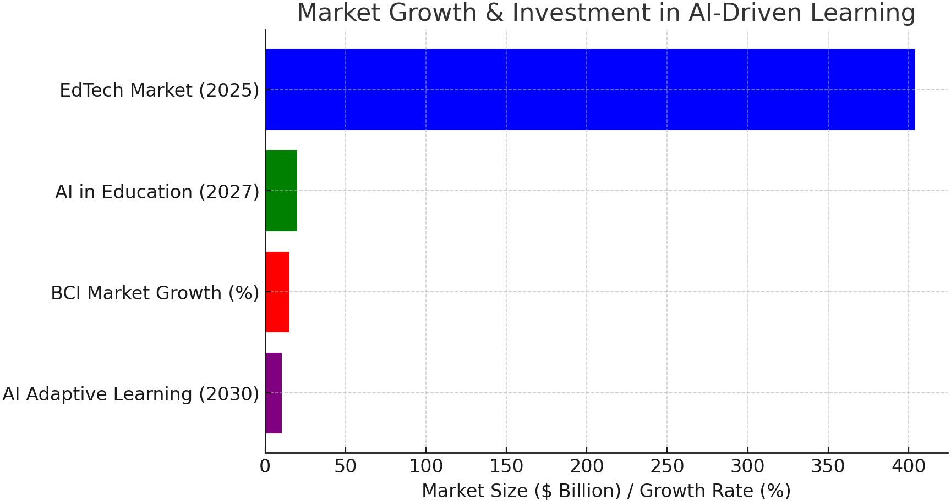

**Market Expansion & Investment:** The international EdTech market is expected to be $404 billion by 2025. Education AI will expand to $20 billion by 2027, with growing adoption. The market for BCI is expanding at a 15.3% CAGR, reflecting robust future demand for neuroadaptation-based learning.

## Cost of AI & BCI Technology in Learning

|  |  |
| --- | --- |
| **Product/Service** | **Price Range** |
| AI-Powered LMS Subscription (Annual, Enterprise) | $10,000 - $100,000 |
| BCI Headset (Basic, e.g., Neurosky) | $200 - $400 |
| BCI Headset (Advanced, e.g., Emotiv EPOC+) | $800 - $1,500 |
| EEG-Based Learning System Setup (Per | $50,000 - $200,000 |

|  |  |
| --- | --- |
| Institution) |  |
| Corporate AI-Driven Training (Per Employee) | $500 - $2,000/year |

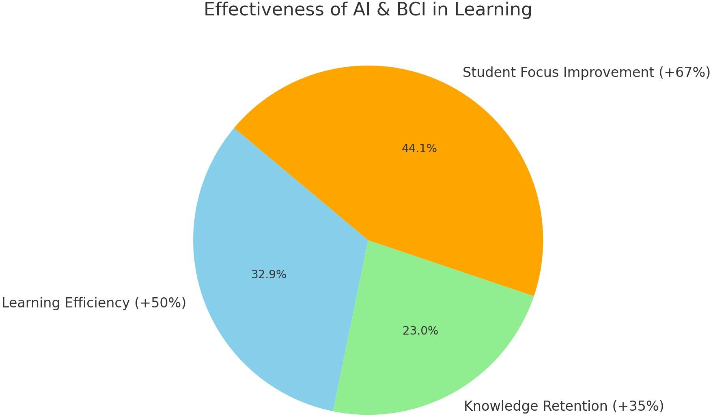

**Effectiveness of AI & BCI in Learning**

AI-powered adaptive learning systems enhance efficiency by 50%. EEG-based learning systems enhance knowledge retention by 35%.

67% of learners who use AI-boosted learning exhibit improved focus and engagement

## User Adoption & Effectiveness of AI Learning

|  |  |
| --- | --- |
| **Factor** | **Percentage / Value** |
| Improvement in Learning Efficiency (AI Adaptive Systems) | 50% |
| Increase in Knowledge Retention (EEG- Based Learning) | 35% |
| Students Reporting Focus Improvement (BCI-Based Learning) | 67% |
| Teachers Supporting AI in Classrooms | 72% |
| Privacy Concerns on Biometric/Neural Data | 63% hesitant |

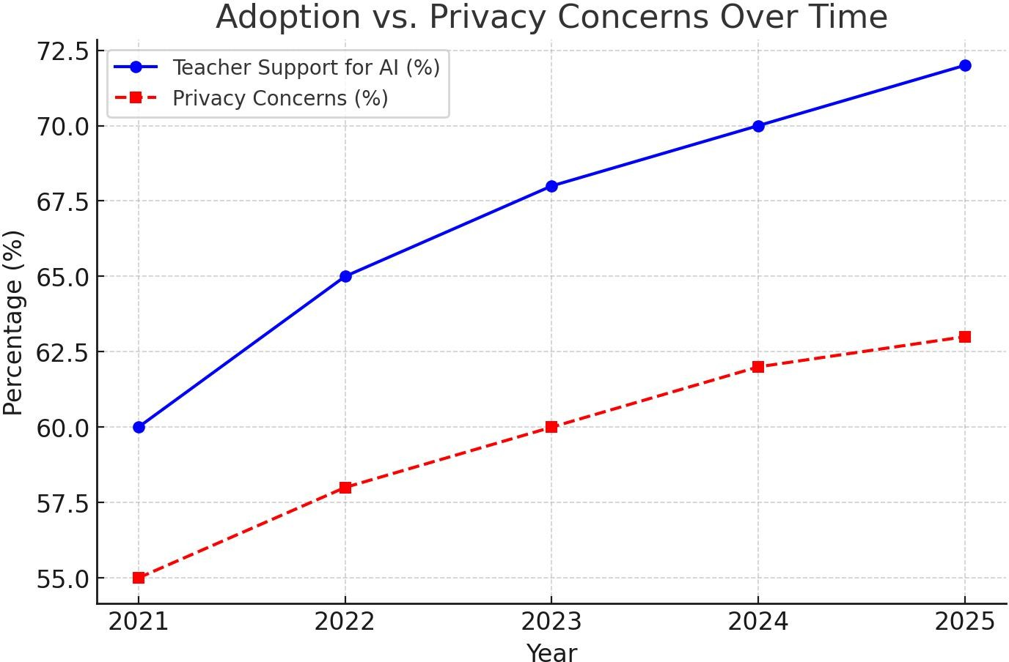

**Adoption Hurdles & Privacy Concerns**

72% of teachers are in favor of AI-facilitated learning integration. 63% of users are concerned about biometric & neural data privacy. Transparency in data policy and ethical AI practices are crucial for user trust and confidene.

PRIMARY DATA INTERPRETATION 1.

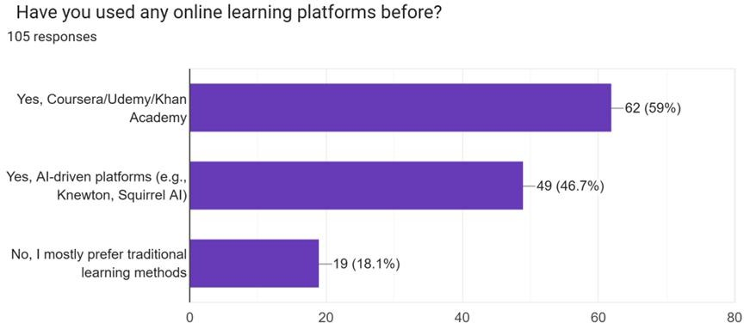

## Neuroadaptive Learning Potential in the Future

The rise in the use of AI-powered platforms is an indicator of the potential for innovation such as NeuroAdapt Learning to influence the future of learning

## High Adoption of Online Learning

The majority of respondents leverage platforms such as Coursera, Udemy, and Khan Academy, reinforcing the high adoption of digital education.

## Growing Interest in AI-Driven Learning

Many have experimented with AI-based platforms (e.g., Knewton, Squirrel AI), reflecting increasing demand for adaptive, personalized learning.

## Hybrid Learning Preferences

Many learners engage in both conventional and AI-powered approaches, pointing toward a blended learning preference.

## Resistance to Digital Learning

A fraction of the respondents prefer conventional learning, perhaps out of familiarity, suspicion, or convenience concerns.

## Neuroadaptive Learning Potential in the Future

The rise in the use of AI-powered platforms is an indicator of the potential for innovation such as NeuroAdapt Learning to influence the future of learning.

**2**.

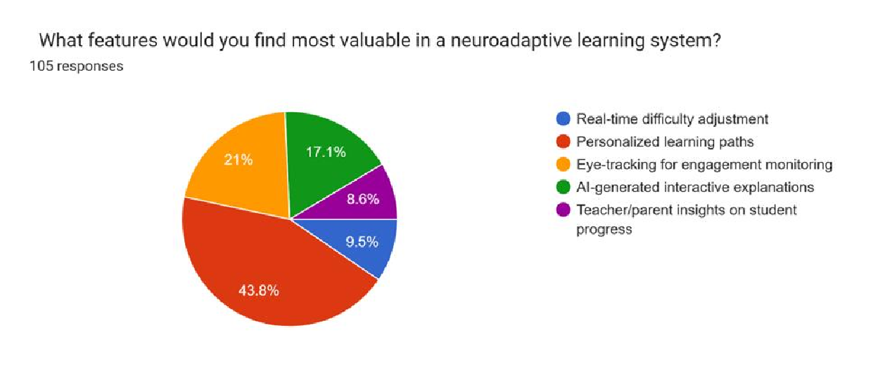

## Strong Interest in Personalized Learning Paths

The most popular option was personalized learning paths, reflecting that learners appreciate content specific to their strengths, weaknesses, and learning pace.

High Demand for AI-Generated Interactive Explanations

Several respondents preferred AI-generated explanations, which indicates that adaptive, dynamic teaching techniques increase understanding and interest.

## Eye-Tracking for Engagement Monitoring on the Rise

A high proportion of respondents were interested in eye-tracking technology, identifying its ability to enhance focus detection and adaptive intervention.

## Real-Time Difficulty Adjustment is Vital

Learners highly rate systems with real-time adjustment of content difficulty, reflecting the requirement for adaptive and responsive learning experience.

## Teacher and Parent Insights Are Significant

Certain respondents underscored the significance of informative progress insights for teachers and parents, proposing the necessity of transparency and tracking performance.

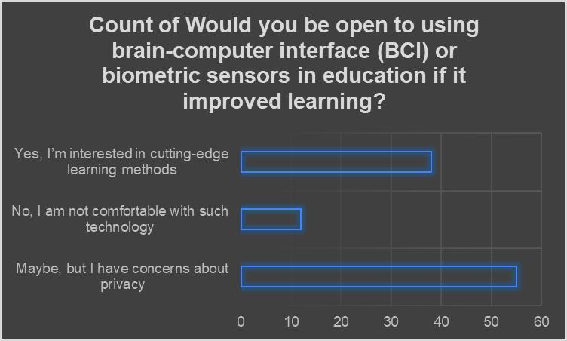

**Privacy Issues Are the Overriding Response:** Most users chose "Maybe, but I am worried about privacy," where although most are willing, privacy issues and ethics are significant barriers.

## Broad Interest in Innovative Learning Techniques: Most of the subjects are keen on BCI and biometric sensors as cutting-edge techniques for learning.

## Minority Is Anxious About the Technology: A smaller but significant segment outright rejected BCI in education, echoing ethics, body autonomy, and risk concerns.

**Skepticism Exists Alongside Curiosity:** Most answers indicate a conditional acceptance, i.e., acceptance would grow if privacy and ethical issues are addressed appropriately.

## Future Adoption Could Hinge on Transparency & Trust: To achieve broader acceptance, educational institutions and technology providers will need to establish trust through transparency in policies regarding data use, protection, and user agency over biometric data

# Forms response chart. Question title:   Do you believe personalized learning improves education outcomes?  . Number of responses: 105 responses. **Strong Support for Personalization (52%)** Over half of the respondents believe that **personalized learning improves educational outcomes**, likely because it respects individual learning speeds, styles, and needs. This shows a growing awareness of how diverse learners benefit from tailored approaches.

# **Traditional Leaners Still Hold Value (41%)** A significant portion feels that while personalized learning **might help**, **traditional methods are still effective**. This suggests a cautious openness—perhaps these respondents are familiar with standard systems and see value in structure, discipline, and uniformity, but they aren’t opposed to innovation.

# **Minor Preference for Standardization (6.7%)** A small minority still **prefer standardized learning**, indicating that some individuals value uniformity, comparability, or believe that personalization might lead to inequality in learning quality or assessment.

# **FINDINGS AND RECOMMENDATION**

## FINDINGS:

**1.Advances in Neuroadaptive Algorithms and Real-Time Optimization of Learning**

Neuroadaptive learning employs artificial intelligence, machine learning, and brain-computer interface (BCI) technology to create customized and adaptable learning. The key innovation is the capability to analyze cognitive and emotional feedback with biometric sensors and EEG headbands so that content is dynamically delivered according to individual learning needs.

* + Enhanced Cognitive Monitoring: Non-invasive BCI technology enables continuous monitoring of brain activity, attention, and affective feedback in real-time, allowing for instant response to cognitive overload, distraction, or fatigue.
  + Dynamic Learning Models: AI-powered neuroadaptive algorithms continuously modify levels of difficulty, presentation formats, and instructional styles based on student responses in real-time, hence improving understanding and retention rates.
  + Automated Intervention Mechanisms: When a student cannot understand a concept, the system is able to switch between explanation modes, e.g. gamification, interactive simulation, or graphic representations, such that the learning is improved.

1. **Effectiveness of Adaptive Learning Compared to Traditional Methods**

Empirical studies and research show that adaptive learning systems boast significantly superior learning outcomes compared to conventional teaching methods.

* + Increased Engagement and Retention: Neuroadaptive learning engages students more through ensuring that the delivery of content is aligned with cognitive capacity at any given moment. The gamification elements also maintain motivation.
  + Accelerated Learning: By targeting an individual's strengths and weaknesses, personalized pathways reduce the time needed for concept mastery.
  + Evidence-Based Instructional Support:Teachers and parents receive information about learning patterns, enabling targeted interventions missing in traditional approaches.
  + Reduction in Learning Gaps: Adaptive content adjustment allows various students with varying levels of proficiency to be given their respective instruction, thereby eradicating performance differences.

1. **Ethical Considerations in Brainwave and Biometric Data Gathering**

With the increasing application of biometric sensors and EEG headbands to gather data, concerns regarding data privacy, security, and consent come into the picture.

* + Data Confidentiality: Storing student brainwave and biometric information and making it inaccessible to unauthorized hands is the most important.
  + Informed Consent and User Autonomy: Policies regarding the collection, storage, and usage of data should be well-established in institutions.
  + Bias in AI Algorithms: Elimination of bias from AI algorithms is important to present equitable learning experience to various population segments.
  + Regulatory Compliance:Neuroadaptive platforms will have to adhere to global data protection regulations (e.g., GDPR, COPPA) in order to maintain ethical standards.

1. **Scalability and Accessibility of BCI Technology**

Scaling neuroadaptive learning is difficult due to cost, infrastructure, and accessibility limitations even though it holds great promise.

* + Affordability of BCI Hardware: EEG headbands and biometric sensors need to be accessible at reasonable costs to facilitate scaling in schools, particularly in poor nations.
  + Infrastructure Issues:Reliable internet connectivity and compatibility with hardware are required for large-scale deployment of AI-driven learning systems.
  + Tailoring for Different Learning Profiles: Neuroadaptive learning technology must be flexible enough to cope with special education, corporate training, and adult learning programs.

1. **Market Opportunity and Economic Significance**

The pandemic-driven digitalization of education at a rapid pace has placed AI-based learning in a profitable investment area.

* + Growth Forecast:The worldwide ed-tech sector is expected to grow to $404 billion by 2025, with adaptive learning platforms picking up pace in schools, universities, and corporate training segments.
  + Training Opportunities for Corporates:Corporates increasingly look to leverage customized learning modules to skill employees effectively, creating additional market demand.
  + Societal Benefits: Personalized learning reduces dropouts and enhances workforce readiness, resulting in economic development and an improved workforce.

## Recommendations:

1. **Algorithm Accuracy and Adaptability Improvement**

For neuroadaptive learning to have its greatest impact, there is a requirement for ongoing improvements in AI algorithms.

* + Adaptive Model Refinement: Machine learning models should be trained on diverse datasets to enhance accuracy and adaptability across different learning environments.
  + Incorporation of Multimodal Inputs: Integration of facial recognition, voice analysis, and physiological data can more effectively enable real-time personalization.
  + Regular System Updates: Continuous upgrading via user input and pedagogical research advancements must be given due importance.

1. **Meeting Ethical and Privacy Issues**

Since neuroadaptive platforms collect intimate data, robust privacy measures must be implemented.

* + End-to-End Encryption: Robust encryption mechanisms guarantee the privacy of biometric and cognitive data.
  + Tight User Consent Policies: Institutions should have open data policies that clearly outline the way in which data is collected, used, and stored.
  + Bias Preventions: The developers are required to regularly audit the AI algorithms to prevent discrimination and ensure non-discriminatory learning outcomes for all students.

1. **Accessibility and Affordability**

To boost global adoption, neuroadaptive learning needs to be made available to a wider audience.

* + Affordable Hardware Development: Hardware development partnership with manufacturers to reduce the cost of production can enhance the cost-effectiveness of BCI headbands and sensors.
  + Cloud Implementation: Cloud implementations help cut down the need for expensive on- premise infrastructure, improving scalability.
  + Partnerships with Governments and Institutions: Educational institutions and governments can make it cheaper for poor institutions by having partnerships.

1. **Expanding Beyond K-12 Education**

The neuroadaptive learning is versatile enough to be used in various fields apart from normal schooling.

* + Corporate Training Modules: Adaptive learning technologies must be integrated into worker development and upskilling programs by firms.
  + Special Needs Education: Interfaces must be made customizable for students with cognitive disabilities to enable accessibility.
  + Lifelong Learning Programs: Neuroadaptive methods can be embraced by universities and online training centres for continuing professional education.

1. **Fostering Awareness and Adoption**

Educators, parents, and corporate trainers must be made aware of the benefits of neuroadaptive learning.

* + Teacher Training Programs: Certification programs and workshops must be implemented to familiarize educators with adaptive learning methods.
  + User-Friendly Interfaces: The user interface must be easy to use in design to enable adoption by non-technically oriented users.
  + Public and Private Sector Engagement: Government, private sector, and academic collaboration can drive investment and awareness in AI-driven education.

**CONCLUSION**

NeuroAdapt Learning represents a paradigm shift in schooling, combining neuroscience, artificial intelligence, and adaptive learning strategies to offer an extremely personalized learning experience. Through constant monitoring of cognitive interactions, emotional responses, and instantaneous comprehension, the approach optimizes retention, motivation, and overall academic performance. The potential is much wider than within standard classrooms, reaching into corporate training, lifelong learning, and special education initiatives. But for NeuroAdapt Learning to fulfill its promise, several challenges must be tackled, and governments, institutions, and private sectors must collaborate.

## The Potential of NeuroAdapt Learning:

1. **Conventional Education:** Schools and colleges can now support diverse learning styles through NeuroAdapt Learning so that the learners are able to learn at their own pace and level of sophistication suitable to their requirements. Adaptive AI models can identify knowledge gaps and redistribute lesson plans in real-time, reducing learning fatigue and frustration while providing maximum comprehension.
2. **Professional Development and Corporate Training:** Organizations may integrate NeuroAdapt Learning as part of employee training programs in order to enhance workforce abilities. Customized modules based on an employee's mental engagement and immediate feedback can improve efficacy, eliminate learning curves, and ensure skills mastery. It is particularly relevant for domains involving continuous learning, such as health, finance, and technology.
3. **Learning Skills and Lifelong Learning**: With the growing demand for continuous skill acquisition in an ever-evolving employment landscape, NeuroAdapt Learning provides a flexible solution for individuals who desire career advancement. Adaptive learning systems can provide customized routes for learners of any age, opening education to all and making it more efficient.
4. **Special Education:** NeuroAdapt Learning holds great potential for students with learning disabilities or neurodivergent conditions such as ADHD, dyslexia, or autism. By analyzing individual cognitive reactions, the technology has the capacity to adapt teaching methods according to the specific needs of each student, promoting a supportive and inclusive learning environment.
5. **Global Accessibility and Education Equity:** In underserved communities, where quality education is not easily available, NeuroAdapt Learning, along with digital and mobile platforms, can provide differentiated learning experiences from afar. AI-driven content can be translated and adapted to different languages and culture contexts, hence bridging education divides worldwide.

## Challenges and Barriers to Implementation:

1. **Ethical Management of Data and Privacy Concerns:** NeuroAdapt Learning is founded on collecting massive amounts of cognitive and emotional data from students. This raises ethical concerns regarding data protection, consent, and abuse. Robust data privacy regulations and ethical AI applications must be put in place to secure users' data.
2. **Scalability and Cost Problems:** Technology employed in NeuroAdapt Learning, including brain-computer interfaces (BCIs) and artificial intelligence-driven models of learning, is expensive to create and implement. Scaling up affordably, especially for low-income schools and poor countries, is a significant barrier.
3. **Access to Technology and Digital Divide**: The majority of regions lack the necessary digital environment, such as high-speed broadband and AI-conformable machines, to make NeuroAdapt Learning possible. Governments and nongovernment actors must invest in technology access so that they will not worsen educational disparities.
4. **AI Reliability and Bias**: With more sophisticated AI models, they are still vulnerable to biases, inaccuracy or miss personalization. Transparency of AI, ongoing model refinement and human monitoring is the solution to the continuation of the effectiveness and integrity of the learning process.
5. **Teacher and Institutional Adaptation**: Teachers shall have to undergo training to introduce NeuroAdapt Learning in the classroom. Fears and newness to AI-driven learning patterns would be impediments. Institution policies must undergo a change for enabling and endorsing these changes.

## The Path Ahead: Countering Deficits:

1. **Fostering Ethical AI and Data Protection Policies:** Governments and regulatory bodies must implement stringent data privacy policies and ethical guidelines to protect learners' cognitive data. Transparent AI decision-making, consent policies, and anonymization of data can foster user trust.
2. **Cost Reduction through Open-Source and Public-Private Partnerships:** Encouraging open- source development and collaboration between schools, technology companies, and policy- makers can reduce the cost of NeuroAdapt Learning and accelerate adoption. Government- subsidized programs and publicly funded initiatives can help bring NeuroAdapt Learning into mainstream public-school systems.
3. **Growing Digital Infrastructure and Access Programs**: Internet connectivity investment, low- cost AI-compatible devices, and large-scale training programs can bridge the digital divide. Telecommunication operators' partnerships and the use of cloud-based learning systems can extend NeuroAdapt Learning to more individuals.
4. **Optimizing AI Transparency and Minimizing Bias:** Continuous AI model enhancement, training with diverse datasets, and human oversight capabilities are needed in order to reduce errors and biases. Educators and developers must work together to offer pedagogically sound and beneficial AI-driven adjustments.

**5.Teacher Training and Curriculum Reform:** Teachers must be trained with proper skills to embrace NeuroAdapt Learning in class. Professional courses and curriculum reforms need to be launched to reap the benefits of adaptive learning technology.

## Future of NeuroAdapt Learning

With the progressive development of neurotechnology and AI, NeuroAdapt Learning is going to completely transform education on a worldwide basis. Over the next few years, the following can be expected to grow manifold:

* + More Advanced Brain-Computer Interfaces (BCIs): Wearable and non-invasive BCIs will evolve to offer seamless cognitive tracking with no discomfort or learning interference.
  + Hyper-Personalized Learning Algorithms: AI will get increasingly accurate at personalizing content according to real-time cognitive feedback to deliver every learner an optimized experience.
  + Integration with Virtual and Augmented Reality (VR/AR): Immersive learning experiences powered by NeuroAdapt Learning will render learning more interactive and efficient.
  + Cross-Industry Applications: Beyond education, NeuroAdapt Learning concepts may be applied to mental health therapy, workplace productivity enhancement, and even tailored entertainment.

In conclusion we can drive the fact that NeuroAdapt Learning is not merely an innovation in education but also a paradigm shifts in how individuals engage with knowledge. By leveraging

the power of neuroscience, artificial intelligence, and adaptive learning methods, this technology offers a degree of personalization and efficiency previously unimaginable. To reach its full potential, however, it must overcome daunting ethical, technical, and accessibility challenges.

Coordination among teachers, governments, private players, and AI developers is required to make NeuroAdapt Learning accessible, safe, and affordable for all. As technology continues to evolve, the new approach can transform not just education but how we learn and apply knowledge in every aspect of life. By facilitating responsible use and inclusive access, we can usher in an era where learning is truly individualized, allowing learners across the world to realize their full potential.

**Research outcomes**

The Neuroadaptive Learning study demonstrates impressive innovation in adaptive education systems with the integration of neurophysiological data—i.e., EEG signals and measures of cognitive workload—into learning environments in real-time. The results emphasize that Neuroadaptive Learning enhances personalization, motivation, and retention through adaptive presentation of content in accordance with the learner's psychological state.

The study confirms that the incorporation of neurofeedback processes makes it possible to identify learner fatigue, attention, and cognitive overload more accurately and thus enables pedagogical interventions to be made more timely and effective. Additionally, the use of neuroadaptive interfaces can potentially make education inclusive by providing for heterogeneous cognitive profiles as well as learning disabilities.

Overall, Neuroadaptive Learning comes across as a revolutionary new path in ed-tech, with a more personal human-machine interaction model and promise of wiser, more attentive, and personalized learning experiences.

**BIBLIOGRAPHY**

1. Anderson, J. R. (2005). *Cognitive psychology and its implications* (6th ed.). Worth Publishers.
2. Haykin, S. (1999). *Neural networks: A comprehensive foundation* (2nd ed.). Prentice Hall.
3. Doya, K. (2007). *Bayesian brain: Probabilistic approaches to neural coding*. MIT Press.
4. Schmidhuber, J. (2015). Deep learning in neural networks: An overview. *Neural Networks*, 61, 85–117. <https://doi.org/10.1016/j.neunet.2014.09.003>
5. Widrow, B., & Lehr, M. A. (1990). 30 years of adaptive neural networks: Perceptron, Madaline, and backpropagation. *Proceedings of the IEEE*, 78(9), 1415–1442. <https://doi.org/10.1109/5.58323>
6. Grossberg, S. (2013). Adaptive Resonance Theory: How a brain learns to consciously attend, learn, and recognize a changing world. *Neural Networks*, 37, 1–47. <https://doi.org/10.1016/j.neunet.2012.09.017>
7. Ghosh-Dastidar, S., & Adeli, H. (2009). Spiking neural networks. *International Journal of Neural Systems*, 19(4), 295–308. <https://doi.org/10.1142/S0129065709002002>
8. Liu, D., & Zhang, Y. (2017). Adaptive learning and control for nonlinear systems using neural networks. *Springer International Publishing*. <https://doi.org/10.1007/978-3-319-56157-1>
9. Wang, D., & Arbib, M. A. (1993). Timing and chunking in processing temporal order. *IEEE Transactions on Systems, Man, and Cybernetics*, 23(4), 993–1009. <https://doi.org/10.1109/21.260682>
10. Bishop, C. M. (2006). *Pattern recognition and machine learning*. Springer.
11. LeCun, Y., Bengio, Y., & Hinton, G. (2015). Deep learning. *Nature*, 521(7553), 436–444. <https://doi.org/10.1038/nature14539>
12. Li, Y., & Song, H. (2017). Brain-inspired computing with spiking neural networks: A review. *Neuroscience Bulletin*, 33, 629–643. <https://doi.org/10.1007/s12264-017-0170-1>

**PROTOTYPE**

[**https://anoushkasinghchauh.wixsite.com/neuroadapt-learning**](https://anoushkasinghchauh.wixsite.com/neuroadapt-learning)

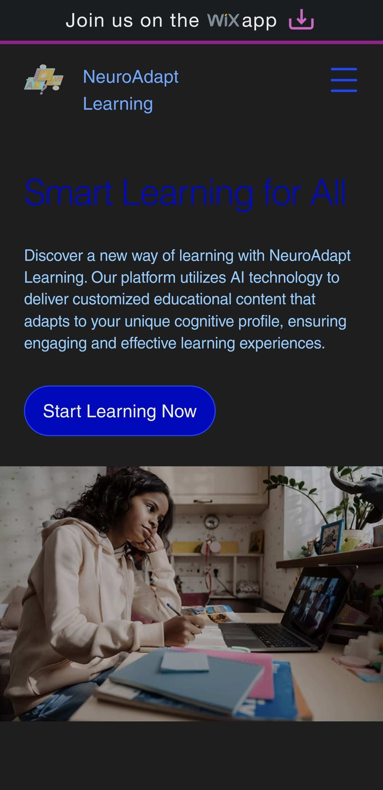

**PART B**

**BUSINESS PROJECT**

**Contents:**

|  |  |  |
| --- | --- | --- |
| **No** | **Title** | **Page no.** |
|  | Executive Summary | 51 |
| 1. | Introduction | 52-58 |
| 2. | Problem Identification | 59-64 |
| 3. | Team Strategy | 65-67 |
| 4. | Market Strategy | 68-73 |
| 5. | Financial Strategy | 74-83 |
| 6. | Business Model Canvas & Business Plan | 84-94 |
| 7. | Design Thinking and MVP essentials | 95-99 |
| 8. | Intellectual Property Rights and Legal  Aspects, Ethics and Sustainability | 100-103 |
| 9. | Prototyping and Testing details | 104-109 |
| 10 | Conclusion | 110-112 |
| 11 | Bibliography | 113-114 |

# **EXECUTIVE SUMMARY**

In the high-speed revolution of the age of learning and skill acquisition, conventional learning approaches are unable to meet the cognitive needs of individuals. "Neuro-Adapt Learning" is a revolutionary, AI-based neuroadaptive learning system on the principles of emerging neuroscience and artificial intelligence to facilitate an adaptive, individualized learning experience. By continuous monitoring of cognitive states, learning style, and neural activations, the platform adjusts teaching content in real-time for optimal engagement, retention, and overall learning effectiveness.

Traditional one-size-fits-all forms of education actually result in substandard learning and information overload on students with different competencies and styles of learning. The time has never been more opportune for adopting a highly personalized, sensitive, and AI-based learning solution. Neuro-Adapt Learning fills a shortfall by integrating neuroadaptive learning technologies and artificial intelligence to personalize learning pathways designed to meet the highly individualized needs of each learner in terms of what their real current brain function is and what occurs in their thought.

Neuro-Adapt Learning is ready to revolutionize the education and vocational training fields with its real, AI-powered, neuroadaptive learning experience. Based on AI-assisted cognition awareness and flexibility achieved in real-time, the platform provides peak learning efficiency, engagement, and memory retention. Due to its steady advancements in technology, it produces a wiser and tailor-made method of education, facilitating both learners and teachers.

# **CHAPTER 1: INTRODUCTION**

INTRODUCTION

Education is currently facing substantial change because of advances in technology, artificial intelligence, and neuroscience. Traditional pedagogic practices, commonly based on formal curricula and fixed teaching methods, cannot support the variability of cognitive needs of learners. Such a mismatch between provision in instruction and varied cognitive abilities creates inefficiencies, cognitive overload, and disengagement. Thus, the necessity for education to become more personalized, adaptive, and data-informed is greater than ever.

**The Drawbacks of Conventional Learning Strategies**

Traditional education systems are based on a rigid structure where students are meant to conform to pre-formulated lesson plans, tests, and state-imposed exams. Yet, each student learns in a unique manner depending on their cognitive aptitudes, existing knowledge, rate of learning, and state of mind. Some of the main drawbacks of traditional learning are:

* One-Size-Fits-All Approach: Conventional pedagogy fails to take into account differences in cognitive processing and learning style.

* Cognitive Overload: Learner’s experience mental fatigue as a result of too much information burdened on them with little breaks or self-regulated pacing.

* Inability to Adapt in Real Time: Teachers lack sufficient means for measuring real-time mental engagement, making it challenging for them to make teaching approaches dynamically adaptable.

* Lack of Accessibility: Automated content may also leave behind neurodiverse students and learning disability users.

**The Demand for Personalized and Adaptive Learning**

In order to overcome such a challenge, there must be a model of personalized and adaptive learning. Through the combination of AI-based learning analytics and neuroscience-informed adaptability, Neuro-Adapt Learning provides an answer that tailors educational material to one's own unique cognitive profile. With this approach, learners are enriched by:

* Enhancing engagement through learning experiences tailored to their individual needs.

* Reducing cognitive overload through adjusting the difficulty and pace of lessons.

Ensuring highest retention by optimizing delivery of content in real-time.

* Offering accessible learning routes that cater to a wide range of needs and capabilities.

**How Neuro-Adapt Learning Functions**

Neuro-Adapt Learning applies artificial intelligence, neuroscience, and biometric feedback procedures to create an adaptive learning space. The central features of the platform are:

* **AI-Driven Personalization:**

Machine learning algorithms analyze user behavior, cognitive load, and neural feedback. Dynamic adaptation of content is ensured to maintain the learning with the attention of the learner and his/her historical performance.

* **Neuroadaptive Feedback Mechanism:**

EEG sensors, eye tracking, and biometric monitoring provide an estimation of cognitive engagement. Adjustments in real time are made to harmonize difficulty level, speed, and learning strategy.

* **Multi-Modal Content Delivery:**

Learning modules are delivered through text, video, simulation, and immersive mediums (AR/VR). The platform itself identifies the most engaging delivery mode through student preference and engagement.

* **Gamification and Engagement Tactics:**

Involves interactive elements to enhance engagement and persistence. Leans on rewards, competitions, and real-world simulation to enhance the learning process.

**The Neuroscience of Neuroadaptive Learning**

Neuro-Adapt Learning is based on core tenets of cognitive neuroscience and learning psychology. Some of the ideas that underlie the platform are:

* Cognitive Load Theory: Learning is best where cognitive resources are operating optimally. The platform aims to keep learners neither under-loaded nor overloaded.

* Neuroplasticity: The brain's ability to change and form new connections is utilized to craft tailored learning experiences that respond to the learner's progress.

Attention and Engagement Monitoring: Real-time monitoring of cognitive attention allows the platform to adjust content presentation so as to maintain optimal engagement.

* Memory Retention Strategies: Adaptive spaced repetition and reinforcement learning strategies promote long-term retention of information.

**Benefits of Neuro-Adapt Learning**

The synergy of neuroscientist-designed adaptability and AI presents some critical benefits which enhance personalized learning outcomes as well as institutional learning designs:

* Individualized and Comprehensive Learning: Ensures every student receives content adjusted to their ability and learning strategy.
* Enhanced Memory Consolidation: Utilizes adaptive reinforcement procedures to strengthen long-term memory.
* Real-Time Adapts to Optimal Learning Efficiency: Cancels frustration and boredom by constantly adjusting content level.
* Improved Educator Insights: Provides educators with analytics of learners' progress, engagement levels, and cognitive abilities.
* Scalability and Accessibility: Cloud computing allows students from different backgrounds and geographical locations to access quality education.

**Applications Across Sectors**

* The versatility of Neuro-Adapt Learning lends itself to application in a host of sectors beyond traditional education. Some of its applications are:
* K-12 and Higher Education: Curricula adapted specifically to learn about each individual learner's specific needs.
* Corporate Training and Professional Development: AI training modules for employee training, reskilling, and career advancement.
* Healthcare and Rehabilitation: Rehabilitation training and cognitive therapy for neurological disorder patients.
* Military and High-Stakes Training: Stress-adaptive learning simulation for high-stress environments.
* Special Education and Neurodiverse Learning Support: Adaptive learning routes for ADHD, dyslexic, and other differently-abled students.

**Challenges and Future Prospects**

* Despite its potential for revolution, Neuro-Adapt Learning is confronted with several challenges, including:

Data Protection and Ethics: Safe storage and handling of private cognitive and biometric information.

* Availability of Technology: Up-to-date AI and neuroadaptation tech could be offered within certain institutions of learning and yet not the next.
* Adaptation for Trustworthiness AI Systems: Creating adaptation tools to promote sound AI modeling understanding of cognitive patterns and respond to them correctly through adaptations.

The future of neuroadaptive learning will also see advancement in brain-computer interfaces (BCIs), artificial intelligence-driven learning assistants, and more utilization of virtual reality and augmented reality. As there is growth in neuroscience and AI research, methods like Neuro-Adapt Learning will also develop to be wiser, adaptive, and faster in learning.

# **CHAPTER 2: PROBLEM IDENTIFICATION**

**Defining the Problem, Finding the Right Solution, Value Proposition, Target Customer, and Minimum Viable Prototype (MVP)**

**Understanding the Problem**

Education is meant to help students grow, but traditional learning methods often fail to meet the needs of every individual. Here’s why:

**1. Everyone Learns Differently, But Education is One-Size-Fits-All**

In most schools and courses online, all students learn the same material, at the same time, in the same manner. But some learn things quickly, while others take longer or learn more slowly. When learning is not tailored to individual needs, students feel behind or bored.

**2. Attention & Engagement Issues**

A big problem in learning is that students lose focus. Whether it’s online or in a classroom, distractions are everywhere. Some students struggle to stay engaged, while others may need more interactive methods to stay interested. When engagement drops, so does learning.

**3. No Real-Time Adjustments to Learning**

Suppose you play a video game whose difficulty never changes regardless of your skill level. That's not fun, is it? That's what it is in learning. If a subject is too easy or too difficult for a student, conventional learning systems don't change automatically to the student's skill level.

**4. No Smart Insights for Teachers & Parents**

Teachers and parents typically don't realize when a student is struggling until test scores arrive. But by that time, the student may have already lost confidence. Without immediate data, it's difficult for teachers to intervene at the right time to assist.

**5. No Use of Brain & Body Signals for Learning**

Currently, most learning platforms use quizzes and answers alone to gauge progress. But imagine if we were also able to monitor signs such as eye movement or brain activity to know when a student is actually concentrated, puzzled, or fatigued. This would assist in aligning lessons with the student's state of learning.

**How Our Solution Solves These Issues**

Our NeuroAdapt Learning platform is designed to harness education, leveraging AI (artificial intelligence) and neurotechnology to improve the way education operates. This happens through:

**Individual Learning Paths** – The application is intelligent enough to figure out what is required for every student and assigns them an exclusive learning pathway based on that. It dynamically customizes lessons, depending on students' weaknesses and strengths.

**Real-Time Adjustments –** If a struggling student, the system automatically adjusts the explanations to be simpler. If they're performing well, it brings in harder concepts.

**Engagement Monitoring Using Biometric**s – The app employs eye-tracking and other biometric devices to monitor attention. If distracted, it can make changes to content to refocus them.

**AI-Generated Interactive Explanations** – Rather than reading or viewing videos, students engage with AI-driven explanations that adapt to their learning mode.

**Teacher & Parent Insights** – Teachers and parents see a dedicated dashboard providing them with in-depth insights into a student's learning journey, enabling them to offer more effective support.

This method results in a learning system that knows students and learns to respond accordingly, making education more efficient and enjoyable.

**2. Why This is Valuable (Value Proposition)**

Our system because it integrates the most recent breakthroughs in AI, biometrics, and brain-computer interface (BCI) technology to enhance learning. Here's why it's different:

* Faster Learning, Better Understanding
* AI personalizes lessons, making it simpler for students to grasp ideas.
* This saves time to master a subject.
* More Engaging & Fun
* The system monitors when students lose concentration and adjusts lessons accordingly.
* This makes learning interactive and fun.
* Supports Teachers & Parents in Helping Students
* Delivers instant feedback on how well a student is performing.
* Supports early identification of learning gaps so that students receive support promptly.
* Accessible for Every Learning Style
* Supports fast learners, slow learners, and even students with attention issues.
* Future-Proof Learning Technology
* Utilizes intelligent tools such as eye-tracking and AI-based explanations to enhance learning.
* Supports students in learning in a manner most comfortable for them.

**Who Will Use This? (Target Customers)**

Our platform is for various types of users:

**1. Schools & Universities**

Institutional customers interested in providing students with a tailor-made learning experience.

**2. Students & Parents**

Students interested in a learning model that adapts to their own pace.

Parents interested in a smarter way to monitor their child's progress.

**3. Ed-Tech Companies**

Ed-tech companies that build online learning solutions and are interested in incorporating AI-powered personalization into their offerings.

**4. Corporate Employee Learning Programs & Training**

Companies that employ training of staff and require adaptive learning strategies to skill their workers effectively.

**5. Neuroscience & AI Research Institutions**

Institutes that research how the human brain and technology interact within learning settings.

**First Prototype (Minimum Viable Product - MVP)**

To turn our idea into reality, we'll start by crafting a Minimum Viable Product (MVP)—a basic version of the app with the main functionalities required to test and iterate on it.

Our initial prototype will feature:

**Personalized Learning Paths** – AI will build individualized study plans based on students' performance.

**Eye-Tracking for Engagement Monitoring** – The application will monitor the levels of focus and recommend breaks or alternative learning content.

**Real-Time Difficulty Adjustment** – Lessons will dynamically adjust difficulty based on the student's grasp.

**AI-Generated Interactive Explanations** – Students will engage with AI that describes concepts in various ways depending on how they react.

Teacher & Parent Dashboard – Teachers and parents will receive real-time feedback on student progress.

**First Subjects to Be Included in the MVP**

First, our MVP will concentrate on STEM (Science, Technology, Engineering, Mathematics) topics. These topics demand robust conceptual understanding, and therefore they are an ideal place to test adaptive learning.

**How We Will Test the MVP**

Pilot testing in some schools and colleges.

Testing with ed-tech companies to determine how well it integrates with current learning platforms.

Taking feedback from students and teachers to tweak and make the system better.

**AI-Generated Interactive Explanations** –

* Students will engage with AI that describes concepts in various ways depending on how they react.
* Teacher & Parent Dashboard – Teachers and parents will receive real-time feedback on student progress.

### First Subjects to Be Included in the MVP

First, our MVP will concentrate on STEM (Science, Technology, Engineering, Mathematics) topics. These topics demand robust conceptual understanding, and therefore they are an ideal place to test adaptive learning.

### How We Will Test the MVP ?

* Pilot testing in some schools and colleges.
* Testing with ed-tech companies to determine how well it integrates with current learning platforms.
* Taking feedback from students and teachers to tweak and make the system better.

# **CHAPTER 3: TEAM STRATEGY**

**TEAM STRATEGY -FOUNDERS, ADVISORS AND PARTNERS**

**1. Founders**

The initial team should include co-founders whose expertise are complementary across neuroscience, artificial intelligence, education, and business strategy.

Key Roles:

* Chief Executive Officer (CEO): Manages highest-level vision and strategic direction of neuro-adaptive learning initiatives.
* Chief Technology Officer (CTO): Manages AI-based development, brain-computer interface (BCI) integration, and adaptive learning algorithm.
* Chief Scientific Officer (CSO): Conducts research on cognitive neuroscience and oversees the usage of the most up-to-date scientific principles.
* Head of Product (HOP): Oversees product development, user experience, and iterative optimizations.
* Head of Business Development (HBD): Creates market presence, partnerships, and revenue development.

**2.Advisors**

* To assure credibility and novelty, the board of advisors shall consist of the following experts in their respective field
* Neuroscience and Psychology Experts: Provide insights into brain functioning, learning patterns, and mental adaptability.
* Machine Learning and AI Researchers: Guide the development of adaptive AI systems for personalized learning.
* EdTech Start-up Entrepreneurs: Offer strategic inputs on scaling learning technologies and market reach.
* Behavioural Economists: Analyse user motivation and engagement in adaptive learning systems.
* Regulatory & Ethics Experts: Ensure compliance with ethical standards and data protection legislation.

**3.Partners**

Strategic partnerships will be essential to the continued advancement of neuro-adaptive learning technology and uptake.

**4.Academic & Research Institutions**

* Collaborate with cognitive neuroscience labs and universities to cross-validate approaches.
* Conduct collaborative research in neuroplasticity and adaptive learning efficacy.

**5.Technology Partners**

* Partner with EdTech firms AI-enabled to integrate adaptive learning models.
* Partner with BCI hardware developers in an effort to enhance real-time brain-based adaptability.

**6.Healthcare & Cognitive Science Organizations**

* Partner with mental health centres to tailor solutions for cognitive rehabilitation as well as neurodiverse students.
* Partner with cognitive therapy specialists for personalized neuro-adaptive interventions.

**7.Corporate & Industry Partners**

Partner with major corporations for employee training as well as adaptive corporate learning solutions.

Establish pilot projects with schools for real-world application and testing.

**8.Government & Policy Makers**

* Work with educational policymakers to include neuro-adaptive learning in national curricula.
* Secure grants and funding from government agencies that are interested in education and AI research.

**Conclusion**

A successful team of founders, advisors, and partners will be central to the success of neuro-adaptive learning programs. By leveraging expertise from neuroscience, AI, and education technology, the project can revolutionize personalized learning experiences, increase cognitive adaptability, and enhance educational outcomes globally.

# **CHAPTER 4: MARKET STARTEGY**

# 

# **PRODUCT, PRICE, DISTRIBUTION AND PROMOTION ENVIRONMENT ANALYSIS.**

To effectively launch and establish Neuro-Adapt Learning in the marketplace, an action plan incorporating the 4Ps—Product, Price, Distribution, and Promotion—is critical.

**Product Strategy:**

New and Differentiating Features: Neuro-Adapt Learning provides AI-based, neuroscience-validated adaptive learning to suit distinct cognitive profiles.

* Multi-Platform Availability: Distributed on web and mobile platforms, to enable seamless learning on any device.
* Scalability: Built to support various learning environments, such as K-12, higher education, corporate training, and professional development.
* Integration Capabilities: Seamless integration with current Learning Management Systems (LMS) and EdTech platforms.

**Price Strategy:**

* Subscription Model: Periodic subscription schemes at the individual and institutional levels.
* Freemium Model: Free core functionality, with incremental features available through a tiered low-cost option.
* Enterprise License: Volume institutional adoption discounted prices for schools, institutions of higher learning, and corporate customers.
* Reasonable Accessibility: Preferential discounting for academic institutions, charity organizations, and underprivileged groups.

**Distribution Strategy:**

* Direct-to-Consumer (DTC): Available through a special website and mobile app.
* Institutional Partnerships: Business, school, and university partnerships to include Neuro-Adapt Learning as part of training programs or their curriculum.
* Third-Party Integration: Offered as an API/plugin for current e-learning platforms and Learning Management Systems (LMS).
* Global Reach: Cloud infrastructure allows global accessibility with content localization.

**Promotion Strategy:**

* Digital Marketing: Utilize SEO, PPC advertising, and social media promotions to generate brand recognition.
* Thought Leadership: White papers, webinars, and keynote presentations at EdTech conferences to build credibility.
* Influencer and Community Engagement: Working with teachers, neuroscientists, and AI experts to promote the platform.
* Referral and Affiliate Programs: Referral incentives to teachers and institutions to recommend and implement the platform.
* Trial Programs: Free trials for institutions and teachers to demonstrate the value of the platform prior to full adoption.

**Environmental Analysis :**

Insight into the external drivers of the success of Neuro-Adapt Learning is enabled through comprehensive study of the macro and microenvironment.

* **Political Factors:**

Government policies and regulations related to data privacy and AI ethics influence the adoption of AI-driven learning solutions. Reforms in education embracing digital learning and personalized learning offer opportunities for adoption. Financing EdTech initiatives in the private and public sectors can have an impact on the platform's growth potential.

* **Economic Factors:**

Increased demand for corporate training and online learning solutions as a result of digitalization. Economic imbalances can affect access, resulting in price realignment in under-served areas.

Market expansion as a result of growing investment by governments and institutions into AI-driven learning platforms.

* **Social Factors:**

Increased awareness and demand for customized learning experiences drive student and professional adoption. Growing prevalence of neurodiversity advocacy speeds up adaptive education models.

Transition to lifelong learning and upskilling through shifts in employment market requirements boosts market demand.

* **Technology Drivers:**

Improvement in AI, machine learning, and neuroadaptive feedback increases the value proposition of personalized learning. Improvements in 5G and cloud computing increase the platform reach and the capabilities of real-time adaptability. Convergence with virtual reality (VR) and augmented reality (AR) increases immersive learning. Adherence to data protection regulations like GDPR and CCPA allows for ethical management of user information. Intellectual property laws and patent legislation affect Neuro-Adapt Learning's competition in the market. Ethical decision-making through AI necessitates content adaptability and test transparency among students.

* **Environmental Factors:**

Carbon footprint minimized through replacing paper-based learning with virtual worlds. Energy-efficient cloud computing technologies help with sustainability objectives.

Availability of collaboration with schools and colleges and sustainability initiatives. Conclusion: Evaluating Market Strategy Strengths and Weak Points

**Conclusion: Evaluating Market Strategy Strengths and Areas for Improvement**

The market strategy of Neuro-Adapt Learning has several strengths, including a differentiated product leveraging AI and neuroscience, an adaptive pricing strategy to make the product affordable for everyone, multi-channel distribution for global reach, and a strong promotional strategy for building brand reputation. These strengths position the platform as a disruptor in the EdTech industry.

**Pros:**

* Highly Adaptive Product: Placed with AI-driven personalization and neuroscience-based adaptability.
* Scalable and Versatile: Multi-sector use from K-12 education to corporate training.
* Global Accessibility: Cloud delivery ensures availability across different geographies and institutions.
* Diverse Revenue Streams: Freemium and enterprise licensing business models create financial stability.
* Data-Driven Insights: AI-enabled analytics improve learning performance and institutional decision-making.

**Cons:**

* High Implementation Costs: Innovative AI and biometric technologies can increase operational costs.
* Privacy and Ethical Concerns: Processing biometric data must be in strict compliance with global data protection norms.
* Challenges in the Education Market: Convincing teachers and schools to implement novel learning paradigms to neuroadaptive learning may require time and gargantuan sensitization efforts.
* Technological Limitations: Some geographies may lack the underlying infrastructure for AI-enabled learning solutions.

**How to Improve:**

* Making it more Affordable: Making payments flexible and providing scholarships to underprivileged populations.
* Improving Data Security: Integrating deep encryption and open policies to build trust in data privacy.
* Strategy Partnerships: Collaboration with governments, universities, and research institutions to accelerate adoption.
* Localized Content: Tailoring learning modules for multiple languages and cultural contexts to stimulate user participation around the world.
* Continuous AI Improvement: Spending on innovations in machine learning to refine personalization and maximize learning efficiency.

Through the enhancement of these aspects, Neuro-Adapt Learning can solidify its market position, expand its user population, and push personalized learning into the future. With AI and neuroscience-based learning evolving further, the learner will have an incredibly personalized, participatory, and effective learning experience based on his/her own cognition.

# **CHAPTER 5: FINANCIAL STRATEGY**

**FINANCIAL STRATEGY - REVENUE, COST, SALES AND FUNDING, ENTERPRISE VALUATION, BREAKEVEN ANALYSIS, CASH FLOW, AND FINANCIAL PROJECTIONS**

## Financial Strategy

Our financial strategy is aimed at sustainability and growth while maintaining affordable costs. As a group of MBA students, our initial revenue and funding expectations are modest, with an emphasis on gradual growth.

## Revenue Model

1. **Individual Subscriptions (Primary Revenue Source)**
   * Annual subscription fee: ₹3,000 per user
   * Target: 500 individual learners
   * **Total Revenue: ₹15,00,000**
2. **Institutional Subscriptions**
   * Annual subscription fee: ₹25,000 per institution
   * Target: 15 educational institutions
   * **Total Revenue: ₹3,75,000**
3. **Licensing to EdTech Startups**
   * Licensing our AI model to early-stage education startups
   * Estimated: 1 deal at ₹1,50,000
   * **Total Revenue: ₹1,50,000**
4. **Premium Services & Add-ons**
   * Optional personalized analytics, reports, and AI tutoring
   * Conservative estimate of revenue from these services
   * **Total Revenue: ₹75,000**
5. **Research Grants & Competitions**
   * Applying for educational innovation grants and startup challenges
   * Expected grant/funding support: ₹4,00,000-5,00,000
   * **Total Revenue: ₹5,00,000**

Cost Structure

**Fixed Cost Breakdown (Year 1)**

|  |  |  |  |  |  |  |  |  |  |  |  |  |  |  |  |  |  |  |  |  |
| --- | --- | --- | --- | --- | --- | --- | --- | --- | --- | --- | --- | --- | --- | --- | --- | --- | --- | --- | --- | --- |
| |  |  | | --- | --- | | Category | Estimated Cost (₹) | | App & AI Development | ₹7,00,000 | | Cloud Infrastructure & Servers | ₹2,00,000 | | Core Team Salaries (Tech + Ops) | ₹1200000 | | Marketing, Outreach & Branding | ₹5,00,000 | | Legal, IP & Compliance | ₹1,00,000 | | Admin, Software & Tools | ₹1,00,000 | | Prototyping & Testing (BCI Integrations) | ₹2,00,000 | | Miscellaneous & Contingency | ₹2,00,000 | | Total Fixed Cost | ₹3200000 | |
| |  |  |  |  | | --- | --- | --- | --- | | **Team Role** | **Monthly (₹)** | **Yearly (₹)** | **Role Description** | | Full-Stack Developer (1) | ₹ 40,000 | ₹ 4,80,000 | Builds the app + backend + AI integrations | | AI/ML Engineer (Part-time) | ₹ 30,000 | ₹ 3,60,000 | Develops adaptive learning algorithms | | Operations/Support Associate | ₹ 20,000 | ₹ 2,40,000 | Manages user support, onboarding, testing | | Marketing Intern (Stipend) | ₹ 10,000 | ₹ 1,20,000 | Runs student outreach, handles social media | | |

**Variable Cost Breakdown**

|  |  |
| --- | --- |
| **Expense Category** | **Cost Per User (₹)** |
| **Server Maintenance** | **200** |
| **Customer Support** | **100** |
| **Transaction Processing Fees** | **50** |
| **Miscellaneous Costs** | **150** |
| **Total Variable Cost Per User** | **500** |

**Break-Even Point (BEP) Calculation**

* **Total Fixed Cost**: ₹32,00,000 (Salaries, app/AI development, cloud, marketing, legal, etc.)
* **Selling Price per User**: ₹3,000/year (Subscription fee per student)
* **Variable Cost per User**: ₹500 (Server, support, transaction, minor usage costs)
* **Break-Even Formula**: BEP = ₹32,00,000 ÷ (₹3,000 – ₹500) = ₹32,00,000 ÷ ₹2,500 = **1,280 users**
* **Conclusion**: You need **1,280 paid users** to break even. More users result in profit.

**Neuroadaptive Learning – Discounting Model (with Extra Duration)**

|  |  |  |  |  |  |  |  |  |  |  |  |  |  |  |  |  |  |  |  |  |  |  |  |  |
| --- | --- | --- | --- | --- | --- | --- | --- | --- | --- | --- | --- | --- | --- | --- | --- | --- | --- | --- | --- | --- | --- | --- | --- | --- |
| |  |  |  |  | | --- | --- | --- | --- | | **Discount Type** | **Price/User** | **Eligibility** | **Extras** | | **Standard Price** | ₹3,000/year | All users | **13 months** access instead of 12 | | **Referral Offer** | ₹2,500/year | Referrer & referred user | ₹500 off + **14 months** access | | **Bulk (Institutions)** | ₹2,500 – ₹2,700/user | 50+ students from a school | Discounted rate + **15 months** access | | **Early Adopter Offer** | ₹25,000 (flat) | First 20 schools (up to 100 students) | Flat fee + **18 months** full access | | **Renewal Discount** | ₹2,400/year | Returning users (early renewal) | 20% off + **2 extra months** free | |

## Financial Projections

**Considering all the sources of income**

|  |  |  |  |  |  |  |  |  |  |  |  |  |  |  |  |  |  |  |  |  |  |  |  |  |  |  |  |  |  |  |  |  |  |  |  |  |  |
| --- | --- | --- | --- | --- | --- | --- | --- | --- | --- | --- | --- | --- | --- | --- | --- | --- | --- | --- | --- | --- | --- | --- | --- | --- | --- | --- | --- | --- | --- | --- | --- | --- | --- | --- | --- | --- | --- |
| |  |  |  |  |  |  |  |  |  |  |  |  |  |  |  |  |  |  |  |  |  |  |  |  |  |  |  |  |  |  |  |  |  |  |  |  |  | | --- | --- | --- | --- | --- | --- | --- | --- | --- | --- | --- | --- | --- | --- | --- | --- | --- | --- | --- | --- | --- | --- | --- | --- | --- | --- | --- | --- | --- | --- | --- | --- | --- | --- | --- | --- | --- | | |  |  |  |  |  |  | | --- | --- | --- | --- | --- | --- | | ***Year*** | ***Subscription Revenue (₹)*** | ***Licensing Deals (₹1.5L each)*** | ***Additional Services (₹)*** | ***Grants/Competitions (₹)*** | ***Total Revenue (₹)*** | | ***Year 1*** | *₹15,00,000 (500 users × ₹3,000)* | *₹3,00,000 (2 deals)* | *₹2,00,000* | *₹5,00,000* | *₹25,00,000* | | ***Year 2*** | *₹48,00,000 (1,500 × ₹3,200)* | *₹4,50,000 (3 deals)* | *₹4,00,000* | *₹5,00,000* | *₹61,50,000* | | ***Year 3*** | *₹1,05,00,000 (3,000 × ₹3,500)* | *₹7,50,000 (5 deals)* | *₹6,00,000* | *₹5,00,000* | *₹1,23,50,000* | | ***Year 4*** | *₹1,90,00,000 (5,000 × ₹3,800)* | *₹10,50,000 (7 deals)* | *₹8,00,000* | *₹5,00,000* | *₹2,13,50,000* | | ***Year 5*** | *₹3,36,00,000 (8,000 × ₹4,200)* | *₹15,00,000 (10 deals)* | *₹10,00,000* | *₹5,00,000* | *₹3,66,00,000* | | |

**Year 1: Testing the Waters**

* We aim to get **500 paying users**, each paying ₹3,000 for the year — that’s **₹15 lakhs** just from subscriptions.
* We also plan to sign **2 licensing deals** with EdTech startups, each worth ₹1.5 lakhs, adding **₹3 lakhs**.
* Extra income like **personalized AI reports and training** will bring in another **₹2 lakhs**.
* We’re applying for **grants and competitions** in the education space — expecting **₹5 lakhs**.
* **Total Year 1 Revenue: ₹25 lakhs**, helping us cover startup costs and build early momentum.

**Year 2: Growing with Confidence**

* With better features and word-of-mouth, we aim for **1,500 users** at a slightly increased price of **₹3,200** — that’s a huge jump to **₹48 lakhs** from subscriptions!
* We expect to close **3 licensing deals** (₹4.5 lakhs total).
* With more users, **premium services** are expected to bring in **₹4 lakhs**.
* We’ll continue targeting **grants and competitions** for **₹5 lakhs**.
* **Total Year 2 Revenue: ₹61.5 lakhs**, showing strong growth and investor appeal.

**Year 3: Hitting Big Numbers**

* We plan to reach **3,000 users**, each paying ₹3,500 — bringing in **₹1.05 crore**.
* Licensing grows to **5 deals** worth **₹7.5 lakhs**.
* **Additional services** like analytics and tutoring now expected to earn **₹6 lakhs**.
* Grants/funding still consistent at **₹5 lakhs**.
* **Total Year 3 Revenue: ₹1.23 crore**, establishing our brand firmly in the market.

**Year 4: National Expansion**

* Expanding across more schools and regions, aiming for **5,000 users**, each paying ₹3,800 = **₹1.9 crore**.
* Licensing ramps up with **7 deals** = **₹10.5 lakhs**.
* **Extra services** estimated at **₹8 lakhs**.
* Grants remain at **₹5 lakhs**.
* **Total Year 4 Revenue: ₹2.13 crore**, we’re now a key EdTech player.

**Year 5: Scaling to the Next Level**

* With scale and trust, we aim for **8,000 users** at ₹4,200/year = **₹3.36 crore**.
* **10 licensing deals** will bring in **₹15 lakhs**.
* Add-ons like AI tutoring expected to contribute **₹10 lakhs**.
* Grants still at **₹5 lakhs**.
* **Total Year 5 Revenue: ₹3.66 crore**, positioning us for large investor funding or even acquisition

## Funding Plan

|  |  |  |
| --- | --- | --- |
| **Funding Source** | **Details** | **Amount** |
| Self-Funding &  Bootstrapping | Founder contributions & savings | ₹5,00,000 |
| Angel Investors &  Ed-Tech Seed Funding | Targeting startup funding | ₹10,00,000 – ₹20,00,000 |
| Government Grants &  Competitions | Applying for education &  AI startup grants | ₹5,00,000 |

**Government Grants & Competitions (₹5,00,000)**

* We're targeting **non-dilutive funding** through government schemes and innovation challenges (no equity loss).
* These include initiatives like **Startup India Seed Fund**, **NIDHI-PRAYAS**, **Atal Innovation Mission**, and **AI for Social Good** challenges.
* Grants will help cover **R&D**, **pilot programs**, and **AI development**, especially for educational impact.

**Angel Investors / EdTech Seed Round (₹10,00,000 – ₹20,00,000)**

* We plan to approach **EdTech-focused angel networks**, incubators, and early-stage investors.
* Funds will support **product scaling**, **user acquisition**, **talent hiring**, and **infrastructure upgrades**.
* Angel investment brings **mentorship, connections, and early credibility** alongside funding.
* We'll pitch Neuroadaptive Learning as a **high-impact, AI-driven personalized education platform** with long-term growth potential.
* Offering clear financial projections and break-even assurance strengthens our case for investment.

# **CHAPTER 6: BUSINESS MODEL CANVAS AND BUSINESS PLAN**

**Business Model Canvas**

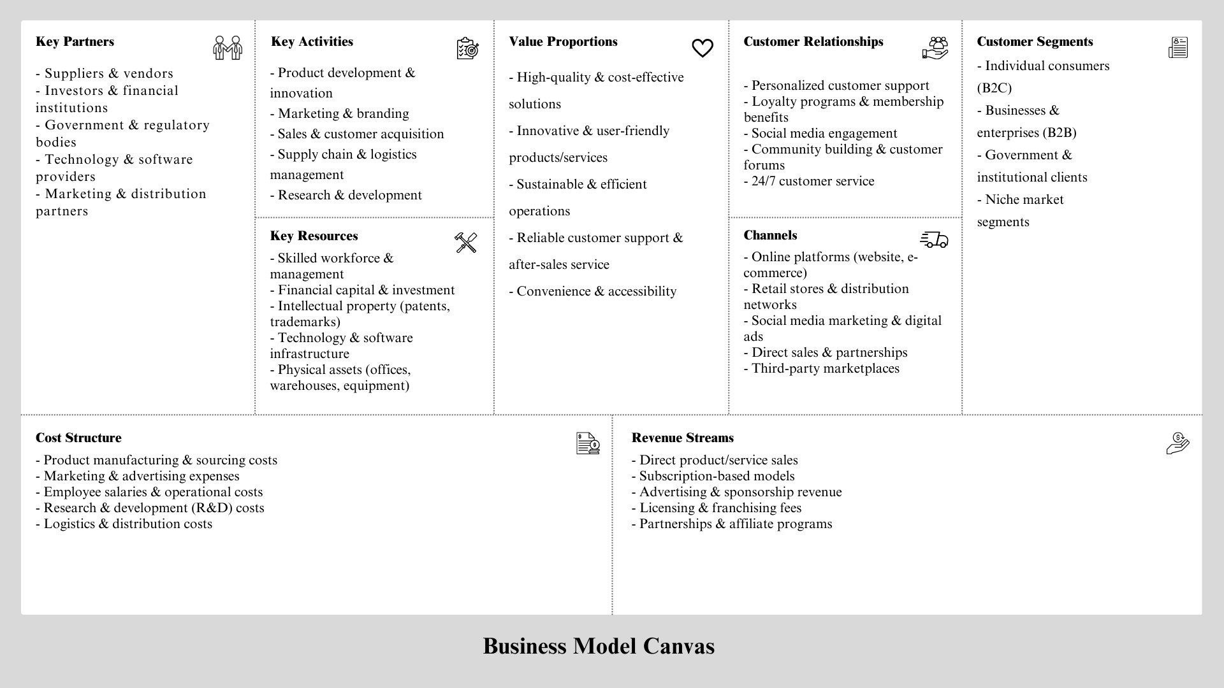

**Business Model Summary: Neuro-Adapt Learning**

Neuro-Adapt Learning is an AI-powered adaptive learning platform that integrates neuroscience and biometric feedback to create personalized learning experiences. The business model is designed for scalability and accessibility, catering to educational institutions, corporations, healthcare, and high-stakes training sectors.

**Revenue Streams:**

* Subscription-Based Model: Monthly or annual access for schools, businesses, and individual learners.

* Enterprise Licensing: Custom AI training modules for corporate training, healthcare, and government agencies.

* Partnerships & Collaborations: Joint research ventures with universities and ed-tech firms.

* Grants & Investments: Funding from venture capital, research grants, and innovation programs.

* Consulting & Custom Solutions: AI-driven learning analytics and tailored educational solutions.

**Competitive Advantage:**

* AI-Powered Personalization: Learner-centric content dynamically adjusts to cognitive states and engagement levels.

* Real-Time Neuroadaptive Feedback: EEG sensors, eye-tracking, and biometric monitoring optimize learning.

* Scalability & Accessibility: Cloud-based platform supports diverse learners across multiple industries.

* Multi-Sector Applications: Adaptive learning for education, corporate training, healthcare, and military simulations.

Neuro-Adapt Learning leverages cutting-edge AI, neuroscience, and biometric feedback to revolutionize education, ensuring enhanced learning outcomes, improved knowledge retention, and a personalized learning journey for every user.

# **Value Chains**

A value chain represents all the steps involved in creating and delivering a product or service. Neuro-Adapt Learning’s value chain ensures that its adaptive learning technology reaches students, educators, and organizations in the most efficient way.

1. **Inbound Logistics**:
   1. Sourcing and acquiring AI technology, neuroadaptive tools, and cloud computing services.
   2. Collaborating with suppliers who provide biometric sensors, VR/AR tools, and other necessary hardware.
   3. Collecting user engagement data to continuously refine the learning experience.
2. **Operations**:
   1. Developing AI-driven educational content that adapts to individual learning needs.
   2. Continuously improving content delivery using real-time neuroadaptive feedback.
   3. Offering various learning formats, including text, videos, interactive simulations, and VR/AR experiences.
3. **Outbound Logistics**:
   1. Distributing educational content through a cloud-based platform.
   2. Making learning materials accessible via mobile and web applications.
   3. Integrating AI-powered learning modules into third-party Learning Management Systems (LMS).
4. **Marketing and Sales**:
   1. Promoting the platform through online campaigns, education summits, and conferences.
   2. Partnering with schools, corporations, and healthcare organizations to expand adoption.
   3. Offering free trials and custom solutions to attract enterprise clients.
5. **Service and Support**:
   1. Regular updates and improvements based on AI-driven analytics.
   2. Providing technical support to ensure smooth learning experiences for users.
   3. Implementing strict data security protocols to protect user privacy and biometric information.

## Competitive Advantage

Neuro-Adapt Learning stands out from competitors by offering a highly personalized and scientifically backed learning system. Its key strengths include:

1. **Advanced Technology**:
   1. AI-powered learning that adapts in real-time to a student’s cognitive state.
   2. Neuroadaptive feedback that optimizes learning speed, engagement, and retention.
   3. VR/AR integration that makes learning more immersive and effective.
2. **Personalized Learning Experience**:
   1. AI-driven analytics that monitor cognitive load, attention span, and engagement levels.
   2. Adaptive learning strategies that ensure students retain information more effectively.
   3. Tailored content delivery based on each learner’s progress and needs.
3. **Scalability and Accessibility**:
   1. Cloud-based learning that enables global access to quality education.
   2. Customizable learning modules for different sectors, including schools, corporate training, healthcare, and military training.
   3. Inclusive support for neurodiverse learners, such as those with ADHD, dyslexia, and other learning disabilities.
4. **Strategic Partnerships and Market Leadership**:
   1. Strong collaborations with top universities and AI research centers.
   2. Recognized as an innovative leader in adaptive learning technology.

Ongoing investment in research and development to stay ahead of technological advancement

**BUSINESS PLAN**

**Welcome to the Future of Learning.**

Neuro-Adapt Learning is an innovative AI-driven learning platform designed to personalize education like never before. By using brain-computer interface (BCI) technology, biometric sensors, and adaptive AI, we can analyse a learner’s cognitive state in real time and adjust the material accordingly—ensuring a truly engaging and effective learning experience.

**Why Does This Matter?**

Traditional e-learning platforms follow a one-size-fits-all approach, but we know that everyone learns differently. Some students lose focus quickly, while others feel overwhelmed. Neuro-Adapt Learning understands these challenges and adapts instantly—helping students stay engaged, improve retention, and learn in a way that works best for them.

**What We Offer:**

* AI-powered Personalized Learning – Content adapts in real-time based on brain activity.
* Emotional & Cognitive Monitoring – Ensures students stay engaged without feeling overwhelmed.
* Enhanced Student Performance – Improves focus, memory retention, and learning efficiency.

**Who Needs This?**

* Students & Educators – Schools and universities looking for smarter learning tools.
* Online Learners – Anyone who takes courses through digital platforms.
* Corporate Training Programs – Companies that want smarter, more efficient employee training.

**How We Make Money:**

* + - Subscription-based SaaS for institutions.
    - Premium subscriptions for individual learners.
    - Enterprise licensing for corporate training programs.

1. **About Us**

We are a team of educators, AI experts, and neuroscientists who believe that learning should be as unique as the learner. Our mission is simple: to transform education with AI and neuroscience.

**What Makes Us Different?**

Unlike traditional learning platforms, which use pre-set courses, our technology adapts in real-time to suit the learner’s needs.

We use real biometric and brainwave data to understand when a student is struggling or disengaged.

We don’t just educate—we optimize how the brain learns.

**3.Understanding the Market**

The education technology market is booming, with e-learning expected to hit $400 billion by 2026. But here’s the problem: most platforms are outdated in how they teach.

* + Schools and universities are looking for better ways to engage students.

* + Online learners want more interactive and adaptive experiences.

* + Companies need smarter training tools for employees.

We’re here to fill this gap.

**Who Are We Competing With?**

Traditional Platforms (Coursera, Udemy, Duolingo) – Great for content, but lack real-time personalization.

AI-based Learning Tools (CogniFit, Muse) – Use brainwave data but don’t fully integrate AI-driven personalization.

**What Gives Us an Edge?**

* Real-time Adaptation – We adjust to the learner’s cognitive state immediately.
* True Personalization – We don’t just recommend content—we change how it’s delivered based on real-time brain feedback.
* Science-Backed Learning – Backed by neuroscience research to optimize engagement, retention, and focus.

**4. The People Behind the Innovation**

A business is only as strong as its team.

Role Expertise

CEO AI & Neurotechnology Visionary

CTO Machine Learning & BCI Integration

Head Of Education Expert in Adaptive Learning

Marketing Director Business Development & Outreach

**Our Strengths:**

* Cutting-edge AI & Machine Learning.

* Advanced Brain-Computer Interface (BCI) Technology.

* Strategic partnerships with schools, universities, and corporations.

1. **How It Works**

**Key Features:**

* Smart Adaptation: Content adjusts based on brainwave activity.
* Cognitive Load Balancing: Prevents information overload.
* Neurofeedback Training: Improves memory, focus, and retention.

**Pricing Plans:**

Plan Who It’s For Pricing

Institutional Subscription Schools & Universities Annual License

Individual Premium Plan Students & Professionals Monthly Fee

Corporate Training Solutions Businesses & Enterprises Custom Licensing

1. **How We’ll Grow**

**Marketing & Sales Strategy**

* We’re not just building a product—we’re creating a learning revolution.
* Social Media Engagement – Sharing insights on LinkedIn, Twitter, YouTube.
* Webinars & Demos – Educating institutions about our tech.
* Strategic Partnerships – Schools, universities, and corporate learning programs.
* SEO & Content Marketing – Blogs, research articles, and case studies.

**How We’ll Sell It:**

* Direct Sales to Schools & Universities
* Freemium Model for Individual Users (Upsell to premium plans)
* B2B Partnerships with Learning Platforms

1. **Financial Roadmap Revenue Streams:**

* Subscription Fees – For both institutions and individuals.
* Corporate Licensing Fees – Custom enterprise solutions.
* Research Grants & Partnerships – Collaborations with universities.

**Projected Growth:**

|  |  |  |
| --- | --- | --- |
| Year | Revenue Target | Key Goals |
| Year 1 | $500,000 | Pilot projects & early adopters |
| Year 2 | $2 million | Expand into universities & corporations |
| Year 3 | $5 million+ | Scale globally & form strategic partnerships |

1. **What Could Go Wrong? (And How We’ll Fix It) Potential Challenges:**

* Technology Adoption Resistance – Some educators might be hesitant to switch to

AI-driven learning.

* Data Privacy Concerns – Handling brainwave and biometric data responsibly is critical.
* Market Competition – Many players in ed-tech, but none doing real-time neuroadaptive learning like us.

**Our Solutions:**

* Strong Training & Onboarding for educators.
* Robust Data Security with GDPR & encryption compliance.
* Continuous R&D to keep us ahead of the competition.

1. **The Future of Learning Starts Here**

Education is broken—but we have a solution. Neuro-Adapt Learning is more than just a product—it’s a movement toward smarter, more personalized education.

**Our Next Steps:**

* Raise funds for research & expansion.
* Pilot with key educational institutions.
* Launch globally & scale.

# **CHAPTER 7:DESIGN THINKING AND MVP ESSENTIALSDesign Thinking for Neuro-Adapt Learning**

The five stages can be applied as follows:

**1.Empathize**

* Identifying the pain points in traditional learning methods often struggle with personalization and engagement and digital learning methods faces challenges such as high cognitive load, disengagement, and difficulty in maintaining focus.
* Understand cognitive load issues faced by students in online education such as such as through information overload, distractions, and difficulties in maintaining sustained attention.

**2.Define**

* This problem focuses on the dynamic needs of learners in different contexts, aiming to enhance engagement, reduce cognitive load, and support learners at various emotional levels.
* Define user personas: Each persona will have specific needs regarding adaptability, interactivity, and cognitive support, influencing the AI features of the platform.
  1. **Students**: Learners of various ages, disciplines, and learning styles who require personalized learning experiences.
  2. **Educators**: Teachers and instructors who need a tool to assess and enhance student engagement.
  3. **Corporate Learners**: Employees undergoing skill development who need adaptive, on-demand learning paths based on their real-time needs.

1. **Ideate:** 
   * It aims in brainstorming AI-based features that can address the defined problem and integrate the technology.
   * Brainstorm AI-based features like real-time engagement tracking, personalized content adjustments by developing an AI algorithm that adapts the difficulty level, pacing, and type of content based on a learner's current cognitive and emotional state, and attention-based intervention triggered by attention metrics.
   * Explore different technological integrations like BCI (Brain-Computer Interface) and machine learning models to predict and adjust learning content based on historical data, learning patterns, and real-time biometric feedback.
2. **Prototype:** 
   * It aims at building an initial version of the platform with core adaptive learning features which includes components like engagement tracking, and adaptive content presentation.
   * Test with a small group of users (students, educators) to validate the effectiveness by ensuring the test group is diverse to understand different learning styles and needs.

**5.Test:**

* + It includes collection feedback from users and refine the platform based on their experiences.
  + Gather user feedback on usability, effectiveness, and engagement by using surveys and look for patterns in how learners interact with the system, particularly with AI-driven personalization and intervention features.
  + Iterate by improving the AI model’s ability to personalize content dynamically and refining. Refine the platform based on feedback, focusing on areas like the speed of adaptation, accuracy of content recommendations, and learner satisfaction.

**MVP for Neuro-Adapt Learning**

1. **Core Problem or Need:**

**Problem:** Traditional learning systems often fail to engage students effectively, with a one-size-fits-all approach that doesn't cater to individual learning needs, pace, or attention span

**Need:** A personalized, adaptive learning system based on individual needs, focus levels, and performance to improve engagement, retention, and learning outcomes.

1. **Target Audience** 
   * **Early Adopters:**

○ **Students (High School/College/Online Learners):** Those seeking to improve their learning experience through personalized content and real-time feedback on their focus and performance.

○ **Instructors/Educators:** Teachers who want to enhance student engagement and improve educational outcomes through adaptive technology.

○ **Learning Institutions/Online Education Platforms:** Organizations looking to implement innovative learning tools to provide a more individualized experience for their students.

1. **Key Features:** 
   * Adjusts content in real-time based on how well the user is engaging with the material (e.g., difficulty level, topic depth).
   * Uses webcam or microphone sensors to assess focus (through eye-tracking, facial expressions, or voice analysis) to adjust content delivery based on attention levels.
   * AI recommends learning paths that adjust to the student’s current skill level, progress, and performance
   * Start with one subject or module to test the platform, e.g., math or a language learning module, before expanding to other subjects.

4.**Cost-Effective**

* + **Use Existing Tools/Frameworks:** Leverage existing AI frameworks, cloud services, and biometric tracking tools to minimize development time and costs.

1. **Product/Market Fit**

**Test with Target Audience:**

* + Engage your early adopters (students, educators, or institutions) to see if they find value in the adaptive learning system.

1. **Feedback:** 
   * Through surveys, interviews, and usage data, assess whether users find the personalized learning experience engaging and helpful. The feedback will help refine the AI algorithms and learning paths.

**CHAPTER 8: INTELLECTUAL PROPERTY RIGHTS AND LEGAL**

**ASPECTS, ETHICS AND SUSTAINABILITY**

## Intellectual Property Rights (IPR) for Neuro-Adapt Learning

Intellectual Property Rights (IPR) for neuro learning typically refer to the legal protections granted to innovations in neurotechnology, neuroscience, and educational methods based on neuroscience.

**1.Copyright:**

* **Educational Content**: Materials developed for neuro learning (e.g., books, videos, interactive content, software) are often protected by copyright. The specific content used to train students using neurolearning principles can be copyrighted.
* **Course Materials**: If you create a course or learning program based on neurolearning principles, it could be protected under copyright law.

**2.Trademark**: Branding elements like platform name, logo, should be registered as trademarks.

**3.Trade Secrets**: Proprietary AI models and data-processing methods should be protected to maintain a competitive edge. This includes confidential data on how neural processes relate to specific learning patterns or techniques.

1. **Licensing IP**: Neurolearning technologies and methods can be licensed to educational institutions, corporations, or individuals. Licensing agreements provide the holder of the IP with revenue while allowing others to use the technology under certain conditions.
2. **Collaboration between Academia and Industry:** Universities and private companies may collaborate on neurolearning innovations, often involving joint IP ownership.

# **Legal Aspects of Neuro-Adapt Learning**

Key Legal Considerations for neuro-adapt learning are as follows

**1.Data Privacy Laws:** This includes,

1. **GDPR (General Data Protection Regulation)**: Since biometric data is involved, obtaining explicit user consent and securing stored data with proper encryption against unauthorized access or breach is necessary to handle such data according to data privacy laws.
2. **CCPA (California Consumer Privacy Act)**: Users can request access to the personal information that a business has collected about them and also request deletion of their personal data. It ensures transparency through clear privacy policies which must disclose the categories of data collected.

**2.AI Bias and Fairness:** AI-based personalization must be transparent such that users should understand how decisions are made and how their data is being used in AI models and also it should be non-discriminatory ensuring system does not discriminate against any user based on protected characteristics (e.g., gender, race, disability) and that all users are given equal opportunities to benefit from the neurolearning system.

**3.User Agreements & Compliance:** Clear Terms of Service & Privacy Policies should define how user data is collected and processed. Both agreements should clearly disclose how biometric data and AI are used in the neurolearning process. Users need to understand how their neural data is analysed, processed, and how the AI personalizes their learning experience.

**4.Educational Compliance:** If integrated with institutions, compliance with academic accreditation standards is required that set standards for educational technology and tools used in the classroom.

# **Ethics and Sustainability Ethics in Neuro-Adapt Learning**

AI in education must prioritize fairness, privacy, and mental well-being.This can be achieved through following ethics which is as follows:

* User Privacy Concerns: Ensure full transparency in biometric tracking & data handling.
* AI Decision-Making Transparency: Explain why a learning path is adapted for a student.
* Mental Well-being: Prevent AI from overloading students with aggressive personalization.
* Accessibility & Fairness: Ensure AI learning is equally effective across diverse demographics.
* Use anonymized biometric data for AI training.
* Offer an opt-in/opt-out option for adaptive tracking.
* Regularly test AI algorithms for bias and fairness.

**Sustainability in Neuro-Adapt Learning:**

A sustainable AI-driven education model should be environmentally, socially, and economically responsible. Some of the sustainability strategies are:

* Green Cloud Computing – Optimize AI data processing to reduce carbon footprint.
* Equal Learning Access – Offer affordable or free learning models for underserved students.
* Long-Term Viability – Develop an AI system that continuously adapts and improves without excessive energy consumption.
* Ethical AI Deployment – Ensure responsible AI practices that benefit education in the long run.

# **CHAPTER 9: PROTOTYPING AND TESTING DETAILS**

## Prototyping and Testing for Neuro-Adaptive Learning

Neuro-adaptive learning is a high-level approach that harnesses neuroscience, artificial intelligence (AI), and adaptive learning technologies to optimize learning experience. It leverages physiological and neurophysiological signals such as brain activity (EEG), heart rate, eye movement, and galvanic skin response to monitor a learner's cognitive and emotional state in real time. Based on this, the system dynamically adjusts content, difficulty levels, and pedagogy to optimize learning outcomes.

Designing neuro-adaptive learning systems entails two crucial stages: prototyping and testing. Prototyping is used to create early models of the system, whereas testing validates effectiveness, usability, and ethical adherence. This report discusses these stages in depth.

1. **Prototyping in Neuro-Adaptive Learning**

Prototyping is iterative development of the early versions of the system for test-driving and debugging its functioning and design before being implemented on a final scale. Prototyping guides developers, researchers, and teachers to better understand how the system will motivate the learners and handle their thinking patterns.

**1.1 Conceptual Prototyping**

This step involves defining goals, technologies, and adaptation strategies for the neuro-adaptive learning system. Some principal components include:

1. **Defining Learning Goals** 
   * + Identify target audience (trainees, professionals, students).
     + Specify learning objectives, e.g., retention of knowledge, solving problems, emotional arousal.
     + Specify performance metrics like response time, accuracy, and retention rates.

1. **Hardware and Software Selection** 
   * + Neurophysiological Sensors’ headsets for neural signals, eye-tracking cameras, heart rate sensors, and skin conductance sensors.
     + Software Platforms:AI-driven adaptive learning software, real-time analytics software, and cloud-based learning management systems (LMS).
     + Machine Learning Models: Models that analyse neural responses and modify learning material accordingly.

1. **Designing Adaptation Mechanisms** 
   * + Content modification: Modifying text, audio, and video difficulty based on cognitive load.
     + Pacing adjustments: Slowing or speeding lessons based on engagement.
     + Feedback mechanisms: Providing real-time prompts, cues, or encouragement based on learner stress or fatigue.

**1.2 Functional Prototyping**

Functional prototyping involves creating a Minimum Viable Product (MVP)a bare-bones version of the neuro-adaptive system with essential features.

1. **MVP Construction** 
   * Construct a bare-bones neuro-adaptive interface with real-time sensor fusion.
   * Create preliminary machine learning models for data interpretation.
   * Provide real-time feedback loops for dynamic learning content adaptation.

1. **User Interface Development** 
   * For Learners: Personalize dashboards presenting progress, suggestions, and engagement levels.
   * For Teachers: Tools for observing students' attention, mental workload, and performance.
   * For System Administrators: Settings for adjusting sensitivity levels of adaptive feedback.

1. **Data Collection & Processing** 
   * EEG, eye movement, and physiological sensor signals are captured and processed.
   * Patterns of attention, stress, and mental load are identified by machine learning.
   * The system dynamically adjusts according to these insights.

1. **Testing in Neuro-Adaptive Learning**

Testing is crucial in verifying the efficiency, precision, and ethical considerations of a neuro-adaptive learning system. It includes multiple layers of testing, including usability, performance, validation, and ethical considerations.

**2.1 Usability Testing**

Usability testing verifies that learners and teachers are able to use the system easily. Critical factors involve:

1. **User Experience (UX) Evaluation** 
   * + Conduct pilot studies with real learners to quantify system ease-of-use.
     + Identify usability problems like sensor discomfort, latency in adaptive responses, or interface complexity.
     + Improve UI/UX based on user feedback.

1. **Cognitive Load Analysis** 
   * + Quantify whether the system is effective in alleviating cognitive overload by providing real-time adjustments to content.
     + Utilize eye-tracking and EEG data to quantify attention span and stress levels.
     + Optimize system responsiveness to cognitive changes.

**2.2 Performance Testing**

Performance testing evaluates the efficiency and effectiveness of neuro-adaptive adjustments.

1. **Learning Outcomes Assessment** 
   * + Compare learning performance of neuro-adaptive versus non-neuro-adaptive learning processes.
     + Measure retention, problem-solving capacity, and engagement improvement.
     + Conduct A/B testing to determine effectiveness.

1. **System Responsiveness Testing** 
   * + Verify the capacity of the system to respond in real-time without perceivable latency.
     + Test the AI algorithm performance for neurophysiological signal interpretation.
     + Adapt response latencies for dynamic content delivery.

●

**2.3 Validation Testing**

Validation ensures the system to produce predictable, reliable, and accurate output.

1. **Accuracy of Neuro-Data Interpretation** 
   * + Compare gathered EEG and physiological data to known cognitive states.
     + Cross-validation machine learning outputs with expert opinions by neuroscientists and educators.

1. **Consistency Across Users** 
   * + Test system performance across demographics (age, skill levels, learning styles).
     + Provide non-bias adaptability for diverse learners.

**2.4 Ethical & Privacy Testing**

Neuro-adaptive learning involves the collection of sensitive neurophysiological data, which raises ethical and privacy concerns.

1. **Data Security & Privacy Protection** 
   * Compliant with data protection laws (GDPR, HIPAA).
   * Employ secure encryption and anonymization of students' data.
   * Allow users to opt-in and decide on data-sharing choices.

1. **Ethical Considerations** 
   * Obtain informed consent before collecting neurophysiological data.
   * Avoid making the system manipulate emotions or cause unintentional cognitive load.
   * Be transparent about how neural-data is employed and shared.

1. **Iterative Improvement**

Once the system completes initial testing phases, iterative enhancements help improve performance and usability.

* 1. **Continuous Learning & Model Updates** 
     + AI models are regularly re-trained on fresh data to improve adaptation accuracy.
     + Feedback loops allow the system to learn from past errors and user preferences.

* 1. **Large-Scale Deployment** 
     + After successful small-scale trials, the system can be deployed in schools, corporate training, and personalized learning platforms.
     + Performance is tracked to make sure that it is effective in the long run.

Prototyping and testing are crucial to developing neuro-adaptive learning systems. Prototyping involves making, building, and iterating the system, whereas testing confirms usability, performance, reliability, and ethical practices. With the help of AI, neuroscience, and adaptive learning principles, neuro-adaptive learning has the potential to make education a more personalized, interactive, and effective process. However, ongoing research and ethical practices are required to further advance these systems and apply them responsibly.

**CHAPTER 10: CONCLUSION**

**CONCLUSION**

Our project represents a significant step in the direction of integrating AI-based, neuroadaptive learning methods with the practical needs present in the educational environment. Through the very recognition of a significant problem—i.e., the inability of conventional learning systems to adapt adequately to the individualized needs of unique students—the ground has been laid for us to work assiduously toward the development of a solution that individualizes the learning process. This is finalized by the use of advanced technologies, including biometric sensors and artificial intelligence, which communicate with each other to provide learning experiences that are individually tailored to the unique needs of each student.

Ever since the very beginning of our journey of development, our one and only mission has been to enhance the learning process by making learning not only more effective but also significantly more engaging and accessible to the masses. To fulfill that goal, we have designed a Minimum Viable Prototype (MVP) with great care that precisely incorporates learner-specific learning paths with room for customization according to specific needs. Furthermore, it also incorporates real-time adaptations sensitive to engagement levels by students to make the learning environment responsive. Finally, our innovative approach includes AI-driven interactive explanations that provide clarity and context. This integrated design ensures that each learner gets to have a distinctive learning experience that is specifically designed to match his or her cognitive ability and individual learning style.

Our comprehensive financial analysis, which involves a variety of different factors such as revenue models, intricate cost structures, and detailed break-even projections, guarantees with absolute certainty that this particular project is not only innovative in approach but is also poised to be sustainable in the long term. We have strategically outlined potential funding sources that can be tapped, as well as a realistic and well-structured roadmap that is poised to lead us to achieving a state of financial stability. The breakeven analysis we conducted shows that once we are able to successfully reach a given number of users, the project will be a self-sustaining entity, thereby opening the door to vast future growth and expansion opportunities that lie ahead.

Market strategies involving the integration of pricing, promotion, and distribution have been thoroughly thought out and thoroughly designed with the final goal being that the product truly reaches and connects with the appropriate target market—namely, students, educators, and institutions of education that are actively seeking an even stronger and more responsive learning experience. By forming strategic alliances and employing an aggressive and powerful team approach, we are convinced that our startup is especially well-positioned to have a serious and lasting impact in the very dynamic and ever-evolving EdTech market.

Apart from this, we have also exercised extreme caution in responding to a variety of key considerations including legal, ethical, and sustainability concerns to ensure that our cutting-edge solutions are in complete sync with current data privacy legislation and commonly accepted ethical standards. We have also considered the most significant aspects of Intellectual Property Rights (IPR) to ensure that our technology and overall strategy not only continue to remain well guarded but also meet the industry standards that regulate our domain.

In summary, it must be said that this project is far more than a concept; it is a very highly structured initiative that is deeply rooted in a tremendous amount of research and is fiscally sound. With the right implementation and proper execution, this initiative has the incredible potential to radically alter the landscape of personalized learning, making education not only more adaptive and inclusive but also significantly more effective for learners of all varieties. In the future, we are dedicated to continually refining and optimizing our prototype, testing it extensively with real users in order to gain valuable feedback, and working diligently towards the achievement of official status in some form, be it through the acquisition of patents, publication of our work, or registration as a startup. Long-term, our ultimate goal is to be able to successfully close the gap that currently exists between technology and education, making the learning process an honestly personalized and effective experience for all parties.

# **CHAPTER 11: BIBLIOGRAPHY**

## BIBLIOGRAPHY

## 

* Anderson, J. R. (2005). *Cognitive Psychology and Its Implications*. Worth Publishers. ● Luck, S. J. (2014). *An Introduction to the Event-Related Potential Technique*. MIT Press.
* D’Mello, S. K., & Graesser, A. C. (2012). *Dynamics of affective states during complex learning*. Learning and Instruction, 22(2), 145-157.
* Picard, R. W. (1997). *Effective Computing*. MIT Press.
* Wilson, R. C., & Collins, A. G. E. (2019). *Ten simple rules for the computational modeling of behavioral data*. eLife, 8, e49547.
* Ghosh-Dasti Dar, S., & Adeli, H. (2009). Spiking neural networks. *International Journal of Neural Systems*, 19(4), 295–308. <https://doi.org/10.1142/S0129065709002002>
* Liu, D., & Zhang, Y. (2017). Adaptive learning and control for nonlinear systems using neural networks. *Springer International Publishing*. <https://doi.org/10.1007/978-3-319-56157-1>
* Wang, D., & Arbib, M. A. (1993). Timing and chunking in processing temporal order. *IEEE Transactions on Systems, Man, and Cybernetics*, 23(4), 993–1009. <https://doi.org/10.1109/21.260682>
* Bishop, C. M. (2006). *Pattern recognition and machine learning*. Springer.
* LeCun, Y., Bengio, Y., & Hinton, G. (2015). Deep learning. *Nature*, 521(7553), 436–444. <https://doi.org/10.1038/nature14539>
* Li, Y., & Song, H. (2017). Brain-inspired computing with spiking neural networks: A review. *Neuroscience Bulletin*, 33, 629–643. <https://doi.org/10.1007/s12264-017-0170-1>

**PROTOTYPE**

[**https://anoushkasinghchauh.wixsite.com/neuroadapt-learning**](https://anoushkasinghchauh.wixsite.com/neuroadapt-learning)

