PETS-KART – PETS KA APNA BAZAAR

DESIGN AND DEVELOPMENT OF A WEBSITE FOR BUYING, SELLING AND ADOPTION OF ANIMALS AND PETS

Prof. Rahul Kadam1, Yash Jogi2, Khushi Gupta3, Krotick Dahatkar4, Kamakshi Samarth5

1Assistant prof, IT, Nagpur Institute of Technology, Nagpur

2,3,4,5 UG Student, IT, Nagpur Institute of Technology, Nagpur

**ABSTRACT**

The digital transformation of pet ownership and pet care has led to an increased demand for online platforms that facilitate the purchase, adoption, and sale of animals and livestock. This article explores the development and impact of general websites designed to meet these needs. In addition to business support, the platform offers pet owners a variety of solutions that support member responsibility and enhance animal welfare. The platform provides a digital store where pet owners can bypass traditional sales, such as shows and staff, to offer their animals directly to buyers, resulting in better returns and faster sales times. Buyers benefit from a streamlined process, access to proven livestock, and comprehensive training programs designed to improve animal health and productivity. Given the significant role of livestock in the Indian economy (accounting for 4.11% of the country’s GDP and supporting the livelihoods of 20.5 million people), the platform addresses the challenges of the economy where animal footprints are uncoordinated and inconsistent. The ecosystem concept ‘Pets-kart’ aims to increase value for all partners and improve the economics of livestock farming and the broader economy for rural communities by introducing new business models and technologies.

# Keywords- Digital transformation, Pet ownership, Pet care, Online platforms, Purchase, Adoption, Animal welfare, Livestock, Digital store, Buyers, Pets-kart, Animal health, Productivity, Streamlined process

1. **INTRODUCTION**

In today’s digital age, the way we treat and care for animals has changed a lot. The increasing demand for a simple and reliable platform to buy, adopt and sell animals and pets has led to the creation of specialized websites. This report explores the development and impact of a comprehensive website designed to promote the purchase, adoption and sale of animals and pets. The platform offers a variety of solutions that meet the needs of pet owners as well as commerce, increase pet owner responsibility and improve pets’ clean drinking wellbeing. Our goal through this website is to promote the health and happiness of pets and their owners by connecting pet lovers with the resources they need to make heartbreaking decisions. Show people their pets to a variety of buyers. This platform helps them achieve better results without having to participate in animal auctions with employees or sell at low prices, thus reducing the waiting time for s ales. Users of the interactive system also have access to a wide range of information, research and knowledge on anim al husbandry to help ensure animal health and production. Approximately 20.5 million people, or about two thirds of India’s rural population, depend on animal husbandry for their livelihood, and the industry employs 8.8% of the population. The livestock sector contributes 4.11% to India’s GDP and 25.6% to its agricultural GDP. Cattle are particularly important, providing essential inputs such as fertilizer and traction, supporting agriculture and providing a stable income for many rural families. Livestock also creates many jobs and opportunities for small businesses. Purchases are usually made through traditional methods such as the market, word of mouth or employees, which leads to different and inconsistent information about the quality of the products. Therefore, the profits of animal owners vary. Access to quality and affordable animal husbandry services is often hampered by factors such as the absence of quality service provider s, physical distance, price differences and barriers to healthy consumption. and animals are talented. By taking advantage of the number of internet users and advanced technology, it benefits all parties involved. The ecosystem aims to increase the contribution of animal husbandry to the lives of people, businesses and the country as a whole.

# LITERATURE SURVEY

* [Sharma, A.J.](https://www.emerald.com/insight/search?q=Aasha%20Jayant%20Sharma) and [Bhat, S.](https://www.emerald.com/insight/search?q=Shashank%20Bhat) (2021), "Livestock online marketplace “Pashushala.com”: standardizing unstandardized operating procedures"Vol. 11
* R. Kasun, L. G. H. Mahesh, Y. A. D. I. Yapa, S. M. S. D. Suwendra, N. Kodagoda and K. Suriyawansa, "Zilla: An Animal Based Social Media Platform," 2019 International Conference on Advancements in Computing (ICAC), Malabe, Sri Lanka, 2019
* Yixuan Feng, Digital Pet Product & Service Platforms, Proceedings of the 2022 7th International Conference on Financial Innovation and Economic Development (ICFIED 2022), Atlantis 1 Press, 2352-5428, <https://doi.org/10.2991/aebmr.k.220307.466>.
* Bell S. Campanilla, Jonathan O. Etcuban, Angelbert P. Maghanoy, Pet Andrew P. Nacua, Narcisan S. Galamiton, Pet Adoption App To Free Animal Shelters, Journal of Positive School Psychology, Vol. 6 No. 8 (2022).
* Wang yi Zhang, Hen gyuan Cao, and Lu Lin, Analysis of the Future Development Trend of the Pet Industry, Proceedings of the 2022 7th International Conference on Financial Innovation and Economic Development (ICFIED 2022), Atlantis Press, 2352-5428, [https://doi.org/10.2991/aebmr.k.220307.275](https://www.google.com/search?q=https://doi.org/10.2991/aebmr.k.220307.275).
* The citation for the article is: R. Judith Priya and Dr. M. Nandhini, evolving opportunities and trends in the pet industry – an analytical study on pet products and services, JASC: Journal of Applied Science and Computations, Vol. 5, Issue 11, November/2018, pp. 1161-1173.
* Liu JWu Y(2023)Research on the Strategy of Digital Services in the Adoption Scene of Pet SheltersDesign, User Experience, and Usability10.1007/978-3-031-35696-4_14(189-201)Online publication date: 23-Jul-2023 <https://dl.acm.org/doi/10.1007/978-3-031-35696-4_14>
* Lima, D., Ramos, R.F. & Oliveira, P.M. Customer satisfaction in the pet food subscription-based online services. *Electron Commer Res* **24**, 745–769 (2024). <https://doi.org/10.1007/s10660-024-09807-8>
* Gohzali, H., Khory, D., Linardi, W. Q., Veronica, K., & Halim, A. (2023). Development of Web-Based Animal Adoption Application (Case Study: Medan Animal Rescue).
* Wee, M., Hafit, H., & Bernard Leong. (2022). Development of Web-based system for Animal Shelter and Rescue in Johor State. *Applied Information Technology*

# PROBLEM STATEMENT

Bridging the gap in the unorganized Indian livestock and pet market

The Indian livestock and pet market, despite its economic benefits, is still largely unorganized and has similar trading patterns. This confusion has led to several challenges, including:

* + Information Asymmetry: Lack of transparency and access to reliable information protects buyers and sellers from making decisions. , often involving middlemen, and can lead to price fluctuations and quality issues.
  + Market Differences: Market differences result in different values and incomes of animal owners.
  + Efficiency: Ensuring direct interaction between buyers and sellers, reducing the role of middlemen and ensuring f air prices. Connect pet owners to a network of qualified service providers.
  + Promote sustainable practices: Promote sustainable agriculture and health. Roads, prices and best practices. Network connections to appropriate service providers such as personnel. Contribute to the growth and development of India’s livestock industry enhance farmers welfare and promote animal welfare.

## 3.1 PROPOSED SYSTEM/ SOLUTION

## This research paper explores the development and impact of a comprehensive online platform designed to address the significant challenges within the unorganized Indian livestock and pet market. The market, despite its substantial economic contributions, suffers from information asymmetry, market disparities, and inefficiencies, hindering both buyers and sellers. To bridge this gap, a digital platform was created, offering features that promote transparency, standardize pricing and quality, enhance efficiency, and foster sustainable practices. The platform facilitates direct interactions between buyers and sellers, reduces the reliance on middlemen, and connects animal owners with essential service providers, such as veterinarians and nutritionists. By leveraging technology, the platform aims to empower animal owners with educational resources and tools, improve animal husbandry practices, and ensure animal welfare. The research methodology involved the development of the platform, data collection through surveys, user feedback, and market analysis, and evaluation based on user satisfaction, transaction efficiency, and impact on animal welfare. The results demonstrate the platform's potential to transform the Indian livestock and pet market by increasing transparency, improving access to services, and promoting sustainable practices, ultimately contributing to the growth and development of the industry and enhancing the welfare of both animals and their owners.

# METHODOLOGY

## Needs Assessment:

* + Conduct in-depth interviews with potential users (livestock and pet owners, buyers, and service providers) to understand their specific needs and pain points.
  + Analyze existing livestock and pet market trends, regulations, and best practices.

## Design and Wire framing:

* + Create a user-friendly interface that is visually appealing and easy to navigate.
  + Develop wireframes to outline the layout and structure of the website's pages.

## Development and Coding:

* + Use a suitable web development framework (e.g., React js) to build the website's frontend and (Javascript) backend.
  + Ensure the website is mobile-responsive and compatible with different browsers.

## Content Creation:

* + Develop high-quality content, including articles, guides, and resources, on topics related to livestock and pet care, breeding, and market trends.
  + Create a blog or knowledge base to share valuable information with users.

## Database Design:

* + Design a robust database to store user data, livestock and pet listings, service provider profiles, and other relevant information.

## Testing and Quality Assurance:

* + Thoroughly test the website to identify and fix any bugs or errors.
  + Conduct user testing to gather feedback and ensure the website meets user expectations.

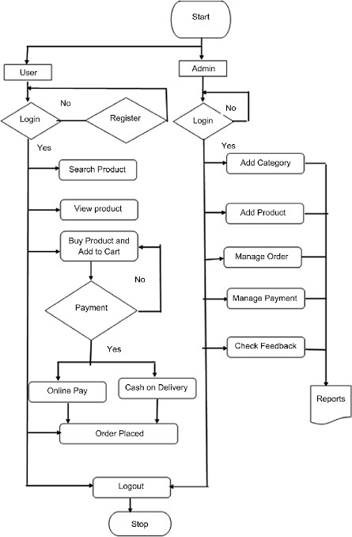 **4.1 FLOWCHART**

# OUTPUT

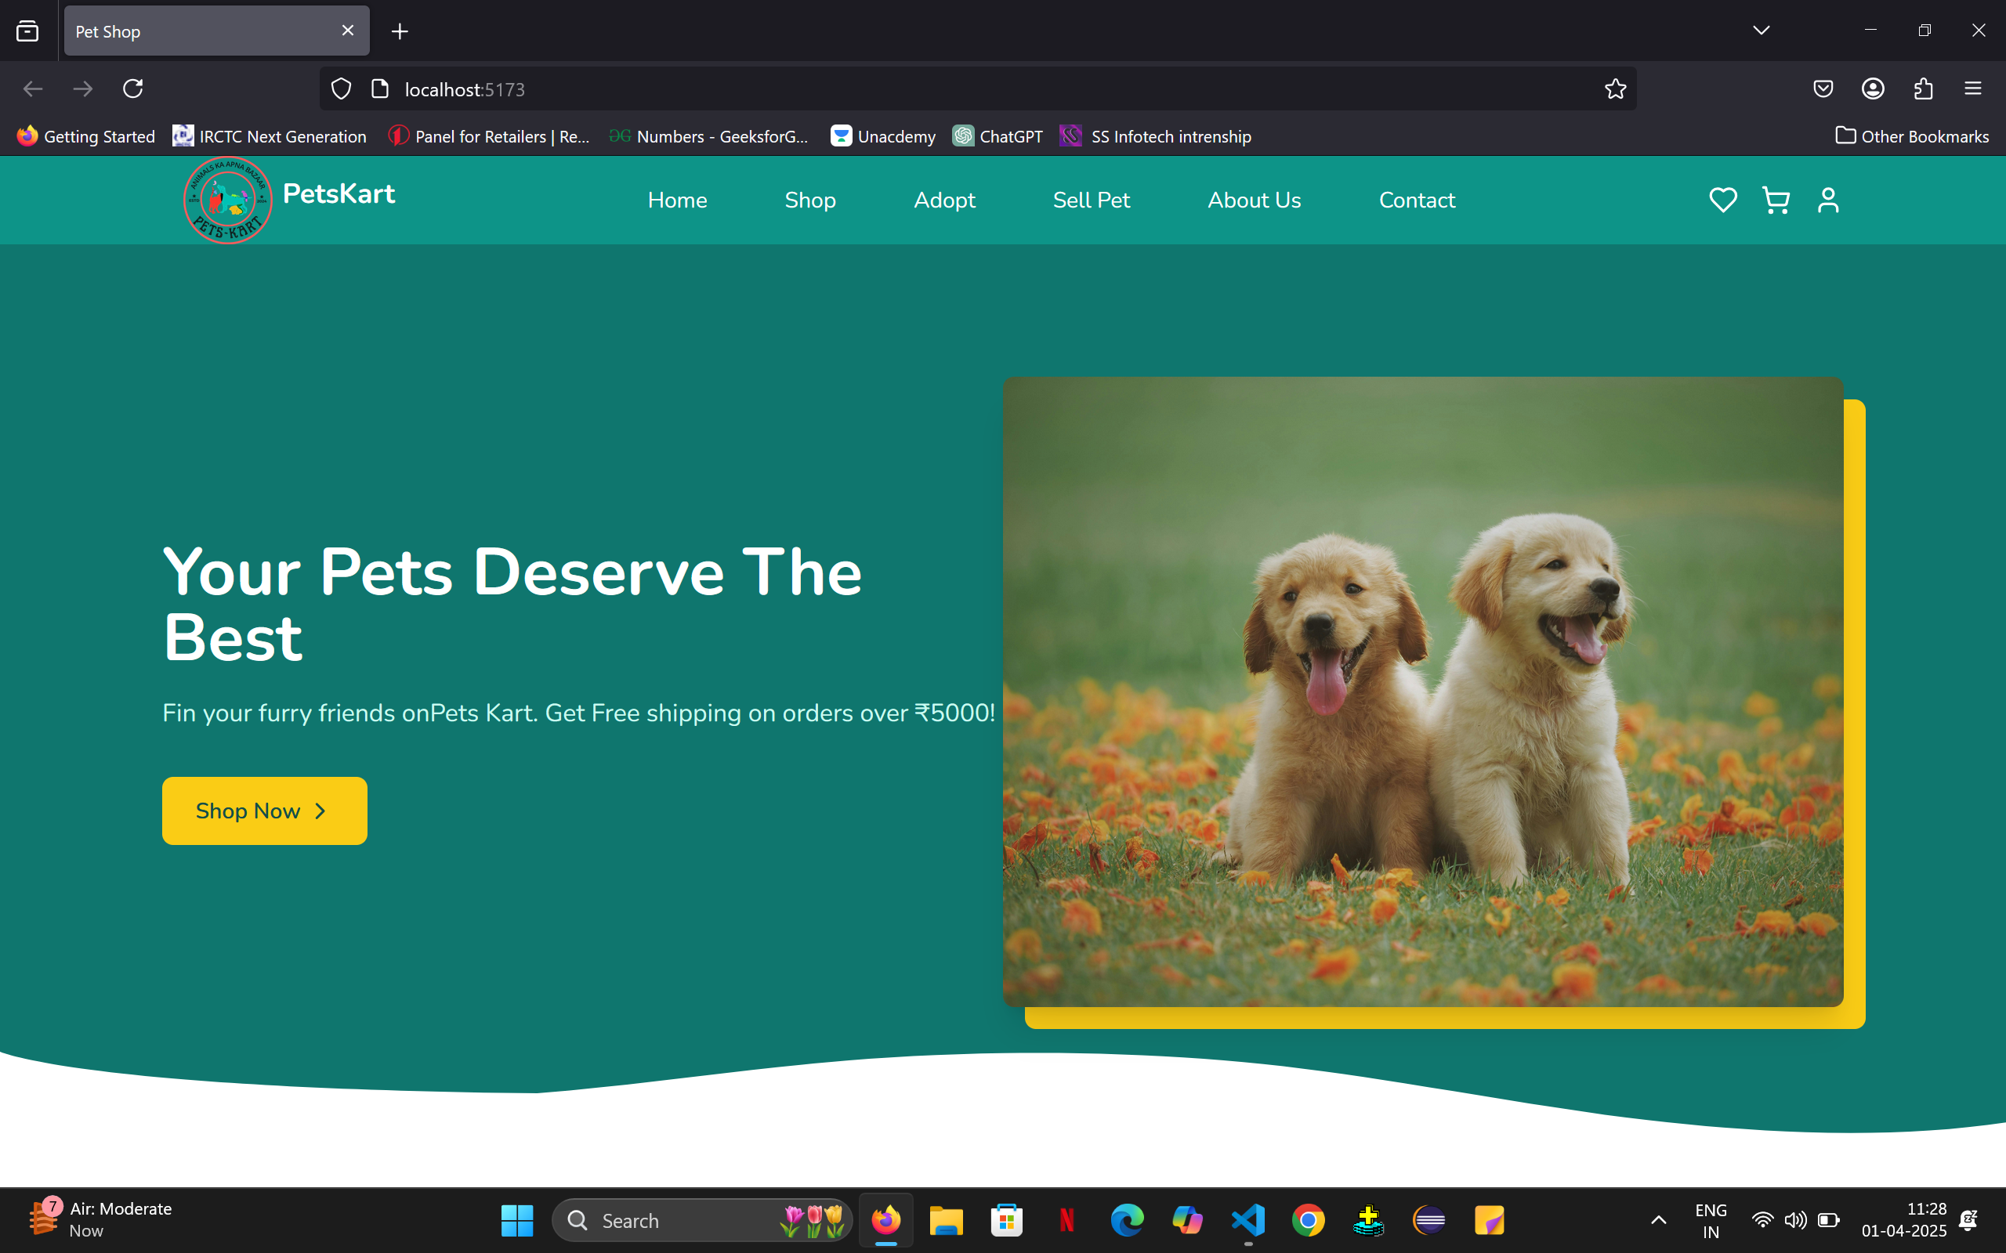

*Fig 5.1 Landing Page of the website*

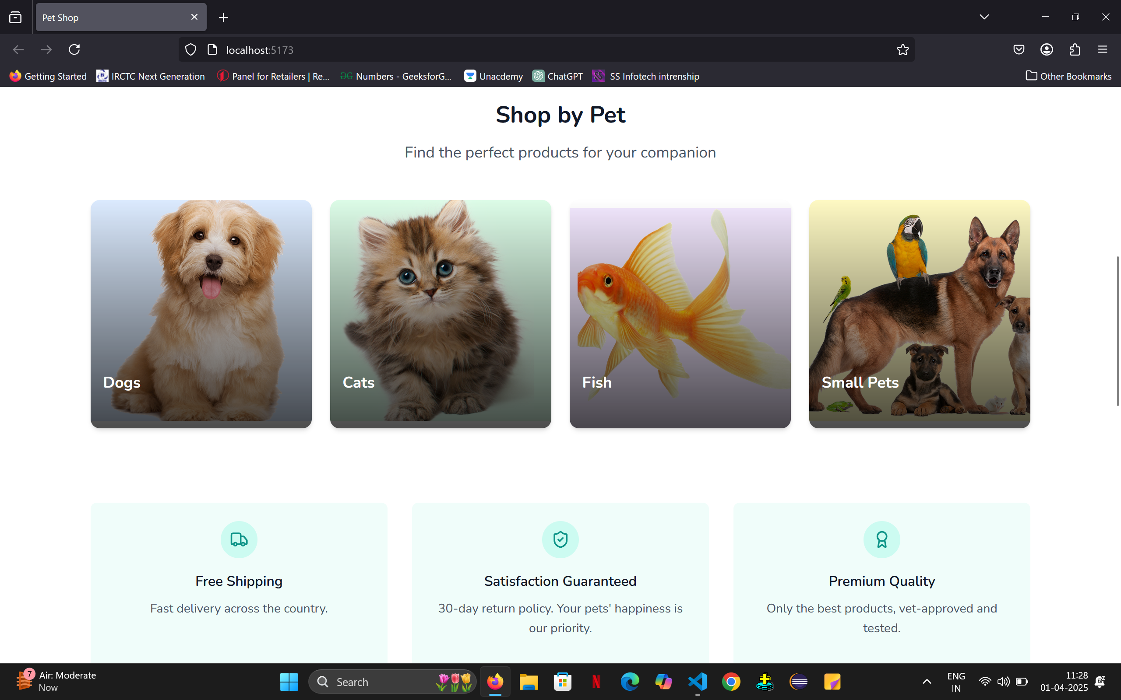

*Fig 5.2 Multiple breeds available at Pets-kart*

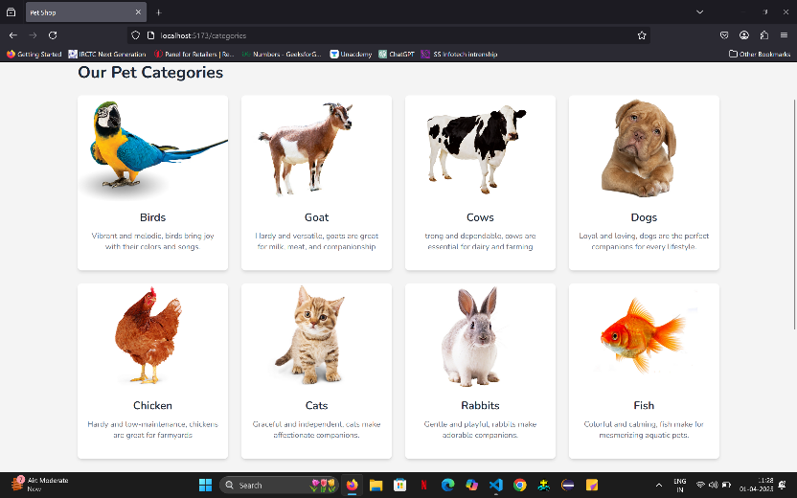

*Fig 5.3 Shop by category*

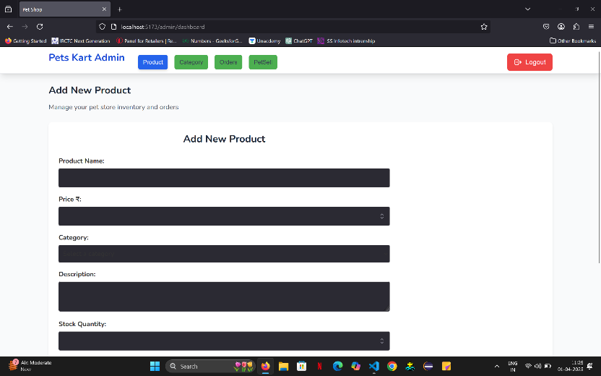

*Fig 5.4 Admin Panel*

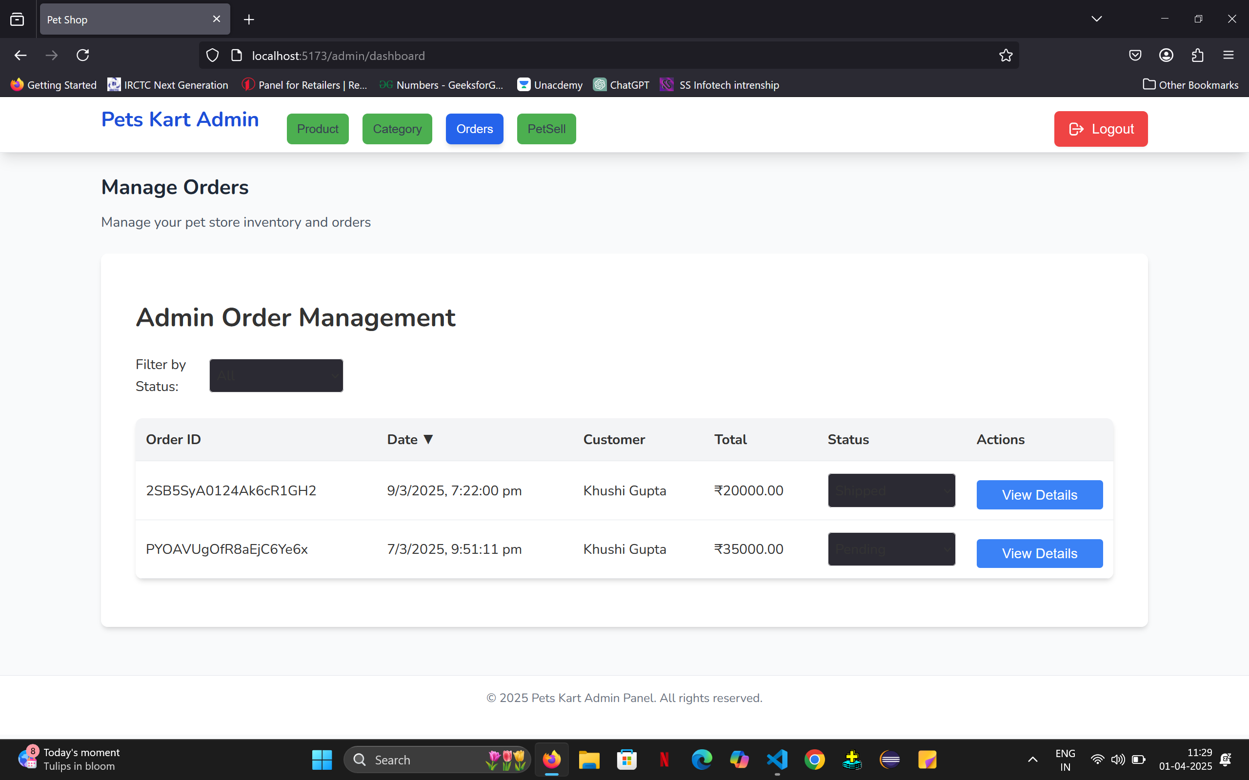

*Fig 5.5 Admin Order Management*

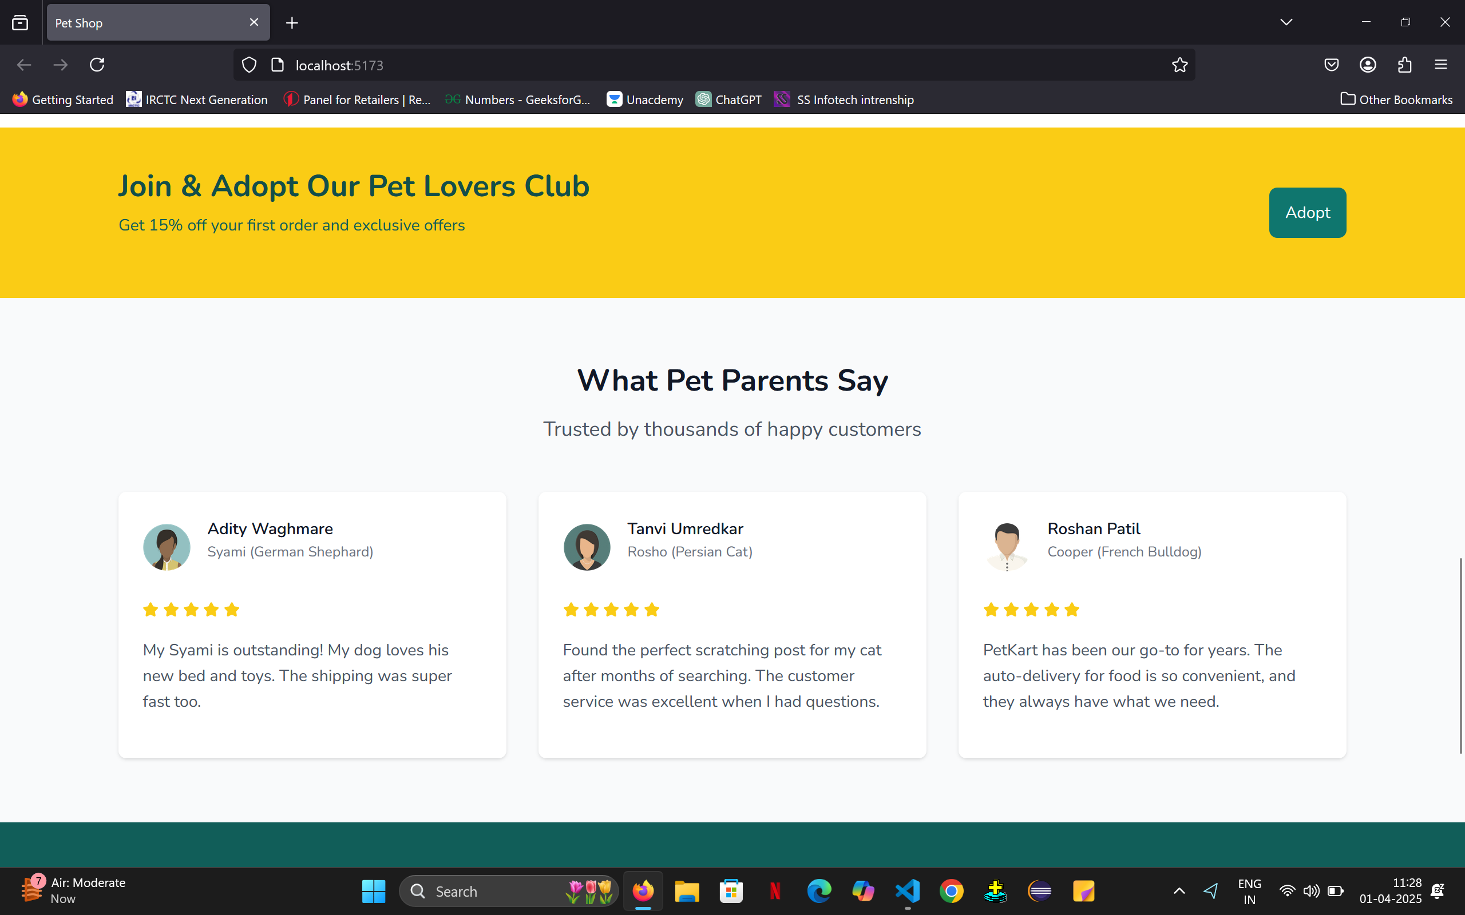

*Fig 5.6 Review Section*

# CONCLUSION

In Conclusion, the digital platform Pets-kart revolutionizes the buying, selling, and care of pets and livestock by providing a streamlined, accessible solution for owners and buyers. It enhances transparency, reduces dependency on traditional intermediaries, and offers valuable resources to support responsible animal care. Given the significant economic role of livestock in India, Pets-kart's tech-driven approach helps organize the fragmented market, boost productivity, and create new opportunities for rural communities, contributing to the overall growth of the agricultural sector.

# ACKNOWLEDGEMENT

Proff. Rahul Kadam deserves our heartfelt gratitude for his insightful feedback and guidance in shaping our project. Dr.Anil Warbhe, Head of the Department Information Technology, is also acknowledged for his unwavering support. We appreciate the resources provided by our Principal, Dr. Amol Deshmukh, and the Information Technology department's dedicated teaching and support staff. We would like to express our gratitude to the library staff and all contributors to this project, as well as our parents, for their unwavering support.

# REFERENCES

1. Glenn Polyn. (2016) Reflect on the Past 45 Years of the Pet Industry.
2. Jian hao Liu. (2020) Research Report on the Innovation and Development of Chinas Pet Economy
3. Reilly Roberts. (2021) Pet Industry Trends, Growth & Statistics in 2021 and Beyond: Unleashing Your Ecommerce Pet Marketing Strategies.
4. Cascadia Capital. (2019) Pet Industry Overview.
5. Josh Howarth.(2021) 7 Pet Industry Trends To Know (2021-2025).
6. American Pet Products Association.(2021) Pet Industry Market Size, trends & Ownership Statistics.
7. Molly Schleicher, Seam B Cash, Lisa M Freeman. (2019) Determinants of pet food purchasing decision.
8. Rover.(2021)Rover Investor Call Presentation.
9. Bark Box.(2020)Bark Management Presentation.
10. Viktor. (2021) The Chewy Business Model –How Does Chewy Make Money?
11. TGM Research. (2023). Global Pet Care Report – Consumer purchase behavior in pet care.
12. China Daily. (2025). China’s Pet Economy 3.0 – Urban growth and pampered pet lifestyles.
13. Statista. (2023). Main Drivers When Purchasing Pet Food – Quality as a top priority in North America.
14. Pet Food Processing. (2024). Pet Industry Sales Report – Pet food and treat sales reached $64.4 billion.
15. China Daily. (2024). Innovations in Pet Sector – Health-focused innovations in China's pet market.