**Nonlinear Analysis of Precast Beam under Four Point Loading**

Kummara Siva Prasad a* 🖂

a* Assistant professor, Sanskrithi School of Engineering, Puttaparthi, Andhra Pradesh, India -515134. Tel: +91-9948567845. 🖂 sivaprasad.k@sseptp.org

**ORCID ID:** Kummara Siva Prasad (https://orcid.org/0000-0001-8277-0196).

**Abstract-** Experimental investigations of precast beams are labor-intensive and costly, but nonlinear analysis offers a viable, efficient alternative. Using equations from basic experiments, finite element models can effectively study flexural properties. This paper presents a nonlinear analysis of precast beams using the finite element analysis tool ABAQUS to study their flexural properties. Precast beams of 1100 x 150 x 150 mm, made of M40 grade concrete, were subjected to four-point loading tests to measure flexure and deflection. Simultaneously, nonlinear analysis was conducted in ABAQUS, accurately modeling the geometry and material properties to replicate experimental conditions. This demonstrates that ABAQUS can effectively simulate the flexural behavior of precast beams when provided with appropriate material properties and boundary conditions. Finally, the nonlinear analysis using ABAQUS is a reliable method for studying precast beams' flexural properties, reducing the need for extensive physical testing and saving time, labor, and costs. This approach offers a robust tool for various structural investigations.

**Keywords:** ABQUS, precast concrete, four-point load, concrete, nonlinear analysis.

**1. Introduction**

The evolution of finite element analysis (FEA) software is closely tied to the advancements in finite element theory and computer technology. As computational capabilities and theoretical frameworks advance, FEA tools become more sophisticated, allowing engineers to tackle increasingly complex problems with greater accuracy and efficiency. Among the myriad of FEA tools available, ABAQUS stands out as one of the most comprehensive and widely used programs in the engineering industry. Its popularity stems from its speed, accuracy, cost-effectiveness, and a user-friendly interface that enhances the operator experience. This is particularly evident in the nonlinear analysis of precast concrete structures. ABAQUS offers a robust platform for simulating complex structural behaviors under various loading conditions. Its capabilities are not limited to linear analysis; it excels in nonlinear analysis, which is crucial for understanding the real-world performance of materials like concrete that exhibit nonlinear stress-strain relationships. The software's advanced algorithms and extensive material models allow for precise simulations that closely mimic actual physical phenomena.

To appreciate the effectiveness of ABAQUS, it is instructive to compare its simulation results with experimental data. For instance, in the analysis of precast concrete beams, researchers often conduct physical tests to measure flexural properties such as strength and deflection. These beams, typically made of high-grade concrete like M40, are subjected to rigorous testing, including four-point loading scenarios. The data collected from these tests serve as a benchmark for validating the accuracy of ABAQUS simulations.

In a typical study, precast concrete beams of dimensions 1100 x 150 x 150 mm are cast and tested in a controlled environment. The beams are subjected to four-point loading to induce flexural stress, and the resulting deflection and cracking patterns are recorded. Simultaneously, a finite element model of the beam is created in ABAQUS. The model incorporates the exact dimensions, material properties, and loading conditions used in the physical tests.

The comparison between experimental results and ABAQUS simulations usually reveals a high degree of correlation. For example, the load-deflection curves obtained from ABAQUS often closely match those from physical tests, validating the software’s accuracy. This congruence confirms that ABAQUS can reliably predict the behavior of precast concrete beams under various loads, making it an invaluable tool for engineers. The benefits of using ABAQUS extend beyond accuracy. The software's user-friendly interface and visualization capabilities significantly enhance the analysis process. Engineers can easily create and modify models, apply loads, and define boundary conditions. The visualization tools allow for the clear presentation of results, making it easier to interpret data and make informed decisions. This is particularly important in nonlinear analysis, where the results can be complex and multifaceted. Moreover, the cost-effectiveness of ABAQUS is notable. Traditional experimental investigations require significant resources, including materials, labor, and time. In contrast, ABAQUS allows for extensive parametric studies without the need for multiple physical prototypes. This not only saves money but also accelerates the research and development process. The use of ABAQUS in the nonlinear analysis of precast concrete structures offers significant advantages in terms of accuracy, user experience, and cost-efficiency. By comparing test results with simulation data, engineers can validate and refine their models, leading to more reliable and optimized designs.

As finite element theory and computer technology continue to advance, tools like ABAQUS will play an increasingly vital role in the engineering industry, driving innovation and improving structural analysis methodologies. This ongoing development provides a valuable reference for further studies and applications of finite element analysis using ABAQUS. The development of finite element analysis software like ABAQUS is crucial for modern engineering practices. As the complexity of engineering challenges increases, the demand for precise and efficient analysis tools also grows. ABAQUS not only meets these demands but also sets a benchmark for other FEA software in the industry. Its continuous improvement and adaptation to new technologies ensure that it remains at the forefront of engineering analysis tools, providing engineers with the capabilities they need to design and analyze structures with unprecedented accuracy and efficiency.

**2 Methodology**

**2.1 ABAQUS Modeling**

ABAQUS is a finite element analysis (FEA) software suite introduced in 1978, renowned for its advanced capabilities in simulating both linear and nonlinear problems across a wide spectrum of engineering applications. As a comprehensive commercial software package, it has become a cornerstone in fields such as civil, mechanical, and aerospace engineering, allowing researchers and engineers to analyze and optimize the performance of complex systems and structures. Its ability to handle intricate material behaviors, large deformations, and sophisticated boundary conditions makes it particularly valuable for modeling reinforced and precast concrete structures.

The versatility of ABAQUS extends to its capability to model real-world structural behaviors under various loading scenarios, making it a preferred choice for simulating and predicting the performance of reinforced concrete elements.



Fig.1: ABAQUS Modeling

The primary objective of this study is to develop a detailed three-dimensional finite element model of a reinforced concrete beam using ABAQUS. This model seeks to capture the nonlinear characteristics of the beam, including crack propagation, material degradation, and stress redistribution, under different loading conditions. The insights gained from this analysis will contribute to a deeper understanding of the structural response and aid in the design and evaluation of efficient and safe engineering solutions.

**2.1.1 Steps involved ABAQUS Modeling Process**

**A. Preprocessing:**

**A.1 Geometry Definition:** The first step involves defining the geometric dimensions of the reinforced concrete beam. This includes specifying the size, shape, and layout of the concrete and reinforcement.

**A.2 Material Properties:** Inputting the material properties for concrete and steel reinforcement. This includes the elastic modulus, Poisson's ratio for the elastic stage, and the stress-strain relationship for the plastic stage. For concrete, specific nonlinear models like smeared cracking or concrete damaged plasticity are defined.

**B. Meshing:** Creating a finite element mesh that divides the geometry into smaller elements. This is crucial for accurate simulation results. The mesh density can be adjusted based on the complexity of the model and the expected stress distribution.

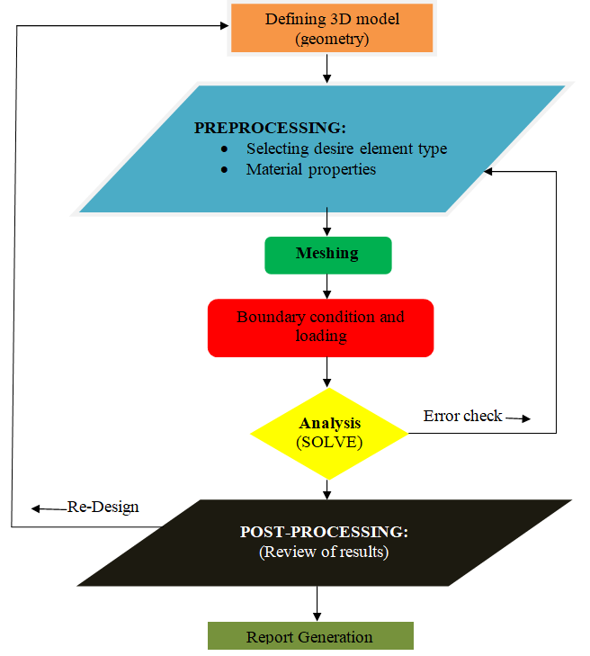

Fig.2: Modeling steps in ABAQUS software

**C. Boundary Conditions and Loading:** Applying boundary conditions to simulate real-world constraints and supports. This includes defining the fixed supports or rollers that the beam would rest on. The loading conditions applied to the beam include point loads, distributed loads, and dynamic loads.

**D. Solution:** Running the analysis by solving the finite element equations. ABAQUS uses iterative solvers to handle nonlinearities in material properties, geometry, and boundary conditions.

**E. Post processing:** Interpreting the results through visualizations and data analysis. This includes evaluating the stress distributions, deformation patterns, and identifying any potential failure points.

By following these steps, the study aims to provide a comprehensive understanding of the nonlinear behavior of reinforced concrete beams, contributing valuable insights for future research and practical applications in structural engineering.

**2.2 ABAQUS nonlinear analysis of precast concrete**

Nonlinearity in reinforced and precast concrete structures primarily arises from material nonlinearity, geometric nonlinearity, and nonlinear boundary conditions. These factors account for the majority of nonlinearity encountered in such structures.

**2.2.1.Material Nonlinearity**

Material nonlinearity refers to the behavior of materials like steel and concrete, which exhibit different properties in their elastic and plastic stages. In the elastic phase, materials respond linearly, characterized by their elastic modulus and Poisson's ratio. However, in the plastic phase, materials undergo permanent deformation. In ABAQUS, we define the material properties of steel and concrete to capture these nonlinear characteristics. For steel, entering the plastic phase involves defining its stress-strain relationship beyond the elastic limit. Concrete, on the other hand, offers three models for the plastic stage: smeared cracking, damaged concrete, and concrete damaged with spreading. The concrete damaged plasticity model in ABAQUS/Explicit is particularly versatile, accommodating various loads including individual, repetitive, and dynamic loads. This model is often preferred due to its satisfactory convergence properties, making it ideal for defining concrete plasticity.

**2.2.2 Geometric Nonlinearity**

Geometric nonlinearity occurs when structural responses are affected by significant displacements. In ABAQUS, this is addressed by including the NLGEOM parameter in the step settings. This parameter ensures that geometric nonlinearity is considered during the analysis, although it can increase computational effort. For routine nonlinear static analysis, the NLGEOM parameter might be omitted to reduce computational complexity. Displacement Effects, When the displacements in a structure are large enough to affect the structural response, geometric nonlinearity must be taken into account. This includes changes in the configuration of the structure that significantly alter its behavior under load.

Understanding and accurately modeling the sources of nonlinearity in reinforced and precast concrete structures are crucial for realistic simulation and analysis. ABAQUS provides the tools necessary to define material, geometric, and boundary nonlinearities, allowing for precise and reliable structural analysis. This approach not only enhances the accuracy of simulations but also provides valuable insights into the behavior of complex concrete structures under various loading conditions.

**3. Analysis Scenario of Beams**

The beams, with its dimensions of 1100 millimeters in length and a cross-section of 150 millimeters by 150 millimeters, offer robust support. Its concrete, boasting strength of 40 MPa, ensures structural integrity under various loads for both conventional and precast concrete beams. For further details on the specifics of this setup, please refer to Fig. 3.

The reinforcement strategy involves utilizing HPB235 reinforcement for both longitudinal reinforcement and stirrups. ABAQUS, the chosen simulation software, employs the C3D8R element for concrete representation and the T3D2 element for reinforced and precast concrete elements. To accurately simulate the bond between concrete and steel, reinforced concrete elements are intricately embedded within the concrete matrix. Addressing potential stress concentrations at the beam's loading surface and supports during load application is crucial. To mitigate these concerns, steel gaskets are strategically placed at the locations where forces act on the beam and its supports. By doing so, the contact area and stiffness are enhanced, ensuring optimal load distribution and structural performance.

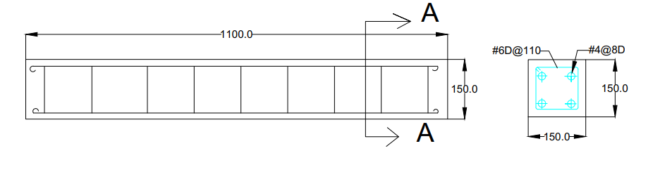

Fig.3 Geometry of precast and reinforced concrete

**3.1 Creating Part**

The beam is modeled as a deformable solid body by initially creating a part with a two-dimensional profile. Subsequently, this two-dimensional profile is extruded to generate the beam in three dimensions. Within the model, three distinct parts are created: BEAM_CONCRETE, REBAR_STEEL, and STIRRUPS_STEEL, each representing different components of the structure. The extruded part, showcasing the three-dimensional representation of the beam, is shown in Figure 4.

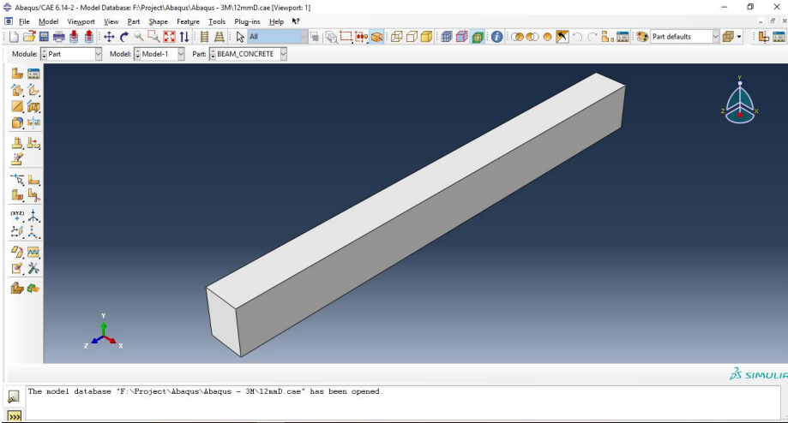

Fig.4: Creating part

In this study, concrete is modeled using eight-nodded elements to accurately capture its behavior under various loading conditions. Conversely, steel components are modeled using two-nodded beam elements, which are suitable for representing the linear behavior of steel materials in structural analysis. This meticulous modeling approach allows for a comprehensive understanding of the structural response of the simply supported beam made from precast concrete, facilitating accurate analysis and interpretation of results. Beam of length 1.1 m and width 150 mm and depth 150 mm is created. Plane stress elements are commonly used to model beams in 2D as the beam is relatively long compared to its width. The reinforcement can be modeled with 2D and 1D element as embedded reinforcement. The rebar’s were modeled as two –node beam elements connected to the nodes of adjacent solid elements.

**3.2 Material Properties**

The material properties utilized in the analysis are meticulously defined within ABAQUS to accurately simulate the behavior of the components involved. These properties play a crucial role in determining the response of the structure under various loading conditions.

**3.2.1. Concrete Properties:**

* Young's Modulus: The Young's modulus of concrete is set to 22,360 MPa, representing its stiffness and resistance to deformation.
* Poisson's Ratio: Concrete exhibits a Poisson's ratio of 0.2, indicating its lateral contraction when subjected to axial loading.
* Mass Density: With a mass density of 2,400 kg/m³, the concrete material is characterized by its density and weight per unit volume.

**3.2.2. Steel Properties:**

* Young's Modulus: Steel, being significantly stiffer, possesses a Young's modulus of 215,000 MPa, reflecting its high stiffness and strength.
* Poisson's Ratio: The Poisson's ratio for steel is set to 0.3, indicating its lateral contraction behavior under axial loading.
* Mass Density: Steel's mass density is specified as 7,460 kg/m³, highlighting its higher density compared to concrete.

These material properties are crucial inputs for the finite element analysis, influencing the structural response and ultimately determining the performance and safety of the simply supported beam constructed with precast concrete as shown in figure5.

By accurately defining these properties, the analysis can provide valuable insights into the behavior of the structure under various loading scenarios, facilitating informed decision-making in structural design and engineering.

**3.3 Assigning Section**

The structural components of the model were defined by assigning appropriate material properties and sections to ensure accurate representation of their behavior. A homogeneous solid section was created and assigned to the beam to represent the primary load-bearing component. This section, developed in the previous step, was defined as concrete to reflect its role in resisting compressive forces. Additionally, the two-node beam elements, which were modeled to simulate the reinforcements, were assigned as steel. These elements represent the tensile capacity of the structure, ensuring compatibility with the overall design requirements.

The material properties of concrete and steel were carefully defined, with concrete characterized by its compressive strength and steel by its tensile strength and ductility. The integration of these two materials within the section allows for a realistic simulation of the composite behavior under various loading conditions. The details of the assigned section are illustrated in Figure 5.

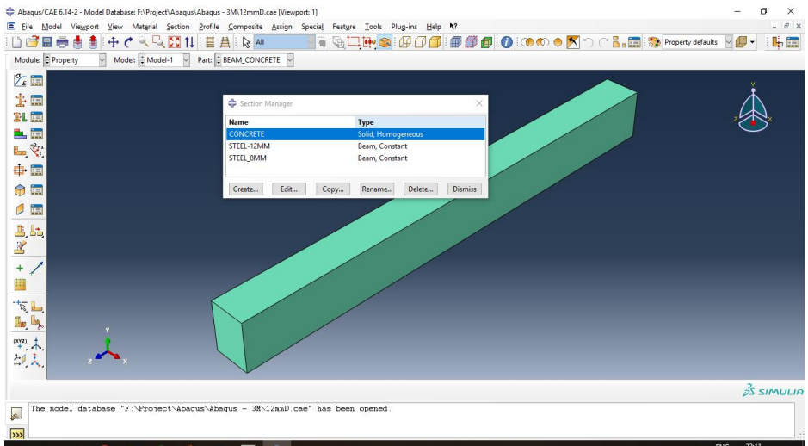

Fig.5: Material property assigned section

**3.4 Step Creation and Assembling the Model**

This simulation investigates the static response of a simply supported beam subjected to a uniformly distributed pressure load applied to its top surface. The goal is to accurately capture the beam's behavior under these conditions, including stress distribution, deformation, and potential failure points. The model is developed and assembled as shown in Figure 6, with the analysis divided into two distinct steps to ensure a comprehensive simulation.

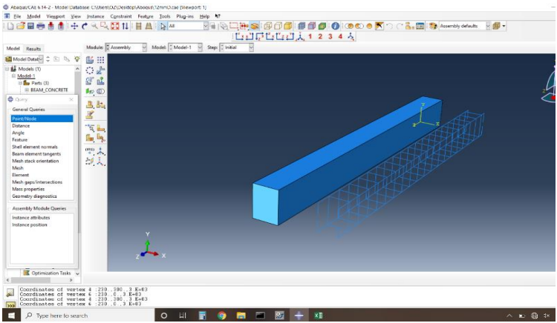

Fig.6: Assembling the mode

The first step is the initial step, during which the boundary conditions are applied to replicate realistic support conditions. Both ends of the simply supported beam are constrained appropriately. This involves fixing the beam at the supports to prevent translation or rotation while allowing it to deform naturally under loading. These boundary conditions are crucial for ensuring stability and realistic simulation outcomes.

The second step is a general static analysis step, where a pressure load is applied uniformly across the top face of the beam. This step captures the structural response to loading, focusing on deformation, stress distribution, and strain development. By dividing the simulation into these steps, the model can account for the progression of loading and boundary effects, providing accurate and reliable results. These steps together ensure the model reflects realistic beam behavior under static loading.

**3.5 Applying boundary condition and loading on the model**

In this phase of the simulation, a new load is created within the model tree to represent the external forces acting on the beam. When the load dialog box appears, the load type is set to **Point Load**. This ensures precise control over how and where the load is applied. For this simulation, the load is defined within **Step 1**, ensuring it is properly assigned in the sequence of analysis steps.

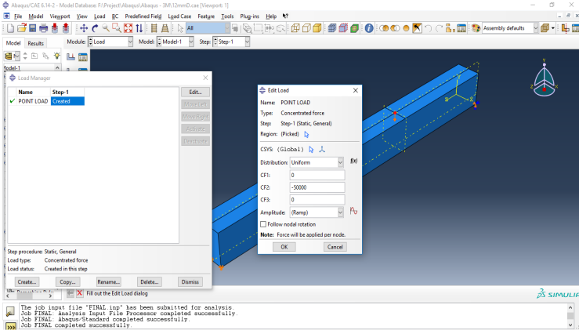

Fig.7: Applying boundary condition

Although initially defined as a point load, in this case, it is effectively distributed over the surface area of the beam in contact with the load application zone. To model this behavior accurately, the load is selected as **Pressure** in the selected step list. The pressure is applied uniformly across the beam's top surface to simulate the distributed load conditions. The magnitude of the applied load is specified as **-50,000 (CF2)**, where the negative sign indicates the direction of the force acting along the negative Y-axis. This direction aligns with the expected downward pressure experienced by the beam under loading conditions. Figure 7 illustrates the beam with its boundary conditions, showing the constraints applied at the supports and the location and distribution of the applied load. This configuration ensures realistic representation of loading effects.

**3.6 Meshing the Model**

Meshing is a critical step in finite element analysis, as it involves dividing the model into smaller, discrete elements to approximate the structural behavior under various conditions. This process generates nodes and elements, which are interconnected to form a mesh. The finite element meshing is carried out using the mesh module in ABAQUS, which provides various tools and techniques for creating an efficient and accurate mesh.

In this simulation, the appropriate meshing technique is selected based on the complexity of the geometry, the type of analysis, and the desired accuracy of the results. ABAQUS offers a range of meshing techniques, allowing users to define the element shape (e.g., hexahedral, tetrahedral) and element type (e.g., linear, quadratic) to suit the requirements of the analysis. Selecting the optimal meshing technique ensures convergence and enhances the precision of the simulation results.

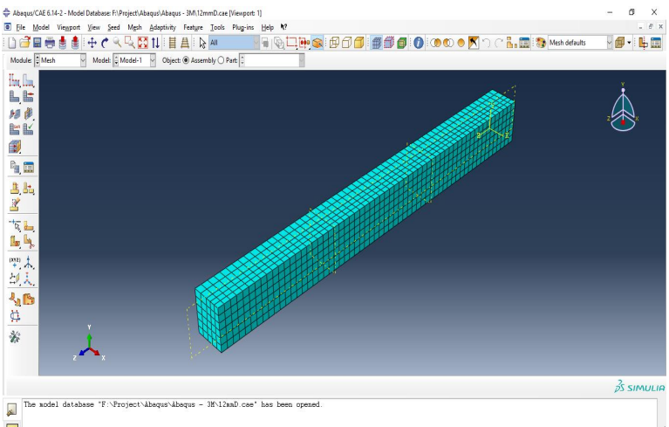

Fig. 8: Meshed model

The default meshing technique in ABAQUS is visually indicated by the color of the model. If the model displays an orange color, it signifies that the default meshing technique is insufficient, requiring manual intervention to refine the mesh. For this study, the model is meshed appropriately to achieve convergence and accuracy. The final meshed model, illustrating the generated elements and nodes, is shown in Figure 8.

**3.7 Creating and submitting an analysis**

Once the model is fully prepared with all the required properties defined, assigned, and meshed, the next step is to create and submit the analysis. At this stage, all the necessary components—including geometry, material properties, boundary conditions, loads, and the mesh—are integrated into the model to ensure accurate simulation results.

In ABAQUS, the analysis process begins by setting up a job that specifies the type of analysis to be performed and the parameters for execution. The model is then analyzed by running the simulation through the job module. This involves solving the defined finite element problem to determine the response of the structure under the applied loading conditions. Figure 9 illustrates the modeled specimen, showcasing the final configuration with its applied boundary conditions, meshing, and loading setup. The analysis results are crucial for understanding the beam's behavior and validating the model’s accuracy.

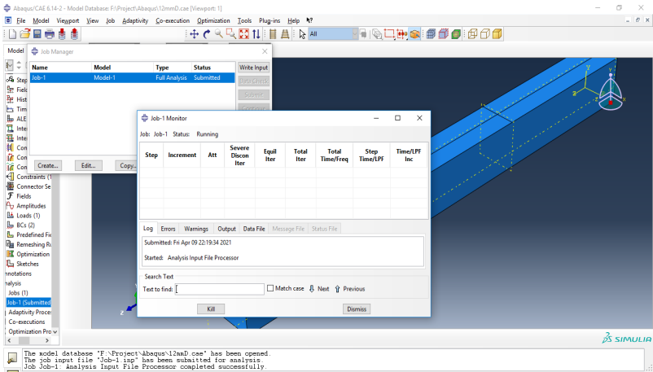

Fig. 9: Running analysis

**4. Evaluation of results**

The beam was analysed by assigning the properties to the model. The analysis without aborting indicates the error free model. The results of the analysis are viewed in the Visualization module. The deflected shape is shown in figure 10. The results of deflection were then compared with the analytical results.

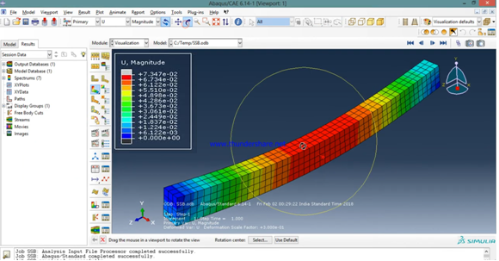

Fig.10: Deflected RCC beam

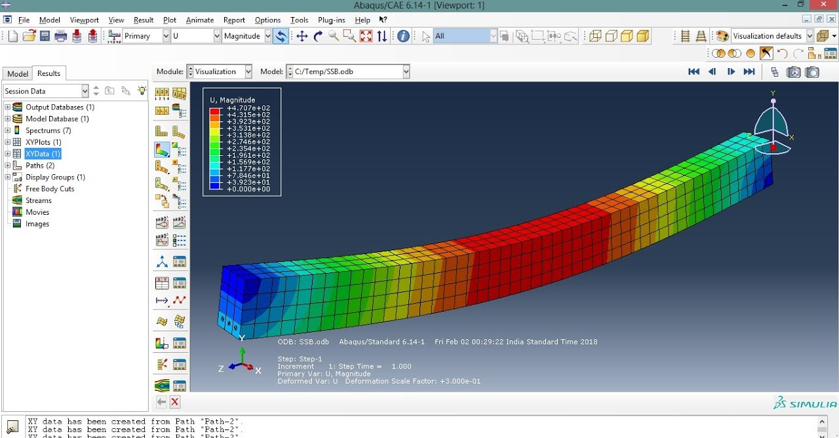Fig.10: Deflected Precast beam

**5. Comparison of results in terms of stress variations**

The stress variations observed in the analysed beam from ABAQUS were compared with theoretical values as outlined in the research. The results revealed a generally consistent behavior with the material properties assigned for both concrete and steel in the model, which conformed to expected values. However, one notable difference was observed due to the higher concrete strength of the precast concrete, which led to lower stress levels compared to conventional concrete. This phenomenon is a direct consequence of the enhanced compressive strength and improved material performance of precast concrete, which results in a more efficient distribution of loads and a reduced tendency for stress concentration. To further investigate stress distribution, the model was assigned two different configurations of tension reinforcement: one with two 8 mm diameter bars at both the top and bottom of the beam, and the other with two 6 mm diameter bars used as transverse reinforcement. In both cases, the results in terms of steel reinforcement behavior were as expected, with appropriate stress responses observed in the tension zones. These variations in reinforcement configurations allowed for a more comprehensive evaluation of stress variation across different reinforcement layouts.

When comparing the stress variations in the precast concrete beam versus the conventional concrete beam, it was observed that the precast beam exhibited lower stress levels under similar loading conditions. This is likely due to the improved material properties of precast concrete, which are designed to better handle tensile forces and reduce the stress that typically occurs in conventional concrete. Additionally, the higher load-carrying capacity of the precast beam was consistent with its lower stress production, suggesting that the precast beam can resist greater loads without experiencing the same level of internal stresses as conventional concrete beams. The analysis revealed that the precast concrete beam, owing to its higher strength, exhibited a more favorable stress distribution and enhanced load-carrying capacity compared to conventional concrete, highlighting the effectiveness of precast materials in reducing stress under load.

**6. Conclusions**

* The stress variations in the analysed beam from ABAQUS were compared with theoretical values, showing consistent results based on the material properties assigned to concrete and steel.
* The precast concrete beam exhibited lower stress levels compared to conventional concrete due to its higher compressive strength and better material performance.
* The improved concrete properties of precast concrete result in more efficient load distribution and a reduced tendency for stress concentration.
* Two different configurations of tension reinforcement were tested: two 8 mm diameter bars at top and bottom, and two 6 mm diameter bars as transverse reinforcement.
* Both reinforcement configurations showed expected stress responses in the tension zones, allowing for comprehensive evaluation of stress variation across reinforcement layouts.
* The precast concrete beam demonstrated lower stress levels under similar loading conditions, likely due to its enhanced ability to handle tensile forces.
* The higher load-carrying capacity of the precast beam was consistent with its reduced stress production, indicating greater efficiency in resisting loads.
* The analysis confirmed that the precast beam, with its superior material properties, displayed a more favorable stress distribution and enhanced load-carrying capacity compared to conventional concrete.

**Data Availability Statement:** All data, models, or codes that support the findings of this study are available from the corresponding author upon reasonable request the FEA models presented in this paper.

**Acknowledgment**

This work is funded by the Sankrithi School of engineering, puttaprthi, Andhra Pradesh India. These supports are gratefully acknowledged.

**References:**

[1] I. Saifullah, M. Nasir-uz-zaman, S. M. K. Uddin, M. A. Hossain, and M. H. Rashid, “Experimental and analytical investigation of flexural behavior of reinforced concrete beam,” Int. J. Eng. & Technol. IJET-IJENS, vol. 11, no. 01, pp. 1-9, Feb. 2011.

[2] S. V. Chaudhari and M. A. Chakrabarti, “Modeling of concrete for nonlinear analysis using finite element code ABAQUS,” Int. J. Comput. Appl. (0975 – 8887), vol. 44, no. 7, Apr. 2012.

[3] H. S., M. S., A. H. A., M. A., and A. S., “Evaluation of reinforced concrete beam behaviour using finite element analysis by ABAQUS,” Sci. Res. Essays, vol. 7, no. 21, pp. 2002-2009, Jun. 2012.

[4] D. Floros and O. A. Ingason, “Modelling and simulation of reinforced concrete beams,” Department of Applied Mechanics, Division of Solid Mechanics, Chalmers University of Technology, 2013.

[5] T. Tejaswini and M. V. Raju, “Analysis of RCC beams using ABAQUS,” Int. J. Innov. Eng. Technol. (IJIET), vol. 5, no. 3, Jun. 2015.

[6] S. M. Soleimani and S. S. Roudsari, “Analytical study of reinforced concrete beams tested under quasi-static and impact loadings,” J. Appl. Sci., vol. 9, 2019.

[7] S. M. S and S. S. R, “Analytical study of reinforced concrete beams tested under quasi-static and impact loadings,” Appl. Sci., 2019.

[8] T. S. Vishnu Kumar and N. Rushwanth Chowdary, “Finite element modeling of RCC beam by using ABAQUS,” Int. J. Creat. Res. Thoughts (IJCRT), vol. 8, no. 7, Jul. 2020.

[9] S. H. L., A. A., K. J., and H. D., “ABAQUS modeling for post-tensioned reinforced concrete beams,” J. Build. Eng., vol. 30, Jul. 2020.

[10] A. Hemamathi, S. Murugavel, B. Sukumar, and M. Usha Rani, “Numerical investigation of precast grouted sleeve connection under cyclic loading using ABAQUS,” J. Phys.: Conf. Ser., vol. 2070, no. 012178, 2021.

[11] L. Jing-Song and L. Hong-Jun, “ABAQUS finite element analysis of reinforced concrete,” Equip. Manuf. Technol., vol. 6, pp. 69-70, 2009.

[12] Z. Zhuo, Z. Fan, and C. Song, ABAQUS Nonlinear Finite Element Analysis and Examples, Beijing: Science Press, 2008.

[13] ABAQUS Inc, ABAQUS Analysis User’s Manual, 2006.

[14] S. A. Kulkarni, B. Li, and W. K. Yip, “Finite element analysis of precast hybrid-steel concrete connections under cyclic loading,” J. Constr. Steel Res., vol. 64, no. 2, pp. 190–201, 2008.

[15] M. Kaya and A. S. Arslan, “Analytical modeling of post-tensioned precast beam-to-column connections,” Mater. Des., vol. 30, no. 9, pp. 3802–3811, 2009.

[16] ABAQUS, “ABAQUS 6.14 analysis user’s guide, volume IV: Elements,” 2014. [Online]. Available: <http://130.149.89.49:2080/v6.14/books/usb/default.htm>

[17] D. C. Feng, G. Wu, and Y. Lu, “Finite element modelling approach for precast reinforced concrete beam-to-column connections under cyclic loading,” Eng. Struct., vol. 174, pp. 49–66, Nov. 2018. [Online]. Available: <https://doi.org/10.1016/j.engstruct.2018.07.055>

[18] A. S. Genikomsou and M. A. Polak, “Finite element analysis of punching shear of concrete slabs using damaged plasticity model in ABAQUS,” Eng. Struct., vol. 98, pp. 38–48, 2015. [Online]. Available: <https://doi.org/10.1016/j.engstruct.2015.04.0>