**Experiment on Different Testing machine and used of Soil Stabilization for Improving the Properties of Soil in Geotechnical Engineering**

**Pankaj Singh1, P.K Roy2**

1Research Scholar Master of Technology Department of Civil Engineering, NIRT, Bhopal

2 Assistant Professor Department of Civil Engineering, NIRT, Bhopal

**Abstract**

Soil stabilization is a method of improving soil properties by blending and mixing bituminous materials. Soil is used sub base and base material, if strength of soil is poor, then stabilization is usually required. Subgrade is sometimes stabilized or changed with solider soil. Soil could be black cotton or as fly ash which could fly in interaction with air. There are many stabilizers used for stabilizing the soil such as, cement, lime, bitumen, fly ash etc., in this paper bitumen as stabilizer. If good earth is not available at the construction site, it becomes imperative to opt for soil stabilization. Soil stabilization is a process to treat a soil to maintain or improve the performance of the soil as a construction material. The stabilizing agent improves the strength parameters of sub grade of road pavement and leads to strengthening of embankment. The objective of this thesis is to review the applications of different stabilizing agents such as lime, fly ash, cement, rice husk, expanded polystyrene geofoam and waste paper sludge for different type of soil. In this research we accumulate the literature of some common material and their end use and conclusions.

**Keyword**s: soil stabilization, CBR, Permeability, Dung soil, Sanitary ceramic, Protector test.

1. **Introduction**

Soil is a combination of minerals, natural matter, gases, fluids, and innumerable living beings that together help life on Earth. Soil consistently goes through advancement via various physical, compound and natural cycles, which include the weathering with associated erosion. The majority of stabilization must be attempted in delicate soils (silty, clayey peat or natural soils) to accomplish advantageous designing properties. As per Sherwood fine-grained granular materials are the least demanding to settle because of their huge surface region according to their molecule distance across. An earth soil contrasted with others has a huge surface region because of level and stretched molecule shapes. Then again, silty materials can be delicate to little change in dampness and, consequently, may demonstrate troublesome during adjustment. Peat soils and natural soils are wealthy in water content of up to around 2000%, high porosity and high natural substance. The consistency of peat soil can fluctuate from sloppy to sinewy, and generally speaking, the store is shallow, however in most pessimistic scenarios, it can stretch out to a few meters beneath the surface Natural soils have high trade limit; it can obstruct the hydration cycle by holding the calcium particles freed during the hydration of calcium silicate and calcium aluminates in the concrete to fulfil the trade limit. In such soils, successful adjustment needs to depend upon the legitimate determination of binder and quantity of binder added.Soil stabilization is the technique to increase the soil parameter such as compressibility, shear, stress, strength, hydraulic conductivity, permeability, and density. Soil stabilization can be done by many ways like consolidation, vertical drains, vibration, and compaction with surcharge load, admixture, reinforcement and growing and other method. Use of wastage materials around the world are new alternate material.

Sanitary ceramic materials for domestic usage are wall tiles, floor tiles, sanitary ware, brick and roof tiles and for public usages are 200kW insulator, 400 kW insulator and sanitary ceramic bush in transformers. In European Union a large sanitary ceramic sector is functioning. The scale of production is represented in following figures 1.1 and 1.2 at European Union and India. In India 200 MT of non- hazardous inorganic solid waste and 14.5 MT of solid waste from construction and demolition waste are being generated. The potentiality of solid waste available for recycling and utilization of building sector is represented in following fig 1.1. In India, overall sanitary ceramic industrial production during 2011-2012 was 18000 crores, approximately 600 million square meters and waste was generated as 55 million square meters, approximately 8 to 10% waste generated from the production.

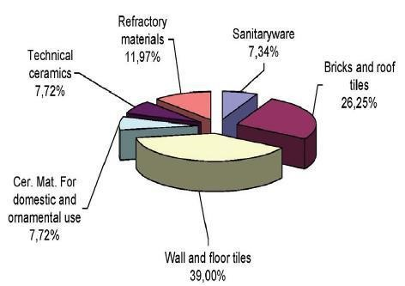

## Fig. 1.1: Production of Sanitary Ceramic in European Union

### **2. Literature Review**

**P.T Ravichandan,et. al.(2022)**-- In this work, the possibility of using shredded rubber powder with an additive to increasing the strength of loose soil was investigated. Strength of soil will be increases with increase the quantity of crumb rubber up to 10% by weight of soil.

**Delfin G.carreon (2022)** studied and inferred that using waste material in soil stabilization is cheaper as compare to other materials. These materials being dump in to landfill space.

**P.Gotteland, et.al (2022**) This paper says that, if we mixing the tyre chips in the various quantity like (5%, 10%, 15%, 20%) from starting. It will increase the strength of soil up to certain quantity. Maximum shear strength at approximately 35% by mass of soil

**Tuncer B.edil, et.al.(2021)** The objective of this study was to determine the effectiveness of self-cementing fly ash produced from combustion of sub bituminous coal at electric power plant.

**Mahmoud Ghazavi(2021)** This paper shows that how shear strength characteristics of sand mixed with different quantity of sand rubber mixture having (0%, 8%,15%, 30%, 50%, 80%) waste hose particles by weight were chosen. Internal friction does not change significantly, but an apparent cohesion occurs. Due to light weight material rubber sand mixture used in geotechnical project.

**Youwai S, Bergado DT(2021)** This paper says about result of triaxial test test were performed with different proportion mixture of sand rubber with increasing the quantity of rubber in the soil mixture, The density ,unit weight and shear strength of mixture increased but compressibility decreased .the dilatancy properties of shredded rubber-sand mixture we relatively same to cohesion less soil.

**J.H Lee, et.al. (2020)** This studied says that waste material produced in large quantity. These wastes are used in constructing reinforced soil structure with unconventional backfill. use of shredded tired as a backfill. triaxial test are conducted to determine stress strain relationship and strength of fire chips and mixture of sand and tire chips.

**Arin Yilmaz, et.al. (2019)** : The aim of this study to find the feasibility of utilizing fly ash and rubber waste with PPC as a composite material for masonry use, with increase the rubber waste compressive strength decreased, while increasing the fly ash strength increased. With increased rubber waste dry unit weight decreased with increased water absorption decreased slightly with increased in the rubber size particles.

**Mohammad Ali Mohammad et.al. (2018**) This paper says that tile and tyre waste are nondegradable which directly impact the environment. So, waste can be used in soil stabilization then both problems can be solved. For civil construction on loose soil, it’s necessary to ensure that the soft soil can meet engineering requirements for stability. Soil strength can be increased by missing the tyre chips in the soil.

**Ahsan Naseem, et.al. (2018)** : This study includes the chemical analysis of Black cotton soil by X-Ray diffraction scanning electron microscopy (SFM) before and after mixing tyre rubber powder (TRP) check stabilization to determine geo-technical properties. Test concludes that not only Decrease the plasticity, it will increase its UCS Maximum cry density. Finally, 5% of tyre Rubber Powder and 10% element kiln dust are required for achieve optimum amount of plasticity and strength characteristics.

**M.Saberian et.al. (2017)** This paper investigated the performance of waste tyre chips (10% by weight) sand (400 kg m3) mixed with pozzolanic binder at doses Range (5%, 10%, 15%) by weight as a stabilizer. After testing it observed that soil sample stabilized with gypsum or lime increases in UC6. If UPC cement used then greatest improvement in UC6 as well as direct shear parameter C &Ꝋ vs & direct shear tests the optimum % of additives would be 5%

**K. Bulbut et.al. (2017)** This experimental work has been performed to determine the influence of randomly oriental Fibre. This reserve evaluates the use of waste material like tyre rubber polythene and polypropene for modification of clays soil. This paper focus on the strength and dynamic behaviour of reinforced soil. These waste materials improve the strength Property and dynamic behaviour of clay soils.

**Youvent nanan et.al (2017)** This paper presents the engineering properties and compressibility behaviour of various type tropical peat soil was on ignition (organic constant) appear to be very useful parameter for Peat. It correlates with natural water constant liquid limit density and sp. Gravity of various soil was determined by using Raw cell consolidation test and conventional odometer test. Compressibility Index and Ca was identified as two crucial parameters to estimate settlements in Peat Soil.

### **3. Methodology**

1. The Sanitary Ceramic waste is readily available everywhere and when it is reinforced with soil it gives a very good strength.
2. The strength and durability properties of Ceramic waste reinforced with dune sand soil is taken in account and controlled.
3. Sanitary Ceramic waste has different functions, it forms as a binder and have fine aggregates which improves the tensile strength and gives a very higher resistance
4. It act as a barrier to separation of particles and thus enhances the strength
5. Physical properties of soil when reinforced with crush grains of sanitary ceramic waste are checked by conducting various tests.
6. Strength is checked by conventional methods of the composite material i.e. dune sand mixed with crushed grains of sanitary ceramic waste.
7. CBR test for assessment of strength.
8. Bearing capacity test and C-Φ test is carried out on soils with sanitary ceramic waste
9. Standard Proctor Test of Soil is also carried out.
10. The results of the behaviour of Sanitary Ceramic waste with applied with soil will be compared with the result of the experiments carried out on soil with different types.
11. To study the changes in CBR test value of dune sand with mixing sanitary ceramic waste of varying percentage in various proportions in soaked and unsoaked conditions.
12. Permeability changes are studied when dune sand is mixed with crushed grains of sanitary ceramic waste at various percentages and in various proportions.
13. Shear Stress changes are studied when dune sand is mixed with crushed grains of sanitary ceramic waste at various percentages and in various proportions.

#### **Dune Sand**

Dune sand is present in various districts of Rajasthan including Barmer, Nagaur, Jaisalmer, Jodhpur, Churu and Bikaner. There texture is loamy fine sand to coarse sand and is not calcareous. Soils are deep yellowish in colour from sandy-to-sandy loam and are deep and well drained. Cultivation is not practised as very much but in the rainy season on the slopes of low to medium high dune sand there is cultivation of Bajra and Kharif.

They are grouped separately from desert soils as they are only deposited sand and and little profile development has taken place. These soils are of varying heights from low shifting sand dunes to high and very stabilized sand dunes.Be it high altitude terrain of Leh-Ladakh or Nubra valley in the north, or the Great Indian Desert of India (The Thar) in the west or the 7500 km long coastal belts of India, sand dunes are the major attractions to all kinds of people including tourists, artists and researchers. A dune is a hill of sand which occurs in different shapes and sizes, formed by interaction with the flow of air or water.

There are also some alternate names; for example, a "dune field" is assigned to an area covered by extensive sand dunes. Large dune fields are known as ergs. A sand ridge would have a long narrow.

natural elevation or striation while self will have a long sand dune with a sharp crest (mainly found in Sahara Desert).

### **Table 1.1: Variables Investigated**

|  |  |  |  |
| --- | --- | --- | --- |
| **S.No** | **Effect of** | **Variables** | **Range**  **Investigated** |
| 1. | Curing environment and C.B.R value. | Type of curing | Soaked and Unsoaked. |
| 2. | Sanitary ceramic waste on | Particle size | 4.75 mm Passing and |
|  | different properties of sand |  | 2.36 mm retaining |
| 3. | Mix sanitary ceramic waste |  | 2%, 4%, 6%, 8%, 10%, |
|  | by | Percentage | 12%, 14%, 16%, 18% and |
|  | Weight of sand | Proportion | 20% |
|  |  |  | 4% water content |
| 4. | MDD and proctor density | Water content | 12% water content  18% water content |

**RESULT**

The tests mentioned were performed to investigate the behavior of Sanitary ceramic waste with varying percentages mixed with dune sand in terms of Particle size distribution of sand, Proctor’s density, California Bearing Ratio, Coefficient of Permeability and Shear Strength Parameters. Results obtained from tests were as under.

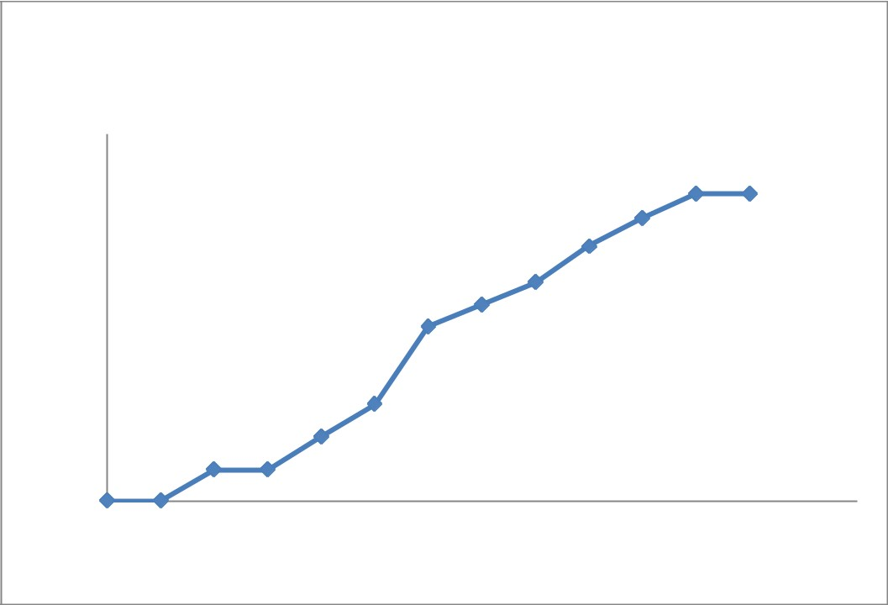

**C.B.R for 0% admixture at density 1.50gm/cc**

**Unsoaked (CA0)**

60

50.2

50.2

50

46.2

41.6

**(**

**kg**

**)**

40

35.7

32.1

**load**

28.5

30

**Actual**

20

15.8

10.5

10

5.1

5.1

0

0

0

0

1

2

3

4

5

6

7

**Penetration in mm**

**Figure 2: C.B.R for 0% Admixture at density 1.50gm/cc Unsoaked**

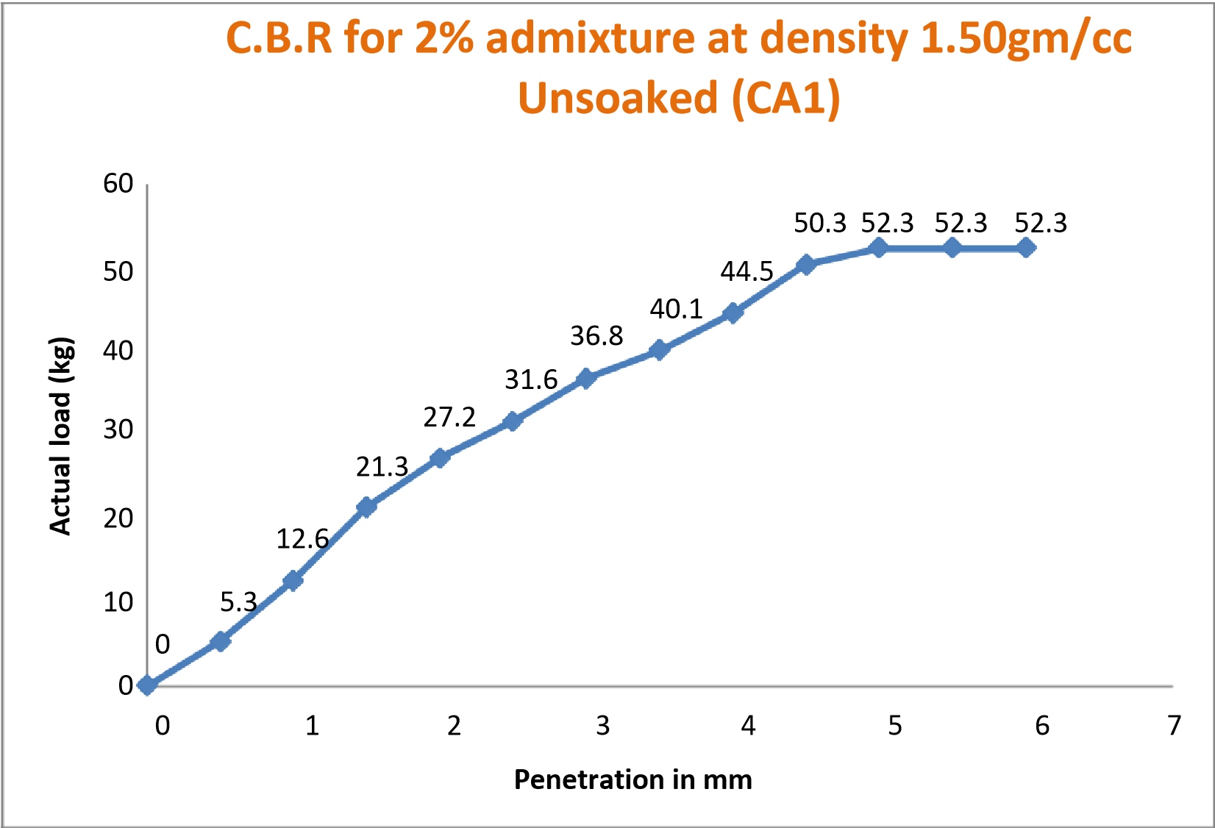

**Figure 3: C.B.R for 2% Admixture at density 1.50gm/cc Unsoaked**

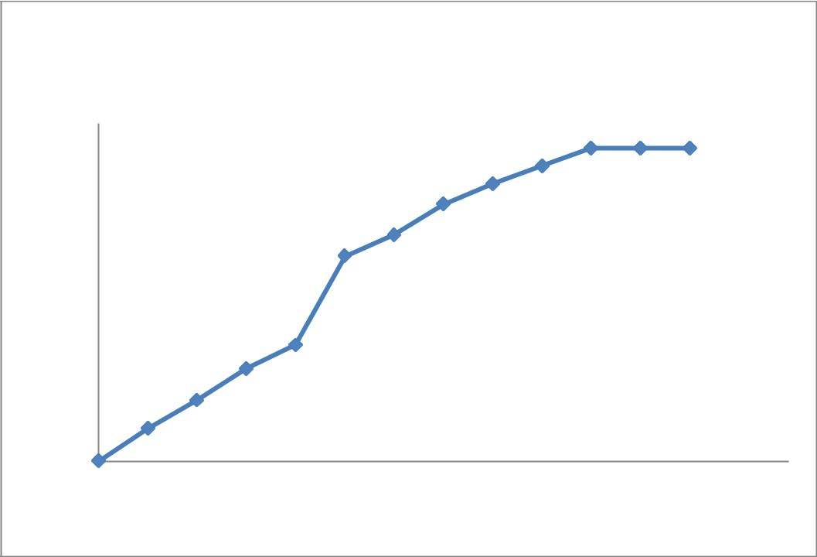

**C.B.R for 4% admixture at density 1.50gm/cc**

**Unsoaked (CA2)**

60

52.4

55.6

55.6

55.6

49.2

50

45.6

40.2

**load (kg)**

40

36.4

30

**Actual**

20.6

20

16.5

10.8

10

5.8

0

0

0

1

2

3

4

5

6

7

**Penetration in mm**

**Figure 3: C.B.R for 4% Admixture at density 1.50gm/cc Unsoaked**

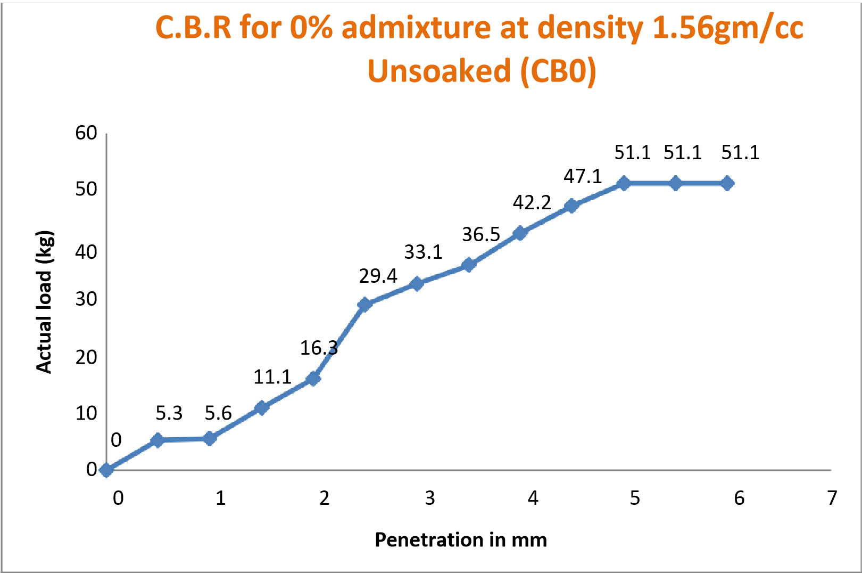

**Figure 4: C.B.R for 0% Admixture at density 1.56gm/cc Unsoaked**

## 4. Conclusions

1. The quantity of wastage is more due to its brittle nature. Sanitary ceramic coarse aggregate procured from industrial waste and crushed sanitary ceramic blocks has shape coefficient similar to that of a coarse aggregate obtained in the crushing of limestone. Usually sanitary ceramic aggregate has more irregular shape and non porous but it can be made porous after crushing and chiseling with hammer. This is one reason to consume more percentage of water than natural coarse aggregate.

1. CBR values of mix compositions, sand with sanitary ceramic waste of varying percentages 0%, 2%, 4%, 6%, 8%, 10%, 12%, 14%, 16%, 18% and 20% at different Density 1.50gm/cc, 1.56gm/cc and 1.59gm/cc indicate linear increase for both soaked and unsoaked conditions. In unsoaked condition, C.B.R. values for CA0 is 2.754, CA1 is 2.998, CA2 is 3.116 at density 1.50gm/cc whereas C.B.R. values for CB0 is 2.812, CB1 is 3.108, CB2 is 3.311 at density 1.56gm/cc whereas C.B.R. values for CC0 is 2.942, CC1 is 3.267, CC2 is 3.502 at density 1.59gm/cc, thus there is an increase with increase in water content. For soaked condition, increase in CBR values is comparatively less than that for unsoaked condition. In soaked condition,

## References

1. Al-Neami M. A. (2018). “Stabilization of sandy soil using recycle waste tire chips”. International Journal of GEOMATE. Vol. 15. pp 175-180
2. Bansal A., Kapoor A., Kumar A., Jain P., and Sharma R. (2014). “Application of waste tyre rubber in granular soils.” International Journal of Engineering Research & Technology (IJERT), volume 2 , pp 1-7
3. Belabdelouahab F. and Trouzine H. (2014). “Research and enhancement of used tyres, such as material innovative in Algeria”, Physics Procedia 55, pp. 68 – 74
4. Cetin H., Fener M. and Gunaydin O. (2006). “Geotechnical properties of tire-cohesive clayey soil mixtures as a fill material”, Engineering Geology 88, pp. 110- 120
5. Foose G. J., Benson C. H. and Bosscher P. J. (1996). “Sand reinforced with shredded waste tires”, Journal of Geotechnical Engg., Vol. 122, No. 9, pp. 760-767
6. Hataf N. and Rahimi M. M. (2006). “Experimental investigation of bearing capacity of sand reinforced with randomly distributed tire shreds”, Construction and Building Materials 20, pp. 910–916
7. Jan U., Sonthwal V. K., Duggal A. K., Rattan J. S. and Irfan M. (2015). “Soil Stabilization Using Shredded Rubber Tyre”, IRJET, Vol 2, issue 9, pp. 741-744
8. Karabash Z., Cabalar A. F. and Akbulut N. (2015). “The behavior of clayey soil reinforced with waste aluminium pieces”. Procedia Earth and Planetary Science. Vol. 15. pp 353-358
9. Lepcha K. H., Agnihotri A. K., Priyadarshee A., and Yadav M. (2014). “Application of tire chips in reinforcement of soil: A review.” Journal of Civil Engineering and Environmental Technology, Vol. 1, No. 5, pp. 51-53
10. Oikonomou N. and Mavridou S. (2009). “The use of waste tyre rubber in civil engineering

works”, Sustainability of construction materials, pp. 213-238, DOI:10.1533/9781845695842.213

1. Prasad P. R. and Ramana M. (2008). “Use of waste plastic and tyre in pavement systems”.

Journal of the Institution of Engineers (India): Civil Engineering Division. Vol. 89, pp.31-35

1. Priyadarshee A., Gupta D., Kumar V., and Sharma V. (2015). “Comparative Study on

Performance of Tire Crumbles with Fly Ash and Kaolin Clay”, Int. J. of Geosynth.

and Ground Eng., DOI: 10.1007/s40891-015-0033-3.

1. Rahgozar M.A. and Saberian M. (2016). “Geotechnical properties of peat soil stabilised with shredded waste tyre chips in combination with gypsum, lime or cement”. Mires and Peat. Vol. 18, Article 03, DOI: 10.19189/MaP.2015.OMB.211.
2. Rao D. K., Shilpa D.G.N.V.V.S.S.L. and Pranav P.R.T. (2012). “A laboratory study on the influence of rubber strips on the improvement of CBR values of expansive soil”, International Journal of Engineering Science and Advanced Technology, Vol. 2, issue 1, pp 12-17
3. Ravichandran P. T., Prasad A. S., Krishnan K. D. and Rajkumar P. R. K. (2016). “Effect of addition of waste tyre crumb rubber on weak soil stabilization”. Indian Jounal of Science and Technology. Vol. 9. Number 5. pp 1-5
4. Rokade S. (2012). “Use of waste plastic and waste rubber tyres in flexible highway pavements”. International Conference on Future Environment and Energy IPCBEE, Vol. 28, pp 105-108