Warehouse Automation and Its Impact on Supply Chain Performance

# Abstract :

By combining cutting-edge technologies like robotics, artificial intelligence (AI), the Internet of Things (IoT), and automated storage and retrieval systems (AS/RS),

warehouse automation has become a disruptive force in contemporary supply chain

management, redefining conventional logistics operations. The main elements, advantages, difficulties, and wider effects of warehouse automation on supply chain performance are all thoroughly examined in this study.

The need for increased efficiency, cost reduction, and improved accuracy in order fulfillment has fueled the rise of automation in warehousing. Automation solves these problems by streamlining workflows, minimizing human intervention, and utilizing data analytics for real-time decision-making. The integration of AI-driven robots, autonomous mobile robots (AMRs), and drone-based inventory management systems has greatly

increased operational efficiency, order processing speed, and inventory accuracy. Traditional warehouse operations, which rely heavily on manual labor, frequently suffer from

inefficiencies such as high operational costs, order inaccuracies, and delays in processing shipments.

The decrease in operating expenses is one of the main benefits of warehouse automation. Automated systems increase production while lowering labor costs by

minimizing the demand for a big workforce. Automation also improves the use of warehouse space since AI-powered storage systems can maximize the placement and retrieval of items.

Real-time warehouse condition monitoring is made possible by the deployment of IoT devices, which lowers losses from theft, product damage, and misplacement. As a result, businesses can improve demand forecasting and streamline supply chain procedures, guaranteeing that inventory levels are effectively managed to satisfy customer demand.

Despite its numerous benefits, warehouse automation also presents several

challenges. High initial investment costs and technical complexities pose significant barriers to entry, particularly for small and medium-sized enterprises (SMEs). The need for

specialized technical expertise in managing automated systems further complicates adoption. Additionally, cybersecurity concerns arise due to the increased reliance on interconnected devices and cloud-based data storage, making warehouses vulnerable to

cyber threats and system failures. Addressing these challenges requires strategic planning, proper risk assessment, and continuous investment in employee training and cybersecurity measures.

Beyond only enhancing operations, warehouse automation has an impact on the larger supply chain ecosystem. Businesses that use automation see shorter lead times, increased customer satisfaction, and quicker order fulfillment. By allowing companies to promptly adjust to changes in demand, automation also improves supply chain resilience by lowering the risks of supply chain interruptions. With the rapid breakthroughs in AI, robotics, and blockchain technology, the future of warehouse automation is projected to witness significant innovations, paving the path for fully autonomous supply chain networks.

This paper will offer insights into the changing environment of warehouse automation and its significant effects on supply chain performance through a combination of case studies and data-driven analysis. This study will highlight the tactics that businesses are employing to use automation for competitive advantage by looking at actual

implementations in businesses like Amazon, Walmart, and DHL. Additionally, it will examine new developments like 5G adoption for real-time data interchange, AI-powered predictive analytics, and the function of green automation in promoting sustainable supply chain practices.

Businesses must manage the potential and constraints of implementing

warehouse automation as it develops further. Although automation offers a promising way to increase productivity and scalability, businesses must carefully assess long-term

integration plans, technology preparedness, and financial considerations. By providing a thorough examination of warehouse automation's effects on supply chain performance, this paper seeks to add to the current conversation on the topic and eventually assist organizations in making well-informed decisions about its adoption and future

advancements.

# Introduction :

The use of cutting-edge technologies to manage and streamline

warehouse operations is known as warehouse automation. This improves supply chain performance overall and increases accuracy and efficiency. For inventory tracking, order fulfillment, and the movement of goods, traditional warehouse management has mainly relied on manual labor, which frequently results in inefficiencies, human error, and higher operating costs. Businesses are investing in automation technologies that transform

warehouse operations in response to the growing demand for logistics solutions that are quicker, more dependable, and more affordable.

Warehouse automation encompasses a broad spectrum of technologies, including robotics, artificial intelligence (AI), the Internet of Things (IoT), automated storage and retrieval systems (AS/RS), autonomous mobile robots (AMRs), and conveyor and sortation systems. These technologies aim to reduce reliance on human labor while improving inventory accuracy, order processing speeds, and operational flexibility.

Companies such as Amazon, Walmart, and DHL have pioneered warehouse automation, setting benchmarks for efficiency and reliability in supply chain management.

# Types of Warehouse Automation

There are various types of warehouse automation, and each one helps to improve productivity and streamline processes. The most popular categories of warehouse automation systems are listed below:

## Automated Storage and Retrieval Systems (AS/RS)

Computer-controlled systems known as Automated Storage and Retrieval Systems (AS/RS) are made to precisely and efficiently handle the storage and retrieval of products. These systems store and retrieve objects without the need for human assistance by using robotic cranes, shuttle systems, and vertical lift modules (VLMs). Because AS/RS systems enable high-density storage and vertical stacking, they help warehouses make the most of their available space.

## Key Features of AS/RS

* + - * High-Density Storage: AS/RS systems minimize the requirement for huge warehouse footprints by utilizing vertical stacking and compact storage designs.
      * Automated Material Handling: Lowers operating expenses and boosts production by reducing the need for manual labor.
      * Real-time inventory management: Order fulfillment, demand forecasting, and precise tracking are made possible by integration with warehouse management systems (WMS).
      * Accuracy and Speed: Increases order processing speed while reducing human error, guaranteeing accurate and on-time delivery.
* Scalability and Flexibility: AS/RS solutions are perfect for companies handling a

variety of items since they can be tailored to meet diverse warehouse layouts and operational requirements.

## Types of AS/RS

1. 1. AS/RS Unit-Load
   * Made to manage big containers or pallets.
   * Employed in industrial and manufacturing warehouses and other bulk storage settings.
2. Mini-Load AS/RS
   * Manages smaller loads, including cartons, bins, and totes.
   * Perfect for minor part storage and order selection in the retail and e-commerce industries.

3. Vertical Lift Modules (VLMs):

These automated vertical storage systems transport things straight to operators, saving space and lowering worker fatigue. They also retrieve trays as needed.

4. Shuttle-Based AS/RS

Uses robotic shuttles to move items within storage racks. o Enhances picking efficiency in high-speed distribution centers.

5. Carousel-Based AS/RS

* Stores and retrieves items using either vertical or horizontal carousels.
* Fit for high-density storage applications and inventory that moves quickly.

## Benefits of AS/RS

* + - * Enhanced Efficiency: By automating material transportation, warehouse throughput is increased and manual picking is lessened.
      * Lower Labor Costs: By reducing the requirement for large staff operations, labor costs are decreased.
      * Increased Accuracy: By lowering order fulfillment errors, automated retrieval guarantees more client pleasure.
      * Enhanced Safety: Reduces workplace injuries by limiting the need for workers to perform heavy lifting or operate dangerous machinery.
        + Improved Safety: Lowers workplace injuries by reducing the need for employees to operate hazardous machinery or lift large objects.

## Challenges of AS/RS Implementation

* • High Initial Investment: AS/RS systems are costly for small firms due to their substantial capital investment requirements.
* • Complex Maintenance Requirements: To keep systems operating efficiently, regular service and technical know-how are required.
* • Integration Issues: There may be issues with compatibility with current supply chain software and warehouse management systems (WMS).

## Operational Disruptions: Transitioning from traditional warehousing to AS/RS may require temporary shutdowns and workforce retraining.

* + 1. **AS/RS Use Cases in Different Industries**

1. 1. Retail & E-Commerce o AS/RS is frequently utilized in e-commerce warehouses to expedite order fulfillment, shorten order processing times, and enhance delivery precision.
2. 2. Pharmaceuticals o Guarantees accurate inventory management and effective storage of delicate medical supplies.

## Automotive & Manufacturing

Simplifies production processes by sending materials and parts to assembly lines automatically.

## Cold Storage & Food Industry

By automating product storage and retrieval, it reduces exposure to temperature variations and aids in maintaining temperature-controlled settings.

## Autonomous Mobile Robots (AMRs)

Self-navigating robots with sensors, cameras, and artificial intelligence that can move goods around a warehouse are known as autonomous mobile robots, or AMRs. AMRs can

dynamically modify their routes in response to current warehouse conditions, unlike standard automated guided vehicles (AGVs), which are reliant on predefined tracks.

## Key Features:

* Optimizes mobility and navigation through the use of AI and machine learning.
* Increases overall efficiency by reducing labor-intensive tasks.
* Provides flexibility in adapting to changing warehouse layouts.

## Use Cases:

* Supports just-in-time inventory management by guaranteeing quick product movement; widely utilized in distribution centers for order pickup and transportation.

## Conveyor and Sortation Systems

The movement and classification of goods in a warehouse are automated using conveyor and sorting systems. These systems reduce reliance on manual material handling, improving order processing speed.

**Important features include: • Smooth product transportation through the use of overhead, belt, and roller conveyors.**

* **Sorts goods according to destination, weight, and size.**
* **Lessens bottlenecks in settings when a lot of orders are fulfilled. Use Cases:**
* Frequently seen in package sorting facilities, retail warehouses, and distribution hubs.
* Increases facility efficiency when managing a large volume and diversity of SKUs.

## Drones for Inventory Management

Real-time inventory tracking and warehouse monitoring are becoming more and more common uses for drones with AI and IoT capabilities. To improve inventory visibility, these drones scan barcodes, RFID tags, and warehouse locations from the air.

## Key Features:

* Provides real-time inventory tracking and auditing.
* Reduces manual stocktaking efforts and improves accuracy.
* Enhances accessibility to hard-to-reach warehouse locations.

## Use Cases:

* Supports sectors with high-value or perishable commodities that need frequent audits; • Perfect for large warehouses and distribution hubs that require quick inventory verification.

## Goods-to-Person (GTP) Systems

Goods-to-Person (GTP) systems eliminate the need for workers to traverse great distances to pick orders by using automation to deliver goods directly to warehouse personnel at workstations.

## Key Features:

* 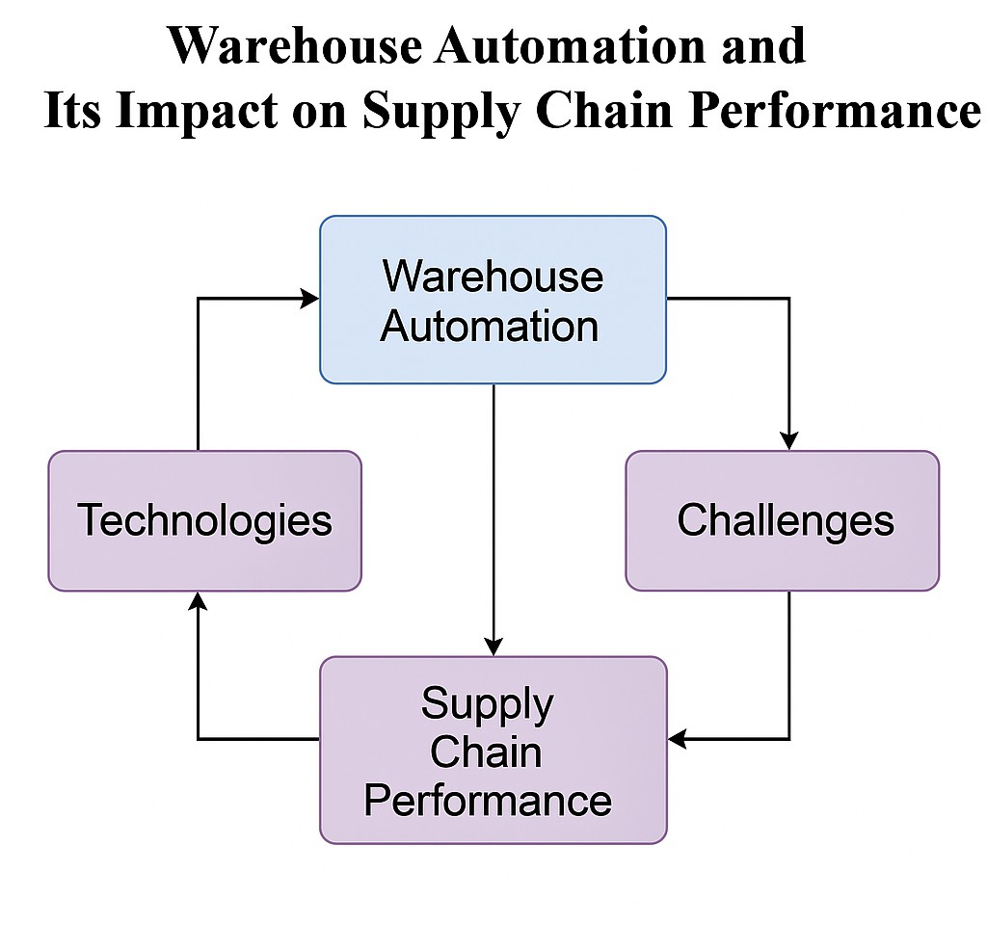Reduces worker fatigue and expedites order picking.
* Improves efficiency in high-demand fulfillment operations.
* Works well in combination with AS/RS and AMR technologies.

## Use Cases:

* Used in e-commerce fulfillment and grocery distribution centers.
* Helps in reducing pick time and optimizing labor resources.

## Automated Guided Vehicles (AGVs)

Robotic transport devices known as Automated Guided Vehicles (AGVs) use guided pathways like magnetic strips, sensors, or pre-planned routes to move products within a warehouse.

## Key Features:

* Follows preset paths to provide a methodical flow of materials; • Moves large loads effectively with little human supervision.
* Improves warehouse safety by lowering the use of forklifts.

## Use Cases:

* Frequently used in automotive and industrial manufacturing warehouses.
* Supports repetitive material transport tasks, reducing reliance on manual labor.

## Benefits of Warehouse Automation

Supply chain management benefits greatly from warehouse automation, which includes increased accuracy, cost savings, scalability, and efficiency. Warehouses can greatly improve their operating capacities and satisfy growing market needs by putting various forms of automation into place.

Every one of these automation forms is essential to enhancing supply chain efficiency and warehouse operations. Warehouses will become more effective, flexible, and sensitive to shifting business requirements as automation technology develops.