PERFORMANCE OF DI DIESEL ENGINE WITH ACACIA BIODIESEL AND Zno NANO ADDITIVE

|  |  |
| --- | --- |
| 1T.KRISHNAIAH | 2DR.P.RAMESH |
| PG Scholar | Associate Professor |
| Department of Mechanical Eng. | Department of Mechanical Eng. |
| S.I.E.T.K, Puttur, A.P, India | S.I.E.T.K, Puttur, A.P, India |

***Abstract-*** The depleting of fossil fuels has simulated the worldwide search for the alternate fuels. As our country is an agricultural based one and large amount of land is available, production of Acacia biodiesel will be more advantageous for our farmers. The Acacia biodiesel is a perfect replacement to diesel because this is derived from indigenous sources and is renewable. But due to its high viscosity and lower calorific value it cannot be directly used in the diesel engine without major modifications to the engine. Hence in the present work it is planned accordingly to use the combination of diesel and biodiesel in the ratio of 80% diesel and 20% Acacia (B20). The combustion of the engine depends on the flow capability of the fuel. With the higher viscosity, Acacia oil fluidity will be less and this can be improved with the addition of nano additives. Further the investigation is planned to study the effect of Zinc Oxide Nano particles as additive on the performance and emission characteristics of Acacia biodiesel blend (B20). It is blended with Zinc Oxide Nano particle in mass fraction of 50 ppm, 100 ppm and 150 ppm. The whole investigation is carried out in a constant speed vertical cylinder water cooled DI Diesel Engine. The performance parameters are analyzed and the results are presented. Zinc oxide nano particles act as an oxygen buffer which improves the combustion results in increase the Brake thermal efficiency and reduction in the Exhaust emissions.

# *Keywords*- Acacia Biodiesel blend, Nano additives. Zinc oxide.

# I-INTRODUCTION

Diesel engines are considered to be used as a work horse for the industry due to their high torque output, durability, exceptional fuel economy and ability to provide power under a wide range of conditions. The consumption and demand of petroleum products are increasing day to day with increase of vehicles and urbanization, along with that the emissions are also enormously increased. Hence the researchers and the industries are concentrating on alternative fuels. These should be renewable, easily available, low cost and eco-friendly. Various types of biodiesels like sun flower oil, Jatropha, Pongamia etc., are available which are produced in India by our farmers. Among all the fuels Acacia biodiesel is most suitable alternate fuel with its properties in diesel engines. Few researches had tried on Acacia as a replacement for diesel and confirmed that with minor changes in engine, the efficiency of diesel engine can be improved marginally. But due to the higher viscosity of Acacia , the flow capacity of is less which is the major drawback for increasing the efficiency of engine. But with the addition of metal and metal oxide nano particles to bio fuels the flow characteristics will improve and the engine performance enhances as well as reduces the harmful gases in the engine exhaust. To overcome this flow problem, in the present work it is planned to work with blending process and with various types of nanoparticles. It is also reported that adding Zinc oxide nano particles to Acacia bio diesel could enhance the ignition properties of biodiesel due to the heat buildup with in the fuel of reactive nature of Zinc Oxide nanoparticles. Size of Nano particles may also affect the parameters like combustion process, ignition delay and burning rates of fuel.

# LITERATURE REVIEW

Considerable amount of research work has been done on various types of biodiesels on diesel engine. Some of them are presented below.

M. Mohan *Rao* et., [1] Investigated the effect of Zinc oxide as a fuel additive in various proportions on diesel engine performance fuelled with Palmolion Stearin Wax biodiesel and concluded that the engine performance and emissions are better compare to diesel. Further the effect of Rhodium oxide as a fuel additive with Pongamia oil and Pongamia pinnata biodiesels was investigated by S. Mani bharathi et. [2] and concluded that the brake thermal efficiency is increased marginally compared to diesel, due to the better combustion in the combustion chamber. Experimental investigations on DI diesel engine with aluminum oxide nano additive with Zizipus jujube methyl ester biodiesel in various mass fractions of biodiesel blends was performed by C. Syed Aalam et. [3] and concluded that the emissions were drastically reduced with the high flow characteristics and inherent oxygen content of nano additive.

# EXPERIMENTAL WORK

For the present experimental work a constant speed, single cylinder, four stroke, vertical, water cooled, high speed diesel engine equipped with AVL flue gas analyzer system and smoke meter is used. Using Zinc oxide nanoparticle additive with Acacia biodiesel blends as a fuel the performance and emission characteristics were obtained for various loads at constant

speed of 1500 rpm at a constant injection timing of 23.4° bTDC (before Top Dead Centre).The engine has a Eddy Current dynamometer to measure its output. A constant load test is conducted and the results were recorded under steady state conditions. The properties of pure diesel, Acacia and B20 (20% Acacia oil and 80% diesel) are measured with standard equipment. The specifications of the engine are mentioned in the following tables.

Table 1. Technical Specifications of the Engine

|  |  |
| --- | --- |
| Make | Kirloskar |
| Type | 4-stroke,1-cylinder diesel  engine (water cooled) |
| Rated power output | 5HP,1500 RPM |
| Bore & Stroke | 80mm x 110mm |
| Compression Ratio | 16.5:1 |
| Dynamometer | Belt brake |
| Emissions | AVL Gas analyzer |

The performance and emission parameters of B20 **(**80% diesel+20% Acacia biodiesel ) blended with the nano particles in the mass fraction of 50 ppm, 100 ppm and 150 ppm are compared with the B20 blend performance parameters. The Acacia biodiesel was supplied by Jatropha oil seed development & Research Hyderabad, India. The Diesel fuel was purchased from The Bharat Petroleum pump outlet, Tirupati, A.P, India. The Zinc oxide nano particles with average size of 30nm are taken from Indian chemicals private limited, Chennai, India. The Acacia oil is blended with diesel in a Ultrasonicator.

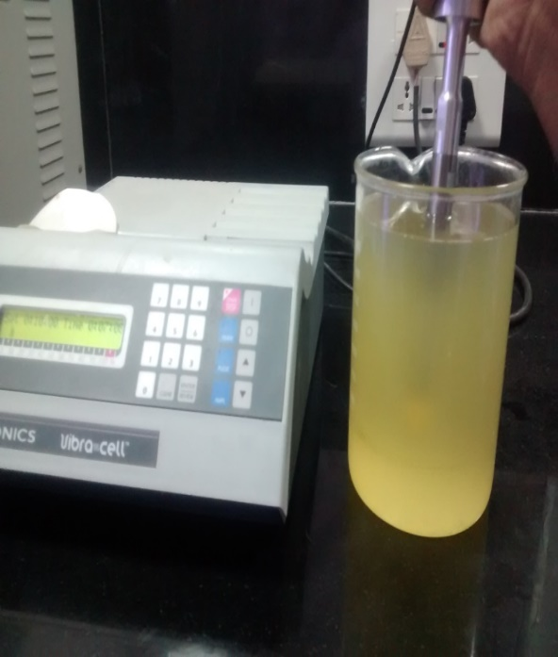

Figure 1. Ultra sonicator

The mixing of Zinc oxide nano particle with Acacia biodiesel was blended in an ultra sonicator at a frequency of 40 kHz and 120W for 60 minutes. The ultrasonicator technique is an act of applying ultrasound energy to agitate particles in a sample. The same procedure is applied for blend of biodiesel with mass fractions of 50 ppm,100 ppm and 150 ppm of nanoparticles.

# RESULTS AND DISCUSSIONS

The following results are obtained after testing the B20 blend at rated load.

The Brake thermal efficiency of B20+100ppm nano additive is increased by 1.14% and 3.29% compare to diesel and the biodiesel blend with 150 ppm respectively. At 100 ppm nanoparticles blend the flow characteristics are improved and further it enhances the combustion with the inherent oxygen in the nanoparticles. But at 150 ppm nano additive blend with the availability of more oxygen in combustion chamber the air fuel ratio becomes lean mixture and further leads to the improper combustion.so the brake thermal efficiency is decreased compare to 100 ppm blend of nano additive.

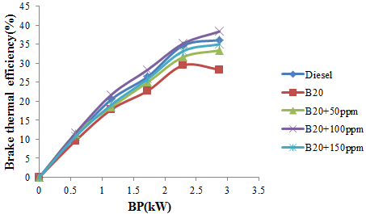

Figure 2. Variation of Brake thermal efficiency with B.P

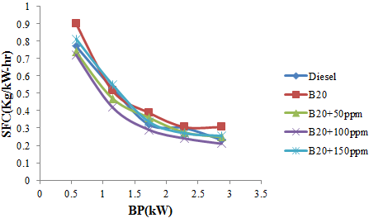

Figure 3. Variation of Specific fuel consumption with B.P

The Specific fuel consumption is decreased by 2.29% at B20+100ppm compare to diesel and it is decreased by 5.9% compare to 150ppm blends of biodiesel. At B20+100ppm we are getting the maximum brake thermal efficiency due to complete combustion. So the specific fuel consumption is decreased, due to inversely proportion relation between them. But at B20+150ppm due to improper combustion the brake thermal efficiency is decreased. So the specific fuel consumption is increased compare to 100ppm blend.

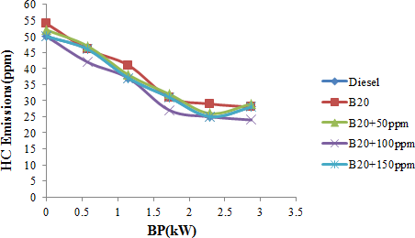

Figure 4. Variation of HC Emissions with B.P

The HC emissions are decreased by 16% at B20+100ppm compare to diesel and by 11% compare to B20+150ppm blend of biodiesel. At B20+100ppm the complete combustion takes place due to sufficient oxygen present in combustion chamber by means of nano additive. so the hydrocarbon emissions are decreased. But at B20+150ppm due to incomplete combustion in chamber compare to 100ppm blend the hydrocarbon emissions are increases.

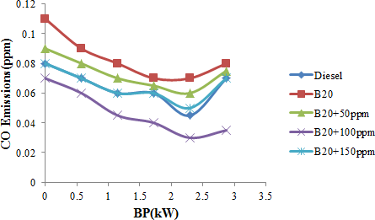

Figure 5. Variation of CO Emissions with B.P

The CO emissions are decreased by 13% at B20+100ppm compare to diesel and it is decreased by 8% at 150ppm blend of biodiesel. At B20+100ppm the air fuel mixture is equal to the stoichiometry air fuel ratio; the complete combustion takes place in the combustion chamber. So the CO emissions are decreased compare to diesel and 150 ppm blend of nano additive.

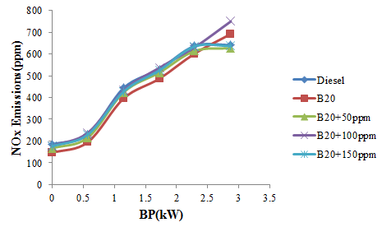

Figure 6. Variation of NOx Emissions with B.P

The NOx emissions are increased by 1.3% at B20+100ppm compare to diesel and it is increased by 3% at B20+150ppm blend of biodiesel. At 100ppm blend of biodiesel we got the maximum brake thermal efficiency. So the temperature in the combustion chamber is also maximum. The NOx are depending up on the temperature in combustion chamber. So at 100 ppm blend of biodiesel the NOx are increased compare to diesel and with B20+150 ppm blend of biodiesel

# CONCLUSION

The performance and emission characteristics of diesel and varies blends of biodiesel are investigated in a diesel engine with Zinc oxide nano additive. The blend B20+100ppm show better performance. The conclusions are as follows.

1. The Brake thermal efficiency is increased by 1.14% and 3.29% compare to diesel and the biodiesel blend with 150 ppm respectively.
2. The Specific fuel consumption is decreased by 2.29% compare to diesel and also it is decreased by 5.9% compare at 150ppm blends of biodiesel.
3. The HC emissions are decreased by 16% compare to diesel and also it is decreased by 11% compare at B20+150ppm blend of biodiesel.
4. The CO emissions are decreased by 13% compare to diesel and also it is decreased by 8% at 150ppm blend of biodiesel.
5. The NOx emissions are increased by 1.3% compare to diesel and also it is increased by 3% at B20+150ppm blend of biodiesel.

# REFERENCES

1. Suthar Dinesh Kumar.L, RathodPravin.P, Prof .Patel Nikul. K. “Performance And Emission by effect Of Fuel Additives for CI Engine fuelled with blend Of biodiesel and Diesel”, JERS Paper Vol.Ш ,2012/01-04.
2. SyedAalam,C.G.Saravanan,M.Kannan Experimental Investigations on a CRDI System Assisted Diesel engine fuelled With Aluminium Oxide Nano Particles blended Biodiesel”, AEJ Paper, April 2015.
3. C.SyedAalam,C.G.Saravanan,B.Premanand “Influence Of Iron (П,Ш) Oxide Nano Particles Fuel Additive on Exhaust emissions and Combustion Characteristics of CRDI System Assited Diesel engine”,IJAERS,Vol-2,March 2015.
4. S.Manibharathi, B. Annadurai, R. Chandraprakash, “Experimental Investigation of CI Engine Performance by Nano Additive in Biofuel”, IJSETR, Vol-3,Dec-2014.
5. MohanRao,D.Krishnaiah,”ExperimentalInvestigation on the effect of Zno Nano Particles with Palmolion Stearin Wax Bio Diesel blend on DI Diesel engine”, IJSART, Vol-1,10-October 2015.
6. B.Sachuthananthan,K.Jeyachandran,”Combustion Performance and Emission Characteristics of Water-Biodiesel Emulsion as fuel with DEE as Ignition improver in a DI Diesel Engine”,JERD,Vol-2, Dec-2007.
7. S.Manibharathi,R.Chandraprakash,B.Annadurai,R.Titus“ExperimentalInvestigation of CI Engine Performance and Emission Characteristics by effect of Nano Additives in Pongamaia Pinaata Biodiesel”, IJSRD, Vol-3. 2015.
8. S.Karthikeyan.,A.Elango,A.Prathima, “Performance and Emission study on Zinc Oxide Nano Particles Addition with Pamolion Stearin Wax Biodiesel of CI Engine”, JSIR, Vol-73, March 2014.
9. .SrinivasRao, R.B. Anand, “Techniques to Improve the Performance while reducing the Pollutants Level in the Exhaust Gases of Compression Ignition Engines – A Review”, APRN Journal Of Engineering and Applied Sciences,Vol-9,No.5,May 2014.