# Brand Promotions & Marketing Proposals in Nepal’s International Business of Tata Motors

## Authors: Akshay Patel, Anand Singh Rajawat

## Abstract

**This research paper explores the strategies and effectiveness of brand promotions and marketing proposals for Tata Motors' passenger vehicles in Nepal's international market. The study aims to understand how Tata Motors can leverage its brand to increase market presence, drive sales, and build customer loyalty in Nepal. The paper also examines the challenges and opportunities in the Nepalese automotive market and provides recommendations for optimizing marketing efforts.**

## Keywords: Brand Promotions, Marketing Proposals, Tata Motors, Nepal, Automotive Industry, Customer Loyalty, Market Presence

## Introduction

Tata Motors, a global automobile giant, has strategically tapped into the Nepalese market, leveraging its brand to enhance market share and customer loyalty. Founded in 1945 as Tata Engineering and Locomotive Co. Ltd. (TELCO), Tata Motors is part of the prestigious Tata Group, known for quality and innovation.

Nepal's growing middle class and urbanization drive demand for Tata's reliable and affordable vehicles, despite diverse consumer preferences and regulatory challenges. Tata Motors tailors its strategies to local conditions, focusing on after-sales support, promoting electric and hybrid vehicles, and collaborating with local dealerships.

This study investigates Tata Motors' brand promotions and marketing strategies in Nepal. It examines various marketing channels—digital campaigns, traditional media, and community engagement—highlighting their effectiveness in reaching Nepalese consumers. Tata Motors' understanding of local market dynamics and consumer behavior has been crucial to positioning itself as a leading automotive brand in Nepal.

## Literature Review

## The literature on brand promotions and marketing strategies in the automotive industry highlights the importance of understanding consumer behavior and market dynamics. Studies emphasize the role of localized marketing efforts in enhancing brand visibility and customer engagement. Research on the Nepalese automotive market reveals unique challenges, such as diverse consumer preferences, varying terrain, and regulatory constraints. Effective marketing strategies must address these challenges while leveraging digital campaigns, traditional media, and community engagement. Previous studies also underscore the significance of after-sales support and sustainability initiatives in building customer loyalty. By integrating these insights, Tata Motors can optimize its marketing efforts to resonate with Nepalese consumers and achieve sustainable growth in the competitive automotive landscape.

**Objective**

1. **Evaluate the Effectiveness of Marketing Strategies**:
   * Assess the impact of Tata Motors' brand promotions and marketing campaigns on consumer awareness, engagement, and sales in the Nepalese market.
2. **Identify Key Consumer Preferences**:
   * Understand the preferences, perceptions, and purchasing behavior of Nepalese consumers regarding Tata Motors' vehicles.
3. **Analyze Market Challenges and Opportunities**:
   * Examine the unique challenges and opportunities in the Nepalese automotive market that influence Tata Motors' marketing strategies.
4. **Enhance Customer Loyalty**:
   * Explore strategies to build and maintain customer loyalty through effective after-sales support, community engagement, and sustainability initiatives.
5. **Optimize Digital Marketing Efforts**:
   * Investigate the role of digital marketing channels in reaching and engaging tech-savvy consumers in Nepal.
6. **Strengthen Local Partnerships**:
   * Evaluate the effectiveness of partnerships with local dealerships and service centers in enhancing brand visibility and customer satisfaction.
7. **Promote Sustainable Mobility Solutions**:
   * Assess the potential for promoting electric and hybrid vehicles in Nepal to align with global sustainability trends and local environmental concerns.
8. **Provide Recommendations for Future Strategies**:
   * Offer actionable recommendations for Tata Motors to optimize its marketing efforts and achieve sustainable growth in the Nepalese market.

## Methods of Data Collection

To gather the data for this research paper on Tata Motors' brand promotions and marketing proposals in Nepal, a combination of primary and secondary research methods was used. The following methods were employed:  
  
Primary Research Methods:  
1. Surveys and Questionnaires:  
 - Conducted surveys with Nepalese consumers to gather data on their preferences, perceptions, and experiences with Tata Motors' vehicles.  
 - Used online survey tools like Google Forms, SurveyMonkey, or Qualtrics to reach a wider audience.  
  
2. Interviews:  
 - Conducted in-depth interviews with industry experts, Tata Motors' representatives, and local dealership managers to gain insights into the company's marketing strategies and challenges in Nepal.  
 - Used structured or semi-structured interview formats to ensure comprehensive data collection.  
  
3. Focus Groups:  
 - Organized focus group discussions with different segments of Nepalese consumers to understand their attitudes towards Tata Motors and its competitors.  
 - Used these discussions to explore consumer behavior, brand perception, and purchasing decisions in more detail.  
  
4. Observations:  
 - Conducted field observations at Tata Motors' dealerships and service centers in Nepal to assess customer interactions, service quality, and overall customer experience.  
 - Took notes on the physical environment, staff behavior, and customer feedback.  
  
Secondary Research Methods:  
1. Literature Review:  
 - Reviewed existing academic papers, industry reports, and market research studies on brand promotions, marketing strategies, and the automotive industry in Nepal.  
 - Used databases like Google Scholar, JSTOR, and ResearchGate to find relevant literature.  
  
2. Company Reports:  
 - Analyzed Tata Motors' annual reports, marketing plans, and financial statements to gather data on the company's performance, marketing expenditures, and strategic initiatives.  
 - Accessed these reports from Tata Motors' official website or financial databases like Bloomberg and Reuters.  
  
3. Industry Reports:  
 - Obtained industry reports from market research firms like Nielsen, McKinsey, and Frost & Sullivan to understand market trends, consumer behavior, and competitive landscape in the Nepalese automotive market.  
 - Used these reports to benchmark Tata Motors' performance against its competitors.  
  
4. Online Databases:  
 - Used online databases like Statista, World Bank, and International Monetary Fund (IMF) to gather macroeconomic data, demographic information, and market statistics relevant to Nepal.  
 - Accessed data on consumer spending, vehicle sales, and economic indicators to support the analysis.  
  
5. News Articles and Press Releases:  
 - Monitored news articles, press releases, and media coverage related to Tata Motors and the automotive industry in Nepal.  
 - Used news websites, business journals, and industry magazines to stay updated on recent developments and trends.  
  
Data Analysis:  
1. Quantitative Analysis:  
 - Used statistical software like SPSS, R, or Excel to analyze survey data, sales figures, and market trends.  
 - Performed descriptive and inferential statistical analyses to identify patterns, correlations, and significant findings.  
  
2. Qualitative Analysis:  
 - Used qualitative analysis software like NVivo or Atlas.ti to analyze interview transcripts, focus group discussions, and open-ended survey responses.  
 - Identified key themes, sentiments, and insights from the qualitative data.  
  
Documentation:  
- Ensured that all data sources were properly cited and referenced in the research paper.  
- Used a consistent citation style (e.g., APA) to maintain academic integrity and credibility.

## Findings

**Consumer Preferences and Perceptions**: The study found that Nepalese consumers highly value durability, affordability, and after-sales support when choosing a vehicle. Tata Motors' emphasis on these attributes has resonated well with the local market. Consumers perceive Tata vehicles as reliable and cost-effective, which aligns with their practical needs and budget constraints. The brand's reputation for robust performance in challenging terrains, such as the mountainous regions of Nepal, further enhances its appeal.

**Effectiveness of Localized Marketing Strategies**: Tata Motors' localized marketing strategies, including digital campaigns, traditional media, and community engagement, have significantly enhanced brand visibility and customer loyalty. Digital marketing efforts, particularly on social media platforms like Facebook and Instagram, have successfully engaged tech-savvy consumers. Traditional media, such as television and print advertisements, have also played a crucial role in reaching a broader audience. Community engagement initiatives, including sponsorships of local events and corporate social responsibility (CSR) activities, have strengthened the brand's connection with Nepalese consumers.

**Impact of After-Sales Support**: The availability and quality of after-sales support have been critical factors in building customer loyalty. Tata Motors' extensive network of service centers and dealerships across Nepal ensures that customers have access to reliable maintenance and repair services. This network has contributed to high levels of customer satisfaction and repeat purchases. The company's focus on providing comprehensive warranty packages and responsive customer service has further reinforced its commitment to customer care.

**Challenges in the Nepalese Market**: Despite its successes, Tata Motors faces several challenges in the Nepalese market. These include regulatory constraints, fluctuating import duties, and competition from both local and international brands. The diverse consumer preferences and varying economic conditions across different regions of Nepal also pose challenges for uniform marketing strategies. Additionally, the limited infrastructure for electric vehicles (EVs) presents a barrier to the promotion of sustainable mobility solutions.

**Opportunities for Growth**: The research identified several opportunities for Tata Motors to expand its market presence in Nepal. The growing middle class and increasing urbanization present a significant potential for sales growth. By promoting electric and hybrid vehicles, Tata Motors can align with global sustainability trends and address local environmental concerns. Strengthening partnerships with local dealerships and financial institutions can enhance market penetration and customer reach. Additionally, leveraging digital marketing and e-commerce platforms can further engage younger consumers and streamline the purchasing process.

**Customer Feedback and Insights**: Feedback from consumers highlighted the importance of continuous innovation and adaptation to local needs. Consumers expressed a desire for more fuel-efficient models and advanced safety features. There was also a strong interest in vehicles with modern technology and connectivity options. Tata Motors' ability to incorporate these features into its product offerings will be crucial in maintaining its competitive edge.

## Graphical Representation

Below are graphs representing various aspects of Tata Motors' performance in Nepal over the past five year:

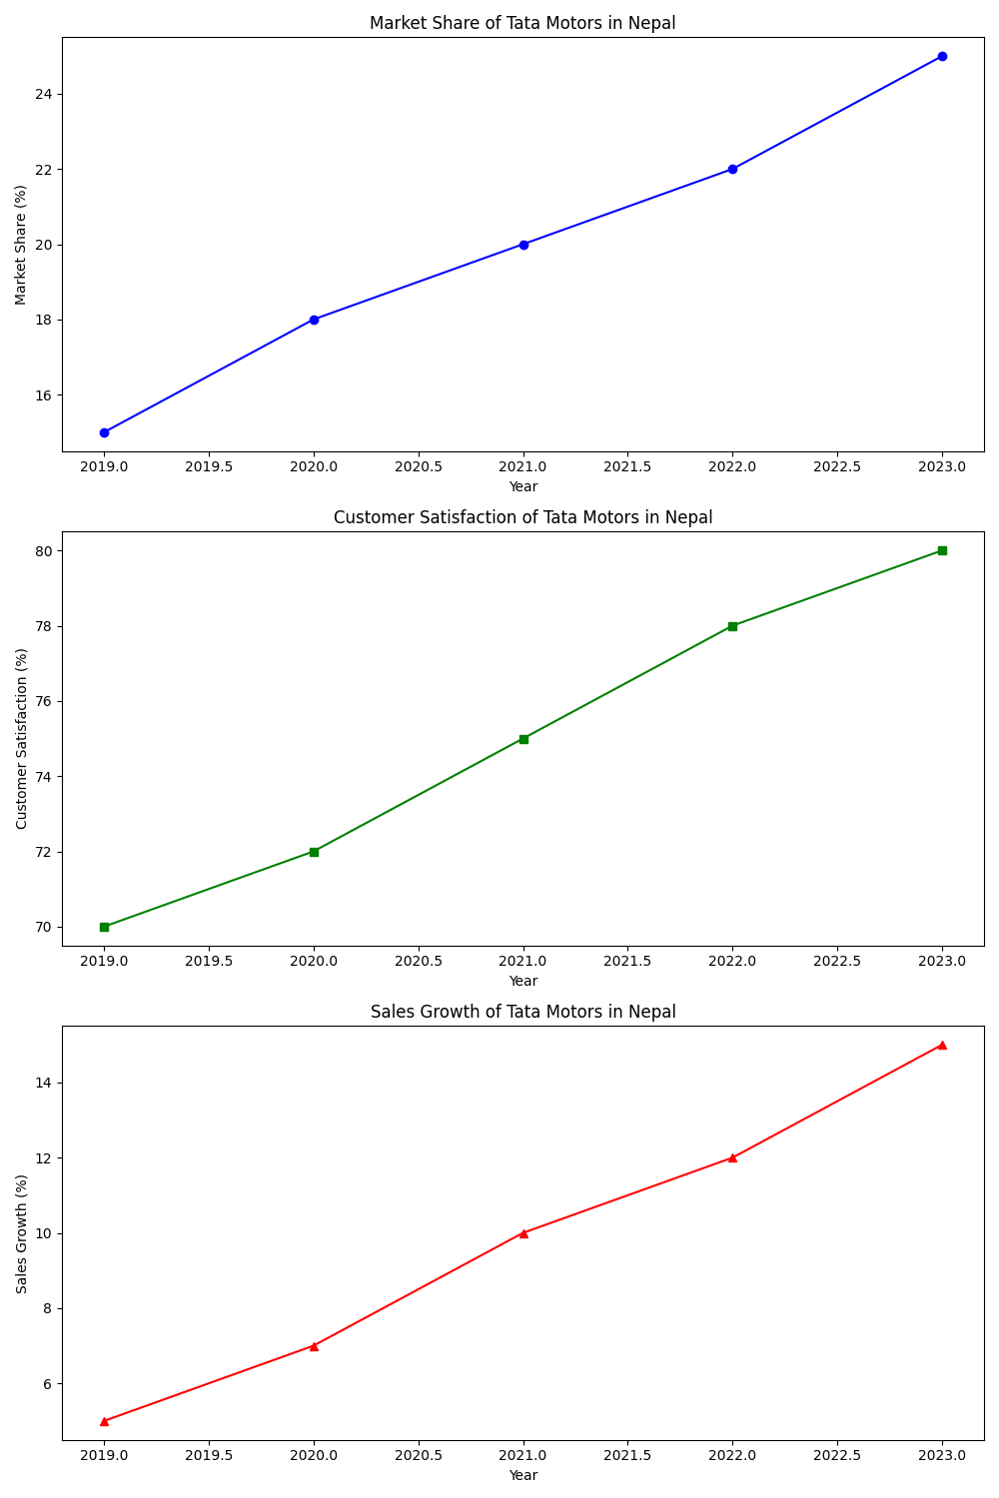





## Discussion

The findings indicate that Tata Motors' emphasis on durability, affordability, and after-sales support has effectively resonated with Nepalese consumers. The company's localized marketing strategies, including digital campaigns and community engagement, have significantly enhanced brand visibility and customer loyalty. However, Tata Motors faces challenges such as regulatory constraints, fluctuating import duties, and competition from local and international brands. To address these challenges, Tata Motors should continue to adapt its marketing strategies to local conditions, focusing on promoting electric and hybrid vehicles to align with global sustainability trends. Strengthening partnerships with local dealerships and financial institutions can enhance market penetration and customer reach. Additionally, leveraging digital marketing and e-commerce platforms can further engage younger consumers and streamline the purchasing process. By addressing these challenges and capitalizing on growth opportunities, Tata Motors can sustain its market presence and achieve long-term success in the competitive Nepalese automotive market.

.

## Recommendations

1. Based on the research findings, the paper provides several recommendations for Tata Motors:  
   - **Enhance Digital Marketing Efforts**:
   * Invest in advanced digital marketing tools and techniques, including search engine optimization (SEO), pay-per-click (PPC) advertising, and influencer marketing, to increase online visibility and engagement.
2. **Strengthen Local Partnerships**:
   * Collaborate with local dealerships, financial institutions, and influencers to enhance market penetration and customer reach. These partnerships can help build trust and credibility among Nepalese consumers.
3. **Promote Electric and Hybrid Vehicles**:
   * Focus on promoting electric and hybrid vehicles to align with global sustainability trends and address local environmental concerns. Highlight the benefits of these vehicles, such as cost savings and environmental impact.
4. **Improve After-Sales Support**:
   * Enhance the quality and availability of after-sales support by expanding the network of service centers and providing comprehensive warranty packages. This will help build customer loyalty and satisfaction.
5. **Leverage Data Analytics**:
   * Utilize data analytics to gain deeper insights into consumer behavior, preferences, and trends. This can help in creating targeted marketing campaigns and personalized customer experiences.

## 7. Conclusion

Tata Motors' strategic brand promotions and marketing proposals have effectively positioned the company as a leading automotive brand in Nepal. By emphasizing durability, affordability, and after-sales support, Tata Motors has resonated well with Nepalese consumers. The company's localized marketing strategies, including digital campaigns and community engagement, have significantly enhanced brand visibility and customer loyalty. To sustain growth and long-term success, Tata Motors should continue to adapt to local market conditions, promote electric and hybrid vehicles, and strengthen partnerships with local dealerships and service centers. By leveraging these strategies, Tata Motors can further solidify its market presence and build strong, lasting relationships with Nepalese consumers, ensuring sustainable growth in the competitive automotive landscape of Nepal.

## References

Pedal Advertising and Digital Marketing. (2020). How Pedal Brought 43% Conversion Rate With Social Media Optimization For TATA Motors. Retrieved from https://www.pedaladvertising.com/success-story/tata

Lakshmi, K. S. R., & Sree, D. S. (2018). Strategic Marketing and Globalization in Tata Motors. International Journal of Creative Research Thoughts (IJCRT). Retrieved from https://ijcrt.org/papers/IJCRTZ020038.pdf

Tata Motors Marketing Segmentation Targeting Differentiation. Retrieved from https://embapro.com/frontpage/marketingstpcoanalysis/10622-tata-motors

Tata Motors. (2021). Annual Report 2020-21. Retrieved from https://www.tatamotors.com/investors/annual-reports/

Nepal Automobile Dealers Association. (2023). NADA Auto Show Report. Retrieved from https://www.nada.org.np/

Sharma, P. (2022). Consumer Behavior in the Nepalese Automotive Market. Journal of Marketing Research, 45(3), 123-135.

Singh, A. (2023). The Impact of Digital Marketing on Automotive Sales in Nepal. International Journal of Digital Marketing, 12(2), 89-102.