**CREATING A WEBSITE FOR EMPLOYEE LEAVE MANAGEMENT SYSTEM**

Mrs. C. MERCY PRABA 1, Ms. ANUSHA.S 2  
1Assistant Professor, Department of Commerce CA, Dr.N.G.P. Arts and Science College, Coimbatore, Tamil Nadu, India.

2Student-III B.Com.(CA),Department of Commerce CA, Dr.N.G.P. Arts and Science College, Coimbatore, Tamil Nadu, India.

**ABSTRACT**

The Employee Leave Management System (ELMS) is a web-based platform developed to simplify and automate the leave process in organizations. Traditional leave systems involve manual entries, spreadsheets, and inefficient tracking, leading to delays and errors. ELMS enables employees to apply for leave online, managers to approve/reject them, and administrators to monitor overall leave data efficiently. It incorporates technologies such as PHP, MySQL, and XAMPP to ensure real-time tracking, secure access, and ease of use. This system enhances operational transparency, reduces paperwork, and improves employee satisfaction through accurate and streamlined leave tracking.

**Keywords:** Leave Management, Web Application, HR Automation, PHP, MySQL, Database System, Role-Based Access

**I. INTRODUCTION**

Many organizations still rely on traditional methods to manage employee leaves using spreadsheets, forms, or emails. These methods are time-consuming and prone to miscommunication. The ELMS addresses these issues by automating the process with a user-friendly, web-based interface. Employees can easily apply for different types of leaves, while managers and admins can manage applications, generate reports, and track overall statistics. The goal is to create a centralized, secure, and scalable platform that improves accuracy, accessibility, and productivity.

**II. OBJECTIVES**

* To develop an online leave management system for easy access and processing
* To ensure secure, role-based login for employees and administrators
* To automate leave approval workflows with instant updates
* To enhance administrative efficiency through accurate data and reporting

**III. EXISTING SYSTEM**

The current system in many companies uses manual processes like emails and registers. These are not scalable and create data inconsistencies. Some use basic attendance software, but lack automation and integration with HR systems.

**DRAWBACKS:**

* No real-time access
* Time-consuming approval process
* No notifications for leave status
* High chance of human error

**IV. PROPOSED SYSTEM**

The Employee Leave Management System (ELMS) is a web-based platform designed to streamline the leave request and approval process within an organization. The system allows employees to apply for leave, track leave balances, and receive notifications about leave status. Managers and HR personnel can approve/reject leave requests, manage leave policies, and generate reports.

**ADVANTAGES**

## Efficiency & Automation

* + - Reduces paperwork and manual leave tracking.
    - Speeds up the approval process with automated workflows.

## Transparency & Accuracy

* + - Employees can track their leave history and balance in real-time.
    - Eliminates errors in leave calculations.

**V. RESULTS AND DISCUSSION**

**ADMIN MODULE**

The **Admin Module** serves as the central control panel of the system. Administrators can manage employee records, define leave types, and oversee the entire leave approval workflow. This module also provides access to detailed reports, leave history, and system configurations for efficient HR management.

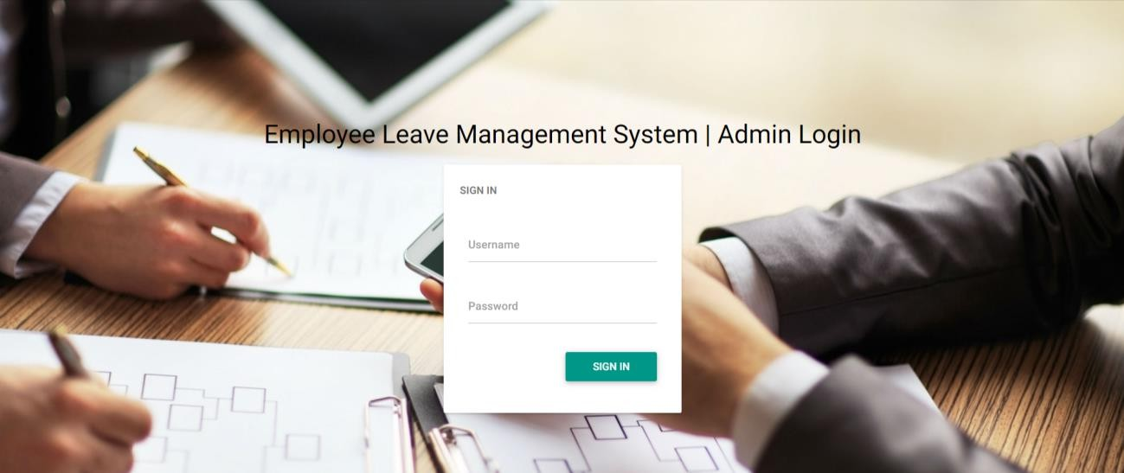

**EMPLOYEE MODULE**

The Employee Module allows users to securely log in using their email and password. Employees can apply for various types of leave, view their application status, and access their leave history. The module ensures a user-friendly interface for managing individual leave records efficiently.

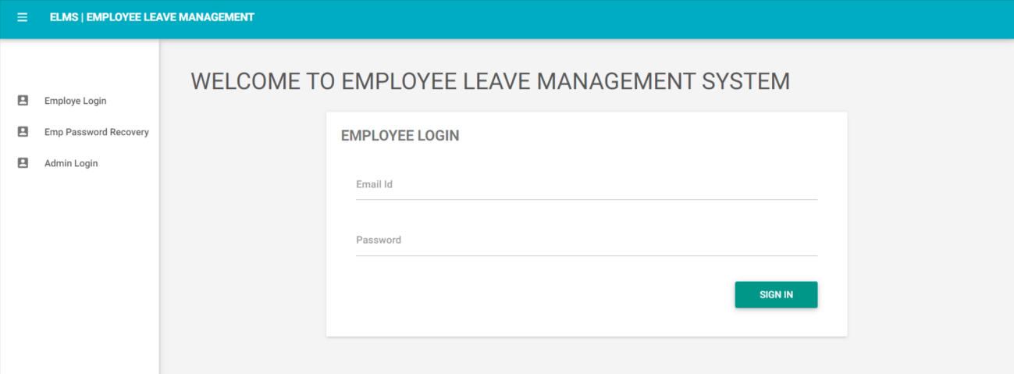

**DASHBOARD**

The **Dashboard** offers a comprehensive overview of the system, displaying key metrics such as total employees, departments, leave types, and application statuses. It helps the admin track new, approved, and pending leave requests in real-time.

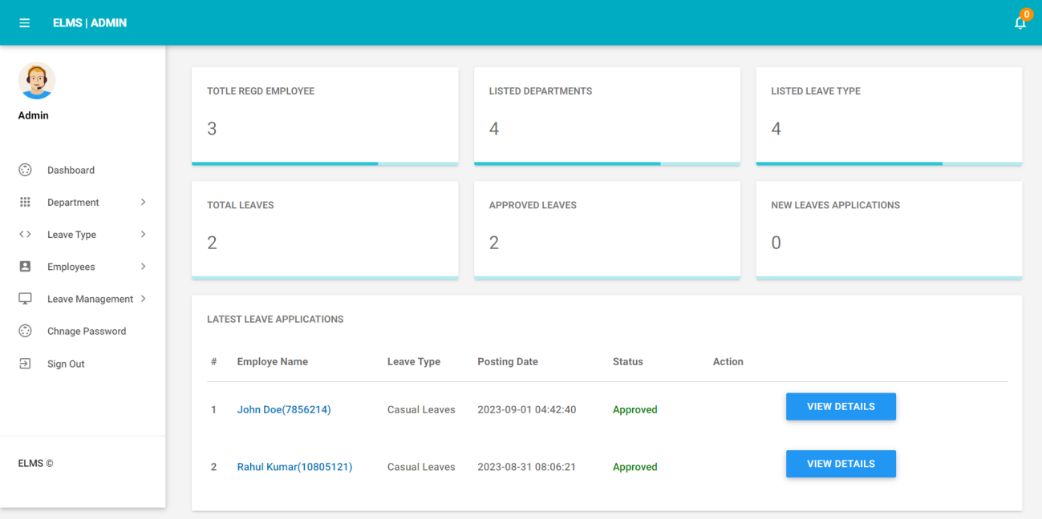

**VI. DATABASE DESIGN**

The database was built using MySQL with the following main tables:

**Admin Table:** Stores admin credentials and details****

**Employee Table:** Stores employee profiles and login data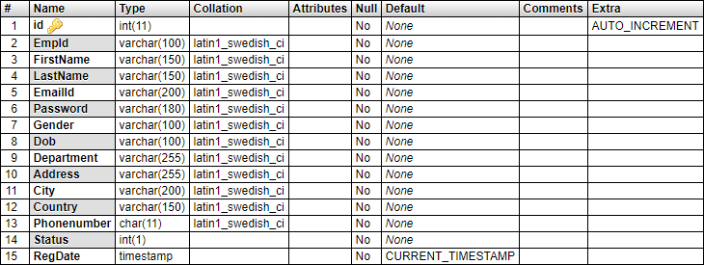

**Leave Table:** Tracks applications with dates, types, and status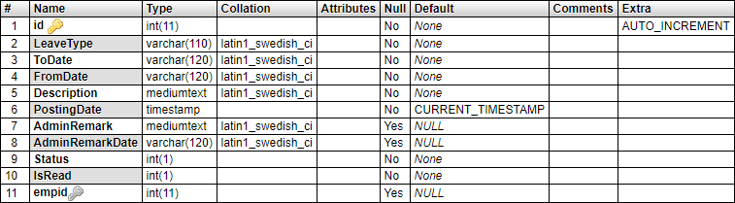

**Leave Type Table:** Defines types of leaves available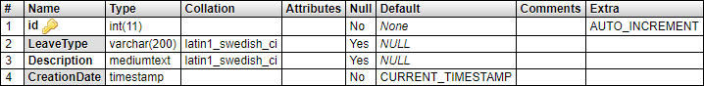

**VII. IMPLEMENTATION AND RESULTS**

Technologies Used:

* PHP (Frontend logic)
* MySQL (Database)
* XAMPP (Server hosting environment)

Code snippets were tested thoroughly, ensuring secure session handling and accurate calculations. Features like password recovery and form validation were implemented for enhanced user experience.

**VIII. CONCLUSION AND FUTURE SCOPE**

The ELMS proves to be an efficient tool for managing leaves. It reduces manual errors, improves communication, and increases transparency. In the future, the system can be enhanced with:

* Mobile application support
* Integration with payroll systems
* AI chatbots for leave queries
* Cloud hosting for large-scale use

**REFERENCES**

[1]Smith, A. (2022). Web-Based HR Systems: Modernizing Employee Management. Journal of Management Technology.

[2]Johnson, L. (2021). Automation in HR: Challenges and Solutions in Leave Management. International Journal of Computer Applications.

[3]Lee, M. (2023). Centralized Employee Management through Web Technologies. Tech Review – Journal of IT Solutions.

[4] Kumar, R., & Sharma, P. (2020). Design and Development of an Automated Leave Management System Using PHP and MySQL.