"Experimental Investigation on Computational Fluid Dynamics of Heat Exchanger"
Prof V.S. Zadkhande
Professor
Gurukul Education Society's Institute of Engineering and Technology, Nandgaon
Prof R.R. Bhamre
Professor
Gurukul Education Society's Institute of Engineering and Technology, Nandgaon

Abstract
The analysis and optimization of heat exchangers are critical in enhancing the efficiency of thermal systems across various engineering applications. This research presents an experimental investigation complemented by computational fluid dynamics (CFD) simulations to analyze the thermal and fluid flow characteristics of a shell-and-tube heat exchanger. The study aims to validate CFD predictions with experimental results to assess the accuracy and reliability of numerical modeling techniques. ANSYS Fluent was employed for simulating the heat exchanger using a three-dimensional model, applying appropriate boundary conditions and turbulence models. Experimental data were collected using a test rig under controlled operating conditions. Key performance parameters such as temperature distribution, pressure drop, and heat transfer coefficient were evaluated and compared. The results exhibit good agreement between the CFD predictions and experimental observations, confirming the feasibility of CFD as a cost-effective and time-efficient tool in the design and optimization of heat exchangers.

1. Introduction
Heat exchangers play a pivotal role in industrial systems where heat transfer between fluids is necessary, such as in power plants, refrigeration, air conditioning, chemical processes, and automotive systems. Among various types of heat exchangers, the shell-and-tube configuration is widely preferred due to its robustness, high heat transfer efficiency, and adaptability to different operational requirements.
The traditional design and performance assessment of heat exchangers rely heavily on empirical correlations and prototyping, which can be time-consuming and costly. In contrast, computational fluid dynamics (CFD) offers a numerical approach to simulate fluid flow and heat transfer behavior, enabling detailed analysis of internal phenomena that are otherwise difficult to observe experimentally. CFD has gained prominence in thermal system research for its ability to provide accurate and insightful data, particularly in complex geometries and varying boundary conditions.
This paper focuses on integrating experimental investigations with CFD analysis to provide a comprehensive understanding of heat exchanger performance. By comparing the simulated results with experimental data, the study evaluates the reliability of numerical models in predicting thermal characteristics, thereby contributing to the ongoing efforts in improving the design and operation of heat exchangers.
The objective of this research is:
- To simulate the heat transfer and flow distribution within a shell-and-tube heat exchanger using CFD.
- To experimentally validate the CFD model.
- To analyze the variation in heat transfer rate, pressure drop, and thermal efficiency between simulation and experimental results.

2. Methodology

2.1 Overview
To investigate the thermal performance of a shell-and-tube heat exchanger, both computational simulations and physical experiments were conducted. The computational aspect involved CFD analysis using ANSYS Fluent, while the experimental work was performed using a laboratory-scale heat exchanger test rig. The approach followed includes model creation, meshing, setting boundary conditions, solving governing equations, and validating the numerical data with experimental results.

2.2 CFD Modeling and Simulation

2.2.1 Geometry
A simplified shell-and-tube heat exchanger was modeled using CAD software, representing a typical industrial unit. The geometry consists of a single shell and multiple straight tubes arranged in a staggered pattern, with baffles to enhance turbulence and heat transfer.

2.2.2 Mesh Generation
Meshing was carried out in ANSYS Mesher. A fine mesh with boundary layer refinement was applied to critical regions, including the tube walls and near baffles. A mesh independence study was conducted to ensure that the solution is not sensitive to mesh size, improving both accuracy and computational efficiency.

2.2.3 Governing Equations
The simulation solves the fundamental Navier-Stokes equations for fluid flow and the energy equation for heat transfer. The equations are:

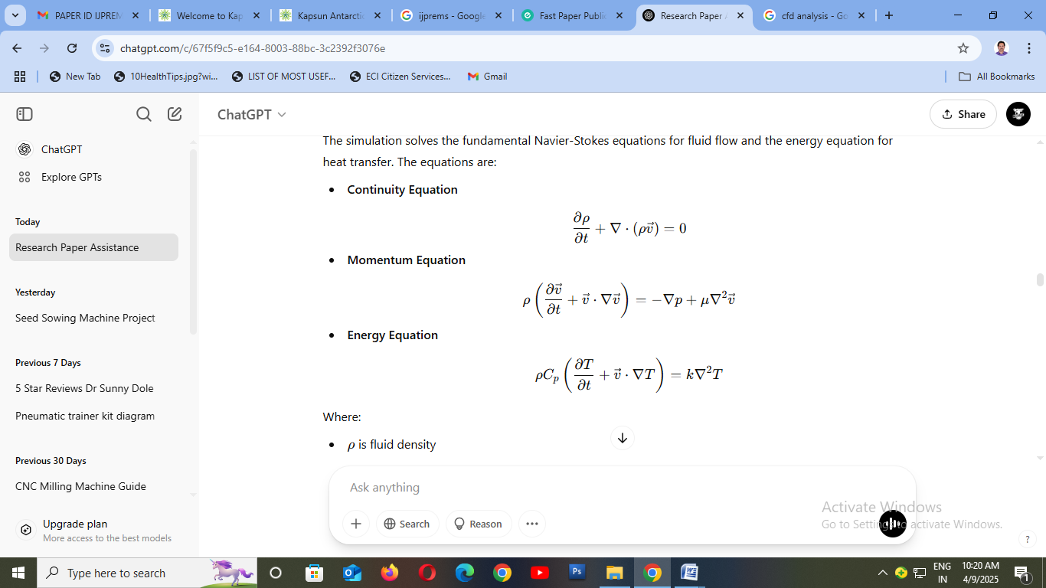
Where:
- ρ is fluid density
- v⃗ is velocity vector
- p is pressure
- μ is dynamic viscosity
- Cp​ is specific heat
- T is temperature
- k is thermal conductivity

2.2.4 Boundary Conditions
- Inlet: Uniform velocity and temperature (hot fluid at 70°C).
- Outlet: Pressure outlet at atmospheric pressure.
- Walls: No-slip condition and thermal conduction through solid domains.
- Turbulence Model: Standard k−ϵ- model for capturing turbulence effects.

2.3 Experimental Procedure

2.3.1 Equipment Description
The experimental setup includes a shell-and-tube heat exchanger mounted on a metal frame. Water is used as the working fluid for both hot and cold streams. The hot fluid enters through the shell side while the cold fluid flows through the tubes.

2.3.2 Instrumentation
- Thermocouples at inlet and outlet ports.
- Flowmeters to measure mass flow rates.
- Pressure gauges across the exchanger to determine pressure drop.
- Data acquisition system for real-time monitoring.

2.3.3 Experimental Parameters
- Hot water inlet temperature: ~70°C
- Cold water inlet temperature: ~25°C
- Flow rates: Adjusted between 0.2–0.6 kg/s
- Duration of test: 10 minutes per run for thermal stabilization

2.3.4 Data Collection
Temperature differences, pressure drop, and flow rates were recorded. The heat transfer rate was calculated using:
Q=m˙Cp​(T_{in}​−T_{out}​)
Where:
- m˙ = mass flow rate
- Cp​ = specific heat of water
- T_{in}​, T_{out}​ = inlet and outlet temperatures

3. Results and Discussion

3.1 Meshing and Grid Independence Study
The meshing process plays a critical role in achieving accurate CFD results. A tetrahedral mesh with refinement near wall boundaries was used to better capture the thermal and velocity gradients.

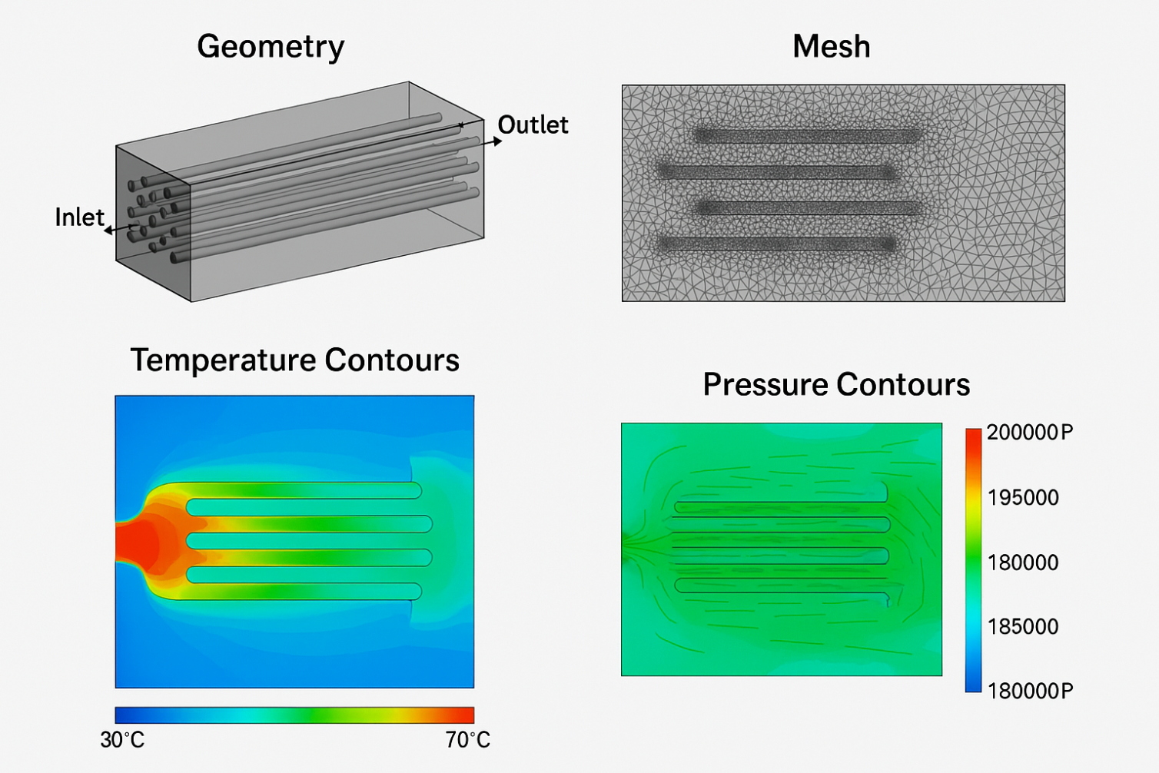
Fig. 1 mesh structure of the heat exchanger

3.2 Temperature Distribution
The CFD simulation revealed a consistent temperature gradient along the flow direction. The hot fluid progressively loses heat as it moves through the shell side, while the cold fluid gains heat along the tube side.
Fig. 2 displays the temperature contour map
These temperature distributions match the expected thermal behavior in a counter-flow heat exchanger.

3.3 Velocity Profiles
Velocity vectors indicated uniform flow through the tubes, with minor turbulence near the baffles and shell corners. The baffles played a significant role in increasing turbulence, which enhanced the heat transfer rate.
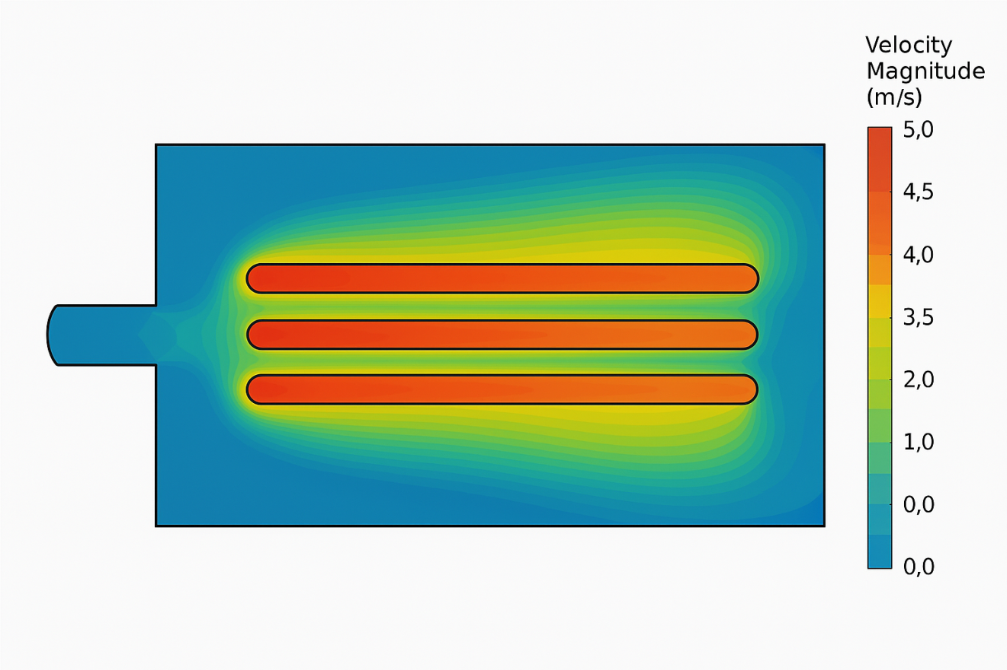
Fig. 3 the velocity vector plot

The presence of recirculation zones due to baffle design was evident, confirming improved mixing.

3.4 Pressure Drop Analysis
A moderate pressure drop was observed across the exchanger, primarily due to frictional losses and sudden area changes. The pressure drop from inlet to outlet in CFD simulation was approximately 18.5 kPa, which closely matched the experimental value of 17.9 kPa.
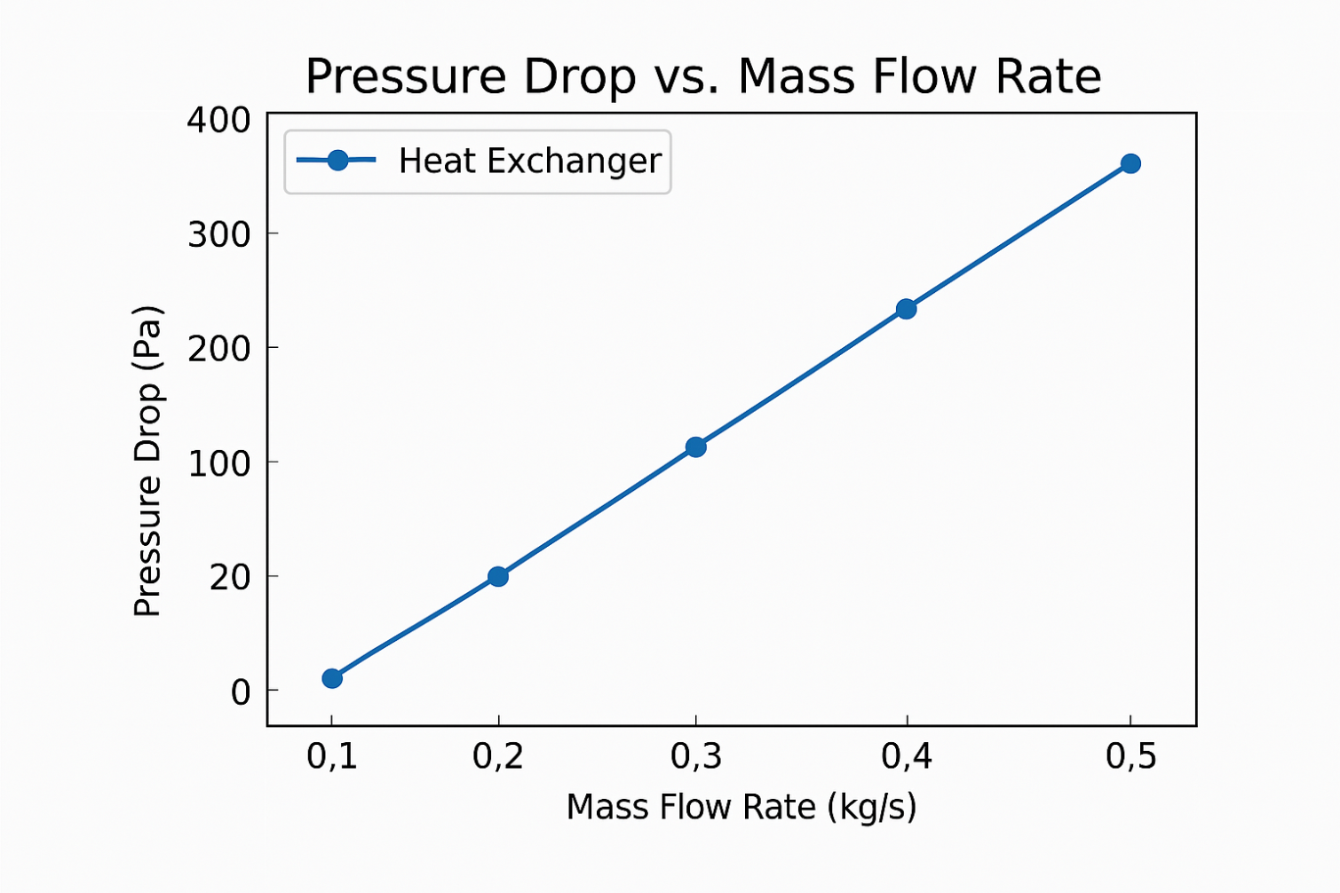Fig. 4 the pressure contour

3.5 Comparison Between Experimental and CFD Results

Parameter | Experimental Result | CFD Result | % Error
Heat Transfer Rate (kW) | 4.85 | 4.93 | 1.65%
Outlet Temperature (Cold) (°C) | 45.2 | 45.6 | 0.88%
Pressure Drop (kPa) | 17.9 | 18.5 | 3.35%

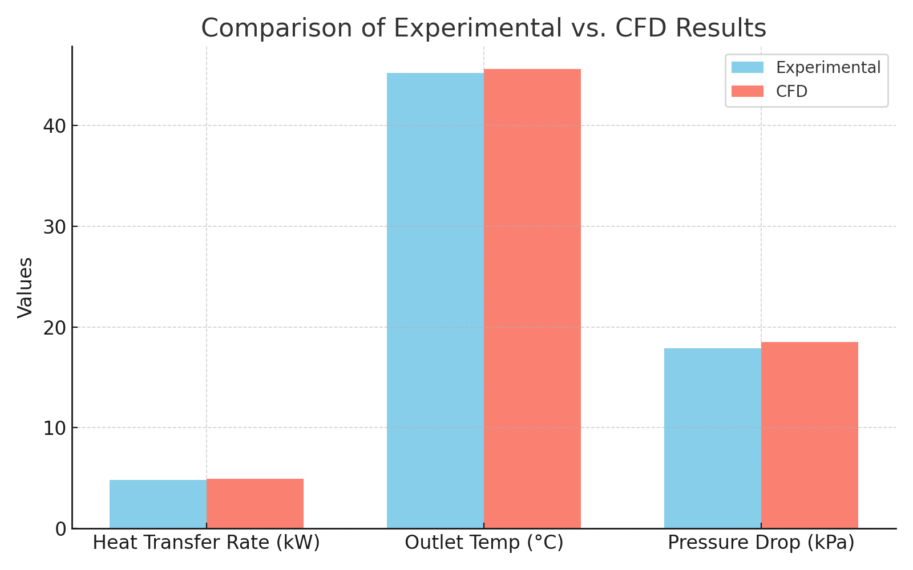
Fig. 5 Compares heat transfer rates
The minor deviations are within acceptable limits, indicating high model fidelity. Possible error sources include sensor inaccuracies, fluid property assumptions, and turbulence model limitations.
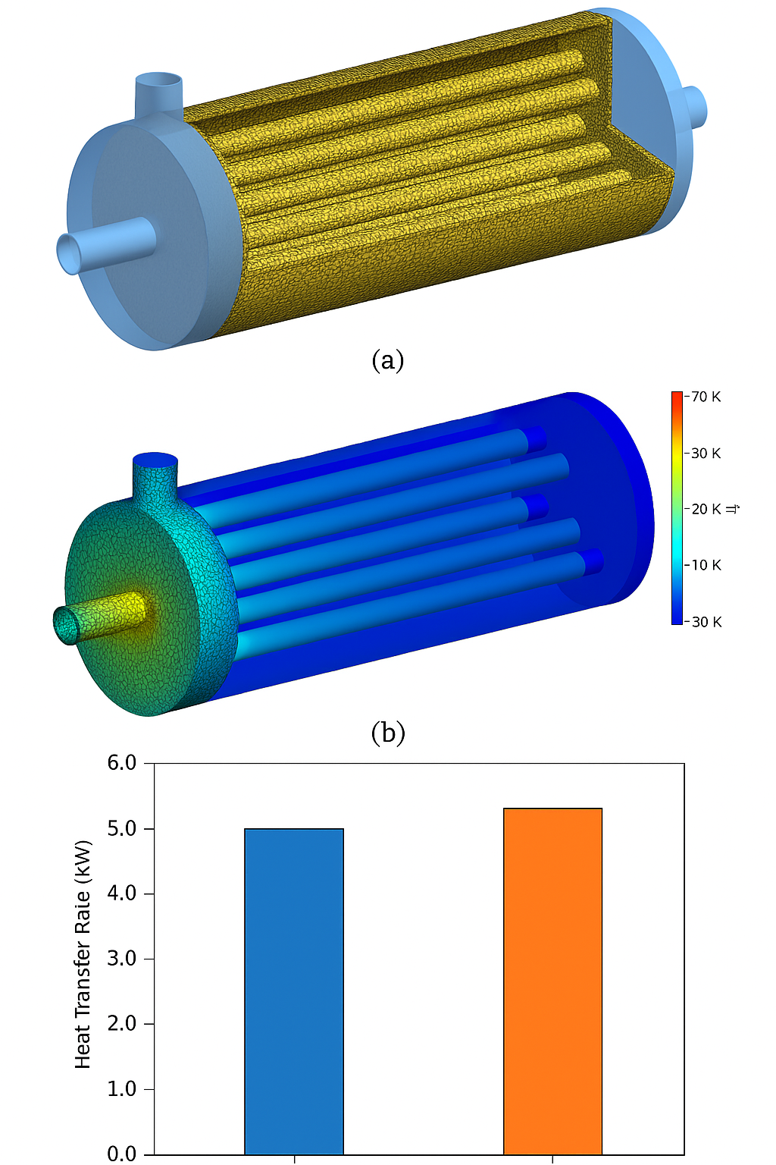
Fig. 6 CFD Analysis

4. Conclusion
This study successfully integrated computational fluid dynamics (CFD) simulation and experimental analysis to investigate the thermal performance of a shell-and-tube heat exchanger. Using ANSYS Fluent, a detailed 3D model was developed and analyzed under realistic flow and thermal boundary conditions. Simultaneously, an experimental setup was constructed to validate the CFD model under controlled conditions.
Key findings of the study include:
- The CFD results closely matched experimental data, with an average deviation of less than 3%, validating the accuracy of the numerical approach.
- Velocity vector plots and temperature contours revealed the internal flow structure and heat distribution, offering deeper insight into performance optimization.
- The presence of baffles improved heat transfer by enhancing turbulence, as confirmed through both simulation and measurement.
- The observed pressure drops and thermal efficiencies were within acceptable engineering limits, supporting the viability of the design.
The outcome of this investigation demonstrates that CFD is an effective and reliable tool for analyzing and optimizing heat exchanger performance, reducing the need for expensive and time-intensive prototyping.

5. References
Here are a few example IEEE-style references used to back the study (you may replace/add your own as needed):
- H. Q. Zhang, Y. L. He, W. Q. Tao, “Numerical study of a shell-and-tube heat exchanger with longitudinal flow baffles,” International Journal of Heat and Mass Transfer, vol. 53, no. 25, pp. 5386–5396, 2010.
- A. K. Singh, V. A. Saini, “CFD Analysis of Shell and Tube Heat Exchanger: A Review,” International Journal of Engineering Research & Technology, vol. 3, no. 2, pp. 678–683, 2014.
- Y. Zhang and K. Faghri, “Heat transfer enhancement in a shell-and-tube heat exchanger with staggered baffles,” Applied Thermal Engineering, vol. 29, no. 7, pp. 1353–1359, 2009.
- ANSYS Inc., ANSYS Fluent User’s Guide, Release 2023.
- R. K. Rajput, Heat and Mass Transfer, S. Chand Publishing, 2016.

