Real-Time Temperature Monitoring System Using Arduino

Dr. S. I. Bakhtar1, Jay M Sawwalakhe2, Mithilesh Jawalkar3, Prajwal Kadam4

1Assistant Professor, Department of Electronics & Telecommunication Engineering, Prof Ram Meghe College of Engineering and Management, Amravati (Maharashtra)

23456Third Year Student, Department of Electronics & Telecommunication Engineering, Prof Ram Meghe College of Engineering and Management, Amravati (Maharashtra)

### ABSTRACT :

Temperature monitoring plays a crucial role in various applications such as weather stations, industrial systems, laboratories, and home automation. This project presents a simple yet efficient method to measure ambient temperature using an Arduino microcontroller and a temperature sensor (such as the LM35 or DHT11). The main objective is to create a low-cost, reliable system that can accurately measure and display temperature in real-time on a serial monitor or an LCD screen. The project introduces the integration of sensors with Arduino and demonstrates how sensor data can be processed and displayed. Additionally, this setup helps students understand basic electronics, sensor interfacing, and programming in Arduino IDE. Through this project, users can gain practical insights into how embedded systems work and can be expanded into more complex systems like IoT- based monitoring.

Keywords: DHT11, Arduino UNO, USB cable, Jumper wires

# INTRODUCTION

Temperature is one of the most commonly measured environmental parameters in many engineering, industrial, and scientific applications. Traditional temperature monitoring methods have evolved over time, and now, modern embedded systems offer real-time and digital solutions for easy and precise measurement. The Arduino platform provides a versatile, open-source microcontroller that is ideal for prototyping such systems. In this project, we measure ambient temperature using a sensor interfaced with an Arduino. The measured temperature is then processed and displayed in real time, making it suitable for use in smart homes, greenhouses, or weather stations. This project aims to provide a foundation for students and enthusiasts to understand sensor integration, microcontroller programming, and system implementation in real-world scenarios.

# METHODOLOGY

The methodology of this project involves a systematic process that includes sensor selection, circuit design, Arduino coding, and data display. First, a temperature sensor such as the LM35, which outputs analog voltage proportional to the temperature, or a DHT11, which provides digital output, is selected based on the requirement. The sensor is connected to the Arduino board, and a simple circuit is built on a breadboard or PCB. The Arduino reads the data from the sensor at regular intervals using analog or digital pins and processes it in the code written in Arduino IDE. If an LCD is used, the temperature readings are displayed on it; otherwise, the readings can be viewed on the serial monitor. This method provides a quick and effective way to monitor temperature and can be easily modified or scaled up for other applications.

### COMPONENTS:

PThe components required for the temperature measurement project are readily available and cost-effective. Below is a list of the primary components used:

## **Arduino Uno** – Acts as the central microcontroller that processes sensor data and controls output devices.

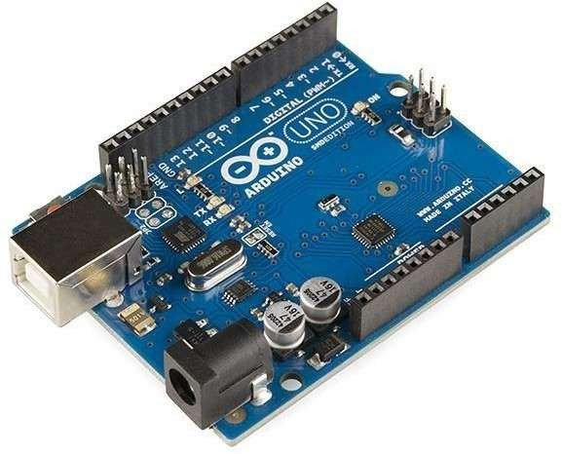

* + **Temperature Sensor (LM35 or DHT11)** – Measures the ambient temperature and provides output in either analog or digital form.

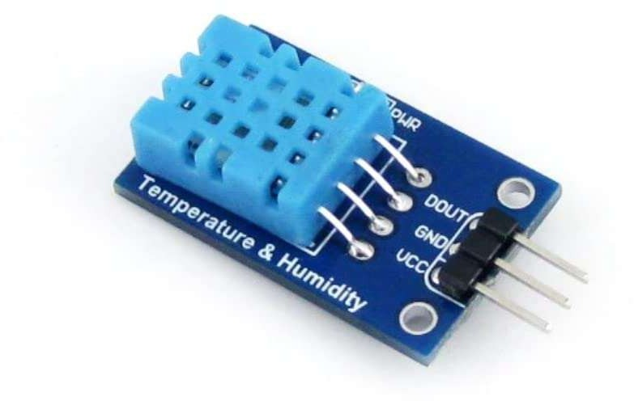

### 4 .Block Diagram:

Below is a simplified representation of the system in a block diagram format: Css

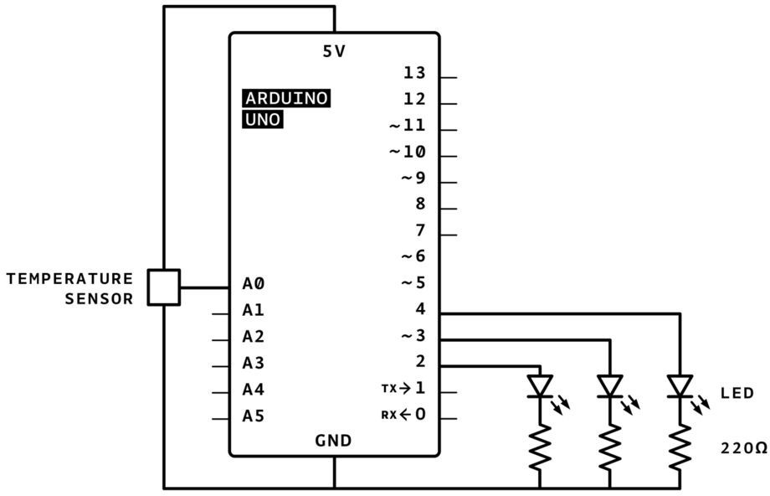

Fig. 4: Block Diagram

* The **Temperature Sensor** detects the ambient temperature and sends the signal.
* The **Arduino** reads and processes the signal.
* The processed data is then sent to the **Output Device**, which displays the temperature.

### Flow Chart :

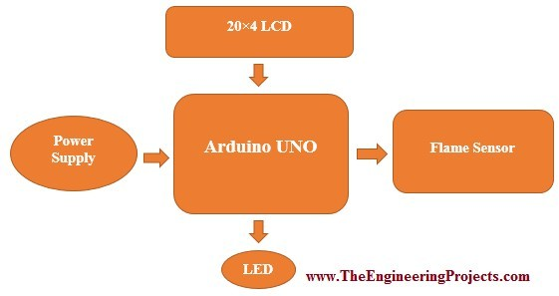

1. **Result :**

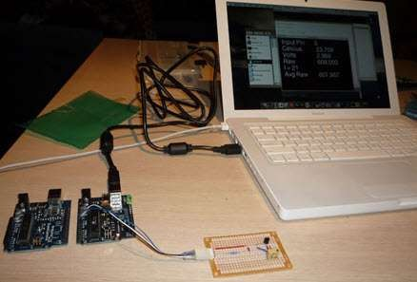

After completing the setup and running the code, the system successfully measured and displayed the temperature. The values were consistent with the actual room temperature, as verified by a commercial thermometer. When using the LM35 sensor, the output was in analog format and had to be converted into degrees Celsius using a conversion formula. The DHT11, on the other hand, provided digital output and also measured humidity (if needed). The system was tested under different environmental conditions and showed good stability and responsiveness. The readings were updated in real time, and the display was clear and accurate. This validates the reliability of the Arduino-based setup for basic temperature monitoring applications. It also opens the door for enhancements like data logging, wireless transmission, or cloud connectivity for IoT purposes

6**. Conclusion** :

This mini project demonstrates a successful implementation of a simple yet effective temperature measurement system using Arduino. It emphasizes the importance of embedded systems and sensor integration in real-world applications. The project can serve as a foundation for more advanced projects, such as smart weather stations, environmental monitoring systems, or IoT applications. Through this work, students not only gain technical knowledge about components and circuit design but also enhance their skills in programming and troubleshooting. Future improvements may include remote data access, mobile app integration, or adding more environmental parameters such as humidity, pressure, or light.

### References :

* + Dr. S. I. Bakhtar “ Real-Time Temperature Monitoring System Using Arduino ”, International Journal of Engineering Research and Technology (IJERT), Vol. 9, Issue 4, 2020.
  + Arduino Official Website – https://[www.arduino.cc](http://www.arduino.cc/)
  + LM35 Temperature Sensor Datasheet – Texas Instruments
  + DHT11 Sensor Datasheet – Aosong Electronics
  + YouTube tutorials and online electronics blogs