**REAL ESTATE INVESTMENT STRATEGIES FOR BEGINNERS**

**RUSHIKESH SANGITRAO MANKAR**

( Student )

**Email Id:** [**rmmankar1010@gmail.com**](mailto:rmmankar1010@gmail.com) **Contact No:** 8668650099

Department Of Business Administration And Research, Shri Sant Gajanan Maharaj College Of Engineering Shegaon.

**DR. M. A. DANDE**

( Assistant professor )

**Email Id:** [**madhande@ssgmce.ac.in**](mailto:madhande@ssgmce.ac.in) **Contact No** **:** 9423619555

Department Of Business Administration And Research, Shri Sant Gajanan Maharaj College Of Engineering Shegaon.

**Abstract**

One of the most proven ways of building wealth and generating passive income, real estate investing has the potential to be daunting for beginners due to the complexity of the market, financial risks involved, and legal matters. Some of the beginner-friendly real estate investment strategies explored in this research include **rental properties, house hacking, Real Estate Investment Trusts (REITs), wholesaling, and the BRRRR (Buy, Rehab, Rent, Refinance, Repeat) strategy**. It brings to the fore crucial aspects that are essential for arriving at sound investment decisions, such as market analysis, financing alternatives, risk strategy, and strategic planning. The purpose of this study is to provide new investors with a well-structured road map for entering the real estate arena with confidence through an analysis of many strategies and best practices in the industry. The findings emphasize how vital financial restraint, education, and sound decision-making are to the success of estate investing.

**“ Real Estate Investment Strategies For Beginners ”**

**Introduction**

Real estate investment can be a powerful way for beginners to build wealth, generate passive income, and achieve financial security. By understanding the basics such as property types, investment strategies, and market dynamics As you gain experience, you’ll be better in work real estate investment is one of the beneficial investment if you do it properly it will give you huge profits to generate or create a wealth. It involves purchasing, owning, managing, renting, or selling properties for profit.

For beginners, choosing the right strategy is crucial. Some of the most common and beginner-friendly real estate investment strategies include **Rental property investing**, **House hacking**, **Real estate investment trusts (REITs)**, **Lease options**, and **Wholesaling**. Each strategy varies in terms of risk, capital requirements, and potential returns, making it essential for investors to assess their financial goals and risk tolerance before entering the market.

Real estate refers to property consisting of land and the buildings on it, along with its natural resources such as crops, minerals, or water. It encompasses a broad category of assets, including residential, commercial, and industrial properties. The real estate market plays a crucial role in the global economy, as it involves the buying, selling, renting, and development of land and properties.

Real estate can be classified into different categories:

1. **Residential Real Estate** : This includes properties intended for personal living, such as single-family homes, apartments.

2. **Commercial Real Estate** : This sector involves properties used for business purposes, including office buildings, shopping centres , hotels, and restaurants.

3. **Industrial Real Estate** : This includes properties used for manufacturing, production, distribution, and storage, such as factories, warehouses, etc.

4. **Land** : This refers to undeveloped that can be used for agriculture, development, or as a natural resource.

**Investment Strategies For Beginners**

* **Buy and Hold Strategy** – Buy a property and rent it out for long-term income.
* **House Hacking** – Live in one unit while renting out the others to cover mortgage costs.
* **Wholesaling** – Find undervalued properties and sell contracts to other investors.
* **Lease Options** – Rent-to-own agreements where tenants pay an option fee to buy the property later.

**Literature Review**

• **Brueggeman, W. B., & Fisher, J. D. (2019). *Real Estate Finance and Investments* (16th ed.). McGraw-Hill Education.**

Brueggeman and Fisher (2019) provide an in-depth exploration of real estate finance and investments, such as market valuation, financing arrangements, risk assessment, and portfolio diversification. The book explores mortgage-backed securities, the business cycle, and the role of capital markets in real estate. It emphasizes risk-return analysis and investment techniques, for example, Real Estate Investment Trusts (REITs) and direct property investment. Case studies of real-life experiences are an effective learning resource, therefore an investment worth making by students, investors, and business professionals alike. The publication stresses the unique function of real estate in capital markets, highlighting its capacity to build wealth and diversify portfolios while also cushioning inherent market risks.

• **Hanlon, R. (2018). Investing in Tax Liens.**

Hanlon (2018) refers to tax lien investing as a lucrative real estate investment wherein investors buy tax lien certificates from municipalities. The author describes how tax liens function, ranging from the legal system, bidding, interest rates, to risks. The author refers to possible returns while focusing on due diligence and research. Hanlon gives step-by-step instructions on discovering profitable opportunities, evading pitfalls, and maximizing returns. The book is a valuable tool for both novice and veteran investors looking to diversify their investment portfolios with low-expense, high-return real estate investments backed by government-insured property tax liens.

• **Jones, P., & Cooper, K. (2020). Lease Options: A Guide for Beginners. Real Estate Investor’s Journal.**

Jones and Cooper (2020) offer a step-by-step guide to lease options, an active real estate investing strategy for beginners with little capital. The book explains how lease options rent-to-own are used to give investors control of properties without owning them. It covers big themes such as structuring deals, negotiating, and risk reduction. Jones and Cooper discuss the benefits of lease options, including cash flow creation and low up-front investment. With real-life examples and clear-cut strategies, this book is a great guide for investors willing to enter the real estate market with minimal exposure of finances and maximum flexibility.

• **Malinowski, J., & Grover, D. (2019). The Real Estate Investor’s Handbook*.* McGraw-Hill.**

Malinowski and Grover (2019) provide a comprehensive guide for real estate investors that covers property purchasing, financing, risk control, and investment strategies. The Real Estate Investor's Handbook offers key concepts for building a successful portfolio of rental homes, fix-and-flip projects, and commercial property. Market research, due diligence, and financial planning are the center to ensure the highest possible returns while keeping risks to a minimum. Case studies of real-life examples and professional advice guide investors past the barriers and towards good judgment. A step-by-step approach, it is an insider's handbook for both first-time and veteran investors in quest of long-term achievement in real estate.

• **Turner, B. (2015). The Book on Rental Property Investing*.* Bigger Pockets Publishing.**

Turner (2015) presents a practitioner guide to building wealth by investing in rental properties. The Book on Rental Property Investing covers some of the most relevant strategies, like buying property, financing, controlling cash flow, and tenant screening. Turner worries about building wealth in the long term by receiving passive income, tax advantages, and portfolio build-up. The book is a step-by-step guide to investing more, how not to commit common errors, and ways of maximizing returns. Practical and based on real-life situations, it is a good book for new investors and veteran investors. Turner's approach to investing in real estate is simple and handy for individuals who wish to generate regular income and achieve financial freedom.

• **Turner, B. (2019). The BRRRR Strategy: How to Invest in Real Estate with No Money. Bigger Pockets Publishing.**

Turner (2019) explores the BRRRR Strategy—Buy, Rehab, Rent, Refinance, Repeat—a high-level way of investing in real estate using minimal, if any, capital. The book provides a step-by-step guide of how to buy distressed properties, rehabilitate to increase value, generate rental income, refinance to pull out equity, and reinvest in additional deals. Turner concentrates on prudent financing, risk management, and accumulating wealth in the long term through this repeat process. With specific examples and real-life inputs, the book acts as a handy guide for investors wanting to enhance their portfolios practically without compromising on returns and initial capital investment.

• **Eldred, G. W. (2009). Investing in Real Estate. John Wiley & Sons.**

Eldred (2009) offers a thorough guide on how to invest in real property, including choosing property, financing, market appraisal, and risk management. Investing in Real Estate describes ways of becoming wealthy through rental homes, house flipping, and business property. Due care, negotiation strategies, and tax advantages are highlighted in the book for profit. Eldred breaks down complicated ideas into simple terms, and real estate is made easy for novices but still provides sophisticated data for experienced investors. With real-world examples and detailed instructions, the book is a how-to guide for individuals who want to create passive income and long-term financial yield in real estate investing.

* **Leinwand & Kleiner (2014) Entry Level Strategies For residential real estate Investing.**

**Leinwand and Kleiner (2014) discuss beginning real estate investing in residential property, with a concentration on low-risk strategies for new investors. They highlight rental properties as a secure means of generating passive income, with a concentration on location, tenant selection, and cash flow management. The authors also mention house hacking, where investors live in one unit and rent out others to keep housing costs to a minimum. Fix-and-flip investing and lease options are presented as alternative methods, requiring careful market research and financial planning. Leinwand and Kleiner (2014) emphasize starting with small, controllable investments, using financing alternatives, and gradually expanding to build long-term wealth in real estate.**

**Research Methodology**

1. **Objective of Project**

* **Income Generation** : This involves earning regular cash flows form real estate assets. Typically, this is achieved through rental income form properties or dividends form real estate investment trust (REIT)
* **Diversification** : Diversification in real estate involves spreading investment across different types of properties, location, and market segment to reduce risk.
* **Long term wealth Building** : This strategy focuses on increasing the value of real estate investment over time through property appreciation equity accumulation and reinvestment.
* **Wealth Maximization** : Maximizing wealth involves enhancing the value and profitability of real estate investment through strategies like property improvement strategic buying and selling and efficient management.
* **Retirement planning** : In the real estate, retirement planning involves creating the portfolio of investment and provide financial security and income during retirement

1. **Data collection method**

* **Primary Data:** Structured questionnaires, interviews, and focus group discussions with stakeholders, observations.
* **Secondary Data:** Documents analysis, case studies, and experiments, data analysis.
* **Sampling Techniques:** (Stratified Sampling) Divide the population into subgroups (strata) based on specific characteristics, such as property type, location, or price range. Then, randomly sample from each subgroup. This method ensures that different segments of the market are represented in your analysis.

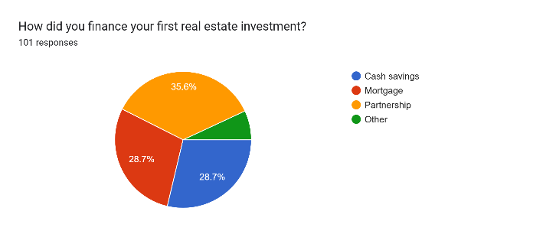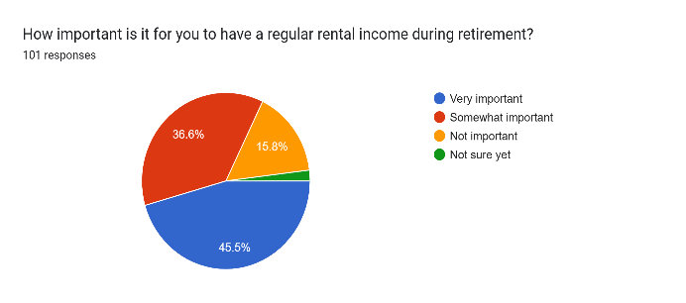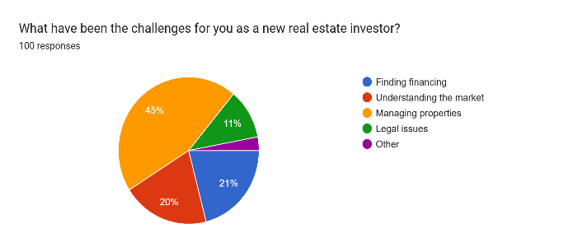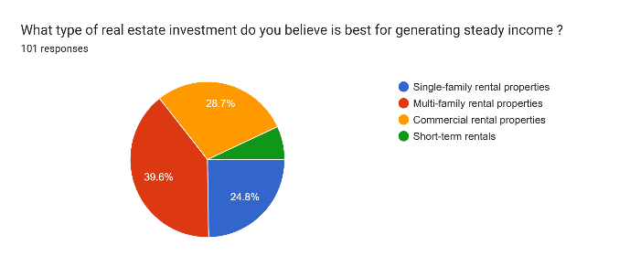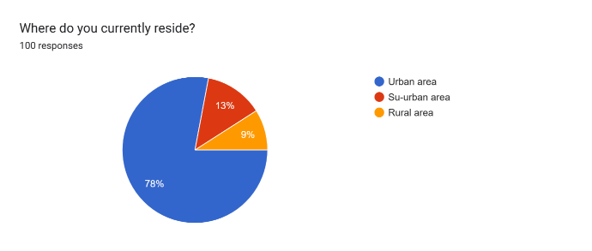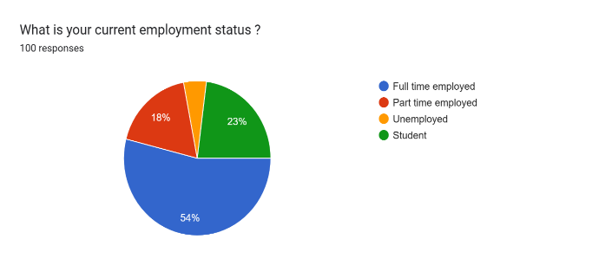The following charts visualize **Real Estate Investment Strategies for Beginners** based on survey responses.

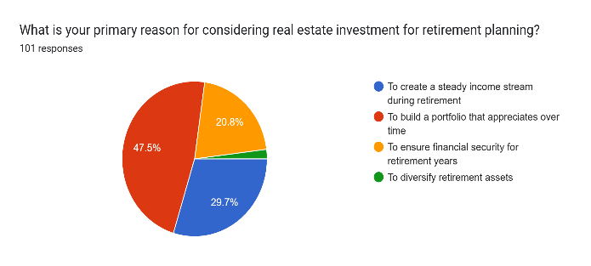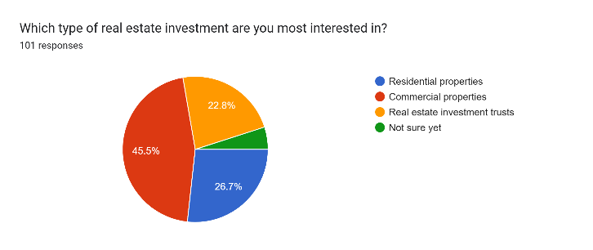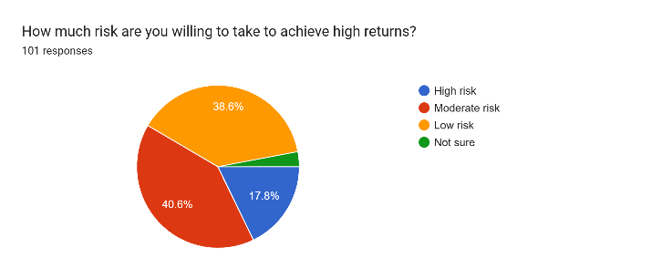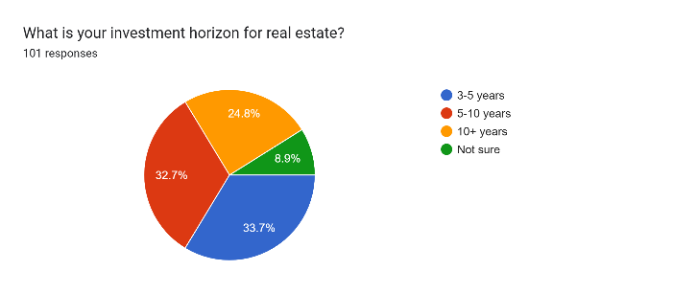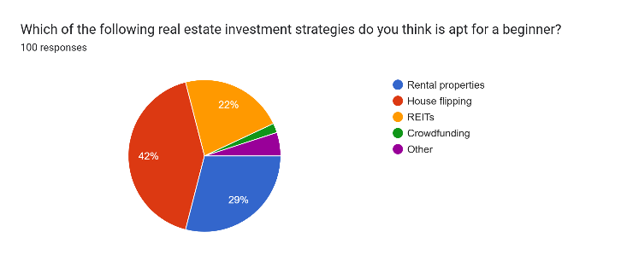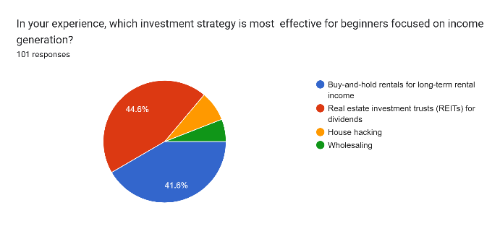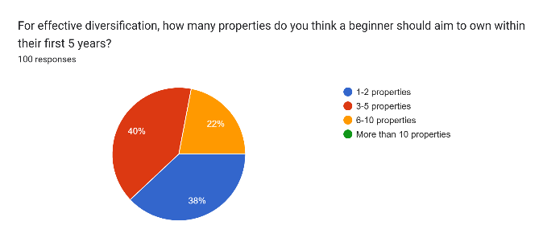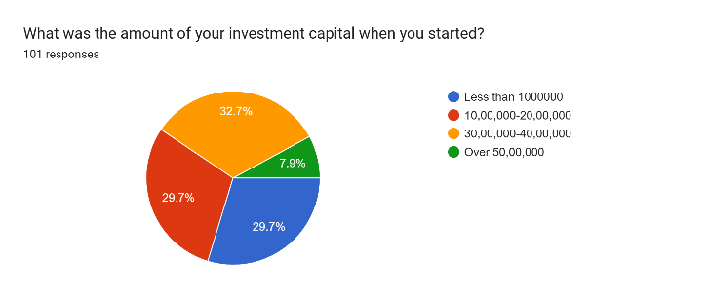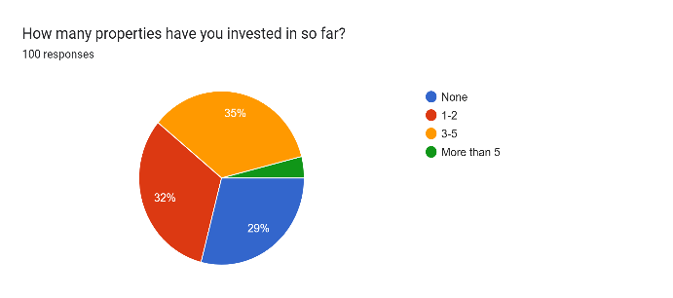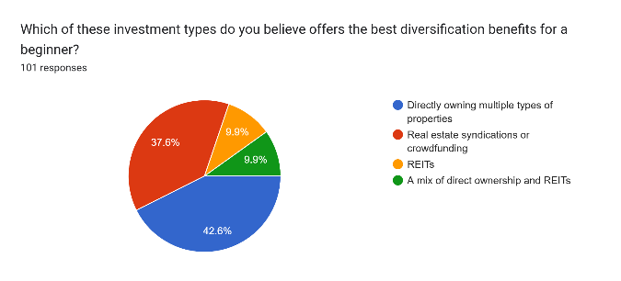

**Conclusion**

Based on the survey data, the following can be concluded regarding real estate investment opportunities for novices:

**1. Income and Demographics:**

• 46% of the respondents are aged between 25-30 years, which indicates that young individuals preferring to become wealthy prefer real estate investment.

• They reside in urban areas (78%), which means that urban real estate markets are more attractive to novice investors.

• Nearly 44.6% of the respondents have a household income of below ₹5,00,000, highlighting that the majority of new entrants are middle-income individuals.

**2. Investment Preferences:**

• Investment Type: The most sought-after type of real estate investment to achieve stable income is commercial property (38%), followed by single-family residential property (24.8%). This indicates a balance between stability in income and scope for growth.

• Diversification Strategies: Around 42% of new investors believe that direct ownership of different types of properties offers the highest diversification benefits, reflecting a need for control over tangible assets.

• Effective Strategies for Beginners: The most recommended beginner strategy is REITs (Real Estate Investment Trusts (42%), which offer easier entry and diversification with less capital requirements.

**3. Challenges and Risk Appetite**

• The greatest concern for new investors is handling properties (40%) followed by obtaining finance (20%). This captures the complexity of handling a property as a significant challenge.

• 40.6% prefer moderate risk and 38.6% prefer low risk, indicating risk aversion among newbies.

**4. Investment Goals and Capital:**

• The primary goal for most newbies (44.6%) is to earn steady income, indicating a preference for security over risky growth.

• Most newbies began with a capital of under ₹10,00,000 (29.7%) indicating smaller-scale investment at the outset.

• The ideal number of properties for diversification over the first five years is 3-5 properties (40%), proposing a moderate but increasing portfolio.

**Key Takeaways:**

• Real estate beginners prefer low-to-moderate risk approaches, emphasizing stability of income and slow diversification.

• REITs and direct ownership of different types of properties are deemed effective means of diversification.

• Commercial buildings and metropolitan cities appear to be more attractive to new investors.

• The issues of property funding and management are core challenges that need to be overcome.

• Aiming for 3-5 properties in the first five years of business for successful diversification appears suitable for beginners.

Overall, the findings conclude that starters would be well-advised to concentrate on steady income strategies with modest diversification and low levels of risk in order to obtain a stable portfolio of real estate.

**Suggestions**

**1**. **Start with Proper Education**

Knowledge of the fundamentals of real estate is needed to become successful. Beginners have to read books, enroll for online courses, participate in seminars, and learn from professionals. Being proficient in property valuation, financing, and investment methods reduces risks and strengthens decision-making. Proper education enables investors to act confidently even amidst adversity and identify profitable opportunities without fear.

**2. Choose Easy Methods for Beginners**

New investors can start with simple approaches like rental property, house hacking, or Real Estate Investment Trusts (REITs). These approaches require less experience and capital but generate steady income and portfolio growth. Starting with low-risk investments allows newbies to gain experience, develop confidence, and invest in real estate ventures in the long run.

**3. Research the Market**

Market studies guide investors with wise decisions. In light of property value, desire to rent, area development, and financial situations secures the investment success. Knowledge of trends in demand and supply, vacancy rate, and provincial regulations prevents money-wasting errors. Real estate investing and risk achievement are enhanced through comparison of locations and types of real estate.

**4. Secure Financing**

Financing is essential in real estate investing. FHA loans, seller financing, traditional loans, and private lenders ought to be viewed by newcomers. Saving for a down payment, good credit report, and negotiation of terms in the loan make financing opportunities good. Awareness of mortgage rates and terms gives the investor quality choices and affordability.

**5. Start Small and Build Gradually**

Investing in a small, portable asset reduces risks and allows beginners to learn. Reinvesting dividends over time in new assets allows strategic portfolio growth. Not overleveraging and steady growth ensures long-term success. Every investment is a learning experience and a chance to fine-tune strategies and become more confident when making real estate investments.

**6. Learn the Legal Side**

Information regarding real estate legislation, tenant law, lease contracts, and tax legislation prevents legal issues. New entrants in the marketplace need to employ a real estate attorney and remain current with zoning ordinances and landlord-tenant statutes. Accurate documentation, checking agreements, and adherence to legislation safeguard investments, which reduces the likelihood of monetary losses as well as legal issues.

**7. Plan for Extra Costs**

Surprises such as property taxes, repairs, maintenance, and vacancies affect profits. Keeping an emergency fund and budgeting for expenses prevents cash flow, making investments viable and profitable in the long term by incorporating insurance, movement within the market, and management fees.

**8. Network with Other Investors**

Interacting with experienced investors, visiting real estate conferences, and local gatherings are enlightening. Learning from others' experience, guidance, and association provide new avenues of investment. Collaboration with professionals, such as real estate agents and builders, makes investment plans more robust and leads new entrants through real estate pitfalls.

**9. Be Patient and Stay Committed**

Real estate investment is a long and arduous process that requires persistence and patience. Overnight success is not inevitable, but consistent learning, flexibility in adapting to the market, and long-term thinking guarantee economic development. Weathering failures, staying focused, and constantly sharpening strategies ensure investors are motivated and achieve real estate investment goals over time.

**Bibliography**

• **Brueggeman, W. B., & Fisher, J. D. (2019).** *Real Estate Finance and Investments* (16th ed.). McGraw-Hill Education.

• **Brueggeman, W. B., & Fisher, J. D. (2010).** *Real Estate Finance and Investments.* McGraw-Hill/Irwin.

• **Jones, P., & Cooper, K. (2020).** *Lease Options: A Guide for Beginners.* Real Estate Investor’s Journal.

• **Leinwand, P., & Kleiner, A. (2014).** *Entry-Level Strategies for Residential Real Estate Investing.*

• **Brandon** **Turner**. The Book on Rental Property Investing. BiggerPockets Publishing, 2015.

• <https://www.investopedia.com/real-estate-investing-5188332>