**Radar System Using Arduino Uno &Ultrasonic Senor**

**Dr. S. I. Bakhtar1, Kartik N. Darokar2, Pranav P.Dukare3 ,Pranav R. Haramkar4,Om L. Tayade5,Kaivalya R. Sontakke6**

**1Assistant Professor, Department of Electronics & Telecommunication Engineering, Prof Ram Meghe College of Engineering and Management, Amravati (Maharashtra)**

**23456Third Year Student, Department of Electronics & Telecommunication Engineering, Prof Ram Meghe College of**

**Engineering and Management, Amravati (Maharashtra)**

**ABSTRACT :**

This project presents the design and implementation of a radar system using an Arduino Uno and an ultrasonic sensor for object detection and distance measurement. The radar system employs the ultrasonic sensor to emit high-frequency sound waves and measure the time taken for the waves to reflect off an object, thus determining its distance. The Arduino Uno acts as the central controller, processing sensor data and providing real-time information on the detected object's distance. The system’s radar-like functionality allows for a visual representation of the detected objects in a display, offering a simple yet effective method for object detection. The radar system can be applied in various fields such as robotics, security, and automotive industries, where proximity detection is crucial. This project demonstrates how combining simple and cost effective components can result in a reliable radar system for basic object detection tasks.

**Keywords :** Ultrasonic Sensor, Servo Motor, Arduino UNO

1. **INTRODUCTION :**

Radar systems are widely used for detecting objects, measuring distances, and determining the speed of objects in various applications such as aviation, automotive, and robotics. Traditional radar systems often involve complex and expensive components. However, with the advent of affordable microcontrollers like Arduino and sensors such as ultrasonic modules, it has become possible to design and implement simple yet functional radar systems for a variety of purposes. This project aims to build a basic radar system using an Arduino Uno microcontroller and an ultrasonic sensor (HCSR04). The system leverages the ultrasonic sensor's ability to emit high-frequency sound waves and measure the time it takes for these waves to bounce off objects and return to the sensor, which is then used to calculate the distance to the object.

The Arduino Uno serves as the processing unit, which controls the ultrasonic sensor, processes the collected data, and provides output in the form of visual feedback, such as a distance reading or a graphical representation of detected objects. This radar system can be used for a variety of practical applications, including object detection, obstacle avoidance in robotics, and proximity sensing for security or automation systems.

The project highlights the ease with which radar systems can be implemented using low-cost, readily available components, and demonstrates the versatility of Arduino as a platform for building real-time sensing systems.

1. **METHODOLOGY :**

The proposed radar system utilizes the Arduino Uno microcontroller in conjunction with an ultrasonic sensor (HC-SR04) and a servo motor to detect and display objects within a certain range. The methodology involves both hardware and software integration to emulate basic radar functionality. The following steps outline the process

* 1. **Hardware Components and Setup:**
* Arduino Uno: Serves as the central processing unit to control the sensor and process the data.
* Ultrasonic Sensor (HC-SR04): Used to measure the distance to objects by emitting ultrasonic pulses and detecting the reflected echo.
* Servo Motor: Enables the ultrasonic sensor to rotate in a sweeping motion (0° to 180°), simulating radar scanning. Jumper Wires: Facilitate the physical connections between components.
* Display Module or PC Interface : For visualizing data, either an LCD display or serial plotter/processing interface on a PC is used
  1. **Working Principle :**

1. Sensor Scanning: The servo motor rotates the ultrasonic sensor across a specified angular range (typically 0° to 180°), pausing at regular intervals (e.g., every 1–2 degrees).
2. Distance Measurement: At each step, the Arduino triggers the ultrasonic sensor to emit a sound pulse. The time taken for the echo to return is measured and converted into distance
3. Data Acquisition: The Arduino collects angular and distance data in real-time during the scanning process.
4. Data Visualization: The measured distances are plotted on a radar-like interface using serial communication with a PC and visualized using software such as Processing IDE or a custom GUI
   1. **Software Implementation :**

* The Arduino is programmed using the Arduino IDE. The program includes:
* Servo motor control using Servo.h library.
* Distance measurement using digitalRead() and pulseIn() functions.
* Serial communication using Serial.print() to transmit data to the PC.
* Optional Processing sketch to graphically represent the radar sweep.
  1. **System Calibration and Testing :**
* The sensor was calibrated by comparing measured distances with actual values at known intervals.
* The radar system was tested in indoor environments with static obstacles placed at different distances and angles to evaluate accuracy and reliability.

**3. COMPONENTS :**

**3.1 Arduino Uno :**

The Arduino Uno is one of the most popular and widely used microcontroller boards in the world of electronics and embedded systems. It is based on the ATmega328P microcontroller, and it's known for its simplicity, affordability, and versatility, making it an ideal platform for beginners and experienced developers alike. The board is used for a wide range of applications, from simple DIY projects to more advanced robotics and IoT systems**.**

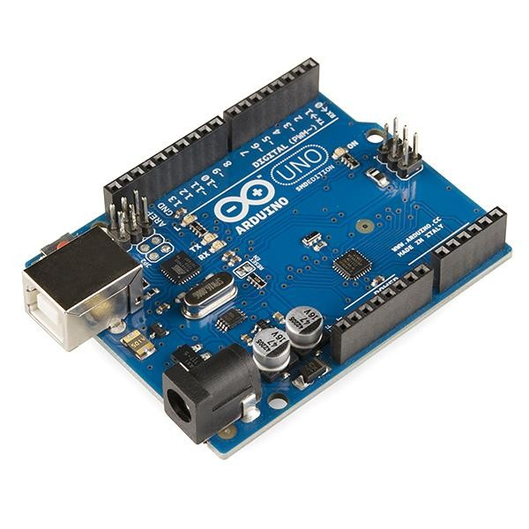

**Fig 1. Arduino Uno**

**Features of Arduino Uno :**

* The operating voltage is 5V
* There commended input voltage will range from 7v to 12V
* The input voltage ranges from 6v to 20V
* Digital input/output pins are14
* Analog input pins are 6
* DC Current for each input/output pin is 40 mA
* DC Current for 3.3V Pin is 50 mA
* Flash Memory is 32 KB

**Applications of Arduino Uno:**

1. IoT (Internet of Things): The Uno can be connected to the internet using additional components like Ethernet shields or Wi-Fi modules allowing it to participate in IoT projects.
2. Home Automation: Arduino Uno is used for controlling devices in smart homes, such as lights, fans, and security systems
3. Robotics: It’s widely used in robotics for controlling motors, sensors, and actuators. Its analog and digital input/output pins make it perfect for robotics applications that require motor control or obstacle detection.
   1. **Ultrasonic Sensor :**

An ultrasonic sensor is a type of sensor that uses ultrasonic waves (sound waves above the human hearing range) to measure distance to an object. These sensors are widely used in various applications like object detection, distance measurement, robotics, and automation. The most commonly used ultrasonic sensor is the HC-SR04, which is a low-cost, easy-to-use module that works well for many basic applications.

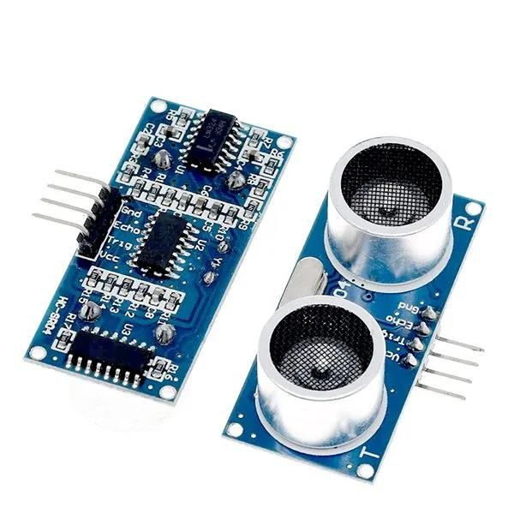

**Fig 2. Ultrasonic Sensor**

**Ultrasonic Sensor Specifications :**

* Voltage: 3.3V – 5V (Some industrial models: 12V/24V)
* Frequency: 40 kHz
* Range: 2 cm – 400 cm (Some models up to 10m)
* Accuracy: ±1 mm to ±3 mm
* Beam Angle: 15° – 30° • Response Time: 10 – 100 ms
* Output: Digital (Trigger/Echo), Analog, UART, PWM
* Power Consumption: ~15mA
* Temperature: -20°C to 70°C
* Protection: Standard (IP65/IP67 for waterproof models)

**Application:**

1. Industrial Automation :

* Object Detection & Proximity Sensing – Used in assembly lines and robotic arms to detect objects without physical contact.
* Level Measurement – Measures liquid or solid levels in tanks and silos.
* Positioning & Distance Measurement – Used in warehouses and logistics to track object positioning.

2. Automotive Applications :

* Parking Assistance – Detects obstacles while parking (reverse parking sensors)
  + Collision Avoidance Systems – Helps in autonomous and semi-autonomous vehicles to detect nearby objects.
* Blind Spot Detection – Alerts drivers about vehicles in their blind spots.

3. Medical & Healthcare :

* Ultrasound Imaging – Used in medical diagnostics for prenatal scans and internal organ imaging.
* Liquid Flow Monitoring – Ensures proper flow of fluids in IV drips and dialysis machines

**3.3 Servo Motor :**

Servo motor is an electrical device which can be used to rotate objects (like robotic arm) precisely. Servo motor consists of DC motor with error sensing negative feedback mechanism. This allows precise control over angular velocity and position of motor. In some cases, AC motors are used.

It is a closed loop system where it uses negative feedback to control motion and final position of the shaft. It is not used for continuous rotation like conventional AC/DC motors. It has rotation angle that varies from 0° to 180°.

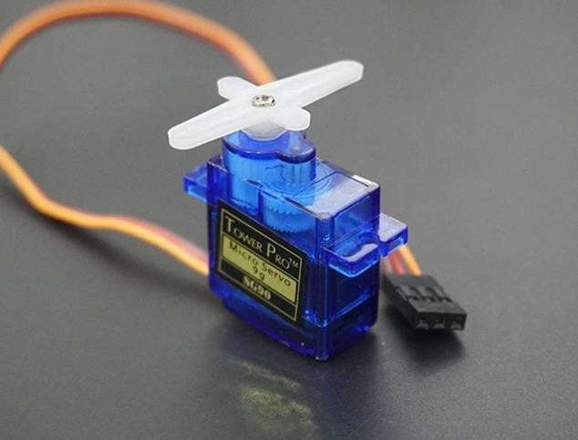

**Fig 3. Servo Motor**

Servo Motor Specifications :

* Operating Voltage – Typically 4.8V to 7.4V (for small servos), higher for industrial types.
* Torque Rating – Measured in kg-cm or N-m, indicating the force it can exert. Example: 10 kg-cm means it can lift 10 kg at a 1 cm distance.
* Speed – Defined as seconds per 60° rotation (e.g., 0.12s/60° at 6V).
* Angle of Rotation – Commonly 0° to 180° (standard) or 360° (continuous rotation servos).
* Control Signal – Operates via PWM (Pulse Width Modulation), typically using a 50Hz signal.
* Weight & Dimensions – Varies based on size, from micro servos (~9g) to industrial servos .
* Gear Type – Plastic gears (lightweight, lower cost) or metal gears (durable, high torque).
* • Current Consumption – Idle: ~5-10mA, Operating: ~100mA-2A depending on load

**Applications :**

* Robotics – Precise movement of robotic arms.
* Industrial Automation – Conveyor belts, CNC machines.
* Aerospace – Flight control systems.
* Medical Equipment – Surgical robots, prosthetics.
* RC Vehicles – Steering and throttle control in cars, drones.

**4 . BLOCK DIAGRAM :**

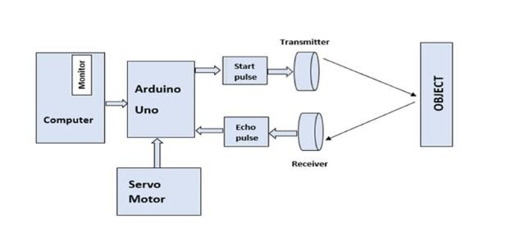

* Computer & Monitor – Displays the detected object’s position and distance visually in a radar-like format.
* Arduino Uno – The microcontroller that controls the system, processes ultrasonic sensor data, and commands the servo motor.
* Servo Motor – Rotates the ultrasonic sensor in a set range (e.g., 0° to 180°) to scan the surroundings.
* Ultrasonic Sensor (Transmitter & Receiver) o Transmitter (Start Pulse) – Emits an ultrasonic pulse toward an object. Receiver (Echo Pulse) – Detects the reflected ultrasonic pulse to measure distance.
* Object – Any obstacle in the range of the ultrasonic sensor that reflects the transmitted signal back.
* Connections & Data Flow –
* Arduino sends a start pulse to the transmitter.
* The pulse reflects off an object and is received back.
* Arduino calculates the time delay and determines the distance.
* The detected information is sent to the computer for visualization.

**5. FLOW CHART :**

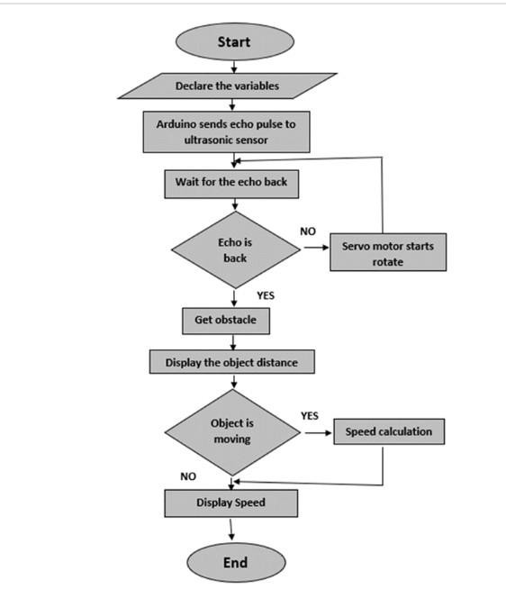

1. Start–The system begins execution.
2. Declare Variables–Initialize necessary variables for sensor reading sand calculations.
3. Send Echo Pulse–The Arduino triggers the ultrasonic sensor to send a sound pulse.
4. Wait for Echo –The system waits for the reflected pulse(echo) to return.
5. Check Echo
6. If NO Echo: The servo motor continues to rotate the sensor to scan the area.
7. If Echo is Received : The object is detected.
8. Get Obstacle–The system confirms an object’s presence.
9. Display Distance–The Arduino calculates and shows the object's distance.
10. Check Object Movement
11. If Moving : Speed is calculated.
12. If Not Moving : Directly display the object's speed(zero or unchanged).
13. End–The process repeats for continuous scanning

**6 . RESULT :**

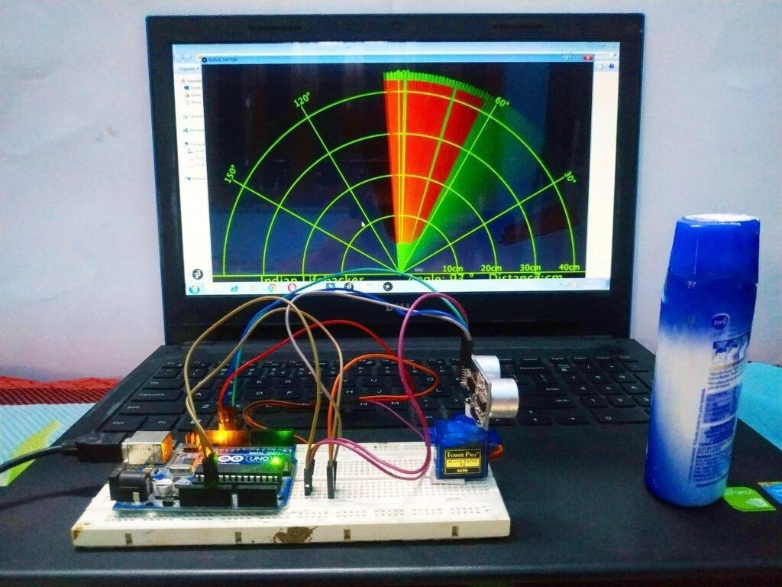

* Rotation: The servo motor moves the ultrasonic sensor in a sweep.
* Distance Measurement: The HC-SR04 sensor sends sound waves, calculates the return time, and computes the distance.
* Data Display: The Arduino displays the angle and distance on the serial monitor or a connected LCD.
* Radar Simulation: The rotating sensor and distance data create a basic radar-like system for detecting objects.

**7. CONCLUSION :**

The Radar System using Arduino Uno and an Ultrasonic Sensor successfully detects and tracks objects by measuring their distance and movement. The system rotates the ultrasonic sensor using a servo motor, continuously scanning the surroundings. When an object is detected, the Arduino processes the echo signal, calculates the distance, and displays the data on a monitor. Additionally, if the object moves, its speed is calculated and displayed

This project demonstrates a cost-effective and efficient way to implement radarlike object detection using simple components. It can be applied in security systems, robotics, obstacle detection, and automation. Future improvements could include integrating a graphical radar interface, using multiple sensors for better accuracy, or implementing wireless communication for remote monitoring

**8. REFERENCES :**

* P. C. Lokhande, A. R. Akhade, and A. A. Gite, “Radar System Using Arduino and Ultrasonic Sensor”, International Journal of Engineering Research and Technology (IJERT), Vol. 9, Issue 4, 2020.
* A. K. Verma and R. Gupta, “Design and Implementation of an Ultrasonic Radar System”, IEEE Sensors Journal, 2021.
* M. Singh and V. Sharma, “Object Detection and Ranging Using Arduino and HC-SR04 Sensor”, International Journal of Science and Research (IJSR), Vol. 8, Issue 6, 2019.
* G. Patel et al., “Real-Time Radar System for Obstacle Detection”, Proceedings of the IEEE International Conference on Robotics and Automation (ICRA), 2021.
* A. Bose and S. Kumar, “Embedded System-Based Radar for Distance Measurement”, Elsevier Measurement Journal, Vol. 151, 2020**.**