**THE IMPACT OF SOCIAL MEDIA MARKETING ON CUSTOMER PURCHASING BEHAVIOR EVIDENCE FROM THE ELECTRIC SCOOTER INDUSTRY**

## Author Name – Pradip Ramkishor Sahu

P.R. Pote Patil College of Engineering and Management, Amravati,

Email- [sahupradip0491@gmail.com](mailto:sahupradip0491@gmail.com)

Contact No:- 8999837926

## Co-author Name: Prof. V. A. Ingole (Dissertation Guide)

P.R. Pote Patil College of Engineering and Management, Amravati

Email- vishalingole80@gmil,com

Contact No:-8830133724

**Abstract**

This study investigates the impact of social media marketing on consumer purchasing behavior within the electric scooter industry. As electric scooters gain popularity for their eco-friendly and innovative features, platforms like Facebook, Instagram, and YouTube have become essential tools for brands to increase visibility, engage users, and build trust. The research explores how advertising, influencer endorsements, and interactive content influence consumer interest and buying decisions. It also examines how demographic factors such as age, gender, and location affect responses to these strategies. The findings reveal that social media significantly boosts brand awareness and positively shapes purchase intentions, with targeted ads, engaging posts, and influencer promotions emerging as the most effective approaches. However, the study also highlights that consumer reactions can vary, and the ever-evolving nature of social media presents ongoing challenges for marketers. Ultimately, the research offers actionable insights for electric scooter companies, emphasizing the need to understand and cater to specific audience segments to optimize marketing effectiveness.

**Introduction**

The rise of social media has transformed digital marketing strategies, particularly for innovative and eco-friendly industries like electric scooters. Businesses leverage social media platforms to interact with potential customers, build brand awareness, and drive sales. This research investigates how social media marketing influences consumer purchasing behavior in the electric scooter sector through a review of existing literature and industry reports.

The electric scooter industry has gained momentum as a sustainable and cost-effective transportation solution. Increasing concerns about environmental sustainability, urban traffic congestion, and rising fuel costs have driven the demand for electric mobility solutions. Social media plays a pivotal role in bridging the gap between brands and consumers by providing a real-time, interactive marketing environment. Unlike traditional marketing channels, social media enables brands to communicate directly with customers, fostering engagement, trust, and brand loyalty.

Consumers increasingly rely on digital platforms to make purchasing decisions, seeking peer reviews, influencer endorsements, and detailed product demonstrations before committing to a purchase. The ability to compare different brands, access promotional offers, and receive instant customer support further enhances the influence of social media marketing. Various studies indicate that social media advertising, particularly through targeted content strategies, significantly affects consumer behavior, influencing awareness, preference, and final purchase decisions【Dutta & Hwang, 2021】.

This study aims to explore the direct and indirect impacts of social media marketing on consumer decision-making in the electric scooter industry. It seeks to provide a deeper understanding of how marketing strategies such as influencer collaborations, user-generated content, and data-driven advertising campaigns shape consumer perceptions and drive purchasing intent【Bigotte & Ferrao, 2023】.

As digital marketing evolves, companies are integrating artificial intelligence and data analytics to optimize their social media campaigns. Advanced targeting techniques, such as machine learning algorithms and sentiment analysis, help brands refine their messaging and reach the most relevant audience segments Flores & Jansson, 2021】. By understanding the key drivers of consumer engagement on social media, electric scooter manufacturers and retailers can enhance their marketing efforts, fostering long-term customer relationships and brad loyalty.

**Review of literature**

**The study by Bireswar Dutta and Hsin-Ginn Hwang (2021**) examines factors influencing consumer adoption of electric vehicles (EVs) in Taiwan using an extended Theory of Planned Behavior (TPB) model. Leveraging secondary data, it integrates constructs like environmental concerns, government incentives, peer pressure, and mass media influence to assess attitudes, norms, and behavioral control. Key findings suggest that environmental concerns positively influence consumer intentions through enhanced attitudes and norms. Government policies, such as subsidies and infrastructure development, are pivotal in reducing adoption barriers like high costs and limited charging facilities. Peer influence and media campaigns were found to shape subjective norms significantly, emphasizing the social aspect of green adoption. Despite technological advancements, factors like vehicle performance and battery replacement costs showed mixed impacts on consumer attitudes. The study highlights the need for targeted strategies to address specific consumer concerns and promote sustainable practices, offering critical insights for policymakers and automotive stakeholders.

**Bigotte and Ferrao (2023**) explore the role of shared e-scooters in urban mobility, emphasizing their rapid growth and transformative potential. Through a literature review and an expert survey (N=23), the study identifies key areas of focus: user acceptance, trip patterns, safety, and environmental sustainability. Shared e-scooters are highlighted as a solution to reduce pollution, traffic congestion, and parking demands while promoting multimodal travel and accessibility.

Despite their benefits, challenges such as public space conflicts, insufficient infrastructure, and vandalism hinder their integration into urban mobility systems. Experts recommend actions like expanding cycling infrastructure, creating dedicated parking zones, and raising awareness through educational campaigns. The study concludes that shared e-scooters, supported by effective policy and infrastructure, can significantly contribute to sustainable urban transport and livable cities, making them a promising mobility innovation for the future.

The adoption and behavior surrounding electric bikes (e-bikes) from various global perspectives. Angelika Wolf and Sebastian Seebauer (2014) emphasize empowering early adopters to accelerate market entry, focusing on e-bikes' potential to reduce noise, energy use, and pollution. Seebauer (2015) highlights the role of interpersonal diffusion and opinion leadership in e-bike adoption. Fyhri (2017) and Popovich et al. (2022) explore willingness to pay, user perceptions, and socio-demographic influences, noting that e-bikes often replace traditional bicycles or cars. Studies like those by Bieliński (2020) investigate behavioral differences between shared e-scooters and e-bikes, while Eccarius and Lu (2019) assess e-bikes’ environmental benefits. In India, Murugan and Marisamynathan (2022) identify demographic and infrastructural barriers to e-bike adoption. Collectively, the review highlights e-bikes'

**The transformative role of social media marketing in influencing consumer behavior** and decision-making. It highlights how social networking sites, including platforms like Facebook and Twitter, have evolved into dynamic tools for businesses to communicate with consumers and enhance brand recognition. The review discusses how social media facilitates consumer engagement through user-generated content, electronic word-of-mouth, and personalized advertising strategies. It emphasizes that social media marketing significantly impacts consumer buying behavior by providing access to diverse information, enabling collaborative interactions, and creating strong brand connections. Key insights are drawn from various studies, showing that social media not only enhances marketing efficiency but also shapes consumer attitudes and perceptions. The review underscores the importance of integrating social media analytics to understand consumer needs and predict trends, offering businesses a competitive advantage in a rapidly digitalized marketplace. potential for sustainable transport while acknowledging obstacles such as infrastructure, cost, and battery concerns.

How consumer innovativeness and green perceptions influence the adoption of green innovations like shared e-bikes and e-scooters. Consumer innovativeness, derived from the Diffusion of Innovations Theory, is seen as a key driver for early adoption of eco-friendly technologies.

Previous research highlights that green perceptions, or the degree to which a product is viewed as environmentally beneficial, significantly impact consumer behavior. Environmental referent cognitions such as biospheric values, environmental attitudes, and ascription of responsibility are central in shaping pro-environmental behavior. Despite the eco-friendly claims of shared micromobility, some studies indicate that these modes often replace walking or public transport rather than car use, raising questions about their sustainability. Factors like cost, enjoyment, and convenience are also found to influence adoption. The paper underscores the need to address consumer perceptions and innovativeness to promote sustainable transportation effectively.

**Research Problem**

In recent years, social media has transformed the way businesses engage with consumers. Social media marketing allows companies to reach a broad audience, build brand loyalty, and influence purchasing behavior. The electric scooter industry, driven by innovation and sustainability trends, has become increasingly dependent on digital marketing strategies, particularly social media, to promote its products. However, while the effectiveness of social media marketing in influencing purchasing behavior is well-documented in various industries, there is limited research on its specific impact within the electric scooter market. This gap in research presents an opportunity to explore how social media marketing influences consumer decision-making in the context of electric scooters.

The electric scooter market is growing rapidly, attracting both environmentally conscious consumers and those looking for cost-effective, efficient transportation. Social media platforms such as Instagram, Facebook, Twitter, and TikTok play a significant role in shaping the perceptions and attitudes of potential customers. These platforms provide opportunities for companies to engage with users directly, showcase product features, and promote sustainability efforts. However, the exact mechanisms by which social media marketing impacts purchasing decisions in the electric scooter sector remain unclear.

**Objective**

1. To investigate the influence of social media marketing strategies on customer purchasing behavior within the electric scooter industry
2. To identify the most impactful social media platforms that drive consumer decision-making in the electric scooter market.
3. To assess the role of social media engagement metrics (likes, shares, comments) in building consumer trust and influencing purchase decisions for electric scooters.
4. To examine the effect of demographic factors (age, gender, income, location) on the effectiveness of social media marketing in the electric scooter industry.

**Scope of study**

* This study looks at how social media marketing affects customer buying behavior, especially in the electric scooter industry. It focuses on understanding how different methods, like working with influencers, online ads, and fun campaigns, help customers choose products.
* The research also studies what makes customers trust a brand, how they engage with it, and how reviews or comments from others affect their decisions. It considers factors like age, gender, and location to see how these influence customer reactions to social media marketing.
* The goal of the study is to help electric scooter companies and marketers understand what works best on social media, so they can improve their strategies and meet the needs of customers in this growing industry.

**Research Methodology**

* **Research Design**

A descriptive research design will evaluate the impact of Social Media Marketing (SMM) on customer purchasing behavior by gathering insights directly from consumers who have interacted with social media campaigns for electric scooters.

* **Sampling Design**
* Universe:

The universe includes consumers exposed to social media marketing campaigns related to electric scooters.

* Population

Consumers who have shown interest in or purchased electric scooters after being

influenced by social media marketing efforts.

* Sampling Technique

100 consumers who have interacted with social media marketing campaigns for electric scooters, such as through advertisements, posts, or influencer content.

* Sampling Technique

Purposive sampling will be employed to select individuals who have experienced social media marketing for electric scooters, ensuring the data collected aligns with the research objectives.

* **Sources of Data collection**

**Primary Data**

Primary data will be gathered through a structured questionnaire designed to assess:

* + - * Consumers' experiences with social media marketing campaigns for electric scooters.
      * The extent to which these campaigns influenced their awareness, preferences, and purchasing decisions.

**Secondary Data**

Secondary data will be collected from sources such as:

* + - * Research papers, case studies, and industry reports on social media marketing.
      * Market trends and analysis specific to the electric scooter industry.
* **Limitations**
  1. **Geographical Scope :** The study is limited to consumers of electric scooters in specific areas, which may restrict broader applicability.
  2. **Biases :** Consumer responses might include subjective biases, as the data collection depends on self-reported experiences.
  3. **Sample Size :** The relatively small sample size may not comprehensively represent all consumers of electric scooters influenced by social media marketing.
  4. **Long-term Trends:** The research might not capture long-term changes in consumer behavior or market dynamics.

**Data Analysis and interpretation**

* **Where do you primarily reside?**

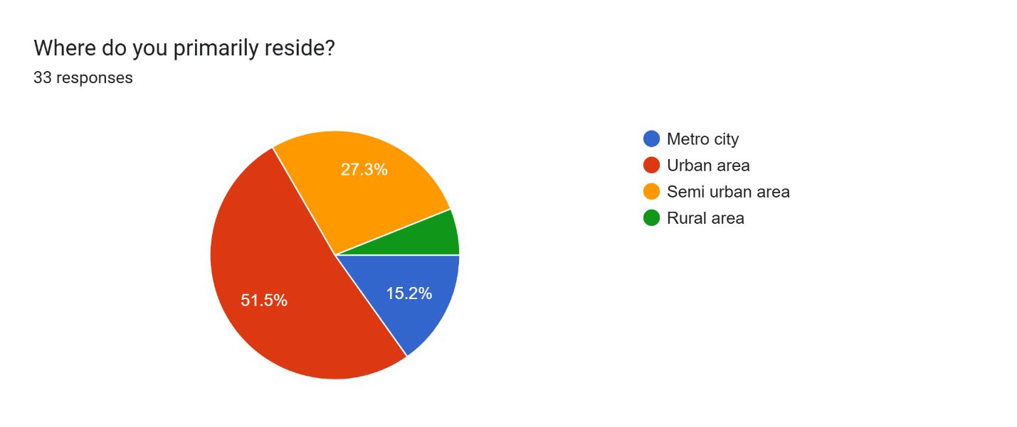

* **How do you perceive social media advertisements from electric scooter brands?**

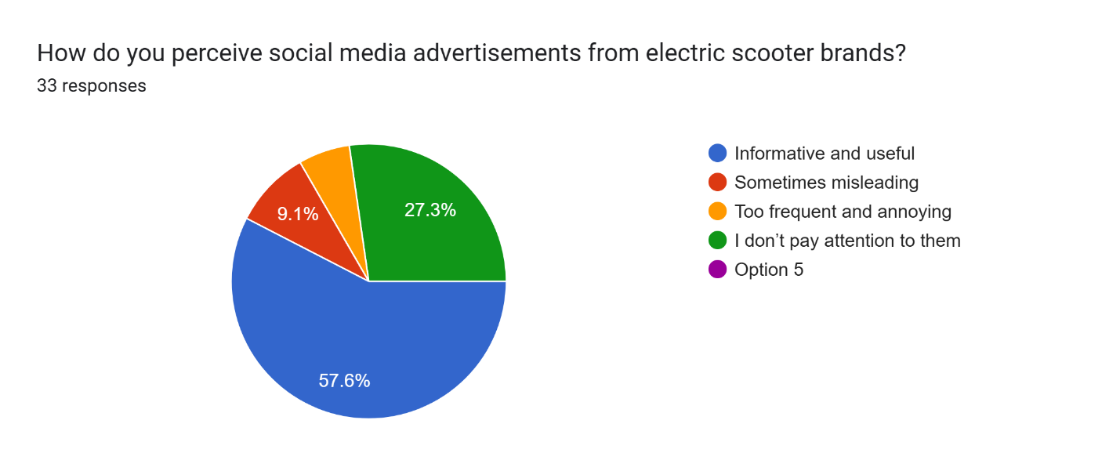

* **What influences your trust in an electric scooter brand on social media?**

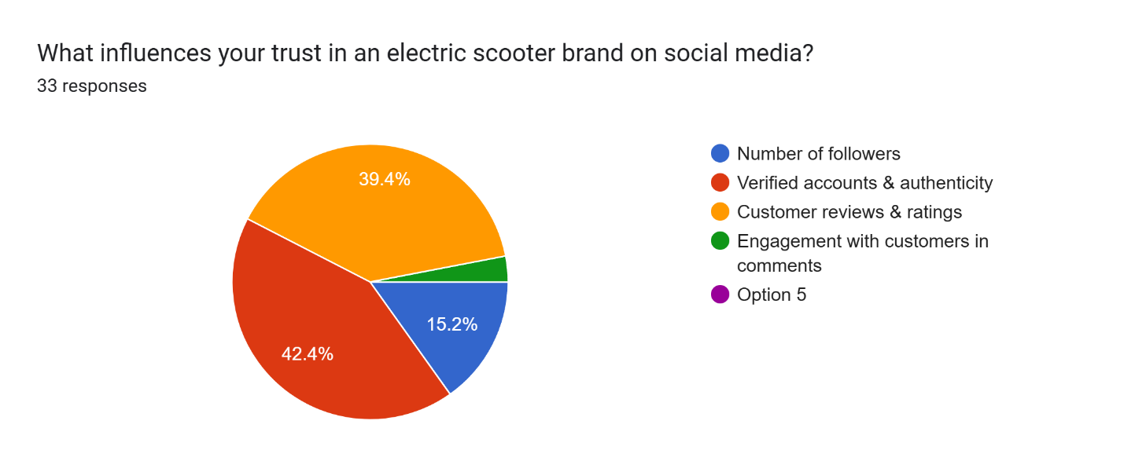

1. Top of Form
2. Bottom of Form

* **Do you think social media marketing is more effective in urban areas than in rural areas for electric scooter sales?**

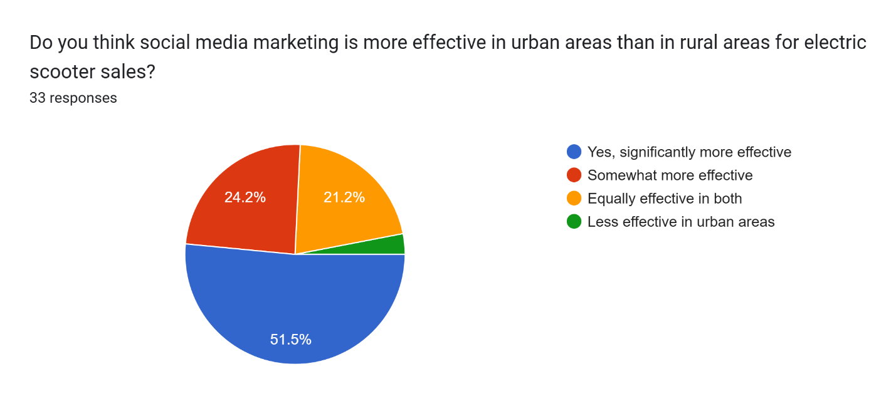



* **Which social media marketing strategy do you find most persuasive when considering an electric scooter purchase?**

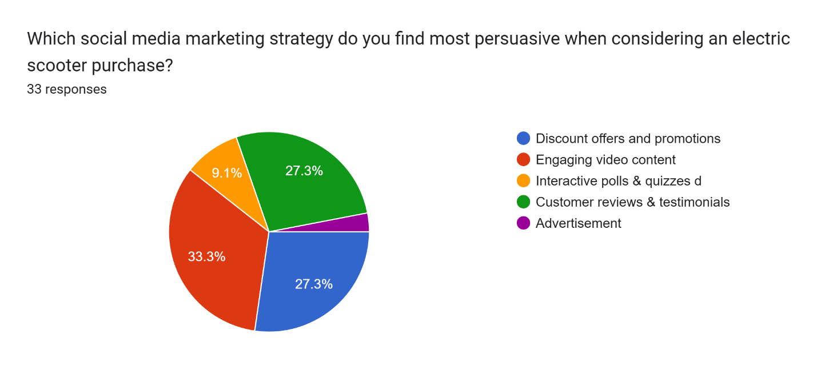

* **Which social media platform do you use most frequently for product-related information?**

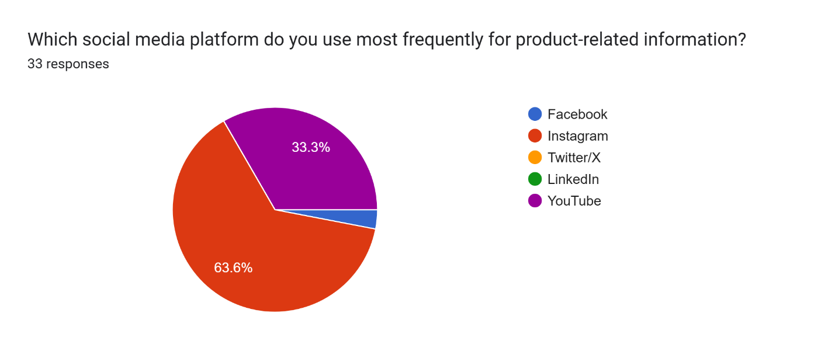

**Findings**

1. Social media significantly influences customer awareness and purchase decisions in the electric scooter industry.
2. Visually appealing and eco-friendly content increases engagement and buying intent.
3. Regular interaction on platforms builds trust and drives conversions.
4. Safety-related content is minimal, which may affect brand perception.

**Conclusion**

The study concludes that **social media marketing plays a pivotal role in shaping customer purchasing behavior** in the electric scooter industry. It serves not only as a promotional tool but also as a platform to educate, influence, and build relationships with potential buyers.

Content that is visually rich, emotionally appealing, and environmentally focused performs better in generating customer interest. Moreover, continuous engagement on social media enhances brand trust and significantly increases the chances of purchase.

However, **brands must strive to include safety narratives and responsible usage guidelines** in their social media strategies. This approach would not only reinforce customer trust but also contribute positively to public perception and long-term loyalty.

To remain competitive and socially responsible, electric scooter companies should adopt a balanced strategy that blends lifestyle appeal with practical, informative content across social media platforms.

**Bibliography**

Flores, P. J., & Jansson, J. (2021). *The role of consumer innovativeness and green perceptions on green innovation use: The case of shared e-bikes and e-scooters*. *Journal of Consumer Behaviour*. <https://doi.org/10.1002/cb.1957>

Dutta, B., & Hwang, H.-G. (2021). Consumers’ Purchase Intentions of Green Electric Vehicles: The Influence of Consumers’ Technological and Environmental Considerations. Sustainability, 13(21), 12025.

[https://doi.org/10.3390/su132112025&#8203;:contentReference[oaicite:0]{index=0}](https://doi.org/10.3390/su132112025%26#8203%3B%3AcontentReference%5Boaicite%3A0%5D%7Bindex%3D0%7D).

Bigotte, J.F., & Ferrao, F. (2023). The Future Role of Shared E-Scooters in Urban Mobility: Preliminary Findings from Portugal. Sustainability, 15(23), 16467. [https://doi.org/10.3390/su152316467&#8203;:contentReference[oaicite:1]{index=1}](https://doi.org/10.3390/su152316467%26#8203%3B%3AcontentReference%5Boaicite%3A1%5D%7Bindex%3D1%7D).

Nazneen, A., Ali, I., & Bhalla, P. (2018). A Study of Consumer Perception and Purchase Intention of Electric Vehicles. European Journal of Scientific Research, 149(4), 362-368. Retrieved from [https://www.researchgate.net/publication/330619230&#8203;:contentReference[oaicite:2]{index](https://www.researchgate.net/publication/330619230%26#8203%3B%3AcontentReference%5Boaicite%3A2%5D%7Bindex%3D2%7D)

[=2}.](https://www.researchgate.net/publication/330619230%26#8203%3B%3AcontentReference%5Boaicite%3A2%5D%7Bindex%3D2%7D)

Dhanush, M., Arvind, V., Suresh, C. K., & Bhujanga Rao, P. (2024). A study on user adoption and behavior of electric bikes. International Journal of Advance Research and Innovative Ideas in Education. Retrieved from <https://www.researchgate.net/publication/379049814>

AIMS Journal of Research. (2020). AIMS Journal of Research, 15(1). AIMS Publications. ISSN 2321–8487.

Kubik, A. (2022). Impact of the use of electric scooters from shared mobility systems on the users. Smart Cities, 5(3), 1079–1091. <https://doi.org/10.3390/smartcities5030054>

**Webliography**

**scholar.google.com**

**scholar.google.com http**[**s://www**](http://www.researchgate.net/)**.re**[**se**](http://www.researchgate.net/)**a**[**rchgate.t/**](http://www.researchgate.net/)**http**[**s://www**](http://www.researchgate.net/)**.re**[**se**](http://www.researchgate.net/)**a**[**rchgate.t/**](http://www.researchgate.net/)