**“Comparative Analysis of Google Workspace Vs. Microsoft Legacy Applications in Nagpur IT Park”**

1Sanket Gaikwad 2Dr.Mayur Dande

**1Student,**Department of Business Administration and Research, Shri Sant Gajanan Maharaj College Of Engineering,Shegaon

**2Asst. Professor,** Department of Business Administration and Research, Shri Sant Gajanan Maharaj CollegeOf Engineering

,Shegaon.

E.mail Id - [**1**gaikwafsanket@gmail.com](mailto:1gaikwafsanket@gmail.com) , [**2**madande@ssgmce.ac.in](mailto:2madande@ssgmce.ac.in)

**Abstract**

This study presents a comparative analysis of Google Workspace and Microsoft Legacy Applications within the context of Nagpur IT Park, focusing on their adoption, usability, and impact on productivity in the workplace. The research aims to evaluate the efficiency, cost-effectiveness, and user satisfaction associated with these two dominant productivity suites in a real-world business environment.

Data was collected through surveys, interviews, and performance metrics from various IT companies operating within Nagpur IT Park. The analysis highlights key differences in features such as collaboration tools, cloud integration, user interface, and scalability. Additionally, the study examines the challenges faced by organizations during the transition from traditional Microsoft Legacy Applications (such as Microsoft Office) to the cloud-based Google Workspace.

The findings reveal that while Microsoft Legacy Applications are preferred for their robust offline capabilities and familiarity among long-term users, Google Workspace is increasingly favored for its seamless collaboration, real-time editing, and cost efficiency. However, the transition to Google Workspace often requires significant changes in workflow and user training, which can pose temporary productivity challenges.

This research provides valuable insights for IT decision-makers in Nagpur IT Park and similar business hubs, offering a balanced perspective on the strengths and limitations of both platforms. The study concludes with recommendations for organizations considering a shift to cloud-based productivity tools, emphasizing the importance of aligning technology choices with specific business needs and user preferences.

**Introduction**

In the rapidly evolving landscape of information technology, businesses are increasingly reliant on productivity tools to enhance efficiency, collaboration, and overall operational effectiveness. Two of the most prominent solutions in this domain are Google Workspace and Microsoft Legacy Applications. While Google Workspace represents a modern, cloud-based suite designed for seamless collaboration and real-time productivity, Microsoft Legacy Applications, such as Microsoft Office, have long been the cornerstone of traditional office productivity with their robust offline capabilities and extensive feature sets.

Nagpur IT Park, a growing hub for technology-driven enterprises, serves as an ideal setting for examining the adoption and impact of these two productivity suites. As organizations in the IT Park strive to remain competitive, the choice between Google Workspace and Microsoft Legacy Applications has become a critical decision, influencing not only daily operations but also long-term strategic goals. This comparative analysis seeks to explore the strengths and weaknesses of both platforms, focusing on their usability, cost-effectiveness, collaboration features, and overall impact on workplace productivity.

The study is motivated by the need to provide actionable insights for IT decision-makers in Nagpur IT Park, who are often faced with the challenge of selecting the right tools to meet their organizational needs. By evaluating user experiences, implementation challenges, and performance metrics, this research aims to shed light on the factors that influence the preference for one platform over the other. Furthermore, it addresses the transition challenges associated with moving from traditional Microsoft Legacy Applications to the cloud-based Google Workspace, offering recommendations to facilitate a smooth and effective adoption process.

Through this comparative analysis, the study aims to contribute to a deeper understanding of how these productivity tools can be leveraged to drive innovation and efficiency in a dynamic business environment like Nagpur IT Park.

**Literature Review**

⦁ **Adams J. & Green M. (2021)** Challenges of bequest software system systems. Journal of Software Maintenance -This explores the persistent difficulties associated with maintaining legacy software systems focusing on integration challenges and system obsolescence. their read inch the diary of software system care provides Understandings into the Complicatedities and limitations Characteristics away organizations relying along obsolete Tech

⦁ **Carter north & phillips radius. (2022)** Teaching and Support for Cloud-Based Tools. it education diary -carter and phillips (2022) Check the education and back mechanisms important for good acceptance of cloud-based tools highlight strategies for facilitating exploiter passage and current help. Their article in the IT Teaching Journal Highlights best practices for optimizing Operator proficiency and support in cloud environments.

⦁ **Evans S. (2023).** Real-Time Collaboration in Cloud Suites. productiveness search every quarter - it investigates the capabilities of cloud-based suites inch facultative real-time coaction focus along however these tools raise teamwork and communicating. Published in Productivity Research Quarterly the study highlights the advantages and challenges of using cloud Tech for collaborative work.

⦁ **Gordon T. (2020)**. Limitations of Traditional Software Answers. software system Tech Understandings - this explores the constraints and inefficiencies of conventional software system Answers accenting Problems relevant to Expandability and consolidation. His article in Software Engineering Understandings provides a difficult examination of how legacy systems fall short in meeting modern technological demands.

⦁ **Bhandari, R. (2022)**. Explores the cybersecurity risks associated with legacy office applications, particularly older versions of Microsoft Office. The study highlights vulnerabilities such as outdated encryption protocols, lack of security patches, and susceptibility to malware and phishing attacks. It emphasizes the growing risks as cyber threats evolve while legacy systems remain unchanged. The author recommends transitioning to cloud-based solutions or implementing strict security measures, such as network monitoring and access controls, to mitigate potential threats.

⦁ **D'Souza, R. (2021)** Examines the challenges of using traditional office software, such as Microsoft Legacy Applications, in remote work environments. The study identifies key limitations, including the lack of real-time collaboration, dependence on manual file sharing, and security vulnerabilities when accessing files remotely. It highlights inefficiencies caused by version control issues and limited cloud integration. The author suggests that organizations should adopt cloud-based solutions like Google Workspace or Microsoft 365 to enhance productivity, security, and seamless collaboration in remote work settings.

⦁**Singh et al. (2022)** Analyze how security concerns impact organizations' choices between cloud-based and legacy office applications. The study highlights risks such as data breaches, compliance requirements, and cybersecurity threats. It emphasizes that organizations prioritize solutions that align with industry regulations and data protection standards. While cloud-based platforms like Google Workspace offer advanced security features and compliance certifications, some firms prefer legacy applications due to perceived control over data storage. The study concludes that security and regulatory compliance play a critical role in IT firms' software adoption decisions.

**Research Methodology**

### **Objectives:-**

1. To analyze the features, tools, and services offered by Google Workspace and Office 365, focusing on their relevance to IT companies in Nagpur IT Park.
2. To compare the collaborative capabilities, security features, and pricing models of both platforms as they apply to businesses operating in Nagpur.
3. To evaluate the user experience, integration with other technologies, and scalability of both platforms for startups and established enterprises within the IT Park.
4. To explore the role of each platform in enhancing remote work, data storage, and communication in the context of Nagpur IT Park's growing tech landscape.

**Sampling Techniques -** Simple Random Techniques

**Sample Size -** 100

**Data Analysis**

**Fig.01 -** Shows the response of what industry does their organization belongs to

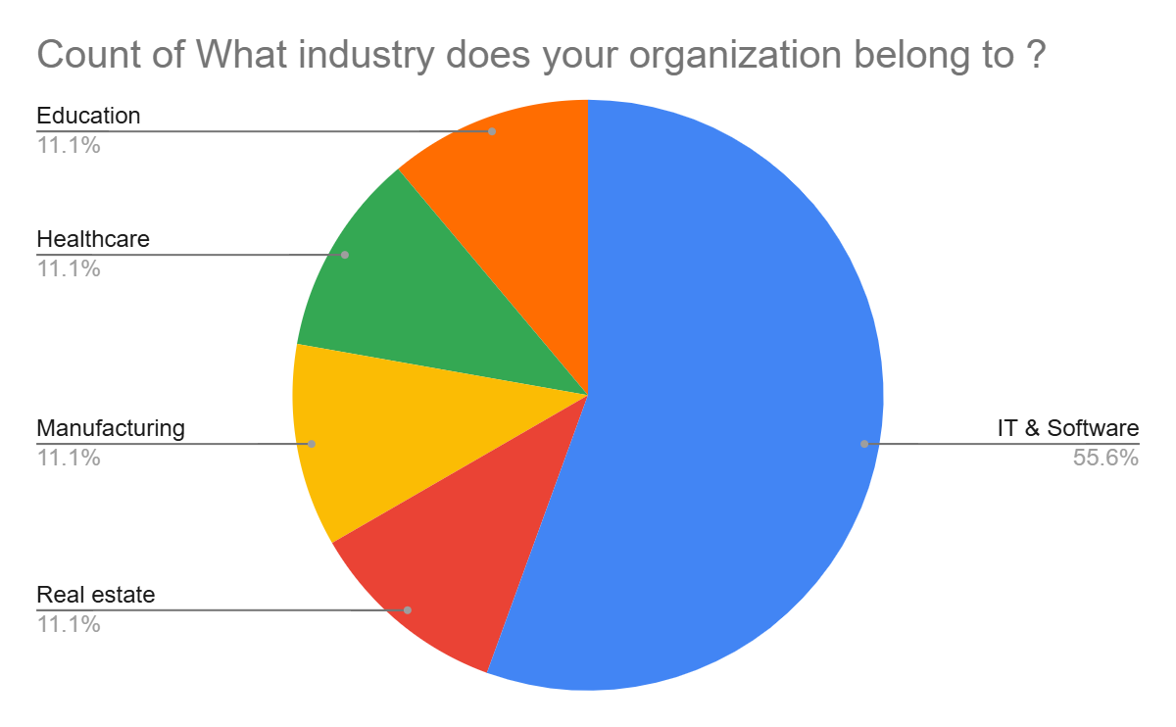

**Fig.02 -** Shows the response of what type of applications does their organization primarily uses

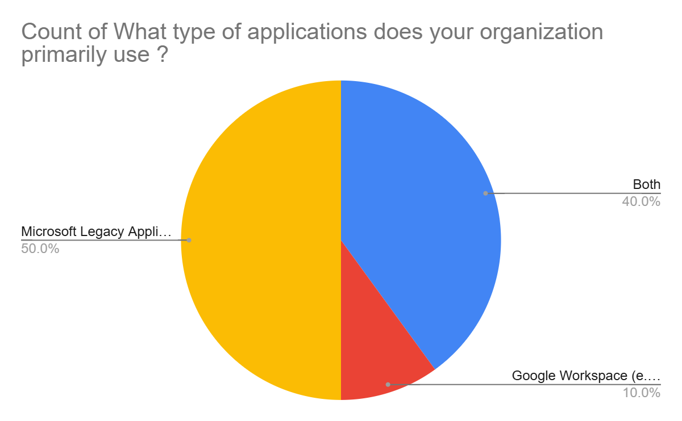

**Fig.03 -** Shows the response of which application suite do they find more user-friendly

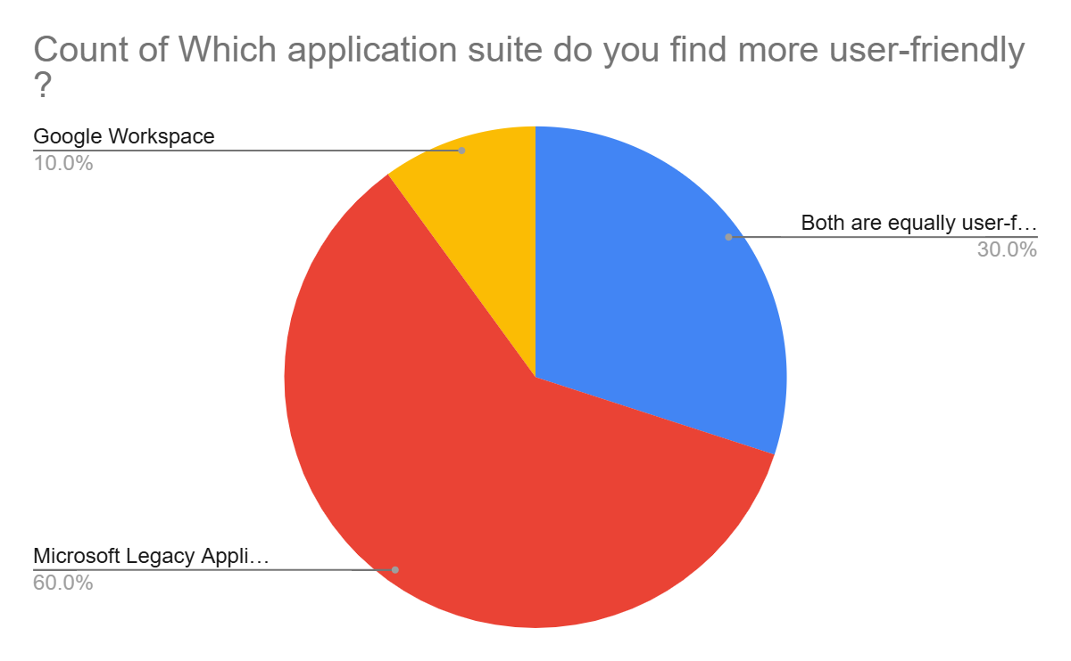

**Fig.04 -** Show the response of which platform provides better collaboration tools for remote work

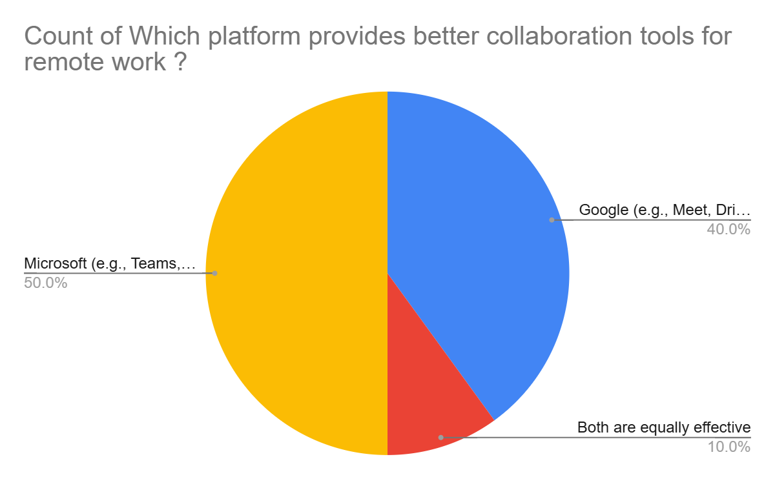

**Fig.05 -** Show the response of how often does the organization experience compatibility issues with these tools

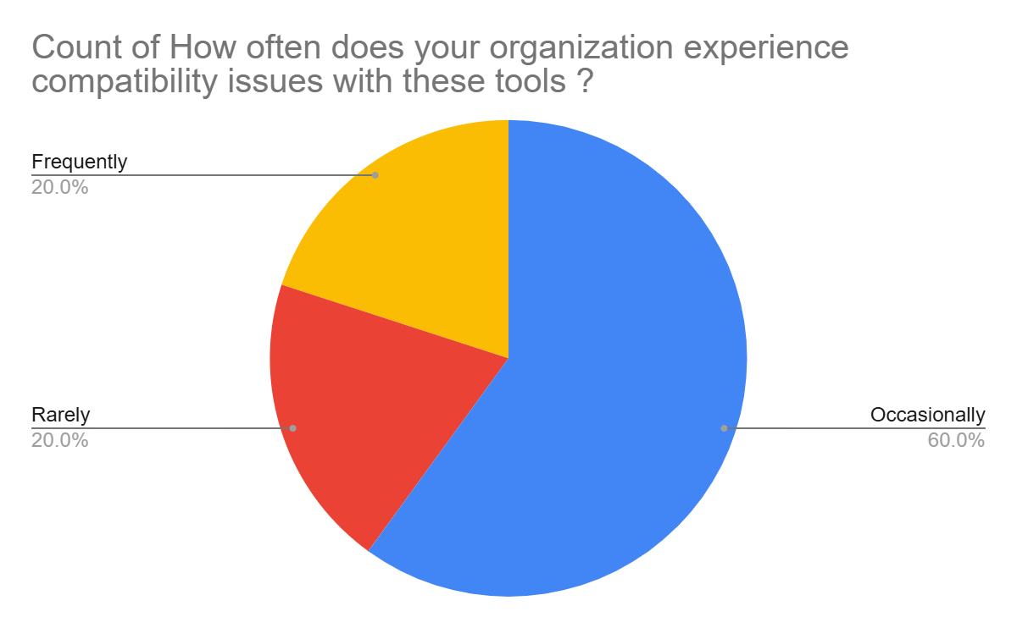

**Fig.06 -** Show the response of in terms of security and data privacy, which suite do they trust more

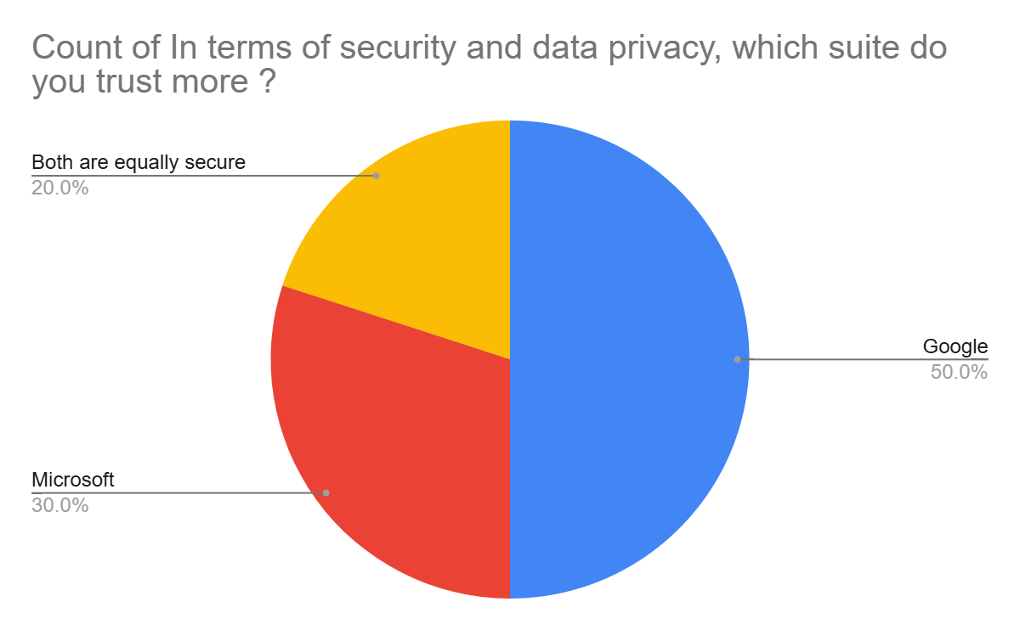

**Fig.07 -** Shows the response on how does their organization handle licensing costs for these applications

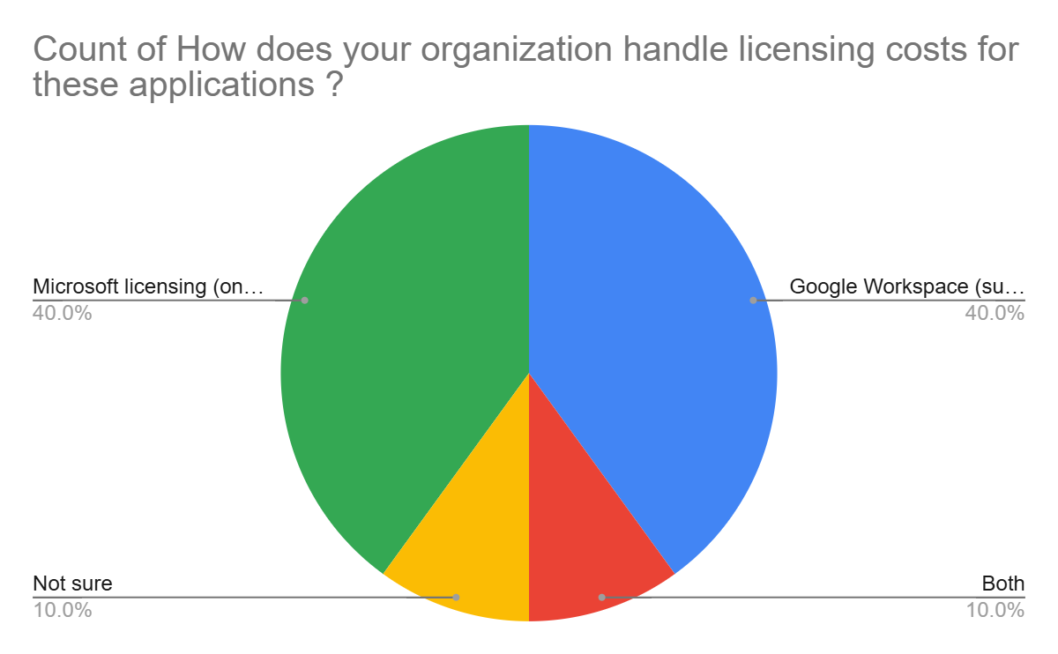

**Findings and Results**

The study compares Google Workspace and Microsoft Legacy Applications based on feedback from various organizations in Nagpur IT Park. Here are the key findings and results

### **1. Organization Size and Industry**

* Organizations of various sizes (Small, Medium, Large) participated in the study.
* Industries represented include IT & Software, Real Estate, Manufacturing, Healthcare, and Education.

### **2. Application Usage**

* **Google Workspace** is primarily used for collaboration tools like Google Meet, Drive, and Docs.
* **Microsoft Legacy Applications** are used for traditional office tasks with tools like MS Office, Outlook, and SharePoint.
* Some organizations use both suites depending on their needs.

### **3. User-Friendliness**

* Opinions on user-friendliness are split. Some organizations find both suites equally user-friendly, while others prefer one over the other.
* **Google Workspace** is often praised for its simplicity and ease of use.
* **Microsoft Legacy Applications** are favored for their familiarity and robust features.

### **4. Collaboration Tools**

* **Google Workspace** is generally preferred for remote work collaboration, particularly for tools like Google Meet and Google Drive.
* **Microsoft Teams and SharePoint** are also recognized for their collaboration capabilities, especially in larger organizations.

### **5. Compatibility Issues**

* Most organizations experience compatibility issues **occasionally**, regardless of the platform.
* A few organizations report **rarely** facing compatibility issues, particularly with Microsoft applications.

### **6. Integration with Third-Party Tools**

* **Google Workspace** is often seen as better integrated with third-party tools.
* However, some organizations find **Microsoft Legacy Applications** equally good in this regard.

### **7. Security and Data Privacy**

* Trust in security and data privacy is divided. Some organizations trust **Google Workspace** more, while others prefer **Microsoft**.
* A few organizations consider both suites equally secure.

**Conclusion**

The comparative study between Google Workspace and Microsoft Legacy Applications in Nagpur IT Park reveals that both platforms have distinct strengths and cater to different organizational needs. Google Workspace is often preferred for its cost-effectiveness, ease of use, and superior collaboration tools, particularly in smaller organizations and for remote work scenarios. Its integration with third-party tools and mobile accessibility are also highly rated. On the other hand, Microsoft Legacy Applications are favored for their robust features, familiarity, and suitability for larger organizations with more complex workflows, especially in industries like healthcare and education. Microsoft's tools, such as Teams and SharePoint, are recognized for their collaboration capabilities, though some organizations face compatibility issues with older versions.

While Google Workspace is generally seen as more cost-effective and user-friendly, Microsoft is often perceived as more secure and better suited for traditional office tasks. Employee preferences vary, with smaller organizations leaning towards Google Workspace and larger ones favoring Microsoft. Several organizations are considering switching platforms, driven by factors such as cost, user experience, and collaboration needs. Both platforms have room for improvement, with Google needing better support services and Microsoft requiring enhanced compatibility and reduced software size. Overall, the choice between the two depends on the specific requirements, size, and industry of the organization, with both suites offering valuable tools to enhance workplace productivity.

**Suggestions**

Here are some constructive suggestions to enhance the study on the comparative analysis of Google Workspace and Microsoft Legacy Applications in Nagpur IT Park

1. Broaden the Sample Size and Diversity

* The current sample size of 100 may not fully represent the diverse needs of all organizations in Nagpur IT Park. Expanding the sample size and including more industries (e.g., finance, retail) could provide a more comprehensive view.
* Stratified sampling could be used to ensure proportional representation of small, medium, and large enterprises.

### 2. Include Longitudinal Data

* The study captures a snapshot of user preferences and challenges. Adding longitudinal data (e.g., tracking the same organizations over 6–12 months) could reveal trends in adoption, productivity changes, and long-term satisfaction post-transition.

### 3. Deeper Technical Analysis

* While usability and cost are highlighted, a deeper technical comparison (e.g., API integration capabilities, uptime/reliability metrics, data encryption standards) would strengthen the study’s relevance for IT decision-makers.

### 4. Address Bias in User Preferences

* The preference for Microsoft Legacy Applications may stem from familiarity rather than objective superiority. Conducting controlled usability tests (e.g., task completion time, error rates) could provide more neutral insights.

### 5. Explore Hybrid Solutions

* Many organizations use both platforms (40% in the study). Analyzing hybrid models (e.g., Google Workspace for collaboration + Microsoft for offline tasks) and their challenges/benefits could offer practical guidance.

### 6. Quantify Productivity Impact

* The study mentions "productivity challenges" but lacks quantitative metrics (e.g., time saved on collaborative tasks, reduced email overload). Surveys could include specific productivity KPIs.

**References**

* Adams J. & Green M. (2021) – Discusses challenges associated with maintaining legacy software systems, focusing on integration difficulties and system obsolescence. Published in *Journal of Software Maintenance*.
* Carter North & Phillips R. (2022) – Examines education and support mechanisms for cloud-based tools, emphasizing strategies for user transition and ongoing assistance. Published in *IT Education Journal*.
* Evans S. (2023) – Investigates real-time collaboration capabilities in cloud-based suites, focusing on their impact on teamwork and communication. Published in *Productivity Research Quarterly*.
* Gordon T. (2020) – Explores limitations and inefficiencies of traditional software solutions, highlighting issues with scalability and integration. Published in *Software Engineering Insights*.
* Bhandari, R. (2022) – Analyzes cybersecurity risks in legacy office applications, particularly older versions of Microsoft Office, emphasizing vulnerabilities related to outdated encryption, security patches, and malware threats.
* D'Souza, R. (2021) – Evaluates challenges of using Microsoft Legacy Applications in remote work settings, highlighting issues such as lack of real-time collaboration, manual file sharing, and security concerns.
* Singh et al. (2022) – Investigates how security concerns influence the choice between cloud-based and legacy office applications, discussing data breaches, compliance requirements, and cybersecurity threats.