**“An Experimental Study on Steel Fibre Reinforced Concrete”**

**Neha Kumari Goyal Dr. Manoj Sharma**

**\*M. Tech Students, IPS College of Technology & Management, Gwalior M.P.**

**\*\* Professor, IPS College of Technology & Management Gwalior M.P.**

**INTRODUCTION**

Concrete is one of the most widely used construction products in the world. Concrete construction does not require highly skilled labor and uses mostly locally sourced materials- sand, gravel and water-as additions to purchased Portland cement powder, which is part of the reason for its wide adoption worldwide. The most important building material in construction is concrete. Concrete could be built in any size or shape from rectangular beam to circular water storage.

The advantages of using concrete are following:

(a)Its compressive strength is high. (b)It is good in fire resistance.

(c)It has high water resistance. (d)It has low cost of maintenance.

The disadvantages of using concrete are following

(a)It has poor tensile strength of concrete. (b)Its low strain of fracture.

So, low these disadvantages like tensile strength, toughness, post crack behavior, impact resistance, flexural strength fiber is added. Steel fibre is extensively used everywhere form pavements to machine foundation, form deck of bridge to offshore structure. Fibres are used in every form of life from space shuttle to human muscles. They are used in everywhere there is a strain. The Space shuttle used it for temperature control and to control the effect of thermal expansion. The fibre has an ability to increase the material strain resistance nature. Thus, SFRC exhibits better performance not only under static and quasi- statically applied loads but also under fatigue, impact, and impulsive loading.

## Objective of thesis

## To develop the M60 grade of concrete by adopting the IS code method, this method is considered the simplest.

## To Study the workability characteristics of concrete incorporated with and with steel fiber.

## To Study the strength characteristics of concrete incorporated with and with steel fiber.

## To study the effect of infiltration rate in concrete incorporated with and with steel fiber.

## To explain when we add steel fibre there is marginally increase in compressive strength and split tensile and flexural strength of concrete increase considerably.

## To explain Maximum compressive strength arrives at 3% fibre replacement.

# LITERATURE REVIEW

**Minglei Zhao, Jie Li** (2024)Present studies show that steel fibres can improve the bond of steel bar in steel fibre reinforced concrete (SFRC) with a correlation to the fibre factor and the fibre distribution uniformity. As a foundation of high-flowability SFRC working together with 400 MPa grade hot-rolled ribbed (HRB400) steel bar in reinforced structures, the bond between them was evaluated through a series of pull-out testing on 48 specimens with a central arranged

steel bar.

**C. Pradeep Kumar (2022)** There are many researches has been done to replace the constituent materials in the concrete to meet out the scarcity of the available raw materials and also, they have proven a successful one up to a certain level. But in this study, we are focused on to improve the structural behaviour by adding steel fibres in concrete without replacing any constituent materials. The scope of this project is to study experimentally the strength properties of the beam on inclusion of steel fibres. It also aims to investigate the structural behaviour of conventional concrete beams and steel fibre reinforced beam when steel fibre is used as a secondary reinforcement in beams.

**L.krishna(2022)** Accumulation of discarded scrap tires are non-biodegradable and have been a major concern. Even after a long period of land fill treatment, unmanaged waste tire poses environmental and health risk though fire hazard. Therefore, utilization of rubber from these scrap tires for the production of building materials in construction industry would help to preserve the natural resources and also maintain ecological balance. So, rubber used as replacement of aggregates with using fibers. Fiber reinforced concrete containing rubber particles have increased levels of toughness in comparison with conventional concrete.

**Satyashiva prasad nannuta** (2017) - In recent years the applications of high strength concrete have increased many part of the world. This growth has been possible as a result of recent developments in technology and demand for high strength concrete there are many advantages in using high strength concrete in building construction. Such as, reduction in member size, reduction in self-weight and early stripping of formwork. Reduced member sizes increase amount of rental area and this is beneficial**.**

**Avinash Joshi (2016)** The various aspects covered are the materials, mix proportioning for M20, M25, M30, M40 grades of concrete. As the concrete is weak in tension, a work has been carried out to investigate the improvement in tensile, shear, flexure, and even compressive strength of concrete and also to investigate the cracking strength and reserve strength of concrete & FRC.M20, M25, M30, M40 grades of concrete have been added to investigate the compressive strength, tensile strength &amp; shear strength of concrete. Steel fibers acts as a bridge to retard their cracks propagation, and improve several characteristics and properties of the concrete. Fibers are known to significantly affect the workability of concrete

**Durga Chaitanya Kumar Jagarapu (2016)** Experimental study on Steel Fiber concrete for M20 grade having mix proportion 1:1.96:2.63 and water cement ratio of 0.45 to study the compressive, flexural and split tensile strength of Steel Fibred Reinforced Concrete (SFRC) containing fibers of 1%, 2%, 3%, volume fraction. In this study steel fibers of Aspect Ratio 50, 60 and 67 were used. The result obtained is analyzed and compared with a control specimen (0% steel fiber).

**Steel fiber-reinforced concrete**

Concrete is a material known for its hardness and durability. However, it is also brittle and can easily crack or chip when subjected to tensile or flexural forces. Earlier, liquid concrete was poured over steel bars during construction to create a more robust and durable structure. Steel bars used in construction can expand and contract with temperature changes; hence, placing the concrete on slabs with expansion joints between them was recommended. But times chang

**Types of Fibre-Reinforced Concrete-**

There are several types of fibres used in reinforced concrete. Descriptions of the most common types follow.

(i)Cellulose Fibres (ii)Natural Fibres (iii)Carbon Fibres(iv)Polyester Fibres (v) Glass Fibres (vi)Polypropylene Fibre .(vii) Steel Fibre

**Advantages of steel fiber-reinforced concrete.**

(i) Increased Strength and Load-Bearing Capacity. (ii)Improved Crack Resistance.

(iii)Enhanced Durability and Longevity. (iv)Increased Flexural Properties.

(v)Reduced Maintenance Costs. (vi)Versatility in Design and Construction

. **The uses of steel-fiber-reinforced concrete**

(i)Highway and Bridge Construction. (ii) Building Construction

(iii)Pavements and Industrial Floors. (iv)Precast Concrete Elements:

(v)Tunnels and Underground Structures

**Applications**

* **Industrial Floors:** SFRC is well-suited for industrial floors due to its enhanced strength, durability, and resistance to abrasion.
* **Pavements:** SFRC can improve the durability and crack resistance of pavements.
* **Precast Concrete Products:** SFRC can ensure better structural integrity and reduced maintenance in precast concrete products.
* **Bridges and Other Structures:** SFRC can be used in bridges and other structures where increased strength and durability are required.
* **Tunneling and Underground Engineering:** SFRC can be used in tunneling and underground engineering applications.

## MATERIALS

## Cement

Cement is binding material which having good role in concrete, its having a peculiar property of strong adhesive premises. It can bind all other mixtures of concrete through a series of chemical reaction termed hydration reaction with the help of water and does it hardens. Cement is a grey coloured fined powder, which is manufactured by smashing, milling and proportioning of CaO ,SiO , AIO in a kiln at 2600F . Portland cement is also named as Ordinary Portland Cement (OPC) is a categorized into three grades I e, OPC 33grades, 43grades, 53grades on account of their 28 days’ compressive strength. In this thesis, OPC 53grade of cement is used for mix design.

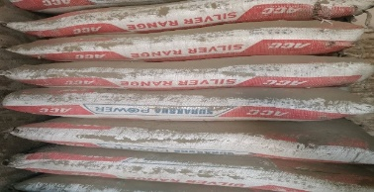Fig.no.1 cement

**Steel Fiber Reinforced Concrete-** Steel fiber reinforced concrete (SFRC) is a composite material whose components include the traditional constituents of Portland cement concrete and a dispersion of randomly oriented short discrete steel fibers. The development of steel fiber reinforced concrete began in the early 1960s. since then, the use of SFRC has gathered great interest, with research demonstrating the potential benefits that may lie in the use of the material in both structural and non-structural applications. The most common applications are pavements, tunnel linings, pavements and slabs, shotcrete and now shotcrete also containing silica fume, airport pavements, bridge deck slab repairs, and so on. There has also been some recent experimental work on roller-compacted concrete (RCC) reinforced with steel fibres**.** Corrugated steel fibers from Local Company as shown in fig no.2 were used those length is 35-45 mm and dia of 0.55-0.73mm having aspect ratio of about. The tensile strength of fibre is 1200 N/mm2.

****Fig no. 2 Steel fiber reinforced concrete

**Water-** these normal tap water used.

Fig.no.3 water

**Fine Aggregate** - The size of fine aggregate is below 4.75 mm, this may have obtained from rivers, lakes but when used in concrete mix. It should properly have washed and tested to a certain total percentage of clay, silt and other organic matter does not exceed this specified limit. The composition, shape, and size of the aggregate of all have signified impact on the workability, durability, strength weight and shrinkage of the concrete. We were using River sand. and whose Specific gravity is 2.63. Absorption of water is -1%.

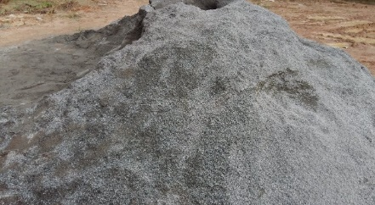

Fig.no. 4 Fine aggregate

**Coarse Aggregate**- Coarse aggregate sizes are larger than 4.75 mm, a maximum shape up to 40 mm is used for coarse aggregate in most structural applications. While for mass concreting purposes such as dams size up to 150 mm may be used.

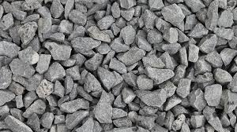Fig no. 5 coarse aggregate

Size of coarse aggregates depends upon the nature of the work. The aggregates are free from dust before used in the dust. The coarse aggregate used in the experimental investigation is 20 mm sized crushed angular in shape. It includes gravel, crushed stone, sand, slag, recycled concrete and goo synthetic aggregates. The following properties are strength, hardness, toughness, durability, shape of aggregate and adhesion with bitumen. The aggregates used in the production of concrete are inert granular materials such as gravel, crushed stone, sand, slag, and recycled concrete. The aggregates might be natural, manufactured, or recycled. specific gravity is 2.57. Absorption of water is 0.8%.

## Experiment

For compression test 27 cubes was casted respectively. We also performed split tensile test and 4-point flexure test. We designed the concrete for M 60 strength. We construct 21 cylinder of size 20×10cm and 14 beams of size 10×10×50 cm. 27 cubes casted 9 cubes are without fibre and rest are with 2%, 2.5%, 3% fiber. We checked the strength on 14 and 28 days for compressive test.

## Compression Test

This test was done in accordance with IS 516-1959.The cubes of standard size 150×150×150mm and 100×100×100mm were used to find the compressive strength of concrete. Cubes were placed on the bearing surface of compression testing machine, of capacity 200 tones and a uniform rate of loading of 140 Kg/cm2 per minute was applied till the crack appear on the cube. The maximum load was noted and the compressive strength was calculated. The results are tabulated in table no.5.1

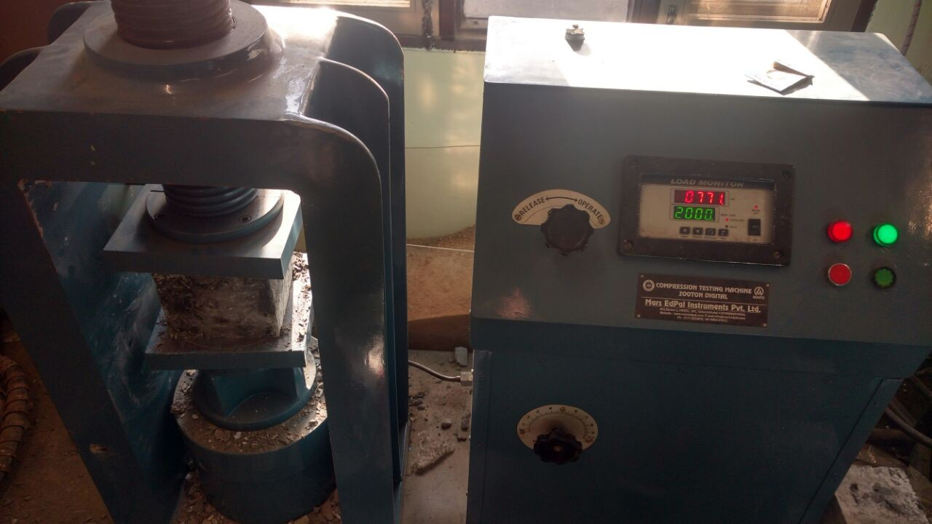Fig. no. 6 Compression testing machine

**Procedure:** -

(i)Prepare the specimen of size 15×15×15cm in size.

(ii)The concrete should be filled in specimen in layer of 5 cm with proper compaction of each layer either vibration machine or hand tamping.

(iii)The mould should be keep at damp condition for 24 hours.

(iv)After that the cube should be put in bath tub at a standard temperature of 27±2 oC.

(v)The cubes should be tested immediately on removal from water.

(vi)The load should be applied slowly without any shock at a rate of approximately 140Kg/cm2/min.

(vii)The max load applied to the specimen should be noted for each cube.

**Calculation:** *-*

Compressive strength in MPa = P/A

Here P = applied load

A = cross sectional area

**Split Tensile Strength Test**

Concrete is brittle in nature and therefore tensile strength plays an important role for structure safety purposes. This test is also performed on CTM machine. In this test we constructed 21 cylinder out of which 3 cylinder are for each 0, 2, 2.5, 3 % steel fibre and 3 each for rice husk ash, fly ash, silica fumes.

**Procedure: -**

* The cylinder of size 20×10 cm size is made.
* Centre line shall be drawn on the two opposite faces of the cube which will ensure that they are in same axial plane.
* The mass and dimension of cylinder should be measured before the testing.
* The rate of loading should be smooth and should not be shock loading.
* The rate of loading should be maintained within the range of 1.2N (mm2/min) to 2.4 N (mm2/min).
* Maintain the rate once applied until failure.
* Note the maximum reading.

**Calculation: -**

Splitting tensile strength fct =2P/πld

Where P = max load applied in Newton applied l = length of cylinder (mm)

d = cross-section dimension of cylinder (mm)

**Casting of Mould**

The materials were weighed accurately using a digital weighing instrument. For plain concrete, fine aggregates, coarse aggregate, cement, water were added to the mixture machine and mixed thoroughly for three minutes. Steel fibres were mechanically sprinkled inside the mixture machine after thorough mixing of the ingredients of concrete as shown in fig. no.7

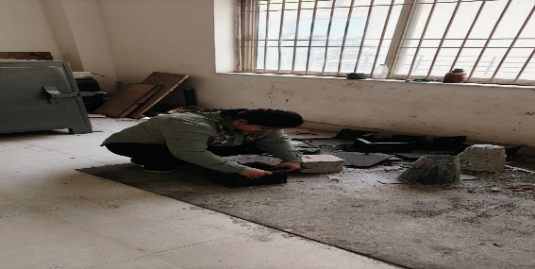

Fig.no.7 Casting of specimen

The cubes of 15×15 cm were prepared. Before mixing the concrete the moulds were kept ready. The sides and the bottom of the all the mould were properly oiled for easy demoulding.

## Curing

Cubes were at a stable ground and kept at a temperature of 27±2˚C for 24 hours as shown in fig.no. 5.4. After this, the cubes and cylinder was marked and removed from the moulds and after that the cubes was submerged in clean fresh water for duration until it was used the testing day. The cubes were allowed to become dry before testing.

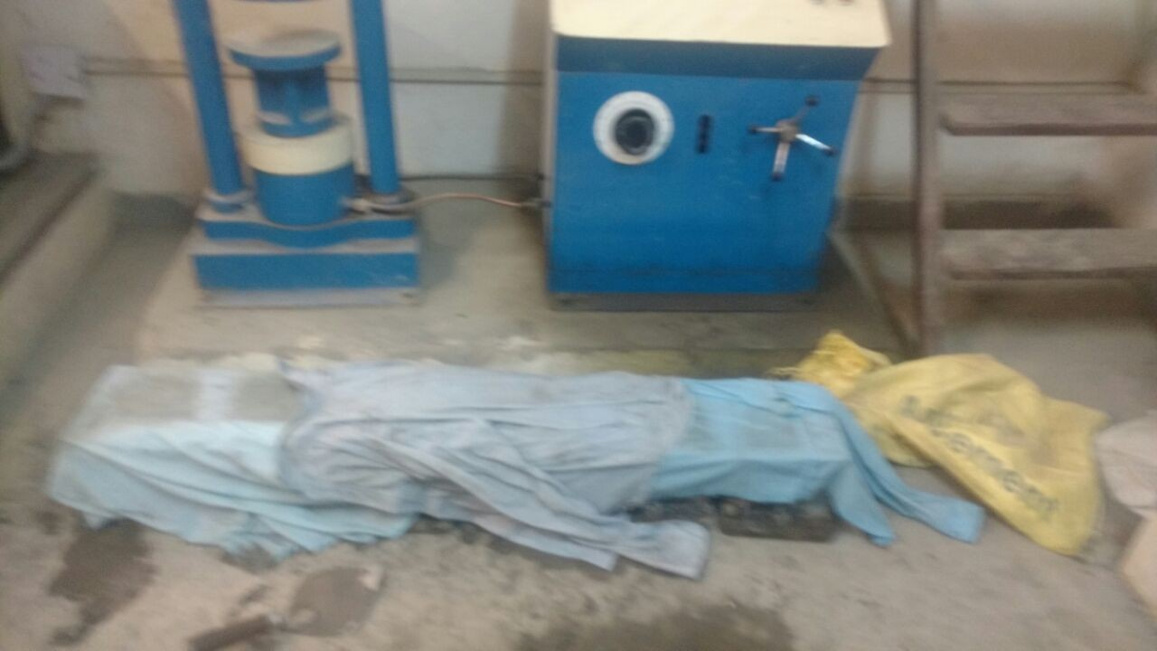

Fig. no 8 Curing of cubes

## Mix Design of Concrete

We have designed our mix by IS 10262:2009

Step 1**:** Characteristic Strength of concrete:

fck’ = fck + 1.65s from IS 456, s= 5 for M60

= 60+1.65×5

= **68.25 MPa**

Step 2: Selection of water/cement or cementations ratio:

Form IS 456, **W/c= 0.24**

Step 3: Selection of water content:

From IS 456, at w/c = 0.50 and angular aggregates having maximum nominal size of 20mm

Suggestive water content = 186 kg/m3

2% super plasticizer by weight of cement is used that result in 30% reduction in water content.

So, Final water content = 186×0.30

= **130.2 kg/m3**

Step 4: Selection of cement content**:**

**Cement content** = water content/water to cement ratio

=130.2/0.22

=**591.82kg/m3**

Step 5: Estimation of Coarse Aggregate Proportion in Total Aggregate**:**

For w/c=0.50 and zone IV and max nominal size of aggregate=20mm

**Coarse aggregate proportion in total aggregate = 0.66**

Since there is a decrease in the w/c ratio (0.50-0.22=0.28) this proportion is increased according to the code recommendation by (0.28/0.05=5.6%)

Corrected coarse aggregate proportion in total aggregate **=** 0.66+5.6/100

**= 0.72**

**Fine aggregate proportion in total aggregate =** 1-0.72

**= 0.28**

Step 6: **Mix design calculations:**

* + 1. Volume of concrete = 1m3
    2. Volume of cement = (Mass /Specific gravity) × (1/1000)

= (591.82/3.15) × (1/1000)

= 0.187m3

* + 1. Volume of water = (Mass /Specific gravity) × (1/1000)

= (130/1) × (1/1000)

= 0.130 m3

* + 1. Volume of super plasticizer = (Mass of super plasticizer/Specific gravity

of water) × (1/1000)

= (2×591.8/1.1×100) ×(1/1000)

=10-2 m3

* + 1. Volume of all in aggregate = 1-(b+ c + d)

= 1-(0.187+0.130+10-2)

= **0.673 m3**

* + 1. Mass of coarse aggregate = (e)×(CA)× (specific gravity of coarse aggregate) ×(1000)

= 0.673 ×0.72 ×2.57 ×1000

= 1245.31 kg/m3

* + 1. Mass of fine aggregate = e × FA × specific gravity of fine aggregate ×1000

= 0.67 ×0.5 ×2.63 × 1000

= 495.5kg/m3

**Final result:**

Cement = 591.82 kg/m3 ,

Water = 130.2 kg/m3 ,

Fine aggregate = 495 kg/m3,

Coarse aggregate =1245.31 kg/m3 ,

Super plasticizer =11.83kg/m3

**Final Ratio:**

**C: W: FA: CA: SP =** 1:0.22:0.83:2.1:0.02

Table no. 1 Mix Design for Steel Fibre

|  |  |  |
| --- | --- | --- |
| %  Replacement | Concrete content(kg/m3) | Steel  fibre(kg/m3) |
| 0 | C: 591; W: 130; F: 495; CA: 1245 | 0 |
| 2 | C: 579; W:127; F: 485.1; CA: 1220.1 | 156 |
| 2.5 | C: 576; W:126.7; F: 482.6; CA: 1214 | 195 |
| 3 | C: 573; W: 126; F: 480; CA: 1208 | 234 |

### Table no.1 shows the ratio of concrete design at different percentage of steel fibre.

Table no. 2 Mix Design for Steel Fibre Per (15×15×15) cm3 cube

|  |  |  |
| --- | --- | --- |
| **%** Replacement | Concrete content per cube (grams) | Steel fibre per cube  (grams) |
| 0 | C: 133; W: 29.3; F: 111.4; CA: 280 | 0 |
| 2 | C: 130; W: 28.575; F: 109; CA: 275 | 35.1 |
| 2.5 | C: 129.6; W: 28.5; F: 109; CA: 273 | 43.9 |
| 3 | C: 129; W: 28.35; F: 108; CA: 272 | 52.6 |

Table no.2 shows the amount of constituents of concrete design at different percentage of steel fibre for cube of 15cm×15cm×15cm.

**RESULTS**

**Compressive Strength**

Compressive strength of concrete= P/A

Here, P = Load applied at the time of failure

A= Area of cross section

Compressive strength of concrete = 1202 kN/225cm2,

=1202×103 /225 × 100 = 53.4 N/mm2

#### Table no. 3 Compressive Strength

|  |  |  |  |  |
| --- | --- | --- | --- | --- |
| Type of Specimen | Compressive Strength.  N/mm2 | | | |
| 14 days | | 28 days | |
| OPC | 55.1 | 55.5 | 62.2 | 64.2 |
| 55.5 | 64.8 |
| 56 | 65.8 |
| HSFRC (3%) | 57.2 | 57.9 | 63.7 | 65 |
| 58.1 | 65.2 |
| 58.4 | 66.1 |
| HSFRC (2.5%) | 56.6 | 56.1 | 61.1 | 63.8 |
| 55.7 | 63.9 |
| 56.1 | 66.5 |
| HSFRC (2%) | 52.1 | 54.9 | 62.7 | 64.23 |
| 55.7 | 65.6 |
| 57.1 | 64.4 |

The result in table no.3 shows that when we add steel fibre there is marginally increased in compressive strength with variation around 1% to -1% at 28 days.

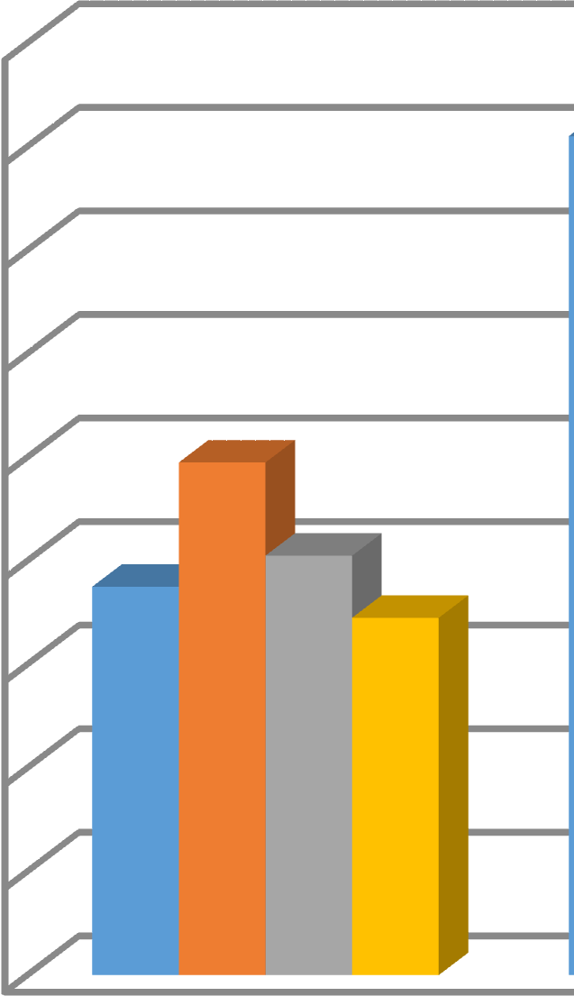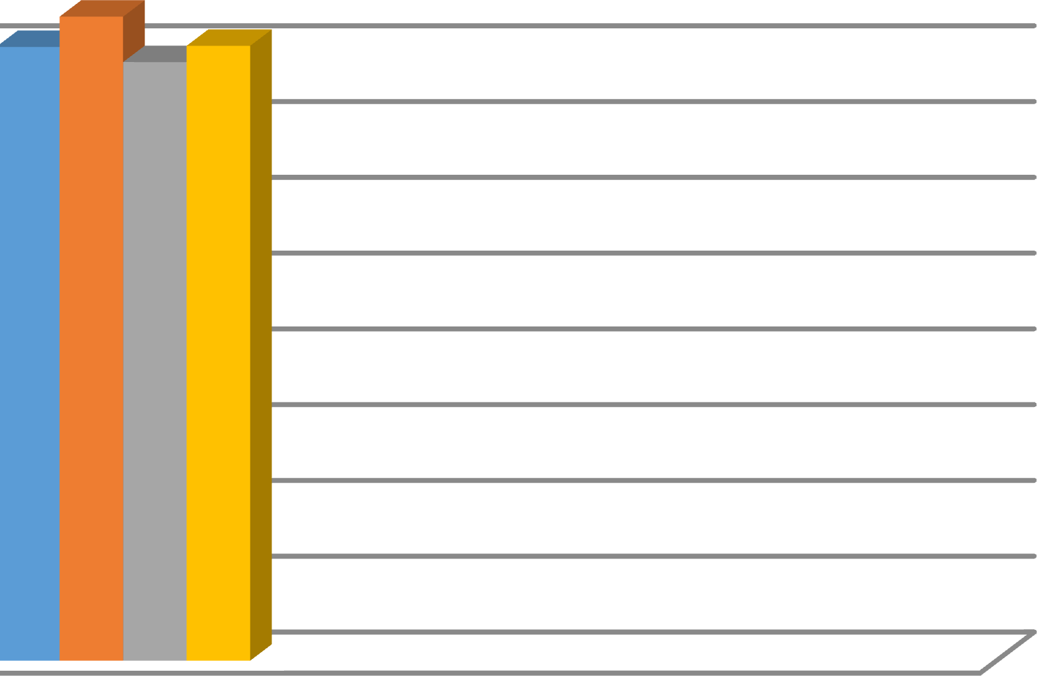

66

64

62

60

58

56

54

52

50

48

OP

HSFRC 3%

HSFRC 2.5%

HSFRC 2%

14 day 28 day

**DAYS**

Fig.no.9 Bar chart for compression testing machine

**COMPRESSIVE STREGTH(MPa)**

In this fig.no.9 we can see that cube having 3% replacement show maximum compressive strength in comparison to other cube.

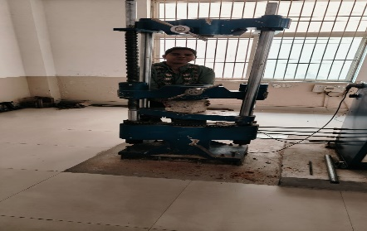 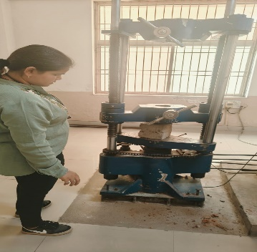

Fig. no. 10 Cube testing Fig.no. 11 Cube testing by UTM

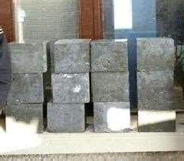This increase in strength is due to the fact that addition of steel fibre reduces the brittleness of concrete. Cubes for compression testing machine are shown in fig. no.10 and fig. no.11 shows the failure pattern of cube after testing.

Fig. no.12 Cubes for UTM testing

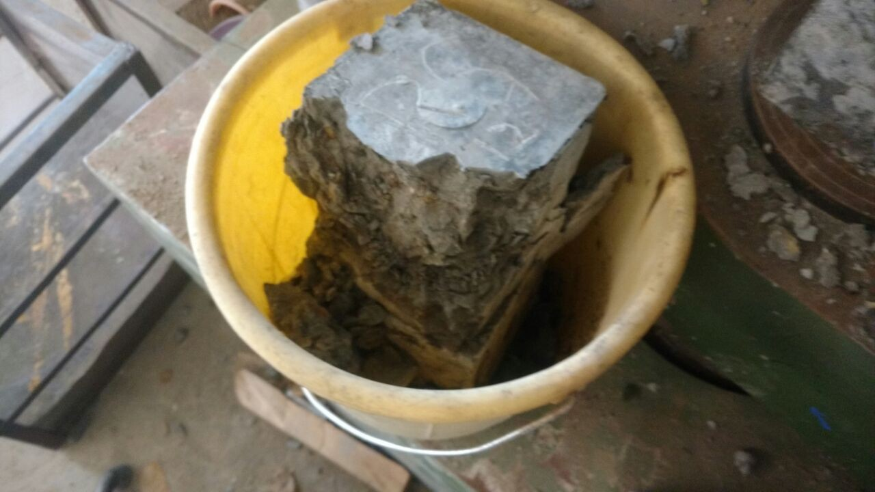

Fig. no. 13 Crack pattern

**CONCLUSION**

On the basis of experiments, we done in our lab and we conclude different things on the basis of result are as following:

* + 1. The result shows that when we add steel fibre there is marginally increase in compressive strength and split tensile and flexural strength of concrete increase considerably.
    2. Maximum compressive strength arrives at 3% fibre replacement.
    3. In experiment we use 2%fibre replacement instead of 3% because workability reduces considerably as percentage of fibre increase.
    4. Maximum compressive strength is arrived on adding 2% steel fibre and 15% replacement of silica fume whereas compressive strength of 2% steel fibre and 10% Rice husk as his little bit less but it is eco-friendlier and cheaper which is good for builders.
    5. Maximum split tensile strength and flexural strength is arrived on adding 2% steel fibre and 10% of rice husk.
    6. Addition of rice husk ash is the best additive material that we can add in concrete due to
       - Greater performance than any other material.
       - Easy availability.
       - Eco friendly.
       - Cheap material as it is a waste material.
       - Good workability then other.

# References

1. Shetty, M. S(2005), **“Concrete Technology Theory and Practice.”** S.Chand and Company, New Delhi.
2. Nguyen van chanh (2008) **“Steel Fibre Reinforced Concrete.”** Japan Society of Civil Engineers.
3. Saravana Raja, Mohan.K, Parthiban.K (2011) **“Strength and Behaviour of Fly Ash based Steel Fibre Reinforced Concrete Composite.”** International Journal of Civil and Structural Engineering.
4. Raveendran, K.G. et al (2012**) “Performance of Silica Fume on Strength and Durability of Concrete.”** International Journal of Engineering Sciences & Emerging Technologies,
5. Shende, A.M et al (2012) **“Experimental Study on Steel Fiber Reinforced Concrete for M-40 Grade.”** International refereed journal of engineering and science,
6. Suman, S. et al (2012) **“Fly Ash Concrete: A Technical Analysis for Compressive Strength.”** International Journal of Advanced Engineering Research and Studies.
7. Dutta, D. et al (2013) **“Influence of Silica Fume on Normal Concrete.”** Journal of Engineering Research and Application.
8. Patel, et al (2013) **“Study on Durability of High Performance Concrete with Alcco Fine and Fly Ash.”** International Journal of Advanced Engineering Research and Studies.
9. Frank, I. et al (2014) **“Blended Rice Husk Ash Concrete; a Marginal Green Construction Material from Extended Hydration.”** International Journal of Scientific & Engineering Research,
10. Jamnu, M.A. et al (2014) **“Effect on Compressive Strength of High Performance Concrete Incorporating Alcco Fine and Fly Ash”.**
11. Obilade (2014) **“Use of Rice Husk as Partial Replacement for Cement in Concrete”.** International Journal of Engineering and Applied Sciences,
12. Chakraborty, S. et al (2015) **“A Study on the Rheological Properties of High Strength Concrete Incorporating Silica Fume.”** The International Journal of Science and Technology;
13. Kumar, R. et al (2015) **“An Experiment Study on Mechanical Properties of Alccofine Based on High Grade Concrete.”** International Journal of Multidisciplinary Research and Development.
14. Avinash Joshi , Pradeep reddy ,Punith kumar and Pramod hatker (2016) **“Experimental Work on Steel Fibre Reinforced Concrete.”** International Journal of Scientific &amp; Engineering Research.
15. Durga Chaitanya Kumar Jagarapu (2016) **“Experimental Study on Steel Fiber Concrete**”. American Journal of Engineering Research.
16. Satyashiva prasad nannuta , Rashmi B R, (2017) **“Experimental Study on the Behaviour of Steel Fibre Reinforced Concrete.”** International Research Journal of Engineering and Technology (IRJET).
17. L.krishna, g. durga rama naidu (2022) **“An Experimental Study on Steel Fibre Reinforced Rubber Concrete”** IJCRT.
18. Minglei Zhao, Jie Li (2024) **“Experimental Study of the Bond Behavior of 400MPa Grade Hot-Rolled Ribbed Steel Bars in Steel Fibre Reinforced Concrete.”**
19. I.S: 10262-2009 **“Indian Code for Recommended Guidelines for Concrete Mix Design”.**
20. I.S 456-2000 **“Indian code of practice for plain and reinforced concrete.”**
21. ASTM A820-97 (1997) **“Standard Specification for Steel Fibres for Reinforced Concrete.**” American society for testing and materials.
22. ASTM C78-97 (1997) **“Standard Specification for Flexural Strength of Concrete.**” American society for testing and materials.
23. ACI Committee 544 (1984) **"Guide for Specifying, Mixing, Placing, and Finishing Steel Fibre Reinforced Concrete."** American Concrete Institute.
24. I.S 516-1959 **“Indian Code for Method of Tests for Concrete.”**