**The Influence of Influencer Marketing on Consumer Purchase Decisions: A Survey Based Study in Amravati**

**Author Name : Anjali Nandkishor Kalbande**

**College Name : P.R.Pote Patil College of Engineering and Management,**

**Amravati.**

**Contact No : 9322973587**

**Email Id :** [**anjalikalbande1234@gmail.com**](mailto:anjalikalbande1234@gmail.com)

**Co-Author Name: Prof.V.A. Ingole (Dissertation Guide)**

**College Name : P.R.Pote Patil College of Engineering and Management,**

**Amravati.**

**Email id :**

**Contact No :**

1. **Abstract:**

In today’s digital era, influence marketing has emerged as a powerful strategy shaping consumer behavior and purchase decisions. with the rise of social media platform like Instagram, YouTube influencer have gained significant credibility and trust among their followers, marketing on consumer purchase decisions through a survey-based study conducted in Amravati.The research focuses on key factors such as influencer credibility, trust,social proof, and brand awareness.by examining consumer perceptions, engagement levels and the effectiveness of influencer marketing strategies, this study provides insights into how digital influencers shape purchasing behavior. The finding will help businesses refine their marketing strategies and enhance their understanding of consumer trust in influencer endorsements.

**2. Keywords:**

Influencer marketing, Consumer Behavior, Purchase Decision, Media, Social Brand Awareness, Trust, Credibility, Social Poor, Digital Marketing

**3. Introduction**

In today's digital age, influencer marketing has emerged as a potent force shaping consumer behavior. By leveraging the credibility and reach of social media influencers, brands can effectively promote their products and services, ultimately driving consumer purchase decisions. This study aims to delve into the intricate relationship between influencer marketing and consumer behavior through a rigorous survey-based analysis.

The rise of social media platforms has fundamentally altered the way consumers interact with brands. Influencers, with their substantial followings and authentic connections, have the power to sway consumer opinions and preferences. By endorsing products or services, these digital influencers can significantly impact purchasing decisions. This study seeks to investigate the factors that contribute to the effectiveness of influencer marketing and to identify the key drivers of consumer behavior in this context.

The advent of social media has revolutionized the way brands communicate with their audiences, creating opportunities for more personalized, interactive, and engaging forms of marketing. One of the most transformative strategies to emerge in this digital age is influencer marketing, a practice that leverages the reach and credibility of individuals who have established significant followings on platforms such as Instagram, YouTube and Twitter. These influencers, by virtue of their expertise, charisma, or relatability, act as intermediaries between brands and consumers, shaping perceptions and, ultimately, purchase decisions.

Unlike traditional advertising, which often relies on broad messaging and impersonal tactics, influencer marketing thrives on authenticity and trust. Influencers cultivate strong relationships with their followers by sharing genuine content, personal experiences, and product endorsements that resonate with their audiences. This relatability creates a sense of trust that brands find difficult to replicate through other means, making influencer marketing a powerful tool in influencing consumer behavior. Studies have shown that consumers are more likely to trust recommendations from influencers they follow than advertisements from brands themselves, highlighting the potential of this approach to drive engagement, awareness, and sales. Consumer purchase behavior in today’s digital-first world is significantly influenced by social proof, online reviews, and recommendations from trusted sources. Influencers, as modern-day opinion leaders, play a critical role in providing this social proof. Whether endorsing fashion products, beauty items, technology gadgets, or lifestyle services, influencers have a direct impact on shaping consumer preferences, particularly among younger demographics who are highly active on social media platforms. This influence is further magnified by the visual and interactive nature of social media, which allows influencers to demonstrate the value of products in real-life scenarios, creating a stronger emotional connection with their audience.

**4. Review of Literature:**

**1.****Dr.Sarathsimha Bhattaru and G.Suvarsha (2024):**The widespread adoption of social networking sites (SNS) has made the internet more personal, with millions of users engaging daily. While these platforms enhance virtual communication and social interaction, excessive use can impact physical health. Social media has transformed modern communication and gained significant attention from both individuals and organizations. Businesses worldwide leverage SNS for advertising, maintaining official pages and blogs to engage with consumers. As social media becomes integral to daily life and corporate strategies, this study aims to explore its influence on consumer behavior across generations, particularly among teenagers, and how it shapes their purchasing decisions.

**2.****Mis. Bhagyashree L and Mrs. Pushpalatha S (2024):**Social networking sites (SNS) have revolutionized digital communication, making the internet more personal and fostering widespread social interaction. With millions of daily users, these platforms significantly influence both individuals and businesses. While they facilitate virtual collaboration and marketing strategies, excessive use can negatively impact physical health. Corporations globally utilize SNS for advertising, engaging consumers through official pages, blogs, and accounts. As social media becomes an essential part of everyday life and business operations, this study examines its role in shaping consumer behavior, particularly among teenagers, and its impact on purchasing decisions.

**3.****Dr. Poornima C and Ms. Rogini and Mr. Muthuvel Kannan B (2025):**This study examines the impact of influencer marketing on consumer purchase decisions in Coimbatore, Tamil Nadu, focusing on factors like authenticity, trust, and information relevance. It explores platform preferences, demographic influences, and various influencer campaign types. Using analytical tools such as percentage analysis, rank, and ANOVA, data from 152 respondents were analyzed. The findings highlight influencer marketing's potential to transform modern advertising, provided brands navigate challenges like market saturation and legal compliance. The study concludes with strategic recommendations for optimizing influencer collaborations to maximize effectiveness.

**4.****Joyce L.Jyvaskyla University (20240:**Thisstudy examines the influence of influencer marketing on consumer purchase intentions using a desk research approach, analyzing existing studies and reports. Findings suggest that consumers are more likely to trust and act on recommendations from influencers perceived as authentic and knowledgeable, particularly those with niche audiences who create personal connections. The interactive nature of social media further strengthens engagement and purchase likelihood. Influencer marketing effectively leverages social proof and word-of-mouth, outperforming many traditional marketing strategies. The study suggests anchoring future research in social influence theory and planned behavior while advocating for strategic brand-influencer collaborations, transparency, and ethical marketing practices.

**5.****Dr. K. Praveen Kumar and Dr. V. Rajalakshmi and Ganesh T (2024):** This study explores the impact of influencer marketing on consumer purchase intentions in the Indian market, analyzing key factors such as trust, credibility, platform effectiveness, content creation, and demographic influences. Through case studies of Nykaa, Mamaearth, and Lenskart, it highlights how influencer marketing enhances brand awareness, builds consumer trust, and drives sales. The research finds that successful campaigns rely on authentic content, careful influencer selection, and regulatory compliance. However, challenges like maintaining authenticity, high costs, and unpredictable outcomes persist. To address these, the study recommends strategies for authenticity, cost management, compliance, and influencer selection. Ultimately, it concludes that despite challenges, influencer marketing remains a powerful tool for brands to engage consumers and boost purchase intentions in India.

**5.Objective of the study**

1. To analyze the impact of product endorsements by social media influencers on consumer purchasing decisions.
2. To assess the effect of influencer marketing on brand awareness and brand recall.
3. To explore the influence of an influencer’s credibility, experience, and appearance on consumer purchase intent.
4. To evaluate the level of trust consumers, place in influencers and its effect on their buying behavior.

**6. Research Methodology:**

* **Research Design:** This study adopts a quantitative research design, utilizing surveys and questionnaires to collect numerical data for statistical analysis. This approach ensures a systematic and objective examination of the relationship between influencer marketing and consumer purchase decisions.
* **Area of Study:** Thestudy is under taken in Amravati city.
* **Sample Size:** Sample size measures the number of individual sample measured used in a survey as sample size of 100 respondents was taken to conduct of study.
* **Data Collection**: The Primary data collected directly from the target population through a survey questionnaire. and Secondary data for his study was also collected through internet.
* **Sample Technique:** The Sample data used for convenience sampling for quick data collection, though it may limit generalizability. Quota sampling is used to ensure demographic representation, balancing factors like age and gender. Additionally, online survey panels help reach a targeted population efficiently.

**7.Data Analysis and interpretation:**

Table 1 Gender wise distributions of respondents.

|  |  |  |
| --- | --- | --- |
| Gender | No. of respondent | Percentage % |
| Male | 26 | 26% |
| Female | 74 | 74% |
| Total | 100 | 100% |

Graph 1 Gender wise distributions of respondents

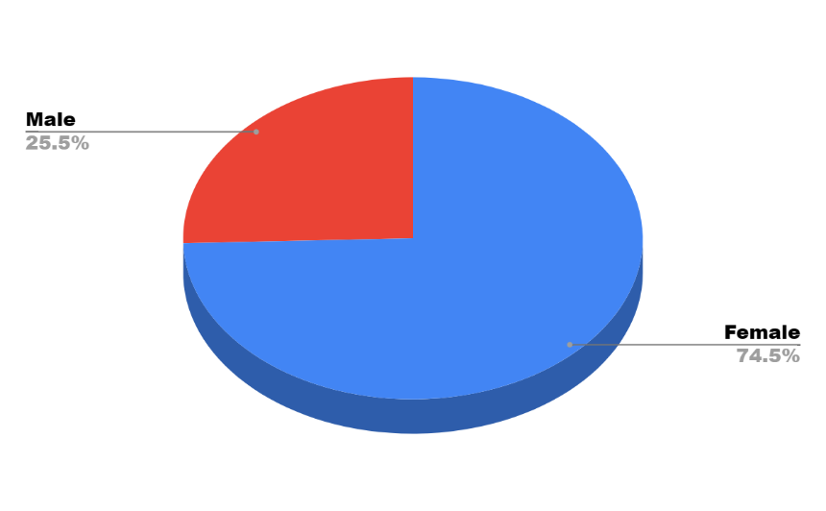

**Interpretation:**

The chart represents the gender distribution of a surveyed population. It shows that 74.5% of respondents are female, while 25.5% are male. This suggests a significant female majority in the sample.

Table 2 Age wise distribution of Respondents Table.

|  |  |  |  |
| --- | --- | --- | --- |
| Sr.No. | Age | No.Of Respondents | Percentage% |
| 1 | Below 18 | 72 | 72% |
| 2 | 18-25 | 8 | 8% |
| 3 | 26-35 | 10 | 10% |
| 4 | 36-45 | 2 | 2% |
| 5 | Above 45 | 8 | 8% |
|  | Total | 100 | 100% |

Graph 2 Age wise distributions of the respondents

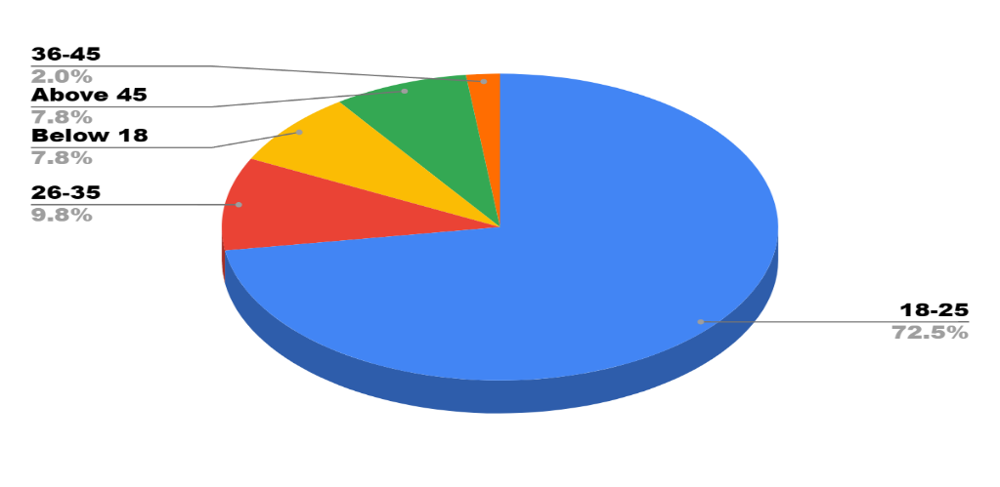

**Interpretation:**

The chart represents the age distribution of a surveyed population. The majority (72.5%) belong to the 18-25 age group, indicating a predominantly young respondent base. The 26-35 age group makes up 9.8%, while both Below 18 and Above 45 contribute 7.8% each. The smallest group is 36-45, accounting for only 2.0% of the total. This suggests that the study or survey is primarily focused on younger individuals.

Table 3 Classification on basis influencer marketing impact consumer purchase decisions.

|  |  |  |
| --- | --- | --- |
| Impact of consumer | No.of Respondents | Percentage% |
| Very much | 30 | 30% |
| Some what | 30 | 30% |
| Neutral | 24 | 24% |
| Not at all | 16 | 16% |
| Total | 100 | 100% |

Graph 3 Classification on basis influencer marketing impact consumer purchase decisions.

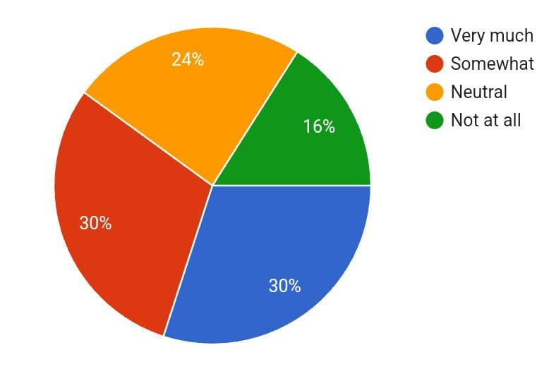

**Interpretation:**The majority of responses are split between "Very much" and "Somewhat," each holding 30%, suggesting a generally positive sentiment. A smaller but notable portion (24%) remains neutral, while only 16% completely disagree. This indicates that most respondents lean towards agreement, though some remain undecided or disagree.

Table 4 Classification on the basis important of influencer’s credibility in consumer purchasing decision.

|  |  |  |
| --- | --- | --- |
| consumer purchasing decision. | No.of Respondents | Percentage% |
| Very important | 20 | 20% |
| Somewhat important | 54 | 54% |
| Neutral | 20 | 20% |
| Not important | 6 | 6% |
| Total | 100 | 100% |

Graph 4 Classification on the basis important of influencer’s credibility in consumer purchasing decision.

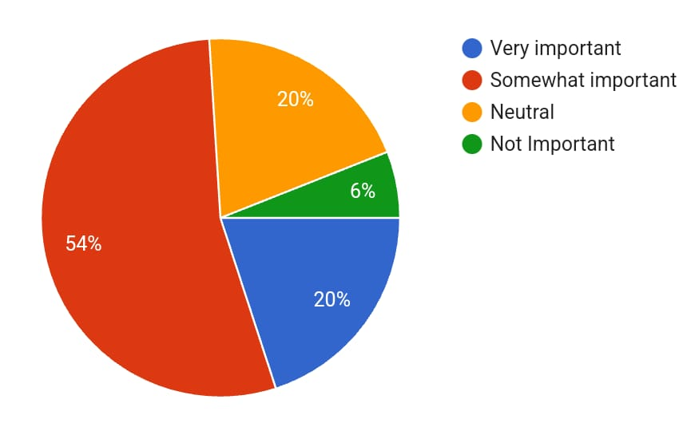

**Interpretation:**

The majority (54%) of respondents consider the subject "Somewhat Important," while 20% find it "Very Important." A smaller percentage (6%) deem it "Not Important," and another 20% remain "Neutral." This indicates that while importance is recognized, there are mixed views, with a significant portion still undecided or considering it of lower priority.

**Table 5** **Classification on the basis what factor makes consumer trust an influencer’s recommendation the most**.

|  |  |  |
| --- | --- | --- |
| Influencer’s recommendation | No.of Respondents | Percentage% |
| Personal experience with the product | 34 | 34% |
| Detailed product review | 44 | 44% |
| Testimonials & real life examples | 20 | 20% |
| Brand partnerships | 2 | 2% |
| Total | 100 | 100% |

**Graph 5 Classification on the basis what factor makes consumer trust an influencer’s recommendation the most.**

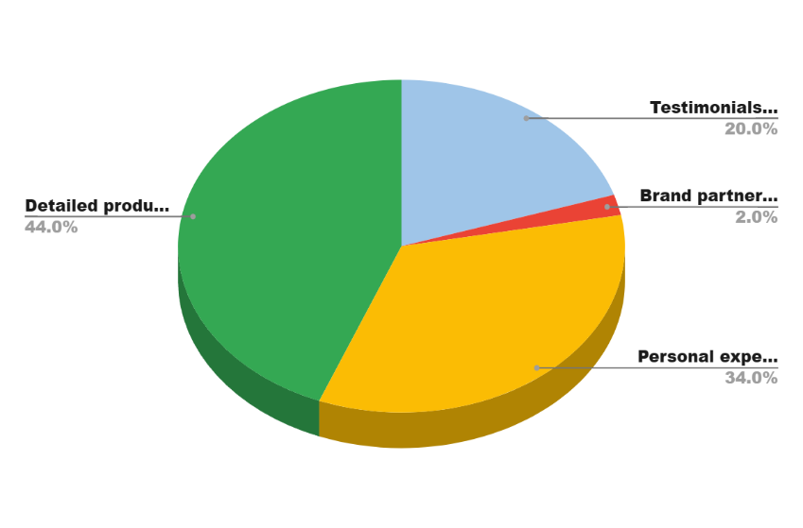

**Interpretation**

The graph illustrates the key factors influencing consumer decisions. Detailed product information (44%) is the most significant, followed by personal experiences (34%), showing that consumers value firsthand usage and knowledge. Testimonials (20%) also contribute, but brand partnerships (2%) have minimal influence. This suggests that transparent product details and user experiences drive purchasing decisions more than endorsements.

**Table 6** **classification on the basis influencers influence your buying decisions more than traditional advertisements**

|  |  |  |
| --- | --- | --- |
| traditional advertisements | No.of Respondents | Percentage% |
| Yes Significantly | 32 | 32% |
| Somewhat | 38 | 38% |
| Neutral | 24 | 24% |
| No | 6 | 6% |
| Total | 100 | 100% |

Graph 6 classification on the basis influencers influence your buying decisions more than traditional advertisements

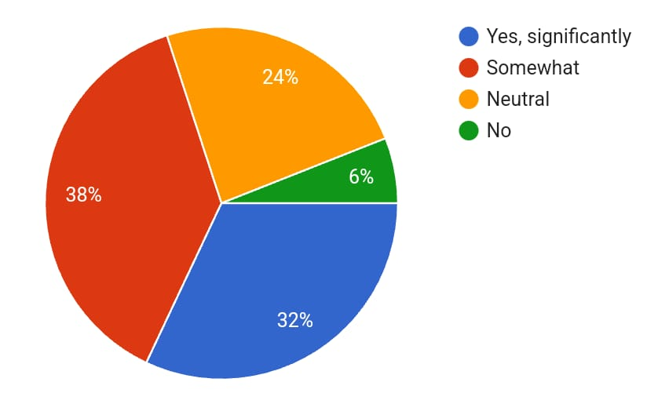

**Interpretation:**

The graph represents responses to a question, with four categories: "Yes, significantly" (32%), "Somewhat" (38%), "Neutral" (24%), and "No" (6%). The largest group (38%) believes the impact is somewhat significant, while 32% feel it is highly significant.A notable portion (24%) remains neutral, indicating mixed opinions on the matter. Only a small fraction (6%) sees no impact, suggesting that most respondents acknowledge some level of influence.

**8.Findings**

* **Gender Distribution**: The majority of respondents (74%) are female, indicating that influencer marketing may have a stronger impact on women.
* **Age Group**: The dominant age group among respondents is below 18 (72%), suggesting that influencer marketing primarily affects younger consumers.
* **Impact of Influencer Marketing**: 60% of respondents agree that influencer marketing influences their purchase decisions to some extent.
* **Influencer Credibility**: 74% of respondents believe that influencer credibility is important in shaping their purchase decisions, with 54% rating it as "Somewhat Important" and 20% as "Very Important."
* **Factors Driving Trust in Influencers**: The most critical factors that make consumers trust influencers are:
  + **Detailed product reviews (44%)**
  + **Personal experience with the product (34%)**
  + **Testimonials & real-life examples (20%)**
  + **Brand partnerships (2%)**, indicating a lower impact from direct brand collaborations.

**9.Conclusion**

The study highlights the significant role of influencer marketing in shaping consumer purchasing behavior, particularly among younger audiences. Influencer credibility, authenticity, and detailed product reviews are the most influential factors in building consumer trust. The findings suggest that brands leveraging influencer marketing should focus on transparent, experience-based endorsements rather than mere promotional partnerships.

While influencer marketing has a notable impact, there remains a segment of consumers who are neutral or unaffected. This indicates that while influencers can drive engagement, other marketing elements such as traditional advertising, word-of-mouth, and brand reputation also play a role in consumer decision-making.

**10.Suggestions**

* **Enhancing Influencer Credibility**: Brands should collaborate with influencers who have a strong reputation for authenticity and expertise in their niche.
* **Emphasizing Detailed Reviews**: Influencers should provide in-depth, experience-based content to build consumer trust.
* **Targeting the Right Audience**: Since younger individuals are more influenced, brands should tailor influencer campaigns to appeal to their interests and preferences.
* **Encouraging User-Generated Content**: Engaging consumers through testimonials and real-life usage scenarios can further boost trust and brand credibility.
* **Diversifying Marketing Strategies**: While influencer marketing is effective, brands should complement it with other marketing techniques such as traditional ads, social media engagement, and customer loyalty programs to maximize reach.

**11. References**

Dr. K. Praveen Kumar and Dr. V. Rajalakshmi and Ganesh T (2024): The impact of influencer marketing on consumer purchase intention in the Indian market Seybold Report Volume 19 Issue 2 Apr-Aug, Pg 54-65.https://www.researchgate.net/publication/382640538

Dr. Poornima C and Ms. Rogini and Mr. Muthuvel Kannan B (2025): The The impact of influencer marketing on consumer purchase decision making in coimbatore city International Journal of Scientific Research and Engineering Development- Volume 8 Issue 1, Jan-Feb 2025

Dr. Sarathsimha Bhattaru and G. Suvarsha (2024)1: "The Impact of Influencer Marketing on Consumer Purchasing Decisions: A Survey-Based Analysis International Journal of Marketing and Human Resource Management (IJMIIRM) ISSN: 0976-6421 Volume 15, Issue 1, January-April 2024, pp. 14-20

Joyce L.Jyvaskyla University (20240: influence of Influencer Marketing on Consumer Purchase Intentions American Journal of Public Relations ISSN 2957-7241 (online) Vol.3, Issue 1, pp. 1-11, 2024

Mis. Bhagyashree L and Mrs. Pushpalatha S (2024):The Impact of Influencer Marketing on Consumer buying behaviour NTERNATIONAL JOURNAL OF CURRENT SCIENCE (IJCSPUB) 2024 IJCSPUB| Volume 14, Issue 2 April 2024 |ISSN: 2250-1770

**12.Webliography**

1.Google Scholar.(n.d.).Advanced research database. <http://scholar.google.com>

2. <https://www.researchgate.net/publication/389023977>

3. <http://shodhganga.inflibnet.ac.in>