EV CHARGE SHARE

Author: Anurag Bankhele

Department of Computer Technology Sou. Venutai Chavan Polytechnic, Pune Email: [anuragbankhele@gmail.com](mailto:anuragbankhele@gmail.com)

Author: Shivam Chorge

Department of Computer Technology Sou. Venutai Chavan Polytechnic, Pune Email: [shivamchorge01@gmail.com](mailto:shivamchorge01@gmail.com)

Author: Suyog Patil

Department of Computer Technology Sou. Venutai Chavan Polytechnic, Pune Email: [suyogudaypatil@gmail.com](mailto:suyogudaypatil@gmail.com)

# ABSTRACT

**As the number of electric vehicles (EVs) on the road increases, many drivers face challenges finding available charging stations due to the low number of EV power stations. This leads to range anxiety and inefficient route planning. This app addresses this problem by providing users with real-time information about the closest charging stations, helping EV drivers quickly locate and navigate to nearby power stations, ensuring a seamless and stress-free charging experience. EV Charge Share represents a transformative approach to electric vehicle (EV) charging, facilitating the efficient use of charging infrastructure through shared access among users. As the adoption of electric vehicles accelerates, the demand for accessible charging stations becomes critical. This initiative leverages technology to connect EV owners with available charging points, enabling real-time information on station availability, pricing, and location through**

Anuja. D. Mate

Lecturer and Project Guide

Department of Computer Technology Sou.

Venutai Chavan Polytechnic, Pune Email: [anujamate12@gmail.com](mailto:anujamate12@gmail.com)

**a user friendly interface. Utilizing HTML, CSS, and JavaScript, the platform aims to create an engaging web application that promotes sustainability by maximizing the utilization of existing charging resources. Users can easily locate and reserve charging stations, fostering a collaborative community of EV users. The integration of mapping services and user feedback mechanisms enhances the overall experience, encouraging more individuals to transition to electric mobility. By harnessing the power of shared resources, EV Charge Share not only addresses the challenges of charging accessibility but also contributes to reducing range anxiety among EV owners, paving the way for a more sustainable and connected transportation future.**

**Keywords:**

**EV charging network, electric vechicle charging, EV charging stations near me,EV power stations , Public EV chargers**

# INTRODUCTION

The EV charge share project is a strategic initiative designed to enhance the growth and optimization of electric vehicle (EV) charging infrastructure, responding to the escalating demand for sustainable transportation solutions in an era of climate change awareness and technological advancement. As the adoption of EVs continues to rise, driven by government policies and consumer preferences for environmentally friendly options, the necessity for a robust and efficient charging network has become increasingly critical. This project aims to analyze user behavior, identify charging patterns, and assess the existing infrastructure to create a comprehensive platform that improves the overall EV charging experience. Through a combination of data collection, advanced analytics, and user feedback, the project will generate valuable insights into optimal charging station placement, usage trends, and potential gaps in the current network. By identifying high-demand areas and understanding user preferences, the project can guide stakeholders in making informed decisions about infrastructure investment and development. Furthermore, the initiative seeks to foster collaboration between public and private entities, encouraging the strategic installation of charging stations in key locations such as urban centers, highways, and rural areas. The project will also emphasize the integration of smart charging solutions, allowing users to manage their charging schedules based on real-time data and grid demand. This not only enhances convenience for users but also contributes to grid stability and energy efficiency. By

supporting renewable energy sources for charging stations, the project aims to promote sustainable practices and reduce the carbon footprint associated with transportation. Ultimately, the EV charge share project aspires to create a more accessible, efficient, and sustainable EV ecosystem. By addressing the challenges and opportunities in EV charging infrastructure, the project plays a vital role in supporting the transition toward cleaner transportation solutions and fostering a greener future for urban mobility.

# SYSTEM ARCHITECTURE

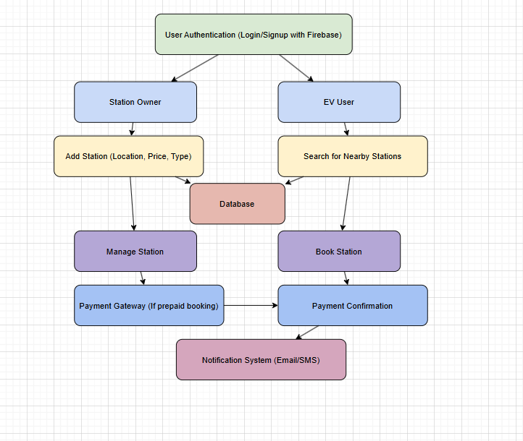

1. **PROPOSED METHODOLOGY**
2. Define Project Objectives: • Establish clear goals for the project, such as assessing the current state of EV charging infrastructure, analyzing user behavior, and recommending optimal charging station placements.
3. Literature Review: • Conduct a thorough review of existing literature on EV charging infrastructure, user preferences, and technological advancements. This will provide insights into current trends, challenges, and best practices.

3Data Collection • Quantitative Data: Gather data from various sources, including government databases, charging station operators, and utility companies, to understand the current distribution and usage of charging stations. • Qualitative Data: Conduct surveys and interviews with EV users to capture their charging habits, preferences, and experiences. This information will help identify common pain points and areas for improvement.

1. . Site Selection: • - Identify key geographic areas for analysis, including urban, suburban, and rural locations. This will help ensure a comprehensive understanding of the charging infrastructure across different contexts.
2. Data Analysis: • Use statistical methods and data analytics tools to analyze the collected data. This will include: • Descriptive Analysis: Identify patterns in charging behavior, peak usage times, and

station utilization rates. • Spatial Analysis: Utilize Geographic Information System (GIS) tools to map existing charging stations and assess the potential demand in various locations.

1. Charging Network Optimization:
   * Based on the data analysis, develop recommendations for optimal charging station placement. This will involve identifying high-demand areas, potential sites for new stations, and strategies for enhancing existing infrastructure.
2. Smart Charging Integration:
   * Explore the feasibility of integrating smart charging solutions that can optimize energy usage and provide real-time information to users. This may involve partnerships with technology providers and utility companies.
3. Stakeholder Engagement:
   * Collaborate with stakeholders, including government agencies, private charging network operators, and EV manufacturers, to align project goals with broader initiatives and policies. Regular communication will ensure that all parties are informed and involved.

# IMPLEMENTATION

* 1. Technologies used Frontend:

Android Mobile Application (Flutter) – The application is developed using Flutter for Android to provide user interaction.

Backend:

Dart – Dart is primarily used with the Flutter framework to create cross-platform mobile apps for iOS, Android, and the web. It features a Just-In-Time (JIT) compiler for development and an Ahead-Of-Time (AOT) compiler for optimized production performance. Dart supports asynchronous programming with Future and Stream, making it efficient for handling UI and network requests.

Auth - Firebase Authentication is a backend service provided by Google that helps developers implement secure authentication in web and mobile applications. It supports various authentication methods

DataBase - Firebase Storage is a cloud-based storage solution from Google that allows developers to store and serve user-generated content, such as images, videos, and other files. It is designed to work seamlessly with Firebase Authentication and Firebase Firestore/Realtime Database for secure and scalable data management.

Notification - Firebase Cloud Messaging (FCM) is a free service from Google that allows developers to send push notifications and messages to users across Android, iOS, and web applications. It is widely used for engaging users with real-time notifications and updates.

Routhing - Google Directions API is a service that provides route planning, navigation, and travel time estimates between locations. It is commonly used in mapping and navigation apps to help users find the best routes for driving, walking, cycling, or public transportation.

Map Display - Google Maps API is a set of services provided by Google that allows developers to integrate interactive maps, location data, and navigation features into web and mobile applications.

Other Technologies & Libraries:

Android SDK – For developing and running the Android application.

* 1. User roles

1. Admin (Superuser)

•Manage users, hosts, and guests.

•Approve or reject charging station listings.

•Monitor and resolve disputes.

•View and analyze platform analytics.

•Manage pricing policies and promotions.

•Configure security settings and system updates.

1. Host (Charger Owner)
   * Register and list charging stations.

•Set charging rates and availability.

* + Approve or deny booking requests.

•Monitor charging sessions.

•View earnings and transaction history.

•Receive user reviews and feedback.

1. Guest (EV Owner/User)

•Search and locate nearby charging Stations.

•View pricing, availability,and station details.

•Book and pay for charging sessions.

•Provide ratings and reviews for hosts

•View charging history and receipts.

# SCOPE FOR FUTURE WORK

The future scope of the EV Charge Share project includes: Expansion of Charging Infrastructure: Increase the network of charging stations, especially in underserved areas. Integration of Renewable Energy: Incorporate solar and wind power to enhance sustainability. Smart Grid Integration: Utilize smart grid technologies for optimized energy distribution and charging schedules. Vehicle- to-Grid (V2G) Technology: Explore V2G options to allow EVs to supply energy back to the grid. Advanced Data Analytics: Leverage data analytics for deeper insights into user behavior and charging patterns. Collaboration with Automotive Manufacturers: Partner with car makers for integrated chargin solutions.Policy Advocacy and Incentives: Advocate for favorable policies to support EV adoption and infrastructure expansion. User Engagement and Education: Enhance awareness and understanding of EV benefits amongusers. Fleet Management Solutions: Develop solutions for businesses managing electric vehicle fleets to optimize operations. Global Outreach: Expand the project’s impact

internationally, adapting strategies to various regions.

# CONCLUSION

The EV Charge Share project aims to enhance the accessibility and efficiency of electric vehicle (EV) charging infrastructure as EV adoption accelerates. By leveraging data analysis and user feedback, the project seeks to identify optimal locations for charging stations and integrate smart charging solutions, addressing range anxiety and promoting renewable energy use. Despite challenges such as infrastructure investment and regulatory hurdles, the project holds significant potential to improve the charging experience, foster collaboration amongstakeholders, and contribute to a more sustainable transportation ecosystem. Ultimately, the EV Charge Share project aspires to facilitate a cleaner, more efficient future for urban mobility, making electric vehicles a viable choice for all.

# ACKNOWLEDGMENT

We are grateful to our guide, Ms.A.D.Mate for their valuable guidance, and support at this project. We are very grateful for the availability of software such as Android Studio, Flutter and Dart, Firebase and API which made the process of application development easy. The project was indeed a unique experience, for which we owe this guidance and creative applications that resulted in its realization, thank you.

# REFERENCES

1. Burinskiene, A., Lorenc, A., and Lerher, T.2018."A Simulation Study for the Sustainability and Reduction of Waste in

Warehouse Logistics". International Journal of Simulation Modelling17(3):485- 497.

1. Albareda-Sambola, M., Fernández, E., Hinojosa, Y., and Puerto, J. 2009. "The multi- period incremental service facility location problem". Computers& Operations Research 36(5): 1356-1375.
2. Axsen, J., and Kurani, K. S. 2010. "Anticipating plug-in hybrid vehicle energy impacts in California: Constructing consumerinformed recharge profiles". Transportation Research Part D: Transport and Environment 15(4): 212-219.
3. Bae, S., and Kwasinski, A. 2012. "Spatial and temporal model of electric vehicle charging demand". IEEE Transactions on Smart Grid 3(1): 394-403.
4. Bardhi, F., and Eckhardt, G. M. 2012. “Access-based consumption: The case of car sharing”. Journal of consumer research 39(4): 881-898.
5. Belk, R. 2007. “Why not share rather than own?”. The Annals of the American Academy of Political and Social Science 611(1): 126-140.
6. Belk, R. 2014. “You are what you can access: Sharing and collaborative consumption online”. Journal of business research 67(8): 1595-1600.
7. Belk, R. W. 1988. “Possessions and the extended self”. Journal of consumer research 15(2): 139-168.
8. Botsman, R., and Rogers, R. 2011. “What's mine is yours: how collaborative consumption is changing the way we live”.

London: Collins.Detecting Forged Images in Forensic Investigation”