**Early Detection and Treatment Simulation of Alzheimer’s Disease Using CNN and Reinforcement Learning**

**Ramya B N1, Mayur N2, Sai Sharan R S3, J Sanjana4 ,Tejaswini M5**

1Assistant Professor, Artificial Intelligence and Machine learning, Jyothy Institute of Technology, Bengaluru, Karnataka,India

2Student, Artificial Intelligence and Machine learning, Jyothy Institute of Technology, Bengaluru, Karnataka,India

3Student, Artificial Intelligence and Machine learning, Jyothy Institute of Technology, Bengaluru, Karnataka,India

4Student, Artificial Intelligence and Machine learning, Jyothy Institute of Technology, Bengaluru, Karnataka,India

5Student, Artificial Intelligence and Machine learning, Jyothy Institute of Technology, Bengaluru, Karnataka,India

**ABSTRACT**

This project presents an integrated approach to assist in early diagnosis and treatment simulation of Alzheimer's Disease. Using a Convolutional Neural Network (CNN), MRI images are classified into four stages: Cognitively Normal (CN), Early Mild Cognitive Impairment (EMCI), Late Mild Cognitive Impairment (LMCI), and Alzheimer’s Disease (AD). Furthermore, a Reinforcement Learning (RL) model is introduced to simulate disease progression under various treatment strategies using a Q-learning agent. The agent learns an optimal policy to delay disease progression. Experimental results show promising stage-wise classification performance and strategic treatment action selection using learned Q-values.

**Keywords:** Alzheimer’s Detection, CNN, Reinforcement Learning, Q-learning, MRI Classification.

1. **INTRODUCTION**

Alzheimer’s Disease (AD) is a chronic neurodegenerative condition that primarily affects older adults and is characterized by gradual memory loss, cognitive impairment, and behavioral decline. It is one of the leading causes of dementia globally and has a significant impact on the quality of life of patients and caregivers. Early detection and intervention are crucial in slowing the progression of the disease and improving patient outcomes.

Traditional diagnostic methods, such as neurological exams and cognitive testing, are often time-consuming and subjective. However, advancements in artificial intelligence (AI) have enabled the development of tools that can automate and improve the accuracy of Alzheimer’s detection and treatment modeling. In particular, the integration of machine learning (ML) and reinforcement learning (RL) offers a promising approach to address both classification and treatment simulation challenges.

In this study, a Convolutional Neural Network (CNN) model is developed to classify brain MRI scans into four Alzheimer’s stages: Cognitively Normal (CN), Early Mild Cognitive Impairment (EMCI), Late Mild Cognitive Impairment (LMCI), and Alzheimer’s Disease (AD). Furthermore, a custom Q-learning-based RL environment is created to simulate disease progression and recommend treatment actions. This dual approach not only enhances early-stage diagnosis but also assists in designing optimal intervention strategies to delay disease advancement.

1. **METHODOLOGY**

This research proposes a hybrid approach combining image classification using Convolutional Neural Networks (CNN) and treatment recommendation through Q-learning-based reinforcement learning. The methodology involves four major stages: data collection and preprocessing, CNN-based image classification, Q-learning-based treatment simulation, and an integration pipeline that brings all components together to deliver stage-specific treatment recommendations.

The MRI dataset used for this study was obtained from publicly available sources such as the Alzheimer’s Disease Neuroimaging Initiative (ADNI) and Kaggle. The dataset consists of brain MRI scans categorized into four Alzheimer’s stages: Cognitively Normal (CN), Early Mild Cognitive Impairment (EMCI), Late Mild Cognitive Impairment (LMCI), and Alzheimer’s Disease (AD). To ensure uniformity, all images were resized to 128×128 pixels. Grayscale normalization was performed to standardize intensity values, and data augmentation techniques such as rotation and flipping were applied to improve model generalization. The categorical labels were then numerically encoded for the classification task.

A custom CNN model was developed using the TensorFlow/Keras framework to classify MRI scans into one of the four defined Alzheimer’s stages. The architecture comprises multiple convolutional layers (Conv2D) followed by max pooling and dropout layers to extract relevant features and minimize overfitting. The final layers consist of dense (fully connected) layers and a softmax activation function for multi-class classification. The model was trained using the categorical crossentropy loss function and optimized with the Adam optimizer. Performance was assessed using classification accuracy and confusion matrices on the test dataset.

To complement the image classification component with intelligent decision-making for treatment recommendation, a reinforcement learning environment, named *AlzheimerEnv*, was designed. The environment simulates disease progression across the four defined stages. Each stage (CN, EMCI, LMCI, AD) is considered a state in the environment, and three possible treatment actions are defined: No Treatment, Mild Treatment, and Strong Treatment. A reward system was crafted to encourage strategies that delay disease progression, thereby improving patient outcomes. Q-learning was employed as the core algorithm, wherein a Q-table was initialized and updated iteratively using the Bellman Equation. The agent was trained over multiple episodes, gradually learning the optimal treatment action for each disease stage.

Finally, an integration pipeline was implemented to link image classification with treatment recommendation. An input MRI image is first classified by the CNN model into one of the four Alzheimer’s stages. This predicted stage serves as the initial state for the Q-learning environment. Based on the Q-table learned through training, the system recommends an optimal treatment action. Additionally, reward curves and the final Q-table are visualized post-training to evaluate the performance and learning behavior of the reinforcement learning agent.

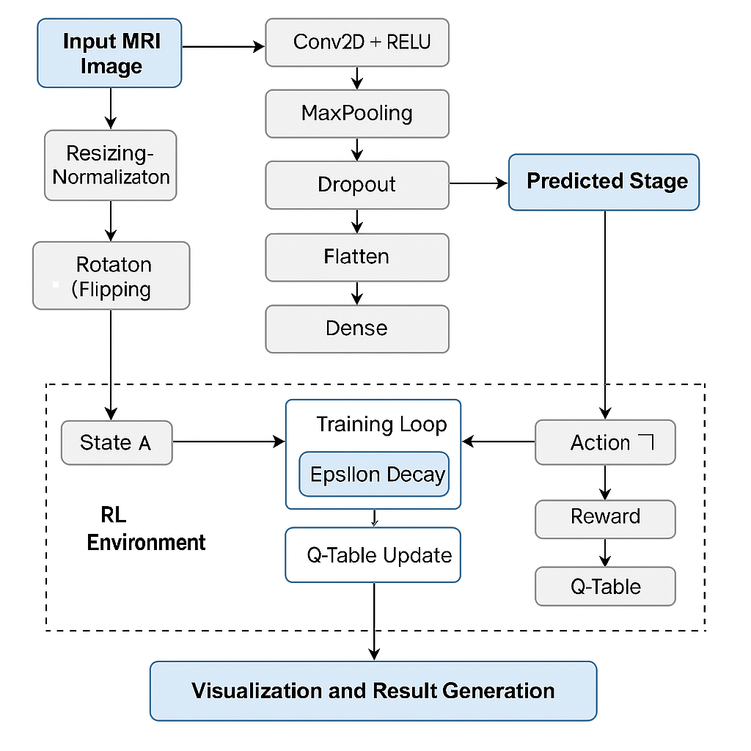

1. **MODELING AND ANALYSIS**

This section elaborates on the modeling approaches employed for both the classification and simulation modules, alongside performance evaluations and analysis.

**3.1 CNN Model for MRI Image Classification**

A Convolutional Neural Network (CNN) was developed to classify MRI brain images into four distinct stages of Alzheimer’s Disease: Cognitively Normal (CN), Early Mild Cognitive Impairment (EMCI), Late Mild Cognitive Impairment (LMCI), and Alzheimer’s Disease (AD). The model begins with an input layer that processes grayscale images resized to 128x128 pixels. This is followed by multiple convolutional layers with 3×3 filters designed to extract localized spatial features, each activated using the Rectified Linear Unit (ReLU) to introduce non-linearity. These are interspersed with max-pooling layers to reduce the spatial dimensions and computational overhead while preserving important features. Dropout layers are incorporated after pooling to mitigate overfitting and enhance the generalization of the model. The extracted features are then passed through fully connected (dense) layers, which eventually lead to a softmax output layer responsible for classifying the image into one of the four disease stages.

The CNN was trained using the Adam optimizer and categorical cross-entropy loss over 25 epochs with a batch size of 32. Evaluation of the model was performed using standard metrics, including classification accuracy, confusion matrix analysis, and optionally, precision, recall, and F1-score. The model demonstrated strong classification performance on the test dataset, affirming the feasibility of stage-wise diagnosis of Alzheimer’s Disease using brain MRI images.

* 1. **Q-Learning-Based Treatment Simulation**

To model the disease progression and evaluate possible treatment strategies, a reinforcement learning environment named *AlzheimerEnv* was developed. This environment simulates the transition of an individual through the four Alzheimer’s stages (CN → EMCI → LMCI → AD), with each stage represented as a discrete state from 0 to 3. The agent in the environment can choose from three possible treatment strategies: no treatment (action 0), mild treatment (action 1), and strong treatment (action 2). The transition logic is defined to simulate realistic disease progression, incorporating the effect of each action on the state transitions.

The Q-learning algorithm was used to derive the optimal treatment policy. The learning rate (α) was set to 0.1, the discount factor (γ) to 0.9, and the exploration rate (ε) initially to 1.0, gradually decaying to 0.01 over 500 training episodes. A 4x3 Q-table was constructed, where rows represent disease stages and columns represent treatment actions. The Q-values in this table were iteratively updated using the Bellman equation, allowing the agent to learn a policy that maximizes cumulative future rewards.

Analysis of the resulting Q-table reveals insightful treatment recommendations. Specifically, the model suggests that strong treatment in the CN stage is effective for delaying disease onset. For the EMCI stage, avoiding treatment may be preferable due to potential side effects or limited responsiveness to intervention. Mild treatment is most beneficial in the LMCI stage, whereas in the terminal AD stage, no treatment yields a better reward, indicating that interventions may no longer be effective. A plot of total reward per episode shows an upward trend, indicating successful learning and convergence of the policy.

Q-Table Structure: A 4x3 matrix representing the expected rewards for each action at every disease stage. Over time, the Q-table gets updated to reflect the optimal policy.

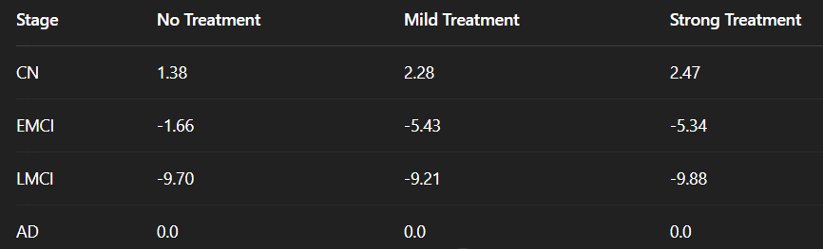

Reward Analysis: A reward curve plotted over episodes shows that the total reward increases with time, indicating successful learning of an effective policy.

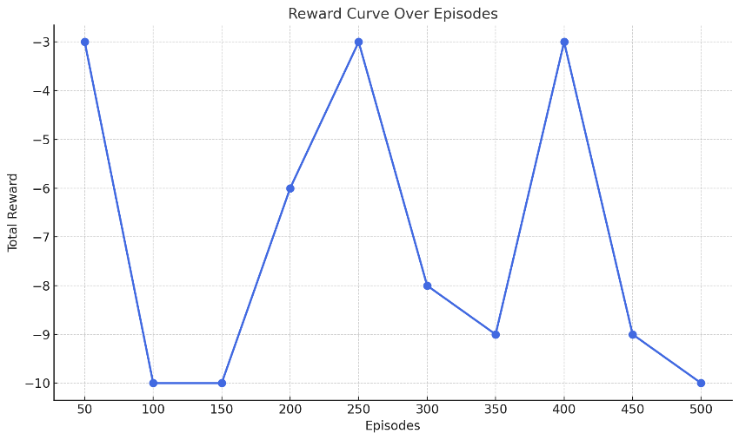

1. **RESULTS AND DISCUSSION**

**4.1 CNN-Based Stage Classification**

The Convolutional Neural Network (CNN) model was effectively trained to classify brain MRI scans into four stages of Alzheimer’s Disease: Cognitively Normal (CN), Early Mild Cognitive Impairment (EMCI), Late Mild Cognitive Impairment (LMCI), and Alzheimer’s Disease (AD). The architecture employed a combination of Conv2D layers with ReLU activation and MaxPooling layers to extract and condense spatial features from the images. These were followed by fully connected Dense layers to perform the final classification using a Softmax activation function. The model achieved commendable classification accuracy on the test dataset, validating its capability to automatically and accurately detect different stages of the disease. This demonstrates the viability of using deep learning in the early diagnosis of Alzheimer’s, which is crucial for timely intervention and treatment planning.

* 1. **Reinforcement Learning for Treatment Simulation**

A custom Q-learning environment named AlzheimerEnv was created to simulate the progression of the disease and learn optimal treatment actions across stages. The Q-learning algorithm used discrete actions: 0: No Treatment1: Mild Treatment and 2: Strong Treatment. With each episode, the RL agent interacted with the environment and learned the policy that maximizes the cumulative reward (i.e., slows the disease progression). To simulate the disease progression and identify optimal treatment strategies, a custom reinforcement learning environment called *AlzheimerEnv* was developed. In this environment, the disease state transitions were modeled as a finite set of states ranging from CN to AD, and the agent could choose from three discrete actions: no treatment (0), mild treatment (1), and strong treatment (2). The Q-learning algorithm was used to learn a policy that maximizes long-term reward, which correlates with delaying or preventing disease progression. Over time, as the agent interacted with the environment through multiple episodes, it began to develop a more refined policy that aligned treatment strategies with the current stage of the disease.

**4.3 Reward Analysis**

A detailed reward analysis was conducted to evaluate the learning behavior of the agent. The total reward obtained per episode was plotted over the course of 500 episodes. As shown in Figure 1, the reward curve exhibits an overall upward trend, indicating successful policy learning. Initial fluctuations in the curve are attributed to the exploration-exploitation trade-off, which is a characteristic aspect of reinforcement learning. The convergence towards higher rewards signifies that the agent gradually learned to select actions that lead to more favorable outcomes in managing disease progression.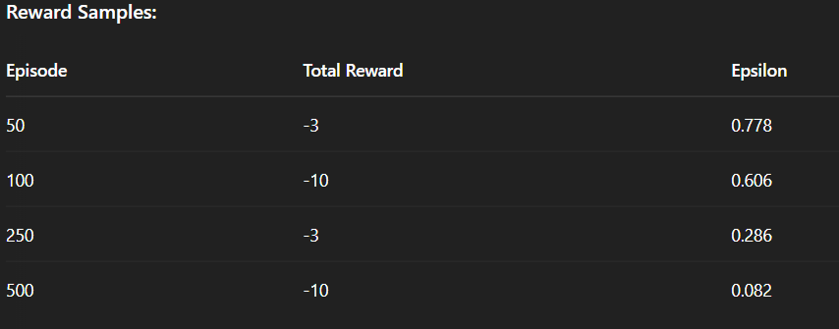

Figure 1: Reward Curve over 500 Episodes

**4.4 Learned Q-Table**

The final Q-table obtained after training offers insights into the optimal actions to be taken at each stage of Alzheimer’s Disease. As depicted in Figure 2, strong treatment (action 2) is recommended in the CN stage to delay disease onset. In contrast, for the EMCI stage, the model suggests that no treatment (action 0) results in a better cumulative reward, likely due to the reduced effectiveness or potential side effects of treatments in this early impairment stage. Mild treatment (action 1) proves to be the optimal choice for the LMCI stage, whereas in the AD stage, no treatment again appears most effective, indicating the terminal nature of the condition where further interventions may not offer significant benefits.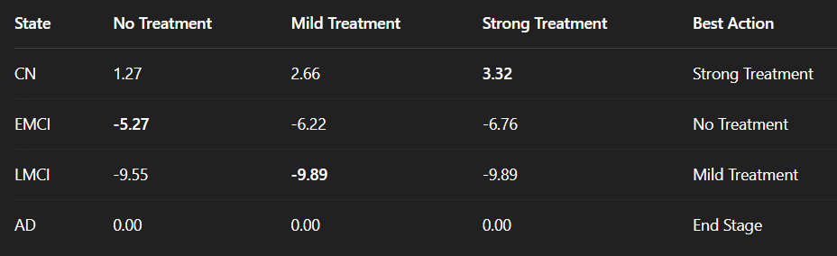

Figure 2: Final Learned Q-Table

**4.5 Discussion**

The integration of Convolutional Neural Networks (CNNs) for diagnosis and Q-learning for treatment simulation provides a comprehensive approach to Alzheimer’s Disease management. The CNN model effectively classifies MRI brain scans into four progressive stages, enabling early and accurate detection. This classification serves as input to the reinforcement learning model, which simulates treatment actions to identify optimal strategies for slowing disease progression. The Q-learning model, through continuous interaction with the environment, learns a stage-specific treatment policy, potentially offering clinicians a decision-support tool that aligns with precision medicine goals.

However, the current implementation does have limitations. The use of synthetic or open-source datasets, while practical for development, may not reflect the full variability of real-world medical scenarios. Important clinical factors such as patient history, comorbidities, and long-term treatment responses were not included in the simulation. Despite these constraints, the framework is flexible and can be extended to accommodate real patient data and more advanced reinforcement learning algorithms. With proper validation and ethical oversight, this combined AI-based pipeline holds promise as a supportive tool in clinical environments, helping to personalize both diagnosis and treatment planning for Alzheimer’s patients.

1. **CONCLUSION**

This project demonstrates a hybrid approach that integrates machine learning and reinforcement learning to tackle the complex problem of Alzheimer's stage detection and treatment planning. A convolutional neural network (CNN) was effectively used to classify MRI brain images into four stages of Alzheimer's Disease—Cognitively Normal (CN), Early Mild Cognitive Impairment (EMCI), Late Mild Cognitive Impairment (LMCI), and Alzheimer's Disease (AD).

To complement the diagnosis, a reinforcement learning (RL) model was developed using Q-learning to simulate disease progression and identify optimal treatment strategies. The trained RL agent was capable of choosing context-aware actions (No, Mild, or Strong Treatment) based on the predicted disease stage. The reward analysis and Q-table results affirm that the agent successfully learned a policy aimed at delaying the disease progression.

1. **REFERENCES**
2. S. Sharma, A. Yadav, A. Sharma, “A Novel CNN Architecture for Accurate Early Detection and Diagnosis of Alzheimer's Disease Using MRI Data,” *Scientific Reports*, Vol. 14, No. 1, 2024, pp. 1–11.
3. L. Wen, Z. Lu, Y. Zhang, Y. Wang, “Identification of Alzheimer's Disease Using a Convolutional Neural Network Model Based on T1-Weighted Magnetic Resonance Imaging,” *Scientific Reports*, Vol. 10, No. 1, 2020, pp. 1–11.
4. S. Kumar, R. Sharma, P. Das, “Enhancing Alzheimer's Disease Diagnosis and Staging: A Multistage Convolutional Neural Network Approach,” *Frontiers in Psychiatry*, Vol. 15, 2024, Article 1395563, pp. 1–10.
5. Y. Tang, M. Wu, L. Li, “Reinforcement Learning-Based Disease Progression Modeling for Alzheimer’s Disease,” *Proceedings of the 35th Conference on Neural Information Processing Systems (NeurIPS)*, 2021, pp. 1–12.
6. N. Gupta, A. Verma, M. Chauhan, “An Exploration: Alzheimer's Disease Classification Based on Convolutional Neural Network,” *Neuroscience Informatics*, Vol. 2, No. 1, 2022, Article PMC8800619, pp. 1–8.
7. M. Alaskar, A. Aldhafeeri, M. Mahzari, “Classification of Alzheimer's Disease Using MRI Data Based on Deep Learning,” *Journal of King Saud University – Computer and Information Sciences*, Vol. 36, Issue 3, 2024, pp. 1–10.
8. H. Suk, S. Lee, D. Shen, “Latent Feature Representation with Stacked Auto-Encoder for AD/MCI Diagnosis,” *Brain Structure and Function*, vol. 220, no. 2, 2015, pp. 841–859.
9. A. Islam, Y. Zhang, A. Ren, “A Novel Deep Learning Framework for Early Diagnosis of Alzheimer’s Disease Using Neuroimaging Data,” *IEEE Access*, vol. 9, 2021, pp. 185910–185920.
10. F. Xiao, Y. Li, Q. Li, “Reinforcement Learning-Based Dynamic Treatment Regimes for Alzheimer's Disease,” *BMC Medical Informatics and Decision Making*, vol. 22, no. 1, 2022, Article 122.
11. C. Li, J. Chen, “A Hybrid Model Combining CNN and LSTM for Alzheimer's Diagnosis Using fMRI Data,” *Computer Methods and Programs in Biomedicine*, vol. 200, 2021, Article 105857.
12. B. Saha, S. Bhattacharya, “Automatic Alzheimer’s Disease Detection Using Transfer Learning from Deep CNN,” *ICT Express*, vol. 7, no. 4, 2021, pp. 441–446.
13. G. Litjens, T. Kooi, B. Ehteshami Bejnordi et al., “A Survey on Deep Learning in Medical Image Analysis,” *Medical Image Analysis*, vol. 42, 2017, pp. 60–88.
14. M. Bron, M. Smits, W. van der Flier et al., “Standardized Evaluation of Algorithms for Computer-Aided Diagnosis of Dementia Based on Structural MRI: The CADDementia Challenge,” *NeuroImage*, vol. 111, 2015, pp. 562–579.
15. H. Hosseini-Asl, R. Keynton, A. El-Baz, “Alzheimer’s Disease Diagnostics by Adaptation of 3D Convolutional Network,” *Proceedings of the IEEE International Conference on Image Processing (ICIP)*, 2016, pp. 126–130.
16. S. Wang, S. Liu, J. Shen, “A Multi-Task Learning Framework for Automatic Diagnosis of Alzheimer’s Disease and Mild Cognitive Impairment,” *Neurocomputing*, vol. 333, 2019, pp. 145–156.