

# TRANSDISCIPLINARY PROJECT CENTRIC LEARNING

**RESEARCH PAPER**

DATE 25/03/2025

# A study on consumer awareness and adaptation of Bamboo Utensils Group no: 158

## SUBMITTED BY:

Apeksha V Kankanwadi (24MBAR0348)

G. Ayya Kumar (24MBAR0288) Bonthala Chidvila Sai (24MBAR0716)

Gudla Satwik (24MBAR0654) Dharmista Khatri (24MBAR0124)

## UNDER THE GUIDANCE OF:

Dr. Vinayak Anil Bhat

# TABLE OF CONTENT

|  |  |  |
| --- | --- | --- |
| Sl no. | Content | Page no. |
| 1 | Executive summary | 3 |
| 2 | Objective | 4 |
| 3 | Introduction | 5 |
| 4 | Review of literature | 6 |
| 5 | Methodology | 9 |
| 6 | Questionnaire | 12 |
| 7 | Data visualization | 15 |
| 8 | Findings | 22 |
| 9 | Recommendation | 26 |
| 10 | Conclusion | 28 |
| 11 | References | 29 |

**Executive Summary:**

This research aims to assess the sustainability, market potential and the socio-economic implications of replacing the plastic and metal utensils with the bamboo-based alternatives. Four key objectives are covered by the research.

1. Verification of the environment effects of bamboo utensils with regard to its environmental sustainability consists of the biodegradation, carbon footprint, and use of resources.
2. Market Potential & Consumer Demand: The usage of bamboo utensils is adopted, including what the market is currently supplying, what the consumers need what it lacks, and what it has to pay attention to in order to incorporate bamboo utensils into the existing market in order to identify opportunities.
3. Community Participation & Local Engagement – This focuses on how local people could be integrated into the cultivation, production and sale of bamboo in order to improve their livelihoods as they conserve the environment.
4. However, the measurements of the degree to which companies that make bamboo cutlery support green entrepreneurship and contribute to sustainable development and green cutlery focus on SDGs objectives, such as plastics pollution reduction, circular economy models promotion. As such, these results offer a point of reference for entrepreneurs, policy makers and environmental causes promoters that want to promote the consumption of bamboo-based products, the local economy, in parallel.

## Key Outcomes Expected:

* + Evidence-based suggestions for the sustainable expansion of bamboo utensil production.
  + Techniques to boost market penetration and consumer adoption.
  + The best ways to improve the economic and environmental resilience of community- driven bamboo businesses.
  + This study adds to the larger conversation about inclusive economic development, green business innovation, and sustainable materials.

# Objectives:

* To assess the sustainability of bamboo utensils
* To assess market potential and consumer demand for kitchen utensils made from bamboo
* To analyze the significance of community engagement and local people participation in making and selling bamboo utensils
* To identify the extent to which eco-friendly bamboo utensil ventures assist with sustainable development and green business entrepreneurship.

# Introduction:

In the past few years, we have experienced a gradual shift towards greener and more eco-friendly substitutes for plastic and metal kitchen cutlery. Out of the many alternatives being considered, the most promising seems to be bamboo cutlery primarily due to the fact that it can be grown and harvested with little harm inflicted on the environment, is easily recyclable and contributes very little to pollution. With rampant plastic waste and deforestation ranking among the most severe concerns for the environment, both consumers and manufacturers are relentlessly searching for much needed alternatives that align with green living and eco-friendly consumption.

As an aggressive cultivar, bamboo is both renewable and nontraditional materials used in kitchenware making it a more sustainable replacement. Unlike plastic which is a pollutant and metal that requires intensive energy extraction processes, bamboo is an environmentally safe and biodegradable substitute. Bamboos are low cost to produce and their natural antibacterial features make them safe for use in kitchens.

This study paper is designed to evaluate the sustainability of bamboo cutlery, determine their market value and consumer acceptability, and examine their role in community participation in production and distribution. Also, it aims to examine the role of sustainable business.

# Review of literature:

### Socio economic impacts of bamboo enterprises in the Mid hills of Nepal: A case study on Pahari community at Badikhel Village, Lalitpur

M. Shakya Bajracharya, Sangeeta Rajbhandary, A. N. Das (Saint Mary's College of California, Tribhuvan University, Kathmandu) 30 Nov 2013

A study on bamboo handicrafts in Nepal found that bamboo-based businesses contribute to local livelihoods, yet lack efficient management and stakeholder involvement. The research emphasizes the need for stronger industry associations to support bamboo entrepreneurship.

### A Review on Sustainable Product Design, Marketing Strategies and Conscious Consumption of Bamboo Lifestyle Products

Neha Prasad 01 Jan 2023:

Conscious consumption trends show rising demand for bamboo lifestyle products. However, challenges include low production rates, aesthetic limitations, and competition from cheaper alternatives. Effective marketing strategies are necessary to bridge the gap between consumer interest and purchase behavior.

### The Revival of the Bamboo Sector in India and Its Relevance to Sustainable Development

Sharayu Bhakare 09 May 2021

Bamboo can significantly contribute to sustainable development goals (SDGs) by promoting ecological balance and economic growth. The study suggests that a structured operational model is required to harness bamboo’s full potential.

### The Bamboo Industry in India: Supply Chain Structure, Challenges and Recommendations

Aniket Baksy (Bard College, London School of Economics and Political Science), 01 Jul 2013 India has a vast domestic and export market for bamboo products but faces issues in supply chain management, policy support, and industrialization. The study presents recommendations to streamline production to consumption processes and improve competitiveness.

### A Review of the Potential Socioeconomic Impacts of Bamboo Plantation on Local Community

Zaiton Samdin , 26 Sep 2024

Bamboo plantations have the potential to enhance community well being and economic stability. The study reviews global research to provide insights into bamboo’s diverse applications and benefits, offering strategies to promote sustainable agroforestry.

### Bamboo: Technology Innovations Towards Value added Applications: A Review

Sangeeta Baksi, Pradeep Srivastava 21 Sep 2023 Agricultural Reviews

Bamboo can replace wood, plastic, and even metals in structural applications. Advancements in bamboo processing can lead to innovative value added products, creating employment and reducing dependency on conventional materials.

1. **Bamboo Production and Value Chain for Quality Life in the Era of Climate Change** Sneha Kumari, V.G. Venkatesh, Yangyan Shi, Havisha Agarwal, Nikhil Jain 07 Mar 2024 Bamboo plays a role in carbon capture and trading, making it a viable solution for climate change mitigation. However, its classification as grass rather than a tree limits its inclusion in international carbon accounting frameworks.

### Redefining Eco Friendly Construction with Nature's Green Steel (Bamboo)

Nikhil Hemate 31 May 2024

Bamboo, known as “green steel,” is emerging as a sustainable construction material due to its durability and low carbon footprint. The study highlights its potential to revolutionize the building industry.

### Multifunctional applications of bamboo crop beyond environmental management: an Indian prospective

R. Rathour, Hemant Kumar, K. Prasad, Prathmesh Anerao, Manish Kumar, Atya Kapley, Ashok Pandey, Mukesh Kumar Awasthi, Lal Singh 25 Mar 2022

Bamboo biomass has bioenergy potential and can contribute to reducing reliance on fossil fuels. Additionally, its fast growth and deep-rooted system make it ideal for ecological restoration and land rehabilitation.

### Evidence on the social, economic, and environmental impact of interventions that facilitate bamboo industry development for sustainable livelihoods: a systematic map protocol.

Lucy Binfield, Tamara L Britton, Chunping Dai, John Innes 20 Oct 2022

Systematic reviews indicate that bamboo industry interventions have significant socio economic and environmental benefits. The study maps key impact areas and research gaps, emphasizing the need for policy driven initiatives.

# Methodology

## Survey Design

**Objective:** To assess consumer awareness, preferences, and attitudes toward bamboo utensils.

## Question Types:

* + Demographic Questions: Age, occupation (to segment responses).
  + Behavioral Questions: Purchase history, reasons for choosing bamboo utensils.
  + Perception Based Questions: Associations with bamboo utensils (e.g., eco friendliness, durability).
  + Attitudinal Questions: Willingness to pay more, views on community involvement, government support.
  + Closed Ended (Multiple Choice): For quantitative analysis (e.g., "Have you ever bought bamboo utensils?").
  + Open Ended (Short Answers): For qualitative insights (e.g., “Why do you choose bamboo utensils?”).

## Sampling Strategy

Target Population: Consumers aged 18–65, including students, professionals, and homemakers. Sample Size: 138 respondents (as per collected data).

### Sampling Method:

1. Convenience Sampling: Distributed via digital platforms (Google Forms, social media).
2. Snowball Sampling: Respondents encouraged to share the survey within their networks.

### Data Collection Process

Platform: Online survey tools (e.g., Google Forms, SurveyMonkey). Duration: Conducted over 2 weeks to ensure adequate responses.

Collected around 138 responses

Ethical Considerations:

Informed consent obtained at the start of the survey. Anonymity maintained (no personal identifiers collected).

1. **Variables Measured** Category: Examples from Survey Demographics: Age, occupation

Consumer Behavior: Purchase history ("Have you ever bought bamboo utensils?") Perceptions Associations: ("Which of the following do you associate with bamboo utensils?") Environmental Awareness: Awareness of benefits ("Are you aware of any environmental benefits?")

Willingness to Pay : Premium pricing acceptance ("Would you pay more for bamboo utensils?") Community & Policy Views :Support for local involvement, government incentives

### Data Analysis Quantitative Analysis:

* Descriptive Statistics: Frequencies, percentages (e.g., "X% of respondents associate bamboo with biodegradability").
* Cross Tabulation: Compare groups (e.g., occupation vs. purchase behavior).
* Tools: Excel, SPSS, or Google Sheets for visualization (bar charts, pie charts).

### Qualitative Analysis:

Thematic coding of open-ended responses (e.g., recurring terms like "sustainability," "price concerns").

### Validation & Reliability

* Pilot Testing: Survey tested with a small group (10–15 people) to refine questions.
* Bias Mitigation:
* Neutral phrasing to avoid leading questions.
* Balanced response options (e.g., included “Neutral” in Likert scale questions).

### Interviews:

* Semi structured interviews were conducted with:
* Consumers (to explore perceptions and barriers to adoption).
* Local Artisans/Bamboo Producers (to understand production challenges and community involvement).
* Entrepreneurs and Retailers (to assess market trends and supply chain dynamics).
* Focus Group Discussions (FGDs): Small groups of 6–8 participants discussed themes like sustainability, pricing, and marketing strategies to extract nuanced opinions.

### Secondary Data Collection

* Literature Review: Analyzed peer reviewed journals, industry reports, and case studies (e.g., the Nepal bamboo enterprise study, India’s bamboo sector revival) to contextualize findings.
* Market Reports: Data from e commerce platforms (Amazon, Bamboo product websites) and government publications on bamboo industry trends.

### Sustainability Assessment Framework

* Life Cycle Analysis (LCA): Compared the environmental impact of bamboo utensils with plastic/metal alternatives in terms of:
* Carbon footprint (from production to disposal).
* Biodegradability and resource efficiency.
* SDG Alignment: Evaluated how bamboo enterprises contribute to SDGs (e.g., SDG 12: Responsible Consumption, SDG 8: Decent Work).

# Questionnaire

1. Occupation
   * Student
   * Self-employed
   * Employee
2. Age
   * 18-20
   * 21-25
   * 26-30
   * above 30
3. Have you ever bought bamboo utensils?
   * Yes
   * No
   * Maybe
4. Why do you choose bamboo utensils over others?
   * Eco-friendly
   * Attractive
   * Lightweight and easy to use
   * Haven't used them yet
5. Which of the following do you associate with bamboo utensils?
   * Biodegradable
   * Recyclable
   * Harmful to the environment
   * Not sure
6. Are you aware of any environmental benefits of using bamboo utensils?
   * Yes, I know they are biodegradable and natural
   * I have heard they are better, but not sure how.
   * No, I'm not aware of any benefits.
7. Would you pay more for bamboo utensils if you knew they are better for the environment?
   * Yes, absolutely
   * Yes, but only slightly more
   * No, I prefer cheaper options
8. Do you prefer local vendors to use bamboo utensils instead of plastic when serving food?
   * Yes
   * No
   * Maybe
9. What do you think is the biggest benefit of community-based bamboo production?
   * Employment for rural communities
   * Preserving traditional skills
   * Reducing environmental damage
10. Should local communities be involved in producing bamboo utensils?
    * Yes, it creates job opportunity and boosts the local economy
    * Maybe, if it ensures quality
    * I don't have an opinion
11. How do you perceive businesses that focus on eco-friendly products like bamboo utensils?
    * Very positively
    * Somewhat positively
    * Neutral
    * Somewhat negatively
    * Very negatively
12. Do you believe that promoting bamboo utensils contributes to sustainable business practices?
    * Yes
    * No
    * Maybe
13. Should the government support eco-friendly businesses like bamboo utensil manufacturers?
    * Yes, with subsidies or promotions
    * Only if they meet quality standards
    * No
14. Does seeing eco-certification (e.g., “100% biodegradable”) influence your buying decision?
    * Yes, I trust certified products
    * Only if the brand is known
    * No, I look at price and design
    * I don’t notice labels
15. Any Suggestions?

**Data Visualization**

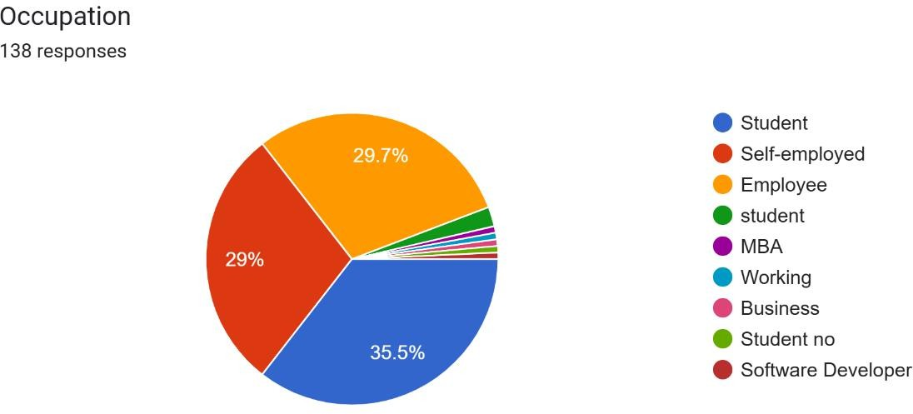

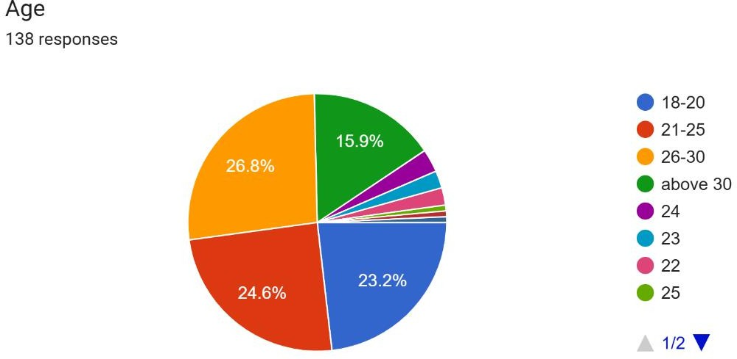

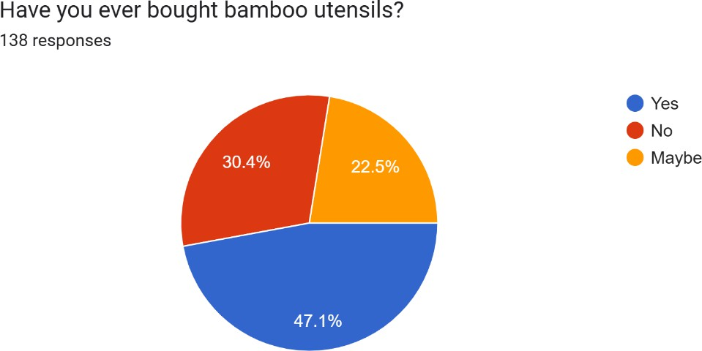

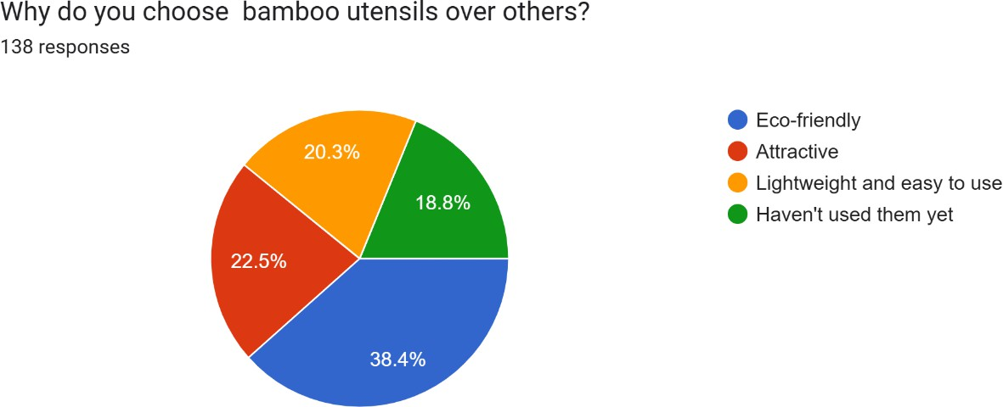

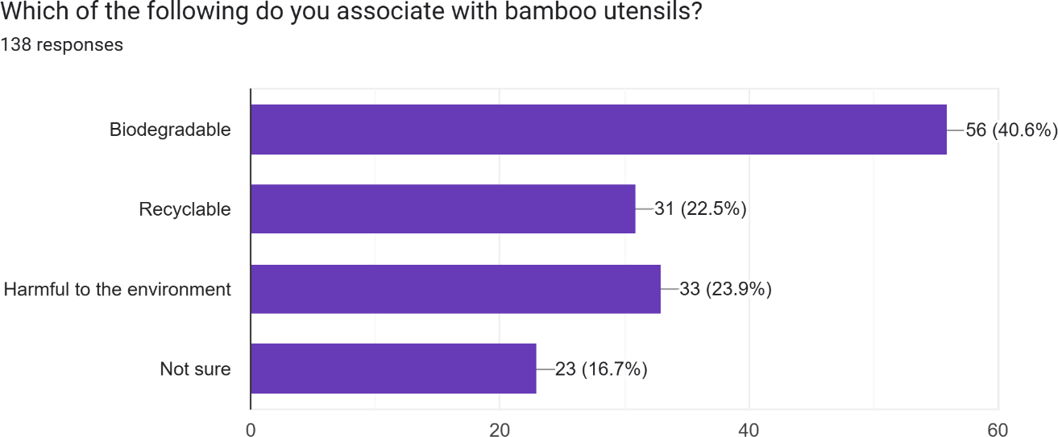

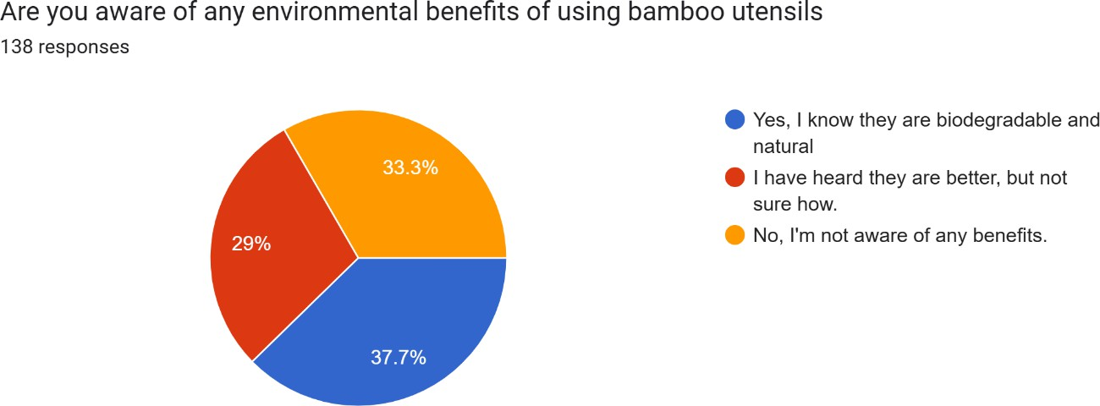

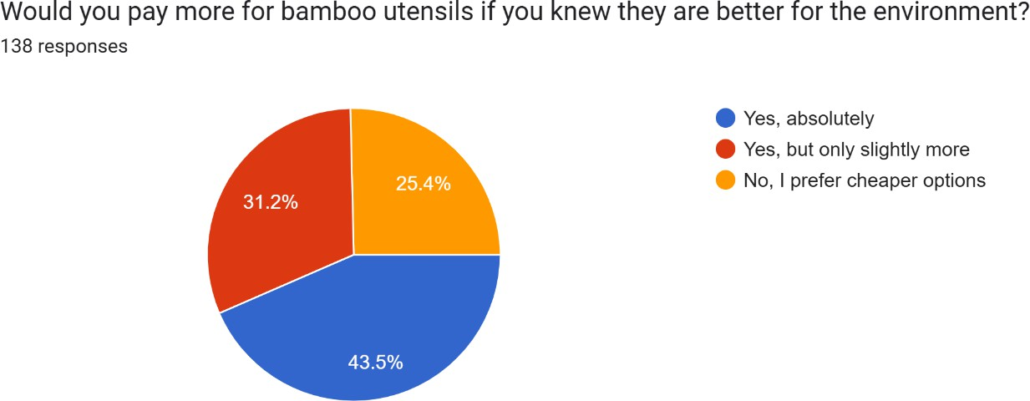

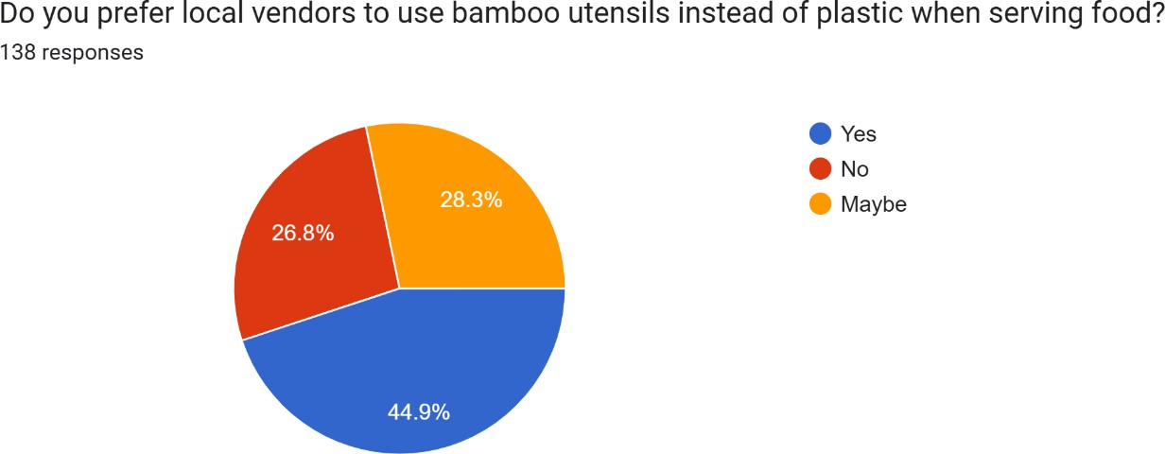

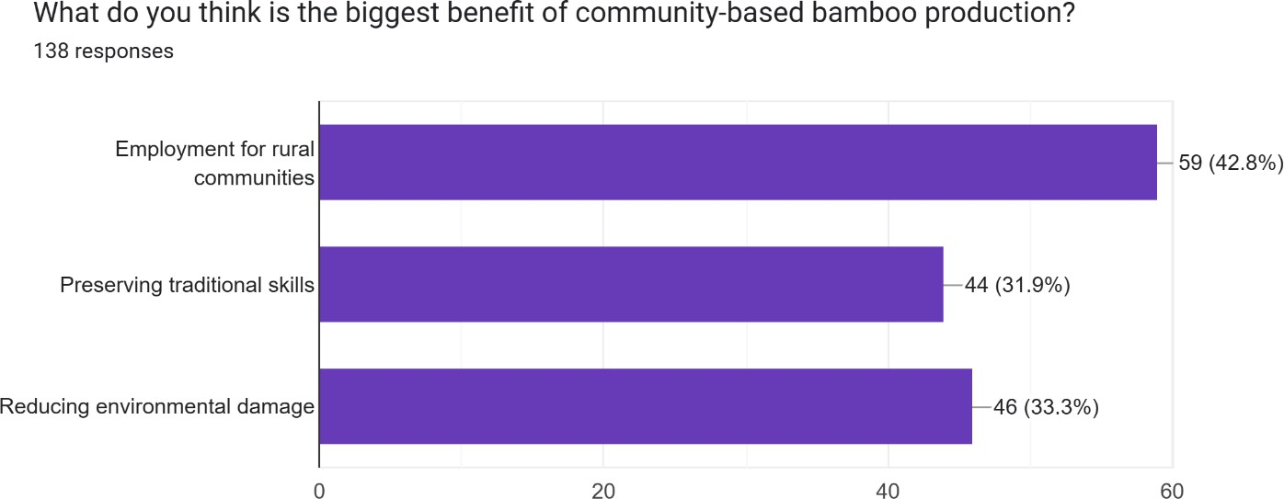

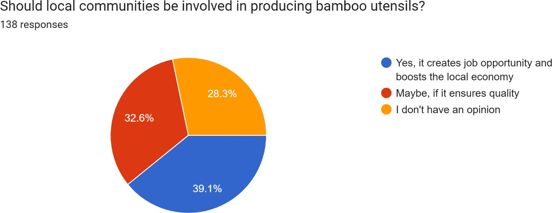

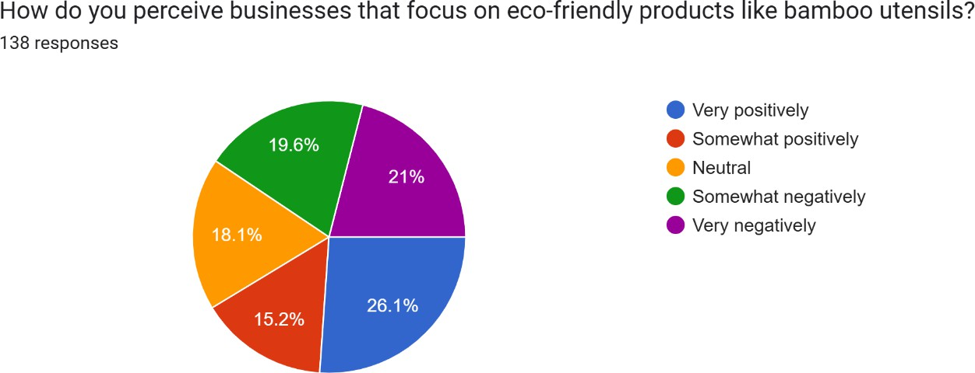

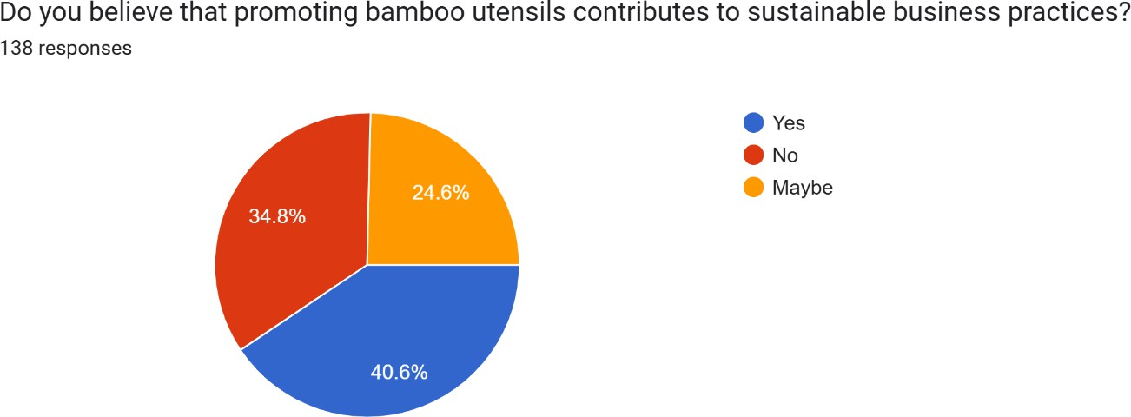

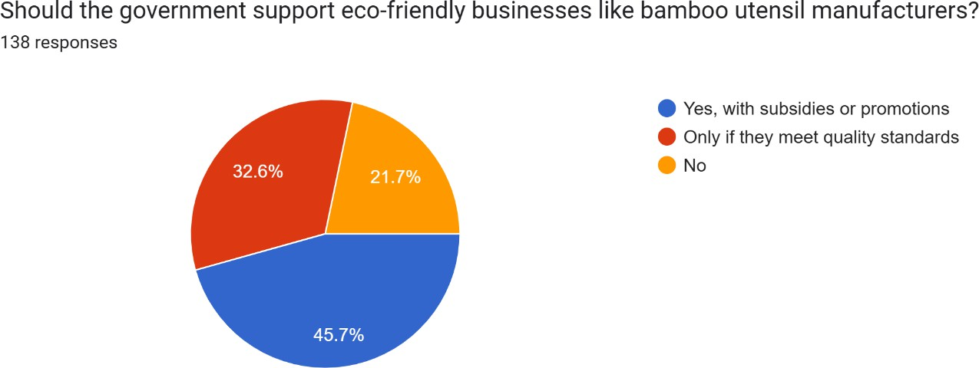

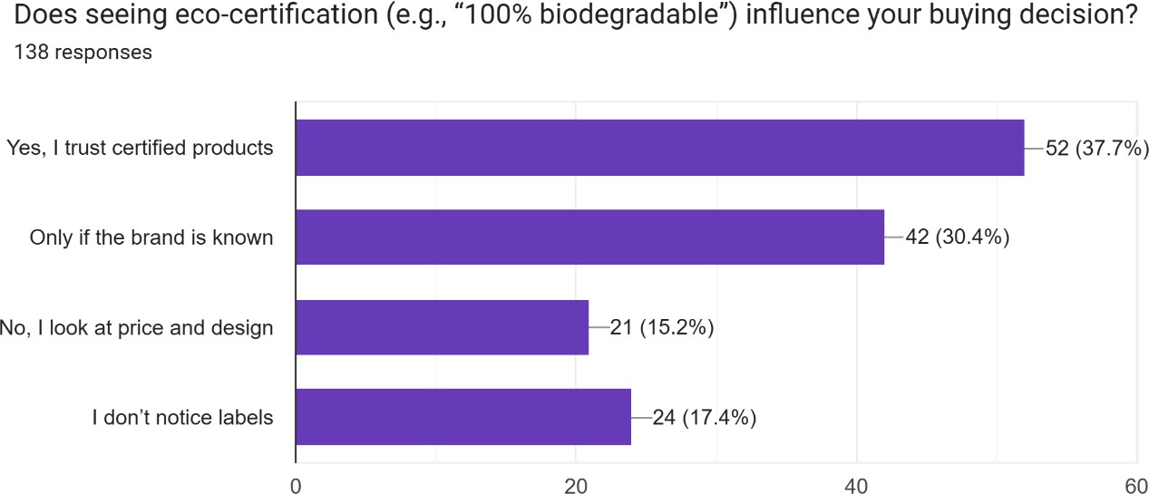

# Findings:

1. A majority of respondents are workers and students, representing a mix of working adults and youth.

* The demographic matters. Working professionals will have higher levels of expendable income, while students will be future customers and trend setters.
* It suggests the popularity of bamboo utensils spans across ages, reflecting a possibly broad market.
* This further shows that the survey captures the views of those who are probably more sensitive to what is going on with the environment.

Implications:

* Strong foundation for further market growth.
* The need for diversified marketing strategies.

1. A very large number have purchased bamboo utensils, mainly due to their eco- image.
   * This confirms that eco product awareness is one of the primary drivers of purchasing bamboo utensils.
   * "Eco-friendly appeal" covers several aspects: less plastic waste, sustainable production, and lower carbon footprint.
   * This underlines the need for clearly highlighting the environmental advantages of bamboo products in marketing materials.

Implications:

* + Excellent market potential for sustainable substitutes.
  + The necessity for companies to focus on the eco-credentials of their products.

1. Consumers link bamboo utensils with being recyclable and biodegradable, with very few negative attitudes.
   * This favorable association is a great plus. Consumers identify with the inherent benefits of bamboo as an eco-friendly material.
   * There is little or no negative perception" to overcome, so there is a relatively blank canvas for bamboo products, and businesses have the opportunity to create strong brand identities.
   * Ensuring that the products are truly biodegradable and recyclable and that the production process is sustainable is necessary in order to maintain this positive image.

Implications:

* + Potential for strong brand building.
  + Ongoing quality and transparency in sustainability practice.

1. Most respondents are aware that bamboo utensils are eco-friendly.
   * It indicates a level of environmental awareness among the target market.
   * It indicates that awareness campaigns about educating the public on green substitutes are effective.
   * This allows companies to market their products, as they will not have to start afresh when educating customers.

Implications:

* + Open market for green products.
  + Opportunities for businesses to continue informing consumers of specific benefits.

1. There are numerous consumers willing to pay extra for bamboo utensils but being price conscious.
   * Consumers do recognize the benefits of sustainable products and are willing to pay.
   * Price, however, is a significant factor.
   * Premium pricing vs. affordability are critical to market penetration.
   * Anything that is likely to support premium pricing, like, quality, durability, and responsible production.

 Implications:

* + Potential for premium pricing strategies.
  + Competitive positioning and value are required.

1. The respondents cite employment creation and economic contribution as significant advantages of bamboo production on a community basis.
   * This highlights the social value of sustainable business.
   * Customers appreciate the positive impact on local communities.
   * This can be a huge selling point, focusing on the ethical and social responsibility of the brand.
   * This allows businesses to interact with consumers on a deeper level, moving beyond the product.

Implications:

* + Business potential to highlight their social contribution.
  + Business potential for community-spirited partnerships.

1. Eco-friendly product firms are favorably regarded by most respondents.
   * This reflects growing demand for sustainable and ethical firms.
   * Favorable brand perception can lead to increased customer loyalty and advocacy.
   * This validates the importance of companies adopting sustainable practices.
   * This also extends to those companies that are not perceived as green, can have their reputations damaged.

 Implications:

High likelihood of high brand loyalty.

* + Businesses' importance to consumers to prioritize sustainability.

1. There is general agreement with the participation of local communities in bamboo utensil production.
   * There is enjoyment and appreciation of local production and sourcing opportunities, perhaps through perceived quality and supporting local economies.
   * This allows for a chance for firms to build high levels of community relationships.
   * This can lead to more open supply chains, and increased consumer confidence.

Implications:

* + Opportunities for collaboration for local players, and supply chain integration.
  + The potential for community-based branding and marketing.

# Recommendations:

1. Encourage Awareness Campaigns for Target Segments

The majority of the respondents are students and working professionals, who are ideal targets for awareness campaigns. Organizing workshops, webinars on sustainability, and college collaborations will make these groups aware of the eco-friendliness of bamboo utensils. There is also the possibility of using influencers and environmentalists to make others aware on social media platforms like Instagram, YouTube, and LinkedIn.

1. Encourage Eco Friendly Value in Marketing

Consumers associate bamboo utensils with sustainability, but spreading this message is crucial. Marketing must emphasize their biodegradable nature, low carbon footprint, and potential to be used as alternatives to plastic and metal products. Eco labels and environmental organization approval can also instill customer confidence.

1. Address Price Anxiety Through Cost Effectiveness Communication

Even though there is widespread demand among consumers for paying more to use bamboo spoons, money is a constraint. Companies ought to highlight long-term benefits of durability, recyclability, and safety to legitimize increased price. Discounts to buyers who order in bulk quantities, loyalty, and discount offer during promotional phases can further address affordability issues.

1. Scale Up Community Based Bamboo Production Efforts

Since the respondents prefer community-led initiatives, companies will need to proactively work with community farmers and artisans as sources of raw materials as well as producers.

Establishing cooperative arrangements with local communities on bamboo farming and production will generate employment and create economic resilience.

1. Collaborate with Local Firms to Enhance Supply Chain Sustainability

Grouping with eco-friendly restaurants, hotels, and shops can boost the market for bamboo cutlery. Encouraging local businesses to replace plastic cutlery with bamboo through incentive programs, corporate social responsibility partnerships, and government-backed initiatives can bring about a massive surge in demand.

1. Encourage Policy Advocacy for Subsidies and Tax Incentives

With the help of policymakers to secure monetary rewards for green businesses, bamboo utensils become competitive. The companies and lobbies must battle for tax credits, reduced import tariffs on raw materials, and grants for green technologies. Public private partnerships can further assist with the big scale adoption.

1. Leverage Digital and Social Media for Customer Education and Marketing

A strong web presence can fuel adoption. Companies need to create educational content, reviews, and product demos to build trust. E commerce websites need to optimize product pages with sustainability certifications, customer reviews, and price comparison to appeal to buyers.

Live Q&A sessions, customer engagement campaigns, and sustainability challenges are some of the interactive features that can fuel visibility and sales further.

# Conclusion:

The results show that the environmental advantages of bamboo utensils are well known and accepted by numerous consumers. However, lack of awareness and price sensitivity tend to pose as greater obstacles. The growth potential within the market for bamboo utensils is substantial… if there is well planned mixed awareness advertising, community-based production campaigns, and cost-efficient marketing initiatives.

Expanding local production capacity not only stimulates the economy, but also meets the demand for eco-friendly business-models. This shift can be facilitated through government subsidies and tax breaks. Moreover, these goals can be achieved more readily through collaborations with other eco-friendly companies and entrepreneurs through social platforms.

Long-term success will depend on the collaborations of businesses and policymakers focused on enabling conditions for consumers to make bamboo utensils, as well as other sustainable products, their primary choice. By enhancing ease of access, attention and price-control, real positive change towards the future can be achieved.

# Bibliography:

[https://www.researchgate.net/publication/272872031_Socio-](https://www.researchgate.net/publication/272872031_Socio-economic_impacts_of_bamboo_enterprises_in_the_Mid-hills_of_Nepal_A_case_study_on_Pahari_community_at_Badikhel_Village_Lalitpur) [economic_impacts_of_bamboo_enterprises_in_the_Mid-](https://www.researchgate.net/publication/272872031_Socio-economic_impacts_of_bamboo_enterprises_in_the_Mid-hills_of_Nepal_A_case_study_on_Pahari_community_at_Badikhel_Village_Lalitpur) [hills_of_Nepal_A_case_study_on_Pahari_community_at_Badikhel_Village_Lalitpur](https://www.researchgate.net/publication/272872031_Socio-economic_impacts_of_bamboo_enterprises_in_the_Mid-hills_of_Nepal_A_case_study_on_Pahari_community_at_Badikhel_Village_Lalitpur)

<https://www.ijsr.net/archive/v10i9/SR21916215934.pdf>

<https://pdfs.semanticscholar.org/bd21/5df5791619463a3a021f46131b46a8e41510.pdf>

<https://www.atlantis-press.com/article/125956275.pdf>

<https://www.scirp.org/journal/paperinformation?paperid=124141>

[https://www.researchgate.net/publication/384398940_A_Review_of_the_Potential_Socioecono](https://www.researchgate.net/publication/384398940_A_Review_of_the_Potential_Socioeconomic_Impacts_of_Bamboo_Plantation_on_Local_Community) [mic_Impacts_of_Bamboo_Plantation_on_Local_Community](https://www.researchgate.net/publication/384398940_A_Review_of_the_Potential_Socioeconomic_Impacts_of_Bamboo_Plantation_on_Local_Community)

[https://www.researchgate.net/publication/272247608_The_Bamboo_Industry_in_India_Supply_](https://www.researchgate.net/publication/272247608_The_Bamboo_Industry_in_India_Supply_Chain_Structure_Challenges_and_Recommendations#%3A~%3Atext%3DThe%20book%20covers%20importance%20and%2Cbamboo%20by%20post%20harvest%20management) [Chain_Structure_Challenges_and_Recommendations#:~:text=The%20book%20covers%20impo](https://www.researchgate.net/publication/272247608_The_Bamboo_Industry_in_India_Supply_Chain_Structure_Challenges_and_Recommendations#%3A~%3Atext%3DThe%20book%20covers%20importance%20and%2Cbamboo%20by%20post%20harvest%20management) [rtance%20and,bamboo%20by%20post%20harvest%20management](https://www.researchgate.net/publication/272247608_The_Bamboo_Industry_in_India_Supply_Chain_Structure_Challenges_and_Recommendations#%3A~%3Atext%3DThe%20book%20covers%20importance%20and%2Cbamboo%20by%20post%20harvest%20management)

<https://papers.ssrn.com/sol3/papers.cfm?abstract_id=2442953>

[https://ijsrem.com/download/redefining-eco-friendly-construction-with-natures-green-steel-](https://ijsrem.com/download/redefining-eco-friendly-construction-with-natures-green-steel-bamboo/) [bamboo/](https://ijsrem.com/download/redefining-eco-friendly-construction-with-natures-green-steel-bamboo/)

<https://www.scirp.org/journal/paperinformation?paperid=124141>