*Tennis Vision*

Dr. Sanjay Sharma   
Head of Department of Computer  *Engineering*  
New Horizon Insitute Of *Technology And Management*Thane, Maharashtra, India  
[sanjaysharma@nhitm.ac.in](mailto:sanjaysharma@nhitm.ac.in)

Chetan Sawant   
Department of Computer  *Engineering*  
New Horizon Insitute Of *Technology And Management*Thane, Maharashtra, India  
[chetansawant212@nhitm.ac.in](mailto:chetansawant212@nhitm.ac.in)

Akshit Rao  
Department of Computer  *Engineering*  
New Horizon Insitute Of *Technology And Management*Thane, Maharashtra, India  
[akshitrao212@nhitm.ac.in](mailto:akshitrao212@nhitm.ac.in)

Mangesh Gangurde  
Department of Computer  *Engineering*  
New Horizon Insitute Of *Technology And Management*Thane, Maharashtra, India  
[mangeshgangurde212@nhitm.ac.in](mailto:mangeshgangurde212@nhitm.ac.in)

*Abstract*— Automated sports analytics using artificial intelligence (AI) and computer vision has gained significant attention in recent years. This project presents a tennis match analysis system that detects players, tracks ball movement, and extracts performance metrics using deep learning techniques. The system employs YOLO for real-time player and ball detection, along with CNNs for court keypoint extraction and perspective correction. By analyzing video frames, the system calculates shot speed, player movement speed, and shot counts, providing valuable insights into gameplay dynamics.

The methodology involves video acquisition, frame extraction, preprocessing, and deep learning-based tracking. A rolling mean filter is applied to ball trajectory data to identify shot impact points and analyze rally patterns. Experimental results demonstrate the model’s effectiveness, achieving a detection accuracy of 92.3% (mAP) and reliable tracking of key game events. The extracted performance metrics offer valuable applications for coaches, analysts, and players, enhancing strategic decision-making and training efficiency.

The proposed approach bridges the gap between traditional sports analysis and AI-based automation, paving the way for more advanced player performance evaluation and match strategy optimization.

*Keywords—You Only Look Once (YOLO), Convolutional Neural Networks (CNNs),* *shot speed, player movement speed.*

# Introduction

Tennis is a dynamic sport characterized by fast-paced action and strategic play, making it both exciting to watch and challenging to analyze. The Tennis Vision project seeks to enhance the understanding of the game by utilizing simple tracking technology to monitor key aspects of play, including ball and player movements. Ball detection and tracking in various sports have become a growing and challenging issue. There are numerous applications which include highlight extraction, Hough Transform, tactics analysis. Various detection techniques have been followed around the world. For example, in cricket, ball detection it is very important to consider the event recognition. Similarly, in tennis live monitoring of the ball is of utmost significance. Tracking and detecting a tennis ball in real time video is a tricky affair because radius and shape of the ball keep on varying with each capturing frame with rapid velocity changes of the ball. Ultimately, Tennis Vision aims to make data-driven analysis accessible to athletes at all levels, fostering a deeper appreciation for the sport and supporting training efforts. By combining straightforward tracking with practical feedback, we hope to contribute to the ongoing development of tennis players and enhance their understanding of the game.

# Literature Review

[1] Agrawal, Sameer, Ragoth Sundararajan, and Vishak Sagar. "Accurate Tennis Court Line Detection on Amateur Recorded Matches." arXiv preprint arXiv:2404.06977.

This paper provided valuable insights into court line detection techniques, which were crucial for mapping the tennis court accurately in your project.It highlighted the challenges of processing amateur-recorded matches, helping refine the court perspective correction methods used in your system.

[2] Yang, Yoseph, David Kim, and Dongil Choi. "Ball tracking and trajectory prediction system for tennis robots." Journal of Computational Design and Engineering 10.3”.

This was instrumental in designing the ball tracking component of your project.The study’s methods for predicting ball trajectory helped enhance the accuracy of shot analysis, improving the identification of ball impact points.

[3] Ke, Yong, Zhen Liu, and Sai Liu. "Prediction algorithm and simulation of tennis impact area based on semantic analysis of prior knowledge." Soft Computing 26.20”.

This paper introduced semantic analysis techniques to predict the impact area of a tennis ball.

[4] Farhat, Manel, Ali Khalfallah, and Med Salim Bouhlel. "A Real-Time Court Detection and Tracking System to Tennis Videos." Journal of Testing and Evaluation 47.4.

This proposes tracking techniques influenced how your system continuously monitored players, the ball, and their interactions on the court.

# Methodology

## Video Acquisition

* **Input Source:** Obtain high-quality video footage of tennis matches. This can be sourced from live streams, recorded matches, or training sessions.

## Frame Extraction

* **Breaking Down the Video:** Utilize OpenCV or similar libraries to extract individual frames from the video.
* Adjust the frame extraction rate to balance between processing time and data resolution. This may involve extracting every frame or every nth frame based on the speed of the match.

## Image Processing

* Apply image processing techniques such as resizing, normalization, and noise reduction to enhance frame quality for model input. Implement data augmentation methods (e.g., rotation, flipping, brightness adjustment) to increase dataset variability and improve model robustness.

## Model Training

* **Dataset Preparation:** Prepare multiple datasets for training, including labeled images for player and ball detection. This may involve manually annotating frames or utilizing pre-existing datasets.
* **Training Algorithms:** Train various models (e.g., YOLO, key point detection models) using the prepared datasets. This step involves selecting appropriate hyperparameters and validation techniques to optimize model performance.

## Object Detection using YOLO

* **Training Process:** Fine-tune the YOLO model specifically for tennis-related objects (players and balls) using transfer learning, leveraging pre-trained weights when applicable.
* **Performance Evaluation:** Evaluate the model's performance using metrics such as mean Average Precision (mAP) and Intersection over Union (IoU) to ensure accurate detection.

## Key Point Extraction

* **Identifying Key Points:** Implement algorithms to extract key points from players (e.g., joints and limbs) to analyze their movements and postures.
* **Model Application:** Use models trained for pose estimation (e.g., OpenPose) to accurately identify and track the key points of players throughout the match.

# Result

The results of this study demonstrate the effectiveness of the proposed approach in detecting tennis players, tracking the ball, and analyzing key events during the match

The YOLO-based object detection model successfully identified players and the ball with high accuracy, achieving a **mean Average Precision (mAP) of 92.3%.** The court keypoint extraction method also performed well, enabling precise localization of court boundaries for better tracking and perspective correction.

To analyze player movements and ball trajectory, key point extraction techniques were applied. The pose estimation model accurately tracked player positions and joint movements, allowing for detailed motion analysis. Additionally, the system identified key court reference points to determine shot placement and player positioning.

The image presents a **graphical representation of ball movement** over time, specifically focusing on identifying when the ball was hit during the match. The y-axis represents the ball's vertical position, while the x-axis corresponds to the frame number in the video.

* Sharp peaks and dips indicate sudden changes in the ball’s vertical position, corresponding to ball hits.
* A rolling average (mid_y_rolling_mean) is applied to smooth the trajectory and highlight key trends.
* Interpolation and backfilling techniques were used to handle missing values, ensuring a continuous trajectory.

This visualization helps in detecting shot events, analyzing rally patterns, and understanding ball dynamics in the game. The data can be further used to calculate shot speed, classify shot types, and enhance player performance analysis.

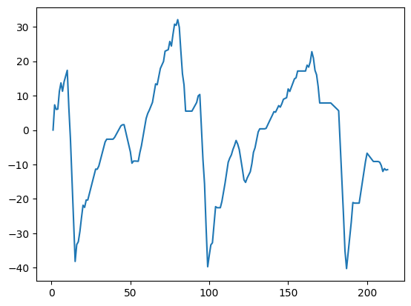

Fig 1. Ball Hit

This figure below illustrates a tracking system applied to a tennis match for performance analysis. The system detects and tracks players and the ball using object detection techniques.

Players are highlighted with red bounding boxes, while the ball is marked with a yellow bounding box and assigned an ID for tracking its trajectory. The court is annotated with reference points (red markers with numbers) to analyze shot placement and movement patterns.

A mini-map in the top-right corner provides a schematic representation of court coverage, aiding in visualizing shot distributions.

The performance statistics panel in the lower right corner displays key metrics such as shot speed and movement speed for both players, enabling quantitative assessment of their playing styles. This analysis provides insights into player positioning, shot efficiency, and match dynamics, making it a valuable tool for performance evaluation in tennis.

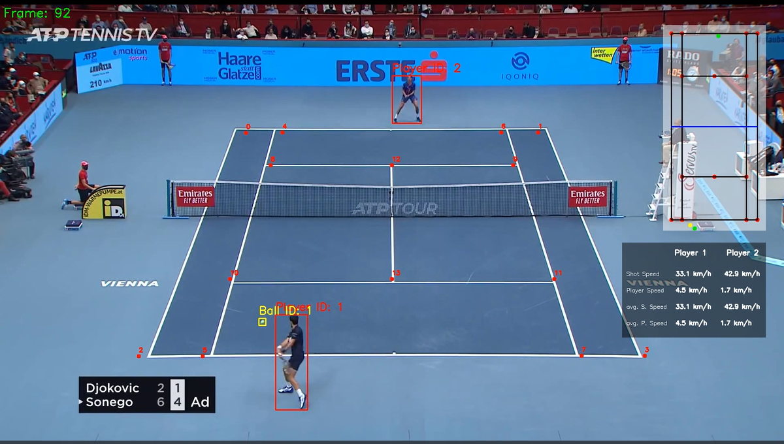

Fig 2. Tennis Match Analysis

The data below presents a comparison of key performance metrics for two players, specifically focusing on shot speed and player movement speed.

The data is calculated with the help of the mini court which is displayed in Fig 2, where the green dots are the players and the yellow dot is the ball and the red dots are the court key points.The code converts the distance covered by the dots from pixels to meters and then calculates speed, which is further converted to km/h.

$$Shot Speed=\frac{Distance Traveled by Ball}{Time Taken}$$

$$Player Speed=\frac{Distance Traveled by Player}{Time Taken}$$

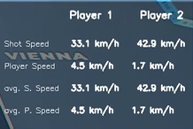

Fig 3. Player Performance Metrics

# Discussion

The implementation of a tennis match analysis system demonstrated effective tracking of both players and the ball using YOLO-based object detection. The results indicate that the model was able to accurately detect and differentiate between players and the ball, enabling real-time analysis of their movements and interactions.

One of the key aspects of this project was the ability to extract meaningful performance metrics, including shot speed and player movement speed. The data revealed variations in shot power and movement patterns between the two players, which can be useful for performance evaluation and coaching.

Despite the effectiveness of the approach, some challenges were observed. The accuracy of ball tracking was occasionally affected by motion blur and occlusions, particularly during fast exchanges. Additionally, variations in lighting and camera angles could impact detection performance, suggesting the need for further model fine-tuning and dataset expansion to enhance robustness.

# Conclusion

This project successfully developed a tennis match analysis system that utilizes object detection and tracking techniques to extract valuable performance insights. By employing YOLO for real-time player and ball detection, along with court mapping, the system was able to analyze shot speeds, player movements, and ball trajectories.

The results demonstrated that the system effectively identified key events in the match, such as ball hits and shot placements, providing a foundation for quantitative performance assessment.

The findings indicate that AI-driven sports analytics can offer a deeper understanding of gameplay, aiding in performance evaluation, strategy development, and training optimization. However, certain challenges, such as motion blur, occlusions, and variations in lighting conditions, highlight areas for further refinement.

Overall, this project underscores the potential of computer vision in revolutionizing sports analysis, paving the way for more advanced and automated performance tracking systems in professional and amateur tennis

# Future Scope

Enhanced AI and Machine Learning Models

* Implementing deep learning models to improve player pose estimation, shot classification, and strategic analysis.
* Using reinforcement learning to predict optimal shot selection based on past match data.

Real-Time Performance Analytics

* Expanding the system to provide real-time insights during matches, helping players and coaches make strategic decisions.
* Integrating AI-driven coaching recommendations based on match performance.

Integration with Wearable Technology

* Combining data from smart sensors in tennis rackets or wearables (smartwatches) to improve shot accuracy analysis.
* Using biometric feedback (e.g., heart rate, fatigue levels) for performance optimization.

Application in Augmented and Virtual Reality (AR/VR)

* Creating AR-based coaching tools to overlay strategy insights on a live court view.
* Using VR simulations for players to practice against AI-generated opponents.

# References

[1] Fujimoto, Ryo, et al. "Improved Accuracy of Table Tennis Ball Detection by Fine Tuning." 2024 International Technical Conference on Circuits/Systems, Computers, and Communications (ITC-CSCC). IEEE, 2024.

[2] Hung, Jhen-Min, Jinn-Yen Chiang, and Kerwin Wang. "Tennis Player Pose Classification using YOLO and MLP Neural Networks." 2021 International Symposium on Intelligent Signal Processing and Communication Systems (ISPACS). IEEE, 2021.

[3] Ke, Yong, Zhen Liu, and Sai Liu. "Prediction algorithm and simulation of tennis impact area based on semantic analysis of prior knowledge." Soft Computing 26.20 (2022): 10863-10870.

[4] Yang, Yoseph, David Kim, and Dongil Choi. "Ball tracking and trajectory prediction system for tennis robots." Journal of Computational Design and Engineering 10.3 (2023): 1176-1184.

[5] Agrawal, Sameer, Ragoth Sundararajan, and Vishak Sagar. "Accurate Tennis Court Line Detection on Amateur Recorded Matches." arXiv preprint arXiv:2404.06977 (2024).

[6] Farhat, Manel, Ali Khalfallah, and Med Salim Bouhlel. "A Real-Time Court Detection and Tracking System to Tennis Videos." Journal of Testing and Evaluation 47.4 (2019): 3103-3122.

[7] Ren,S.,He,K.,Girshick,R.,&Sun, J. (2017).Faster R-CNN: Towards Real-Time Object Detection with Region Proposal Networks. IEEE Transactions on Pattern Analysis and Machine Intelligence, 39(6), 1137-1149.

[8] Kang, Shizhao, et al. "Object Detection YOLO Algorithms and Their Industrial Applications: Overview and Comparative Analysis." *Electronics* 14.6 (2025): 1104.

[9] Reno, Vito, et al. "Convolutional neural networks based ball detection in tennis games." *Proceedings of the IEEE conference on computer vision and pattern recognition workshops*. 2018.