**A COMPREHENSIVE STUDY OF WORK LIFE BALANCE** **AMONG EMPLOYEES**

Gokul R1, Keerthi S2,

1 MBA Student, School of Arts, Humanities and Management, Jeppiaar University, Chennai, India.

2Assistant Professor, School of Arts, Humanities and Management, Jeppiaar University, Chennai, India.

1 [gokulgokul230503@gmail.com](mailto:gokulgokul230503@gmail.com)

2 [k.g.s.keerthi@gmail.com](mailto:k.g.s.keerthi@gmail.com)

**ABSTRACT**

In the contemporary workplace, where individuals are expected to perform at heightened levels of productivity with limited resources, the pursuit of work-life balance often becomes an unrealistic aspiration, leading to stress, decreased productivity, and strained relationships; this paper explores the consequences of work-life imbalance, its advantages, and effective strategies for achieving a healthier equilibrium.

**INTRODUCTION**

Work-life balance means balancing the demands of work with the fulfillment of personal and family responsibilities. It covers many things, including allocating time and energy, managing stress, maintaining healthy boundaries, and finding personal interests outside of work. Achieving a satisfactory work-life balance is important not only for personal health and happiness, but also for the success of the organization. When employees become overwhelmed by work commitments and neglect their personal lives, this can lead to burnout, decreased productivity, and increased turnover.

The importance of work-life balance goes beyond personal health to impact organizational performance. Research shows that organizations with supportive work life balance and practices will lead to greater employee engagement, job satisfaction, and insurance. In addition, a good work-life balance leads to a harmonious and diverse work environment because it allows employees to primarily manage challenges and adapt to their specific needs and circumstances.

Additionally, leadership style and organizational structure can lead to a “workaholic” culture that prioritizes productivity over health, energy, and balance. To see the importance of solving these problems, many organizations have started to implement various measures and policies to improve work-life balance.

These may include flexible working arrangements, telephone consultation options, parental rights policies, health, and measures to promote a culture of respect for the individual's time. However, the effectiveness of these measures depends on their compatibility with the needs and preferences of employees and the culture and values of the organization.

**Achieving Harmony Between Work and Life**

Finding the perfect balance between professional and personal responsibilities is a delicate art. It involves juggling multiple aspects of life, including family, community, leisure, social obligations, health, and personal growth.

**The Evolution of Work-Life Balance**

* Unique to Each Individual: Work-life balance is a highly personal concept that changes over time.
* Dynamic Interplay: It's about finding the right mix of work and personal life, which can shift as circumstances change.
* Supportive Environment: A supportive work environment, effective management, and strong personal relationships can help minimize conflicts between work and personal life.

**The Challenges of Implementing Work-Life Balance**

* Implementing Effective Policies: Organizations face challenges in creating policies that cater to diverse employee needs.
* Employee Expectations: Employees expect employers to prioritize their well-being, not just provide a pay check.
* Measuring Success: Companies must find ways to measure the effectiveness of their work-life balance initiatives.

**RESEARCH REVIEW**

1. **Amazue, Lawrence August 2016**  The study examined stress coping strategies, perceived organizational support and marital status as predictors of work-life balance. Two hundred and fifty-four bank workers participated in the study. Results of the regression analyses showed that stress coping strategies were a significant predictor of work-life balance (β = .34, p = .000) and contributed 11 % variance in work-life balance after controlling for the effects of gender, age, and education. The result further revealed that perceived organizational support significantly predicted workers' work-life balance (β = .22, p= .001) and contributed additional 4 % variance in work-life balance after the effects of gender, age, education, and coping strategies have been controlled. Marital status was not related to work-life balance. The findings of the study were discussed based on Nigerian socio-economic realities. The implications of the findings to work-life policies and practices were discussed.
2. **Hye Kyoung Kim 2014**. The main purpose of the study was to investigate the effect of work life balance on affective commitment and in-role performance and to explore the mediating role of affective commitment to link work-life balance and in-role performance in the Korean. context. Design/methodology/approach: Through the literature review, the hypothesized model and hypotheses were developed. Using data gathered from 293 Korean workers, the current study tested hypotheses using structural equation modelling (SEM) and regression analysis. Findings: The results showed no direct effect of work-life balance on in-role performance. However, it was found that employees' experience of work-life balance increases affective commitment, and that affective commitment has a positive influence on in role performance. Originality/value. Despite favourable outcomes of work-life balance and the increased interest in this topic, less attention has been made on what effect work-life balance has on employees' attitudes and behaviours. Indeed, most of the studies to date on work-life balance have been conducted in Western countries, not in Asian countries. Thus, this study sought to understand work-life balance in Asian countries, especially in Korea, and to compare the results with those from studies conducted in Western countries. The findings of this study could be useful for Korean organizations to understand the role of work-life balance in employees' personal and work life.
3. **Kim, Ji Sung, Ryu, Sangyub, Public Administration & Development. October 2017** This study investigates the relationship between public employees' satisfaction with work-life balance policies (WLBPs) and organizational commitment in the relatively unexplored Philippine context. Our findings show that (i) employees' overall satisfaction with WLBPs is positively related to organizational commitment, (ii) when specific WLBPs are examined, only satisfaction with health and wellness programs are positively associated with organizational commitment, and (iii) when accounting for employees' preferences for WLBPs, compensatory time-off, childcare policy, health insurance benefits, and paid sick leave are positively related to organizational commitment. The findings indicate that understanding which WLBPs employees prefer is important before implementing WLBPs. The article discusses the theoretical and practical implications of this study in the developing country context.
4. **Lopamudra. March 2017** Information Technology (IT) sector plays a significant role in the growth of Indian economy and is also one of the largest employers. However, the IT sector faces many challenges such as tough competition, economic uncertainty, and dynamic business environment. Therefore, to overcome such challenges and for sustainable development, the companies are concerned about their productivity. To enhance productivity, organizations should effectively manage their resources, particularly human resources for effective achievement of targets by the employees. When targets are tough, it ultimately makes it difficult to balance their personal and professional lives. This often becomes a big bottleneck in the achievement of targets by the employees. Organizations also realize the worth of employees and are concerned about their problems. Therefore, today’s IT sector implements many employee-oriented practices. Though many researchers have studied various work-life balance practices that different companies have adopted for their employees, still most of the literature has taken the demographic variables gender, in their study. However, there is scope to include other demographical aspects such as experience and age.

**5. Lakshminarayanan, S. Savarimuthu May 2016** The purpose of the study is to explore the impact of the work-family conflict and family work conflict on the work-life balance of women employees working in Information technology industries located in Bengaluru Regression analysis was used to test the proposed hypothesis. The research finding says that the work-family conflict is having a significant impact on work-life balance, and it is impacting the work-life balance of the women employees working in IT industries in a negative manner whereas the family work conflict is not having any significant impact on work-life balance.

**OBJCECTIVES OF THE STUDY**

**Primary objective:**

To study on employees, work life balance with reference to organization.

**Secondary objectives:**

* To assess the respondent's perception of their organization's work-life balance policies and practices.
* To evaluate the effectiveness of specific organizational benefits and welfare schemes in supporting work-life balance for employees.
* To understand the impact of long working hours on employee efficiency and productivity.
* To explore the various organizational factors, such as shift changes, policies, strategies, and working hours, that may affect employee efficiency levels.
* To examine the relationship between work-life balance practices and individual/organizational productivity from the respondent's perspective.

**BARRIERS TO ACHIEVE A WORK-LIFE BALANCE**

**Organizational Barriers**

* **Unsupported Work Culture**: Employees may feel judged or scrutinized for using flexible working options.
* **Career Consequences:** Employees may believe that using flexible working options will harm their career advancement.
* **Mismatch between Policies and Life Stages:** Policies may not align with employees' changing needs at different life stages.

**Managerial Barriers**

* **Lack of Managerial Support:** Managers may not understand or support flexible working options.
* **Poor Communication:** Managers may not effectively communicate flexible working options to employees.

**Individual Barriers**

* **Self-Perception:** Employees may feel that they cannot use flexible working options due to workload or other constraints.
* **Perfectionism:** Employees may feel that they need to be perfect and constantly available.
* **Overreacting to Work Demands:** Employees may feel pressured to respond to work demands immediately, without prioritizing tasks.

**Solutions**

* **Empowerment:** Employees need to be empowered to make choices about their work-life balance.
* **Effective Communication:** Managers and supervisors need to communicate effectively with employees about flexible working options.
* **Measuring Effectiveness:** Organizations need to focus on outcomes and productivity, rather than just time spent in the office

**ANALYSIS AND INTERPRETATION OF THE DATA:**

**1. ABOUT ORGANIZATION WELFARE SCHEME HELPS TO BALANCE THEIR** **PERSONAL LIFE**

**Table: 1 Figure: 1**

|  |  |  |  |  |  |
| --- | --- | --- | --- | --- | --- |
|  |  | Frequency | Percent | Valid  Percent | Cumulative  Percent |
|  | Strongly disagree | 13 | 12.6 | 12.6 | 12.6 |
|  | Disagree | 16 | 15.5 | 15.5 | 28.2 |
|  | Neutral | 38 | 36.9 | 36.9 | 65.0 |
|  | Agree | 27 | 26.2 | 26.2 | 91.3 |
|  | Strongly  Agree | 9 | 8.7 | 8.7 | 100.0 |
|  | Total | 103 | 100.0 | 100.0 |  |

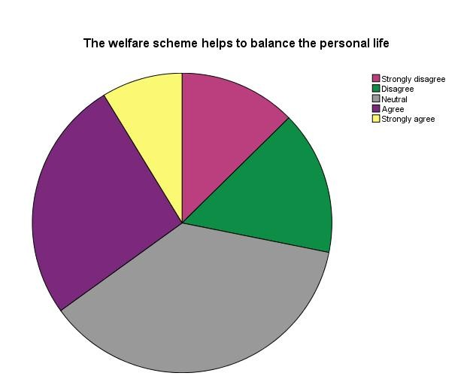

**Inference** Above table, it was found that 8.7% of the respondents are strongly agree with the above statement, 26.2% of the respondents are agree with the above statement, 36.9% of the respondents are neutral with the above statement, 15.5% of the respondents are disagree with the above statement and 12.6% of the respondents are strongly disagree with the above statement. From the above table it was inferred that most of the respondents (36.9%) agree neutrally that the organization welfare scheme helps to balance their personal life.

**2. ABOUT ORGANISATION RESPONSIBILITIES ARE AFFECT THEIR** **CARIEER AND FAMILY LIFE**

**Table: 2**

|  |  |  |  |  |  |
| --- | --- | --- | --- | --- | --- |
|  |  | F Frequency | Percent | Valid  Percent | Cumulative  Percent |
| Yes | Ye | 37 | 35.9 | 35.9 | 35.9 |
| No | No | 36 | 35.0 | 35.0 | 70.9 |
|  | M Maybe | 30 | 29.1 | 29.1 | 100.0 |
|  | Total | 103 | 100.0 | 100.0 |  |

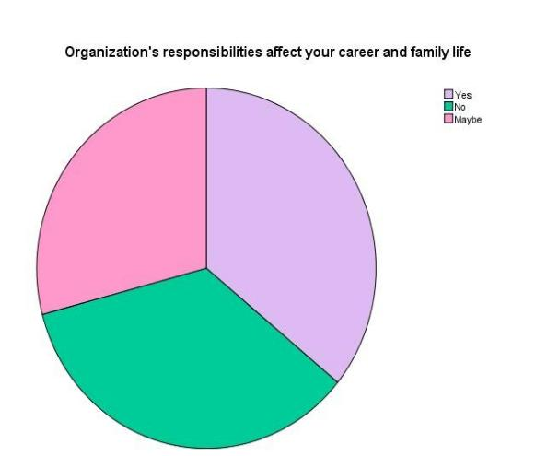

**Figure: 2**

**Inference** Above table, it was found that 35.9% of the respondents gave positive comments and 35% of respondents are said negative comments and 29.1% of the respondents said neutral comments. From the above table it was inferred that majority of the respondents (35.9%) said organization policies affect their career and family.

**3. CLASSIFICATION OF DATA BASED ON WORKING HOURS** **RESPONDENTS**

|  |  |  |  |  |  |
| --- | --- | --- | --- | --- | --- |
|  |  | F Frequency | Percent | Valid  P Percent | Cumulative  Pe Percent |
| 8 ho | 8 hours | 50 50 | 48.5 | 48.5 | 48.5 |
|  | 8-9 hours | 41 41 | 39.8 | 39.8 | 88.3 |
|  | More than  9 hours | 12 12 | 11.7 | 11.7 | 100.0 |
|  | Total | 103 | 100.0 | 100.0 |  |

**Table : 3 Figure 3**

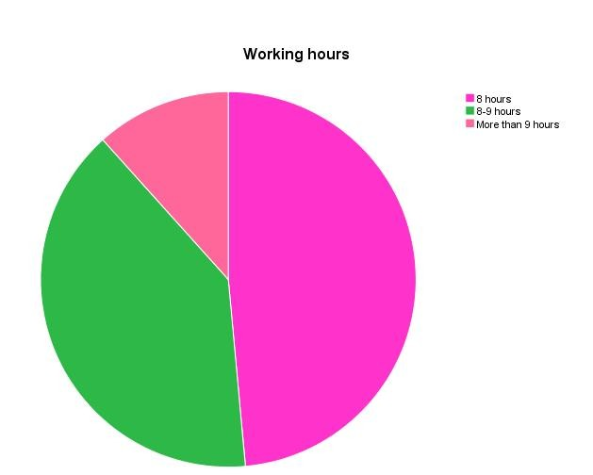

**Inference** Above table, it was found that 48.5% of respondents are works 8 hours and 39.8% of respondents are 8-9 hours works and 11.7% of respondents are works more than 9 hours. From the above table, it was inferred that the most (48.5%) of the respondents are works 8 hours per day.

**CONCLUSION**

The study is about the feeling of employees work life in our organization at Mirage Private Limited is done through tools, the questionnaire method to measure the work life balance in our organization. It was found that most of employees accepted the new work life balance policies in the organization. The employees are also satisfied the factors of new work life balance policies to balance their personal and professional life. And also, they are achieving their individual efficiency and improve organization productivity. By creating a better work life balance from the employees’ job and personal life that will motivate to achieve their career goal and organization targets.

**REFERENCES**

1. **Adisa, Toyin Ajibade;** Gbadamosi, Gbolahan; Osabutey, Ellis L. C. Personnel Review.2017, Vol. 46 Issue 8, p1651-1671. 21p. DOI: 10.1108/PR-08-2016- 0222.
2. **Amazue, Lawrence**; Onyishi, Ike. Social Indicators Research.Aug2016, Vol. 128 Issue 1, p147-159. 13p. DOI: 10.1007/s11205-015-1023-5.
3. **Hye Kyoung Kim.** Global Business & Management Research.2014, Vol. 6 Issue 1, p37-51. 15p.
4. **Ierodiakonou, Christiana; Stavrou, Eleni.** International Journal of Human Resource Management.Dec2017, Vol. 28 Issue 21, p3015-3038. 24p. 2 Diagrams, 4 Charts, 2 Graphs. DOI: 10.1080/09585192.2017.1362658
5. **Kim, Ji Sung; Ryu, Sangyub.** Public Administration & Development.Oct2017, Vol. 37 Issue 4, p260-276. 17p. DOI: 10.1002/pad.1794. Kim, Ji Sung; Faerman, Sue R.
6. **European Management Journal.** Oct2013, Vol. 31 Issue 5, p505-521. 17p. DOI: 10.1016/j.emj.2013.04.012
7. **Kashi, Kia; Zheng, Connie; Molineux, John**. Journal of Organizational Computing & Electronic Commerce.2016, Vol. 26 Issue 3, p203-223. 21p. DOI: 10.1080/10919392.
8. **Lopamudra. Vilakshan:** The XIMB Journal of Management. Mar2017, Vol. 14 Issue 1, p101-109. 9p. **Lakshminarayanan, S.; Savarimuthu, A.** AIMS International Journal of Management. May2016, Vol. 10 Issue 2, p101-111. 11p.
9. **Pandita, Sarjue;** Singhal, Ritesh. IUP Journal of Organizational Behavior.Jan2017, Vol. 16 Issue 1, p38-57. 20p.
10. **Riđić, Ognjen; Avdibegović, Adnan;** Bušatlić, Senad. Economic Review: Journal of Economics & Business / Ekonomska Revija: Casopisza Ekonomijui Biznis. Nov2016, Vol. 14 Issue 2, p44-55. 12p. 5 Charts, 1 Graph. **Sangeetha, R.; Kumar, N. Pradeep**. XIBA Business Review.2016, Vol. 2 Issue 2, p22- 28.
11. **Zheng, Connie;** Kashi, Kia; Fan, Di; Molineux, John; Ee, Mong Shan. International Journal of Human Resource Management.Mar2016, Vol. 27 Issue 5, p501-526. 26p. 3 Diagrams, 6 Charts. DOI: 10.1080/09585192.2015.1020447.

**BOOKS**

* + Uma Sekaran Research method for business Fourth edition New York; John Wiley & sonsInc 2003.
  + Kothari Research Methodology New Delhi; Viswa Prakashnan 1985.
  + Statistics for management, Levin R.I and Rubin, Prentice Hall of India Pvt. Ltd, New Delhi,2010.