"An Analysis of Customer Satisfaction with Tata Motors in Salem"

Vijayshri M

PG Scholar

Department of Management studies

Vivekanandha Institute of Information & Management Studies

Namakkal,Tamilnadu

<Vijayshri664@gmail.com>

**ABSTRACT:**

One of the primary cornerstones of the Indian economy is the automobile sector. The purpose of the survey is to gauge customer satisfaction with a company. Customer satisfaction are measure of how well a business's goods along with services meet or exceed their potentials. Regarding future purchases and customer loyalty, it is the most important indicators. It helps generate revenue, as well as support business growth predictions. The key to satisfying customers is consistency. A sample size of 210 responses will be collected for this investigation. The investigation was conducted at several Tata service centers and showrooms in the Salem area.

***Key Words:*** *Market, Automobile, Transportation, Customer Service, and Analysis*

**INTRODUCTION:**

In many industrialized nations, the vehicle serves as the main form of transportation. Mumbai is home to the global headquarters of the Indian carmaker TATA Group, which includes TATA Motors Limited. Jehangir Ratanji Dadabhoy Tata founded it first. It was 77 years ago, in 1945. Tata Motors was the first company in India to produce a competitive domestic vehicle when it made its debut with the Tata Sierra in 1991 after entering the passenger car market in 1988. Since the establishment of the latter, Tata Motors has held Jaguar and Land Rover, having purchased the brands from Ford in 2008. In India, Twelve percent of Gross value added (GVA) related to manufacturing comes from the automotive industry. and 49% of the manufacturing GDP. By about 4%, TATA Motors contributes to the country's GDP growth. Because it believes in "Connecting Aspirations," Tata Motors provides creative mobility solutions that support their clients' objectives. The largest carmaker in India, Tata Motors, is leading the charge to transform the commercial vehicle industry in the nation when new electric solutions and powertrains are introduced that offer the lowest life-cycle costs, both user comfort and optimal power performance. With their remarkable blend of performance, connection, and driveability, the new passenger cars and utility vehicles are built on Impact Design. To have a strong desire to anticipate and deliver the greatest vehicles and experiences that thrill clients everywhere.

**OBJECTIVES:**

* To evaluate how satisfied customers are with the cars and services offered by Tata Motors.
* To determine the main determinants of consumer experience, including cost, quality, and post-purchase support. To assess post-purchase assistance, including warranty, maintenance, and service centers.
* To examine brand perception and consumer loyalty in relation to rivals.
* To research how digital marketing affects consumer happiness and engagement. To assess how consumers react to electric cars (EVs) made by Tata Motors.

**METHODOLOGY:**

Any research topic may be solved methodically with research technique. It is the scientific study of methodical research methods. A research design is an exploratory plan, structure, and approach used to find solutions to research issues and questions. "Primary and Secondary Data" are two sources from which the study materials are gathered.

**SAMPLING DESIGN:**

The guidelines and practices used to choose sample members from the population are referred to as the sampling design.

**SAMPLING METHOD:**

Simple random sampling is the sampling technique employed in this study to collect information from the participants.

**DATA SOURCE:**

A newly created questionnaire was used to collect primary data from the sample respondents for this investigation. Websites, journals, magazines, and published as well as unpublished research projects are examples of secondary sources provided additional relevant data for the study.

**REVIEW OF LITRETURE:**

According to a 2020 study by Mehta and Sharma, customer happiness is influenced by digital marketing initiatives and online platform engagement. Tata Motors has improved brand-customer interactions by utilizing digital marketing and consumer feedback systems. Through social media, tailored email campaigns, and AI-powered chatbots, the business actively engages with clients, ensuring prompt response times and enhanced accessibility to services. Additionally, by enabling consumers to remotely examine vehicle features, Tata Motors' investments in virtual showrooms and augmented reality (AR) have improved the car-buying experience. Customer satisfaction and brand loyalty have increased as a result of these digital efforts, which have enhanced Tata Motors' interactions with its customers.

According to a study on expectation-disconfirmation theory by Oliver (1999), the discrepancy between perceived and expected performance has an impact on consumer satisfaction. Advertising, brand reputation, and prior brand experiences are among the key elements that shape consumer expectations in the automotive sector. Maintaining client trust for Tata Motors depends on controlling consumer expectations through precise marketing and producing high-quality automobiles. According to Singh and Sharma (2022), customer satisfaction levels have been positively impacted by Tata Motors' longstanding reputation in the Indian car industry.

(2011) Dr. Sandesh Kumar Sharma. Customers are happy with the pricing, according to his research, but there are issues with upkeep and the property's poor resale value. These two main factors, among others, include disgruntled customers who are not attended to by customer support. It is imperative that TATA Motors improve its customer service, reduce the price of replacement components, and make them available nationwide.

In 2013, S Arun Priya and M Shanthini Devi. The results of the current survey show that consumers favor the TATA Nano vehicle. The car's price is the primary motivator for them. The brand's popularity is another factor that influences consumers' purchasing decisions. Although they do wish there were more options for customization, price, look, and comfort of the car, in congested areas, satisfy the majority of buyers.

**SUMMARY OF TATA MOTORS:**

With annual sales of USD 42 billion, India's largest carmaker is TML. The company is focusing on developing Intelligent transportation options for intelligent cities along with being one of the world's top producers military vehicles, trucks, buses, cars, also utility vehicles. Additionally, Tata Motors is creating a line within intelligent EVs to assist the government in electrifying all vehicles, which will hasten the adoption of EVs across the country.. Originally from India, Tata Motors operates in Thailand, South Korea, Indonesia, South Africa, and the United Kingdom. It is a member of the $100 billion Tata group. Tata Motors is a prominent player in the Indian commercial vehicle sector and one of the top producers of passenger automobiles, with over 9 million vehicles on Indian roads. Due in large part to the corporation, the country has become a hub for luxury car production and continues to promote its expansion. Tata Motors has consistently set the benchmark for providing goods and services that live up to the high standards of our clients while utilizing technical both commercial and passenger car innovation. Tata Motors' commitment to providing better travel experiences has been emphasized with the introduction of its new corporate brand identity, Connecting Aspirations. pursuing the development of creative products that would appeal to customers alike. Participating in the Tata Motors Group, which comprises 76 businesses globally and includes some of the world's most renowned brands, such as Tata Daewoo in the business has built a solid name in South Korea and in the UK thanks to Jaguar Land Rover.. Tata Motors' production facilities are spread across India's main industrial hubs, including Sanand (Gujarat), Dharwad (Karnataka), Pune (Maharashtra), Lucknow (Uttar Pradesh), and Jamshedpur (Jharkhand). The company is well-positioned to influence India's transportation scene thanks to its exceptional quality, uniqueness, and technical and design know-how. The company’s Engineering Research Center employs 4,500 scientists, engineers, and technicians. In addition to Pune, India, Tata Motors has Facilities for research and development in United Kingdom and South Korea. In reaction to the situation, Tata Motors launched the TAMO sub-brand. quickly evolving automotive sector. By encouraging new collaborations, business plans, and technological advancements that contribute to the development of future mobility solutions, TAMO acts as a center for innovation. To produce quick prototypes of concepts and advancements, it initially employs a low-volume, low-cost strategy as a flexible, ring-fenced vertical. TAMO will completely transform how people engage and communicate with customers and the broader community. In the future, Tata Motors will be able to serve the mainstream sector by utilizing the digital environment it will give. Sustainability as well as the notion of "giving back to society" are two of Tata Motors' core values. Good corporate responsibility also has a strong foundation in the company's culture. In FY 23–24, as per the Affirmative Action Program, about 5 lakh people.

**DATA ANALYSIS AND INTERPRETATION:**

**Table 1: Respondents' Age Group**

|  |  |  |
| --- | --- | --- |
| **Age** | **No. of Respondents** | **Percentage (**%) |
| 21-30 yrs | 90 | 47.33 |
| 31-40 yrs | 65 | 32.66 |
| 41-50 yrs | 45 | 16.66 |
| 51 yrs above | 10 | 3.33 |
| **Total** | **210** | **100** |

**Age Group of Respondents in Chart 1**

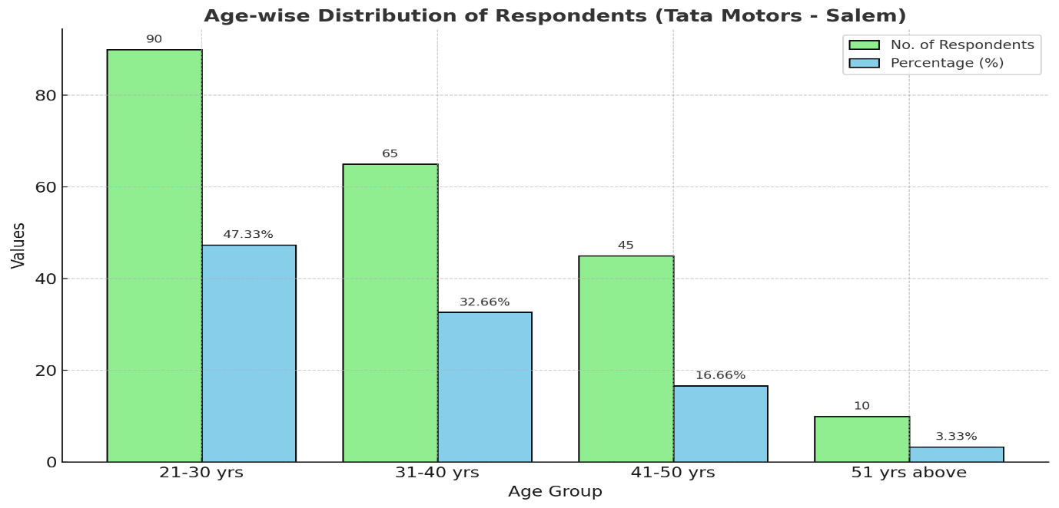

**Interpretation:**

According to the data, the majority of respondents, or 47.33%, fall within the age range of 21 to 30. The remaining 3.33% are aged 51 and above.

**Tab 2: Respondents' Annual Income**

|  |  |  |
| --- | --- | --- |
| **Annual Income**  **Level** | **No of Respondents** | **Percentage (%)** |
| 1Lakhs - 2Lakhs | 70 | 20 |
| 2Lakhs -  3Lakhs | 85 | 52 |
| Above 3Lakhs | 55 | 28 |
| **Total** | **210** | **100** |

**Chart 2: Respondents' Annual Income**

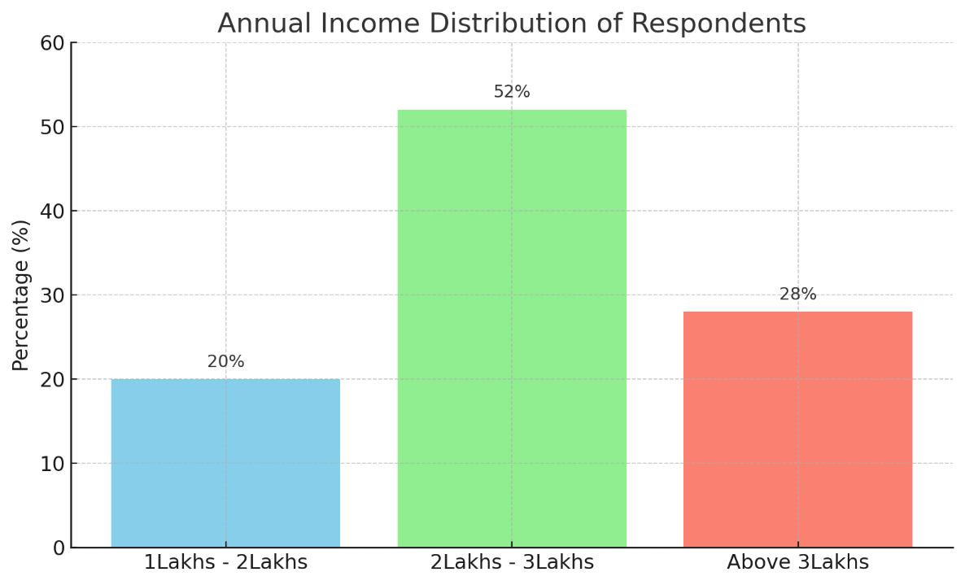

**Interpretation:**

According to this following table, 20% of respondents make between one and two lakhs per year, while 52% of respondents make between two and three lakhs.

**FINDINGS:**

The study discovered a statistically significant correlation between customer satisfaction and age. The bulk of responders are "between the ages of 21 and 30." The mean customer satisfaction scores were lower for those over 51. Because of their power, performance, ease of maintenance, and driving comfort, Tata motors are frequently chosen over competing models. The majority of customers are happy with the Tata Motor dealerships' purchase pricing, service, and test drive options. Additionally, it indicates that customers are more affected by the inadequacy service centers. By concentrating on these concerns, Tata Motors can increase market performance and establish adequate service centers to meet customer needs.

**CONCLUSION:**

The goals of the current study have all been met. Numerous important criteria that guarantee greater customer satisfaction among automobile customers have been identified according to the study. The key findings will benefit not only Tata Motors but also all other automakers. in carrying out their operations more efficiently. Tata will continue to be a pride of our nation in the future.

**REFERENCE**

1. S Jyothirmayi Reddy, B Venkateswara Reddy, Prof S Durga Rao (2016), Study on customer Satisfaction towards Tata Motor cars in Andhra Pradesh.
2. M Shanthini Devi, S Arun Priya (2013), Study on customer satisfaction towards Tata nano car with special reference to Coimbatore city. Volume-2, issue:8, ISSN No 2277-8160.
3. Dr Sandesh Kumar Sharma, Kiran Sharma, Makshud Khan (2011), A Study and Analysis of Customer Satisfaction of Tata Motors in Jaipur, Rajasthan. Volume-2(4),2011,250-257, ISSN:2229-6247.
4. Dr P Kuppuraj, G Sabarinathan and M Mohan (2019), A Study on Customer Satisfaction towards Tata Motors in Coimbatore North. Volume-4, Issue-03, March-2019, ISSN:2455-385(Online) , Research Review International Journal of Multidisciplinary www.rrjournals.com (UGC listed Journal).
5. <https://www.tatamotors.com/wp-content/uploads/gms2018/tata-motors-profile-english.pdf>