**Stock Market Analysis and Prediction**

**L. Bharath Balaji Naidu1, K. Bindhu Madhavi****2, B. Siva Venkata Harshith3, P. Sowmya4,**

**P. Sunny 5, S.V. R. Vara Prasad6,**

1, 2, 3, 4, 5B. Tech Student, Department of Computer Science and Information Technology

6Assistant Professor, Department of Computer Science and Information Technology

1, 2, 3, 4, 5, 6 Lendi Institute of Engineering and Technology, Vizianagaram.

**ABSTRACT**

The project focuses on leveraging an LSTM neural network to predict stock market behaviour, addressing the challenges posed by market volatility and complexity. LSTM's capability to handle long-term dependencies make it suitable for analysing historical stock prices and forecasting future trends. The model’s effectiveness is assessed through its accuracy and ability to generalize across various stocks and market conditions. Initial results indicate that the LSTM model can identify significant trends and patterns, though its accuracy is influenced by the quality of input data. Future enhancements could include incorporating additional market indicators and news sentiment to improve predictive performance and provide deeper insights for investors.

***Key Words***: Stock Market Analysis, LSTM Model, Time-Series Forecasting, Predictive Analytics, Recurrent Neural Network.

**1. INTRODUCTION**

The stock market serves as a cornerstone of the global financial system, offering opportunities for investors and traders to generate financial returns. However, accurately predicting stock prices remains a formidable challenge due to the market’s volatile and nonlinear nature. Traditional approaches such as fundamental and technical analysis often fall short when attempting to model the complex dependencies that drive price movements. In recent years, advancements in artificial intelligence (AI) and machine learning (ML) have opened new possibilities for improving stock market forecasting.

One of the most promising techniques in financial time-series analysis is Long Short-Term Memory (LSTM), a type of recurrent neural network (RNN) specifically designed for sequential data processing. LSTM networks excel in capturing long-term dependencies within time-series data, making them particularly well-suited for stock market predictions. This research aims to explore the effectiveness of LSTM models in forecasting stock prices for major technology firms, including Apple (AAPL), Google (GOOG), Microsoft (MSFT), and Amazon (AMZN).

The objectives of this research are to conduct a thorough analysis of historical stock prices, develop an LSTM-based prediction model, and evaluate its performance against traditional forecasting methods.

**2. MOTIVATION AND PROBLEM IDENTIFICATION**

Stock market prediction is an inherently complex task due to its reliance on numerous internal and external factors such as economic indicators, political developments, company performance, and investor sentiment. Several key challenges make stock price forecasting difficult:

First, stock prices exhibit nonlinear patterns that conventional statistical models struggle to capture. Second, market prices experience high volatility, often influenced by unexpected global or economic events. Third, stock price movements are highly dependent on historical data, emphasizing the need for time-series forecasting techniques. Lastly, stock market data is inherently complex, requiring extensive preprocessing and feature engineering to extract meaningful patterns for predictive modeling.

Given these challenges, LSTM networks provide a robust solution by leveraging their ability to learn sequential dependencies and extract hidden trends from historical stock data, ultimately improving prediction accuracy.

**3.** **RELATED WORK**

Several studies have explored the use of machine learning in stock market prediction. Liu et al. demonstrated that an LSTM-based model significantly outperformed traditional forecasting methods in stock transaction predictions. Borovkova and Tsiamas employed an ensemble of LSTM networks for stock classification, highlighting the effectiveness of deep learning in financial analysis. Additionally, Selvin et al. conducted a comparative study of LSTM, RNN, and CNN models for stock price prediction, concluding that LSTM models provided superior results due to their ability to retain long-term dependencies in time-series data.

These studies underscore the potential of LSTM networks in financial forecasting, motivating further exploration and optimization of such models for stock market prediction.

**4. PROPOSED WORK**

This research presents a comprehensive LSTM-based framework for stock price prediction, encompassing data preprocessing, model development, training, and evaluation. The methodology involves collecting historical stock prices from Yahoo Finance, normalizing the data, implementing an LSTM model, and assessing its predictive performance using established evaluation metrics.

**5. SYSTEM WORKFLOW**

The proposed system follows a structured approach for stock market prediction. It begins with **data collection** from Yahoo Finance for AAPL, GOOG, MSFT, and AMZN. Next, **data preprocessing** involves filtering relevant features, normalizing values, and splitting the dataset for training and testing. The **LSTM model** is then developed with optimized layers and hyperparameters. During **training and validation**, the model learns patterns from historical stock data and is tested on unseen data. Finally, **prediction and evaluation** are conducted by generating stock price forecasts and assessing accuracy using RMSE and other performance metrics.

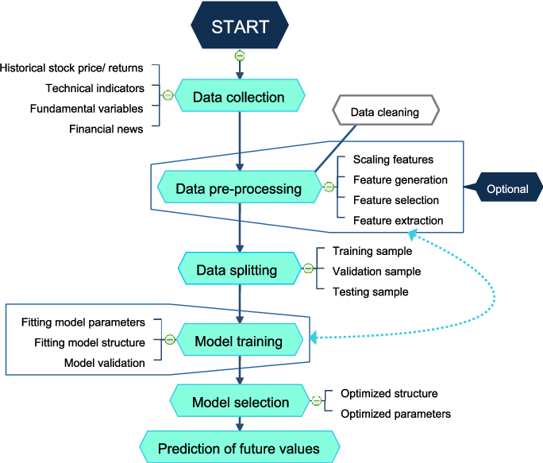

**6. METHODOLOGY**

**6.1 Data Collection and Preprocessing**

The study utilizes historical stock price data from Yahoo Finance, accessed via Python’s finance library. The dataset consists of daily adjusted closing prices and trading volumes from January 1, 2012, to the present.

**Preprocessing steps include:**

* **Filtering:** Retaining only the 'Close' price column to focus on closing price prediction.
* **Scaling:** Applying MinMaxScaler from sklearn to normalize values between 0 and 1.
* **Splitting:** Dividing the dataset into 95% training and 5% testing data.
* **Sequence Creation:** Creating 60-day sequences as input features (X), with the 61st day's closing price as the

target (Y).

Figure 1 and Figure 2 show the visualization of data we use.



**Figure 1.**　Visualization of Historical Stock Prices for AAPL, GOOG, MSFT, and AMZN (2012-Present).



**Figure 2.**　Preprocessed Data for LSTM Model Training: Scaled and Sequenced Closing Prices.

**6.2 LSTM Model Architecture**

The LSTM model architecture is designed to capture temporal dependencies in stock price data. The model consists of the following layers:

* **Input Layer:** Accepts sequences of 60 days’ worth of closing prices.
* **LSTM Layers:** Two LSTM layers, the first with 128 units returning sequences, and the second with 64 units.
* **Dense Layers:** Two dense layers (25 and 1 units) for final prediction.
* **Compilation:** Adam optimizer and Mean Squared Error (MSE) loss function are used.

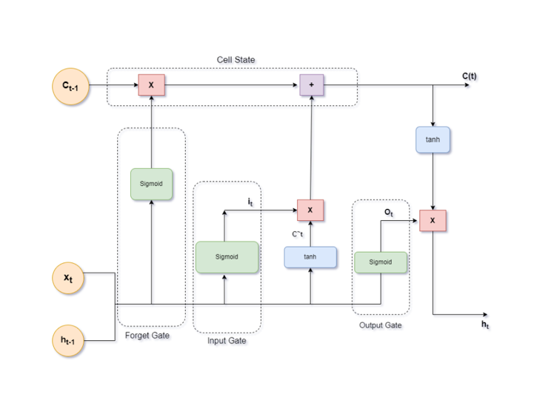

**Figure 3.**　Architecture Visualization of LSTM Neural Network Model for Stock Price Prediction.

**6.3 LSTM Computation**

LSTM computation is defined by the following equations:

1. **Input Gate:**

i_t = \sigma ( W_i H + b_i )

1. **Forget Gate:**

f_t = \sigma ( W_f H + b_f )

1. **Output Gate:**

o_t = \sigma ( W_o H + b_o )

1. **Cell State Update:**

c_t = \tanh ( W_c H + b_c )

1. **Memory Update:**

m_t = f_t \cdot m_{t-1} + i_t

1. **Hidden State:**

h_t = \tanh ( o_t . m_t )

**6.4 Model Training and Evaluation**

The model is trained with a batch size of 1 and 1 epoch. Evaluation is conducted using the test dataset, comparing predicted and actual closing prices. The root mean squared error (RMSE) metric is used to assess model accuracy:

**RMSE = \sqrt{ \frac{1}{n} \sum_{i=1}^{n} ( y_i - \hat{y}_i )^2 }**

**7. RESULTS AND DISCUSSION**

The trained LSTM model was tested on unseen data, and its performance was analyzed. The model successfully captured underlying trends in stock price movements, achieving an RMSE value of 18.89. The predicted stock prices closely aligned with actual trends, demonstrating the model’s ability to process sequential financial data effectively.

The study’s findings highlight that LSTM networks are well-suited for modeling stock market patterns. However, certain limitations remain. The model's accuracy could be improved by incorporating external factors such as economic indicators, financial news sentiment, and macroeconomic trends. Additionally, optimizing hyperparameters and increasing the dataset size may enhance predictive performance.



**Figure 4.**　Comparison between Predicted and Actual Closing Stock Prices with LSTM Model.

**8. CONCLUSION**

This research explores the potential of LSTM networks for stock market forecasting, demonstrating their effectiveness in capturing complex price patterns. The study illustrates that LSTM models can provide reasonably accurate stock price predictions for major technology firms. However, future work should focus on integrating additional financial indicators and exploring hybrid approaches that combine LSTM with other machine learning techniques to further improve predictive accuracy.

**9. REFERENCES**

1) Liu S, Liao G, Ding Y. Stock Transaction Prediction Modeling and Analysis Based on LSTM. In Proceedings of the 2018 13th IEEE Conference on Industrial Electronics and Applications (ICIEA), Wuhan, China, 18–22 August 2018.

2) Borovkova S, Tsiamas I. An Ensemble of LSTM Neural Networks for High ‐ Frequency Stock Market Classification. *Journal of Forecasting* 2019; **38**(**6**): 600–619.

3 Baek Y, Kim HY. ModAugNet: A New Forecasting Framework for Stock Market Index Value With an Overfitting Prevention LSTM Module and a Prediction LSTM Module. *Expert Systems with Applications* 2018; **113**: 457–480.

4 Eapen J, Bein D, Verma A. Novel Deep Learning Model With CNN and Bi-Directional LSTM for Improved Stock Market Index Prediction. In Proceedings of the 2019 IEEE 9th Annual Computing and Communication Workshop and Conference (CCWC), Las Vegas, NV, USA, 7–9 January 2019.

5 Selvin S, Vinay Kumar R, Gopalakrishnan EA, Menon VK, Soman KP. Stock Price Prediction Using LSTM, RNN and CNN-Sliding Window Model. In Proceedings of the 2017 International Conference on Advances in Computing, Communications and Informatics (ICACCI), Udupi, India, 13–16 September 2017.

6 Nelson DM, Pereira AC, de Oliveira RA. Stock Market’s Price Movement Prediction With LSTM Neural Networks. In Proceedings of the 2017 International Joint Conference on Neural Networks (IJCNN), Anchorage, AK, USA, 14–19 May 2017.

7 Sherstinsky A. Fundamentals of Recurrent Neural Network (RNN) and Long Short-Term Memory (LSTM) Network. *Physica D: Nonlinear Phenomena* 2020; **404**: 132306.

8 Nabipour M, Nayyeri P, Jabani H, Mosavi A, Salwana E, Shahab S. Deep Learning for Stock Market Prediction. *Entropy* 2020; **22**(**8**): 840.

9 Bhandari HN, Rimal B, Pokhrel NR, Rimal R, Dahal KR, Khatri RKC. Predicting Stock Market Index Using LSTM. *Machine Learning with Applications* 2020; **9**: 100320.

10 Althelaya KA, El-Alfy E-SM, Mohammed S. Evaluation of Bidirectional LSTM for Short-and Long-Term Stock Market Prediction. In Proceedings of the 2018 9th International Conference on Information and -5- Zhenglin L, et al. *Innov. Appl. Eng. Technol.* 2023, 2(1)

Communication Systems (ICICS), Irbid, Jordan, 3–5 April 2018.