**Artificial Intelligence in Cybersecurity: Enhancing Threat Detection, Prevention, and Response with Machine Learning and Deep Learning Techniques.**

**Ms. Payal Bute,** Student, Department of Computer Application, MIT Arts Commerce and Science College, Alandi, Pune, India

**Ms. Akanksha Kadam,** Student, Department of Computer Application, MIT Arts Commerce and Science College, Alandi, Pune, India

**Mrs. Harsha Patil**, Assistant Professor,Department of Computer Application, MIT Arts Commerce and Science College, Alandi, Pune, India

**Dr.Vikas Mahandule**, HOD & Assistant Professor, Department of Computer Application, MIT Arts Commerce and Science College, Alandi, Pune, India

**Abstract:**

The integration of Artificial Intelligence (AI), specifically Machine Learning (ML) and Deep Learning (DL), in cybersecurity has revolutionized threat detection, prevention, and response mechanisms. AI’s work in cybersecurity is mostly focused on threat identification and prevention. Using machine learning algorithms and complex data analysis, artificial intelligence may recognize the patterns abnormalities in user behavior and network traffic that may point to possible cyberattack. This make it possible for security staff to react swiftly and proactively to possible assaults. AI can be used to stop assaults by using predictive modeling. This paper explores how AI technologies bolster cybersecurity strategies, examining various ML and DL models that contribute to early detection, adaptive prevention, and real-time response to emerging threats. We also address the challenges and ethical considerations involved in AI-driven cybersecurity and future prospects for these technologies in securing digital landscapes.

**Keywords:**

Artificial Intelligence, Cybersecurity, Machine Learning, Deep Learning, Threat Detection, Prevention, Response, Anomaly Detection.

**1. Introduction :**

The cybersecurity threat landscape has significantly evolved in recent years due to technological advancements, digital ecosystem expansion, and increased device connectivity. Major threats include malware, ransomware, phishing, zero-day vulnerabilities, advanced persistent threats (APTs), supply chain attacks, IoT vulnerabilities, and social engineering and insider threats. Malware has evolved from simple viruses and worms to more complex forms like trojans, spyware, and botnets. Ransomware attacks have surged in frequency and severity, targeting individuals and organizations, particularly critical infrastructure like healthcare and government services. Phishing campaigns have evolved into spear-phishing and whaling, targeting specific individuals and high-profile executives. Zero-day vulnerabilities are security flaws in software that are unknown to the vendor and have no patches available at the time of discovery. Advanced persistent threats (APTs) are prolonged cyberattacks where an unauthorized user gains network access and remains undetected for an extended period. Supply chain attacks target vulnerabilities in a company's supply chain, compromising software or hardware vendors to gain access to the broader network. IoT vulnerabilities have expanded the attack surface, as many devices lack adequate security measures. Insider threats pose a significant risk, where employees or trusted partners compromise security either deliberately or through negligence.

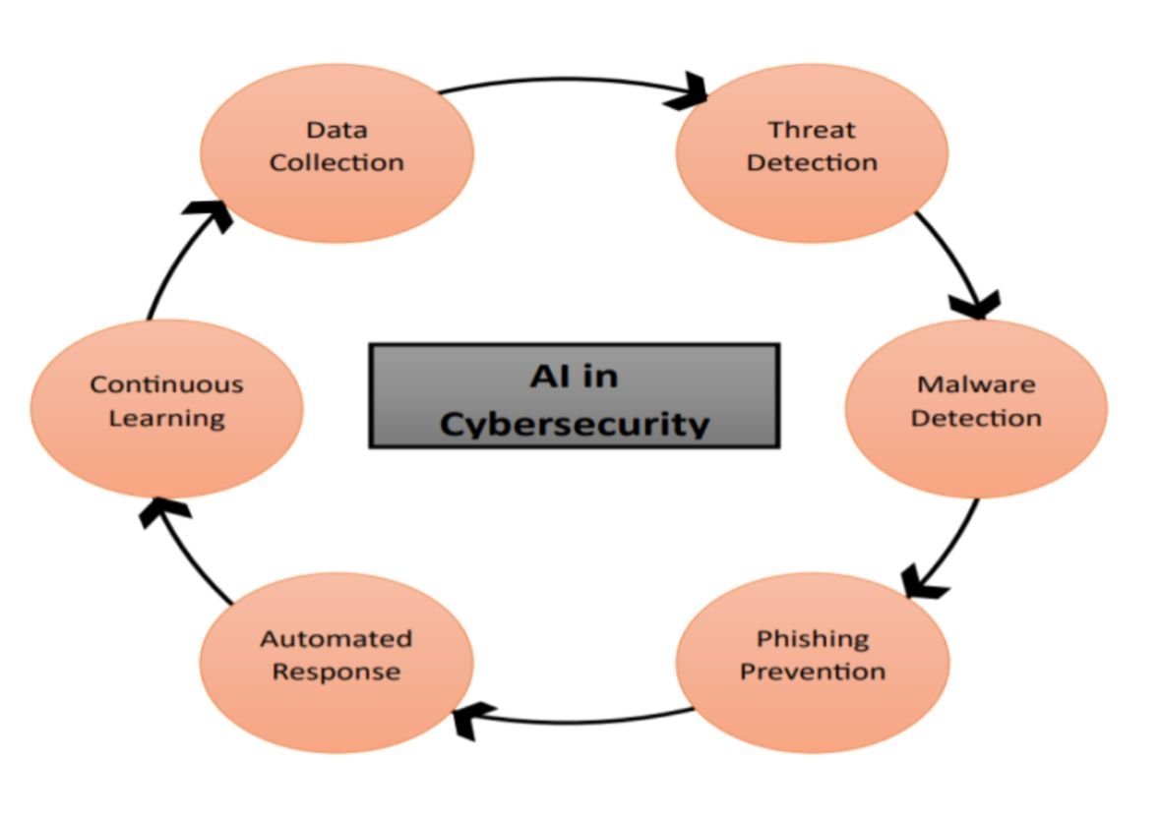

Fig 1: AI in Cybersecurity

The Fig 1 titled "AI in Cybersecurity" illustrate an AI in cybersecurity works by collecting data from various sources, analyzing for protection threats, and detecting malware and phishing attempts. It automates response like blocking suspicious activities and continuously learns from new incidents to improve detection accuracy, creating an adaptive defense system that evolves over time.

**2. Crucial Research Components :**

Artificial Intelligence is the ability of machines to carry out tasks that usually need human intelligence, including learning, reasoning, problem-solving, and adapting to new circumstances.

In cybersecurity, AI serves as a transformative technology that enhances traditional security methods by automating tasks, analyzing large datasets, and improving the detection and responses to changing cyber threats.

AI’s role in this field includes various techniques such as machine learning, natural language processing, and pattern recognition, all aimed at bolstering the defense of digital systems against malicious activities. The objective is to enable computers to replicate human cognitive abilities to proactively identify and address potential cybersecurity risks.

**2.1. Evolution of AI in Cybersecurity:**

The evolution of AI in cybersecurity has been significant, with traditional systems depending on rule-based mechanisms like firewalls and antivirus software, artificial intelligence (AI) in cybersecurity has undergone a substantial evolution. When it came to emerging cyber threats and zero-day assaults, these technologies were useless. AI-powered cybersecurity makes security more proactive and adaptable by analyzing big information, identifying anomalies, and forecasting possible threats using machine learning and deep learning. Machine learning (ML)-based techniques have significantly replaced rule-based systems since ML models can learn from data and get better over time, spotting new attack patterns without the need for explicit programming. Real-time detection of sophisticated cyberthreats has been greatly improved using unsupervised learning approaches like anomaly detection. By automating security procedures, decreasing manual intervention, and speeding up response times, AI-driven automation has completely changed threat detection. AI-powered security tools can monitor network traffic, user behavior, and system logs to detect anomalies and predict cyberattacks before they occur, enhancing efficiency and reducing false positives.

**2.2.** **AI in Cybersecurity**

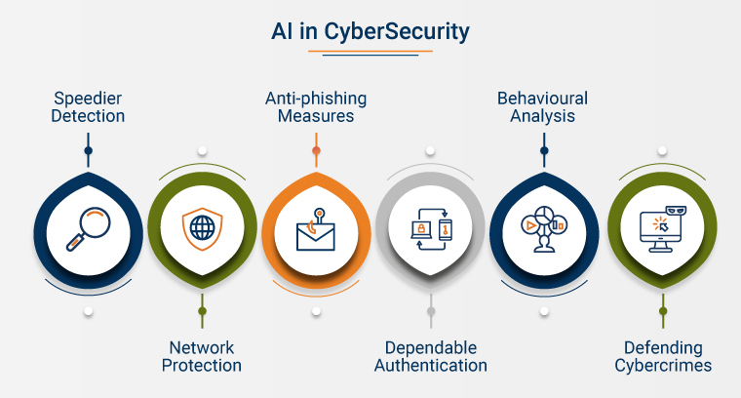

Fig 2: AI's Role in Cybersecurity

The Fig 2 titled "AI's Role in Cybersecurity" illustrates five key areas where Artificial Intelligence contributes to strengthening cybersecurity measures. Here is a breakdown of each section:

AI technology offers several benefits, including faster threat detection, network protection, anti-phishing measures, reliable authentication, behavioral analysis, and cybercrime prevention. It uses machine learning algorithms to analyze large amounts of data in real-time, identifying anomalous traffic patterns and weak points. AI also helps in detecting phishing attempts by examining email content and highlighting suspicious connections. It also reduces the need for passwords and provides early warnings based on user behavior.

**2.3. Cyber Security Framework Overview:**



Fig 3: Cyber Security Framework Overview

The Fig 3 titled "Cyber Security" illustrate a circular framework of key components that contribute to comprehensive cybersecurity measures. These components are interconnected, showcasing the multidimensional approach needed to ensure robust security. Here is a breakdown of each area:

The policy outlines various security measures, including end-user education, application security, information security, network security, operational security (OPSEC), internet security, ICT security, and IoT security. It aims to educate users about online threats, prevent software vulnerabilities, protect data from unauthorized access, and ensure smooth operation of IT systems. It also covers internet security, ICT security, and IoT security to prevent hackers from exploiting linked devices.

**3. Threat Detection Using AI:**

AI plays a crucial role in modern threat detection, enhancing cybersecurity decision-making. It helps organizations identify malicious activities and automate incident response strategies. Traditional methods rely on rules and signature-based systems, while AI-driven systems process large data volumes in real time, identifying patterns and behaviors for early detection and faster responses.

**3.1. Intrusion Detection Systems (IDS) and AI-Powered SIEM**: IDS (intrusion detection systems) keep an eye on network traffic for any security breaches and suspicious activities. The signature-based detection used by traditional IDS is ineffective against emerging attack patterns. Real-time threat identification is achieved by AI-enhanced IDS using machine learning and anomaly detection. In a similar vein, Security Information and Event Management (SIEM) systems use AI to enhance cybersecurity defenses by correlating logs, detecting anomalies, and automating attack responses.

**3.2. Artificial Intelligence for Malware and Ransomware Detection:** Conventional malware detection relies on signature-based scanning, which is ineffective against zero-day attacks. AI-powered solutions identify malware based on patterns rather than predefined signatures by using behavioral analysis and deep learning. AI is capable of detecting suspicious activities, monitoring file encryption behaviors, and stopping harmful programs before they encrypt user data in the case of ransomware.

**3.3. Natural Language Processing (NLP) for Phishing Detection:** Phishing emails frequently include misleading information intended to fool recipients into clicking on harmful links. Email content is analyzed using AI-driven Natural Language Processing (NLP), which looks for anomalies, deceptive language, and fraudulent tendencies. By evaluating the tone, structure, and sender information, natural language processing (NLP) models can identify phishing efforts and lower the chance of credential theft.

**3.4. AI for Identity Verification and Fraud Detection:** Cybercriminals perpetrate identity theft and financial fraud using advanced methods. In order to identify irregularities, AI-powered fraud detection systems examine user behavior, transaction patterns, and geolocation data. AI and biometric verification (voice, fingerprint, and face recognition) increase identity identification by thwarting fraudulent activity and unlawful access.

**4. Role of AI in Cybersecurity:**

**4.1. Advanced Anomaly Detection:** Traditional methods depend on predefined signatures to recognize known threats. Al, however, excels in analyzing large datasets from network traffic, user behaviors, and system logs, allowing it to identify subtle deviations and anomalies that could indicate new attacks-issues that signature-based methods may overlook. This capability facilitates the detection of zero-day threats, which are unknown vulnerabilities.

**4.2. Enhanced Threat Intelligence:** Al, especially generative Al, can automatically scrutinize extensive amounts of code and network traffic to uncover potential threats. This automation alleviates security analysts from mundane tasks, enabling them to concentrate on more complex investigations. Additionally, Al can produce reports and insights that deepen the understanding of threat dynamics.

**4.3. Predictive Threat Detection:** Al can assess historical attack data and threat intelligence feeds to identify patterns, helping predict potential future attacks. This foresight enables security teams to implement preventative measures and strengthen defenses before an attack occurs, significantly improving the overall security posture.

**4.4. User and Entity Behavior Analytics (UEBA):** Al can monitor user activities to detect deviations from established norms, aiding in the identification of insider threats. For instance, if an employee attempts to access sensitive data in a suspicious manner, Al can generate an alert that prompts further investigation.

**4.5. Automating Repetitive Tasks and Reducing Alert Fatigue:** Security teams frequently face an overload of alerts from conventional systems. Al can streamline the analysis of these alerts, eliminating false positives and prioritizing the most critical ones. This helps reduce alert fatigue among security personnel, allowing them to focus on genuine threats.

**5. Challenges in AI-Driven Cybersecurity:**

**5.1. Adversarial Attacks**: AI models can be tricked by hackers, requiring robust models to withstand adversarial inputs. Cyber adversaries can us ethe method to exploit AI systems, including adversarial examples- inputs that have been slightly modified to mislead machine learning models and make them ineffective. With the increasing use of AI systems, attackers can create dynamic threats that adapt based on the defenses they face, posing challenges for conventional security measures to keep up.

**5.2. Data Privacy**: AI systems often require extensive datasets for training, which can involve sensitive information. This raises concerns about data handling practices and compliance such as GDPR and CCPA. Concerns over data collection, storage, and use are growing, leading to research into privacy-preserving techniques like differential privacy and federated learning.

**5.3. Algorithmic Bias**: AI systems can inherit biases from the data they are trained on, requiring diverse and representative datasets to reduce bias. It can reflect biases present in their training data, potentially leading to discriminatory practices or the overlooking of certain threats.

**5.4. Explainability**: AI models, often seen as "black boxes," lack transparency, making it difficult for cybersecurity professionals to understand decision-making. This lack of transparency can the ability to assess and trust AI-driven security measures. If AI systems storing sensitive data are compromised, the fallout can be significant. Attackers could exploit vulnerabilities in AI models to gain access to confidential information.

**5.5. Accountability:** As AI technology progresses, regulatory frameworks are also evolving. Organization needs to stay informed about illegal obligations and ensure their AI systems adhere to new laws and standards. The integration of AI in security brings up questions regarding accountability. In the event of failure, it can be ambiguous who is responsible- whether it is the organization, the AI developers, or the technology vendors.

**6. Future Directions and Prospects:**

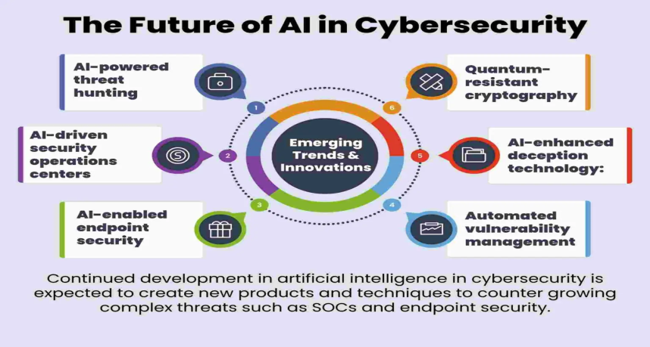

Fig 4: The Future of AI in Cyber Security

The Fig 4: “The Future of AI in Cyber Security” highlights emerging trends and innovations in AI-driven cybersecurity. The advancements are categorized into six key areas, which are expected to enhance security operations, detect threats efficiently, and mitigate vulnerabilities.

**6.1. AI-Powered Threat Hunting Overview:** The use of machine learning and AI in identifying cyber threats, analyzing large datasets, reducing false positives, and predicting future attack patterns through threat intelligence feeds and AI models offers benefits such as faster detection, reduced dependency on manual security analysis, and proactive security measures.

**6.2. AI-Driven Security Operations Centers(SOCs):** Utilize AI and automation for real-time cybersecurity incident monitoring and response, automating threat detection and response, analyzing large log data and network traffic, and correlating security events across multiple sources for attack detection.

**6.3. AI-Enabled Endpoint Security:** The system enhances endpoint security by protecting devices from cyber threats, continuously monitoring device behavior, and using AI-driven antivirus and EDR to detect zero-day malware and stop advanced persistent threats using behavioral analysis. It ensures real-time monitoring and detection.

**6.4. Automated Vulnerability Management:** AI-driven vulnerability management automates software vulnerability detection and patching, prioritizing risks based on impact and exploitability. It aids in patch management and security updates, offering faster detection, reduced attack surface, and time-saving in manual vulnerability scanning.

**6.5. AI-Enhanced Deception Technology:** The technology enhances deception through honeypots and decoys, creates fake assets, files, and systems to lure attackers, analyzes hacker behavior for security strategies, traps attackers before reaching real systems, provides valuable insights into hacker techniques, and reduces damage.

**6.6. Quantum-Resistant Cryptography:** AI aids in developing cryptographic algorithms to resist quantum attacks, enhancing data encryption, protection against cyber threats, and enhancing privacy and secure communications. Quantum computers can break current encryption methods like RSA and AES.

**7. Conclusions :**

Artificial Intelligence (AI) has significantly improved cybersecurity through advanced threat detection, prevention, and response mechanisms. AI’s contribution to cybersecurity will only grow as the technology develops. Techniques like Machine Learning and Deep Learning have improved the ability to detect anomalous behavior, recognize malicious patterns in real-time, and predict potential threats. AI-driven systems excel in handling the increasing complexity of cyberattacks, such as malware, ransomware, phishing, and zero-day exploits. AI offers enhanced threat detection, proactive prevention, automated response, and behavioral analytics. Threat detection and response capabilities could be further improved by innovations like quantum AI and more sophisticated language models. But as AI becomes increasingly common in cybersecurity are also changing. AI will likely be utilized in increasingly complex assaults, so business will need to remain alert and update their security often However, challenges remain, such as adversarial attacks, data privacy, ethical AI use, and biases in AI algorithms. Addressing these issues is crucial to ensure trust and effectiveness in AI-powered cybersecurity solutions.

**8. References :**

1. Ahmed, M., Mahmood, A. N., & Hu, J. (2016). *A survey of network anomaly detection techniques. Journal of Network and Computer Applications*, 60, 19-31.
2. Roy, S., & Chellappan, S. (2020). *A survey of machine learning methods for cybersecurity*. IEEE Transactions on Neural Networks and Learning Systems.
3. Kim, D. H., & Kim, J. J. (2020). *A review of cybersecurity datasets for anomaly detection in the Internet of Things*. Applied Sciences, 10(4), 1270.
4. López-Martín, M., Carro, B., & Sánchez-Esguevillas, A. (2020). *Application of deep reinforcement learning to intrusion detection for communication networks*. Applied Sciences, 10(11), 3701.
5. Roy, S., & Dey, N. (2021). *Use of natural language processing for cybersecurity: A survey*. IEEE Access, 9, 130207-130223.
6. Salih, Y., & Fan, X. (2022). *Machine learning models for predictive cybersecurity risk: A survey and research roadmap*. Journal of Cybersecurity and Privacy, 2(2), 245-271.
7. Gupta, M., & Srivastava, R. (2019). *A survey of security orchestration automation and response for cloud computing security*. International Journal of Cloud Computing and Services Science, 8(3), 643-657.
8. Biggio, B., & Roli, F. (2018). *Wild patterns: Ten years after the rise of adversarial machine learning*. Pattern Recognition, 84, 317-331.
9. Papernot, N., McDaniel, P., Goodfellow, I., et al. (2017). *Practical black-box attacks against machine learning*. Proceedings of the 2017 ACM on Asia Conference on Computer and Communications Security, 506-519.
10. Calo, R. (2017). *Artificial intelligence policy: A primer and roadmap*. University of Washington School of Law Research Paper, (2017-04).
11. Shor, P. W. (1997). *Polynomial-time algorithms for prime factorization and discrete logarithms on a quantum computer*. SIAM Journal on Computing, 26(5), 1484-1509.
12. Li, Z., & Hoi, S. C. H. (2018). *Online continual learning with growing long-term and short-term memory*. International Conference on Machine Learning (ICML), 2346-2355.