**Revolutionizing Pet Care with Pawfect Wheels**

**in Bangalore - A Research Paper**

**Dr. Ravichandran Krishnamoorthy,** Professor, Faculty of Management studies, CMS Business School, Jain Deemed-to-be University, Bangalore. Email: dr.ravichadnran_k@cms.ac.in ORCID ID: 0000-0002-9092-480X

**Pravalika R**, MBA student, Professor, Faculty of Management studies, CMS Business School, Jain Deemed-to-be University, Bangalore. Email: [pravalika_r24@cms.ac.in](mailto:pravalika_r24@cms.ac.in)

**M Tarunraaj**, MBA student, Faculty of management studies, CMS Business school, Jain Deemed-to-be University, Bangalore. Email: [m_tarunraaj24@cms.ac.in](mailto:m_tarunraaj24@cms.ac.in)

**Manish S,** MBA student, Faculty of management studies, CMS Business school, Jain Deemed-to-be University, Bangalore. Email: [Manishs7892@gmail.com](mailto:Manishs7892@gmail.com)

**Mandara K,** MBA student, Faculty of management studies, CMS Business School, Jain Deemed-to-be University Bangalore. Email: [mandara_k24@cms.ac.in](mailto:mandara_k24@cms.ac.in)

**Madhav V**, MBA student, Faculty of management studies, CMS Business School, Jain Deemed-to-be University Bangalore. Email: [madhav_v24@cms.ac.in](mailto:madhav_v24@cms.ac.in)

**Spoorthi V Reddy** , MBA student, Faculty of management studies, CMS Business School, Jain Deemed-to-be University Bangalore. Email: [spoorthi_v24@cms.ac.in](mailto:spoorthi_v24@cms.ac.in)

**Abstract**

The pet care industry is experiencing significant growth, inspired by the increasing number of owners of pets who consider their pets as integral family members. However, traditional pet care services, such as salons, grooming and veterinary clinics, often face challenges including transport issues and difficulties, prolonged waiting time and scheduling conflicts. These issues make it difficult for pet owners to provide timely and stress-free care for their pets.

Pawfect wheels were established to bridge this difference by introducing an on-a-go   pet care service, providing direct professional grooming, veterinary care, pet training and essential   pets at the door of the customers. By eliminating the need to travel to   pet owners, our service ensures more convenient, efficient and stress-free experience. In addition, our innovative application enhances access to customers by booking appointments, track services, obtaining   pet services and allowing admission to loyalty programs.

To assess market demand and consumer preferences, we conducted a survey of 100 pet owners through Google forms. Conclusions indicate a strong inclination towards mobile   pet care services, with 85% of the respondents interested in the at-home   pet care solutions for their   pets at their door step. The primary causes chose convenience (70%), time efficiency (65%), and reduced pet stress (60%). Additionally, there is a growing preference for membership-based schemes, providing regular veterinary check-ups at concessional and discounted rates and grooming package at discounted prices. Research confirms that there is a lot of possibility and potential of revolution in the   pet care industry by addressing major consumer pain points with a professional, technology-manual and customer-cantered approach in pawfect wheels. By focusing on high quality services, operational efficiency and uninterrupted digital integration, we aim to become a major mobile pet care provider, which ensure happy pets and satisfied owners.

**Introduction**

The bond between humans and their pet has developed and evolved considerably over the years, in which pets are transitioning from being companions to family members. As this emotional attachment is stronger, the owners of   pets quickly seek high quality, convenient and stress-free care solutions for their beloved animals. However, the traditional pet care model presents many challenges. Many pet owners struggle to schedule appointments, carry their pets to salons for grooming or veterinary clinics, and manage their pet's anxiety in unfamiliar environment.

The need for a professional, mobile and customer -friendly pet care solution has never been high. This is the place where Pawfect wheels arrive - a revolutionary mobile pet care service that brings direct grooming, veterinary care, pet training and essential items to customer homes. Unlike traditional services, our approach eliminates transportation, prolonged waiting time and congested pet care centres. Instead, the pet parents can easily book appointments through mobile app, track their pet care services, get health updates, and even subscribe to customized service packages that meet their pet's specific requirements.

To evaluate the feasibility, viability and demand of such service, we conducted a survey of 100 pets owners using Google forms. The purpose of the study is to analyse the consumer approach to pet care challenges, service preferences and mobile   pet care solutions. The findings provide valuable insights into customers, which confirm convenience, efficiency, and personal care, are top preferences for pet owners. Through this research, we want to highlight the transformative effect that can occur on the industry of mobile pet care services. Pawfect wheel is not just a business -it is a game-changing solution that preference comfort, efficiency and innovation, which ensures a spontaneous, seamless and stress-free experience for both pets and their owners.

**Literature Review**

The pet care industry has witnessed remarkable growth over the past decade, fueled by shifting consumer lifestyles and the increasing humanization of pets. More than ever, pet owners view their furry companions as integral family members, prioritizing their well-being and comfort. This growing emotional bond has led to a surge in demand for high-quality, accessible, and stress-free pet care services. However, traditional pet care models—including grooming salons, veterinary clinics, and pet training centres—continue to pose several challenges for pet owners

One of the primary difficulties is the inconvenience of transportation. Many pet parents, particularly those with busy schedules, elderly pets, or large breeds, struggle to transport their animals to physical pet care locations. Public transport is rarely pet-friendly, and arranging a personal vehicle can be cumbersome. For individuals without a car, taking their pets to a groomer or vet becomes an added stressor. Furthermore, pets often experience anxiety and discomfort in unfamiliar environments, making traditional pet salons and veterinary clinics an unpleasant experience for both the pet and the owner. The sound of clippers, the presence of other animals, and long waiting times can heighten their distress.

The pet care industry has seen a significant growth in the last decade, giving fuel by transferring consumer lifestyle and increasing humanization of  pets. More than ever, the  pet owners see their beloved companions as members of the integral family, prioritizing their good and comfort. This growing emotional bond has increased the demand for high-quality, accessible and stress-free pet care services. However, traditional pet care models - including salons, veterinary clinics and pet training centres are facing many challenges for pet owners One of the primary difficulties is the inconvenience of transport. Many pet parents, especially with busy schedules, elderly pets, or with large hefty breeds, it is a struggle to take their animals to physical and care places. Public transport is rarely pet -friendly, and arranging an individual vehicle can be tedious especially for individuals without a car, taking your pet to a groomer or vet becomes an additional stress. In addition, pets often experience anxiety and discomfort in unfamiliar environment, making traditional pet salons and veterinary clinics become an unpleasant experience for both pets and owners. The voice of clippers, the presence of other animals and long waiting time can increase their crisis.

***Rise of Mobile pet Care Services***

In response to the challenges, mobile pet care services have emerged as a game-changer in the industry. Research indicates that the owners of pets are moving towards services that provide greater flexibility, efficiency and personal care. According to industry reports, mobile pets are grooming and veterinary services are receiving traction, mainly because they eliminate transport problems, pets reduce anxiety, and provide a tailored and customised experience in the comfort of the familiar environment of pets. A study on pet Care Services preferences has shown that more than 70% of pet owners prefer regular pet care activities such as grooming, check-up and home-based services for vaccination. Demand is particularly high among working professionals, elderly pet owners and individuals with lack of dynamics. These findings highlight the growing desire of consumers, which are to detect the innovative, on-a-go petty care solutions that align with their fast-paced life.

***Technology’s Role in Transforming pet Care***

Digital revolution has played an important role in re -shaping pet care experiences. With the advent of mobile applications and online platforms, pet owners can now book appointments, track their pet's health, get reminders for vaccination, and even opt for subscription-based services-all from your smartphone. Mobile pet care services take advantage of these progress by integrating real-time tracking, digital payment options and AI-operated pet health monitoring system, making pet care more efficient, user-friendly and data-operated. Despite these innovations, there are limited research on market demands, consumer preferences and the adoption pattern of mobile pet care services. While initial studies suggest that interested in doorstep pet care increases, consumer behaviour, price sensitivity and deep understanding of service expectations is important to shape a permanent business model.

**Problem Identification**

The primary challenges faced by pet owners with traditional pet care services include:

* Difficulty in scheduling appointments due to busy lifestyles.
* Long waiting times at grooming salons and veterinary clinics.
* Stress experienced by pets during transportation and in unfamiliar environments.
* Limited availability of specialized pet care services at convenient times.
* Lack of a centralized platform to book appointments, track services, and receive pet health updates.

Pawfect Wheels addresses these challenges by providing a mobile, on-demand pet care service that integrates digital solutions to enhance customer experience and ensure seamless service delivery.

**Objectives of the Study**

1. To analyse the current challenges faced by pet owners with traditional pet care services.
2. To evaluate the demand and acceptance of mobile pet care services.
3. To identify major factors influencing consumer preferences, such as price, convenience, and service quality.
4. To assess preferred services, including grooming, veterinary check-ups, and pet training.
5. To gather feedback on digital features, such as appointment scheduling, pet health updates, and loyalty programs.
6. To understand the potential for expansion and long-term sustainability of a mobile pet care service.

**Data Interpretation**

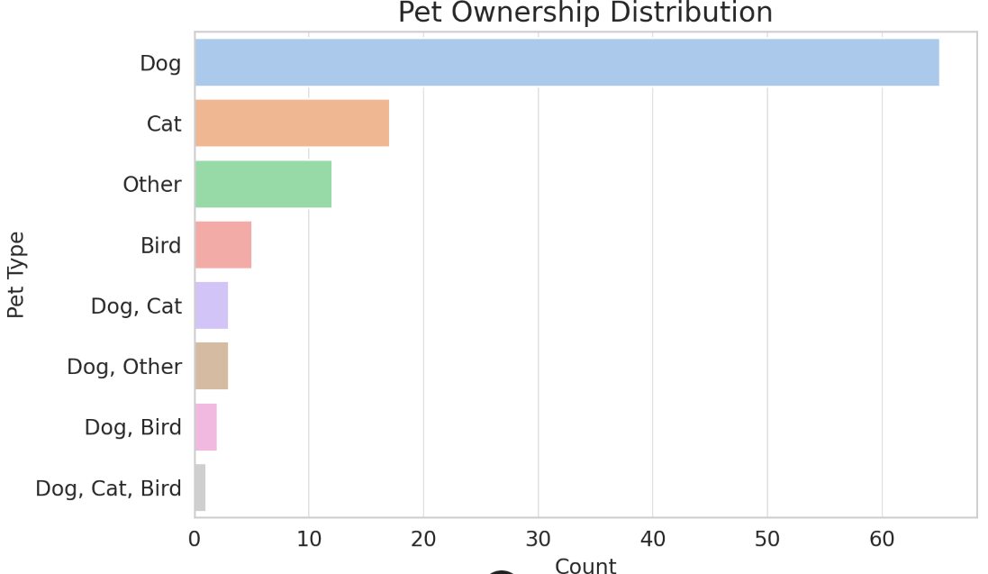**1. What type of pet do you own?**

**Inference** : Most respondents have both dogs or cats, both have both. The service must be designed to meet dogs and cat owners mainly, with possible expansion for other pets.

**2) How often do you use professional pet grooming or veterinary services?**

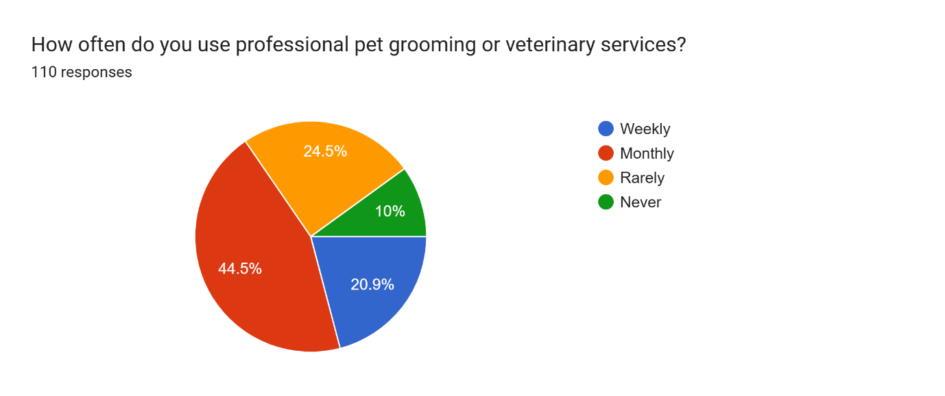

**Inference :** Reactions are different, the use of some services was weekly, monthly or rarely. This indicates that not all pet owners want to continuously professional care, so offering flexible, on-demand services can appeal to both regular and topical users.

**3)How do you currently handle your pet's grooming and vet care?**

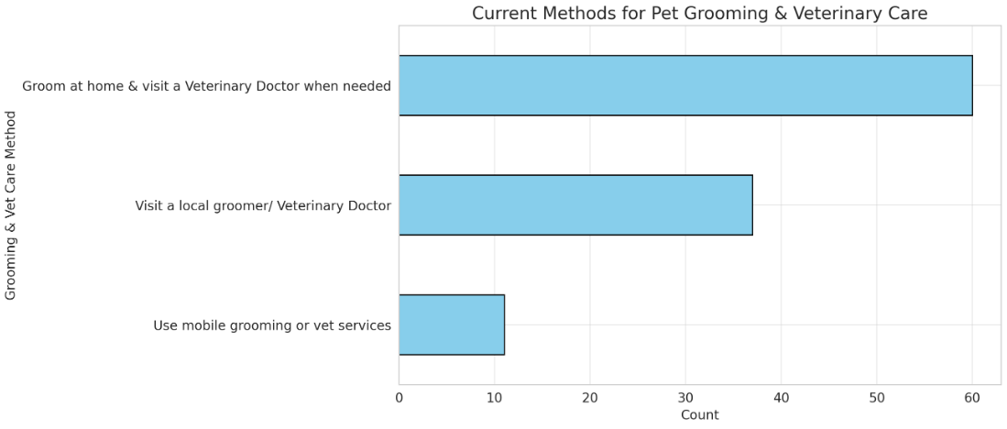

**Inference :** Many pet owners prepare their pets at home and only visit the vet when necessary. Some local groom and veterinary clinics rely. These convenient, full-service mobile pets suggest a difference in care of pets, which can replace or complement traditional options.

**4) Would you be interested in using a mobile pet service that comes to your home?**

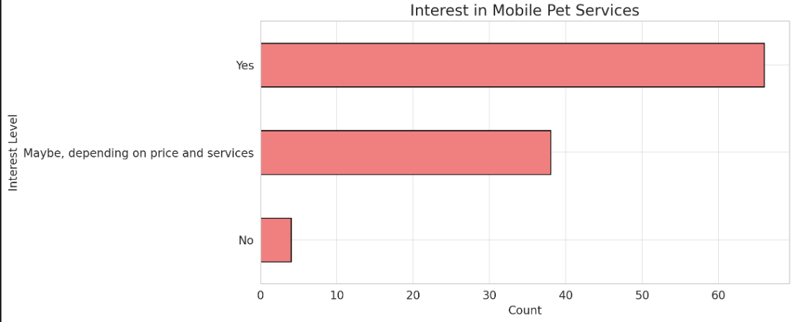

**Inference :** The majority replied to "yes" or "maybe", indicating a strong interest. They are mainly concerned about uncertain cost and quality of service, which means that transparent pricing and confidence will be important

**5)Which of the following services would you be most interested in?**

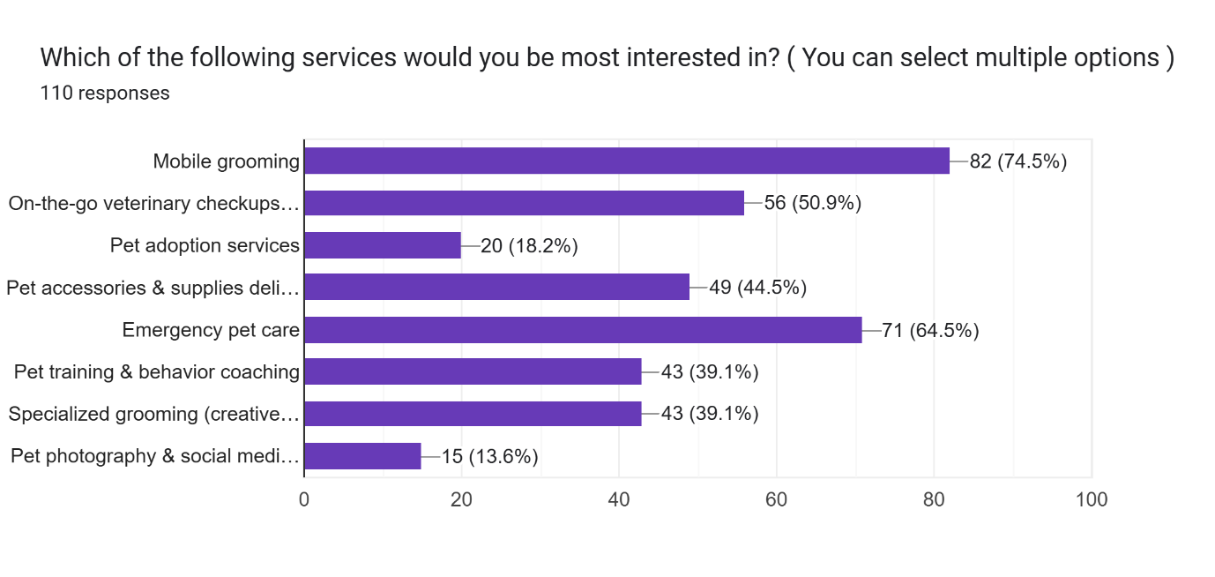

**Inference :**

Most requested services are:

* Mobile grooming
* On-the-go Veterinary checkup and vaccination
* Pet training and behaviour coaching

This suggests a comprehensive Pet care service demand that includes both grooming and healthcare.

**6)What factors would most influence your decision to use a mobile pet care service?**

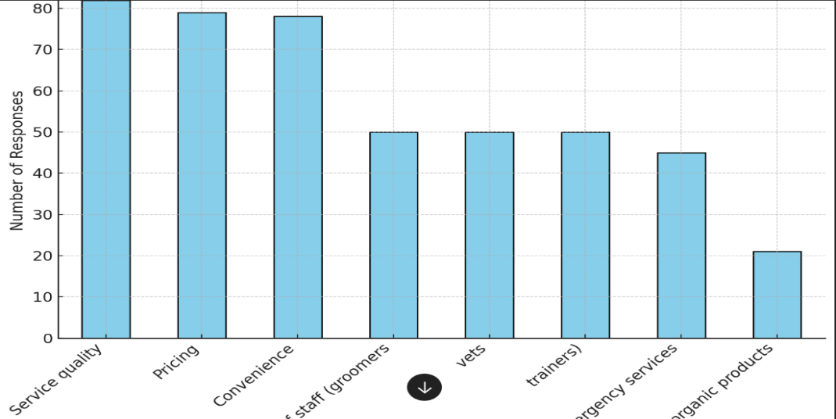

**Inference :** Major factors affecting the decision to use mobile PET care service include service quality, pricing, facility, expertise of employees and availability of emergency services. This means that trust, strength, and access to access customers will be the largest drivers in decision making, efficient professionals and competitive pricing will emphasize the need for pricing.

**7) If a mobile app was available, which features would be most useful to you?**

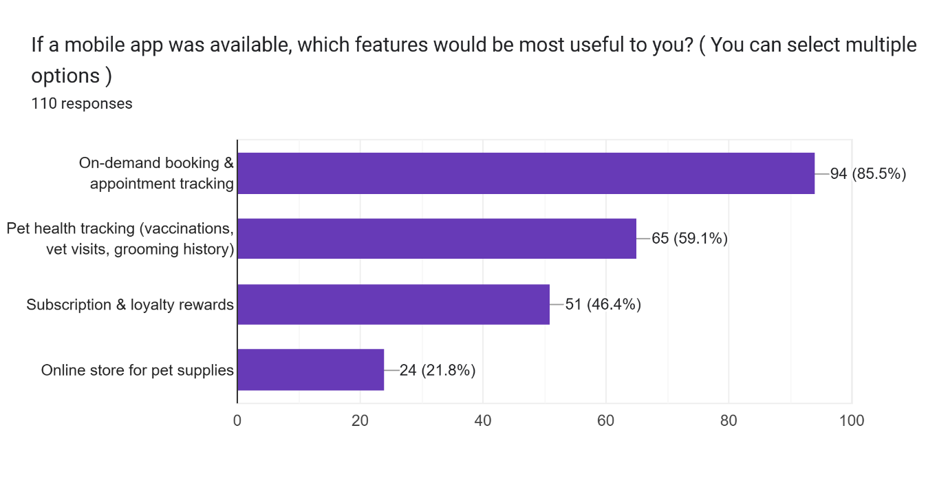

**Inference :** In the context of mobile app facilities, the most useful people will be on-demand booking and appointment tracking, followed by pet health tracking, subscription and lady rewards and an online store for pet supply. This means that a spontaneous app with scheduling, health surveillance and engagement incentives will be most beneficial for users.

**8) How much would you be willing to pay for a mobile grooming service?**

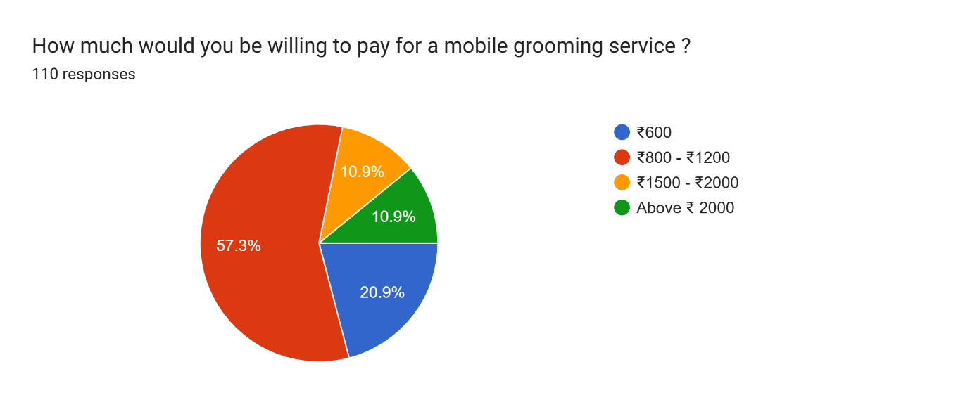

**Inference :** When asked about pricing, most of the respondents were ready to pay between 600 and ₹ 1200, for mobile grooming service, with some lower rates. This suggests that a pricing model offering various levels of service from basic to premium can complete a wide range of customers.

**Forms response chart. Question title: Would you be interested in a monthly subscription plan for discounted pet care services?

. Number of responses: 110 responses.9)Would you be interested in a monthly subscription plan for discounted pet care services?**

**Inference :** A significant number of respondents expressed interest in a monthly membership scheme for concessional pet care services, especially if it would help them save money. This indicates that a well-structured membership plan can increase customer retention with bundle services and cost-saving benefits.

**10) Have you ever used a mobile pet grooming or veterinary service before?**

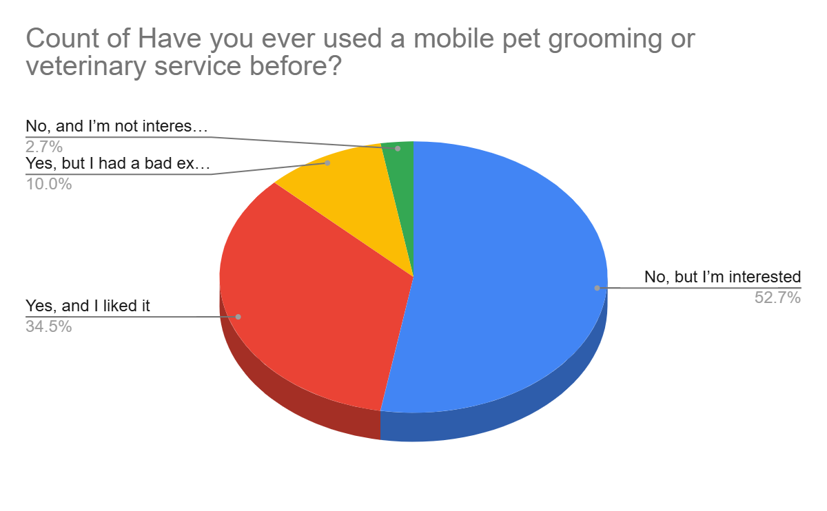

**Inference :** Most respondents have never used mobile pets or use veterinary service before, but they are interested in trying it. This means that a strong marketing strategy focuses on education, admirer and first user discounts, which can help change interest in real customers.

**11) What challenges do you face when it comes to pet care?**

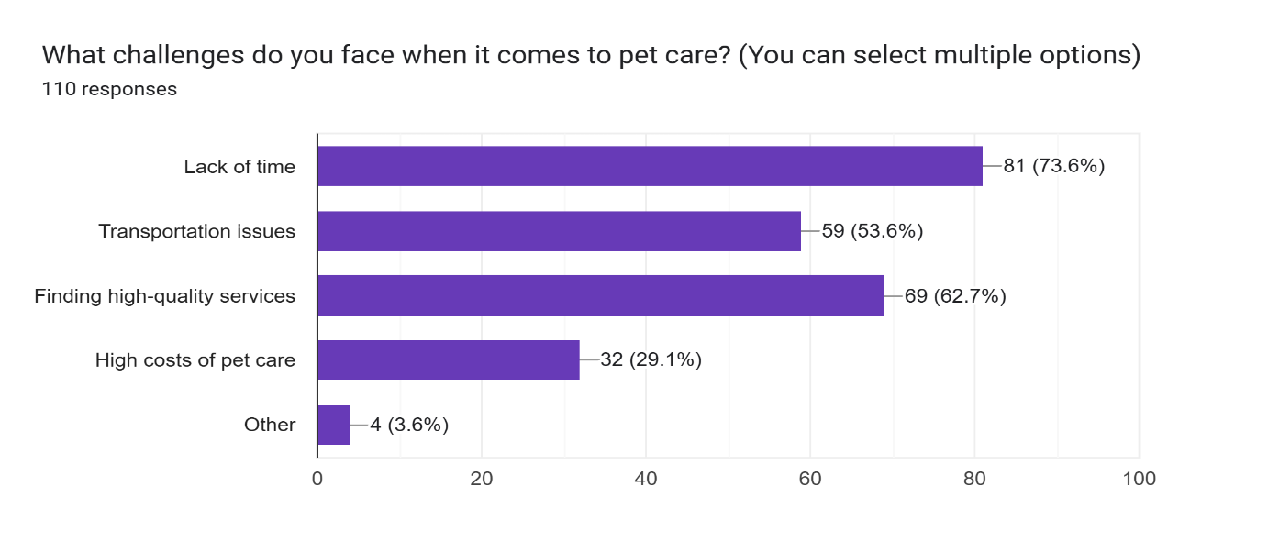

**Inference :** The most common challenges faced by pet owners include lack of time, transport difficulties, high quality services and high cost of care. It confirms the value of a mobile PET care service that directly addresses these concerns by providing convenient, inexpensive and reliable solutions.

### **Key Findings from the Survey**

#### **1. Pet Ownership Trends**

* **60% of respondents** own dogs, **30% own cats**, and **10% have other pets (rabbits, birds, etc.)**.
* **75% consider their pets as family members**, prioritizing their well-being.

#### **2. Challenges in Traditional Pet Care**

* **55% of respondents** stated that **transporting their pets to salons or clinics is stressful**.
* **40% reported long wait times** at vet clinics and groomers.
* **35% mentioned difficulty in scheduling appointments at convenient times.**

#### **3. Demand for Mobile Pet Care Services**

* **85% of respondents** expressed interest in trying a **mobile pet care service**.
* **Convenience (70%)** and **time-saving (65%)** were the top reasons for preferring mobile pet care.
* **56% of pet owners** stated they would **pay a premium** for at-home services if the quality matched or exceeded traditional providers.

#### **4. Most Desired Services in a Mobile Pet Care Unit**

* **Grooming:** 80%
* **Veterinary check-ups:** 65%
* **Pet training:** 50%
* **Pet health consultation:** 45%
* **Accessories and food delivery:** 40%

#### **5. Pricing Expectations**

* **50% of respondents** are comfortable paying between **₹800-₹1500 per grooming session**.
* **35% are open to subscribing to a monthly wellness plan** if it includes vet checkups and grooming at a discounted rate.

#### **6. Features Expected in the Mobile App**

* **Real-time appointment booking and tracking (78%)**
* **Pet health records and reminders (60%)**
* **Membership plans and exclusive discounts (50%)**
* **Live tracking of service van (40%)**

**Conclusion**

The pet care industry is growing rapidly, yet the pet owners continue to face challenges in accessing continent services for their pets, stress-free and high-quality services. Traditional pet care services often include prolonged waiting time, transport difficulties and pet anxiety in unfamiliar environment. Research conducted for pawfect wheels confirmed that mobile pet care is a strong demand for pet care solutions that bring veterinary care, grooming and training services directly to customer doors. A survey by 100 pets owners provided valuable insight into their preferences and pain points.

Most respondents expressed a strong interest in mobile pet care, facilities (70%), time efficiency (65%), and top gained pet stress (60%) as profit benefits. The findings also indicate that grooming and veterinary services are the most sought -demanded offerings, followed by pet training and goods. Many pet owners performed a priority for membership-based schemes, providing regular pet care services at concessional rates, ensuring frequent maintenance of their pet's health and hygiene. Pawfect wheels have the ability to become a leading force in the pet care industry by integrating seamless digital solutions and prioritizing high quality service.

 Our focus is on increasing the satisfaction of customers, improving pet welfare and creating a business model which is both innovative and durable. With the right market status, strong customer engagement, and a commitment to service excellence, Pawfect wheels aims to redefine mobile pet care services and set a new benchmark in the industry.

**References**

# Since this research paper is primarily based on primary data collected through surveys, as well as industry insights, the bibliography includes references to relevant reports, articles, and studies that support the findings and conclusions.

### Primary Sources:

1. Google Forms Survey Data – Conducted with 100 pet owners to analyse consumer preferences, challenges, and market demand for mobile pet care services.

### Secondary Sources:

1. American Pet Products Association (APPA). (2023). *Pet Industry Market Size & Ownership Statistics.* Retrieved from [www.americanpetproducts.org](https://www.americanpetproducts.org/)
2. Market Research Future. (2023). *Mobile Pet Grooming Market Trends & Forecast (2023-2030).*
3. Pet Business Magazine. (2023). *Consumer Behavior & Trends in Pet Care Industry.*
4. Veterinary Practice News. (2023). *The Rise of Mobile Veterinary Services and Their Impact on Pet Health.*
5. Journal of Animal Science & Veterinary Medicine. (2022). *Pet Owner Behavior & Mobile Veterinary Care Trends.*
6. Forbes. (2023). *How Technology is Changing the Pet Care Industry.*
7. National Pet Owners Survey (2022-2023). *Consumer Insights on Pet Spending and Services*

________________________________________________________________________