**TRANSDISCIPLINARY PROJECT CENTRIC LEARNING**

TD-PCL Report submitted in partial fulfilment of the requirement for the award of the degree of

**Master of Business Administration (MBA)**

Submitted By

1. **JOTHI V (24MBAR0151)**
2. **ASHISHK M (24MBAR0674)**
3. **ASHWIN RAJ (24MBAR0649)**
4. **APARNA MANOJ (24MBAR0726)**
5. **AISVARYA LAKSHME (24MBAR1041)**
6. **AVIKSHIT KURTARKAR (24MBAR0093)**

Under the Guidance of

**Dr Moovendhan V**

Faculty of Management Studies, CMS Business School



**No.17, Seshadri Rd, Gandhi Nagar, Bengaluru, Karnataka 560009**

[**Phone**](https://www.google.com/search?rlz=1C1DIMC_enIN830IN830&q=cms+business+school+phone&ludocid=111339774717340472&sa=X&ved=2ahUKEwj-vIzom6XlAhV873MBHQvxCb8Q6BMwEnoECAoQLg)**: 080 4684 0400**

**2025**

**Financial Literacy- To bring awareness to the young minds about the power of financial literacy**

**Dr Moovendhan V, Jothi V, Ashwin Raj,** **Aparna Manoj,** **Ashish K M,** **Avikshit Kurtarkar,** **Aisvarya Lakshme R**

***Faculty of Management Studies, CMS Business School***

***JAIN (Deemed-To-Be-University), Bangalore, India.***

**ABSTRACT**

*Financial literacy is an essential skill in today’s rapidly evolving economic environment. This research paper explores financial knowledge, behaviour, and attitudes among young people, areas of financial education, and a need for formal learning. With more sophisticated financial systems, with the advent of online banks, investment websites, and cryptocurrency, financial literacy has become a foundation of financial well-being and autonomy. The research conducted a survey of 136 participants to determine their level of financial literacy in major financial issues like budgeting, saving, investing, credit management, and financial planning. The results show that though most respondents realize the significance of financial literacy, many do not have hands-on experience and confidence in handling their finances. Over half of the respondents admitted to not knowing how credit cards and interest rates work, and a significant majority had never invested in the financial markets. Moreover, financial education is not very common in school curricula, adding more fuel to financial ignorance. Encouragingly, 92.6% of the respondents of the survey had expressed interest in attending financial literacy workshops, validating a strong demand for education courses. In addition, specific topics of interest were also found by the respondents, such as investing in the stock market, financial planning by students, tax, and innovative options for financial education. The research validates the inclusion of financial literacy courses in school and college curricula, empowering young people with the necessary abilities to make sound financial choices. Guided by these results, the study advises governments to introduce systematic financial literacy courses, promote investment education, decode finance lingo, and take advantage of web platforms in an attempt to enhance financial awareness. Closing these loopholes will see policymakers, teachers, and banks empower young people with the skills and self-confidence needed to move around the finance sector, to economic security and empowerment in the long run.*

**Keywords:** *Financial Literacy, Youth Financial Behaviour, Financial Education, Budgeting and Saving, Investment Awareness, Economic Empowerment*

**JEL Classification Number:** D14

**I INTRODUCTION**

In an era of more dynamic economic influences and more complex financial systems, the need for youth financial literacy has never been more urgent. As young adults and teenagers make their way out of school settings into independent financial decision-making, they are confronted by a complex array of financial challenges requiring sophisticated knowledge and careful thought. Even as personal finance has become increasingly sophisticated, mainstream education systems have not been able to keep up with it, and the majority of young people remain susceptible to making financial errors.

The emergence of online money platforms, crypto currency, advanced investment products, and changing credit systems has revolutionized the economic landscape. Young people today have to move through these multi-layered spaces with more limited first-hand experience, having to make do with piecemeal information from internet sites, social media, and limited formal financial education. This study will examine the reality of young people's financial literacy, including the gaps in knowledge, the obstacles to financial literacy, and suggesting potential ways to comprehensive financial education.

The subject of our investigation seeks to study some of the facets of young people's financial literacy, i.e.:

* Familiarity with essential money concepts and principles
* Familiarity with saving, budgeting, and investment procedures
* Familiarity with managing credit and avoiding debt
* Ability to make well-educated economic decisions within an increasingly computerized economic scene

**1.2 Technological Disruption and Financial Complexity**

The modern financial arena is marked by unprecedented technological transformation. Digital forums, artificial intelligence-driven financial offerings, blockchain platforms, and cutting-edge investment mediums have transformed how financial choices are made and conducted. Youngsters today need to have some extent of financial awareness that earlier generations could hardly imagine.

Cryptocurrency is a standout example here. DeFi platforms, NFTs, and blockchain-based financial products have introduced whole new dimensions of financial engagement. These technologies introduce unimaginable avenues of financial participation but also come with equally high technology literacy, risk analysis, and strategic planning demands.

**1.3 The Psychological and Social Dimensions of Financial Literacy**

Financial literacy is not just knowing numbers and financial products. It involves an intricate interplay of psychological, social, and cognitive processes affecting financial decision-making. Young adults need to learn:

* Build emotional intelligence in financial decision-making
* Exercise critical thinking to assess financial information
* Be resilient against financial uncertainties
* To distinguish between reliable and misleading financial advice
* Have a long-term perspective in financial planning and wealth accumulation

The social context of financial literacy has another level of complexity. Young people are saturated with cross-messages about money on social media, peer groups, and online platforms. Influencer culture, get-rich-quick adventures, and pushy selling of financial products make it difficult to impart good sense in financial decision-making.

**1.4 Socioeconomic Implications of Financial Illiteracy**

The consequences of financial illiteracy extend far beyond individual economic challenges. Young people who lack comprehensive financial knowledge face significantly higher risks of:

* Accumulating unsustainable personal debt
* Making suboptimal investment decisions
* Experiencing prolonged financial instability
* Becoming vulnerable to predatory financial practices
* Limiting their long-term economic potential and social mobility

The interconnected nature of economies in today's world causes personal financial choices to have larger systemic impacts. Economic inequality tends to be self-sustaining by virtue of disproportionate access to information and awareness regarding finance. The financially illiterate are put into a huge disadvantageous position with no capacity to benefit from financial opportunities or safeguard themselves from economic risks.

**1.5 The Changing Nature of Work and Financial Independence**

The traditional pathways to financial stability have undergone radical transformation. The gig economy, working from home, freelancing, and the decline of the conventional models of employment force youths to become more autonomous in handling their money. Sophisticated financial planning is now a survival necessity.

Side hustles, entrepreneurial activity, digital nomadism, and streams of secondary incomes demand the scope of financial competency beyond traditional job paradigm boundaries. Grown-up citizens must serve today as their own financial stewards, investment counsel, and career strategists. That demands an overarching intuition of personal finances incorporating digital aptitude, situational cognition, and mutable planning.

**1.6 Cultural and Generational Shifts**

Generational attitudes towards money, work, and financial success are rapidly evolving. Millennials and Generation Z exhibit unique money-making styles compared to their forebears. They will prioritize experiences over traditional wealth building, accept technology-driven financial options, and demand more open and ethical financial operations.

But these shifts in generations also highlight the acute need for responsible financial education. While young people are more tech-savvy, they are often lacking in the rudimentary financial knowledge required to make smart, strategic decisions in an increasingly complex economic system.

Through systematic examination of all these dimensions, we hope to contribute to a better understanding of youth financial readiness and make targeted recommendations to schools, policymakers, and personal finance educators.

**1.7 Review of Literature**

**Agarwal, S., Amromin, G., Ben-David, I., Chomsisengphet, S., & Evanoff, D. D. (2015).** In this study they talk about financial literacy and financial planning behaviour based on a financial advisory program in India. They evaluate survey responses to three standard questions previously used to measure financial literacy. They then break down the data across demographic and socioeconomic groups and compare responses.

**Babiarz, P., & Robb, C. A. (2014):** This study investigates the correlations between subjectively and objectively assessed measures of financial knowledge, and the probability of having savings adequate to cover 3 months of typical expenses. Results indicate that households who are more financially knowledgeable or more confident in their financial ability are significantly more likely to report having emergency funds.**Wolfe-Hayes, M. A. (2010):** This study talk about an environmental scan of financial literacy activities and information resources. The complex intermingling of economic policies with perceived need for improved financial literacy are touched on. Organizations providing financial literacy and education are identified with their corresponding agendas and available information resources. Reviews of effectiveness of sample financial education programs for adults and K-12 are described. **San, M., Le, T., & Hoque, A. (2021):** This study's results provide valuable recommendations for the policymaker to improve financial inclusion in the developing country context. A comprehensive and long-term education program should be delivered broadly to the rural population to make a big stride in financial inclusion, a key driver of poverty reduction and prosperity boosting.**Huston, S. J. (2010):** This study summarizes the broad range of financial literacy measures used in research over the last decade. An overview of the meaning and measurement of financial literacy is presented to highlight current limitations and assist researchers in establishing standardized, commonly accepted financial literacy instruments.**Atkinson, A., & Messy, F. A. (2012),** In this research, financial literacy and financial inclusion are studied among several countries. The authors point out inequalities in financial knowledge and availability of financial services and call for special programs in financial education to redress these imbalances.**Hastings, J. S., Madrian, B. C., & Skimmyhorn, W. L. (2013)** This study examines the effect of financial literacy on financial decision-making, with a focus on retirement saving and investment behavior. The results indicate that financial literacy is higher where individuals have good financial planning as well as asset building.**Brown, M., Grigsby, J., Van der Klaauw, W., Wen, J., & Zafar, B. (2016)** This research examines the correlation between financial education and borrowing through student loans. The authors discover that students who are more financially literate borrow more wisely and are less likely to be financially strained.Loke, V. (2017) This research examines the influence of financial education in combating wealth inequality. It emphasizes that financial knowledge exposed early in life aids low-income households in establishing good financial behaviors and enhancing their economic welfare.**Carpena, F., Cole, S., Shapiro, J., & Zia, B. (2019)** This study assesses the impact of financial education programs in emerging economies. The research concludes that financial education enhances knowledge but its effect on behavior is usually constrained without accompanying financial products and services.**Klapper, L., Lusardi, A., & Panos, G. A. (2013)** This paper looks at financial literacy and its nexus with entrepreneurship. The authors establish that those who are financially literate are more likely to initiate and maintain businesses successfully, pointing to the role of financial knowledge in economic development.

**Lusardi, A., & Mitchell, O. S., 2011:** This study examines financial literacy across different age groups and highlights the impact of financial knowledge on retirement planning. The authors find that financial literacy is particularly low among young individuals, emphasizing the need for early financial education to promote better financial decision-making throughout life.

**Shim, S., Barber, B. L., Card, N. A., Xiao, J. J., & Serido, J., 2010:** This study explores the financial behaviors of young adults and the role of parental and peer influences in shaping financial literacy. Findings suggest that financial discussions within families and social networks significantly contribute to better financial knowledge and responsible money management.

**OECD, 2018:** This report provides a comprehensive analysis of financial literacy levels worldwide, focusing on young individuals. It highlights gaps in financial education in schools and suggests policy recommendations to improve financial literacy among young people through curriculum integration and digital learning tools.

**Fernandes, D., Lynch, J. G., & Netemeyer, R. G., 2014:** This study investigates the effectiveness of financial literacy education programs. The authors find that while financial literacy programs have a positive impact, their long-term effectiveness depends on reinforcement through real-life financial experiences and continuous learning.

**Xiao, J. J., Chatterjee, S., & Kim, J., 2014:** This study examines the relationship between financial literacy and financial stress among young individuals. Findings indicate that poor financial literacy contributes to higher financial anxiety, leading to impulsive spending and poor financial decision-making. The study suggests that financial education should also address financial stress management.

**1.8 Objectives**

1. To bring awareness to the young minds about the power of financial literacy
2. To empower young individuals with practical financial decision-making skills
3. To cultivate financial confidence and emotional intelligence in economic decision-making

**II RESEARCH METHODOLOGY**

1. Survey Design: The research design to study financial literacy among youth was appropriately planned to obtain in-depth and accurate data collection. A standardized questionnaire was developed to obtain vast information regarding financial knowledge, attitudes, and behaviours among youth.
2. Data Collection: The research utilized primary data collection techniques, and 136 participants representing various demographic segments were taken into account. The participants were selected with careful consideration to be a broad base of educational groups, socioeconomic groups, and geographical areas so as to have a representative sample among 16 to >25 years old youths.
3. Data collection was conducted through an online survey platform, specifically Google Forms, which allowed for widespread distribution across social media platforms, educational networks, and professional communities. There was tight anonymity procedures set in place for the sake of giving accurate and unswayed answers. Every participant gave consent before they completed the survey.
4. Questionnaire Development: The survey used a mix of close-ended and open-ended questions to get extensive information regarding financial literacy. Questions touched upon several dimensions such as financial knowledge, investment knowledge, saving behaviour, credit management, and use of financial services by technological platforms.

The survey questionnaire was drafted with care to address key research objectives, discussing all financial literacy aspects in an exhaustive yet clear and understandable fashion.

1. Data Analysis: It involved sophisticated computational techniques, including percentage distribution calculations, various statistical techniques, graphical representations and statistical charts were created to visualize key findings and trends for illustration.
2. Reporting & Interpretation of Results: The final reporting phase included systematic presentation of findings, crisp-cut segregation of research results, and formulation of well-thought-out recommendations. The study was designed to document not only the current status of financial literacy but also offer practical recommendations for educational interventions and policy formulation.

The research design provided a systematic, rigorous method to financial literacy among young people that combined scientific accuracy with extensive exploratory research.

**III DATA ANALYSIS & INTERPRETATION**

The research utilized primary data collection techniques, and 136 participants representing various demographic segments were taken into account.

Assessment Link: <https://forms.gle/2espzKKfQ7eHkGQJ7>

The questionnaire demonstrates a comprehensive approach to assessing financial literacy among youth. Its merits are that it has a well-designed question set that addresses several aspects of financial literacy, with both demographic and diverse question types considered. The survey effectively probes savings behaviours, investment knowledge, and decision making.

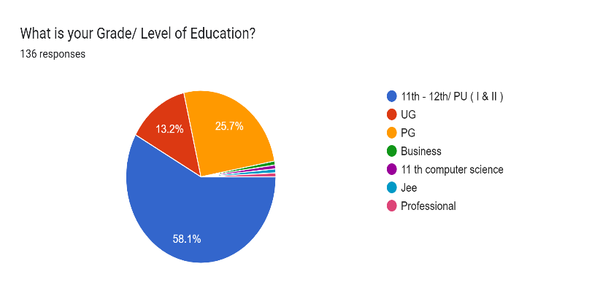Overall, the questionnaire provides a basis to understand youth financial literacy and offers useful information about young people's financial knowledge, attitudes, and behaviour.

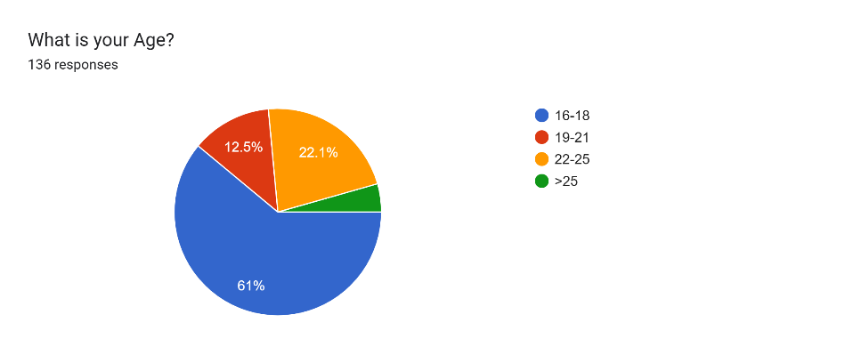

The survey of 136 participants reveals a predominantly young population. Nearly 61% of the participants fall in the 16-18 age group, while 22.1% fall in the 19-21 age group. The pre-university level or 11th-12th grade has the least percentage at 58.1%, followed by 25.7% undergraduate students. 13.2% of the sample is postgraduate students, and there are hardly any members from other education levels. The sample is a dense cluster of high school and first-year college students.

**Section I**

1. **Do you have a personal savings account?**

|  |  |
| --- | --- |
| **Personal Savings Account** | **Percentage of Responses** |
| Yes | 87.5 |
| No | 12.5 |

**Table 1.1 Responses of Personal Saving Accounts**

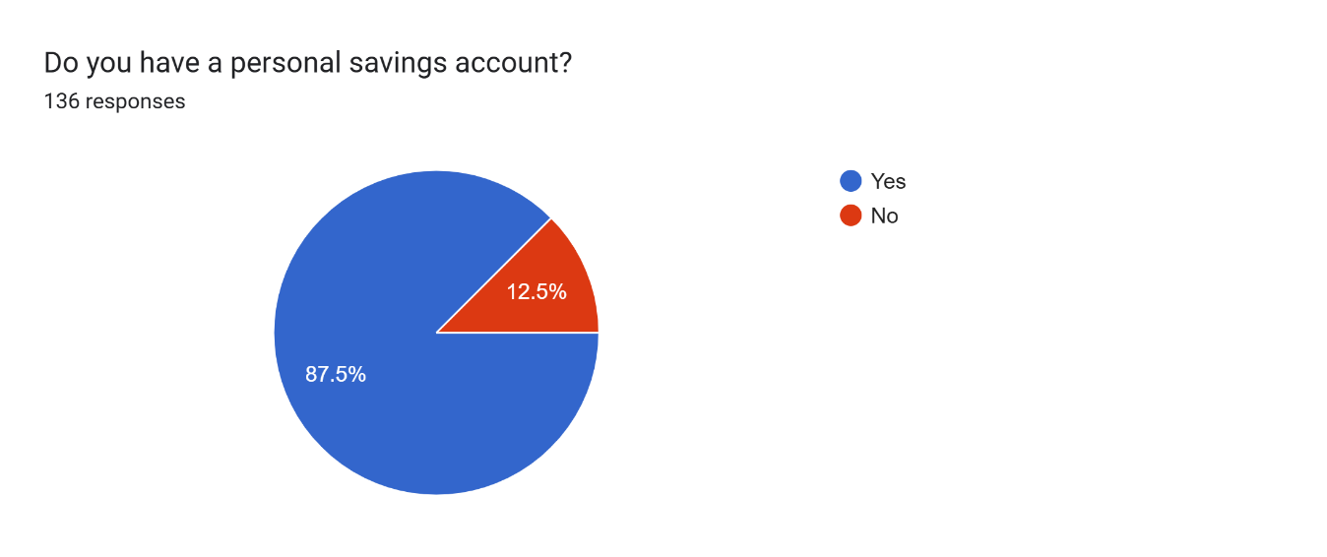

**Figure 1.1 Responses of Personal Saving Accounts**

The pie chart indicates how many individuals out of the group of 136 have a savings account. Almost 87.5% have a savings account, while a mere 12.5% do not possess one. From this, it can be noted that saving and financial literacy occur in a regular pattern among the sample population. The large number of individuals possessing savings accounts highlights the prevalence towards financial security and planning. The relatively low proportion of non-savers may be explained by reasons including reliance on guardianship, lack of knowledge regarding money, or low income. Generally, the figures indicate an encouraging trend towards personal financial control, with a majority of the respondents appreciating the importance of a savings account.

1. **Do you receive pocket money from your parents/guardians?**

|  |  |
| --- | --- |
| **Receive Pocket Money** | **Percentage of Responses** |
| Yes | 83.1 |
| No | 16.9 |

**Table 1.2 Responses of Receive of Pocket Money**

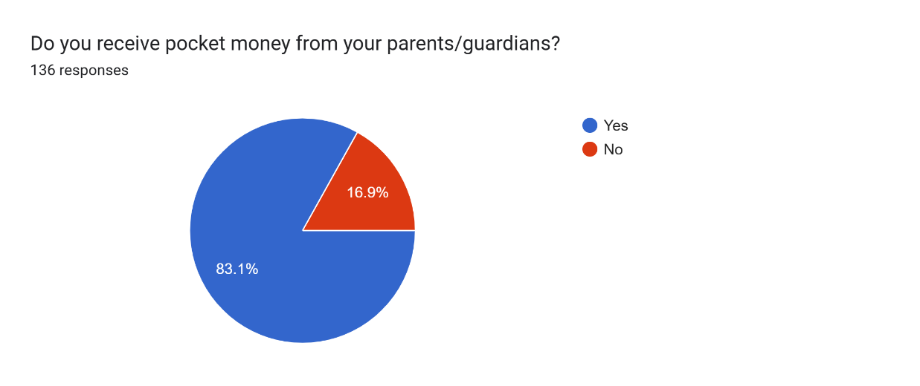

**Figure 1.2 Responses of Receive of Pocket of Money**

The graph tells us that most, 83.1% of the respondents, are given pocket money by parents or guardians, but 16.9% of them are not. It implies that providing money support by guardians is a common practice, which allows young people to cover personal expenses. The minority group of respondents who are not given pocket money can be attributed to economic independence, other sources of money, or household budget constraints. In most cases, the data shows that most individuals rely on their guardians or parents for finances in one form or another.

|  |  |
| --- | --- |
| **Pocket Money Range** | **Percentage of Responses** |
| 0 - 1000 | 33.8 |
| 1001 - 5000 | 41.9 |
| 5001 - 10,000 | 19.1 |
| > 10,000 | 5.2 |

1. **If yes, how much pocket money do you receive per week/month?**

**Table 1.3 Responses of Pocket Money Range**

**Figure 1.3 Responses of Pocket of Money Received**

The bar chart shows the percentage distribution of pocket money received across various income groups. The highest proportion, 41.9%, receives between 1001 and 5000, followed by 33.8% who receive up to 1000. A lower percentage, 19.1%, receives between 5001 and 10,000, and 5.2% receive more than 10,000. This is evidence that a relatively small amount of pocket money is given to most individuals, and a huge majority receive 1001-5000. That the ratio falls as it grows is a sign that the larger pocket money awards are rare. The amounts reveal that money reliance on the allowances exists but most get amounts that are being kept in hand, perhaps for budgeting and financial discipline reasons.

1. **How often do you receive pocket money?**

|  |  |
| --- | --- |
| **Pocket Money Frequency** | **Percentage of Responses** |
| Daily | 0 |
| Weekly | 8.8 |
| Monthly | 62.5 |
| Occasionally | 27.9 |

**Table 1.4 Responses of Pocket Money Range**

**Figure 1.4 Responses on how often they get Pocket money**

The graph indicates the frequency at which the pocket money is received. The majority, 62.5%, get it monthly, and this indicates an official system of support. More than a third, 27.9%, get it at times, and this indicates that their support is need-based and not a fixed one. A mere 8.8% get it weekly, and none got it daily. This distribution indicates a preference for regular monetary payment, possibly to instil budgeting routines and efficient money management among the recipients. The prevalence of small weekly allowances and the lack of pocket money on a daily basis indicate that guardians or parents would prefer to make payments in larger but less frequent amounts.

1. **Do you track your income and expenses regularly?**

|  |  |
| --- | --- |
| **Track Income & Expenses** | **Percentage of Responses** |
| Yes | 35.3 |
| No | 64.7 |

**Table 1.5 Responses on Tracking of Income & Expenses**

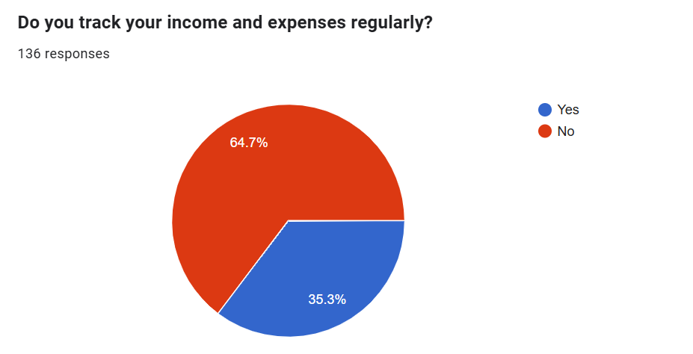

**Figure 1.5 Responses on Tracking of Income & Expenses**

The chart reveals that a majority, 64.7%, do not track their income and expenses regularly, while only 35.3% actively monitor their financial activities. This suggests that financial awareness and budgeting habits may not be widely practiced among the respondents. The lack of tracking could lead to inefficient spending and reduced savings. However, the presence of a significant minority who do monitor their finances indicates that there is some awareness of financial responsibility. Encouraging more individuals to adopt budgeting habits could lead to better financial management and planning for the future.

1. **Have you ever created a budget for yourself?**

|  |  |
| --- | --- |
| **Created a Budget** | **Percentage of Responses** |
| Yes | 32.4 |
| No | 67.6 |

**Table 1.6 Responses on creation of Budget**

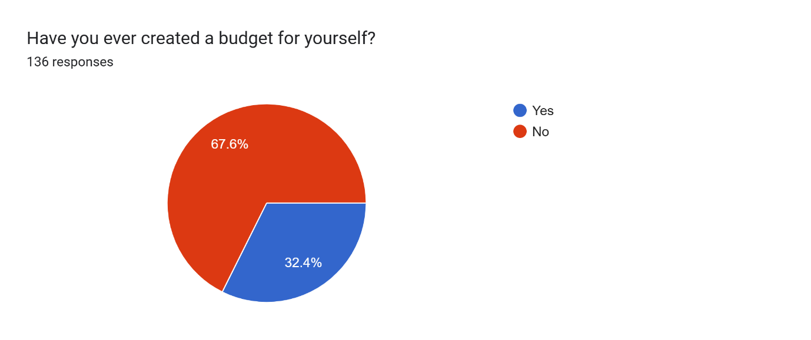

**Figure 1.6 Responses on creation of Budget**

The chart indicates that 67.6% of people have never budgeted at all, and a mere 32.4% have ever budgeted. This means that the majority might not have a methodical approach to handling their money, which can result in bad spending habits and inability to reach financial objectives. The fairly low proportion of people with a budget indicates the necessity for greater financial awareness and understanding of the advantages of budgeting. Encouraging more people to adopt budgeting behaviour would assist in enabling more financial security and long-term planning.

**Section II**

|  |  |
| --- | --- |
| **Response** | **Percentage** |
| Yes | 77.2% |
| No | 22.8% |

1. **Are you aware of the concept of financial literacy?**

**Table 1.7 Responses on awareness of the concept of financial literacy**

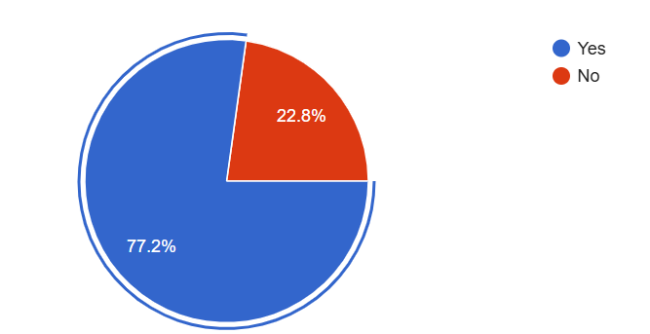

**Figure 1. 7 Responses on awareness of the concept of financial literacy**

The 136-survey sought to capture the level of familiarity of financial literacy. Based on the findings, 77.2% indicated familiarity with the term and 22.8% didn't know. This is a clear sign that an overwhelming majority indicated a level of familiarity of financial literacy, which is a good sign. The fact that there is close to a quarter of respondents who do not know is a call for campaigns in financial education. Increasing financial literacy has the potential to contribute to better money management, planning, and overall economic well-being.

1. **Is financial literacy included in your school/college curriculum?**

|  |  |
| --- | --- |
| **Response** | **Percentage** |
| Yes | 19.1% |
| No | 57.4% |
| Not Sure | 23.5% |

**Table 1.8 Responses on financial literacy included in your school/college curriculum**

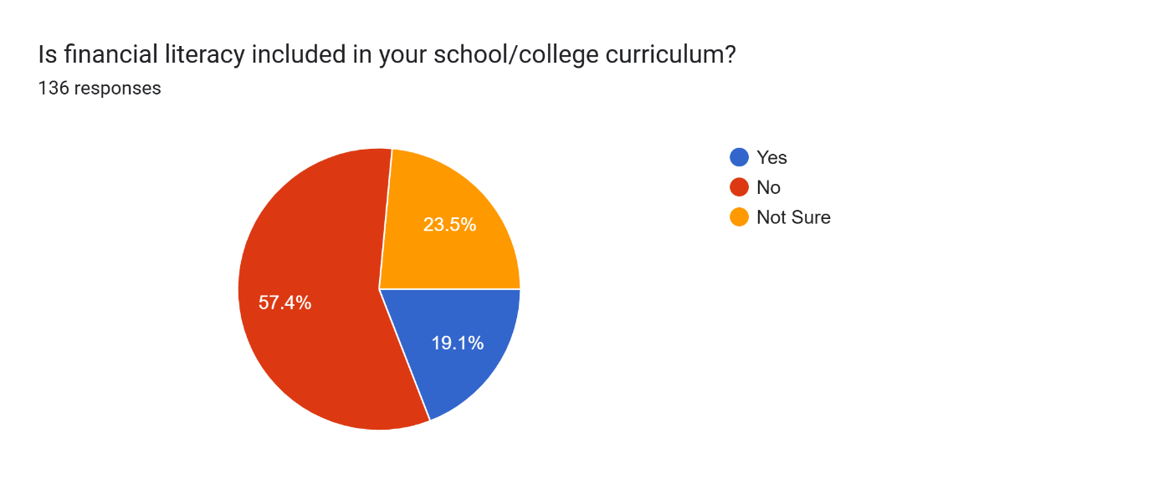

**Figure 1. 8 Responses on financial literacy included in your school/college curriculum**

The findings of the survey reveal that 19.1% of the respondents have financial literacy covered in their college or school syllabus, while 57.4% state that it is not covered. Moreover, 23.5% do not know if it is covered in their syllabus. The meaning of such findings could be that financial literacy is not well integrated in formal education, and that could be one of the explanations for student financial knowledge gaps. The small percentage of people who do not have or are unaware of financial education is a testament to the necessity for financial education to be incorporated in institutions. Enhanced financial education at an early age can enable one to make sensible financial choices when they are older.

1. **If yes, how would you rate the quality of the financial literacy education provided?**

|  |  |
| --- | --- |
| **Response** | **Percentage** |
| Poor | 36% |
| Fair | 22.1% |
| Good | 18.4% |
| Excellent | 7.4% |
| NIL | 3.7% |
| Wasn’t Included | 2.9% |
| Not provided | 2.2% |
| No it is not there in our school | 7.3% |

**Table 1.9 Responses on Quality of Education Provided**

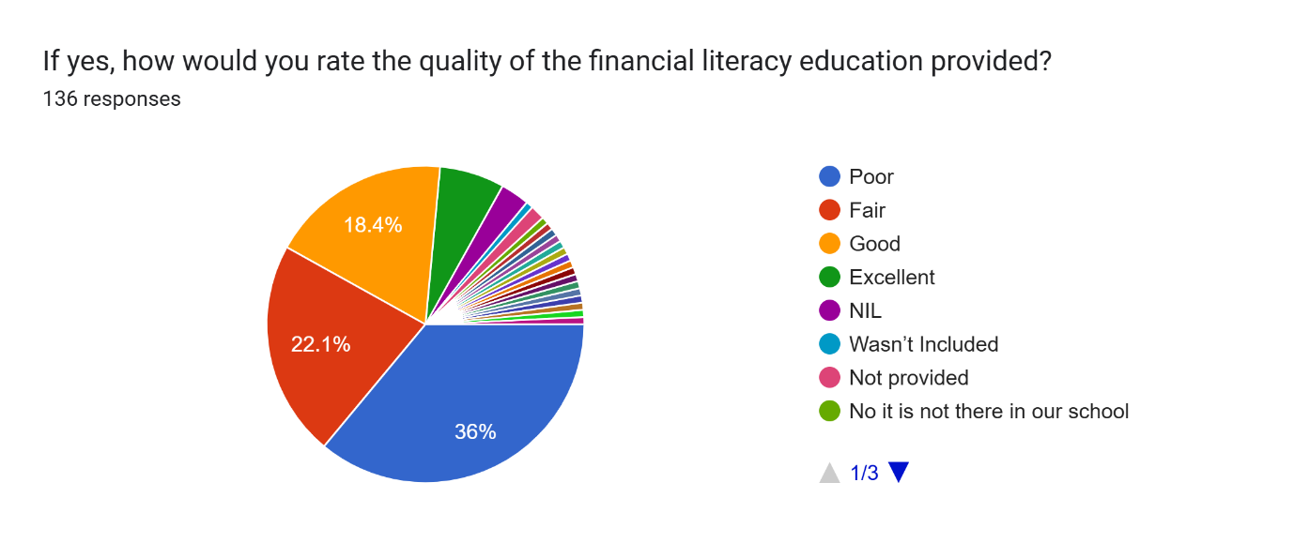

**Figure 1. 9 Responses on Quality of Education Provided**

The survey results indicate that 36% of respondents rated the quality of financial literacy education as poor, while 22.1% found it to be fair. A smaller proportion, 18.4%, rated it as good, and only 7.4% considered it excellent. Additionally, various responses indicate that financial literacy education was either not included or not provided in their institutions. These findings highlight concerns regarding the effectiveness and availability of financial literacy programs. The predominance of poor and fair ratings suggests that even where financial literacy education is available, its quality may not be adequate to equip students with essential financial skills. Strengthening the curriculum, improving teaching methodologies, and incorporating real-world financial applications could enhance the effectiveness of financial education.

1. **If not, do you think financial education should be taught in schools/colleges?**

|  |  |
| --- | --- |
| **Response** | **Percentage** |
| Yes | 97.8% |
| No | 2.2% |

**Table 1.10 Responses on implementation of Financial Education in their Curriculum**

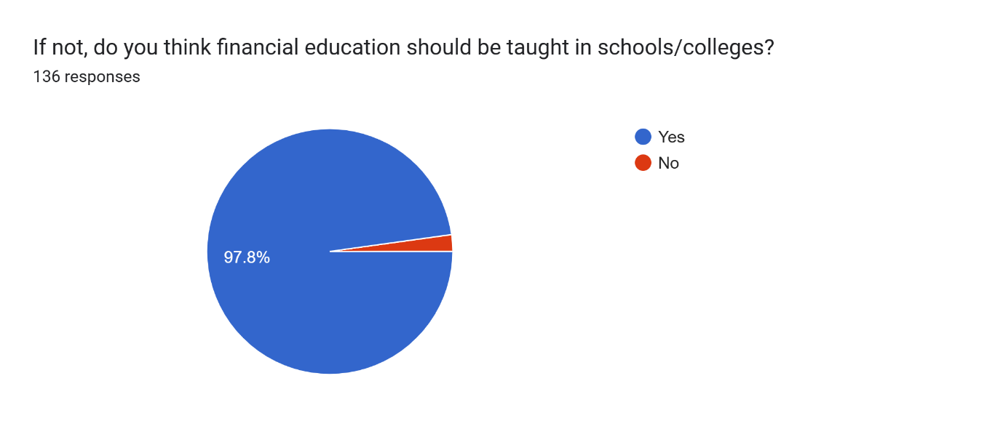

**Figure 1. 10 Responses on implementation of Financial Education in their Curriculum**

Most of the sample (97.8%) believe that financial education must be included in schools and colleges, whereas 2.2% do not share the same opinion. The general agreement on this aspect points towards the reality that financial literacy is recognized on both sides as a critical skill for students. The findings reflect a strong need for the inclusion of financial education as part of the academic curriculum. As financial literacy is becoming more vital to both personal and economic success, schools must introduce formal financial literacy programs to better prepare students for real-world financial responsibility.

|  |  |
| --- | --- |
| **Interest Level** | **Percentage** |
| Not Interested | 2.2 |
| Slightly Interested | 13.2 |
| Moderately Interested | 35.3 |
| Very Interested | 49.3 |

1. **How interested are you in learning about financial literacy?**

**Table 1.11 Responses in Learning Financial Literacy**

**Figure 1. 11 Responses in Learning Financial Literacy**

All the participants, almost half (49.3%), were highly interested in financial literacy, with a high level of interest in knowing about finance. A huge majority (35.3%) were moderately interested, indicating that a large majority of people are willing to learn finance. Low scores (13.2%) were somewhat interested, and as low as (2.2%) were not interested at all. The overall trend is that there is widespread acknowledgment that financial literacy matters, and a majority would concede that it's worth something. What this entails is that financial education efforts to promote will find good reception and have the ability to be seriously effective in regards to the market they are trying to reach.

1. **Do you understand how credit cards and interest rates work?**

|  |  |
| --- | --- |
| **Response** | **Percentage** |
| Yes | 44.9 |
| No | 55.1 |

**Table 1.12 Responses on Credit cards**

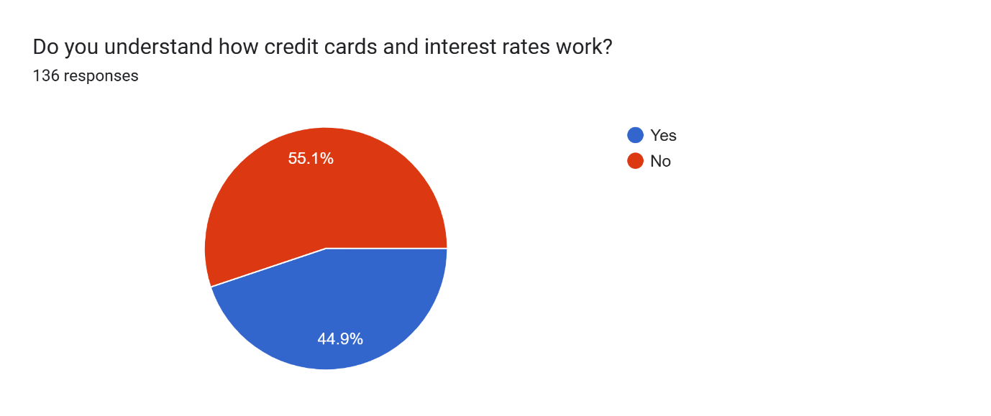

**Figure 1. 12 Responses on Credit cards**

The information shows that most of the participants (55.1%) do not know how interest and credit cards work, reflecting that there is low financial literacy. On the other hand, 44.9% suggest that they know, reflecting that almost half of the participants are to some degree financially literate. The findings emphasize the necessity of introducing programs of financial education in credit management and interest rates since misconceptions in such areas may contribute to financial issues like debt build-up and unfavorable credit choices. Enhancing financial education programs would therefore fill the gap and impart the necessary finance skills.

1. **Have you ever invested in stocks, mutual funds, or cryptocurrencies?**

|  |  |
| --- | --- |
| **Response** | **Percentage** |
| Yes | 25.7 |
| No | 74.3 |

**Table 1.13 Responses on investments**

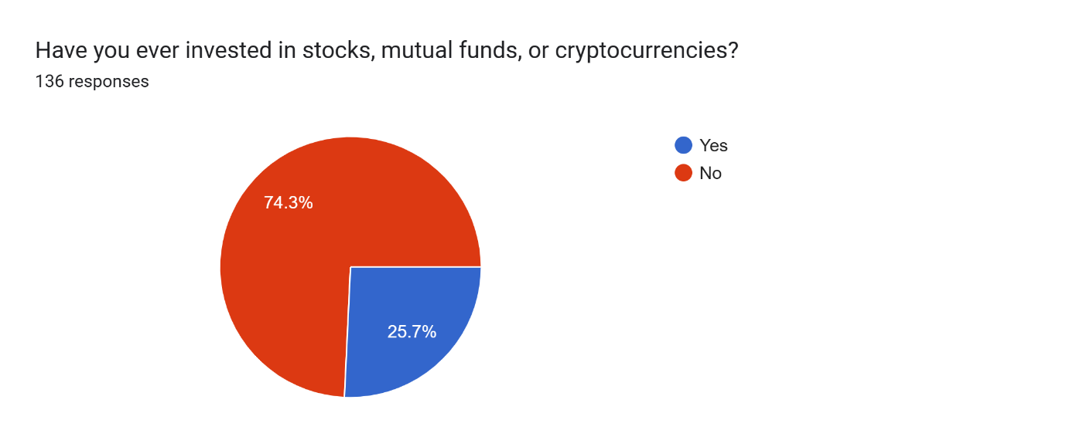

**Figure 1. 13 Responses on investments**

The evidence indicates that a very high percentage (74.3%) of the interviewees never bought shares, mutual funds, or cryptocurrency, while merely 25.7% of interviewees ever possessed some type of investment. It portrays non-involvement in the financial market due to numerous possible reasons like non-financial knowledge, self-categorization of too much risk, or limitations to invest in the financial markets. The findings highlight the importance of rising financial education in relation to investment strategies, risk management, and the possibility of creating wealth through investment. Promoting financial literacy and de-mystifying investment choices may enable individuals to become more confident about participation in financial markets.

1. **Do you feel confident about managing your finances independently?**

|  |  |
| --- | --- |
| **Response** | **Percentage** |
| Yes | 42.6 |
| No | 57.4 |

**Table 1.14 Responses on Confidence of managing Finances independently**

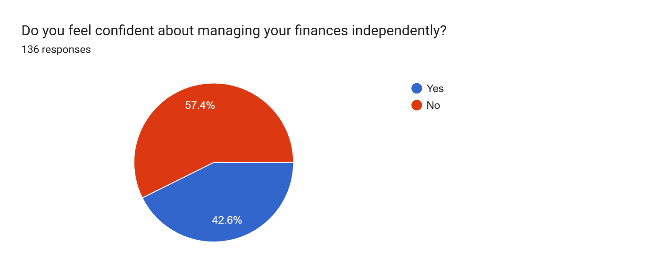

**Figure 1. 14 Responses on Confidence of managing Finances independently**

The statistics would show that more than half (57.4%) of the respondents don't believe they can manage their finances on their own, while 42.6% are certain they can make decisions about their financial affairs confidently. This is a sign that maybe there isn't any experience or expertise in finance, therefore they are not able to budget, save, invest, and manage debt. The financial insecurity could be due to inadequate education on money management or a lack of real-life exposure to money management. Remedial measures through money management programs, workshops, or publications could help individuals better manage their finances and make appropriate financial decisions.

1. **Would you attend a financial literacy workshop if given the opportunity?**

|  |  |
| --- | --- |
| **Response** | **Percentage** |
| Yes | 92.6 |
| No | 7.4 |

**Table 1.15 Responses of interest in Workshops**

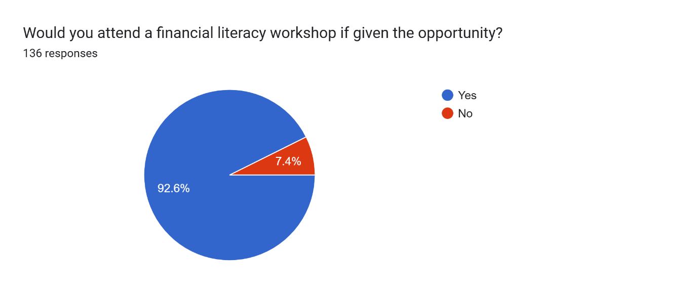

**Figure 1. 15 Responses of interest in Workshops**

The numbers clearly indicate that a vast majority (92.6%) of the respondents would be interested in attending a financial literacy workshop if offered, while a very small percentage (7.4%) do not want to. The high level of interest is an indication of a shared realization of the significance of financial education and willingness to learn more about finance. The high interest suggests that having financial literacy sessions run could be very helpful and in demand, and individuals would be equipped with the necessary skills in order to manage their finances successfully.

1. **What additional topics would you like to learn about in financial literacy programs?**

* **Strong Interest in Budgeting and Financial Management**
  1. Many respondents express a desire to learn how to maintain a budget and manage their finances effectively.
  2. Topics such as independent spending, financial planning, and savings strategies are considered essential for day-to-day life.
* **High Demand for Investment and Stock Market Education**
  1. Investment-related topics, including stock market analysis, mutual funds, systematic investment plans (SIPs), and portfolio management, are frequently mentioned.
  2. Respondents are particularly interested in understanding low-risk investment strategies and ways to build wealth.
* **Importance of Financial Literacy in Schools and Colleges**
  1. Several respondents emphasize that financial literacy should be taught at the school level, particularly for students aged 15-18.
  2. They recognize that financial knowledge is crucial as students transition to college and financial independence.
  3. Some suggest including books like *The Psychology of Money* as part of the curriculum.
* **Practical Aspects of Financial Education**
  1. Many responses highlight the need for knowledge on essential financial concepts such as taxes, loans, credit scores, inflation, and debt-equity management.
  2. The importance of understanding different types of bank accounts, foreign currency exchange, and real estate investments is also noted.
* **Engaging and Innovative Teaching Methods**
  1. Several respondents suggest that financial literacy topics should be taught in an engaging and relatable manner.
  2. Some express an interest in learning financial concepts through real-world applications, case studies, and interactive sessions.
* **Emerging Financial Trends and Technologies**
  1. Topics like cryptocurrency, blockchain, and digital gold investments are of interest to some respondents.
  2. Behavioural finance is also highlighted as an area of curiosity, indicating a growing awareness of how psychological factors influence financial decisions.
* **Diverse Financial Literacy Needs**
  1. Some respondents provide broad topics such as financial literacy, financial planning, and investment strategies without specifying details, indicating a general need for financial education.
  2. A few responses indicate uncertainty about what financial literacy topics they need to learn, suggesting the need for structured guidance.

**IV FINDINGS & RECOMENDATIONS**

**Interest in Financial Literacy**

The study found that most of the respondents are extremely interested in acquiring knowledge on financial literacy. Almost half of the respondents expressed immense interest, and there were a significant number of people who were moderately interested. This indicates greater sensitivity toward the need for financial awareness among the population.

**Understanding of Credit and Interest Rates**

Most of those polled do not have a clear grasp of how credit cards and interest rate’s function. More than half said they did not have a complete understanding of these financial instruments, which points to an essential deficiency in personal finance education.

**Investment Participation**

According to the study, the majority of those polled have never invested in stocks, mutual funds, or cryptocurrencies. This indicates reluctance or ignorance in investment options, which might hold back long-term financial growth.

**Confidence in Financial Management**

More than half of the respondents lack confidence in managing their finances alone. This is an indication of the requirement for formalized financial education programs to boost financial decision-making ability.

**Willingness to Attend Financial Literacy Workshops**

Overall, most of the participants showed a strong desire to participate in financial literacy workshops if given the chance. This is proof of an encouraging attitude towards learning finances and increasing financial security.

**Implementing Financial Literacy Programs**

As a response to the tremendous need for financial literacy, institutions should adopt formal financial education programs. These should feature fundamental financial essentials like budgeting, saving, credit management, and investment strategies.

**Enhancing Awareness of Credit and Interest Rates**

To bridge the knowledge gap, there should be targeted public campaigns by banks and educators that define credit and interest rate terminology in basic language. Interactive sessions, live case studies, and websites can be employed to promote awareness.

**Encouraging Investment Education**

Because the majority of people have not invested, programs need to demystify investment products like stocks, bonds, and mutual funds. Investment practice sessions and simulations can enhance confidence in financial decision-making.

**Strengthening Financial Confidence**

Building programs that enable people to manage finances successfully is important. Financial mentorship programs, counselling services, and access to quality financial resources can promote people's financial confidence.

**Promoting Accessible Financial Literacy Workshops**

Since most of the participants indicated an interest in attending financial literacy workshops, organizations can offer free or low-cost workshops for different groups. Online sessions, webinars, and in-person workshops must be offered to cater to all.

**V CONCLUSION**

Financial literacy is an essential skill in today’s complex economic landscape, yet many young individuals lack the necessary knowledge and confidence to manage their finances effectively. These results highlight extensive financial education deficits, especially in credit management, investment coverage, and decision-making. There is a high demand for financial literacy, but formal schooling is hindered from fully acquainting individuals with and applying the money tools.

The results indicate that most of the participants are willing to learn personal finance but are not well educated. Few people monitor their spending, budget, or invest in the financial market, and such action may have a bearing on their future economic situation. Moreover, inadequate financial education offered in school courses further promotes such problems so that new generations become unable to face actual economic issues.

To fill these gaps, systematic school and college financial literacy programs need to be implemented to provide students with a proper knowledge of money management, saving, and investment. There needs to be collaborative effort from policymakers, educationalists, and financial institutions to come up with engaging and interactive financial education programs. Through the provision of experiential learning experiences through workshops, online platforms, and interactive simulations, one can improve financial literacy among youth.

Overall, it is important to encourage financial literacy at a young age in order to enable one to make rational financial choices, steer clear of debt traps, and secure the financial future. Through these areas of knowledge shortcomings, we are able to give young people the skills to realize financial independence and stability in today's digitalized and dynamic world.

**VI BIBLIOGRAPHY**

* Agarwal, S., Amromin, G., Ben-David, I., Chomsisengphet, S., & Evanoff, D. D. (2015). Financial literacy and financial planning: Evidence from India. *Journal of Housing Economics*, *27*,4-21.
* Babiarz, P., & Robb, C. A. (2014). Financial literacy and emergency saving. *Journal of Family and Economic Issues*, *35*, 40-50.
* Wolfe-Hayes, M. A. (2010). Financial literacy and education: An environmental scan. *The International Information & Library Review*, *42*(2),105-110.
* Hasan, M., Le, T., & Hoque, A. (2021). How does financial literacy impact on inclusive finance? Financial innovation, 7(1), 40.
* Huston, S. J. (2010). Measuring financial literacy. Journal of consumer affairs, 44(2), 296-316.
* Fernandes, D., Lynch, J. G., & Netemeyer, R. G. (2014). Financial literacy, financial education, and downstream financial behaviours. *Management Science, 60*(8), 1861-1883.
* Lusardi, A., & Mitchell, O. S. (2011). Financial literacy and retirement planning in the United States. *Journal of Pension Economics & Finance, 10*(4), 509-525.
* OECD. (2018). *Financial education in schools: Challenges, impacts, and policy implications*. Organisation for Economic Co-operation and Development.
* Shim, S., Barber, B. L., Card, N. A., Xiao, J. J., & Serido, J. (2010). Financial socialization of first-year college students: The roles of parents, work, and education. *Journal of Youth and Adolescence, 39*(12), 1457-1470.
* Xiao, J. J., Chatterjee, S., & Kim, J. (2014). Factors associated with financial independence of young adults. *International Journal of Consumer Studies, 38*(4), 394-403.
* Atkinson, A., & Messy, F. A. (2012). Measuring financial literacy: Results of the OECD / International Network on Financial Education (INFE) pilot study. OECD Working Papers on Finance, Insurance and Private Pensions, 15, 1-73.
* Hastings, J. S., Madrian, B. C., & Skimmyhorn, W. L. (2013). Financial literacy, financial education, and economic outcomes. Annual Review of Economics, 5(1), 347-373.
* Brown, M., Grigsby, J., Van der Klaauw, W., Wen, J., & Zafar, B. (2016). Financial education and the debt behavior of the young. The Review of Financial Studies, 29(9), 2490-2522.
* Loke, V. (2017). Financial education and program effectiveness: A study on low-income individuals. Journal of Consumer Affairs, 51(1), 219-247.
* Carpena, F., Cole, S., Shapiro, J., & Zia, B. (2019). The ABCs of financial education: Experimental evidence on attitudes, behavior, and cognitive biases. Management Science, 65(1), 346-369.
* Klapper, L., Lusardi, A., & Panos, G. A. (2013). Financial literacy and entrepreneurship. Journal of Financial Economics, 107(3), 617-634.