**Automatic Car Parking Toll Gate System Using Arduino and Ultrasonic Sensor**

**Aastha Rathi1, Aishwarya Bokade2, Aishwarya Datir 3 ,Devyani Khandekar 4 ,Gunjan Gupta 5 , Dr. S. I. Bakhtar6**

12345Third Year Student, Department of Electronics & Telecommunication Engineering, PRMCEAM, Amravati, Maharashtra, India

6Assistant Professor, Department of Electronics & Telecommunication Engineering, PRMCEAM, Amravati, Maharashtra, India

**ABSTRACT (Automatic Car Parking Toll Gate System Using Arduino and Ultrasonic Sensor)**

The "Automatic Car Parking Toll Gate System Using Arduino and Ultrasonic Sensor" is an innovative solution designed to automate the process of car parking and toll gate operations. This project is to set up a smart parking system. According to primary investigation, nowadays maximum people want a smart parking system for hassle free parking with digital assistant. The Ultrasonic Range Detection Sensor is utilized with Arduino to indicate the empty slot. By measuring the distance using ultrasonic sensor drivers are able to find the empty slot in parking to park the car and help the driver to find the slot easily and reduce the searching time. As the parking place is found to be empty it is detected using ultrasonic sensors. We achieved this by programming the sensors and Arduino. This sensor and Arduino Microcontroller based technological solution can prevent inadequate parking, take payment digitally and save time and manpower. This can be a sustainable solution in a cheaper cost. The discussed systems will be able to reduce the problems which are arising due to unavailability of a reliable, efficient and modern parking system, while the economic analysis technique will help in analyzing the projects feasibility. Smart car parking project aims at providing a confusion free and easy parking. This project helps the drivers of the cars to park their vehicles with minimum wastage of time with accurate information of the availability of the space to park It includes an Arduino Uno as the microcontroller unit to which the servo motors, LCD display ultrasonic sensors (HC-05) are interfaced. The LCD displays the availability of the space, the ultrasonic sensors keep the check of the number of cars entering and exiting the parking space. The ultrasonic sensors detect the availability of the parking space.

**Keywords:** Arduino, Ultrasonic Sensor, Traffic Control

**I. INTRODUCTION**

The “Automatic Car Parking Toll Gate System Using Arduino and Ultrasonic Sensor” aims to address these issues by providing an automated, reliable, and cost-effective solution for parking management. This system leverages an Arduino microcontroller to control the parking gate operations, while ultrasonic sensors are used to detect the presence of vehicles in the parking lot. The ultrasonic sensors measure the distance between the vehicle and the sensor, which helps in accurately determining whether a parking space is occupied or available.

The system automatically opens the parking gate when a vehicle enters, assigns an available parking spot, and records the entry time. Upon exit, the system calculates the parking duration and calculates the toll fee, ensuring that the fee is proportional to the amount of time the vehicle has occupied the space. The gate then opens to allow the vehicle to exit.

This paper presents the design and implementation of the automatic car parking toll gate system, which not only enhances parking efficiency but also minimizes human intervention, reduces errors, and improves the overall user experience. By combining Arduino-based automation with ultrasonic sensing technology, this project aims to provide a scalable and effective solution for modern parking needs, contributing to smarter, more efficient urban infrastructure.

**II.HARDWARE PROTOCOL**

The **hardware protocol** for the "Automatic Car Parking Toll Gate System Using Arduino and Ultrasonic Sensor" involves the use of various electronic components to detect vehicles, manage the parking process, and control the gate mechanism. Here's an overview of the hardware setup and communication protocols used in this project:

**Hardware Components:**

1. **Arduino Microcontroller (e.g., Arduino Uno):**
   * The central processing unit of the system, controlling the flow of the entire operation.
   * Acts as the interface between all the sensors, actuators, and the toll system.
   * Uses input from ultrasonic sensors to detect vehicle presence and triggers outputs like opening or closing the toll gate.
2. **Ultrasonic Sensors (e.g., HC-SR04):**
   * Used for detecting the presence of vehicles and measuring the distance from the sensor to the vehicle.
   * Operates by sending a sound wave and measuring the time taken for the wave to reflect back from the object (vehicle).
   * The sensor communicates with the Arduino via digital input/output pins (Trigger and Echo).
3. **Servo Motor / DC Motor (for Gate Mechanism):**
   * Controls the opening and closing of the toll gate.
   * A servo motor is commonly used because it provides precise control of the gate position.
   * The motor is controlled by a PWM (Pulse Width Modulation) signal sent from the Arduino.
4. **Power Supply:**
   * Provides the necessary power to run the Arduino, sensors, motors, and display.
   * A suitable DC power supply (e.g., 5V for Arduino) and motors are needed.

**Communication Protocols:**

1. **Digital I/O Protocol (for Ultrasonic Sensors, Motors):**
   * The ultrasonic sensor communicates with the Arduino using two digital pins: one for triggering the ultrasonic pulse (Trigger) and another for receiving the reflected pulse (Echo).
   * The servo motor is controlled by PWM signals sent from the Arduino to control the gate mechanism's opening and closing.
   * A buzzer is activated by a digital pin from the Arduino to indicate status or alert users.
2. **Serial Communication Protocol (optional, for debugging or advanced features):**
   * The Arduino can use serial communication to display debugging information or status updates on the connected computer through the USB connection.
3. **PWM (Pulse Width Modulation) Protocol (for Motor Control):**
   * If a DC motor is used for the gate mechanism, it may be controlled using PWM, where the Arduino adjusts the duty cycle of the signal to control the speed and movement of the motor.
   * Servo motors use specific PWM signals to adjust their position precisely.
4. **Wires and Jumper Cables:**
   * Use jumper wires to connect the components to the breadboard and Arduino.
   * Ensure that all connections are securely made to avoid interruptions during the operation.

**III.DESIGN LAYOUT**

The design of the system can be represented through two essential visual tools: a **Block Diagram** and a **Flowchart**. These diagrams help explain the overall structure and the logical flow of the project, highlighting the interaction between various components

### Block Diagram:

A **Block Diagram** represents the major components of the system and how they interact with each other. The main components are the **Arduino**, **Ultrasonic Sensor**, **Servo Motor**, **LCD Display**, **Buzzer**, and the **Power Supply**. Here’s an explanation of the design layout through the Block Diagram:

### **Working Principle (Step-by-Step)**

1. A vehicle approaches toll gate, and the ultrasonic sensor detects its presence.
2. Arduino processes sensor data and determines whether access should be granted.
3. If access is granted, the servo motor opens the gate, allowing the vehicle to pass.
4. Once the car crosses gate, the ultrasonic sensor detects the passage, and Arduino signals servo motor to close barrier.

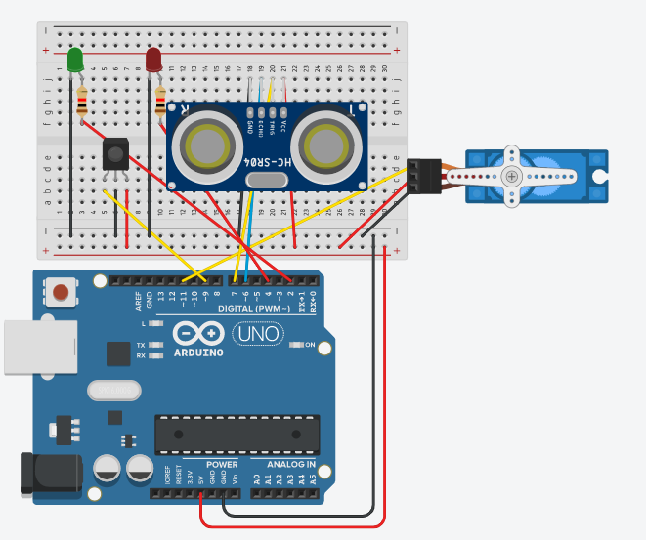

**Explanation of the component Of Block Diagram:**

* **Power Supply:**
  + Supplies power to the Arduino, sensors, and motor. A 9V battery or a USB power bank is used to power the system.
* **Arduino Microcontroller:**
  + The brain of the system. It processes data from the sensors, controls the servo motor, handles the display output, and manages the overall operation.
* **Ultrasonic Sensor (HC-SR04):**
  + This sensor detects the presence of vehicles and measures the distance to determine when the car enters or exits the parking lot.
* **Servo Motor:**
  + Controls the movement of the parking gate. When a vehicle enters or exits, the servo motor opens or closes the gate.
* **LCD Display:**
  + Displays system status, such as parking space availability, toll fees, and time elapsed for the car in the parking lot.

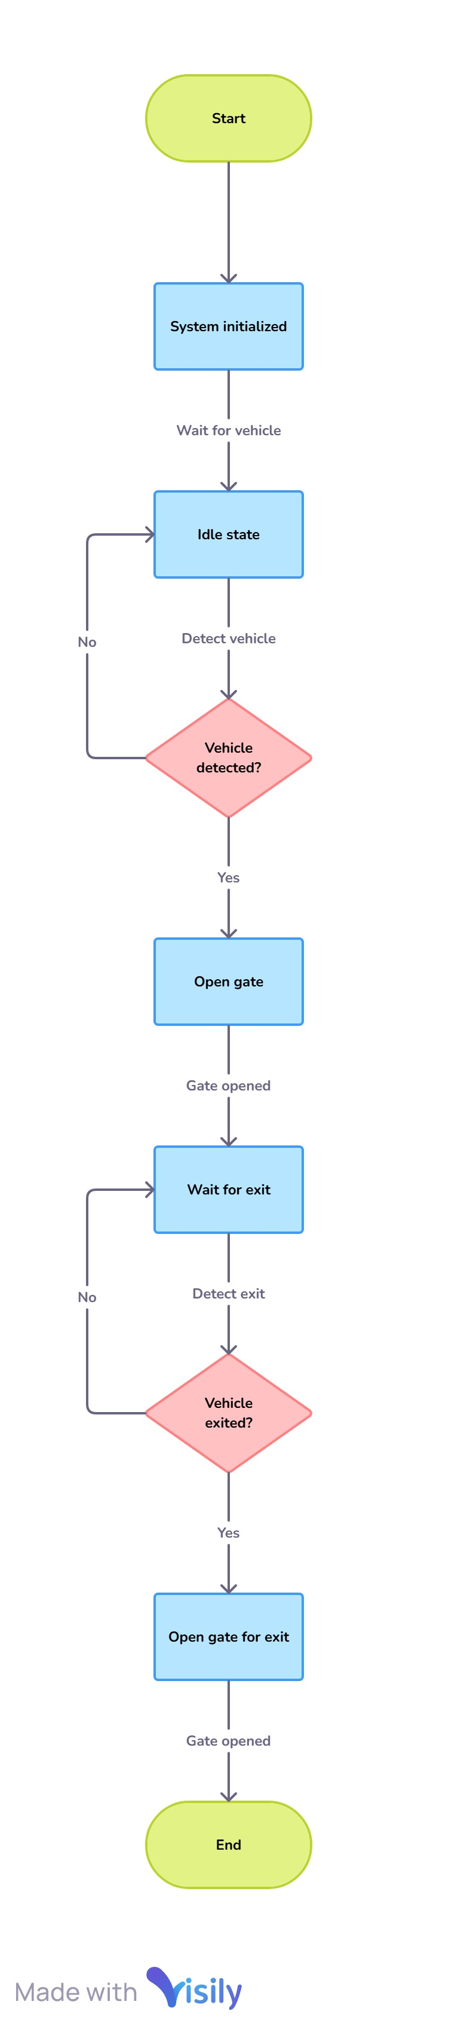**2. Flow Diagram:**A Flowdiagram with Overview of Components.

1. **Start System:**
   * The system is initialized, and the main operations begin.
2. **Wait for Vehicle:**
   * The system remains idle, waiting for the vehicle to arrive at the parking entrance.
3. **Detect Vehicle Using Ultrasonic Sensor:**
   * The ultrasonic sensor continuously checks for the presence of a vehicle. If the distance is below a certain threshold, it confirms that a car is approaching.
4. **Vehicle Detection Check:**
   * If a vehicle is detected, the system proceeds to open the gate using the servo motor.
   * If no vehicle is detected, the system continues waiting.
5. **Open Gate (Servo Motor):**
   * The servo motor is triggered to open the gate for the vehicle to enter.
6. **Wait for Vehicle Exit:**
   * The system continues to monitor the vehicle's stay in the parking lot.
7. **Detect Vehicle Exit:**
   * When the vehicle exits, the ultrasonic sensor detects the change in distance, indicating the vehicle’s departure.
8. **Calculate Toll Fee:**
   * Based on the time the vehicle spent in the parking lot, the system calculates the parking fee.
9. **Open Gate for Exit:**
   * The servo motor opens the gate for the vehicle to exit.
10. **End Process:**
    * The system completes the process and waits for the next vehicle.

**Overview Of Flow Diagram:**

1️.**Vehicle Detection:** The **ultrasonic sensor** continuously monitors the entry point for an approaching vehicle.

2️.**Signal Processing:** The **Arduino** receives the sensor input, analyzes the distance, and determines whether a car is present.

3️.**Gate Operation:** If a vehicle is detected, Arduino signals the **servo motor** to open the gate.

4️.**Vehicle Passes Through:** The vehicle moves past the gate while the sensor continues detecting its position.

5️.**Gate Closure:** Once the vehicle has fully passed, Arduino commands the **servo motor** to close the gate.

6️.**System Resets:** The system returns to its initial state, ready to detect the next vehicles.

**IV.RESULT**

The **Automatic Car Parking Toll Gate System** efficiently detects vehicles using an **ultrasonic sensor** and controls the **servo motor** to open and close the gate. The system responds **instantly** when a car approaches, ensuring **seamless, contactless entry**. With **precise detection and smooth operation**, it minimizes human intervention and enhances toll management efficiency.

A **cost-effective, low-maintenance solution** that enhances automated parking systems while maintaining reliability and simplicity.

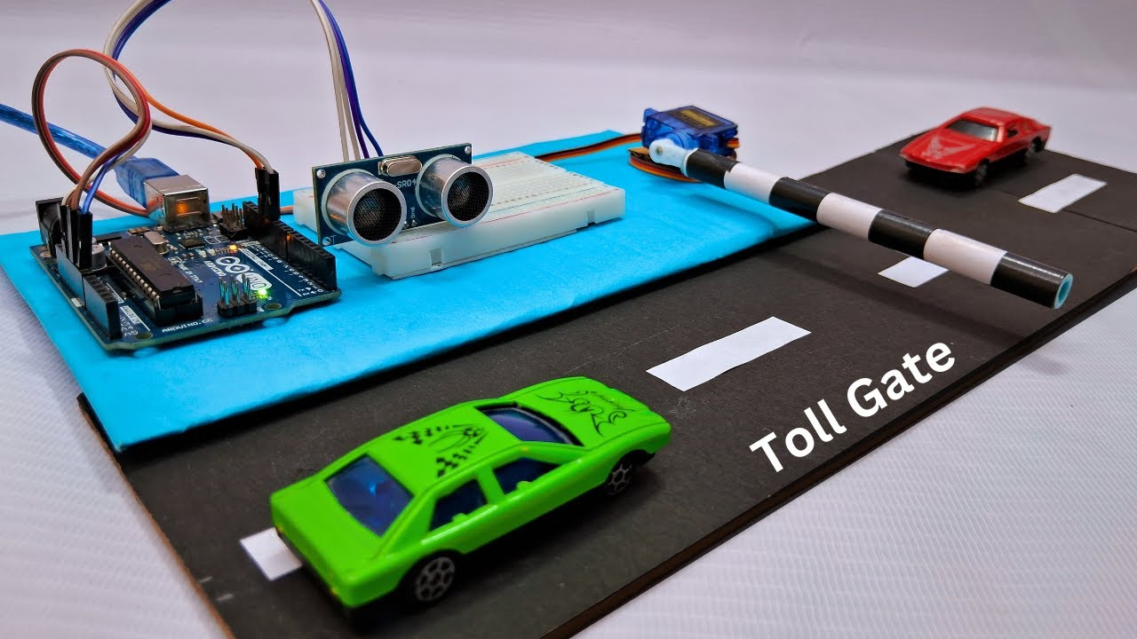

**V.CONCLUSION**

The "Automatic Car Parking Toll Gate System Using Arduino and Ultrasonic Sensors" provides an efficient and cost-effective solution for modern parking management. By automating vehicle detection and toll collection using ultrasonic sensors and an Arduino microcontroller, the system reduces human intervention, minimizes errors, and improves overall efficiency. The system automatically opens the gate when a vehicle enters, records the parking time, and calculates the toll fee when the vehicle exits. The use of an LCD display and buzzer enhances user experience, while the servo motor ensures smooth gate control.

This project demonstrates how embedded systems and sensors can improve parking operations, making it an ideal solution for urban parking challenges. The system is scalable, adaptable, and provides a foundation for further innovations in automated parking systems, offering a more efficient, user-friendly approach to parking management.

**VI.REFERENCES**

[1] E. A. Lee and S. A. Seshia, Introduction to embedded systems: A cyber-physical systems approach. Mit Press, 2016.

[2] F. J. Belmonte, S. Martín, E. Sancristobal, J. A. Ruiperez-Valiente, and M. Castro, "Overview of embedded systems to build reliable and safe ADAS and AD systems," IEEE Intelligent Transportation Systems Magazine, 2020.

[3] I. Aydin, M. Karakose, and E. Karakose, "A navigation and reservation based smart parking platform using genetic optimization for smart cities," in 2017 5th International Istanbul Smart Grid and Cities Congress and Fair (ICSG), 2017, pp. 120-124: IEEE.

[4] S. Kubler, K. Främling, and W. J. C. i. I. Derigent, "P2P Data synchronization for product lifecycle management," vol. 66, pp. 82-98, 2015.

[5] S. Kubler, M.-J. Yoo, C. Cassagnes, K. Främling, D. Kiritsis, and M. Skilton, "Opportunity to Leverage Information-as-an-Asset in the IoT--The road ahead," in 2015 3rd International Conference on Future Internet of Things and Cloud, 2015, pp. 64-71: IEEE.

[6] ] Z. Ji, I. Ganchev, M. O'Droma, and X. Zhang, ``A cloud-based intelligent car parkingservices for smart cities,'' in Proc. 31st URSI General Assembly Sci. Symp. (URSI GASS), Aug. 2014.

[7] Hamada R.H.AI-Absi,Patrick Sebastian ,”Vision-Based Automated Parking System”in10th International Conference on Information science,2010

[8] Sarfraz nawaz, Christos Efstratiou, Celia Mascolo,“Parksense: Asmartphone based sensing system foron street parking” in Cambridge university

[9] B. K. Konstantinos Domdouzis and C. Anuba., “An experimental study of the effects of different medium on the performance of rfid system,” vol. 21. Advanced EngineeringInformatics, 2011.

[10] K. Finkenzeller, Fundamentals and Applications in Contactless Smart Cards andIdentification. John Wiley and Sons LTD,2003

[11] K. M. R. Sudeep Dogra, “Radio frequency identification(RFID) applications: A brief Introduction, advanced engineering informatics.” The IUP journal of Electrical and Electronics Engineering, 2011, p. 3.

[12] J. Dongjiu Geng, Yue Suo, Yu Chen, Jun Wen, Yongqing Lu, Remote Access and Control System Based on Android Mobil Phone, vol.2. Journal of Computer Applications, 2011, pp. 560-562

[13] M.A.R. Sarkar, A.A. Rokoni, M.O. Reza, M.F. Ismail, "Smart Parking system with image processing facility", I.J. Intelligent Systems and Applications, 2012, vol. 3, pp. 41-47.

[14] Z. L. Wang, C. H. Yang, and T. Y. Guo, "The design of an autonomous parallel parking neuro-fuzzy controller for a car-like mobile robot," in Proceedings of the SICE Annual Conference, Taipei, 2010, pp. 2593-2599.

[15] J. Dongjiu Geng, Yue Suo, Yu Chen, Jun Wen, Yongqing Lu, Remote Access and Control System Based on Android Mobil Phone, vol.2. Journal of Computer Applications, 2011, pp. 560-562