**A STUDY ON RECRUITMENT AND SELECTION PROCESS**

Shelmi M1,Mrs Keerthi S2,

1MBA Student, School of Arts, Humanities and Management, Jeppiaar University, Chennai, India.

2Assistant Professor, School of Arts, Humanities and Management, Jeppiaar University, Chennai, India.

1***shelmims2003@gmail.com***,

2***K.g.s.keerthi@gmail.com***,

**ABSTRACT**

An essential part of human resource management is the recruiting and selection process, which helps businesses find, attract, and hire top talent. The importance, steps, and best practices of the recruitment and selection process are all examined in this study. The results emphasize the importance of a thorough selection process, a well-thought-out recruitment strategy, and an efficient job analysis in guaranteeing the best possible fit between the company and the applicant. The study also looks at how technology, such as application monitoring systems and social media, might improve the hiring and selection process. Organizations looking to enhance their hiring and selection procedures and draw in top talent in a competitive labor market should take note of the findings.

**INTRODUCTION**

A key component of human resource management is the recruiting and selection process, which helps businesses find, attract, and hire top personnel to propel their operations. Organizations must implement efficient recruiting and selection procedures in the current competitive labor market in order to draw in and keep the top applicants. A crucial part of human resource management is the recruiting and selection process, which needs to be carefully planned and carried out in order to draw in and keep top talent. Organizations can create successful strategies to propel corporate success by comprehending the significance, phases, and difficulties of the recruitment and selection process.

**OBJECTIVES OF THE STUDY**

1. Attract Top Talent: Find and recruit exceptionally skilled and driven individuals to occupy available positions.
2. Choose the Best Applicant: Based on their qualifications, experience, and talents, select the best applicant for the position.

**Secondary Objectives**

1. Develop Successful Recruitment Strategies: Make plans for hiring that will draw in top talent and enhance the company's reputation as an employer.
2. Enhance Selection Procedures: To find the most qualified applicants for the position, employ valid and trustworthy selection procedures.
3. Cut Down on Time-to-Hire: To lessen the effect on company operations, cut down on the amount of time it takes to fill employment vacancies.

**RESEARCH METHODOLOGY**

**Data Collection Methods**

1. Surveys: To collect information on hiring managers' and HR professionals' experiences and opinions on the recruiting and selection process, online surveys will be sent to them.
2. Interviews: To learn more about recruiting managers' and HR experts' experiences and perspectives, in-depth interviews will be held with them.
3. Case Studies: In-depth analyses of organizations' hiring and selection procedures will be carried out through case studies.

**Sampling Strategy**

1. Population: Hiring managers and HR specialists from a range of industries will make up the study's population.
2. Sample Size: A survey will be administered to 100 HR experts and hiring managers, and ten case studies will be carried out.
3. sample Methodology: A purposive sample method will be employed to choose the organizations for the case studies, while a convenience sampling method will be employed to choose survey respondents.

**DATA ANALYSIS AND INTERPRITATION :**

**AGE OF THE RESPONDANTS :**

|  |  |  |  |
| --- | --- | --- | --- |
| **S.NO** | **PARTICULARS** | **NO.OF RESPONDANTS** | **AGE OF RESPONDANTS** |
| **1** | Below 20 Years | **6** | **6%** |
| **2** | 26 – 30 Years | 65 | 65% |
| **3** | 31 – 35 Years | 17 | 17% |
| **4** | Above 35 Years | 12 | 12% |
|  | **TOTAL** | 100 | 100% |

**Sources : primary Data**



0

10

20

30

40

50

60

70

**INFERENCE :-**

It can be deduced from the above table that 65% of respondents are between the ages of 26 and 30, 17% are between the ages of 31 and 35, 12% are over the age of 35, and 6% are under the age of 20.

**GENDER OF THE RESPONDENTS :**

|  |  |  |  |
| --- | --- | --- | --- |
| S.NO | **PARTICULARS** | **NO. OF**  **RESPONDENTS** | **GENDER OF**  **RESPONDENTS** |
| 1 | Male | 77 | 77% |
| 2 | Female | 23 | 23% |
|  | **TOTAL** | **100** | **100%** |

**GENDER OF THE RESPONDENTS:-**

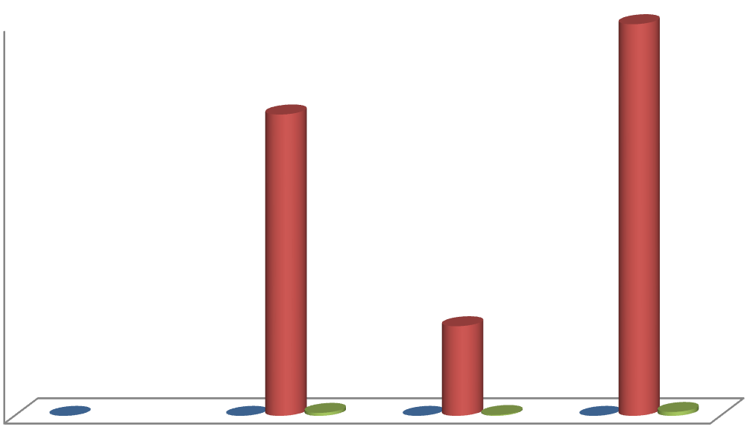

0

10

20

30

40

50

60

70

80

90

100

**INFERENCE:-**

It is clear from the preceding table that 23% of respondents are women and 77% of respondents are men.

**QUALIFICATION OF THE RESPONDENTS:**

|  |  |  |  |
| --- | --- | --- | --- |
| **S.NO** | **PARTICULARS** | **NO.OF**  **RESPONDENTS** | **AVG OF**  **RESPONDENTS** |
| 1 | Below SSLC | 26 | 26% |
| 2 | SSLC | 12 | 12% |
| 3 | HSC | 18 | 18% |
| 4 | UG | 33 | 33% |
| 5 | PG | 11 | 11% |
|  | **TOTAL** | **100** | **100** |

**QUALIFICATION OF THE RESPONDENTS:-**

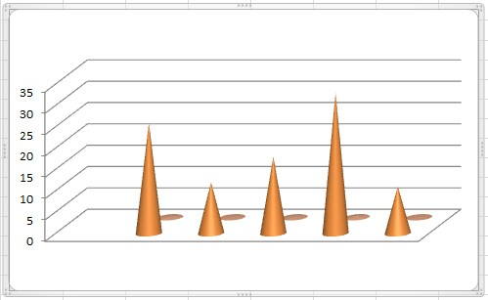

**INFERENCE :**

According to the following table, 33% of respondents have completed their undergraduate degree, 26% have qualifications below the SSLC, 18% have passed their HSC, 12% have achieved their SSLC, and 11% have earned their postgraduate degree.

**EXPERIENCE OF THE RESPONDENTS :**

**TABLE :4.1.4**

|  |  |  |  |
| --- | --- | --- | --- |
| **S.NO** | **PARTICULARS** | **NO.OF**  **RESPONDENTS** | **PERCENTAGE%** |
| 1 | Below one year | 6 | 6% |
| 2 | 1-2 years | 23 | 23% |
| 3 | 2-3 years | 10 | 10% |
| 4 | 3-4 years | 40 | 40% |
| 5 | Above 4 years | 21 | 21% |
|  | **TOTAL** | **100** | **100%** |

**INFERENCE :-**

40 percent of respondents have three to four years of experience, 23 percent have one to two years, 21 percent have more than four years, 10 percent have two to three years, and 6 percent have less than a year of experience, according to the above table.

**FINDINGS**

**RECRUITMENT AND SELECTION PROCESS**

1. Ineffective Job Descriptions: A lot of companies have job descriptions that aren't precise enough to describe the requirements of the position.
2. The pool of possible applicants may be reduced by organizations' frequent reliance on a single sourcing technique.
3. Interview procedures are frequently insufficient; many companies do not employ validated interview questions or evaluate candidate fit.
4. Lack of Inclusion and Diversity: A lack of inclusion and diversity in the workplace is a result of many firms' inability to draw in and keep diverse applicants.

**SUGGESTIONS**

1. Employ Clear and Concise Language: To make sure that applicants comprehend the job requirements, use clear and concise language in job descriptions.
2. Include vital Duties and Responsibilities: To make sure that applicants are aware of the requirements of the position, include vital duties and responsibilities in job descriptions.
3. engage a Variety of Sourcing Techniques: To expand the pool of possible applicants, engage a variety of sourcing techniques, including social media, job boards, and employee recommendations.
4. Make Use of Employee Networks: To reach a larger pool of possible candidates, make use of employee networks.
5. Employ Validated Interview Questions: To evaluate a candidate's skills and fit, use validated interview questions.
6. Evaluate Candidate Fit: Evaluate how well the candidate aligns with the culture and values of the company.

**CONCLUSION**

An essential part of human resource management is the hiring and selecting process, and businesses need to make sure that their procedures are successful and efficient. Organizations may recruit and retain top people and accomplish their business goals by upgrading job descriptions, sourcing candidates more effectively, interviewing candidates more effectively, and encouraging diversity and inclusion.

**BIBLIOGRAPHY:**

1. In 2019, Armstrong, M. The Handbook of Human Resource Management Practice by Armstrong. Page Kogan.
2. Gold, J., and Bratton, J. (2017). Theory and Practice of Human Resource Management. Macmillan, Palgrave.
3. W. F. Cascio (2018). Managing Human Resources: Profits, Work Life Quality, and Productivity. McGraw-Hill Learning.
4. G. Dessler (2019). Management of Human Resources. Pearson Education.
5. Hollenbeck, J. R., Gerhart, B., Noe, R. A., & Wright, P. M. (2019). Managing Human Resources: Getting a Competitive Edge. McGraw-Hill Learning.