ROBOTICS

Presented by:

Sarvesh Sontakke 23BG310980

Sohan Sable 23BG310992

Sarosh Khan 23BG310978

Shreyash Sadafale 23BG310984

Under the guidance of

Dr. Abhishek, M, Agrawal

Associate Professor of,

Dept of EXTC 3rd year



Abstract

The robots are used instead of human being to perform a particular task. It is inbuilt with some intelligence called artificial intelligence. Technology and engineering are involved in building a robot thus, making the field of robotics a highly interdisciplinary area of specialization. Robots are specialized mainly in Mechatronics engineering (combination of electronically and mechanical engineering), Computer engineering, Manufacture engineering. material technology. To in build intelligence into a robot a powerful computer with artificial intelligence, artificial neutral network and genetic algorithms etc are involved.

The work presented here oriented in this direction. It proposes the introduction of basics of robots. The primary contribution of this work are in the area of representation and conceptualizations for modern robots like Mobile robot, Industrial robot, Service robot, Military robot, Telerobots, Medicinal robots, Space robots, BEAM robots, Humanoid robot, Micro robots.

Robotics is an interdisciplinary field that integrates computer science, engineering, and artificial intelligence to design, build, and operate robots. These machines are used in various domains, including healthcare, manufacturing, space exploration, and automation. This paper explores the fundamentals of robotics, its applications, and future trends.

Introduction:

Robotics is a branch of technology that deals with the design constructions; operations and application of robots. Robots are the physical that performs the task by manipulating the physical world. They are setup with sensors to make out their environment and effectors to insist physical forces on it. Robots are needed because of its speed, accuracy. Robots can work in dangerous temperatures and can do repetitive task. Robots have character of movement, energy, intelligence.

Robots have evolved from simple mechanical devices to sophisticated autonomous systems capable of performing complex tasks. The primary aim of robotics is to create machines that can assist or replace human effort in hazardous or repetitive tasks. The development of robotics has been driven by advancements in artificial intelligence, machine learning, and sensor technologies.

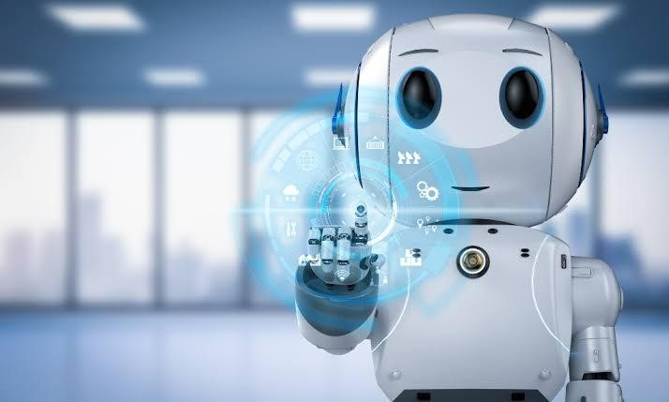

History:

The word "Robot" is derived from Czech word Robot which means forced work or compulsory service. It was firstly used by Czech play Wright kerel Capek in 1918 in his short story and again same concept was used in 1920 for the title R. U. R. which stood for RASSUM'S UNIVERSAL ROBOTS.

The first industrial robot "UNIMATE" in 1954 and it was designed by George Devol which was call as Universal Automation and this became first Robot Company (1962). The first human robot "ELEKTRO" which was designed by Westinghouse in 1937 that could walk, talk and smoke. The first space robot NASA'S Pathfinder landed on Mars. The wheeled Robotic rover sent images and data about Mars back to Earth.

The term Robotics was coined by Russian born American Scientist and writer Isaac Asimov With Robot reality and intelligence robot a likely prospect a better understanding of interaction between robots and human are embodied in such as modern films as Spielberg's A.J(movie in 2001), Proyas

1 robot(2004) and Shankar's

Robo(2010)and Robo 2.0(2018).

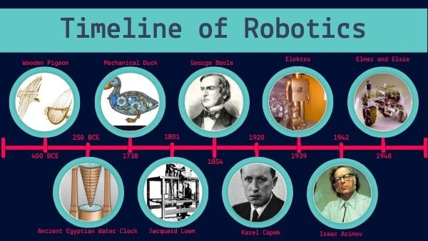

The laws of robotics:

It was proposed by author and scientist Isaac Asimov in 1940

First law:

A robot may not injure a human being, or, through inaction, allow a human being to come to harm.

Second law:

A robot must obey orders given it by human beings except where such orders would conflict with the first law.

Third law:

A robot must protect its own existence as long as protection does not conflict with the first or second law.

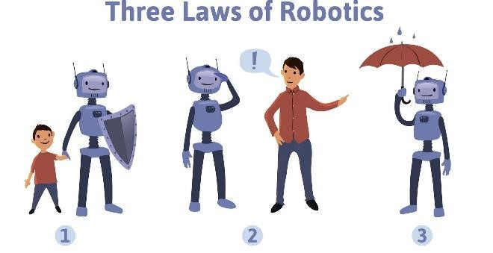

Asimov's reversed law of robotics (1985):

Zeroth law:

A robot may not injure humanity, or, through inaction allow humanity to come to harm.

First law:

A robot may not injure human being, or, through inaction allow human being to come harm, unless this would violate the Zeroth law of robotics.

Second law:

A robot must obey orders given it by the human being, except where such order would conflict with the Zeroth and first law.

Third law:

A robot must protect its own existence as long as such protection does not conflict with

Zeroth, first or second law

Robotic Hardware:

Sensors:

These are the sub area of robot intended to give sensing capabilities so that robots are more human like. The different sensors in robots are:

Light sensor, Proximity sensors, Sound sensors, Temperature sensors, Acceleration sensors are the types of sensors in robots. The sensors in robots are based on function of human sensory organ.

End Effectors:

These are devices that attaches to the wrist of the robot arm. And it enables robots to perform particular task. The major effectors are Grippers which are used to grasp and manipulates objects. These are the tools to perform a process like spot welding spray painting.

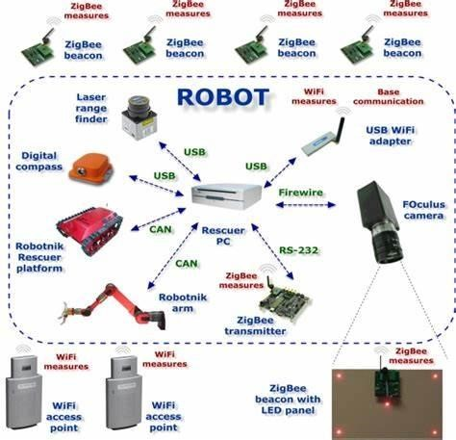

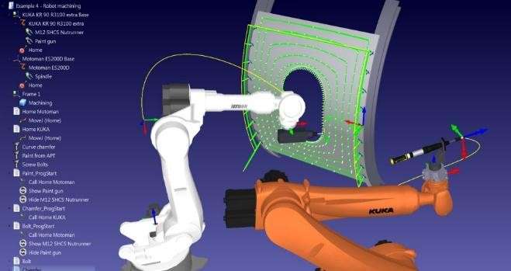

The three important things of power generation circuit of robot should do are:

1. Regulate at set voltage.

1. Supply a minimum required amount of power.

1. Allow for additional features based on application.

Robotic software:

The minimum specification is a pe with Intel® Core™ i5-8250U CPU @ 1.60GHz 1.80GHz, 8.00GB RAM, 2TB free HD space. Advance graphics performance using a standard 3D graphics card with hardware support of OpenGL.

Open G specification describes and abstract for drawing 2D and 3D graphics.

Robots are controlled by programming languages such as C, BASIC,

Assembler, or SBASIC.

Controllers;

The "brain" of the robot, processing data from sensors, making decisions based on AI algorithms, and sending commands to actuators.

Mechanical structure:

The physical body of the robot including joints, linkages, and the overall design that allows for movement and manipulation.

Working of robots;

Robots are not directly controlled by human but it includes feedback-driven connection between sense and action takes electromagnetic motors or effectors to move up open or close gripes.

The step by step, control is provided by program to microcontroller computer. computer run on (embedded computer ).

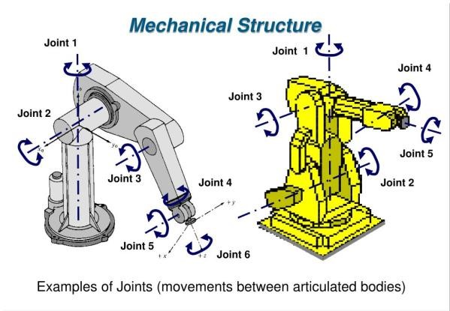

Artificial intelligence

How AI interacts with robotic hardware:

Perception:

AI algorithms process data from sensors to interpret the environment, recognizing objects, navigating spaces, and understanding complex situations.

Decision-making:

AI uses machine learning models to analyze sensor data and make decisions about actions to take, like path planning, object manipulation, or response to unexpected situations.

Control:

AI algorithms translate those decisions into precise control signals for actuators, enabling smooth and coordinated movements.

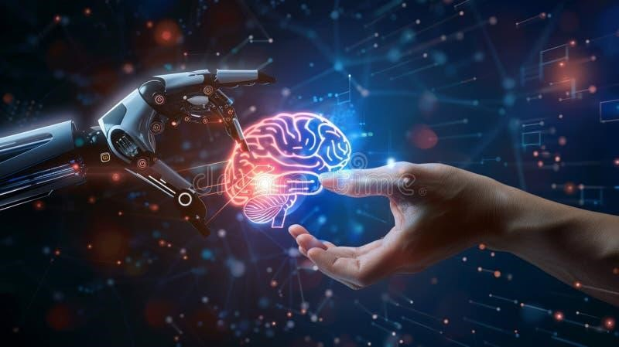

Modern Robots:

1. Autonomous Mobile robots(AMRs):

Mobile robots are used everywhere including in space research and even in land mining detection. NASA'S FIDO ROVER is a mobile robot used in for exploration of mars. Even Military robots are also remote controlled mobile robots designed by military applications. These are fitted with a camera and are sent to enemy territory to capture the images. These military robots won't get tired or won't close their eyes or have any sort of fear.

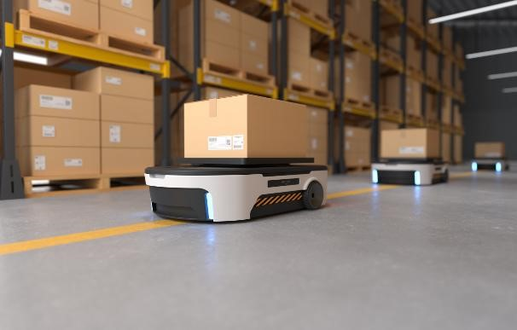

1. Medicinal robots:

These medicinal robots controlled by computer. These robots are used for surgeries

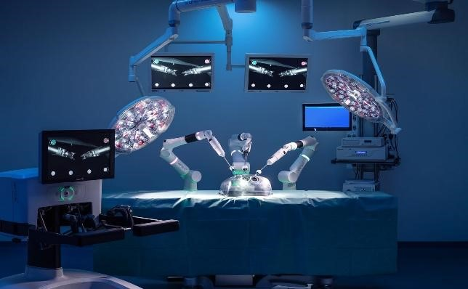

1. Humanoid robots:

This robot resembles human body. These humanoid robots have torso with head, two arms and two legs. The first robotic citizen is "Sophia" which was developed by Hong Kong based company Hanson robotics.

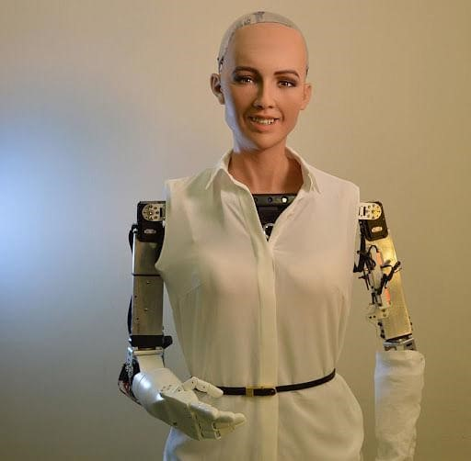

1. Articulated robots (robotic arms):

An articulated robot has rotary joints and can have up to 10 or more axes. This gives them more freedom of movement which brings with it great versatility. Their precision and style of movement closely mimic that of a human arm.

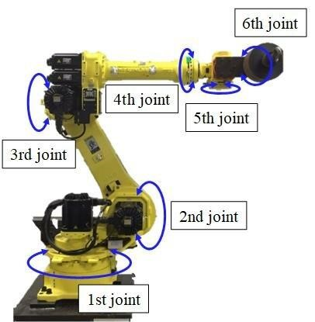

Applications of Robotics:

1. Security

One of the top applications of robotics is in the field of security. Imagine a world where all security guards are robots. Even thieves would think twice before committing a crime! That’s why robotics is being considered as a solution to enhance security

1. Space Exploration

Many things in space are very dangerous for astronauts to do. Humans can’t roam on Mars all day to collect soil samples or work on repairing a spaceship from the outside while it’s in deep space! In these situations, robots are a great choice because there are no chances for the loss of human life. So space institutions like [NASA](https://www.geeksforgeeks.org/nasa-full-form/) frequently use robots and autonomous vehicles to do things that humans can’t. This can be one of the top applications of robotics.For example, Mars Rover

1. Entertainment

Another top application of robotics is robots are also a big draw in the entertainment industry. While they cannot exactly become actors and actresses, they can be used behind the sets in movies and serials to manage the camera, provide special effects, etc. They can be used for boring repetitive tasks that are not suitable for a human as cinema is, after all, a creative industry

1. Agriculture

Agriculture is the sector that is the basis of human civilization. However, agriculture is also a seasonal sector that is dependent on ideal weather conditions optimal soil, etc. One of the top applications of robotics in agriculture is for harvesting crops. Robotic harvesters streamline the harvesting process, allowing farmers to complete tasks more efficiently

1. Manufacturing

One of the top applications of robotics in the manufacturing industry is automating repetitive tasks. Many repetitive and common tasks in the manufacturing industry don’t require any usage of the mind like welding, assembly, packing, etc. These tasks can be easily done by robots while leaving the mentally challenging and creative tasks to humans

1. Military

Applications of Robotics in the military can be vast. They can be used as drones to keep surveillance on the enemy, they can also be used as armed systems to attack the opposing forces or as Medicare agents to help friendly forces.

1. Customer Service

Some robots are developed to look exactly like humans for cosmetic purposes. These robots are primarily used in the field of customer service in high-visibility areas to promote robotics. For example is Nadine, a humanoid robot in Singapore

Challenges in Robotics:

1. Perception and Sensing

– Robots struggle to interpret complex and dynamic environments accurately, especially in unstructured settings.

2. Autonomy and DecisionMaking

– Developing robots that can make real-time decisions without human intervention remains difficult.

3. Dexterity and Manipulation

– Achieving human-like dexterity for tasks like grasping irregular objects is a major hurdle.

4. Energy Efficiency

– Battery life and energy consumption limit robot performance, especially for mobile and aerial robots.

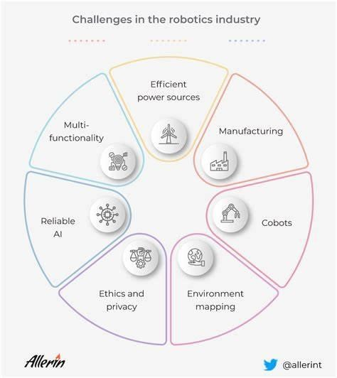

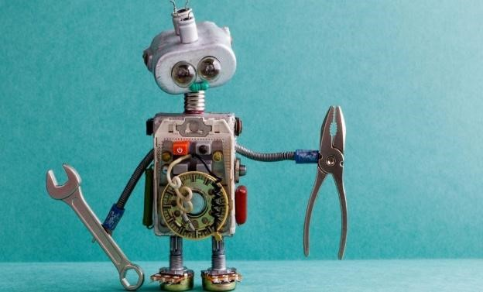

5. Human-Robot Interaction

– Ensuring safe and effective collaboration between robots and humans is an ongoing challenge.

6. Artificial Intelligence and Learning

– Improving AI models for better adaptation, reasoning, and learning in real-world scenarios is crucial.

1. Cost and Scalability –

Making advanced robotics affordable and scalable for mass adoption is a key issue.

1. Ethical and Social Concerns

– Questions about job displacement, security, and the ethical use of robots need careful consideration.

Future Trends in Robotics:

1. AI-Powered Robotics:

* Robots will become more autonomous with advanced AI, enabling better decisionmaking and adaptability in dynamic environments.
* Large language models (like GPT) will be integrated into robotics for improved human interaction and learning capabilities.

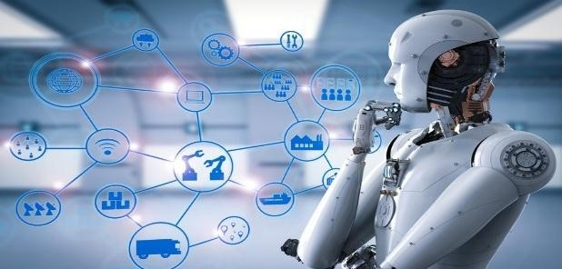

2. Collaborative Robots (Cobots):

* Cobots will work alongside humans in factories, offices, and even homes, improving efficiency and safety.
* Enhanced sensors and AI will make them more intuitive and responsive to human needs.

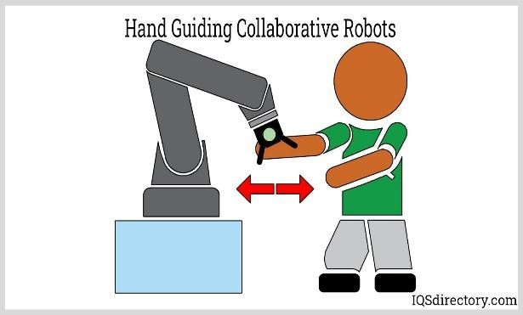

3. Swarm Robotics:

* Inspired by nature, multiple small robots will work together to solve complex problems, such as search-and-rescue operations and large-scale construction.
* Applications in agriculture, military, and space exploration will expand.

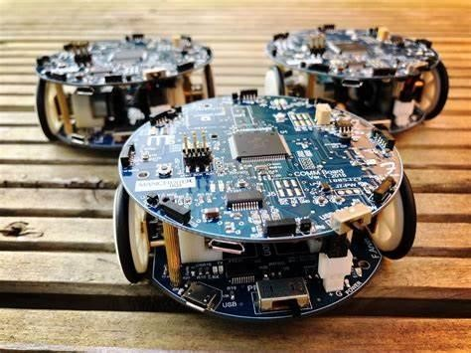

4. Soft Robotics:

* Robots made from flexible, bio-inspired materials will handle delicate tasks in healthcare, food production, and personal assistance.
* These robots will be used in surgeries, prosthetics, and rehabilitation.

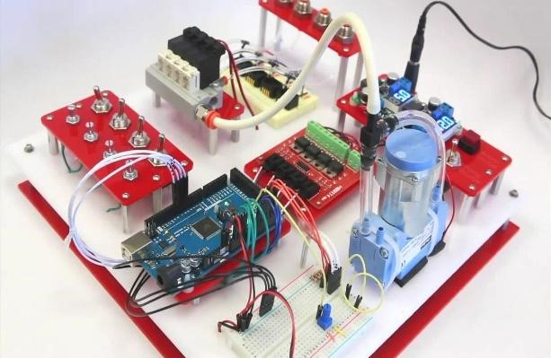

5. Robotics in Space Exploration:

* NASA, SpaceX, and other agencies will deploy autonomous robots for deep space missions, asteroid mining, and Mars colonization.
* AI-powered rovers and drones will enhance space exploration efficiency.

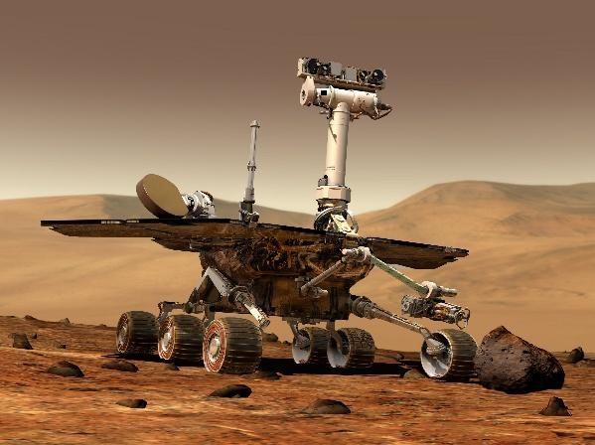

6. Autonomous Vehicles & Drones:

* Self-driving cars, trucks, and delivery drones will become more prevalent in logistics and transportation.
* AI-powered navigation and safety features will improve efficiency and reliability.

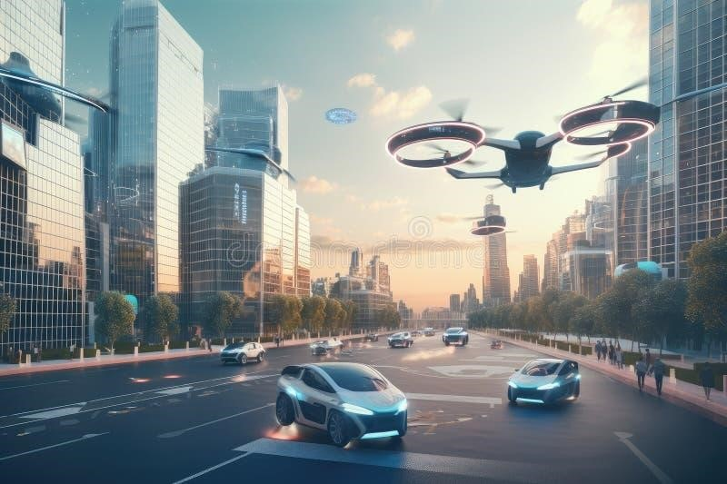

7. Healthcare & Medical Robotics:

* AI-driven robotic surgeons will enhance precision in operations.
* Care robots will assist the elderly and disabled, improving healthcare accessibility.

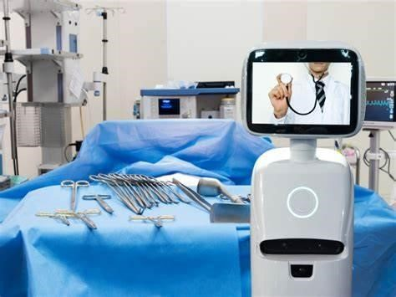

8. Robotics in Agriculture:

* Autonomous tractors, robotic harvesters, and AI-driven monitoring systems will revolutionize farming.
* Precision agriculture will optimize resource use and increase yields.

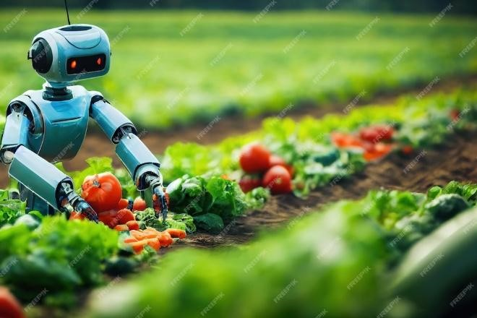

Conclusion:

robotics which aids in bringing an improvement in the present technologies, and then we can expect new ways of using robots which will bring new hopes and new potentials. so robots can be used in better way in today's generation. There are many applications on robots in today's generation like in industrial purpose, military purpose and medicinal purpose at so оn. There are many research university associated in the field of robotics which aids in bringing an improvement in the present technologies, and then we can expect new ways of using robots which will bring new hopes and new potentials. So robots can be used in better way in today's generation.

Robotics is revolutionizing multiple industries by enhancing efficiency, accuracy, and safety. Continuous advancements in AI, sensor technologies, and control systems will further expand the capabilities of robots. However, addressing ethical, economic, and technical challenges is crucial for responsible and sustainable growth in robotics.

Reference:

www.scribd.com www.wikipedia.com www.roboticshop.com