# AUTONOMOUS HUMAN BODY CONTROL, PART II: BLOOD PRESSURE CONTROL USING I-1/2, 2/2 SECOND-ORDER COMPENSATORS COMPARED WITH A PI CONTROLLER

**Galal Ali Hassaan**

Emeritus Professor, Department of Mechanical Design and Production, Faculty of Engineering, Cairo University, Cairo, Egypt

**ABSTRACT**

This is the second part in a series of research papers investigating autonomous human body control. The paper proposes two compensators from the second generation of control compensators presented by the author since 2014 to control the human blood pressure: feedforward I-1/2 and feedforward 2/2 second-order compensators. The compensators are tuned for the control of the human blood pressure using a combination of three tuning techniques without optimization. The effectiveness of using the proposed compensators is evaluated through comparison with the use of a conventional PI controller from the first generation of PID controllers and the best compensator/controller for the purpose of blood pressure control is assigned.

**Keywords:** Human blood pressure control, I-1/2 compensator, 2/2 second-order compensator, PI controller, compensator tuning

1. **INTRODUCTION**

High blood pressure represents a real challenge for human health care since it leads to death and continuous monitoring, diagnosis and treatment is required [1]. On the other hand, low blood pressure has some symptoms such as: fading vision, dizzy feeling, fainting, fatigue, concentration problems and upset stomach [2]. Fortunately, to save human body life automatic control systems are in use to keep the blood pressure around desired safe levels. Classical PID controllers are in use with different tuning techniques. Here in the present work I introduce two compensators from the second generation of control compensators introduced by the author in 2014 to improve the performance of the control system for fast and accurate time response. Before going deeply in the details we present some of the efforts of researchers in this important application since 1980 to 2025.

Slate (1980) designed a sampled data feedback system for infusing sodium nitroprusside (SNP) in post-surgical cardiac patients using model-based techniques and computer simulation. He assigned the transfer function model of the blood pressure in response to the infusion drug. He used a first-order model with two pure delays which are still in use up to now [3]. Pajunen, Steinmetz and Shankar (1990) presented an approach for adaptive control of blood pressure using SNP. They developed a modified stochastic model reference adaptive control algorithm with time varying reference model. They imposed clinical constraints on the infusion rate and mean arterial pressure. They used the dynamic model of Slate [3] in their simulation work [4].

Cushman et al.(2002) outlined that systolic blood pressure is more difficult to control than diastolic blood pressure and at least two antihypertensive medications are required to achieve blood pressure control. They outlined also that the majority of people with hypertension could achieve a blood pressure < 140/90 mmHg with the antihypertensive medications available [5]. Nguyen et al. (2005) presented a fuzzy gain scheduling for PID control of mean arterial pressure during general anaesthesia by SNP. They used the Slate model [3] to test the PID controller with fuzzy gain scheduler and applied simulation and clinical results in deep hypertensive controls at 40 mm Hg on pigs indicating safety and stability of the designed controller. Their control system could settle to 40 mm Hg with 2% tolerance in about 200 s with fuzzy gain scheduling and about 800 s using c conventional PID controller [6].

Mend, Adgcy, Griffith and Kassianes (2011) outlined that some important aspects of treatment are not routinely considered in practice in particular the need for good 24-hour blood pressure control. They concluded that a treatment with a long duration of action may be important in managing blood pressure over 24 hours [7].

Ribeiro et al. (2011) proposed a solution to the manual monitoring of patient’s blood pressure through the design and implementation of an embedded PID controller to control the blood pressure in an optimal way. The used the blood pressure transfer function of Slate [3] and presented a step time response having 23.4 % maximum overshoot and 384 s settling time using a tuned PI controller [8]. Elamvazuthr, Mohamed, Ezzedin and Salih (2013) a robust and efficient intelligent control approach for blood pressure control using PID-neural network. Their approach was used to optimize the regulation of the mean arterial pressure through the infusion of SNP and used the blood pressure transfer function of Slate [3] obtaing a step time response having about 7.1 s settling time with P controller and 5.5 s with PI controller [9].

Silva, Maitelli, Leao and Seabra (2015) used a multiple model adaptive control for a computer-based feedback control system regulating the infusion rate of the SNP drug to maintain the blood pressure as close as possible to the desired value. They used the transfer function model of Slate [3] in their analysis and achieved very small overshoot and about 300 s settling time [10]. Urooj and Singh (2016) developed a fractional order PID control system for mean arterial pressure of cardiac patients after surgical operation. The PID controller was designed to inject SNP drug in a controlled way to reduce the high blood pressure. They claimed that the system output using the fractional order PID could give better result in cardiac patients. They used the transfer function of Slate [3] and obtained a step time response having about 54 % overshoot and 800 s settling time [11].

Bash, Vivekanandan and Puthasar (2018) outlined that SNP is used to reduce the blood pressure in fast action. They used PID, IMC and MPC controllers for the control of the blood pressure and evaluated their performance for sensitive, normal and insensitive patients. They used the transfer function model of Slate [3] and presented the step time response of the blood pressure for the three types of patients with zero maximum overshoot and 948, 738 and 706 s settling time for the normal patient with PID, IMC and MPC controllers respectively [12]. Tajoujian, Salavati, Franchet and Grigoriadis (2019) presented a robust and parameter-varying controllers for regulating blood pressure in critical hypertensive patients using vasopressor drug infusion. They modeled the patient’s time response as a delayed first-order dynamic model with varying parameters. They used an IMC strategy to design a fixed PID controller and the small gain theorem for robust stability condition. They evaluated the performance of the control system through simulation and provided step time responses without performance measures [13]. Karam and Haamed (2020) presented a nonlinear control system to control the mean arterial pressure. They used Slate’s transfer function model [3], squirrel search algorithm and the bacterial foraging optimization to tune the controller. They presented control results for sensitive, normal and insensitive patients and the step time response of the blood pressure having 240, 450 and 770 s for sensitive, normal and insensitive patients when the squirrel search algorithm was used to tune the PI-ID controller with zero undershoot and overshoot [14]. Sandeep, Patel and Mistry (2022) discussed the control of the mean arterial blood pressure using the infusion rate of SNP. They used the transfer function model of Slate [3] and used the sliding mode control technique to design the controller. Their analysis considered patient’s sensitivity and compared with the internal model control strategy and checked the robustness of the controller. They didn’t give measures for the control time response performance [15].

Baykuziyev, Khan, Karmakar and Baloch (2023) discussed various closed-loop approaches for blood pressure management. They examined the integration of advanced monitoring technique and artificial intelligence algorithms in closed-loop systems with overview of their potential contribution [16]. Abouali and Mojallali (2025) used a fractional order PID controller tuning using a hybrid-evolutionary optimization algorithm to control patients’ blood pressure. They used IAE, ISE and ITAE objective functions and claimed that their control structure could reduce the settling time and steady-state error [17].

1. **THE BLOOD PRESSURE AS A PROCESS**

Slate used a first-order transfer function model with double time delays to relate the changes in blood pressure and the infusion of SNP drug and control it using a PI-controller [3]. His transfer function model GBP(s) was a first-order one with double time delays as given below [3]:

## GBP(s) = P(s)/I(s) = Kse-Tis(1+αe-Tcs)/(1+Ts) (1)

Where:

P(s) = arterial blood pressure change.

I(s) = Infusion rate change.

**α**  = recirculation parameter.

Ti = transport delay.

Tc = recirculation delay.

T = time constant.

Ribeiro et al. used the following patient model parameters [7]:

Ks = 0.9137 , Ti = 41.2319 , Tc = 65.0625 , α = 0.3736 (2)

The transfer function in Eq.1 has two time delay elements which need easier form to facilitate writing the transfer function in a standard polynomial form to obtain time and frequency responses of the process and closed-loop control system. Bade approximation is used to replace the time delay terms with rational polynomial terms [18]. A first-order Pade approximation for the exponential expressions in Eq.1 is given by [18]:

e-Tis = (2-Tis)/(2+Tis) , e-Tcs = (2-Tcs)/(2+Tcs) (3)

Combining Eqs.1 and 3 gives the blood pressure process as:

Ks(2-Tis)[2+2α+(Tc-αTc)s]

GBP(s) = -------------------------------- (4)

(1+Ts)(2+Tis)(2+Tcs)

Eq.4 can be set in standard form using simple zeros and simple poles as follows:

-Ko(s-z1)(s+z2)

GBP(s) = ------------------------ (5)

(s+p1)(s+p2)(s+p3)

Where using Eq.2:

Ko = Ks(1-α)/T = 0.0181 , z1 = 2/Ti = 0.0485 , z2 = (2+2α)/(Tc-Tcα) = 0.0674 , p1=1/T = 0.03163 ,

p2 =2/Ti = 0.0485 , p3 = 2/Tc = 0.03074

Moreover, Eq.5 can be written I a polynomial form as:

Ko[-s2+(z1-z2)s+z1z2]

GBP(s) = ------------------------------------------------------ (6)

S3+(p1+p2+p3)s2+(p1p2+p1p3+p2p3)s+p1p2p3

The unit step time response of the blood pressure due to a unit step input of the infusion rate change is generated using the process model in Eq.6 using the step command of MATLAB [19] and shown in Fig.1.

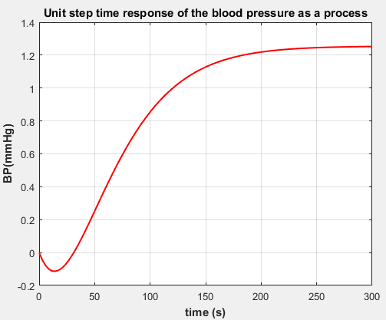

**Figure 1:** Unit step time response of the blood pressure (BP) as a process.

COMMENTS:

* Maximum overshoot: zero
* Maximum undershoot: -0.1137 mmHg
* Settling time: 210.3 s
* Steady-state error: -0.2526 mmHg

- Any proposed successful compensator or controller has to cope with this large undershoot, settling time and steady-state error of the closed-loop control system.

1. **CONTROLLING THE BLOOD PRESSURE USING A PI CONTROLLER**

A conventional PD controller was used by Ribeiro et al. to control the first-order with two time-delays blood pressure process [7]. They tuned the PI controller and provided its two gain parameters Kpc and Ki as:

Kpc = 0.750 , Ki = 0.014 (7)

The step time response for 100 mmHg desired blood pressure was drawn using the closed-loop transfer function of the single-loop block diagram with the PI controller and process of Eq.6 using the step command of MATLAB [19] and shown in Fig.2.

COMMENTS:

* Maximum overshoot: 23.36 %
* Maximum undershoot: -11.175 mmHg
* Settling time: 384 s
* Steady-state error: zero

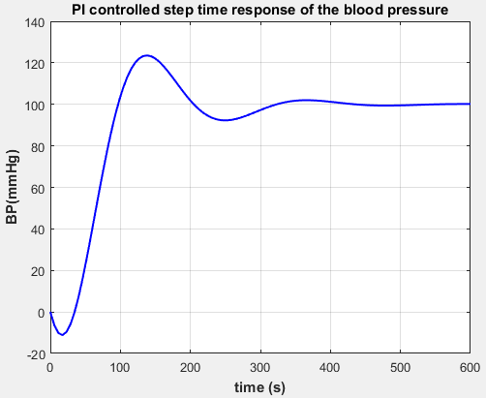

Figure 2: Blood pressure step time response using a PI controller.

1. **CONTROLLING THE BLOOD PRESSURE USING A NOVEL I-1/2 FEEDFORWARD COMPENSATOR**

The I-1/2 feedforward compensator is one of the second generation of control compensators introduced by the author since 2014. It has a structure composed of two control modes in cascade with the controlled process in a single-loop block diagram. The first control mode is an integral mode of gain Ki and the second control mode is a 1/2 order dynamic model having one zero zc and two poles p1c and p2c. It has a transfer function GI-1by2(s) given by:

GI-1by2(s) = (Ki/s)(s+zc)/[(s+p1c)(s+p2c)] (8)

The I-1/2 feedforward compensator is tuned as follows:

* The zero/pole cancellation technique [20] is used to cancel the zero of the forward compensator with the pole s+p3 in Eq.5. This reveals the compensator zero as:

zc = p3 = 0.03074 (9)

* Now, we are left with three compensator parameters: Ki, p1c and p2c. Fortunately, it was easy to tray some manual settings for the three compensator parameters, derive the transfer function of the closed-loop control system comprising the I-1/2 compensator and the BP process and plot its step time response using the ‘step’ command of MATLAB [19].
* The set of compensator parameters giving good results with this novel compensator is:

zc = 0.03074 , Ki = -255 , p1c = 2 , p2c = 5 (10)

* The time response of the control system is obtained for a 100 mmHg step input, the derived transfer function of the closed-loop control system and the compensator parameters in Eq.10 is shown in Fig.3.

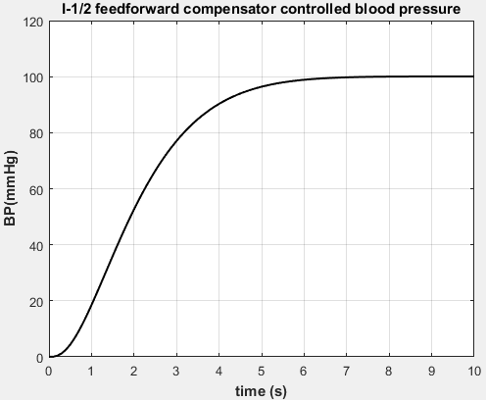

Figure 3: Blood pressure step time response using an I-1/2 feedforward compensator.

COMMENTS:

* Maximum overshoot: 0.01 % compared with 23.36 % for the PI controller.
* Maximum undershoot: zero compared with -11.175 mmHg for the PI controller.
* Settling time: 5.54 s compared with 384 s for the PI controller.
* Steady state error: zero.

1. **CONTROLLING THE BLOOD PRESSURE USING A SECOND-ORDER FEEDFORWARD COMPENSATOR**

The second order compensator was introduced by the author in 2015 to control a highly oscillating second-order-like process [21] as one of the second generation of control compensators used to control processes having bad dynamics and introduced by the author since 2014. The 2/2 second order compensator has the transfer function G2by2(s) given by:

G2by2(s) = Kc3(s+z3)(s+z4)/[(s+p4)(s+p5)] (11)

Where Kc3 is the compensator gain, z3, z4 are its two zeros and p4, p5 are its two poles parameters. The five gain parameters of the 2/2 second order compensator are tuned as follows:

* The zero/pole cancellation technique [20] is used to provide some of the compensator parameters. In the open-loop transfer function of the control system incorporating the 2/2 compensator and the blood pressure process we let (s+z4) equals (s+p3), (s+p4) equals (s-z1) and (s+p5) equals (s+z2). This reveals the following compensator parameters:

z4 = 0.03163 , p4 = -0.0485 , p5 = 0.0674 (12)

* Now, using the compensator gain parameters in Eq.12 will give a closed-loop transfer function M3(s) given by:

M3(s) = -KoKc3/(s+p2-KoKc3) (13)

* Eq.13 reveals the transfer function of a first-order control system having a non-zero steady-state error. The steady-state error can be derived easily from Eq.13 which will be function of the compensator gain Kc3. For a desired steady-state error of (say) 0.1 mmHg, the derived equation of the steady-state error reveals the following value for the compensator gain:

Kc3 = -2676.8 (14)

* Now, we add one more performance parameter which is the settling time mathematical expression for first-order control systems step time response [22]. The settling time, Ts3 of a first-order control system is related to its time constant T3 through the relationship [22]:

Ts3 = 3.9T3 (15)

* The time constant of the first-order control system is derived from Eq.13 be setting the denominator in the form 1+T3s. For a desired settling time of (say) 3.9 s, Eq.15 reveals Kc3 as:

Kc3 = -52.569 (16)

* From Eqs.14 for 0.1 mmHg steady-state error and 16 for 3.9 s settling time, Kc3 can be tuned as:

Kc3 = -2677 (17)

* The step time response of the control system for blood pressure using the proposed feedforward 2/2 second-order compensator using the process blood pressure parameters and the compensator gain parameter in Eq.17 is shown using the step command of MATLAB [19] and shown in Fig.4 for 100 mmHg desired blood pressure.

COMMENTS:

* Maximum overshoot: zero compared with 23.36 % for the PI controller.
* Maximum undershoot: zero compared with -11.175 mmHg for the PI controller.
* Settling time: 0.0817 s compared with 384 s for the PI controller.
* Steady state error: 0.11 mmHg compared with zero for the PI controller.

1. **COMPARISON OF THE PROPOSED COMPENSATORS WITH A PI CONTROLLER**

The time-based characteristics of the control systems used to control the blood pressure are compared as follows:

## Graphical Comparison

The step time response of the control systems proposed to control the UAV velocity with graphical comparison with PI controller is shown in Fig.6 for 100 mm Hg desired blood pressure.

## Numerical Comparison

The time-based characteristics of the control systems proposed to control the UAV velocity as extracted from Fig.6 are tabulated in Table 1 compared with those of uncontrolled and PI controlled velocity.

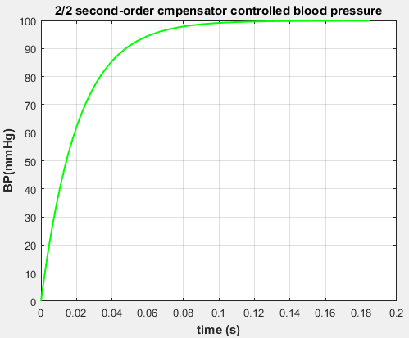

Figure4: Blood pressure step time response using a feedforward 2/2 second-order compensator.

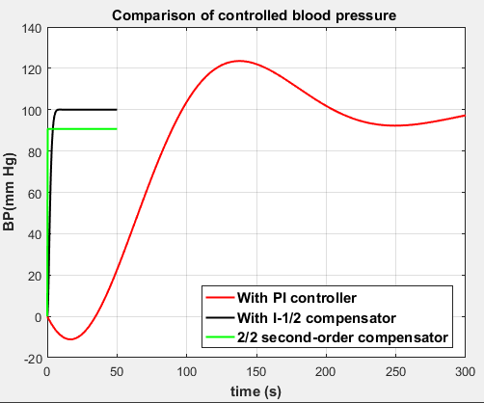

Figure 5: Blood pressure step time response comparison.

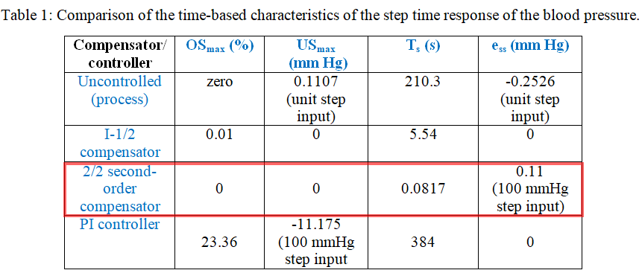

OSmax: maximum overshoot

USmax: maximum undershoot

Ts: settling time

ess: steady-state error

1. **CONCLUSION**

* The control of the human blood pressure was investigated in this research paper using two compensators from the second generation of control compensators: I-1/2 forward compensator, and feedforward 2/2 second-order compensator
* The use of the two compensators was compared with the use of a PI controller from the first generation of PID controllers.
* The compensators were tuned using a combination of two techniques: zero/pole cancellation and the fulfillment of special requirement for some characteristics of the step time response of the closed-loop control system.
* The unit step time response of the closed-loop control system was presented and the main time-based characteristics were extracted from the plot.
* The compensators performance in controlling the blood pressure was compared with the PI controller graphically and quantitatively.
* The I-1/2 compensator could reduce the maximum overshoot to only 0.01 % (compared with 23.36 % for the PI controller) , could eliminate the maximum undershoot (compared with -11.17 mm Hg for the PI controller), could eliminate completely the steady-state error and could achieve a settling time of 5.54 s (compared with 384 s for the PI controller).
* The feedforward 2/2 second-order compensator could eliminate completely the maximum overshoot (compared with 23.36 % for the PI controller), could eliminate the maximum undershoot (compared with -11.17 mm Hg for the PI controller), and the steady-state error for 100 mm Hg desired blood pressure was only 0.11 mm Hg and achieve a settling time of only 0.0817 s (compared with 384 s for the PI controller).
* The feedforward 2/2 second-order compensator was selected as the best compensator/controller for the control of the human blood pressure for its perfect performance depicted in Fig.5 and Table 1 compared with the other control devices investigated.

1. **REFERENCES**
2. A. Brasoveanu et al., “High blood pressure – A A high risk problem for public healthcare”, Current Health Sciences Journal, Volume 45, Issue 3, 2019, pp. 251-257.
3. Maya Clinic Staff, “Low blood pressure (hypotension)”, <https://www.mayoclinic.org/diseases-conditions/low-blood-pressure/symptoms-causes/syc-20355465> , 2025.
4. J. B. Slate, “Model-based design of a controller for infusing sodium nitroprusside during post-surgical hypertension”, Ph. D. Thesis, University of Wisconsin, Madison, USA, 1980.
5. G. Pajunen, M. Steinmetz and R. Shankar, “Model reference adaptive control with constraints for postoperative blood pressure management”, IEEE Transactions on Biomedical Engineering, Volume 37, Issue 7, 1990, pp. 679-687.
6. W. C. Cushman et al. , “Success and prediction of blood pressure control in diverse North American settings: The antihypertensive and lipid-lowering transient to prevent heart attack trial”, The Journal of Clinical Hypertensions, Volume 4, Issue 6, 2002, pp. 393-404.
7. C. N. Nguyen et al., “An online fuzzy gain scheduling for blood pressure regulation”, 16th Triennial World Congress, Prague, Czech Republic, 2005.
8. M. Mend, J. Adgey, K. Griffith and G. Kassianes, “Controlling blood pressure over 24 hours: A review of the evidence”, The British Journal of Cardiology, Volume 15, 2008, pp. 31-34.
9. A. G. Ribeiro et al., “Design of an embedded PID controller applied to blood pressure control”, Conference Proceedings, Annual International Conference of the IEEE Engineering in Medicine and Biology Societies, August 2011, 5 pages.
10. I. Elamvazuthi, A. Mohamed, H. Ezzedin and Y. Salih, “An intelligent control for blood pressure system using PID and MLP neural networks”, 8th IEEE Conference on Industrial Electronics and Applications, 2013, pp. 1049-1053.
11. H. Silva, M. Maitelli, C. Leno and E. Seabra, “Multiple model SPGPC for blood pressure control”, Proceedings of the 12th International Conference on Information in Control, Automation and Robotics, 2015, pp. 563-568.
12. S. Urooj and B. Singh, “Control of mean arterial pressure using fractional PID controller”, 3rd International conference on Computing for Sustainable Global Development, New Delhi, 2016, pp. 1556-1559.
13. A. Bash, S. Vivekanandan and P. Parthasarathy, “Evolution of blood pressure control identification in lieu of post-surgery diabetic patients: A review”, Health Information Science and Systems, Volume 6, Issue 17, 2018, 10 pages.
14. S. Tasoujian, S. Salavati, M. Franchek and K. Grigoriadis, “Robust IMC, PID and parameter-varying control strategies for automated blood pressure regulation”, International Journal of Control, Automation and Systems, Volume 17, 2019, pp. 1803-1813.
15. E. Karam and R. Haamed, “Controlling of mean arterial pressure by modified PI-ID controller based on two optimization algorithms”, International Journal of Modern Education and Computer Science, Volume 4, 2020, pp.40-47.
16. B. Sandeep, H. Patel and K. Mistry, “Regulation of mean arterial blood pressure by sliding mode control”, IFAC Papers Online, Volume 55, Issue 1, 2022, pp. 631-636.
17. T. Baykuziyev, M. Khan, A. Karmakar and M. Baloch, “Closed-loop pharmacologic control of blood pressure: A review of existing systems”, Cureus, Volume 15, Issue 9, 2023, 16 pages.
18. A. Abouali and H. Mojallali, “Blood pressure regulation using a FOPID controller based on a hybrid-evolutionary optimization algorithm”, First International Conference on Applied Research in Electrical Engineering, Ahvaz, Iran, 2025, pp.1-6.
19. A. Mehta and R. Swarnalatha, “Adopting Pade approximation for first-order plus dead time models for blending process”, International Journal of Engineering & Technology, Volume 7, Issue 4, 2018, pp. 2800-2805.
20. Mathworks, “Generating a step response in MATLAB”,

<https://ctms.engin.umich.edu/CTMS/index.php?aux=Extras_step>

1. M. C. Campi, “The problem of pole-zero cancellation in transfer function identification and application to adaptive stabilization”, Automatica, Volume 32, Issue 6, 1996, pp. 849-857.
2. G. A. Hassaan, "tuning of a novel second-order compensator for use with a highly oscillating second-order-like process", International Journal of Engineering and Advanced Research Technology, Volume 1, Issue 1, 2015, pp. 32-35.
3. Electrical for you, “Settling time: What is it? Formula and how to find it in MATLAB”, <http://www.electrical4u.com/settling-time/> , April, 25, 2024.

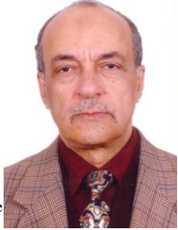**BIOGRAPHY**

***GALAL ALI HASSAAN***

* Emeritus Professor of System Dynamics and Automatic Control.
* Has got his B.Sc. and M.Sc. from Cairo University in 1970 and 1974.
* Has got his Ph.D. in 1979 from Bradford University, UK under the supervision of Late Prof. John Parnaby.
* Now with the Faculty of Engineering, Cairo University, EGYPT.
* Research on Automatic Control, Mechanical Vibrations, Mechanism Synthesis and History of Mechanical Engineering.
* Published 350 research papers in international journals and conferences.
* Author of books on Experimental Systems Control, Experimental Vibrations and Evolution of Mechanical Engineering.
* Member of the Editorial Board of some engineering and computer technology international journals.
* Reviewer in some international journals.