**A Study on Transformation and Evolution from Traditional to Digital Marketing**

1 Mr. Deepakraj R, 2 Dr. Ramprathap,

Student, Assistant Professor,

Department of Management Studies,

M. Kumarasamy College of Engineering. Karur, Tamil Nadu, India

**Abstract:** The marketing landscape has undergone a significant transformation over the years, evolving from traditional marketing methods to digital strategies. This study explores the shift from conventional marketing techniques, such as print advertisements, television commercials, and direct mail, to digital marketing approaches, including social media, content marketing, search engine optimization (SEO), and pay-per-click (PPC) advertising. The research examines the driving forces behind this evolution, the impact of technology, consumer behaviour shifts, and the effectiveness of digital marketing strategies in comparison to traditional ones. Through a detailed analysis, this study highlights the advantages, challenges, and future prospects of digital marketing, providing insights for businesses to adapt to the ever-changing market dynamics.

**Keywords:** Traditional marketing, digital marketing, transformation, consumer behavior, online advertising, marketing evolution.

**Introduction:** Marketing has always been an essential component of business growth, helping organizations reach their target audience and enhance brand visibility. Traditional marketing methods, including newspapers, television, radio, and billboards, dominated the industry for decades. However, the rapid advancement of technology and the internet has led to a paradigm shift, paving the way for digital marketing. With increasing internet penetration and the rise of social media platforms, businesses have embraced digital marketing to engage customers more effectively.

This study aims to explore the factors influencing the transition from traditional to digital marketing, analyze the impact on businesses and consumers, and evaluate the benefits and challenges associated with this transformation.

**Objectives of the Study:**

1. To examine the key differences between traditional and digital marketing.
2. To analyze the driving forces behind the shift towards digital marketing.
3. To assess the effectiveness of digital marketing strategies compared to traditional marketing.
4. To identify challenges businesses face in adapting to digital marketing.
5. To explore future trends and innovations in digital marketing.

**Review of Literature:**

1. *Kotler & Keller (2020)* discussed the evolution of marketing strategies and the role of digital platforms in modern business operations.
2. *Chaffey & Smith (2019)* highlighted the significance of digital marketing tools, such as SEO, content marketing, and social media engagement, in improving brand reach and customer interactions.
3. *Ryan (2021)* examined the impact of data analytics and artificial intelligence in shaping targeted marketing strategies.
4. *HubSpot Marketing Report (2022)* presented insights on the growing influence of influencer marketing, email campaigns, and paid advertising in digital branding efforts.

**Methodology:** This research employs a mixed-method approach, combining qualitative and quantitative analysis. Primary data is collected through surveys and interviews with marketing professionals and consumers, while secondary data is sourced from academic journals, industry reports, and case studies. Statistical tools are used to analyse trends in consumer behavior and business adaptation to digital marketing.

**Results and Discussion**

**Findings and Discussion:**

1. **Consumer Behavior Shift:** Digital marketing has influenced purchasing decisions by providing personalized content and interactive engagement through social media.
2. **Cost-Effectiveness:** Digital marketing is more affordable compared to traditional methods, allowing businesses to optimize their marketing budget.
3. **Measurable Results:** Tools like Google Analytics and Facebook Insights enable marketers to track campaign performance and adjust strategies accordingly.
4. **Challenges in Digital Marketing:** Despite its advantages, businesses face challenges such as data privacy concerns, algorithm changes, and the need for continuous content creation.
5. **Future Trends:** The integration of artificial intelligence, voice search optimization, and augmented reality in marketing strategies is expected to shape the future of digital marketing.

**Results and Discussion**

### Table 1

### Years of Experience in Marketing

|  |  |  |
| --- | --- | --- |
| Years of Experience in Marketing | No of Respondents | Percentage % |
| 6 - 10 years | 34 | 28.33% |
| Less than 1 year | 31 | 25.83% |
| More than 10 years | 30 | 25.00% |
| 1 - 5 years | 25 | 20.83% |
| Total | 120 | 100.00% |

**Inference:** From Table No: 4.3.5, Years of Experience in Marketing, it was found that 28.33% of the respondents selected '6 - 10 years', 25.83% of the respondents selected 'Less than 1 year', 25.00% of the respondents selected 'More than 10 years', 20.83% of the respondents selected '1 - 5 years'.

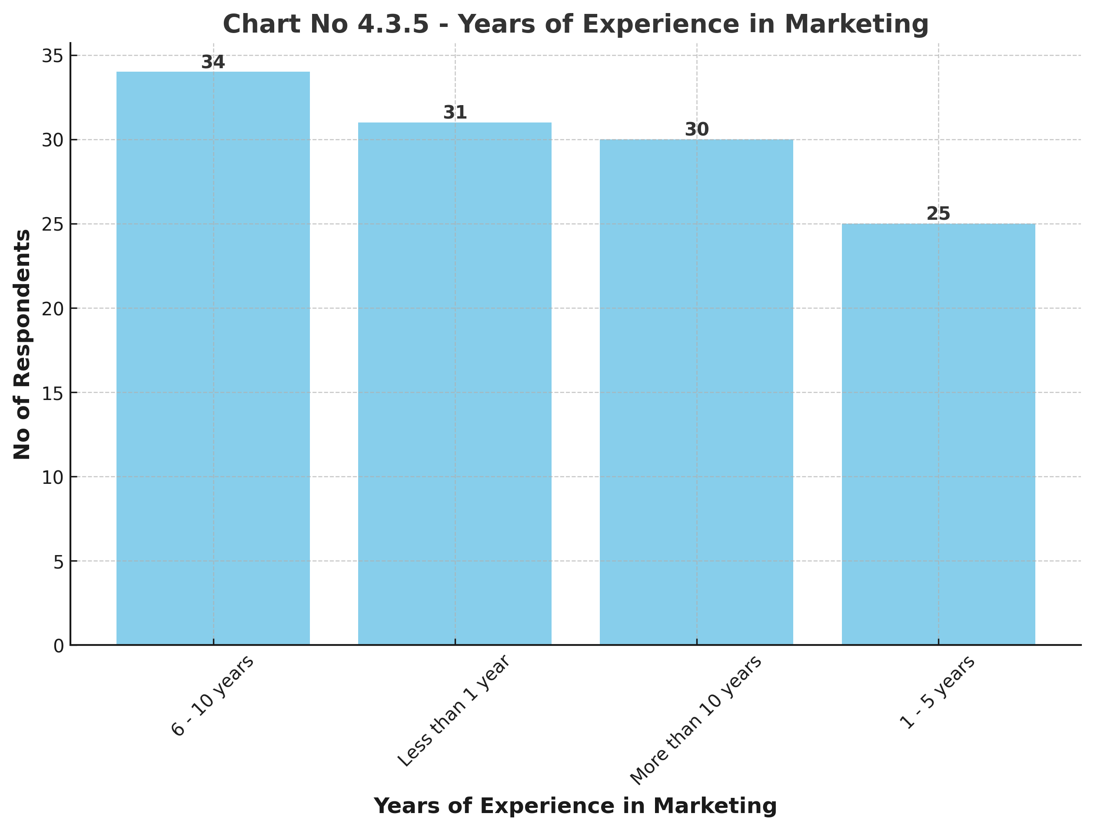

### Table 2

### Marketing Decision-Making

|  |  |  |
| --- | --- | --- |
| Marketing Decision-Making | No of Respondents | Percentage % |
| No | 63 | 52.50% |
| Yes | 57 | 47.50% |
| Total | 120 | 100.00% |

**Inference:** From Table No: 4.3.6, Marketing Decision-Making, it was found that 52.50% of the respondents selected 'No', 47.50% of the respondents selected 'Yes'.

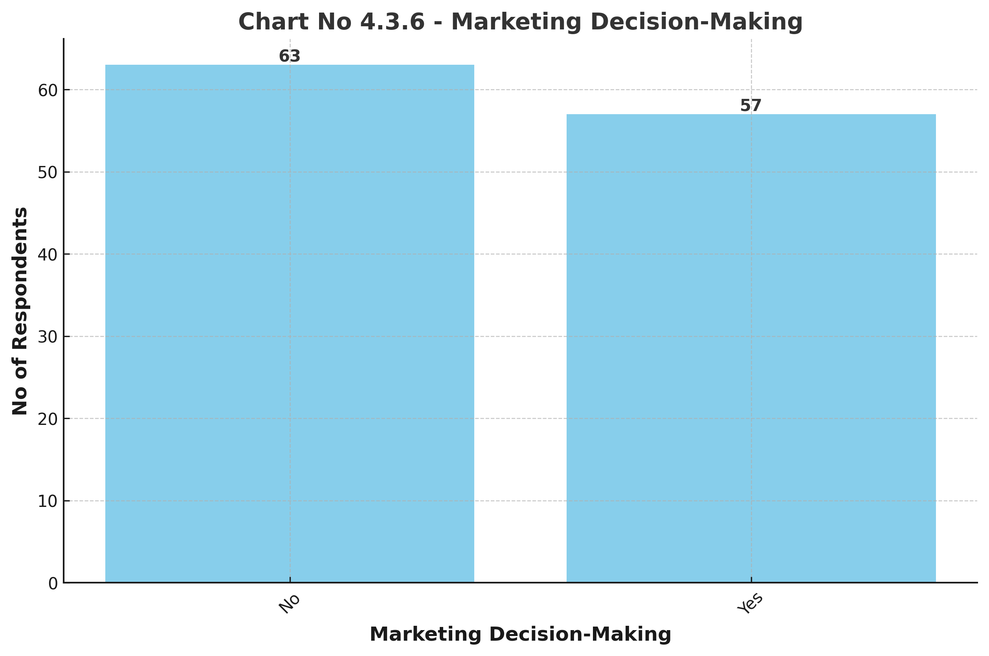

**Conclusion:** The transformation from traditional to digital marketing has revolutionized the way businesses engage with consumers. While traditional marketing still holds relevance in certain sectors, digital marketing offers superior reach, cost efficiency, and real-time analytics. Companies must continuously adapt to emerging digital trends to maintain a competitive edge. This study provides valuable insights for marketers to strategize effectively and leverage digital platforms for business growth.

**References:**

1. Kotler, P., & Keller, K. L. (2020). *Marketing Management*. Pearson.
2. Chaffey, D., & Smith, P. R. (2019). *Digital Marketing Excellence: Planning, Optimizing and Integrating Online Marketing*. Routledge.
3. Ryan, D. (2021). *Digital Marketing: Strategy, Implementation, and Practice*. Pearson.
4. HubSpot (2022). *The State of Marketing Report 2022*. HubSpot.