**A STUDY ON THE EFFECT OF HRM PRACTICES ON EMPLOYEE PERFORMANCE IN ALL SECTORS**

Aquna Thres Gloriya M1,Mrs Keerthi S2,

1MBA Student, School of Arts, Humanities and Management, Jeppiaar University, Chennai, India.

2Assistant Professor, School of Arts, Humanities and Management, Jeppiaar University, Chennai, India.

1***aqunathresgloriya1811@gmail.com***,

2***K.g.s.keerthi@gmail.com***,

**Abstract**

Any organization's human resources are essential to its success. Human resources possess the abilities, know-how, and skills needed to carry out organizational planning and policy. Improved business performance and a sustained competitive advantage depend heavily on human resources. A human resource management practice addresses every facet of how employees are hired and overseen within the company. Strategic human resource management, resourcing (including talent management, recruiting and selection, and human resource planning), performance management, learning and development, reward management, employee relations, and employee well-being are among the topics it covers. This study uses a review of the literature on research done between 2009 and 2019 to investigate how HRM practices affect employee performance across all industries.Secondary data from earlier studies and a literature review of research papers on HRM practices and employee performance comprise the research approach used in this work. Employee performance is impacted by HR strategies related to hiring and selection, training and development, and compensation, according to this paper's extensive literature review. Numerous studies on human resource management have shown that HR strategies improve employee performance. However, some research showed that HR procedures had a detrimental effect on workers' performance. As a result, this study suggests that the three practices are what determine an employee's performance.

**Keywords:**HR procedures, worker performance, hiring and selection, education and training, and pay

**INTRODUCTION**

Any organization's people resources are its most important and crucial asset. The individuals who work for a company and contribute to its competitive edge are known as human resources. The optimal use of human resources to accomplish the organization's goals and objectives is referred to as integrating the notion of human resource with human resource management.  
  
About 90% of people worked in jobs related to agriculture in the 1890s. These people were in charge of carrying out a range of duties and were usually their own employers. The quality of their output determined whether they succeeded or failed. The majority of nations transitioned from agrarian to industrial societies between the late 1800s and the 1960s.

The management began to understand the value of human resources throughout this transition. Up until that point, every company had an administrative or personnel department that handled hiring, managing wages, granting leave, making promotions, and placing and transferring employees.   
Indian management began to understand the value of human resources in preserving competitive advantage in 1981. This made it necessary to connect capabilities and improve labor skills in order to meet market demands.

The Human Resource Management Department gained more prominence in the field of organizational practices following globalization.   
  
For the past few years, the western world has considered human resources (HR) to be a substantial and vital component of management, including HR practices. Over the past 25 years, there has been a substantial global focus on the impact of HR practices on performance (Mohammad, Miah, Rahman, & Rahaman, 2017), which was cited by Khan, Yusoff, Hussain, & Ismail, 2019. Over the last two decades, academics have also started to pay closer attention to the impact that HR policies have on employee well-being and on employee-centered outcomes like employee well-being (e.g., Jiang et al., 2012), which Khoreva & Wechter (2017) note.The importance of employee well-being as a mechanism via which HR practices affect employee performance has also been explored (Fisher,   
  
Khoreva & Wechter (2017) quoted Van De Voorde and Beijer (2015).   
Numerous studies have demonstrated the connection between employee performance and HR procedures. The main goal of this essay is to review the literature on human resource strategies related to hiring and selection, training and development, pay, and worker performance.

**LITERATURE REVIEW**

According to Goyal and Shrivastava (2012), the practices can be a system, a procedure, an activity, a norm, a rule, an accepted or anticipated habit, or just a way of doing things. Human resource practices are what set the foundation for company management culture; they raise awareness of the need for employees to accomplish company objectives in the most effective and moral way feasible. It is generally acknowledged that personnel are an essential component of an organization's resources and have the capacity to increase its practical advantage (Hazra, Sengupta, & Ghosh, 2013). Employee performance refers to the tasks that are expected of them on the job and the quality of their execution.In order to identify areas for general improvement, the majority of firms evaluate employee performance either annually or periodically. The way your employees perform on a daily basis within your company is referred to as employee performance. The quality, quantity, and efficacy of an employee's job as well as the behaviors they exhibit at work are all part of their performance.   
According to Andrew (2017), employee performance is the results of activities taken by those who perform in a certain environment.

**Using a literature review, the effect of hiring and selection on workers' performance**  
Collins and Kehoe (2009) investigated the relationship between firm-level performance and various staffing systems. In order to better comprehend the function of recruitment and selection, this study examines current theories of organizational design and structure. Internet recruitment techniques have been identified by Kumar & Garg (2010) from important literature, and they explain how their advantages can affect recruitment performance. The study's conclusions demonstrated the growing significance of information technology in hiring procedures. Kepha et al. (2012) demonstrated how hiring and selection practices affect staff performance in a Kenyan research institute. 256 employees made up the sample size for this study, which used a stratified sampling technique. Data was gathered via a questionnaire, and SPSS was used for analysis. The findings showed a significantly substantial correlation between hiring and selection practices and employee performance. When filling open posts, the report advised research institutions to closely follow job specifications. Mokaya (2013) investigated how hiring procedures affected worker performance in Kenya's cooperative industry.

Ntiamoah (2014) assessed Ghanaian public sector hiring and selection procedures. A self-administered questionnaire was used to gather data, and regression and correlation analysis were used for analysis. To achieve the goal, 256 employees were selected as the sample size using a representative sampling technique. A questionnaire was used to gather data from the employees, and statistical methods such as tables, bar graphs, and pie charts were used for analysis. The study's findings showed a significantly significant relationship between hiring and selecting practices and employee performance.Additionally, this study suggests that while hiring for open positions, research organizations should closely follow the job specifications. Ekwoabo et al. (2015) use Fidelity Bank PLC Logas Nigeria as their focus to examine how hiring and selection criteria affect performance.

**Literature review on the effect of pay on worker performance**  
Hofisi & Mago (2012) investigated the connection between employee performance and pay.In-depth interviews with senior, middle, and junior leadership as well as shop floor staff were used to gather data. The results demonstrated that pay can only improve employee performance if it is not only correlated with performance but also democratized to take into account employee feedback and is installed and maintained correctly. Yamoah (2013) investigated the connection between productivity and pay in Ghana's banking sector. Data was gathered from Ghanaian commercial bank workers in the Greater Accro Region using a descriptive survey.The Pearson Chi-Square Test and descriptive statistics were used to evaluate the data.The findings showed a strong correlation between production and pay. Permeate (2013) investigated how employee performance is affected by pay and how far compensation management may be applied as a strategy to enhance organizational performance in the service industry. Information was gathered from 100 respondents using the analytical survey method. The ChiSquare test was used to examine the data. The outcome demonstrated that employee performance was directly impacted by compensation management. The study also demonstrated that in order to maintain talent over time, monetary awards needed to be accompanied by non-monetary benefits. Odunlami & Mathew (2014) investigated how employee performance in the manufacturing industry was impacted by pay management. Both primary and secondary data were used, and both descriptive and inferential statistics were used for analysis.

**In light of the previously provided explanation, this study suggests:**

1. Employee performance is positively impacted by recruitment and selection.
2. Employee performance is positively impacted by training and development.
3. Employee performance is positively impacted by compensation.

**RESEARCH FRAMEWORK**

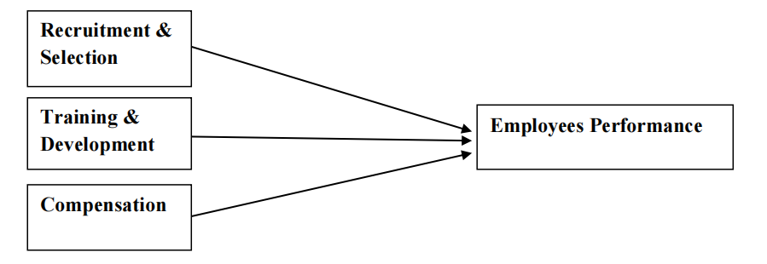

**Figure - 1 the Proposed Framework**

According to the literature review, many HR procedures, including hiring and selection, training and development, and compensation, have an effect on employees' performance. It is suggested that there is sufficient data to demonstrate how HR procedures affect employees' performance based on an analysis of pertinent literature. This is demonstrated in Figure 1, which shows the suggested structure with employee performance as the dependent variable and HR procedures as the independent factors. Training and development, as well as recruiting and selection, are used to gauge HR practices. Task and contextual performance could be used to gauge employee performance and determine compensation.

**DATA ANALYSIS AND INTERPRETATION**

1. **AGE RESPONDENTS**

|  |  |  |
| --- | --- | --- |
| AGE | NO OF RESPONDENTS | PERCENTAGE |
| 20 | 25 | 25 |
| 26-35 | 44 | 44 |
| 36-45 | 23 | 23 |
| 46-50 | 8 | 8 |
| TOTAL | 100 | 100 |

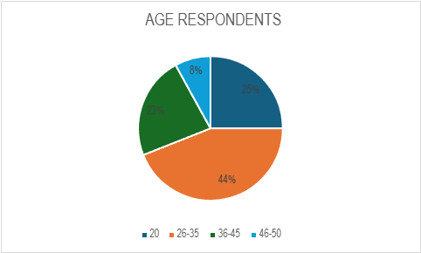

**DATA INTERPRETATION AND INFERENCE**

The table given above shows that 25% of the respondents are >20, 44% of the respondents are 26-35, 23% of the respondents are 36-45 and 8% of the respondents are 46-50.

1. **GENDER RESPONDENTS**

|  |  |  |
| --- | --- | --- |
| **GENDER** | **NO OF RESPONDENTS** | **PERCENTAGE** |
| MALE | 100 | 100 |
| FEMALE | 0 | 0 |
| TOTAL | 100 | 100 |

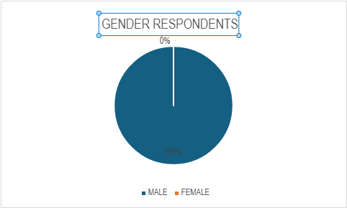

**DATA INTERPRETATION AND INFERENCE**

The table given above shows that 100% of the respondents are male and 0% of the respondents are female.

1. Employees of the responders participated in safety training sessions.

|  |  |  |
| --- | --- | --- |
| **Response** | **frequency** | **Percentage** |
| Monthly | 67 | 75 |
| Quarterly | 20 | 14 |
| Annually | 13 | 11 |
| Total | 100 | 100 |

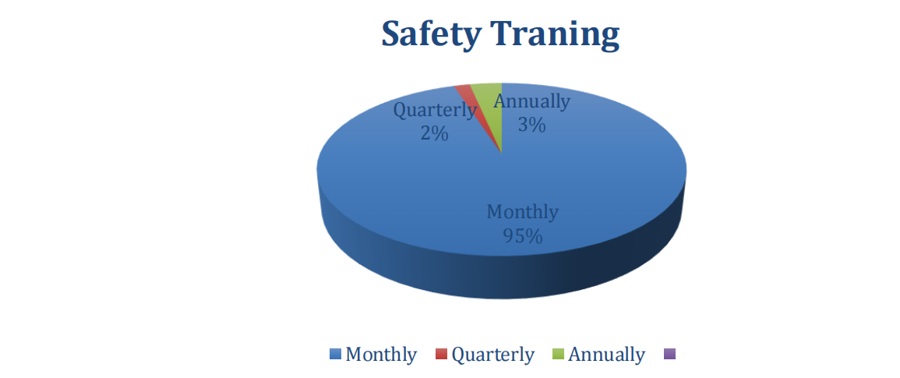

It is evident from the above table that 95% of respondents (N=57) say that safety training sessions are held monthly, 2% (N=1) say that they are held quarterly, and 3% (N=2) say that they are held annually.

**CONCLUSION AND DISCUSSION**

The study's goal was to use a literature review to ascertain how HRM methods affected workers' performance across all industries. This study reviewed the literature on how hiring and selection procedures, training and development, and pay affect workers' performance.  
Studies on recruiting and selection procedures revealed a strong relationship between worker performance and these procedures in research institutes (Kepha, Mukulu, & Waittu, 2014). The performance of the employee is more influenced by recruitment resources (Makaya, Njugana and Mukhweso (2013). There was a strong favorable association between the public sector and the hiring process. The Malaysian Skill Institute (MSI) found a significant correlation between employee performance and hiring, selection, and pay.According to real sector research, an organization's strength and weakness are determined by the quality of its workforce, and a sound plan can help an organization hire skilled workers who can improve performance (Oaya, Ogbu, & Ramibkun, 2017). The education sector discovered that teacher performance and recruitment and selection were positively correlated, and they suggested that the teacher service commission should place more emphasis on carrying out fair and transparent recruitment and selection.

Research on compensation methods revealed a strong correlation between employee productivity and pay in the banking industry (Yamoah, 2013). The service industry found that in order to retain talent over time, monetary rewards have to be accompanied by non-monetary benefits (Premalatha, 2013). The manufacturing industry demonstrated a considerable positive correlation between employee performance and compensation management (Odunlami & Mathew, 2014). Engro Food Limited discovered that discrimination based on title and status existed in several industries, which will help employees perform better and decrease employee turnover.

**REFERENCES**

**Books**

1. M. Armstrong (2010). Armstrong Essential Practices for Human Resource Management: A Handbook for People Management. Kogan Page Limited, United States and Great Britain.
2. Robbins, S. P., and D. A. DeCenzo (2005). Human Resource Management Fundamentals, Eighth Ed. Haryana: John Wiley & Sons, Kundli.
3. V.S.P. Rao (2016). Text and Cases on Human Resource Management, Third Edition. : Dr. Rajan Chopra, New Delhi.

**Journals**

1. Nasir, A., Anis, A., Rehman, I. U., & Safwan, N. (2011). A remuneration perspective on the relationship between employee retention and training and development. 5 (7), 2679-2685, African Journal of Business Management.
2. Kahoe, R. R., and Collins, C. J. (2009). hiring and choosing. ILS school digital communications at Coenell University, 209–223.
3. In 2017, Dayanandan, R. A meta-analysis examining the impact of pay on hospital staff members' work performance. Journal of Science and Management, 4
4. H. Ehsan (2018). An analysis of the telecom industry shows how employee performance is affected by pay, work design, and performance reviews. Global Economy Journal, 6(3).
5. Ikeiji, U. U., Ekwoabo, J. O., and Ufoma, N. (2015). Selection and recruitment criteria's effects on an organization's performance. Human resource management worldwide, 3 (2), 22–33.
6. Imbulana, L., and Gamage, P. N. (2013). Employee performance, training, and development: evidence from Pakistan's telecom industry in Sri Lanka. International Journal of Management Research, Financial Services, and Marketing, 2 (9).
7. Shrivastava, M., and R. Goyal (2012). An analysis of HR procedures and how they affect workers' job satisfaction and organizational loyalty in the pharmaceutical sector. International Journal of Teaching and Business Trends, 2 (3).
8. Sengupta, P. p., Hazra, K., and Ghosh, P. (2013). An empirical investigation of a few chosen hospitality organizations on the effects of HR policies on worker performance. 3 (2), 654-674, SIT Journal of Management.
9. Mago, S., and Hofisi, C. (2012). Compensation's varied effects on public sector employees' performance: An example involving Zimbabwe's premier medical aid society. Journal of Public Affairs in Africa, 5 (2).
10. Jean, K. N., Robert, A., and Ngui, T. K. (2017). A case study of Mambasa Cement Limited examining the impact of compensation strategies on worker performance. International Journal of Humanities and Social Science Research, 25–42.
11. Waititu, A., Gichuhi, E., and Kepha, O. (2014). the impact of hiring and selection practices on staff performance in Kenyan research institutions. Journal of Science and Research International, 3 (5).
12. Waittu, G. A., Mukulu, E., and Kepha, O. (2014). the impact of hiring and selection practices on staff performance in Kenyan research institutes. Journal of Science and Research International, 3 (5).
13. Wechter, H., and V. Khoreva (2017). The mediating role of well-being in HR practices and employee performance. 40 (2), 227-243.
14. Cowden, R., Kum, F. D., and Karodia, A. M. (2014). An analysis of ESCON Consulting's case demonstrates how training and development affect workers' performance. Journal of Management Studies and Business Economics in Singapore, 3 (3).