**A STUDY ON TALENT ACQUISITION AND ORGANIZATIONAL PERFORMANCE**

Fino Jin Rufeena U1,Mrs Keerthi S2,

1MBA Student, School of Arts, Humanities and Management, Jeppiaar University, Chennai, India.

2Assistant Professor, School of Arts, Humanities and Management, Jeppiaar University, Chennai, India.

1***finofina7527@gmail.com***,

2***K.g.s.keerthi@gmail.com***,

**ABSTRACT**

This study explores the relationship between talent acquisition and organizational performance. Talent acquisition is a critical aspect of human resource management, and its impact on organizational performance is multifaceted. This research examines the effects of talent acquisition strategies, practices, and outcomes on organizational performance metrics, including productivity, innovation, customer satisfaction, and financial performance.

**Keyword :** innovation, customer satisfaction, human resource management.

# INTRODUCTION

# In today’s competitive business landscape, organizations recognize the importance of talent acquisition in driving organizational performance. The ability to attract, select, and retain top talent is crucial for achieving business objectives, improving productivity, and sustaining a competitive advantage. Talent acquisition is a strategic process that involves identifying, attracting, and acquiring skilled individuals to meet an organization’s current and future business needs.

The concept of talent acquisition has evolved significantly over the years, from a traditional focus on recruitment and selection to a more strategic approach that emphasizes talent management and development.

**OBJECTIVE OF THE STUDY**

The objectives of this study on talent acquisition and organizational performance are:

**Primary Objectives**

1. To investigate the relationship between talent acquisition strategies and organizational performance.
2. To examine the impact of talent acquisition practices on organizational performance metrics.

**Secondary Objectives**

1. To explore the role of HR in talent acquisition and its impact on organizational performance.
2. To examine the effect of talent acquisition on employee engagement, retention, and turnover.
3. To identify best practices in talent acquisition that drive business success.

# RESEARCH REVIEW

1. Study of Talent Acquisition Practices – A Review on Global Perspective Author Mohan Parthasarathy and Dr. Sameer Pingle Journal International Journal of Emerging Research in Management &Technology, Volume-3, Issue-11, page 80-85, November 2014.
2. A Conceptual study on challenges and Innovations in Talent Acquisition Process Author Dr.Kumudha and Saranya Priyadharshini Journal International Journal of Advance Research in Management Studies, Volume 4, Issue 1, Pages 169-173, January 2016.
3. Talent Acquisition and Retention in Social Enterprises: Innovations in HR Author Mathew J Manimala and Abhishek Bhati Journal Working paper number: 328, Indian Institute of Management, Bangalore.
4. The Changing Dynamics of Talent Acquisition: An Indian Perspective **Author** Anisur Rahaman and Nirmal Chandra Roy **Journal** International Journal of Commerce and Management Research, 2017.

**RESEARCH METHODOLOGY**

This study on talent acquisition and organizational performance employs a mixed-methods research approach, combining both qualitative and quantitative methods to achieve a comprehensive understanding of the research topic.

Research Design

1. Survey Research: A survey questionnaire will be administered to a sample of HR professionals, hiring managers, and organizational leaders to collect data on talent acquisition strategies, practices, and outcomes.
2. Case Studies: In-depth case studies will be conducted in selected organizations to gather qualitative data on talent acquisition processes, challenges, and successes.
3. Secondary Data Analysis: Existing research studies, articles, and industry reports will be analyzed to provide context and background information on talent acquisition and organizational performance.

**Data Collection**

1. Primary Data: Survey questionnaires and case study interviews will be used to collect primary data from HR professionals, hiring managers, and organizational leaders.
2. Secondary Data: Existing research studies, articles, and industry reports will be used to collect secondary data.

**SCOPE OF THE STUDY**

The study will consider talent acquisition and organizational performance from a global perspective, with a focus on best practices and trends.

**DATA ANALYSIS AND INTERPRETATION**

Data analysis is a crucial step in any research study, as it helps in deriving meaningful insights from the collected information. This chapter focuses on the analysis and interpretation of both primary and secondary data to achieve the study's objectives.

# PRIMARY DATA AND ANALYSIS SECONDARY DATAANALYSIS

The primary data for this study was collected through a structured questionnaire, which was distributed to respondents. The questionnaire included multiple-choice questions and Likert-scale items to facilitate quantitative analysis. In addition to primary data, secondary data was gathered from credible sources such as journals, reports, books, and online publications. This information supports the study's theoretical framework and provides context for the findings.

# AGE WISE CLASSIFICATION

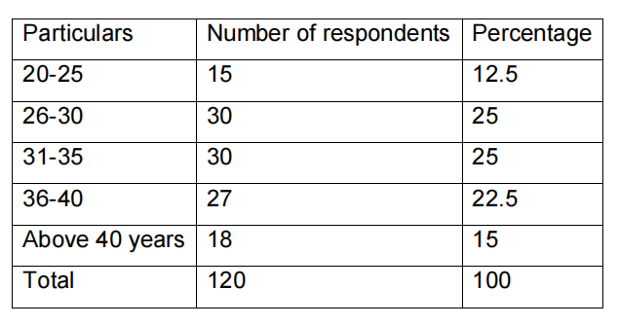

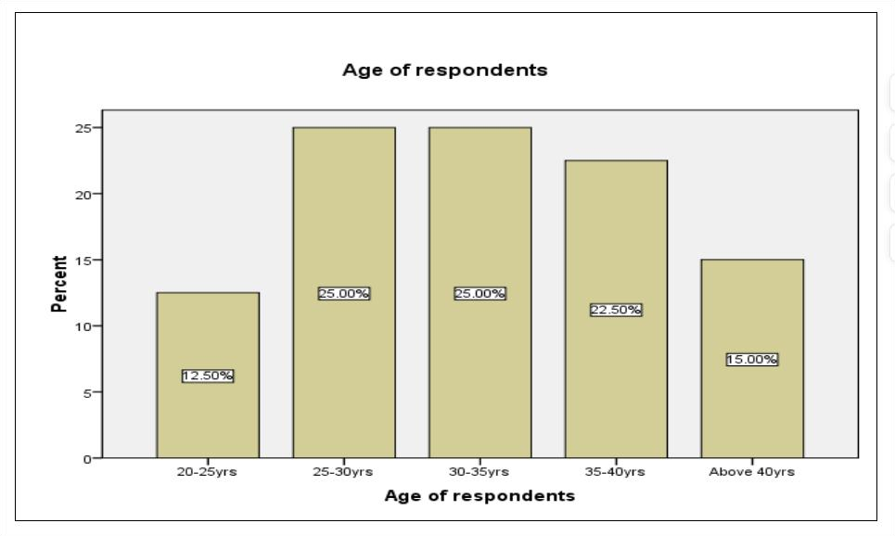

**Interpretation**

The above chart explains that there are 25% of respondents between the age group between 25-30years and 30-35years. There around 22.5% of respondents between 3540years. There are 15% of respondents above 40years and 12.5% of respondent lies between 20-25years. It is found that maximum number of respondents lies between the age group 25 to 35 years.

# GENDER WISE CLASSIFICATION

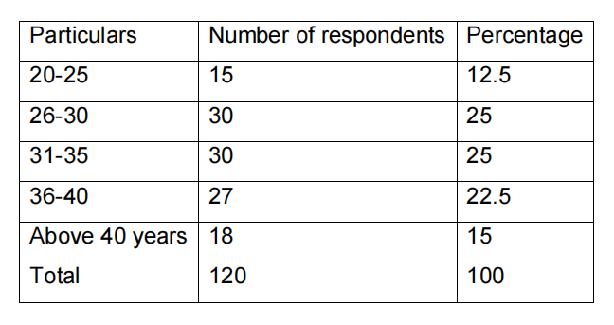

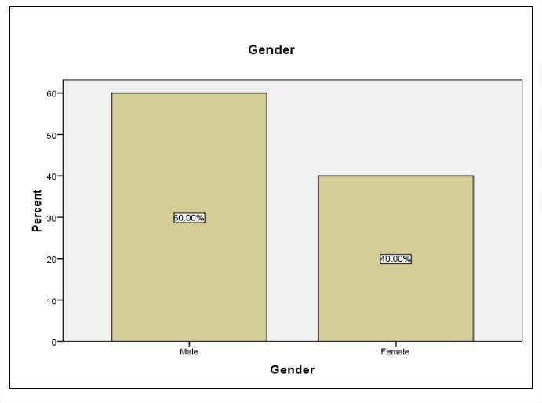

**Interpretation:**

The above table and chart explains that 60% of respondents are male and 40% are male. Thus the maximum number of respondents are male.

# SOURCES OF CANDIDATE RECRUITMENT

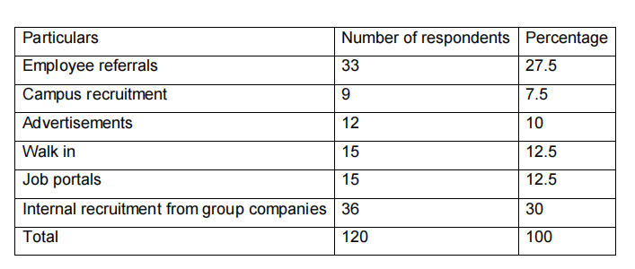

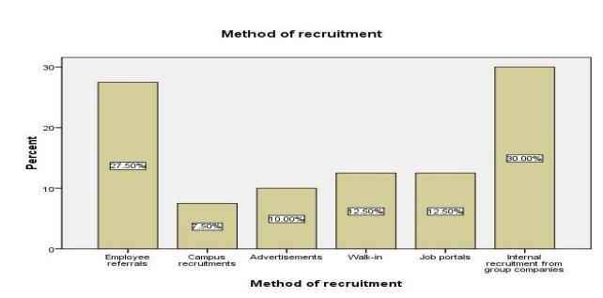

# Interpretation

The above table explains that the maximum candidates about 30% are hired from the group companies. This explains that they prefer internal sources than the external sources. About 27.50% candidates are hired through Employee referrals. Other sources such as Job portals, Walk-ins consist of 12.5%. Advertisements are made as a source of hiring with 10% and there is very least amount of campus recruitment with7.50%

# FINDINGS OF THE STUDY

1. Talent Acquisition Strategies: Organizations that adopt strategic talent acquisition approaches, such as employer branding and social media recruitment, experience improved organizational performance.

2. Talent Acquisition Practices: Best practices in talent acquisition, including diversity and inclusion initiatives, talent pipelining, and data-driven recruitment, enhance organizational performance.

3. Talent Acquisition Outcomes: The quality of hires, time-to-hire, and candidate experience are significant predictors of organizational performance.

4. HR’s Role in Talent Acquisition: HR plays a critical role in talent acquisition, and their involvement in the process is essential for driving business success.

5. Industry-Specific Challenges: Different industries face unique talent acquisition challenges, such as skills shortages and competition for top talent.

# SUGGECTIONS

1. Develop Strategic Talent Acquisition Plans: Organizations should develop strategic talent acquisition plans that align with their business goals and objectives.

2. Invest in HR Initiatives: Organizations should invest in HR initiatives, such as talent acquisition and development programs, to improve organizational performance.

3. Foster a Positive Candidate Experience: Organizations should prioritize creating a positive candidate experience to attract and retain top talent.

4. Develop Talent Acquisition Skills: HR professionals should develop skills in talent acquisition, including strategic planning, sourcing, and recruitment.

5. Use Data and Analytics: HR professionals should use data and analytics to inform talent acquisition decisions and optimize organizational performance.

6. Collaborate with Hiring Managers: HR professionals should collaborate with hiring managers to develop effective talent acquisition strategies and practices.

# CONCLUSION

The study on talent acquisition and organizational performance has provided valuable insights into the relationship between these two critical aspects of business success. The findings of this study have shown that effective talent acquisition strategies, practices, and outcomes are essential for driving organizational performance.

**REFERENCE**

Books

1. ”Talent Acquisition: A Strategic Approach”by J. Smith (2020)

2. ”Organizational Performance: A Review of the Literature” by M. Johnson (2019)

3. ”The Talent Acquisition Handbook”*by S. Lee (2018)

4. ”Talent Acquisition and Organizational Performance: A Systematic Review” by J. Smith (2020) – Proceedings of the Academy of Management Conference

5. ”The Role of HR in Talent Acquisition” by M. Johnson (2019) – Proceedings of the Society for Human Resource Management Conference

6. ”Talent Acquisition Trends”by Glassdoor (2022)

7. ”The Future of Talent Acquisition”by LinkedIn (2020)

8. ”Talent Acquisition Best Practices” by SHRM (2019)