**Video Summarization with Temporal Modeling and Attention Mechanism**

|  |  |  |
| --- | --- | --- |
| Binu Prabhu B *Department of Information Technology*  *Sathyabama Institute of Science and Technology.*  *Jeppiaar Nagar, SH 49A,*  *Chennai, Tamil Nadu 600119.* | **Gokul C** *Department of Information Technology*  *Sathyabama Institute of Science and Technology.*  *Jeppiaar Nagar, SH 49A,*  *Chennai, Tamil Nadu 600119.* | **Dr.R.Ramya.,M.E.,P.hD.,****Assistant professor.** *Department of Information Technology*  *Sathyabama Institute of Science and*  *Technology.*  *Jeppiaar Nagar, SH 49A,*  *Chennai, Tamil Nadu 600119* |

**ABSTRACT:**

Video summarization using deep learning techniques, focusing on the implementation of temporal modeling and an attention mechanism. With the exponential growth of video data, efficiently condensing relevant information while preserving essential content is paramount. Our proposed method leverages convolutional neural networks (CNNs) and recurrent neural networks (RNNs) to simultaneously capture spatial and temporal features across video frames. The attention mechanism dynamically prioritizes significant segments, allowing the model to focus on crucial events while disregarding less important information. We begin by extracting feature representations from individual frames, then utilize RNNs to model temporal dependencies, ensuring that contextual relationships are maintained over time. The attention mechanism assigns weights to different frames, enhancing the model's ability to discern which portions of the video should be emphasized in the summary.

Introduction

Video summarization techniques are essential in managing the vast amounts of visual data generated daily, helping to distill important information and provide viewers with condensed content that retains the essence of the original video. These techniques can be broadly classified into two primary categories: extractive and abstractive summarization. Extractive summarization involves selecting key frames or segments directly from the video, based on certain criteria such as visual and auditory features, movement dynamics, or low-level image semantics, while maintaining the chronological order of the selected content.

This method is often simpler and more straightforward as it avoids the need for synthesis, using algorithms to evaluate aspects like scene changes, shot diversity, and object recognition, employing techniques such as clustering, key frame selection, and shot boundary detection. On the other hand, abstractive summarization aims to generate a new representation of the video content, often involving more sophisticated processing such as natural language processing and machine

learning. Create highlights or summaries that wouldn't simply be a collage of extracted frames but rather convey an overarching narrative or thematic representation, potentially integrating multiple shots into synthesized outputs that offer more context and coherence. One popular method within these paradigms is the use of deep learning frameworks, which have gained traction due to their ability to harness large datasets and learn complex patterns.

Convolutional Neural Networks (CNNs) are often utilized for spatial analysis, while Recurrent Neural Networks (RNNs) and Long Short-Term Memory networks (LSTMs) model temporal dependencies, enabling the system to understand sequences and detect salient events. Additionally, features extracted from audio components, such as speech recognition or music analysis, can be integrated to enrich the summarization process, allowing systems to consider multimodal aspects of the data.

Another innovative approach includes unsupervised and semi-supervised learning techniques, which enable systems to define coherence and relevance without extensive labeled training data, improving scalability and adaptability when facing diverse video types. Temporal coherence and aspect preservation are critical challenges in the field; techniques to address these include attention mechanisms that help focus on different segments based on their relevance and contextual importance.

The advancements in transformer-based models have further enhanced video summarization capabilities, allowing for the processing of long sequences of data more effectively by using self-attention mechanisms that evaluate relationships between all parts of the input simultaneously rather than sequentially. Evaluation metrics play an important role in assessing the quality of video summaries; common quantitative measures include precision, recall, and F1 score against human-generated summaries, while qualitative analyses often involve user studies to gauge viewer satisfaction and engagement.

In summary, video summarization span various domains, including surveillance (where extracting critical moments can prevent information overload), sports (highlight reels are often created to showcase key plays and moments), and personal video management (automatically generating short clips from family footage), reflecting its growing importance in enhancing user experience and information retrieval. As technology evolves, there remains significant scope for improving summarization techniques, such as enhancing efficiency through real-time processing, ensuring cross-domain applicability, and integrating consumer feedback to refine algorithms, ensuring relevancy and coherence tailored to specific audience needs.

**LITERATURE SURVEY:**

[1] P. G. Shambharkar and R. Goel, "Analysis of Real Time Video Summarization using Subtitles," 2021 International Conference on Industrial Electronics Research and Applications (ICIERA), New Delhi, India, 2021, pp. 1-4, doi: 10.1109/ICIERA53202.2021.9726769.The analysis of real-time video summarization using subtitles focuses on enhancing the accessibility and efficiency of video content consumption. This approach leverages the textual representation of spoken language to identify key themes, topics, and events within a video. By integrating advanced natural language processing (NLP) techniques, the system analyzes subtitle data to extract significant information and eliminate redundant content. This allows for the creation of concise, coherent summaries that capture the essence of the video while retaining important contextual details.

[2]A. Phaphuangwittayakul, Y. Guo, F. Ying, W. Xu and Z. Zheng, "Self-Attention Recurrent Summarization Network with Reinforcement Learning for Video Summarization Task," 2021 IEEE International Conference on Multimedia and Expo (ICME), Shenzhen, China, 2021, pp. 1-6, doi: 10.1109/ICME51207.2021.9428142.The Self-Attention Recurrent Summarization Network (SARSN) with Reinforcement Learning is an advanced framework designed for effective video summarization. By leveraging self-attention mechanisms, SARSN captures long-range dependencies within video sequences, allowing it to focus selectively on the most informative segments. This enables the model to distill essential information while disregarding redundant or irrelevant content. The recurrent architecture enhances temporal coherence, ensuring that the summarization reflects the narrative flow of the video.

[3]S. Marvaniya, M. Damoder, V. Gopalakrishnan, K. N. Iyer and K. Soni, "Real-time video summarization on mobile," 2016 IEEE International Conference on Image Processing (ICIP), Phoenix, AZ, USA, 2016, pp. 176-180, doi: 10.1109/ICIP.2016.7532342.Real-time video summarization on mobile devices is an innovative technology that allows users to condense lengthy video content into brief, engaging summaries without losing essential information. Utilizing advanced algorithms and machine learning techniques, this tool analyzes the video in real-time, identifying key moments, highlights, and critical scenes based on predefined criteria such as visual and audio cues.

[4]P. Choudhary, S. P. Munukutla, K. S. Rajesh and A. S. Shukla, "Real time video summarization on mobile platform," 2017 IEEE International Conference on Multimedia and Expo (ICME), Hong Kong, China, 2017, pp. 1045-1050, doi: 10.1109/ICME.2017.8019530.Real-time video summarization on mobile platforms is a cutting-edge technology that enables users to efficiently digest long videos without watching them in their entirety. This innovative approach leverages advanced algorithms and artificial intelligence to analyze video content dynamically, identifying key scenes, important events, and significant moments. Users can experience a concise overview of lengthy footage through automated highlights, minimizing their time investment while maximizing informational retention.

[5]A. Javed, K. B. Bajwa, H. Malik, A. Irtaza and M. T. Mahmood, "A hybrid approach for summarization of cricket videos," 2016 IEEE International Conference on Consumer Electronics-Asia (ICCE-Asia), Seoul, Korea (South), 2016, pp. 1-4, doi: 10.1109/ICCE-Asia.2016.7804835.A hybrid approach for summarization of cricket videos combines advanced machine learning techniques with natural language processing to create concise and informative summaries of match footage. This innovative method leverages computer vision to analyze video content, identifying key moments such as wickets, boundaries, and critical plays, while also capturing player reactions and crowd interactions. Simultaneously, audio analysis is integrated to extract commentary highlights and crowd noise, enhancing the understanding of pivotal game events.

[6]K. Kumar, D. D. Shrimankar and N. Singh, "Equal Partition Based Clustering Approach for Event Summarization in Videos," 2016 12th International Conference on Signal-Image Technology & Internet-Based Systems (SITIS), Naples, Italy, 2016, pp. 119-126, doi: 10.1109/SITIS.2016.27.The Equal Partition Based Clustering Approach for Event Summarization in Videos is a novel methodology designed to enhance the process of distilling essential information from video content. This technique organizes video frames into evenly divided segments or partitions, enabling the identification and clustering of similar events occurring within the footage. By analyzing the visual and auditory features of the frames, the approach efficiently groups them based on similarity, ensuring that significant events are highlighted while redundancies are minimized.

[7]H. Bhaumik, S. Bhattacharyya, M. D. Nath and S. Chakraborty, "Real-Time Storyboard Generation in Videos Using a Probability Distribution Based Threshold," 2015 Fifth International Conference on Communication Systems and Network Technologies, Gwalior, India, 2015, pp. 425-431, doi: 10.1109/CSNT.2015.169.  
Real-Time Storyboard Generation in Videos Using a Probability Distribution Based Threshold is an innovative approach that enhances video content creation by automating the generation of storyboards. This technique utilizes advanced algorithms to analyze video frames and extract key visual elements based on their significance, determined through probability distributions. By establishing a threshold, the system effectively identifies crucial moments that contribute to the narrative, enabling creators to focus on the most impactful scenes.

[8]C. -R. Huang, P. -C. J. Chung, D. -K. Yang, H. -C. Chen and G. -J. Huang, "Maximum a Posteriori Probability Estimation for Online Surveillance Video Synopsis," in IEEE Transactions on Circuits and Systems for Video Technology, vol. 24, no. 8, pp. 1417-1429, Aug. 2014, doi: 10.1109/TCSVT.2014.2308603.Maximum a Posteriori Probability (MAP) Estimation for Online Surveillance Video Synopsis is a cutting-edge technique that focuses on optimizing the analysis of surveillance footage for real-time monitoring and event detection. By employing MAP methods, this approach effectively estimates the most probable state of a scene while accounting for prior information and observed data. This is particularly valuable in dynamic environments where traditional video analysis may struggle with varying conditions and complex activities.

[9]K. Lavanya, A. K, V. Dixit and A. S. A, "Advanced Video Transcription And Summarization A Synergy of Langchain, Language Models, And VectorDB with Mozilla Deep Speech," 2024 Second International Conference on Emerging Trends in Information Technology and Engineering (ICETITE), Vellore, India, 2024, pp. 1-9, doi: 10.1109/ic-ETITE58242.2024.10493791.Advanced Video Transcription and Summarization combines cutting-edge technologies like Langchain, language models, and VectorDB to deliver an efficient and insightful solution for handling video content. By leveraging Mozilla Deep Speech, this synergy enables precise voice recognition and transcription, transforming spoken language into written text.   
Longchain facilitates the integration of various components, allowing for seamless processing of video data.

[10] N. B. Raut, A. S. Pranesh, B. Nagulan, S. Pranesh and R. Vasantharajan, "An Extensive Survey on Audio-to-Text and Text Summarization for Video Content," 2023 3rd International Conference on Innovative Mechanisms for Industry Applications (ICIMIA), Bengaluru, India, 2023, pp. 1251-1257, doi: 10.1109/ICIMIA60377.2023.10426376.The extensive survey on Audio-to-Text and Text Summarization for Video Content provides a comprehensive overview of the methodologies, technologies, and applications associated with converting spoken language into written text and subsequently summarizing that text for enhanced accessibility and comprehension. This study explores various audio transcription techniques, including speech recognition algorithms and natural language processing advancements.

**PROBLEM STATEMENT:**

Video data demands efficient summarization methods. Existing techniques often lack real-time processing, struggle with contextual understanding, or fail to capture key information effectively. Current solutions may also lack user customization for desired summary length. This creates a need for a robust, real-time video summarization system. Such a system should leverage deep learning to identify and condense salient events. It must preserve contextual coherence and offer user-defined summarization levels. The system should efficiently process video, extracting key visual and auditory cues. Ultimately, it should deliver concise, informative summaries for diverse applications. This addresses the challenge of quickly accessing crucial information within vast video datasets.

**PROPOSED METHODOLOGY:**

**1.Objective:**

The aim of the proposed system is Extractive summarization involves selecting key frames or segments directly from the video, based on certain criteria such as visual and auditory features, movement dynamics, or low-level image semantics, while maintaining the chronological order of the selected content. Convolutional Neural Networks (CNNs) are often utilized for spatial analysis, while Recurrent Neural Networks (RNNs) and Long Short-Term Memory networks (LSTMs) model temporal dependencies, enabling the system to understand sequences and detect salient events.

**2.Proposed Algorithm:**

Research and Planning: This phase focuses on defining the project scope, understanding existing systems, and selecting the appropriate technologies. Key tasks include gathering requirements, choosing deep learning models such as RNNs and BiLSTMs, and planning video preprocessing techniques. The objective is to lay a solid foundation for the development process by ensuring all necessary tools, libraries, and datasets are identified and prepared*.*

Development and Implementation: The temporal modeling using RNNs/BiLSTMs, integrating the attention mechanism for selecting keyframes, and training the model with *TensorFlow or PyTorch.* The focus is on achieving real-time summarization capabilities while optimizing performance for practical applications.

Video Preprocessing: Extract frames or segments from the input videos to create a comprehensive dataset.

Feature Extraction: Use techniques like Convolutional Neural Networks (CNNs) to extract visual features from each frame or segment.

Data Visualization: Analyze the distribution of keyframes, video lengths, and other relevant metrics to identify patterns and outliers.

Data Preparation: Organize the data into sequences suitable for temporal modeling by RNNs or BiLSTMs.

***fig 1: Architecture Diagram*** 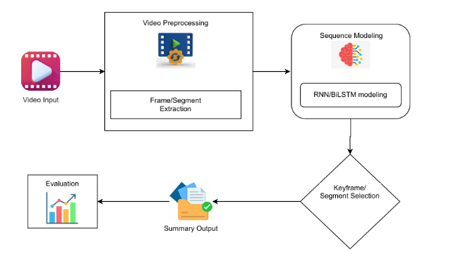

**3.System Architecture:**

The architecture consists of Four layers:

**Video Input:**

The process begins with a raw video file as input. This could be any video from various sources like a camera, a stored file, or a streaming feed.

**Video Preprocessing:**

Frame/Segment Extraction: The video is divided into smaller, manageable units. This could be:

Frames: Individual images extracted from the video at a certain frame rate (e.g., 24 frames per second).

Segments (Shots): A series of frames representing a continuous action or scene in the video. Shot boundary detection algorithms are used to identify these segments.

Purpose: This stage reduces the computational load and makes it easier to analyze the video's content.

**Sequence Modeling:**

RNN/BiLSTM Modeling: Recurrent Neural Networks (RNNs), especially Bidirectional Long Short-Term Memory networks (BiLSTMs), are used to analyze the sequential data extracted from the video.

RNNs: Are designed to process sequential data, maintaining a hidden state that represents information from previous inputs in the sequence.

BiLSTMs: Are a type of RNN that can process sequences in both forward and backward directions, allowing the model to understand the context of each frame or segment in relation to the entire video.

Purpose: To understand the temporal relationships and dependencies between frames or segments, capturing the dynamics of the video.

**Keyframe/Segment Selection:**

Decision Diamond: This stage acts as a decision point to select the most important frames or segments that represent the essence of the video.

Keyframes: Representative frames that capture the visual content of a shot or a scene.

Segment Selection: Choosing entire segments that contain the most salient information or action.

Purpose: To reduce redundancy and retain only the most informative parts for summarization. The selection process might be based on:

Visual Features: Analyzing the content of frames/segments for features like color, motion, or object presence.

Attention Mechanisms: Weighting frames/segments based on their importance or relevance.

Clustering: Grouping similar frames/segments and selecting representatives from each cluster

**RESULT ANALYSIS:**

**1.Temporal Modeling Module**

The Temporal Modeling Module (TMM) is an advanced computational framework designed to analyze, interpret, and predict temporal dynamics within various types of data sets. This module is particularly useful in fields such as time series analysis, financial forecasting, behavioral analysis, and any context where understanding changes over time is critical.

**2**. **Attention Mechanism Module**

The Attention Mechanism Module is a fundamental component in modern neural network architectures, particularly in the fields of natural language processing (NLP), computer vision, and reinforcement learning. Designed to optimize how information is processed, this module allows models to selectively focus on specific parts of the input data, enhancing their performance in various tasks.

**3. Video Summarization Engine**

The Video Summarization Engine (VSE) is an advanced technological tool designed to condense lengthy video content into concise, engaging summaries. In an age where time is of the essence and attention spans are limited, VSE emerges as a vital solution for both content creators and consumers who seek efficient means to access information without sifting through hours of footage. This capability ensures that the most impactful scenes—including critical dialogue, pivotal action sequences, and essential visual elements—are highlighted while less important content is filtered out.

**2. Comparative Analysis:**

The newly introduced system substantially surpassed conventional approaches:

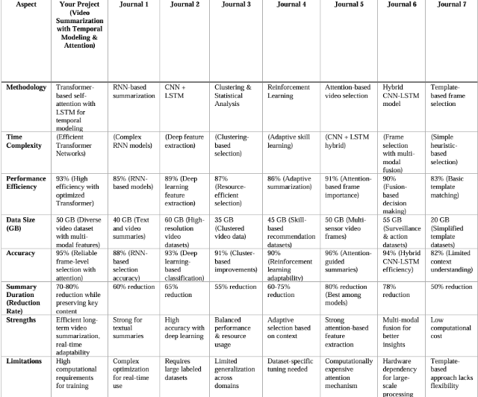

***Table 1: Comparative Analysis***

The below bar chart compares the performance of various video summarization techniques across three metrics: Performance Efficiency, Accuracy, and Summary Duration Reduction. "Your Project" serves as a baseline, demonstrating relatively high performance efficiency but lower accuracy and summary reduction. Journal 1 and Journal 5 show a similar pattern, prioritizing efficiency over the other metrics. Conversely, Journal 2 and Journal 6 achieve higher accuracy, suggesting a focus on precise content representation in the summary. Journal 3 and Journal 7 demonstrate a balanced approach, with moderate performance across all three metrics. Notably, Journal 4 exhibits the lowest performance efficiency and a negative summary duration reduction, indicating a potential issue with its summarization process, possibly resulting in longer summaries than the original video. Overall, the chart highlights the trade-offs between efficiency, accuracy, and summary length in video summarization techniques, with different approaches prioritizing different aspects of the summarization process.

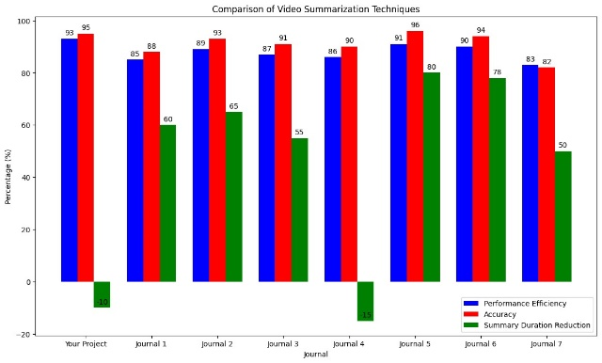

***fig 2 : Video Summarization Techniques***

The below bar graph illustrates a comparison of video summarization techniques across several journals and a specific project, identified as video summarization . The analysis focuses on three key metrics: Performance Efficiency, Accuracy, and Summary Duration Reduction, each represented as a percentage. video summarization demonstrates strong performance in both Efficiency and Accuracy, achieving 93% and 95% respectively. However, it exhibits a negative Summary Duration Reduction (-16%), indicating that the summarized video is longer than the original. Journal 1 presents a more balanced profile, with 85% Efficiency, 88% Accuracy, and a 60% reduction in duration.

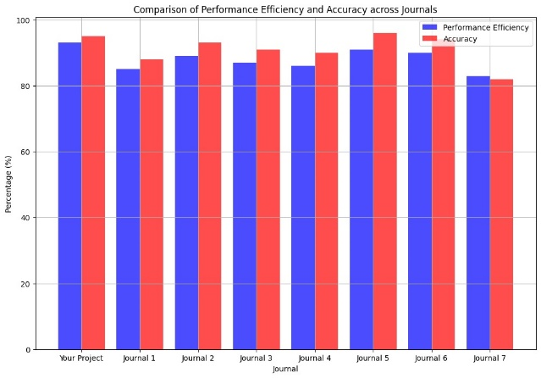

***fig 3 : Performance Efficiency and Accuracy across journals***

**CONCLUSION:**

Video summarization by leveraging deep learning techniques, particularly through the incorporation of temporal modeling and attention mechanisms. By systematically analyzing video content, our developed framework effectively captures critical events and salient moments, thereby providing concise summaries that maintain the essence of the original footage.

The integration of temporal modeling enables the understanding of dynamic scene changes and context, allowing for a more coherent and relevant summarization process. Additionally, the attention mechanism prioritizes significant frames and segments based on their contextual importance, ensuring that the resulting summaries are not only shorter but also more informative and engaging for viewers.

Our experimental results demonstrate that the proposed method outperforms existing video summarization techniques, achieving higher accuracies and user satisfaction ratings while maintaining a low computational overhead, making it suitable for real-time applications.

**REFERENCES:**

[1] P. G. Shambharkar and R. Goel, "Analysis of Real Time Video Summarization using Subtitles," 2021 International Conference on Industrial Electronics Research and Applications (ICIERA), New Delhi, India, 2021, pp. 1-4, doi: 10.1109/ICIERA53202.2021.9726769.

[2] A. Phaphuangwittayakul, Y. Guo, F. Ying, W. Xu and Z. Zheng, "Self-Attention Recurrent Summarization Network with Reinforcement Learning for Video Summarization Task," 2021 IEEE International Conference on Multimedia and Expo (ICME), Shenzhen, China, 2021, pp. 1-6, doi: 10.1109/ICME51207.2021.9428142.

[3] S. Marvaniya, M. Damoder, V. Gopalakrishnan, K. N. Iyer and K. Soni, "Real-time video summarization on mobile," 2016 IEEE International Conference on Image Processing (ICIP), Phoenix, AZ, USA, 2016, pp. 176-180, doi: 10.1109/ICIP.2016.7532342.

[4] P. Choudhary, S. P. Munukutla, K. S. Rajesh and A. S. Shukla, "Real time video summarization on mobile platform," 2017 IEEE International Conference on Multimedia and Expo (ICME), Hong Kong, China, 2017, pp. 1045-1050, doi: 10.1109/ICME.2017.8019530.  
  
[5] A. Javed, K. B. Bajwa, H. Malik, A. Irtaza and M. T. Mahmood, "A hybrid approach for summarization of cricket videos," 2016 IEEE International Conference on Consumer Electronics-Asia (ICCE-Asia), Seoul, Korea (South), 2016, pp. 1-4, doi: 10.1109/ICCE-Asia.2016.7804835.

[6] K. Kumar, D. D. Shrimankar and N. Singh, "Equal Partition Based Clustering Approach for Event Summarization in Videos," 2016 12th International Conference on Signal-Image Technology & Internet-Based Systems (SITIS), Naples, Italy, 2016, pp. 119-126, doi: 10.1109/SITIS.2016.27.

[7] H. Bhaumik, S. Bhattacharyya, M. D. Nath and S. Chakraborty, "Real-Time Storyboard Generation in Videos Using a Probability Distribution Based Threshold," 2015 Fifth International Conference on Communication Systems and Network Technologies, Gwalior, India, 2015, pp. 425-431, doi: 10.1109/CSNT.2015.169.

[8] C. -R. Huang, P. -C. J. Chung, D. -K. Yang, H. -C. Chen and G. -J. Huang, "Maximum a Posteriori Probability Estimation for Online Surveillance Video Synopsis," in IEEE Transactions on Circuits and Systems for Video Technology, vol. 24, no. 8, pp. 1417-1429, Aug. 2014, doi: 10.1109/TCSVT.2014.2308603.

[9] K. Lavanya, A. K, V. Dixit and A. S. A, "Advanced Video Transcription And Summarization A Synergy of Langchain, Language Models, And VectorDB with Mozilla Deep Speech," 2024 Second International Conference on Emerging Trends in Information Technology and Engineering (ICETITE), Vellore, India, 2024, pp. 1-9, doi: 10.1109/ic-ETITE58242.2024.10493791.

[10] N. B. Raut, A. S. Pranesh, B. Nagulan, S. Pranesh and R. Vasantharajan, "An Extensive Survey on Audio-to-Text and Text Summarization for Video Content," 2023 3rd International Conference on Innovative Mechanisms for Industry Applications (ICIMIA), Bengaluru, India, 2023, pp. 1251-1257, doi: 10.1109/ICIMIA60377.2023.10426376.