**A STUDY ON THE EFFECTS OF ARTIFICIAL INTELLIGENCE ON HUMAN RESOURCE MANAGEMENT TASKS**

Meji M1,Mrs Keerthi S2,

1MBA Student, School of Arts, Humanities and Management, Jeppiaar University, Chennai, India.

2Assistant Professor, School of Arts, Humanities and Management, Jeppiaar University, Chennai, India.

1***mejimartin0126@gmail.com***,

2***K.g.s.keerthi@gmail.com***,

**ABSTRACT**

The way businesses handle their employees is changing as a result of the growing application of artificial intelligence (AI) in human resource management (HRM). This study looks at how AI is affecting HRM tasks like hiring, performance management, talent management, and employee engagement. This study, which combines primary and secondary data, concludes that AI has enhanced HRM services' accuracy, efficiency, and employee experience. But it also brings up issues with bias, data security, and employment displacement.

Keywords: AI ethics, human resources, and artificial intelligence

**INTRODUCTION**

The way businesses operate is being altered by artificial intelligence. Human Resources (HR) is one field where AI is having a big impact. Employees are an organization's most precious asset, and human resources (HR) are in charge of managing them. From hiring and recruitment to training and development, human resources is essential to an organization's success.Artificial Intelligence (AI) has begun automating a number of Human Resource (HR) functions in recent years, including interview scheduling, resume screening, and employee inquiries. Although AI may appear to be a danger to HR workers, it is also opening up new avenues for HR to increase the value of the company.Additionally, by offering individualized learning and development opportunities, the incorporation of Artificial Intelligence (AI) in HR not only boosts productivity but also improves the general employee experience. It provides insightful information about employee behavior that aids businesses in making data-driven decisions that support their objectives.

**OBJECTIVES**

The following are some goals for researching how AI affects human resource management (HRM):

1. To assess how artificial intelligence (AI) is now affecting human resource management.
2. To determine AI's advantages and difficulties in HRM.
3. To look into how AI is affecting HR positions and duties.
4. To determine the most effective methods for integrating AI into HRM.
5. To determine the future paths that AI will take in HRM, as well as how AI will affect employee engagement and experience.

**REVIEW OF LITERATURE**

Researchers and practitioners are very interested in the growing application of artificial intelligence (AI) in human resource management (HRM). The purpose of this review of the literature is to give a broad picture of the status of the study on how AI is affecting HRM.

1. Recruitment (2010): Since the early 2010s, AI technologies have automated resume screening and preliminary candidate interactions, streamlining the hiring process and reducing prejudices while producing higher-quality recruits.
2. Onboarding (2015): AI has improved onboarding procedures since about 2015 by tailoring resources and training for new hires, increasing retention and engagement rates.
3. Training (2016): Since 2016, AI-powered adaptive learning systems have become more popular, tailoring training materials to each learner's requirements and promoting more efficient skill development.
4. Employee Engagement (2018): Since 2018, sentiment analysis and other AI techniques have become popular, enabling businesses to measure worker satisfaction and proactively resolve issues.
5. AI-based Performance (2019): Employees can receive coaching and feedback in real time via management systems.
6. Concerns around data privacy, AI prejudice, and job displacement have surfaced as a result of the advancement of AI technologies in the 2020s, underscoring the necessity for ethical standards in AI use.

Chatbots and virtual assistants driven by AI can give staff members rapid and simple access to information and assistance (2020, IBM). HR workers can find areas for development and make data-driven decisions with the aid of AI-powered analytics (Society for Human Resource Management, 2020). Concerns around bias, accountability, and transparency are among the primary obstacles and restrictions associated with the application of AI in HRM. In general, AI is improving HR productivity and decision-making in 2023 and 2024, but as these technologies advance, it will be increasingly important to address ethical concerns.

**REASEARCH METHODOLAGY**

A quantitative and descriptive study design is used in this methodology to examine how AI is affecting HR. The purpose of this study is to investigate the advantages, difficulties, and potential ramifications of AI adoption in human resources.

1. Goals of the Research

* To assess the degree of AI usage in HR functions as of right now
* To determine the advantages and difficulties of applying AI to HR
* To investigate how AI will be applied to HR tasks and responsibilities in the future

1. Hypotheses for Research

* Over the next two years, AI adoption in HR will rise sharply.
* AI will increase employee engagement and streamline the HR process.
* AI will necessitate major adjustments to HR jobs and responsibilities.

1. Design of Research

* Quantitative research: numerical data will be gathered using online surveys and questionnaires.
* Descriptive information: the study will outline the influence of AI adaptation in HR as it stands today.

1. Techniques for Gathering Data

* Primary data: an internet platform will be used to create and distribute a survey questionnaire to HR experts.
* Secondary data: an analysis of previous AI research papers, publications, and books will be done.

1. Method of Sampling

* Convenience Sampling Method: HR professionals will receive invitations via social media and email to participate in an online survey.
* Participants will be invited to recommend additional HR professionals to the survey as part of the snowball sampling process.

**DATA ANALYSIS**

Sampling Size: - the sampling size is 70

1. **Had the company implemented AI-powered HR tools?**

|  |  |  |
| --- | --- | --- |
| **Options** | **Percentage** | **Total** |
| yes | 98 | 65 |
| No | 2 | 5 |

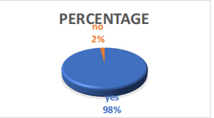

**INTERPRETATION**

Based on this, it appears that 98% of businesses have used AI-powered HR department technologies, compared to just 2% that have not.

1. **To what extent do you know about AI technologies?**

|  |  |  |
| --- | --- | --- |
| **Familiar** | **Percentage** | **Total** |
| Very familiar | 15 | 10 |
| Somewhat familiar | 67 | 48 |
| Not familiar | 15 | 10 |
| Expert | 3 | 2 |

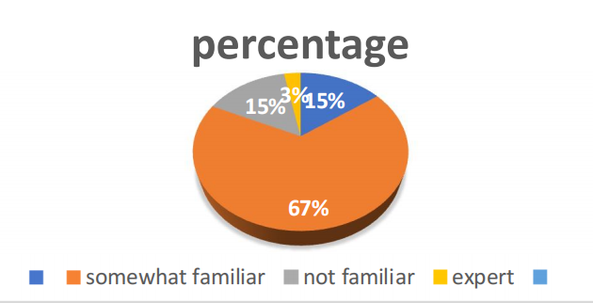

**INTERPRETATION**

The answers about people's acquaintance with AI technologies show that different people have different perspectives. Only 15% of respondents are highly familiar with AI, although 67% are at least somewhat knowledgeable, indicating a general awareness and interest in the technology. A knowledge gap that could be filled by education is indicated by the 15% who are completely unfamiliar. The fact that only 3% of people think of themselves as experts emphasizes how uncommon actual AI expertise is still.

1. **What area do you think the AI can impact the most?**

|  |  |  |
| --- | --- | --- |
| **Areas** | **Percentage** | **Total** |
| Recruitment | 30 | 20 |
| Training | 40 | 30 |
| Performance evaluation | 18 | 13 |
| Payroll | 12 | 7 |

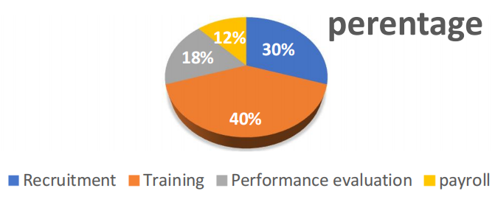

**INTERPRETATION**

According to the replies, training is anticipated to be the area where AI will have the biggest impact on HR, followed by recruitment (30%), performance evaluation (18%), and payroll (12%). There is no denying AI's influence on HR.

1. How has AI impacted HR process in your organization

|  |  |  |
| --- | --- | --- |
| **Impact** | **Percentage** | **Total** |
| Improved efficiency | 50 | 34 |
| Enhanced employee experience | 30 | 20 |
| Increased accuracy | 20 | 16 |

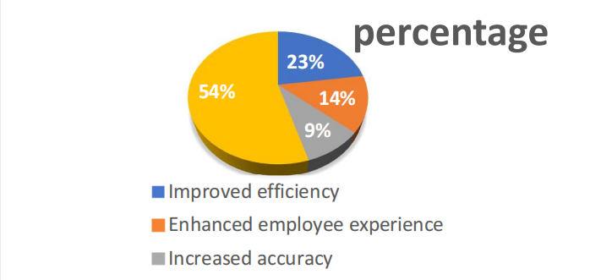

**INTERPRETATION**

When asked how AI affected HR, 50% of respondents said it improved efficiency, 30% said it improved employee experience, and 20% said it boosted accuracy. This poll indicates that increased efficiency has had a greater influence on the HR procedure.

1. **What changes do you think AI posses the HR?**

|  |  |  |
| --- | --- | --- |
| **Changes** | **Percentage** | **Total** |
| Job displacement | 33 | 28 |
| Bias discrimination | 27 | 22 |
| Data security concerns | 30 | 12 |
| Lack of transparency | 10 | 8 |

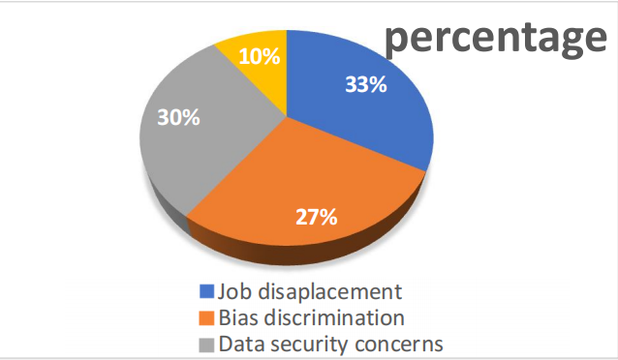

**INTERPRETATION**

Data from respondents indicates that 33% of HR changes are due to AI, followed by job displacement (27%), and bias and discrimination (27%). 10% goes toward openness, and 30% goes toward data security. As a result, AI has the ability to alter job displacement.

1. **Do you think AI can take the role of human resources positions?**

|  |  |  |
| --- | --- | --- |
| **Option** | **Percentage** | **Total** |
| Yes | 59 | 38 |
| No | 25 | 20 |
| Maybe | 16 | 12 |

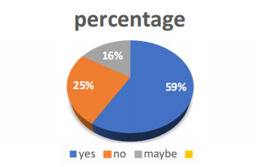

**INTERPRETATION**

Maybe (16%), no (25%), and yes (59%). According to respondents, since the "yes" option received the majority of votes, AI can take the role of HR positions.

**FINDINGS**

The impact of AI technology on HRM is becoming more and more clear as it develops. The results of the thorough investigation of how AI affects HRM are shown in the following findings.

1. Benefits

* Automated recruitment: AI-driven technologies can arrange interviews, screen resumes, and enhance the hiring procedure as a whole.
* Improved employee experience: AI-powered chatbots and virtual assistants can help staff members around-the-clock, enhancing their work experience in general.

1. Adverse Effects

* AI has the capacity to automate HR tasks, which could result in the replacement of certain HR workers.
* AI systems have the potential to reinforce preexisting biases and discriminate against specific employee or job applicant groups.

1. Implications for the Future

* HR professionals working in hybrid jobs will need to cultivate abilities like creativity, emotional intelligence, and strategic thinking that go hand in hand with AI.
* Developing ethical AI systems that support justice, accountability, and transparency should be an organization's top priority.

1. Ideas

* Keep abreast on advancements in AI.
* Make sure AI is impartial, transparent, and equitable.
* Become emotionally intelligent
* Teach HR employees how to use AI.

**CONSLUSION**

My research leads me to the conclusion that while AI can save time and increase accuracy, there are certain disadvantages as well. For instance, if AI is not properly programmed, it may make biased decisions and displace some jobs. Businesses must strike a balance between utilizing technology and maintaining a human touch if they want to maximize the benefits of AI in HR. This entails utilizing AI to assist with activities while also ensuring that workers receive considerate and respectful treatment. All things considered, AI in HR will keep developing and altering how businesses operate.

**REFERENCES**

1. The worldwide journal of advanced research in computer science and software engineering published an article titled "The Impact of AT on HR Management."
2. The international journal of human resource management published "The Role of Artificial Intelligence in Human Resource Management: A Conceptual Framework."
3. AI and HR in the Society for Human Resource Management (SHRM)
4. AI and Work in the Harvard Business Review
5. Rothwell, W. J., Prescott, R.K. & Taylor, M.W. (1998). Strategic Human Resource Leader: How to prepare your organization for the six key trends shaping the future. California: Davies-Black Publishing
6. Ulrich, D.(1997), Human Resource Champions. Boston Harvard Business School Press.
7. Ulukan, C (2005), “Leadership and Managerial Implications”.Turkish Online Journal of Distance Education Vol.6 No. 5, Art. 8.
8. Weber, M (1946) From Max Weber. Oxford University Press Oxford quoted in Armstrong (2006) Wick, C W and Leon, L S (1995) Creating a Learning Organization: London From Ideas to action. Summer
9. Wilson, J P (1990) Human Resource Development. London Kogan Page Limited
10. Wilson, J P (2005) Human Resource Development. London Kogan Page Limited.