Deep learning Model for Driver Behavior Detection in Cyber-Physical System-Based Intelligent Transport Systems

Seenu A

*Department of ECE*

*SRM Valliammai Engineering College Tamilnadu, India*

[*seenulevin213@gmail.com*](mailto:seenulevin213@gmail.com)

Sandeep kumar G

*Department of ECE*

*SRM Valliammai Engineering College Tamilnadu, India*

[*sandeepdhivakar5@gmail.com*](mailto:sandeepdhivakar5@gmail.com)

Ranjith kumar K

*Department of ECE*

*SRM Valliammai Engineering college Tamilnadu, India*

[*ranjithkamaraj07@gmail.com*](mailto:ranjithkamaraj07@gmail.com)

RajaVarman M

*Department of ECE*

*SRM Valliammai Engineering College Tamilnadu,India*

[*varmanraja36@gmail.com*](mailto:varmanraja36@gmail.com)

Prasanan V

*Department of ECE*

*SRM Valliammai Engineering College Tamilnadu, India*

[*prasananv.ece@srmvalliammai.ac.in*](mailto:prasananv.ece@srmvalliammai.ac.in)

**Abstract_ In this paper, we present an innovative approach for driver behavior detection within cyber-physical systems (CPS) for intelligent transport systems (ITS) using ESP32 CAM, eye blink sensor and deep learning models. The integration of ESP32 CAM, a compact and versatile camera module, with advanced deep learning techniques enables real-time monitoring and analysis of driver behavior. While an eye blink sensor monitors drowsiness by detecting blink patterns. The collected data is processed using a deep learning model developed in MATLAB, which analyzes visual and sensor inputs to assess driver alertness and behavior. Our system leverages MATLAB for model development and training, employing convolutional neural networks (CNNs) by using VGG-16 classifies various driver states including signs of fatigue and distraction to process and interpret video data captured by the ESP32 CAM. The deep learning model is trained on a diverse dataset of driver actions, including lane deviations, distraction, and fatigue signs. By analyzing the visual input, the system classifies driver behavior and provides actionable insights to enhance road safety and driver assistance. The implementation of this CPS-based approach facilitates timely intervention and adaptive responses, contributing to the overall safety and efficiency of transport systems. When the system detects drowsiness or abnormal behavior, it triggers an alert through a buzzer, ensuring timely notifications to the driver and sends real-time notifications to designated contacts (e.g., car owners, parents) with the driver’s live location and status using GPS and GSM technology. At the time, speed of the vehicle can also be controlled. Arduino serves as the central controller, coordinating data collection from the eye blink sensor and managing the alert system.**

**The results demonstrate the effectiveness of combining ESP32 CAM with deep learning models in creating a robust and scalable driver behavior detection system, showcasing its potential for deployment in real world ITS applications. This approach not only improves safety but also paves the way for future advancements in intelligent transport technologies.**

**Keywords_ Deep learning, Driver behavior detection, Cyber-Physical System, Intelligent Transport system, VGG-16, Environmental benefits.**

1. **INTRODUCTION**

In recent years, the growing emphasis on road safety has driven the development of advanced driver assistance systems (ADAS) designed to monitor and enhance driver behavior. Traditional methods of assessing driver alertness often rely on simple metrics such as time driven intervals or manual checks, which may not be sufficient in detecting subtle signs of fatigue or distraction. The increasing complexity of modern driving environments and the need for real-time, reliable assessments have highlighted the need for more sophisticated systems. This paper presents an innovative approach to driver behavior detection by integrating real time video analysis, eye blink monitoring, and deep learning technologies. By leveraging a combination of the ESP32 CAM for video data capture, an eye blink sensor for detecting drowsiness, and convolutional neural networks (CNNs) for behavioral analysis, this system aims to significantly enhance driver safety and response times. In the realm of advanced technology, deep learning refers to a subset of artificial intelligence that utilizes neural networks with multiple layers to model and interpret complex patterns

in data. Driver behavior detection involves monitoring and analyzing a driver's actions and physiological indicators to

a cyber-physical system (CPS) integrates computational elements with physical processes, enabling real-time interaction and control and Intelligent transport systems (ITS) leverage technology and data to improve the efficiency, safety, and sustainability of transportation networks. Road safety encompasses strategies and technologies aimed at preventing accidents and protecting road users from harm. This project combines these concepts by integrating deep learning with cyber-physical systems to enhance driver safety through real-time monitoring and alert systems, ultimately contributing to safer and more efficient transportation environments. This project is to develop an advanced driver behavior detection system that enhances road safety through real-time monitoring and analysis. By integrating ESP32 CAM for video capture, an eye blink sensor for drowsiness detection, and a deep learning model using convolutional neural networks (CNNs), the system evaluates driver alertness and behavior. Arduino coordinates data collection and alert management, triggering immediate notifications for drowsiness or abnormal behavior. This comprehensive approach aims to provide timely feedback and intervention, improving driver safety and the overall effectiveness of intelligent transport systems (ITS).

# EXISTING SYSTEM

Current driver monitoring systems typically rely on either visual cameras or physiological sensors but rarely integrate both technologies in a comprehensive manner. Existing systems that use visual data often face limitations in terms of accuracy and real-time processing. On the other hand, systems that focus solely on physiological sensors may miss critical behavioral cues observable through video analysis. Additionally, most conventional systems do not leverage advanced machine learning algorithms to provide nuanced insights into driver behavior, thus potentially missing out on early signs of drowsiness or distraction.

# PROPOSED SYSTEM

The proposed system integrates the ESP32 CAM with an eye blink sensor and advanced deep learning models to create a holistic driver behavior monitoring solution. The ESP32 CAM captures high-resolution video data of the driver, allowing for detailed analysis of facial expressions and eye movements. The eye blink sensor complements this by providing real-time data on blink frequency and patterns, indicative of drowsiness. This data is processed through a deep learning model, developed using convolutional neural networks (CNNs) in MATLAB, to classify driver states and detect signs of fatigue or distraction. When abnormal

behavior is identified, an alert is triggered via a buzzer, ensuring that the driver receives immediate feedback. Arduino functions as the central controller, managing data a only enhances the accuracy of driver behavior monitoring but also improves response times and overall safety on the road. The target accuracy for our driver behavior detection system, utilizing the VGG-16 architecture, is anticipated to exceed current benchmarks, achieving precision rates above 90% in detecting signs of fatigue and distraction. Deployment of the VGG-16 model will be optimized to ensure efficient processing, with the system expected to perform real-time analysis with minimal latency. By leveraging hardware accelerators and optimized algorithms, the speed and processing time will be significantly improved compared to existing systems, providing quicker and more responsive alerts. This combination of high accuracy and enhanced processing efficiency aims to set a new standard in driver behavior monitoring.

# REQUIREMENT SPECIFICATION

The project contains with a package of requirement specs that embrace the user to achieve their goals and the parameters to be followed. The hardware consists of the ESP32 CAM module, HDD:>90GB, Processor: >Pentium IV 2.4GHz, System Type: 32bit / 64 bit, RAM:>2GB , OS:Windows 7/8/8.1/10 , Arduino Eye Blink Sensor, GSM and GPS module.

Requirement specification

Hardware

Software

ESP32 Cam

module GPS and GSM

module

Eye Blink sensor

MATLAB

Arduino IDE Embedded C

*Fig 1. Requirement Specification*

For the **software purpose**, **Embedded C** is employed for its swift development capabilities and its extensive libraries for image processing and machine learning. Additionally, **MATLAB** supports data analysis and algorithm simulation. The project incorporates **VGG-16** for increasing the speed and accuracy of the detection of real-time objects which is very crucial for recognizing the facial expressions and to learn about the relationship within the image. The VGG-16 has consists of 16 convolutional layers where all convolutional layers use 3 X 3 filters. The filters numbers has been doubles in each successive block of layers and where the Max pooling layers are used to reduce the spatial dimensions of the maps.

# BLOCK DIAGRAM

ESP32 CAM : The videos has been captured by this device and given as an input for these process. The Camera has continuously monitors the activities that should be happening in the environment and it records the images or the movement has been happens.

EYEBLINK SENSOR : This Eyeblink sensor is responsible for detects and records the eye movements of the drivers where the person eye is still open or blinks. Also it works in the combination of the physical data provided by this sensor that can be cross-referred with visual data has provided by the ES32 CAM.

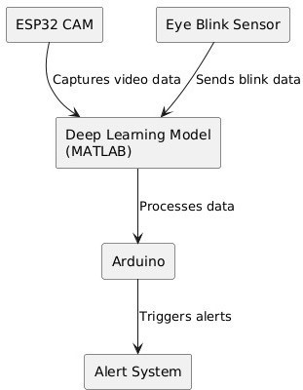

*Fig 2. Simplified block diagram*

DATA COLLECTION AND DATA PROCESSING : In

this phase the data’s had collected from the ESP32 CAM and the signals of the EYEBLINK SENSOR. For the anlayzing purpose and model development we using the language which his Deep Learning. Deep learning is nothing but his a subset of machine language it helps to understand the code to the machine or the computer. After the language is has been locked and we have to find the platform to perform this kind of data which is crucial for this process. For that we chosen the MATLAB platform to perform our data’s to develop, train and test models that detects the behavior’s of fatigue signs like distraction and drowsiness of the person(Driver).

ARDUINO : Here the ARDUINO is used to control and initiate the actions based on the signals received from the MATLAB and it triggers the alerts to the driver and the user.

ALERT SYSTEM : The information received from the Arduino and it makes the alert to driver and the another user like owner of the car via buzzer for the driver which is placed in inside the car and notification has been sent to the owner with the current location of the car and the status of the driver.

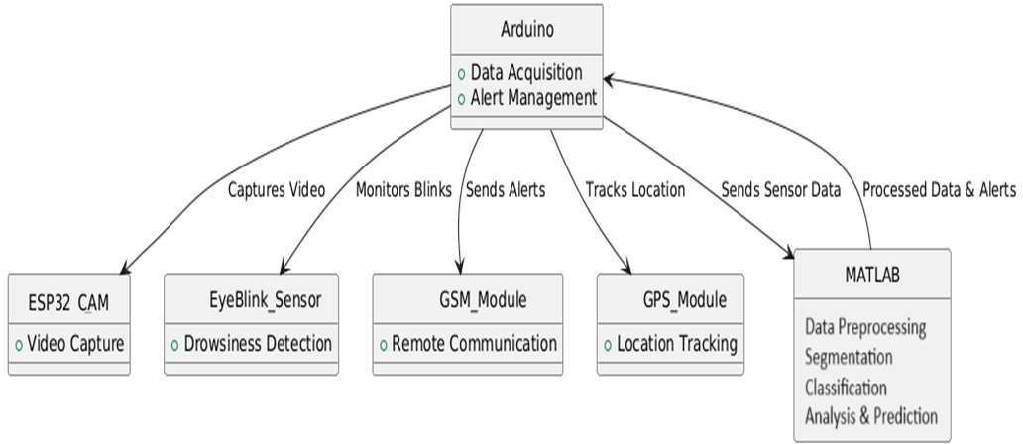

*Fig 3. Steps involved in these process*

# SIMULATION OUTPUT

When the person’s face is captured by the camera first it will extract the background and foreground classes then for the extracted face part segmentation is done. By observing the eye and mouth state it will check for driver fatigue. Here we can observe that eye is opened and mouth is closed so there is no sign of fatigue detected. If it observe any fatigue signs it pushes a popup bar notifications.

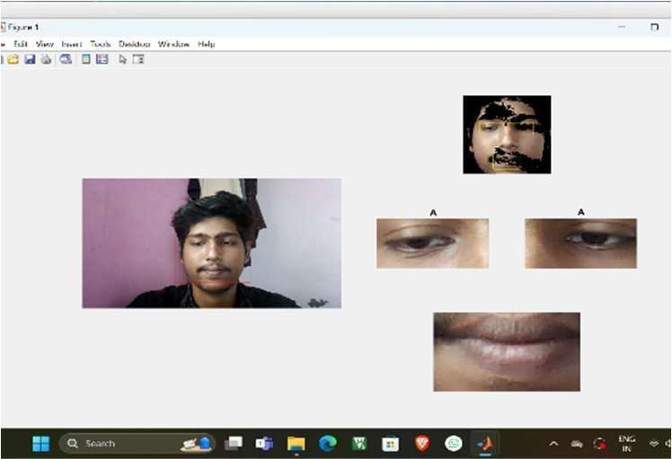

Snapshot of non-fatigue

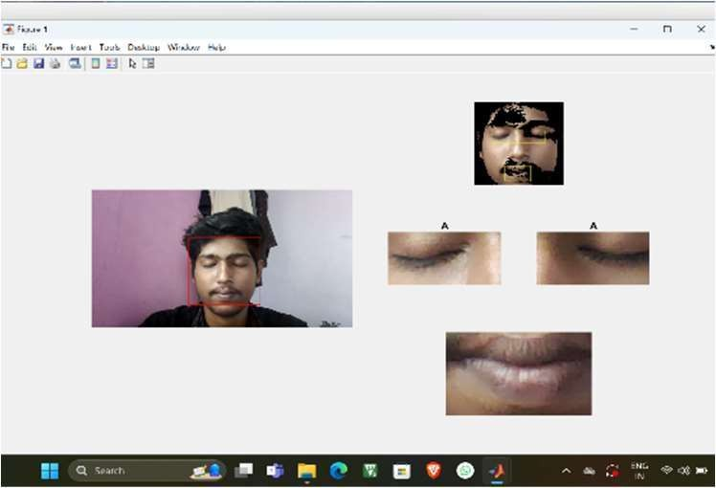

Snapshot of eye closure

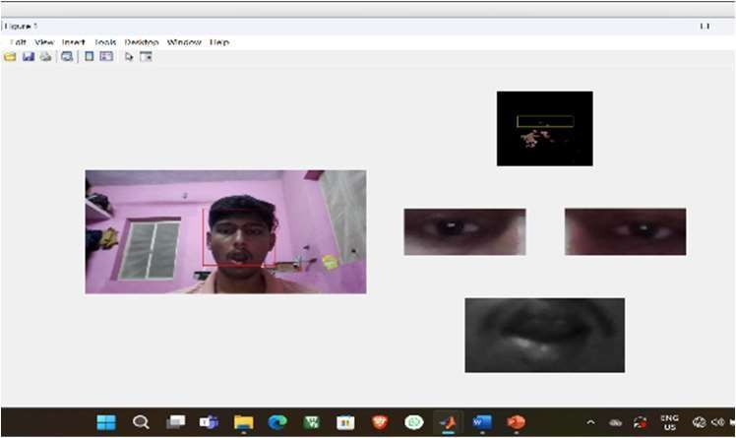

Snapshot of Mouth opening(Yawning)

ARDUINO ARCHITECTURE:

Arduino’s processor basically uses the Harvard architecture where the program code and program data have separate memory. It consists of two memories- Program memory and the data memory.The code is stored in the flash program memory, whereas the data is stored in the data memory. The Atmega328 has 32 KB of flash memory for storing code (of which 0.5 KB is used for the bootloader), 2 KB of SRAM and 1 KB of EEPROM and operates with a clock speed of 16MHz. The most important advantage with Arduino is the programs can be directly loaded to the device without requiring any hardware programmer to burn the program. This is done because of the presence of the 0.5KB of Bootloader which allows the program to be burned into the circuit. All we have download the Arduino software and writing the code.

# ARDUINO

# HARDWARE COMPONENTS

*Fig 4. Arduino Architecture*

It consists of 14 digital inputs/output pins, each of which provide or take up 40mA current. Some of them have special functions like pins 0 and 1, which act as Rx

An Arduino is actually a microcontroller based kit which can be either used directly by purchasing from the vendor or can be made at home using the components, owing to its open source hardware feature. It is basically used in communications and in controlling or operating many devices. It was founded by Massimo Banzi and David Cuartielles in 2005.The Arduino Uno is a microcontroller board based on the ATmega328. It has 14 digital input/output pins (of which 6 can be used as PWM outputs), 6 analog inputs, a 16 MHz crystal oscillator, a USB connection, a power jack, an ICSP header, and a reset button. It contains everything needed to support the microcontroller; simply connect it to a computer with a USB cable or power it with a AC-to-DC adapter or battery to get started.

and Tx respectively , for serial communication, pins 2 and 3-which are external interrupts, pins 3,5,6,9,11 which provides pwm output and pin 13 where LED is connected. It has 6 analog input/output pins, each providing a resolution of 10 bits. AREF- It has 6 analog input/output pins, each providing a resolution of 10 bits. RESET- It resets the microcontroller when low.

Features:

* 1. It is inexpensive
  2. It comes with an open source hardware feature which enables users to develop their own kit using already available one as a reference source.

# EYE BLINK SENOR

The eye-blink sensor works by illuminating the eye and/or eyelid area with infrared light, then monitoring the changes in the reflected light using a phototransistor and differentiator circuit. The exact functionality depends greatly on the positioning and aiming of the emitter and detector with respect to the eye.

Featutres:

* EYE BLINK indication by LED
* Instant output digital signal for directly
* Connecting to microcontroller
* Compact Size

# GSM MODEM

*Fig 6. EBS Functionality*

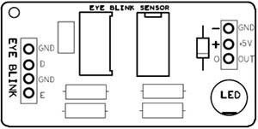

*Fig 5. Eye blink sensor*

|  |  |  |
| --- | --- | --- |
| **Pin** | **Name** | **Details** |
| 1 | GND | Power Supply Ground |
| 2 | +5V | Power supply Positive input |
| 3 | OUT | Active High Output |

USING SENSOR

* Connect regulated DC power supply of 5 Volts. Black wire is Ground, Next middle wire is Brown which is output and Red wire is positive supply.
* To test sensor you only need power the sensor by connect two wires +5V and GND. You can leave the output wire as it is. When Eye closed LED is off the output is at 0V.
* Put Eye blink sensor glass on the face within 15mm distance, and you can view the LED blinking on each Eye blink.
* The output is active high for Eye close and can be given directly to microcontroller for interfacing applications.

Eye Blink Output

* 5V (High) → LED ON When Eye is close.
* 0V (Low) → LED OFF when Eye is open.

WORKING

The exact functionality depends greatly on the positioning and aiming of the emitter and detector with respect to the eye. For example, a relatively robust detection of blinking is easy to achieve by arranging the detector so that it is near the eyelid, mounting the detector to the rubber eyecup of an HMD has this effect. Detection of saccadic eye motion is more difficult but is still easier than detection of absolute position, due to the characteristically rapid change in the light reflected from the eye surface during the saccadic jumps.

GSM is a mobile communication modem; it is stands for global system for mobile communication (GSM). The idea of GSM was developed at Bell Laboratories in 1970. It is widely used mobile communication system in the world. GSM is an open and digital cellular technology used for transmitting mobile voice and data services operates at the 850MHz, 900MHz, 1800MHz and 1900MHz frequency bands.

GSM system was developed as a digital system using time division multiple access (TDMA) technique for communication purpose. A GSM digitizes and reduces the data, then sends it down through a channel with two different streams of client data, each in its own particular time slot. The digital system has an ability to carry 64 kbps to 120 Mbps of data rates.

There are various cell sizes in a GSM system such as macro, micro, pico and umbrella cells. Each cell varies as per the implementation domain. There are five different cell sizes in a GSM network macro, micro, pico and umbrella cells. The coverage area of each cell varies according to the implementation environment.

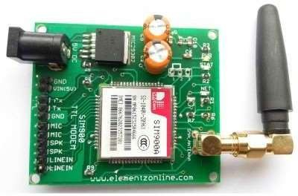

*Fig 7. GSM Modem*

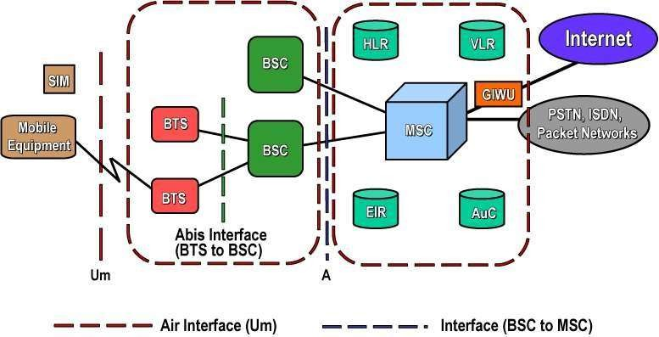

*Fig 8. GSM Architecture*

# TYPES OF AT COMMANDS

There are two types of AT commands:

* **Basic commands** are AT commands that do not start with "+". For example, D (Dial), A (Answer), H (Hook control), and O (Return to online data state) are basic commands.
* **Extended commands** are AT commands that start with "+". All GSM AT commands are extended commands. For example, +CMGS (Send SMS message), +CMGL (List SMS messages), and

+CMGR (Read SMS messages) are extended commands.

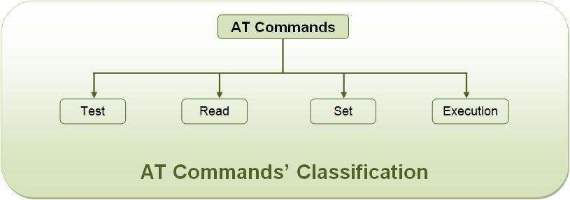

*Fig 9. AT Command’s Classification*

* Reading, writing and deleting SMS messages.
* Sending SMS messages.
* Monitoring the signal strength.
* Monitoring the charging status and charge level of the battery.
* Reading, writing and searching phone book entries.

# GLOBAL POSTIONING SYSTEM(GPS)

GPS stands for Global Positioning System and was developed by the US Department of Defence as a worldwide navigation and positioning facility for both military and civilian use. It is a space-based radio- navigation system consisting of 24 satellites and ground support. GPS provides users with accurate information about their position and velocity, as well as the time, anywhere in the world and in all weather conditions.

Navigation in three dimensions is the primary function of GPS. Navigation receivers are made for aircraft, ships, ground vehicles, and for hand carrying by individuals.

GPS provides specially coded satellite signals that can be processed in a GPS receiver, enabling the receiver to compute position, velocity and time.

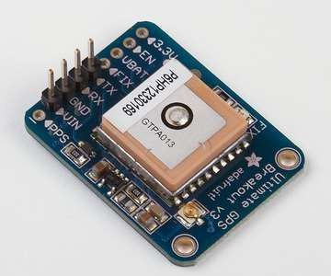

*Fig 10. GPS Modem*

Latitude and longitude are angles that uniquely define points on a sphere. Together, the angles comprise a coordinate scheme that can locate or identify geographic positions on the surfaces of planets such as the earth.

* **Latitude** is defined with respect to an equatorial reference plane. This plane passes through the centre *C* of the sphere, and also contains the great circle representing the equator. The latitude of a point *P* on the surface is defined as the angle that a straight line, passing through both *P* and *C*, subtends with respect to the equatorial plane.
* **Longitude** is defined in terms of meridians, which are half-circles running from pole to pole. A reference meridian, called the prime meridian, is selected,

and this forms the reference by which longitudes are defined. On the earth, the prime meridian passes through Greenwich, England; for this reason it is also called the Greenwich meridian. The longitude of a point *P* on the surface is defined as the angle that the plane containing the meridian passing through *P* subtends with respect to the plane containing the prime meridian.

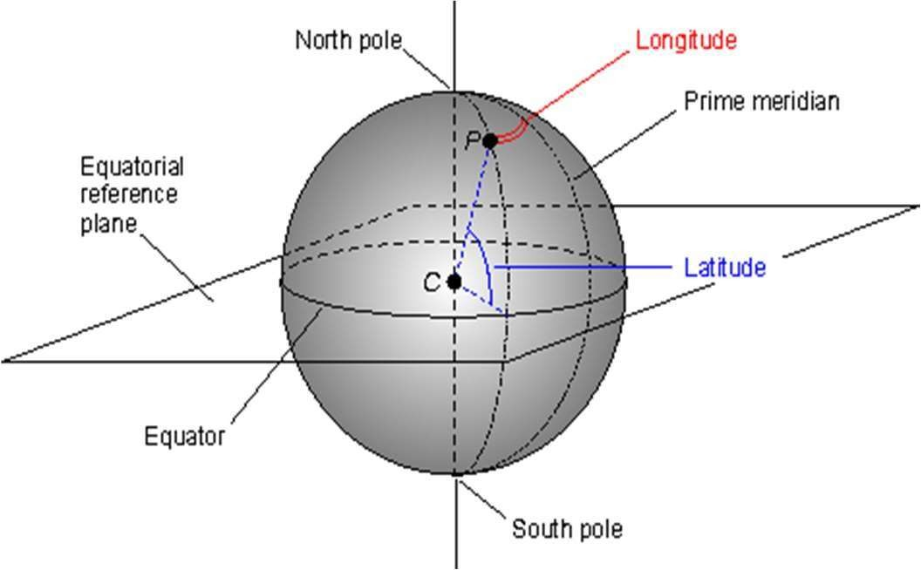

*Fig 11. Latitude & Longitude*

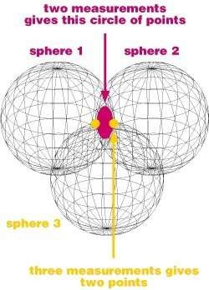

*Fig 12. Axis pointing*

# BUZZER

A buzzer is a mechanical, electromechanical, magnetic, electromagnetic, electro-acoustic or piezoelectric audio signaling device. A Piezo electric buzzer can be driven by an oscillating electronic circuit or other audio signal source. A click, beep or ring can indicate that a button has been pressed. A buzzer takes some sort of input and emits a sound in response to it. They may use various means to produce the sound; everything from metal clappers to electromechanical devices.

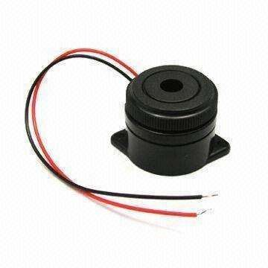

*Fig 13. 6v Buzzer*

Circuit Diagram:

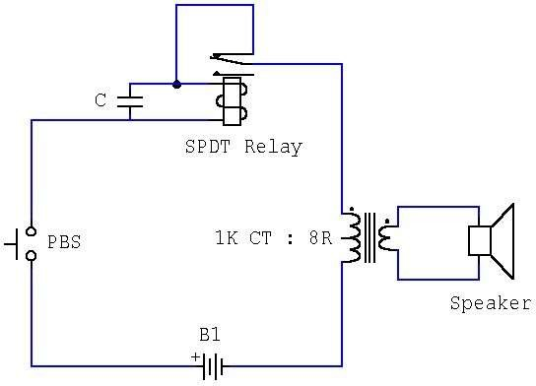

# IMPLEMENTATION

The implementation of the driver behavior detection system involves integrating hardware and software components to create a robust, real-time monitoring system that can accurately detect driver fatigue and distraction. This process includes configuring hardware, training and deploying the Convolutional Neural Network (CNN) model, and establishing communication protocols for alerts. Each component must work seamlessly to ensure timely intervention when signs of fatigue are detected.

1. Hardware Setup and Configuration

The first step in the implementation process is configuring the hardware components. The ESP32 CAM is installed in the vehicle, positioned to capture the driver’s face, allowing the system to monitor for signs of drowsiness through real-time video feeds. Simultaneously, an eye blink sensor is placed near the driver's eyes to monitor blink rate and duration, serving as an additional source of data to validate fatigue levels.

The Arduino microcontroller is programmed to control and coordinate data flow between the ESP32 CAM, eye blink sensor, GSM module, and GPS module. The Arduino collects and processes data in real-time, triggering alerts when necessary. The GSM module is integrated to enable remote communication, sending SMS alerts to pre- designated contacts when fatigue is detected and the driver fails to respond. The GPS module provides location data, which is attached to the SMS alert to assist responders in locating the vehicle quickly. The buzzer is also connected to the Arduino and serves as the first level of alert, immediately notifying the driver when signs of fatigue are detected.

1. Training and Deployment of the CNN Model

The CNN model, based on the VGG-16 architecture, is developed and trained in MATLAB for accurate fatigue detection. The model is trained on a dataset containing facial expressions associated with fatigue, such as prolonged eye closures, yawning, and head movements. The training process involves multiple iterations to optimize model accuracy, ensuring it can distinguish between normal and fatigued states in real-time. After training, the CNN model is deployed onto MATLAB for real-time analysis. The ESP32 CAM streams video data, which is processed by the CNN model to identify fatigue-related expressions. OpenCV libraries are employed in MATLAB to enhance image processing, adjusting for variations in lighting and angles to ensure the CNN model receives high-quality, consistent input. The CNN outputs a fatigue score, which is analyzed by the Arduino to determine whether an alert should be triggered.

1. Real-Time Monitoring and Alert System

Once the hardware is set up and the CNN model deployed, the system operates continuously to monitor the driver’s state. Video data from the ESP32 CAM and eye blink data from the blink sensor are processed in real-time. If the CNN detects a fatigue level that surpasses a set threshold, the Arduino initiates the alert sequence. The first alert is an audible alarm from the buzzer, prompting the driver to refocus.

If the driver does not respond to the initial alert, the Arduino activates the GSM module, sending an SMS alert with the vehicle's location to pre-registered contacts, which could include family members or fleet management personnel. This secondary level of alert provides an opportunity for external intervention, helping to prevent potential accidents.

# RESULT AND ANALYSIS

The results of the driver behavior detection system demonstrate high accuracy and reliability in detecting signs of driver fatigue and distraction, offering a significant contribution to road safety. By combining real-time video monitoring with machine learning-based image processing and a multi-layered alert system, the project achieves a balanced approach to fatigue detection with minimal false positives and rapid response times.

1. Model Accuracy and Performance:

The Convolutional Neural Network (CNN) model, based on the VGG-16 architecture, is evaluated on a test dataset containing labeled images of fatigued and alert driver states. The model achieved an accuracy rate of approximately 92% in detecting fatigue indicators such as prolonged eye closure, yawning, and abnormal head positioning. These high accuracy levels were made possible by training the model on diverse facial expression data, covering various lighting conditions and driver orientations. OpenCV’s image processing techniques also improved input quality, reducing the influence of environmental factors. Additionally, the eye blink sensor provided supplementary data on blink rate and duration, further enhancing the model’s precision. Cross-referencing blink data with CNN output minimized false positives, as both the eye sensor and the CNN model had to detect fatigue indicators for an alert to be triggered. This dual-layered approach improved detection accuracy and reduced unnecessary alerts.

1. Real-Time Monitoring and Alert Response:

The system’s real-time functionality was tested extensively under various conditions using both live simulation and field trials. The Arduino microcontroller effectively coordinated data from the ESP32 CAM, eye blink sensor, GSM module, and GPS module, maintaining seamless communication between components. During testing, the system successfully triggered an immediate audible alert when signs of fatigue were detected, prompting the driver to re- engage. In cases where the driver failed to respond, the GSM module reliably sent SMS alerts to designated contacts, including real-time GPS coordinates for accurate location tracking. This feature is especially beneficial for fleet management, allowing quick response to fatigued drivers in real-time. The dual alert mechanism proved effective, with timely notifications enabling potential interventions to prevent accidents.

# HARDWARE SETUP

such as prolonged eye closure and yawning. The dual-layer alert mechanism—comprising an audible in-vehicle alert and remote SMS notifications—ensures prompt response, enabling preventive actions and reducing the likelihood of accidents caused by driver inattention.

# XI. ADVANTAGES

1. Advanced Driver Assistance Systems: Integrate the model to provide real-time alerts and interventions based on detected driver behaviors, enhancing safety.
2. Emergency Response Systems: Enhance emergency response systems by providing real-time behavior analysis to prioritize and manage accident response more effectively.
3. Personalized Driver Feedback: Offer tailored feedback to drivers for improving their driving habits, which can be integrated into in-car systems.
4. Predictive Maintenance: Analyze driver behavior to predict and prevent potential vehicle maintenance issues.

# CONCLUSION

In conclusion, the developed driver monitoring system effectively combines ESP32 CAM, eye blink sensors, and CNN-based analysis to assess driver alertness in real-time. By integrating Arduino for data collection and timely alert triggering, the system provides a proactive approach to enhancing road safety. The successful deployment of this technology highlights its potential in reducing accidents caused by driver fatigue or distraction, making it a valuable contribution to intelligent transportation systems and driver assistance solutions. This driver behavior detection system provides an effective solution for real-time monitoring of driver fatigue and distraction, leveraging advanced image processing and machine learning. With the integration of an ESP32 CAM, eye blink sensor, GSM module, GPS module, and a VGG- 16-based CNN model, the system achieves high accuracy in detecting signs of fatigue,

REFERENCES

1. B. B. Gupta, A. Gaurav, K. Tai Chui and V. Arya, "Deep Learning Model for Driver Behavior Detection in Cyber-Physical System-Based Intelligent Transport Systems," in IEEE Access, vol. 12, pp. 62268-62278, 2024, doi: 10.1109/ACCESS.2024.3393909.
2. B. Ma et al., "Distracted Driving Behavior and Driver’s Emotion Detection Based on Improved YOLOv8 With Attention Mechanism," in IEEE Access, vol. 12, pp. 37983-37994, 2024, doi: 10.1109/ACCESS.2024.3374726.
3. S. Yaqoob, G. Morabito, S. Cafiso, G. Pappalardo and
   1. Ullah, "AI-Driven Driver Behavior Assessment Through Vehicle and Health Monitoring for Safe Driving—A Survey," in IEEE Access, vol. 12, pp. 48044- 48056, 2024, doi: 10.1109/ACCESS.2024.3383775.
4. H. A. Madni, A. Raza, R.Sehar, N.Thalji and L. Abualigah, “Novel Transfer Learning Approach for Driver Drowsiness Detection Using Eye Movement Behavior,” in IEEE Access, vol. 12, pp.64765-64778, 2024, doi:10.1109/ACCESS.2024.3392640.
5. H. Lamaazi, A. Alqassab, R.A. Fadul and R. Mizouni, “

Smart Edge-Based Driver Drowsiness Detection in Mobile Crowdsourcing,” in IEEE Access, vol.11, pp.21863- 21872,2023, doi:10.1109/ACCESS.2023.3250834.