**A NOVEL ARTIFICIAL NEURAL NETWORK APPROACH TO DETECT COVID-19 DISEASE FROM X-RAY IMAGES USING CONVOLUTIONAL NEURAL NETWORKS**

# Afreen Hussain,S.K.B.Rathika,P.Dhivya, BharathyGnanam G

1,2,3,4,5Department Of Information Technology, Adithya Institute of Technology,Coimbatore,India.

# ABSTRACT

The novel Coronavirus also called COVID-19 originated in Wuhan, China in December 2019 and has now spread across the world. It has so far infected around 1.8 million people and claimed approximately 5,14,698 lives overall. As the number of cases is rapidly increasing, most of the countries are facing shortage of testing kits and resources. The limited quantity of testing kits and increasing number of daily cases encouraged us to come up with a model that can aid radiologists and clinicians in detecting COVID-19 cases using chest X-rays.

In this study, a dataset of X-ray images from patients with common bacterial pneumonia, confirmed Covid-19 disease, and normal incidents, was utilized for the automatic detection of the Corona virus disease. The aim of the study is to evaluate the performance of state-of-the-art convolutional neural network architectures proposed over the recent years for medical image classification.

In machine learning, Convolutional Neural Networks are a class Of Deep, Feed-Forward artificial neural networks which has been successfully applied for analyzing visual imagery in the field of Computer Vision and Natural Language Processing and others.

**Keywords: dataset,machine learning,artificial neural networks ,CNN,**

# INTRODUCTION

Coronavirus is an epidemic that spreads very quickly. For this reason, it has very devastating effects in many areas worldwide. It is vital to detect COVID-19 diseases as quickly as possible to restrain the spread of the disease. The similarity of COVID-19 disease with other lung infections makes the diagnosis difficult. In addition, the high spreading rate of COVID-19 increased the need for a fast system for the diagnosis of cases. For this purpose, interest in various computer-aided (such as CNN, DNN, etc.) deep learning models has been increased. In these models, mostly radiology images are applied to determine the positive cases. Recent studies show that, radiological images contain important information in the detection of corona virus.

Convolutional Neural Networks are used for the detection of COVID-19 disease is proposed by using chest X-ray images. The proposed approach is designed to provide fast and accurate diagnostics for COVID-19 diseases with binary classification (COVID-19, and No-Findings), and multi-class classification (COVID-19, and No-Findings, and Pneumonia). The proposed method achieved an accuracy of 97.24% and 84.22% for binary class and multi-class respectively. It is thought that the proposed method may help physicians to diagnose COVID-19 disease and increase the diagnostic performance. In addition, we believe that the proposed method may be an alternative method to diagnose COVID-19 by providing fast screening.

The COVID-19 disease caused by the SARS-CoV-2 virus first appeared in Wuhan, China.COVID-19 affects the respiratory system, causing fever and cough, and in some serious cases, causes pneumonia.

Pneumonia is a type of infection that causes inflammation in the lungs, and besides the SARS-CoV-2 virus, bacteria, fungi, and other viruses often play a role in the emergence of this disease.

Conditions such as weak immune system, asthma, chronic diseases and elderliness increase the severity of pneumonia. Treatment of pneumonia varies depending on the organism causing the infection, but usually antibiotics, cough medicines, antipyretics, and pain killers are effective for treatment. Depending on the symptoms, patients can be hospitalized and, in more severe cases, they can be taken to the intensive care unit. The COVID-19 outbreak is considered a serious disease due to its high permeability, and contagiousness. In addition, this epidemic has a great impact on the healthcare system, by virtue of the high number of patients hospitalized in intensive care units, the length of treatment, and the lack of hospital resources. Thus, it is vital to diagnose the diseased at an early stage in order to prevent such scenarios.

Computed tomography, and X-ray images play an important role in the early diagnosis and treatment of COVID-19 disease. The fact that X-ray images are cheaper and faster and patients are exposed to less radiation cause these images to prefer more than CT images. However, it is not easy to diagnose pneumonia manually. White spots on X-ray images need to be examined and interpreted in detail by a specialist.

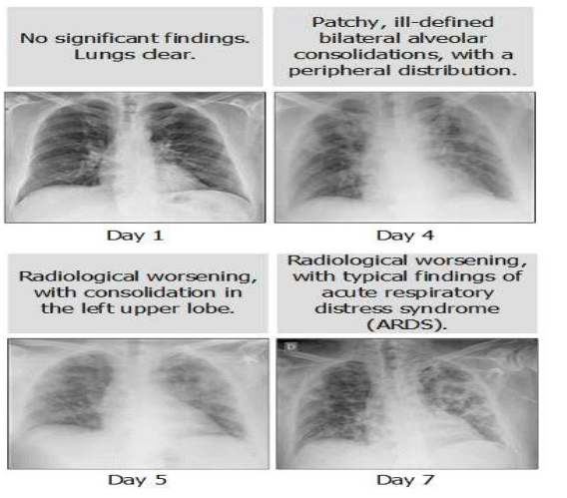

**ARTIFICIAL NEURAL NETWORK**

An Artificial Neural Network (ANN) is the piece of a computing system designed to simulate the way the human brain analyzes and processes information. It is the foundation of Artificial Intelligence (AI) and solves problems that would prove impossible or difficult by human or statistical standards. The idea of ANNs is based on the belief that working of human brain by making the right connections, can be imitated using silicon and wires as living neurons and dendrites.

The human brain is composed of 86 billion nerve cells called neurons. They are connected to other thousand cells by Axons. Stimuli from external environment or inputs from sensory organs are accepted by dendrites. These inputs create electric impulses, which quickly travel through the neural network. A neuron can then send the message to other neuron to handle the issue or does not send it forward.

ANNs are composed of multiple nodes, which imitate biological neurons of human brain. The neurons are connected by links and they interact with each other. The nodes can take input data and perform simple operations on the data. The result of these operations is passed to other neurons. The output at each node is called its activation or node value.

Each link is associated with weight. ANNs are capable of learning, which takes place by altering weight values. The following illustration shows a simple ANN −

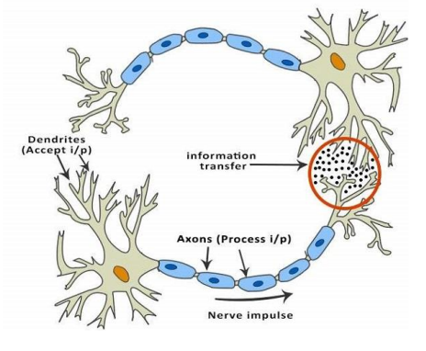**1.3 TYPES OF ARTIFICIAL NEURAL NETWORKS**

In general, each type of neural network has its distinct strengths and use cases. We outlined some of them below.

**1. Feed forward Neural Network**

Feed forward neural network or deep feed forward network is one of the simplest types of artificial neural networks. In this ANN, data goes through several input nodes (computational units also known as artificial neurons) until it arrives at an output node.

Simply put, information passes through in a single direction from an entry point or input node to an exit point or output node. It differs from other more complex ANN types in that it does not have feedback connections where the output from each layer of neurons is fed back to it for learning. A feed forward neural network does not form a cycle or loop to allow a program to learn.

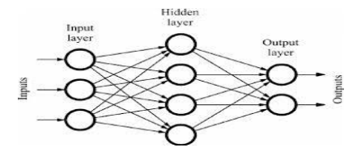

**Applications**

Feed forward neural networks are used in computer vision and facial recognition applications.

**2. Radial Basis Function Neural Network (RBFNN)**

This type of ANN only has three layers—the input layer, the hidden layer, and the output layer. It is limited to a single hidden layer compared with other ANN types. The hidden layer is basically hidden in between input and output layers, and it reduces redundancies in data. Compared with other ANN types that can have several hidden layers, learning is faster in an RBFNN.

To further understand what the different ANN layers are for, imagine that you want to in form your computer that the picture it is shown depicts a car. For the computer to understand, it needs separate tools (or layers). Your car detector can thus have a wheel detector so it can tell something has wheels. It should have a vehicle body detector, which could allow it to differentiate a car from a truck, and a size detector so it can do likewise. These are just some elements that make up hidden layers inartificial neural networks. They do not present the entire image but are parts of it.

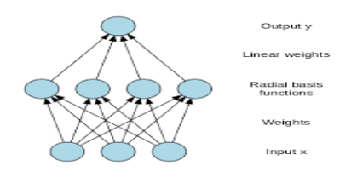

**Applications**

RBFNNs can be used in complex power restoration systems. In case of a blackout, they can be used to restore electrical power to normal conditions with minimal losses and less societal impact. They can also be extensively applied for time-series prediction. An example would be in stock trading, where computers predict what stocks are likely to increase or decrease in value, allowing users to invest wisely.

**3. Recurrent Neural Network (RNN)**

This type of ANN is similar to a feed forward neural network, but it saves the output of a specific layer and feeds it back as input. As a result, it can help predict several possible outcomes from any particular layer.

Drilling down to specifics: If the first layer receives the output and sends it back as input, the next layers will start the recurrent neural network process. Each node retains a memory from the previous step. And so, the system remembers wrong predictions and learns from them to improve its next ones. In short, RNNs can learn from each step to predict the outcome in the next step.

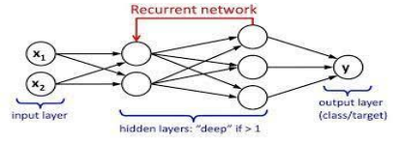

**Applications**

RNNs are used in text-to-speech applications that predict what users may want to say next, depending on the context of their initial input.

**4. Multilayer Perceptron (MLP)**

This type of ANN has three or more layers that classify data that cannot be linearly separated (i.e., go through a straight path). Thus, it is fully connected, which means that each node within a layer is connected to the succeeding node in the next layer.

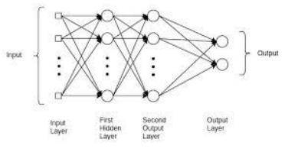

**Applications**

MLPs aid in speech recognition and machine translation technologies.

**5. Convolutional Neural Network (CNN)**

This type of ANN applies a different version of MLPs by having several layers that can be completely interconnected. The primary purpose of CNNs is to decipher specific features of a given image such as a face. They identify features based on how near or far each pixel (which makes up every facial feature) is from a reference point.

CNN consists of three basic layers: convolution, pooling and fully connected layers .Convolution layers perform feature extraction by convolving the input image with a set of learned kernels. The layer typically consists of a combination of convolution operation and activation function.

The output of the convolution layer is then passed through a non-linear activation function. The most common non-linear activation function used is the rectified linear unit (ReLU) and its variant Leaky ReLu. The pooling layer is used to reduce the spatial resolution of the activation map and thereby reducing the number of parameters. Pooling helps to decrease the computational cost and overfitting. Max-pooling and average pooling are the most common methods of pooling.

Every neuron in the previous layer are connected to a fully connected (FC) layer. Features generated by the previous layer are flattened in a feature vector by the FC layer. It then performs weight updates to improve the predicting ability of feature vector. Features are extracted from the last fully connected layer of the pre-trained CNNs with 1000 neurons. Each pre-trained CNN produces a feature matrix of size *n*× 1000, where *n* is the number of X-ray images. The feature matrices of the multi-CNN are combined together to form a feature matrix of dimension *n*× 1000 *m*, where *m* is the number of pre-trained networks used in the multi-CNN.

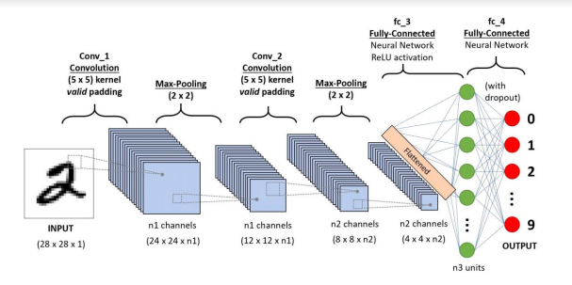

**Applications**

CNNs are widely used for accurate face detection even if the input image is of low resolution. They are also particularly useful for improving a self-driving car’s estimation of its driving field since they are very good at determining distances. Other applications include Natural Language Processing (NLP), paraphrase detection, and image classification.

The types of artificial neural networks above use different methods to achieve a desired outcome. However, all of them work in a way that resembles how neurons in our brains work. Like the neurons in the human brain, ANNs learn more and improve their functions every time they receive more data and are used more often. And just like our brain, which it mimics, its applications can also be limitless.

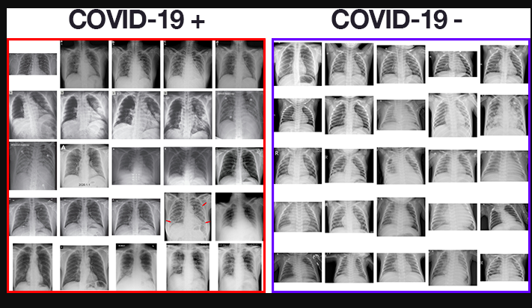

**REFERENCES**

1. Covid-19: automatic detection from X‐rayimages utilizing transfer learning with convolutionalneural networks -Ioannis D. Apostolopoulos · Tzani .A, Mpesiana.

2. COVID-19 identification in chest X-ray images on flat and hierarchical classification scenarios

Rodolfo M. Pereira Diego Bertolini, Lucas O. Teixeira, Carlos N. Silla Jr.,Yandre M.G.

3. Application of deep learning for fast detection of COVID-19 in X-Rays using nCOVnet -Harsh

Panwar P.K. Gupta, Mohammad Khubeb Siddiqui, Ruben Morales-Menendez,Vaishnavi Singh.

4. Automated detection of COVID-19 cases using deep neural networks with X-ray images-TulinOzturk, Muhammed Talo, Eylul Azra Yildirim, Ulas Baran Baloglu, Ozal Yildirim,U. RajendraAcharya.

5. Covid-19: automatic detection from X-ray images utilizing transfer learning with convolutionalneural networks - Ioaniss.Apostolopoulos.Tzani A.mpesiana

6. github.com/ieee8023/covid-chestxray-dataset

7. <https://www.tutorialspoint.com/python/index.htm>

8. <https://keras.io/>