FLOODWALL : A REAL TIME FLASH FLOOD MONITORING AND FORECASTING BY USING IOT

G. Sree Ramya*1, S. Neelima*2, A. Bala Sai*3, C. Kalyan Kumar*4

Department of Electrical and Electronics Engineering, Sanskrithi School Of Engineering,

Puttaparthi, Andhra Pradesh, India.

Abstract : An Arduino Uno microcontroller processes the sensor data and displays real-time values on an LCD; in the event of abnormal conditions, a buzzer activates and an alert message is sent via a GSM module; the collected data is uploaded to the ThingSpeak cloud platform using a NodeMCU module for further analysis and monitoring; and the project, FLOODWALL: A Real-Time Flash Flood Monitoring and Forecasting System Using IoT, is designed to detect and monitor flood-related parameters using multiple sensors: a raindrop sensor detects the presence of rainfall, an ultrasonic sensor measures the water level, a water flow sensor tracks water movement, and a DHT11 sensor records environmental temperature and humidity.

Keywords: floodwall, Real Monitoring, Flash flood, Flood Forecating

Introduction : In order to improve flood detection and forecasting, FLOODWALL is an Internet of Things (IoT)-based real-time flash flood monitoring prototype that incorporates sensors to track temperature, humidity, water flow, rainfall, and water levels. An Arduino Uno processes the data and displays it on an LCD in abnormal circumstances. A buzzer sounds in unusual circumstances, and GSM is used to send out alerts.

Floodwall is a cutting-edge, real-time flash flood monitoring and forecasting system that harnesses the power of Internet of Things (IoT) technology to provide early warnings and critical insights, mitigating the devastating impacts of flash floods on communities, infrastructure, and the environment, by deploying a network of IoT sensors and devices to monitor water levels, rainfall, and other environmental factors, analyzing data using advanced algorithms and machine learning techniques to predict flash flood events with high accuracy.

Floodwall is a cutting-edge, real-time flash flood monitoring and forecasting system leveraging IoT technology to provide early warnings and critical insights, mitigating devastating impacts on communities, infrastructure, and environment, by deploying IoT sensors and devices to monitor water levels, rainfall, and environmental factors, analyzing data using advanced algorithms and machine learning techniques to predict flash flood events with high accuracy, enabling timely alerts and notifications to authorities, emergency services, and affected communities, improving public safety, enhancing decision-making, reducing economic losses, and promoting resilience, utilizing a scalable, flexible, and reliable IoT-based architecture, integrating data from various sources, including weather forecasts, hydrological data, and sensor readings, to provide a comprehensive view of flood risk, supporting proactive measures to prevent or minimize flood damage, and ensuring effective emergency response and recovery efforts, ultimately saving lives, reducing damage, and promoting sustainable development, through a collaborative approach, involving stakeholders from various sectors, including government, emergency services, and local communities, Floodwall aims to become a vital tool for flood risk management, enhancing the ability to anticipate, prepare for, and respond to flash flood events, and creating a safer, more resilient future for all.

Existing Model : Several IoT-based flood monitoring systems exist, including smart flood monitoring with GSM alerts, WSN-based detection using Zigbee/LoRa, satellite and radar-based forecasting, Arduino-GSM alert systems, and AI-driven flood prediction models. These systems use various sensors and communication methods for real-time data collection and forecasting. FLOODWALL follows an IoT-based approach with multiple sensors and cloud integration via ThingSpeak but remains a prototype without real-time testing capabilities.

Proposed Model : An Internet of Things prototype for real-time flash flood monitoring and forecasting is called FLOODWALL. A raindrop sensor for rainfall detection, an ultrasonic sensor for water level measurement, a DHT11 sensor for temperature and humidity monitoring, and a water flow sensor for tracking water movement are some of the sensors that are integrated to detect important environmental parameters. The data is processed by an Arduino Uno microcontroller, which then shows the sensor results on an LCD. In case of abnormal conditions, a buzzer activates, and a GSM module sends alert messages. Data is uploaded to the ThingSpeak cloud platform via NodeMCU, enabling remote monitoring and analysis. This system provides a scalable and cost-effective flood detection solution, though it is developed as a prototype and cannot be tested in real flood conditions.

Block Diagram :

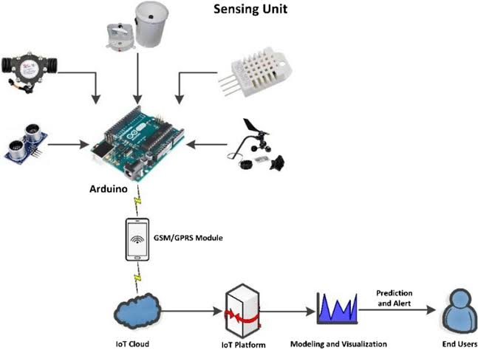

Hardware Components :

* Arduino
* Raindrop sensor
* Water flow sensor
* Ultrasonic sensor
* Dht11 sensor
* Lcd
* Nodemcu
* Gsm
* Buzzer
* Power supply

Software Components :

* Arduino ide
* Embedded c

Arduino : Arduino Uno is a very valuable addition in the electronics that consists of USB interface, 14 digital I/O pins, 6 analog pins, and Atmega328 microcontroller. It also supports serial communication using Tx and Rx pins.   
There are many versions of Arduino boards introduced in the market like Arduino Uno, Arduino Due, Arduino Leonardo, Arduino Mega, however, most common versions are Arduino Uno and Arduino Mega. If you are planning to create a project relating to digital electronics, embedded system, robotics, or IoT, then using Arduino Uno would be the best, easy and most economical option.

It is an open-source platform, so the boards and software are easily available and anyone can alter and optimize the boards for greater functionality.  
The IDE (Integrated Development Environment) software, which is free to use and requires some basic knowledge to acquire, is used for Arduino devices. The programming languages C and C++ can be used to program it.  
Some people mistakenly believe that Arduino and Microcontroller are the same thing. The former is merely a 40-pin on-system chip with an integrated microprocessor, while the latter is a board with a microcontroller at the board's base, bootloader, and easy access to input-output pins that facilitates program uploading and burning.

Since the platform is open-source, anyone can alter and improve the boards for improved functionality. The software and boards are also easily accessible.   
The IDE (Integrated Development Environment) software, which is free to use and requires some basic knowledge to acquire, is used for Arduino devices. The programming languages C and C++ can be used to program it.   
An Arduino and a microcontroller can be confusing to some individuals. The former is merely a 40-pin on-system chip with an integrated microprocessor, whereas the latter is a board with a microcontroller at the board's base, bootloader, and simple access to input-output pins that facilitates program uploading and burning.

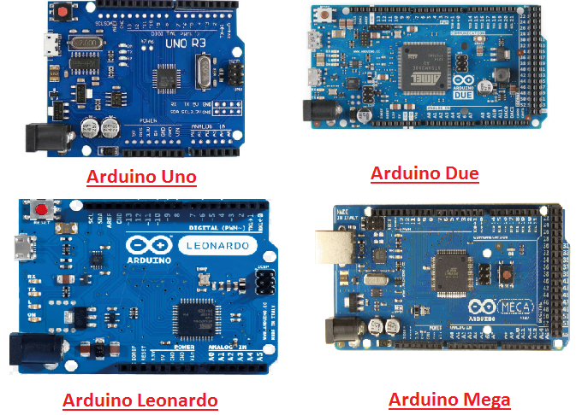

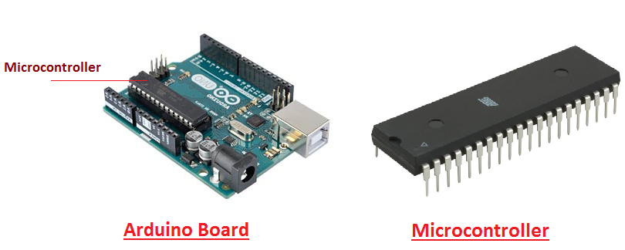

Overview of Arduino   
 Arduino Uno is a microcontroller board developed by Arduino.cc which is an open-source electronics platform mainly based on AVR microcontroller Atmega328.

First Arduino project was started in Interaction Design Institute Ivrea in 2003 by David Cuartielles and Massimo Banzi with the intention of providing a cheap and flexible way to students and professional for controlling a number of devices in the real world.   
 The current version of Arduino Uno comes with USB interface, 6 analog input pins, 14 I/O digital ports that are used to connect with external electronic circuits. Out of 14 I/O ports, 6 pins can be used for PWM output.   
 It allows the designers to control and sense the external electronic devices in the real world .

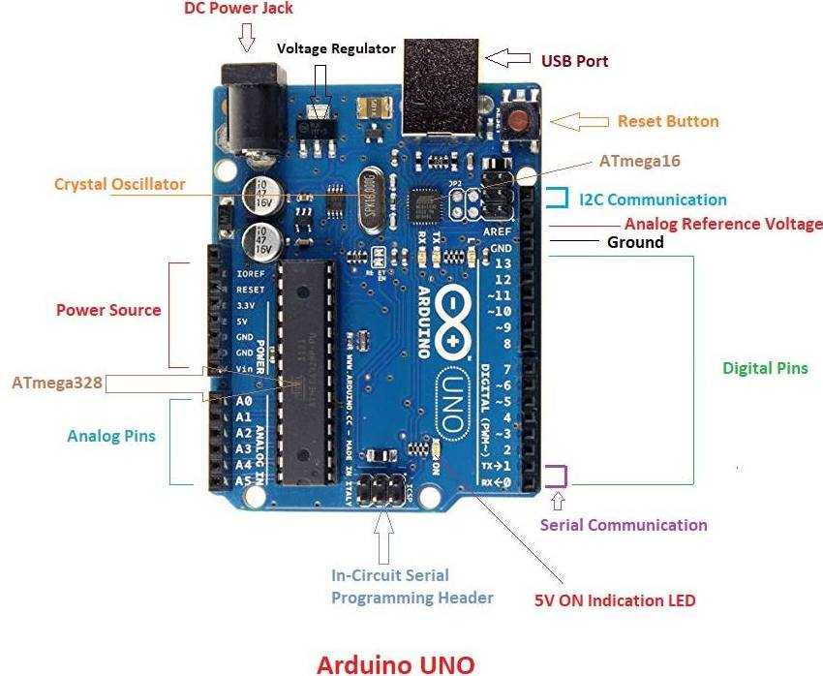

• This board has all the functionality needed to operate the controller and can be linked straight to the computer via a USB cable. The IDE (Integrated Development Environment) software, which was primarily created to program Arduino, is used to transmit code to the controller.

• This board has all the functionality needed to operate the controller and can be linked straight to the computer via a USB cable. The IDE (Integrated Development Environment) software, which was primarily created to program Arduino, is used to transmit code to the controller. Although Linux, Mac, and Windows can all utilize the IDE, Windows is the preferred operating system. The IDE uses programming languages like C and C++.  
In addition to USB, the board can be powered by a battery or an AC to DC adapter. In terms of operation and functionality, Arduino Uno boards are fairly identical to other Arduino boards; however, they lack the FTDI USB to Serial driver chip.

**Features of Arduino**

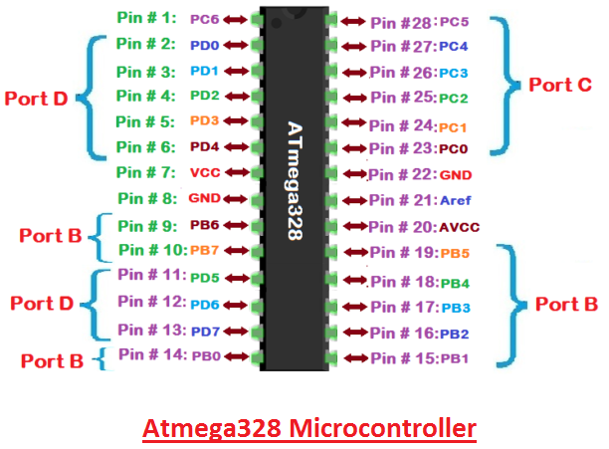

**Raindrop Sensor:**

Raindrop Sensor is a tool used for sensing rain. It consists of two modules, a rain board that detects the rain and a control module, which compares the analog value, and converts it to a digital value. The raindrop sensors can be used in the automobile sector to control the windshield wipers automatically, in the agriculture sector to sense rain and it is also used in home automation systems. 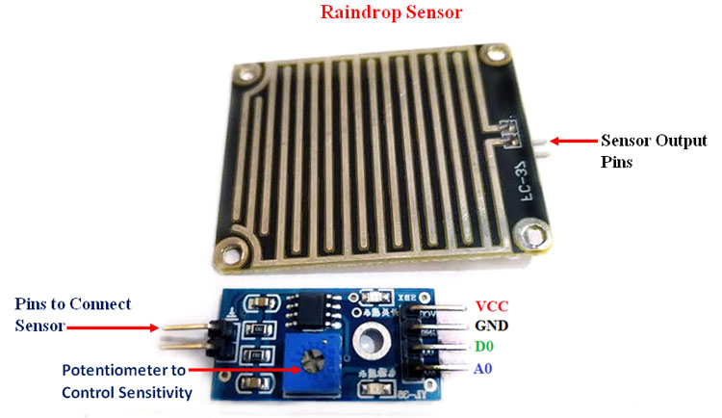

**Flow Sensor:**

Flow Sensor: Also known as a "flow meter," a flow sensor is an electronic device that monitors or controls the rate at which liquids and gases move through pipes and tubes. Although they can also be connected to computers and digital interfaces, flow sensors are typically used in conjunction with gauges to provide their measurements. They are frequently found in septic systems, chemical factories, medical devices, and HVAC systems. Leaks, obstructions, pipe ruptures, and variations in liquid concentration brought on by pollution or contamination can all be found with flow sensors. 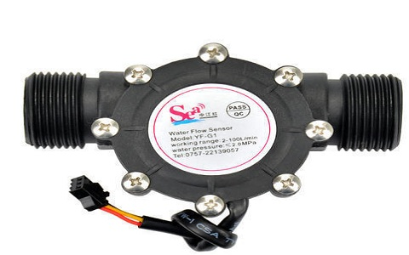

**Ultrasonic sensor**

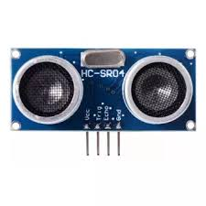 Ultrasonic waves are sent into the atmosphere by an ultrasonic sensor, which then picks up reflected waves from an object. Ultrasonic sensors have a wide range of uses, including backup sensors for cars, automatic door openers, and intrusion alarm systems.

**DHT11 SENSOR (TEMPERATURE/HUMIDITY):**

The DHT11 is a basic, low-cost digital temperature and humidity sensor. It uses a capacitive humidity sensor and a thermistor to measure the surrounding air, and spits out a digital signal on the data pin (no analog input pins needed). It’s fairly simple to use, but requires careful timing to grab data. The only real downside of this sensor is you can only get new data from it once every 2 seconds.

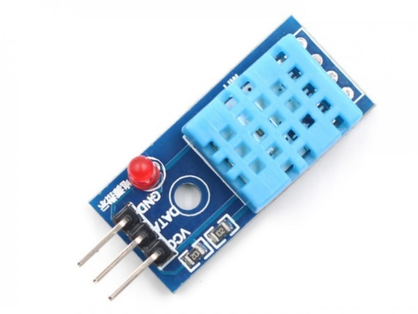

**Images of LCD Display:-**

**[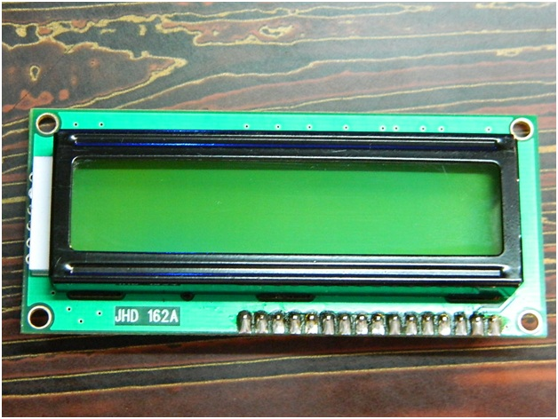](http://www.circuitstoday.com/wp-content/uploads/2012/02/LCD-Display-Front-Side.jpg)**

**LCD – Front View**

**[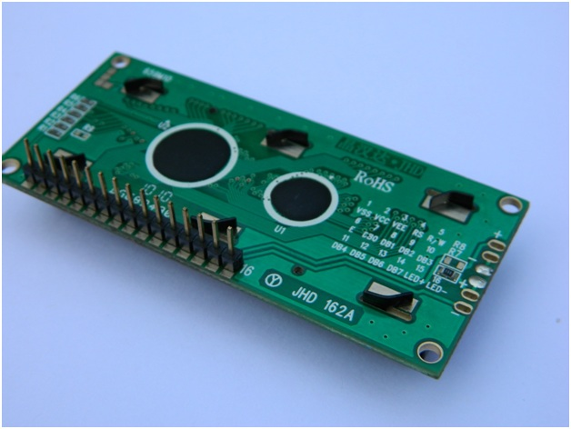](http://www.circuitstoday.com/wp-content/uploads/2012/02/lcd-display-back-side.jpg)**

**LCD – Back View**

**Pin Diagram:**

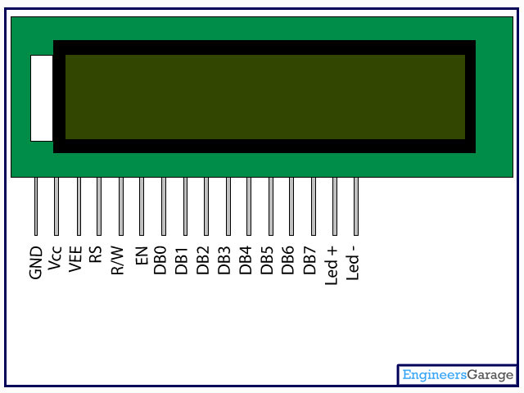

**Conclusion:**

The FLOODWALL system provides an IoT-based real-time flash flood monitoring and forecasting solution using multiple sensors to track key environmental parameters. With Arduino Uno for processing, LCD for display, and GSM module for alerts, the system ensures timely warnings during abnormal conditions. Data is uploaded to ThingSpeak via NodeMCU, enabling remote monitoring. This prototype offers a cost-effective and scalable approach to flood detection, though it cannot be tested in real-time flood scenarios**.**

**References:**

References: D. S. Rani, G. N. Jayalakshmi, and V. P. Baligar, “Low cost IoT based flood monitoring system using machine learning and neural networks,” Mar. 2020.

M. Ragnoli, G. Barile, A. Leoni, G. Ferri, and V. Stornelli, “Autonomous low-power LoRa-based flood-monitoring system,” 2020.

O. Mendoza-Cano, R. Aquino-Santos, J. López-De La Cruz, R. M. Edwards, A. Khouakhi, I. Pattison, et al., “Experiments of an IoT-based wireless sensor network for flood monitoring in Colima, Mexico,” 2021.

B. Basnyat, N. Singh, N. Roy, and A. Gangopadhyay, “Design and deployment of a flash flood monitoring,” Sep. 2020.

O. R. Jan, H. S. Jo, R. S. Jo, and J. Kua, “Real-time flood monitoring with computer vision through edge computing-based Internet of Things,” 2022.